Input:
1. Technology: The Rise of Agentic AI
The global software market has shifted toward "Agentic Workflows," where AI agents now autonomously manage end-to-end software development lifecycles with minimal human oversight. This transition has led to a 40% increase in deployment speed for enterprise applications but has raised significant concerns regarding code security and logic transparency [Source: TechPulse Annual Report 2026].
2. Geopolitics & Trade: The Indo-EU Strategic Pact
The signing of the India-EU Free Trade Agreement in early 2026 has restructured global supply chains, significantly reducing maritime shipping costs between Kochi and Rotterdam. While this creates a massive opportunity for Indian manufacturing exports, European regulators have introduced strict "Carbon Border Taxes" that pose a threat to non-compliant heavy industries [Source: Global Trade Journal].
3. Finance: The Digital Currency Shift
Central Bank Digital Currencies (CBDCs) reached a critical adoption milestone in 2026, with over 30 nations now utilizing blockchain-based ledgers for interbank settlements. This shift has drastically reduced the influence of traditional SWIFT systems, although it has introduced new vulnerabilities regarding sovereign cybersecurity and data privacy [Source: Financial Futures Review].
4. Healthcare: AI-Driven Personalized Medicine
Advancements in Generative AI for genomics have enabled healthcare providers to offer hyper-personalized treatment plans that reduce drug adverse-reaction rates by nearly 60%. Despite these clinical successes, the high cost of implementation remains a major weakness, limiting access primarily to high-end metropolitan medical centers [Source: Healthcare Innovation Monthly].
5. Sustainability: The Green Data Center Mandate
New environmental protocols enacted in 2026 now mandate that all hyperscale data centers must operate on at least 80% renewable energy or face heavy daily penalties. This regulation is driving a massive investment opportunity in liquid-cooling technologies and modular nuclear reactors, though existing legacy infrastructure faces an immediate risk of obsolescence [Source: EcoEnergy Intelligence].

Output:
(vemv2) PS C:\Users\Vishn\Documents\Agentic AI Training\demolanggraph\day2> python MarketAnalysisBrief.py
----- Market Analysis Brief Generator Initialized------
Please paste the combined news articles and internal reports: 1. Technology: The Rise of Agentic AIThe global software market has shifted toward "Agentic Workflows," where AI agents now autonomously manage end-to-end software development lifecycles with minimal human oversight. This transition has led to a 40% increase in deployment speed for enterprise applications but has raised significant concerns regarding code security and logic transparency [Source: TechPulse Annual Report 2026].2. Geopolitics & Trade: The Indo-EU Strategic PactThe signing of the India-EU Free Trade Agreement in early 2026 has restructured global supply chains, significantly reducing maritime shipping costs between Kochi and Rotterdam. While this creates a massive opportunity for Indian manufacturing exports, European regulators have introduced strict "Carbon Border Taxes" that pose a threat to non-compliant heavy industries [Source: Global Trade Journal].3. Finance: The Digital Currency ShiftCentral Bank Digital Currencies (CBDCs) reached a critical adoption milestone in 2026, with over 30 nations now utilizing blockchain-based ledgers for interbank settlements. This shift has drastically reduced the influence of traditional SWIFT systems, although it has introduced new vulnerabilities regarding sovereign cybersecurity and data privacy [Source: Financial Futures Review].4. Healthcare: AI-Driven Personalized MedicineAdvancements in Generative AI for genomics have enabled healthcare providers to offer hyper-personalized treatment plans that reduce drug adverse-reaction rates by nearly 60%. Despite these clinical successes, the high cost of implementation remains a major weakness, limiting access primarily to high-end metropolitan medical centers [Source: Healthcare Innovation Monthly].5. Sustainability: The Green Data Center MandateNew environmental protocols enacted in 2026 now mandate that all hyperscale data centers must operate on at least 80% renewable energy or face heavy daily penalties. This regulation is driving a massive investment opportunity in liquid-cooling technologies and modular nuclear reactors, though existing legacy infrastructure faces an immediate risk of obsolescence [Source: EcoEnergy Intelligence].
----- Final Market Analysis Brief ------

## Market Research Brief: Technology & Global Shifts

This brief summarizes the current state of key market trends for 2026, focusing on their impact across various sectors. The rise of intelligent systems and a global shift in trade dynamics are shaping the landscape, presenting both immense opportunities and notable challenges.

**Narrative Summary:**

The world stands at the cusp of a significant technological transformation. "Agentic Workflows" fueled by AI agents are revolutionizing software development, leading to faster deployment speeds. However, concerns surrounding code security and transparency necessitate careful consideration. Geopolitical shifts with the India-EU pact offer immense potential for Indian manufacturing exports but present challenges due to the emergence of "Carbon Border Taxes." Digital currencies like CBDCs are rapidly transforming financial transactions, reducing reliance on traditional SWIFT systems while raising cybersecurity concerns. In healthcare, AI-driven personalized medicine promises greater precision in treatment plans, though high implementation costs limit access. Finally, sustainability demands have intensified with the Green Data Center mandate, driving investments in renewable energy and new technologies.

**Structured Data (JSON):**

```json
{
"swot": {
"strengths": [
"Rapid deployment of software applications due to autonomous AI-powered workflows.",
"Significant opportunity for Indian manufacturing exports through the India-EU Free Trade Agreement.",
"Reduction in interbank settlement costs and increased transparency in financial transactions with CBDCs."
],
"weaknesses": [
"Security concerns regarding code transparency and potential vulnerabilities in "Agentic Workflows".",
"High implementation cost of AI-driven personalized medicine limiting access for many patients.",
{
"swot": {
"strengths": [
"Rapid deployment of software applications due to autonomous AI-powered workflows.",
"Significant opportunity for Indian manufacturing exports through the India-EU Free Trade Agreement.",
"Reduction in interbank settlement costs and increased transparency in financial transactions with CBDCs."
],
"weaknesses": [
"Security concerns regarding code transparency and potential vulnerabilities in "Agentic Workflows".",
"High implementation cost of AI-driven personalized medicine limiting access for many patients.",
"swot": {
"strengths": [
"Rapid deployment of software applications due to autonomous AI-powered workflows.",
"Significant opportunity for Indian manufacturing exports through the India-EU Free Trade Agreement.",
"Reduction in interbank settlement costs and increased transparency in financial transactions with CBDCs."
],
"weaknesses": [
"Security concerns regarding code transparency and potential vulnerabilities in "Agentic Workflows".",
"High implementation cost of AI-driven personalized medicine limiting access for many patients.",
"strengths": [
"Rapid deployment of software applications due to autonomous AI-powered workflows.",
"Significant opportunity for Indian manufacturing exports through the India-EU Free Trade Agreement.",
"Reduction in interbank settlement costs and increased transparency in financial transactions with CBDCs."
],
"weaknesses": [
"Security concerns regarding code transparency and potential vulnerabilities in "Agentic Workflows".",
"High implementation cost of AI-driven personalized medicine limiting access for many patients.",
"Rapid deployment of software applications due to autonomous AI-powered workflows.",
"Significant opportunity for Indian manufacturing exports through the India-EU Free Trade Agreement.",
"Reduction in interbank settlement costs and increased transparency in financial transactions with CBDCs."
],
"weaknesses": [
"Security concerns regarding code transparency and potential vulnerabilities in "Agentic Workflows".",
"High implementation cost of AI-driven personalized medicine limiting access for many patients.",
"Significant opportunity for Indian manufacturing exports through the India-EU Free Trade Agreement.",
"Reduction in interbank settlement costs and increased transparency in financial transactions with CBDCs."
],
"weaknesses": [
"Security concerns regarding code transparency and potential vulnerabilities in "Agentic Workflows".",
"High implementation cost of AI-driven personalized medicine limiting access for many patients.",
"Reduction in interbank settlement costs and increased transparency in financial transactions with CBDCs."
],
"weaknesses": [
"Security concerns regarding code transparency and potential vulnerabilities in "Agentic Workflows".",
"High implementation cost of AI-driven personalized medicine limiting access for many patients.",
],
"weaknesses": [
"Security concerns regarding code transparency and potential vulnerabilities in "Agentic Workflows".",
"High implementation cost of AI-driven personalized medicine limiting access for many patients.",
"New cybersecurity challenges associated with digital currency adoption (CBDCs) and sovereign vulnerabilities."
],
"opportunities": [
"Security concerns regarding code transparency and potential vulnerabilities in "Agentic Workflows".",
"High implementation cost of AI-driven personalized medicine limiting access for many patients.",
"New cybersecurity challenges associated with digital currency adoption (CBDCs) and sovereign vulnerabilities."
],
"opportunities": [
"Potential to leverage AI for faster development cycles and innovative applications in various sectors.",
"Expansion of manufacturing opportunities in India alongside growing European markets.",
"New cybersecurity challenges associated with digital currency adoption (CBDCs) and sovereign vulnerabilities."
],
"opportunities": [
"Potential to leverage AI for faster development cycles and innovative applications in various sectors.",
"Expansion of manufacturing opportunities in India alongside growing European markets.",
"Investment in green energy infrastructure and sustainability solutions due to the Green Data Center mandate."
],
"threats": [
"Strict "Carbon Border Taxes" on heavy industries hindering global trade amidst restructuring supply chains.",
"Potential to leverage AI for faster development cycles and innovative applications in various sectors.",
"Expansion of manufacturing opportunities in India alongside growing European markets.",
"Investment in green energy infrastructure and sustainability solutions due to the Green Data Center mandate."
],
"threats": [
"Strict "Carbon Border Taxes" on heavy industries hindering global trade amidst restructuring supply chains.",
"Cybersecurity vulnerabilities related to CBDCs, data privacy concerns in finance, and potential for sovereign disruption."
]
},
"Investment in green energy infrastructure and sustainability solutions due to the Green Data Center mandate."
],
"threats": [
"Strict "Carbon Border Taxes" on heavy industries hindering global trade amidst restructuring supply chains.",
"Cybersecurity vulnerabilities related to CBDCs, data privacy concerns in finance, and potential for sovereign disruption."
]
},
"threats": [
"Strict "Carbon Border Taxes" on heavy industries hindering global trade amidst restructuring supply chains.",
"Cybersecurity vulnerabilities related to CBDCs, data privacy concerns in finance, and potential for sovereign disruption."
]
},
"top_trends": [
{"trend": "Agentic Workflows", "description": "Autonomous AI-driven software development lifecycles lead to faster deployment and enhanced productivity.", "citation": "[TechPulse Annual Report 2026]"},
{"trend": "India-EU Free Trade Pact", "description": "Restructures global trade chains, offering opportunities for Indian exports but presenting challenges with "Carbon Bor "Cybersecurity vulnerabilities related to CBDCs, data privacy concerns in finance, and potential for sovereign disruption."
]
},
"top_trends": [
{"trend": "Agentic Workflows", "description": "Autonomous AI-driven software development lifecycles lead to faster deployment and enhanced productivity.", "citation": "[TechPulse Annual Report 2026]"},
{"trend": "India-EU Free Trade Pact", "description": "Restructures global trade chains, offering opportunities for Indian exports but presenting challenges with "Carbon Border Taxes".", "citation": "[Global Trade Journal]"},
{"trend": "CBDC Adoption and Digital Currency", "description": "Accelerates digital financial transactions, reducing reliance on traditional SWIFT systems but raising cybers "top_trends": [
{"trend": "Agentic Workflows", "description": "Autonomous AI-driven software development lifecycles lead to faster deployment and enhanced productivity.", "citation": "[TechPulse Annual Report 2026]"},
{"trend": "India-EU Free Trade Pact", "description": "Restructures global trade chains, offering opportunities for Indian exports but presenting challenges with "Carbon Border Taxes".", "citation": "[Global Trade Journal]"},
{"trend": "CBDC Adoption and Digital Currency", "description": "Accelerates digital financial transactions, reducing reliance on traditional SWIFT systems but raising cybersecurity and data privacy concerns.", "citation": "[Financial Futures Review]"}
]
}
```
der Taxes".", "citation": "[Global Trade Journal]"},
{"trend": "CBDC Adoption and Digital Currency", "description": "Accelerates digital financial transactions, reducing reliance on traditional SWIFT systems but raising cybersecurity and data privacy concerns.", "citation": "[Financial Futures Review]"}
]
}
```

ecurity and data privacy concerns.", "citation": "[Financial Futures Review]"}
]
}
```

}
```

**Note:** This JSON provides a structured representation of the market analysis. Each trend's description and citation are incorporated for transparency and verification.
Screenshots:
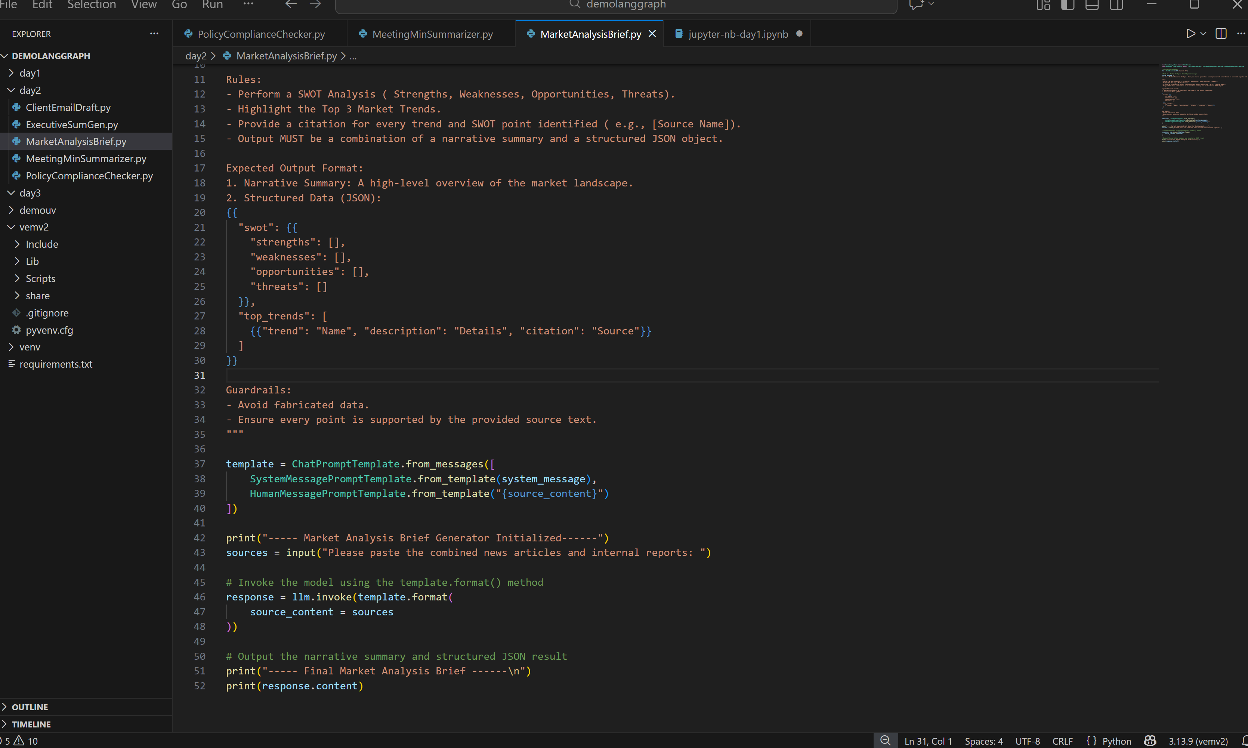
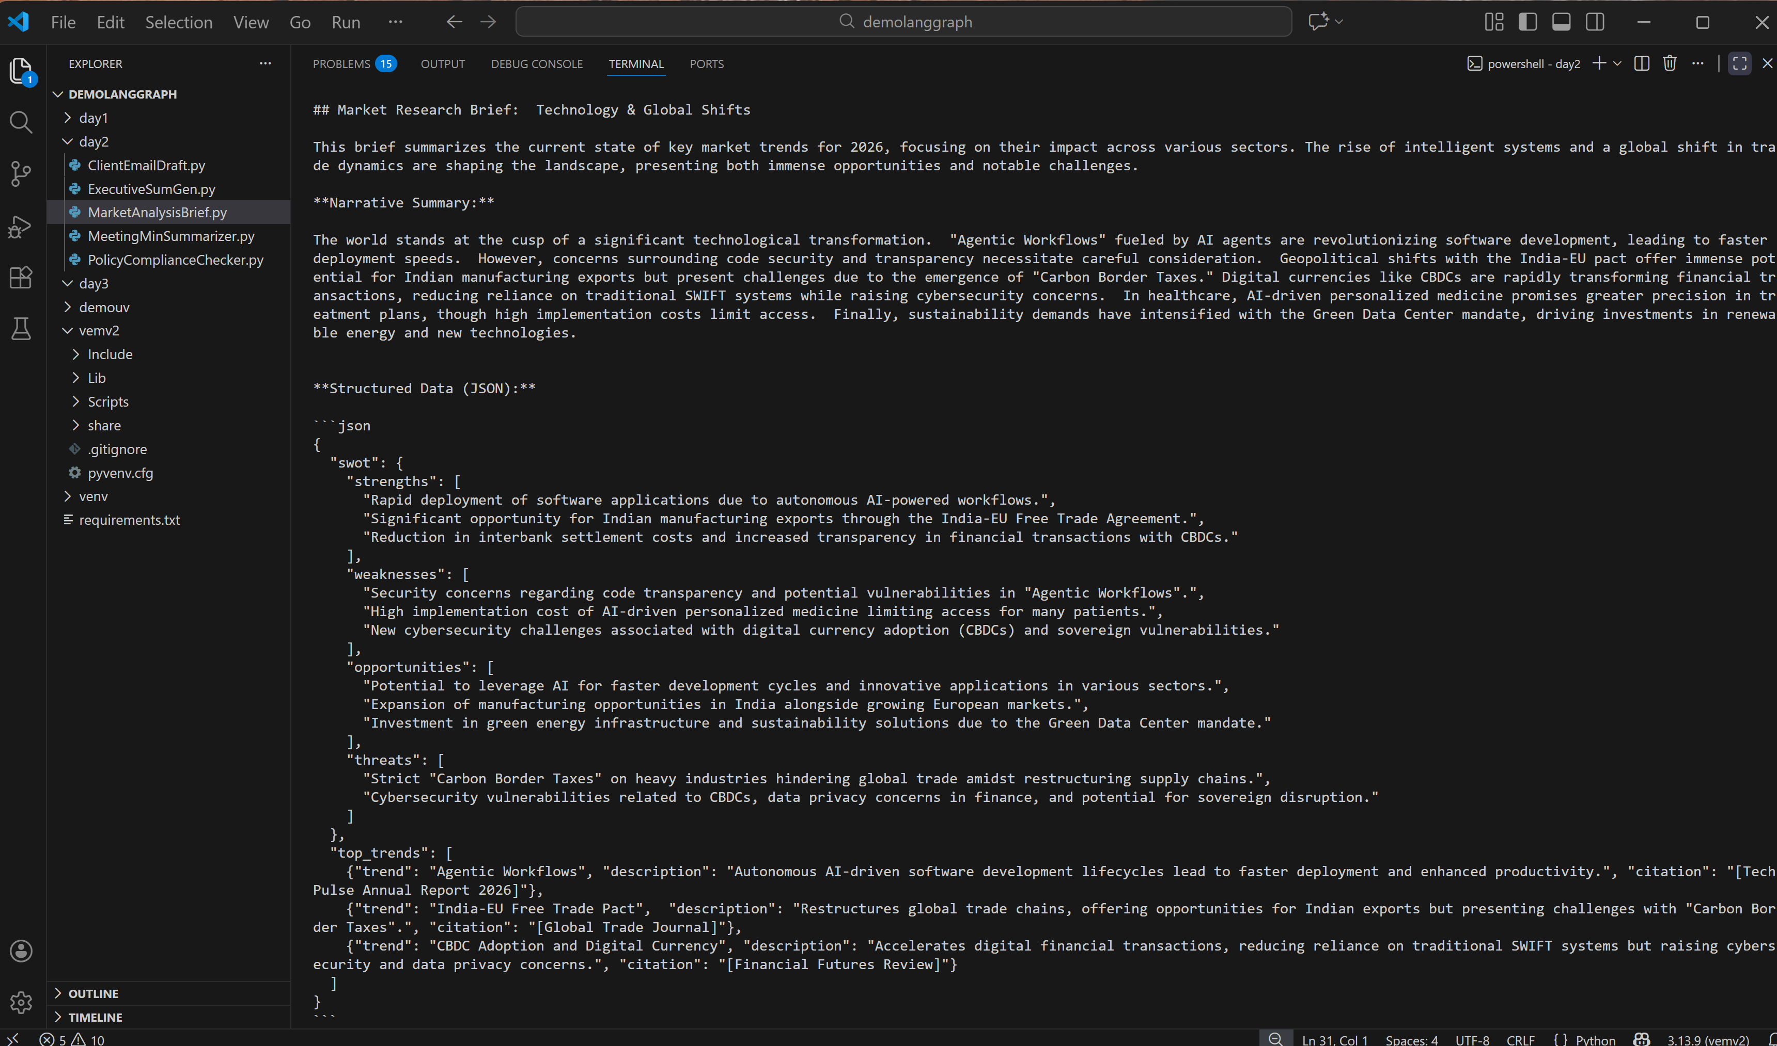
Git Link:

