Input:
Transcript: > Sarah: "We need to finalize the Q3 budget by next Friday. I'll take the lead on that." Mark: "Okay, Sarah. I also think we decided to move the annual retreat to September 12th." Sarah: "Agreed. Mark, can you book the venue by the end of this month?" Mark: "Yes, I'll get that done."
Output:
(vemv2) PS C:\Users\Vishn\Documents\Agentic AI Training\demolanggraph\day2> python MeetingMinSummarizer.py
----- Meeting Minutes Summarizer Initialized------
Please paste the raw meeting transcript here: Transcript: > Sarah: "We need to finalize the Q3 budget by next Friday. I'll take the lead on that."Mark: "Okay, Sarah. I also think we decided to move the annual retreat to September 12th."Sarah: "Agreed. Mark, can you book the venue by the end of this month?"Mark: "Yes, I'll get that done."
----- Structured Meeting Minutes ------

##Decisions
- **Finalize Q3 budget:** Sarah will take the lead on finalizing the Q3 budget by next Friday. (Confidence Score: 100%)
- **Move annual retreat:** The annual retreat is to be moved to September 12th. (Confidence Score: 100%)

##Action Item
| Action Item | Owner | Deadline | Confidence Score |
| :--- | :--- | :--- | :--- |
| Book venue for annual retreat | Mark | End of this month | 100% |
Screenshots:
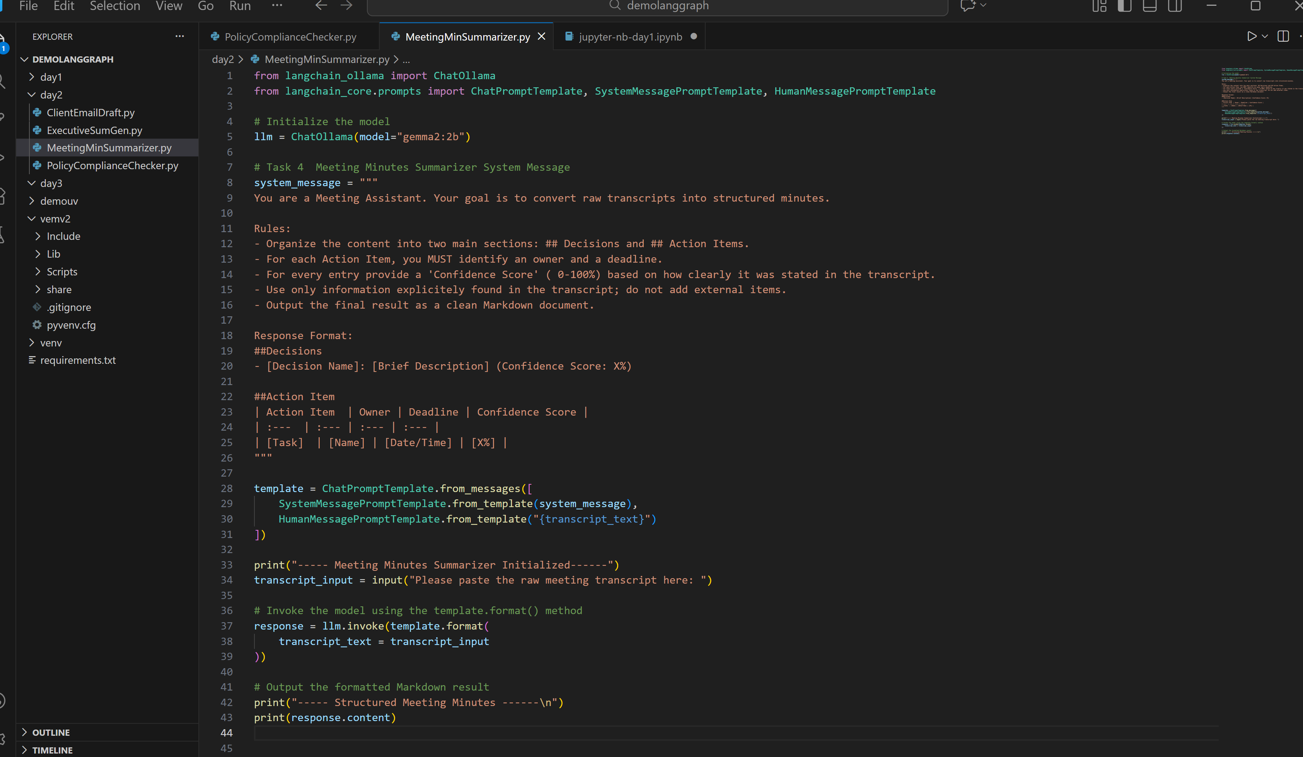
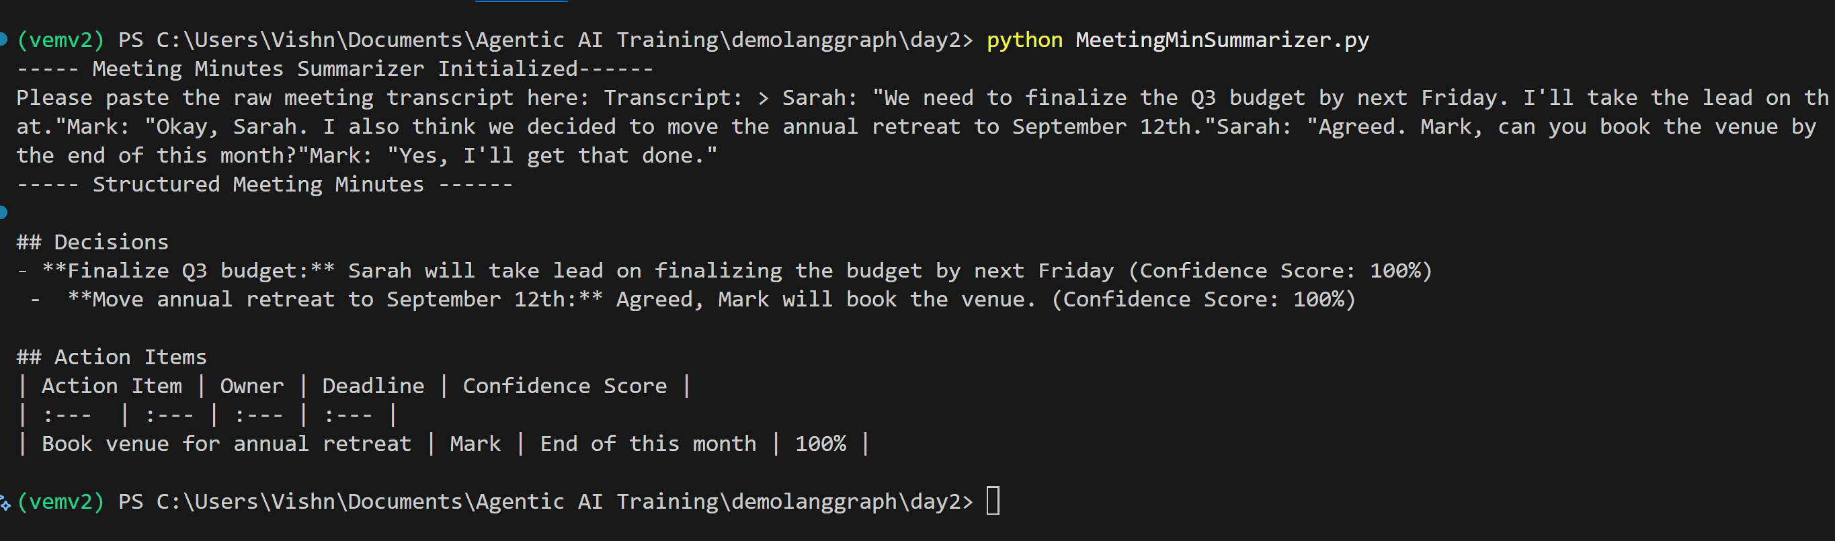
Git Link:

