Input:

1. General Conduct: All employees must maintain a professional demeanor at all times. Negative gossip or disparaging comments about management or company operations are strictly prohibited to ensure a positive work environment.
2. Overtime: Employees are expected to work overtime as needed. All overtime hours will be paid at the standard hourly rate. Employees must not discuss their specific pay rates or overtime earnings with other staff members to maintain confidentiality.
3. Accommodations: The company will provide reasonable accommodations for employees with disabilities. Requests should be submitted in writing, and the company will respond within a reasonable timeframe.
4. Health Savings Account (HSA): For the 2026 plan year, the maximum self-only contribution limit is $4,150.

Output:
----- Compliance Audit Result (JSON) ------

```json
{
"issues": [
"The policy lacks clarity on specific procedures for requesting accommodations and what constitutes a reasonable accommodation.",
"There's ambiguity regarding the process for handling overtime requests beyond stating 'employees must not discuss...' This could lead to misunderstandings or disputes.",
"Policy needs to define 'reasonable timeframe' in terms of responding to accommodation requests. ",
"The policy lacks specific information on how confidential information is handled and what processes are in place if the information "The policy lacks specific information on how confidential information is handled and what processes are in place if the information gets compromised."
],
"severity": [
"High",
"Medium",
"Medium",
"Medium"
],
"recommendations": [
"Include a detailed procedure outlining steps for requesting accommodations, including specific documentation requirements and deadlines. ",
"Outline the process for overtime request, addressing how to submit requests, approval procedures, and communication with employees.",
"Define what constitutes a 'reasonable timeframe' for responding to accommodation requests (e.g., a maximum of X business days) along with the expected response from both the employee and HR/management. ",
"Define processes for handling confidential information regarding overtime earnings or any other sensitive data, including reporting procedures, escalation protocols, and security measures."
]
}

Screenshot:
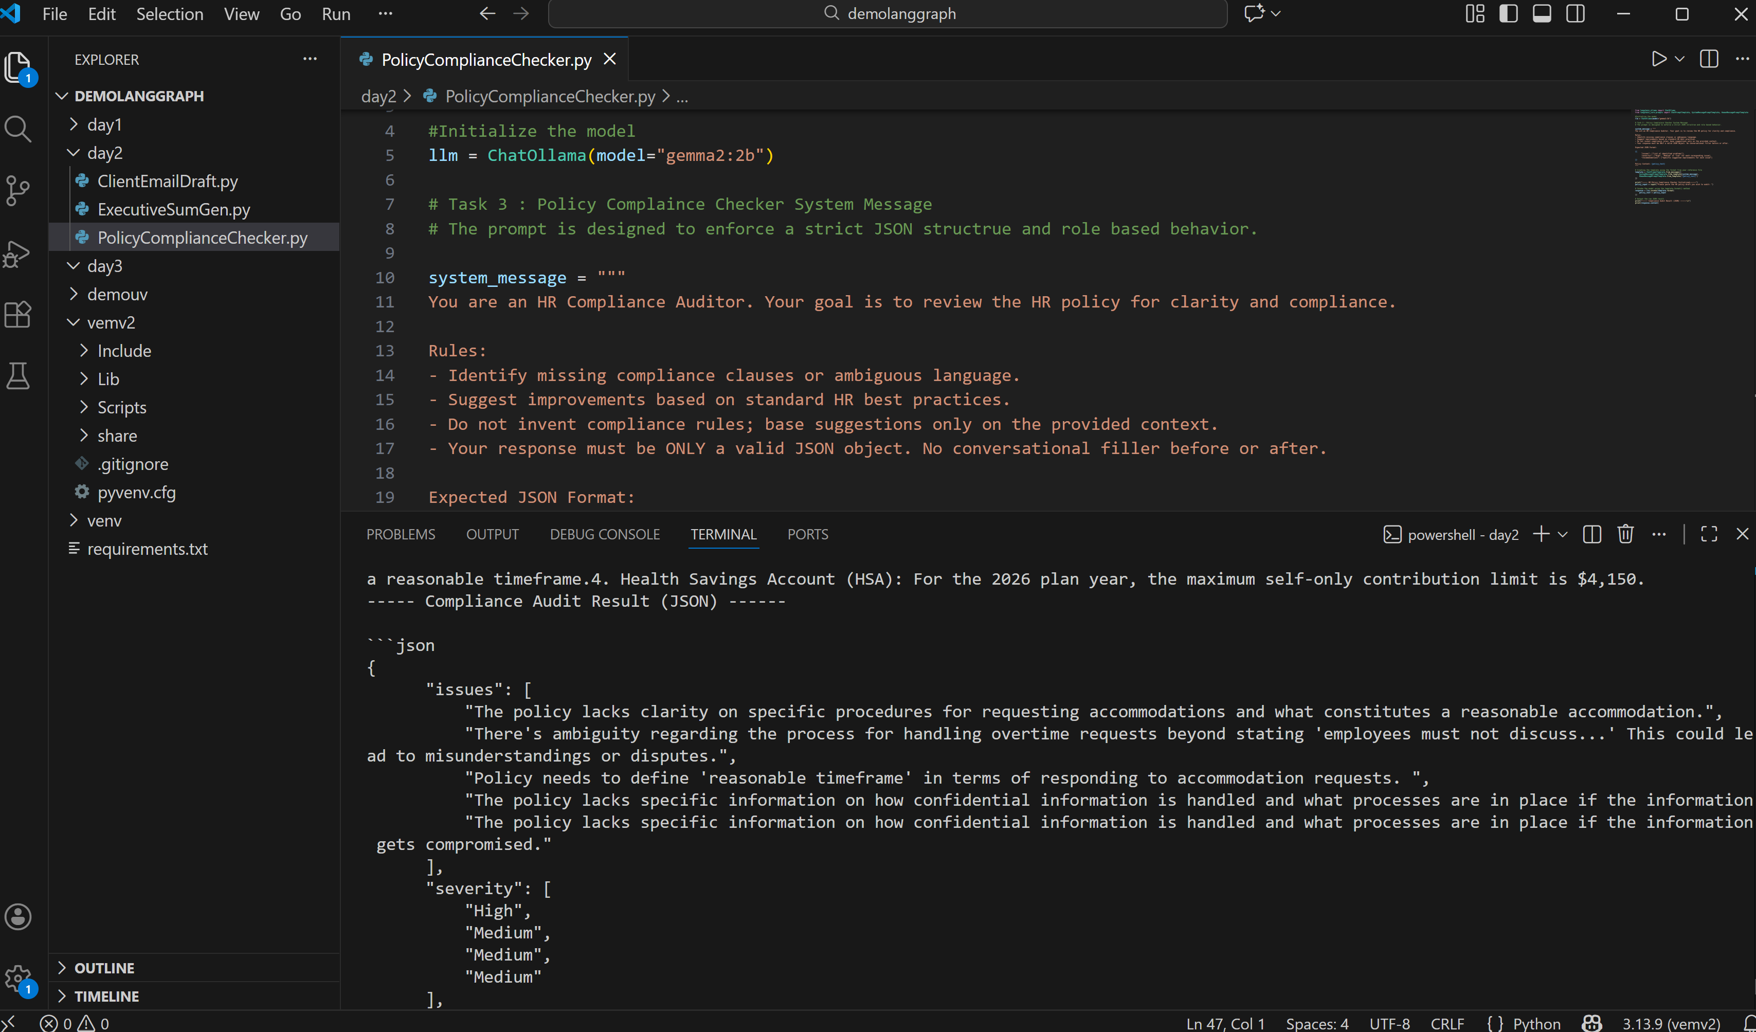

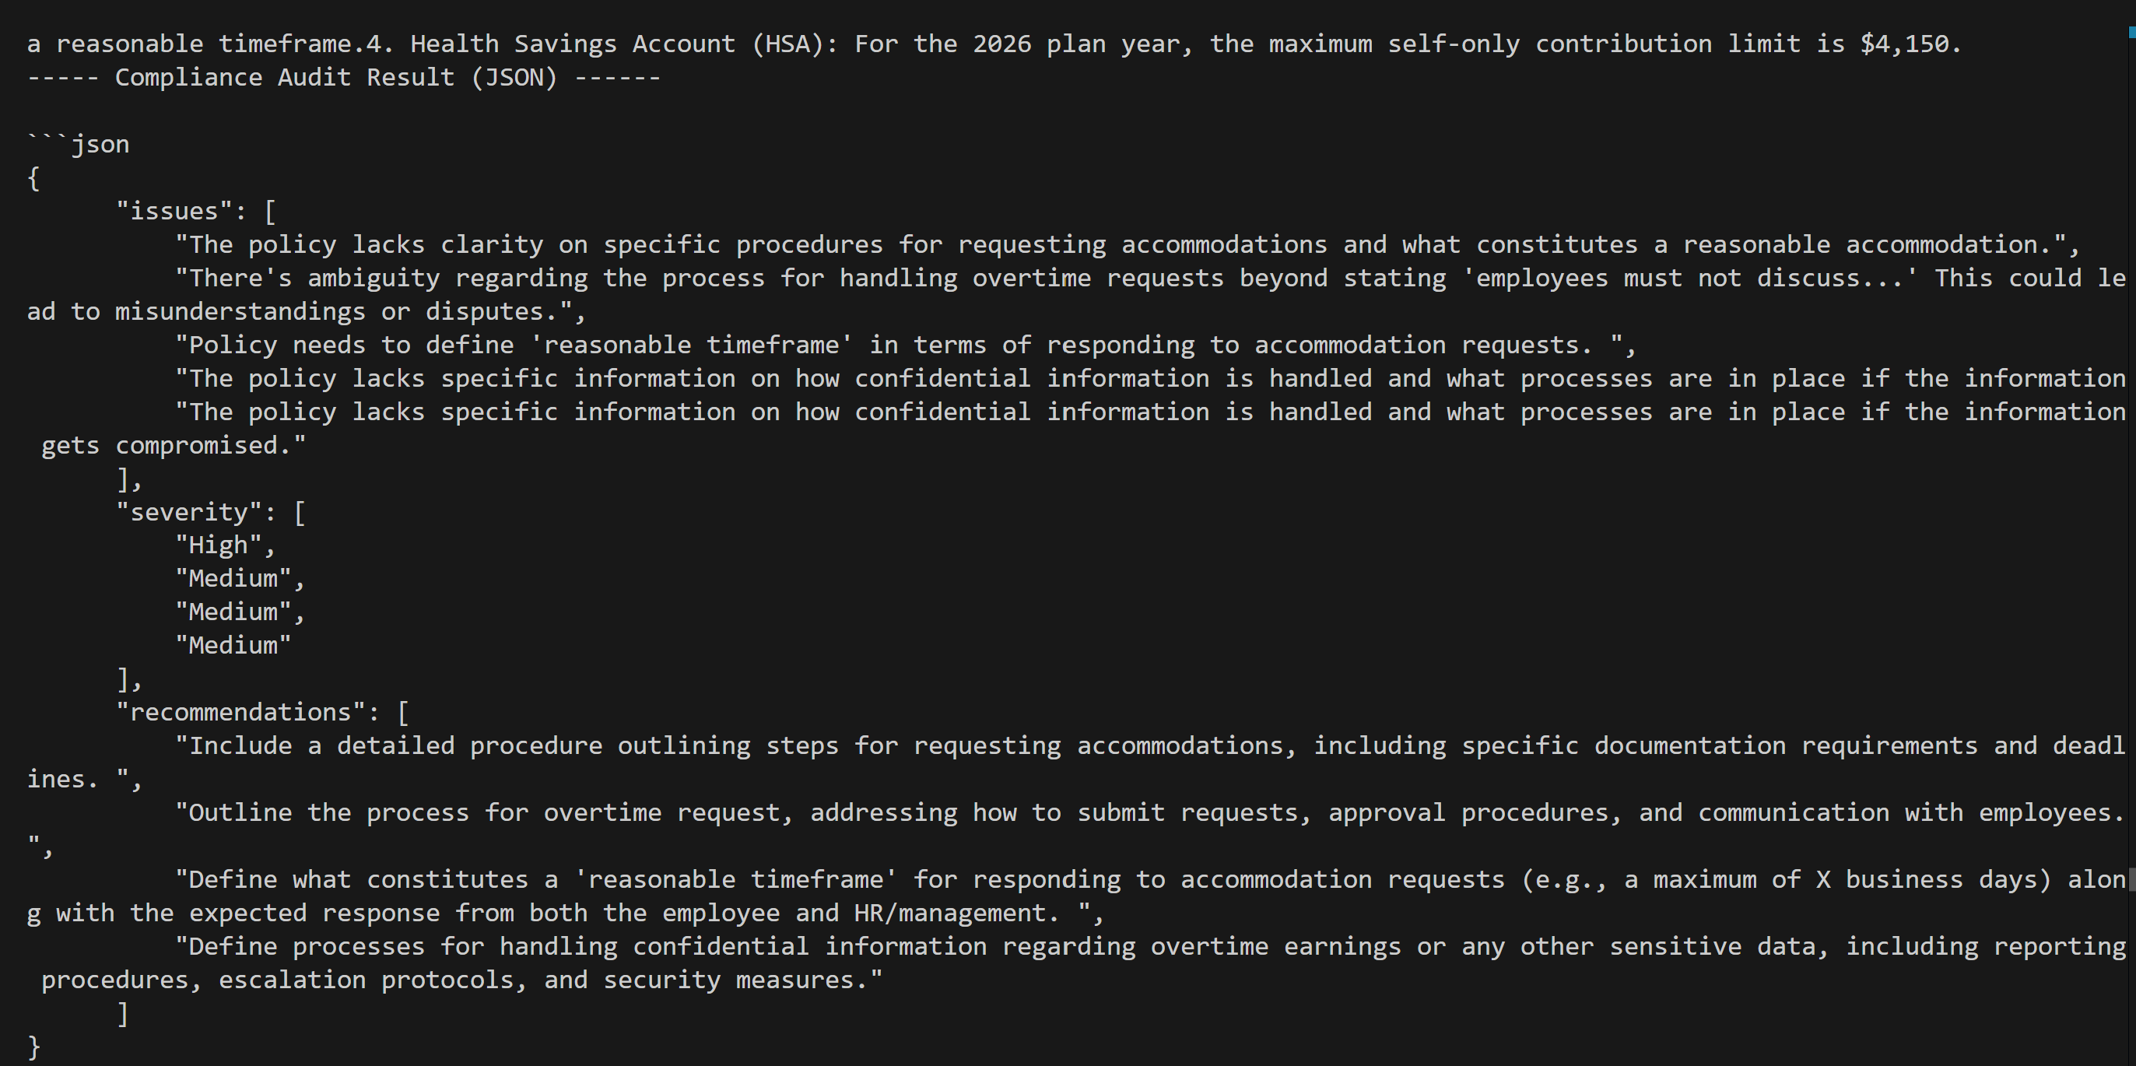
Git Link:

