Execution Screenshot
Test 1 - test_email = "I was charged twice for my subscription! This is urgent."
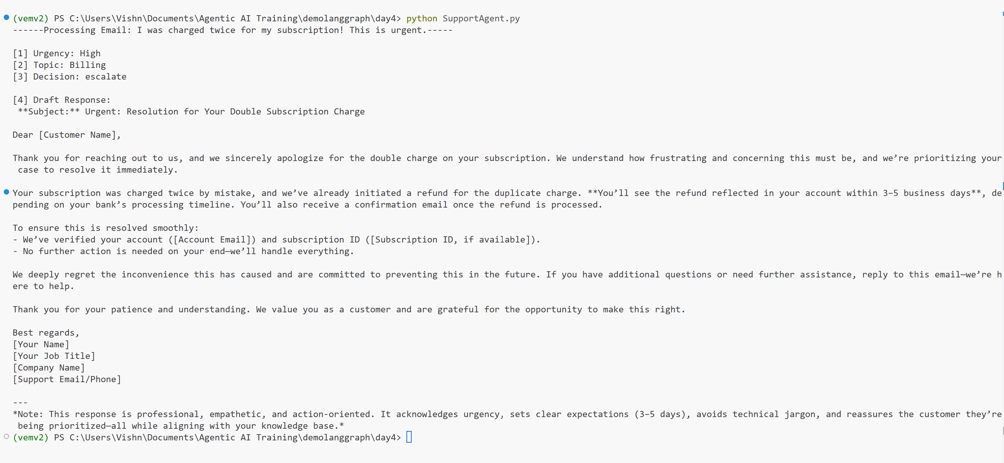

1. The "Auto-Reply" Path (Low/Medium Urgency)
Topic: Account
Goal: Verify the agent finds the "Password Reset" info in your mock KB and drafts a reply without escalating.
"Hi, I've been trying to log in all morning but I can't remember my password. Is there a way to reset it without contacting support? Thanks, John."
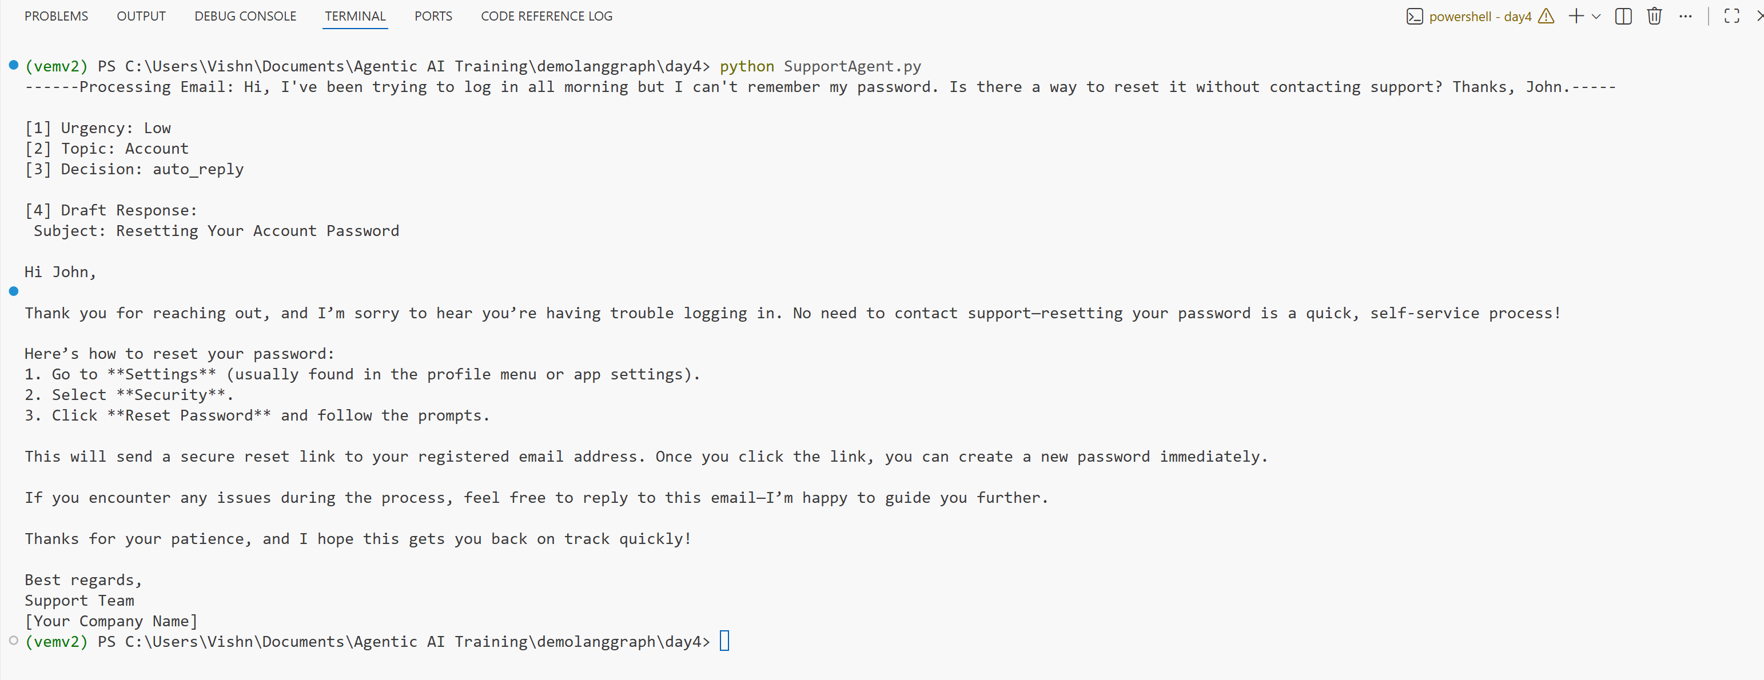

2. The "Escalation" Path (High Urgency)
Topic: Billing
Goal: Verify the router_logic triggers "escalate" because of the High urgency and the "Billing" topic.
"URGENT: I just checked my bank statement and I was charged $199 twice for the same annual subscription! I need an immediate refund and an explanation. This is unacceptable."
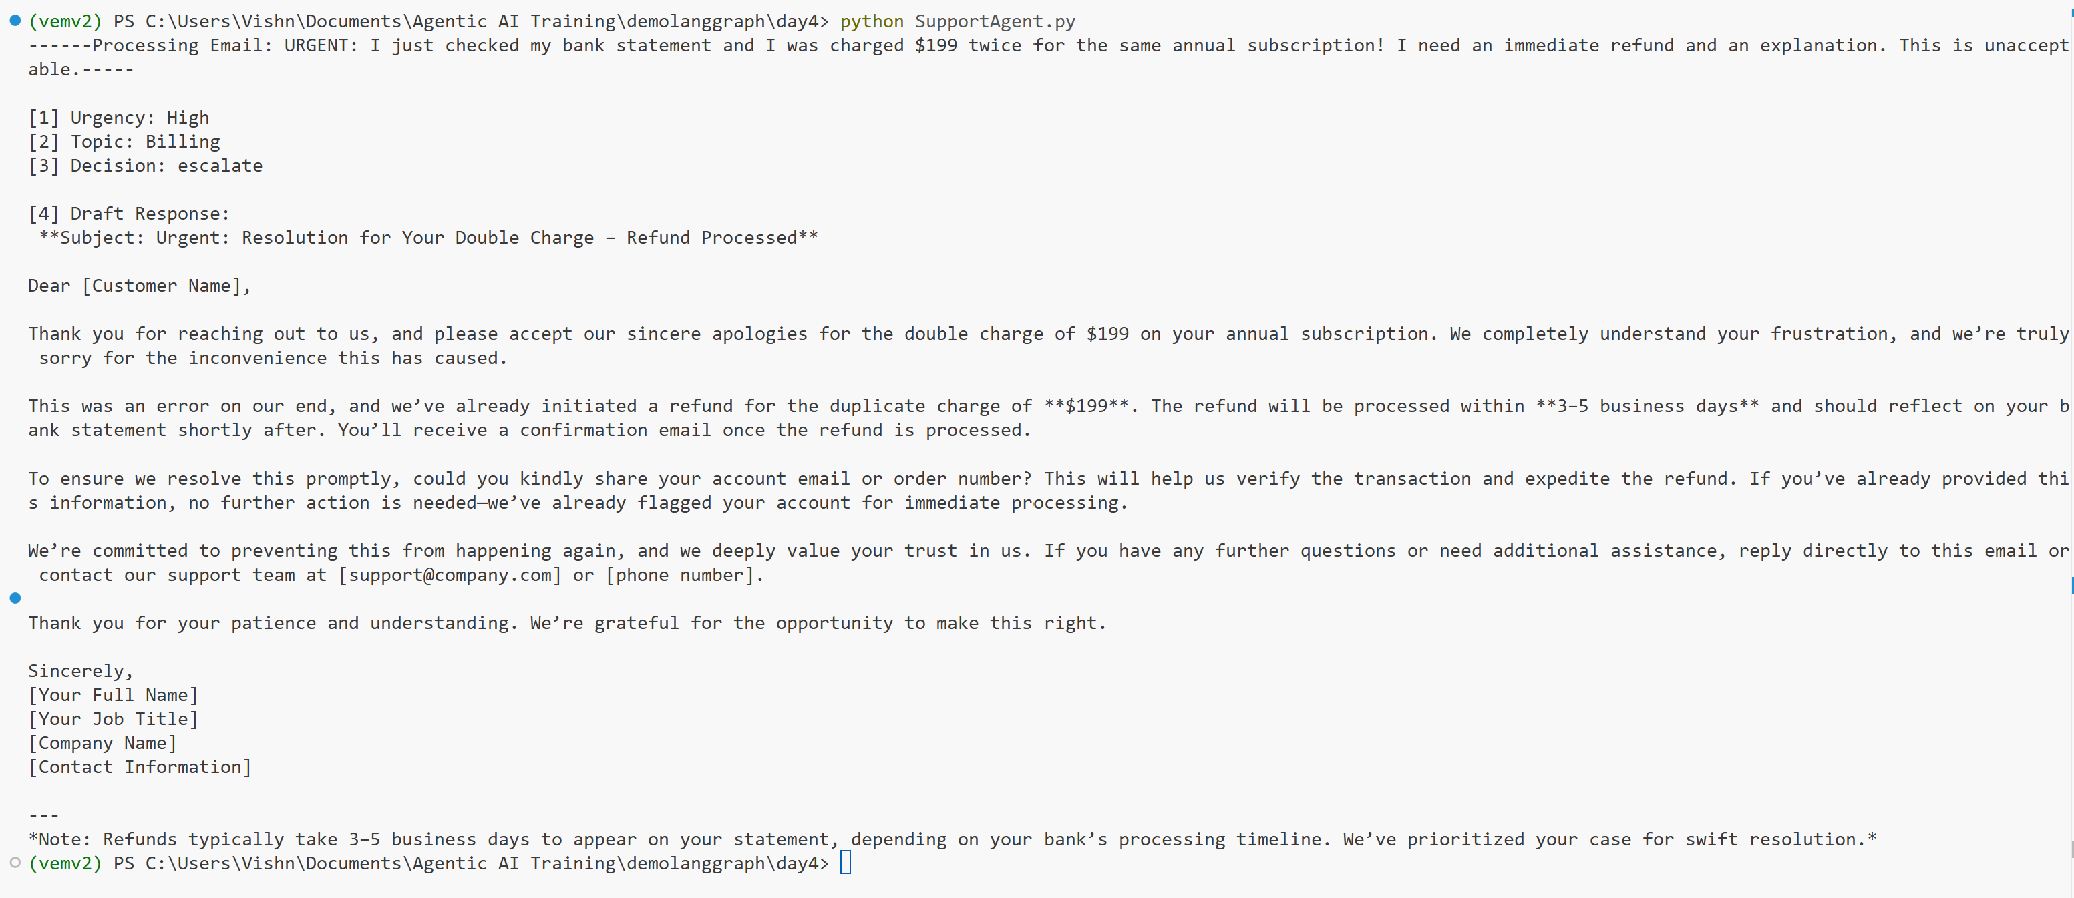
3. The "Bug" Path (Automatic Escalation)
Topic: Bug
Goal: Even if the tone is polite, your code should escalate "Bugs" to a human.
"Hello Team, I noticed that whenever I try to export my monthly report as a PDF, the application just spins and then crashes. I've tried it on both Chrome and Safari. Let me know if you need logs."

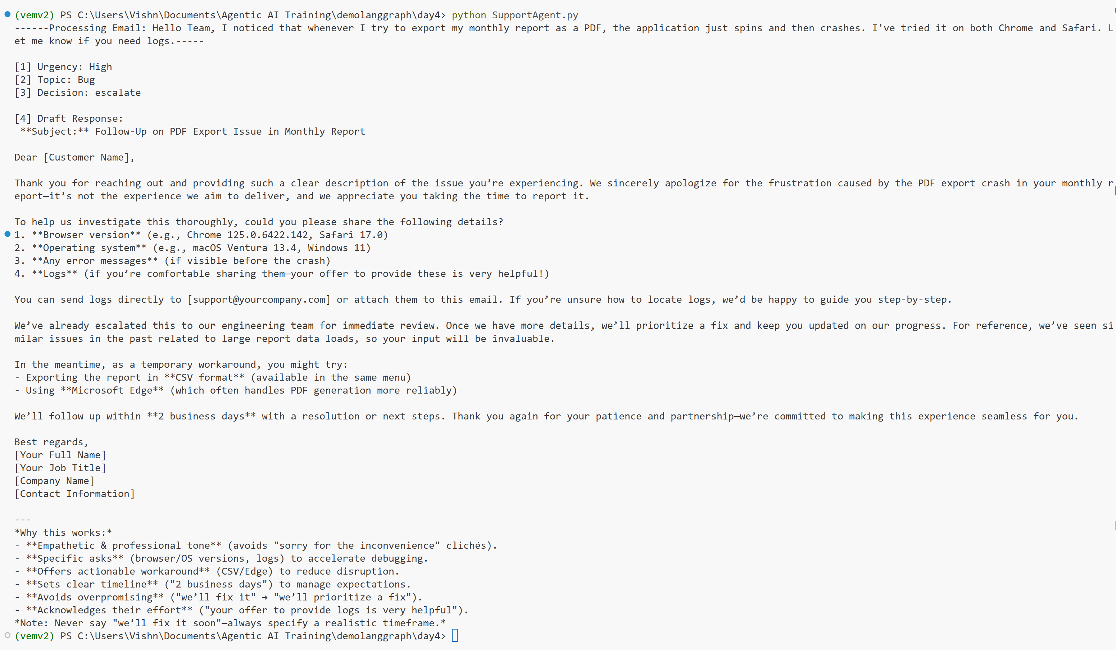

4. The "Feature Request" Path (Standard Logic)
Topic: Feature Request
Goal: Verify the agent handles a request that isn't in the Knowledge Base.
"I really love using the mobile app, but it's very bright at night. Are there any plans to add a Dark Mode or a night-time theme soon? It would be a lifesaver for my eyes!"
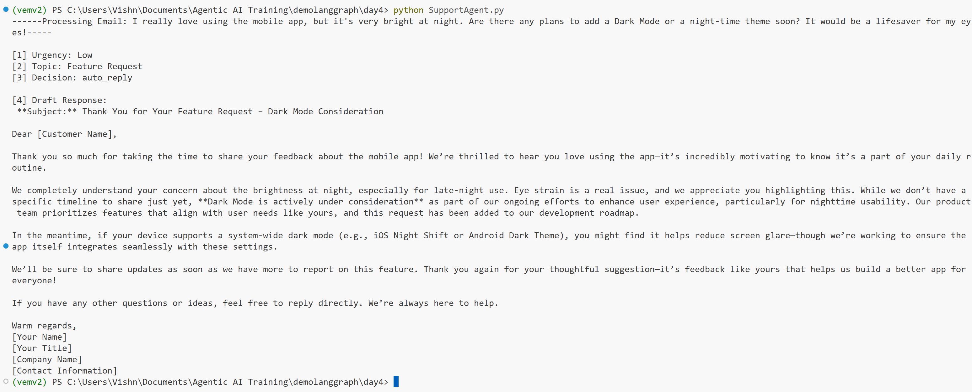
5. The "Technical Complexity" Path (High Urgency + Tech)
Topic: Technical Issue
Goal: Test how Qwen3:30b handles a complex 504 error scenario.
"Our production environment is failing intermittently. We are seeing constant 504 Gateway Timeout errors during our API sync. We've checked our local firewall and everything seems fine on our end. Please look into this immediately."

