ONLINE FOOD DELIVERY CUSTOMER ANALYSIS AND PREDICTION
Machine Learning Project Report

1. Abstract
This project analyzes an online food delivery customer dataset and builds a machine-learning classifier to predict the Output field. The original dataset contains 388 records and 14 columns. There are 103 exact duplicate records; after removing them, 285 unique records remain. The workflow includes data cleaning, exploratory data analysis, preprocessing, model training, evaluation, cross-validation, feature importance and example prediction. Logistic Regression and Random Forest are compared. The column 'Unnamed: 13' is removed because it duplicates Output, and Feedback is excluded from prediction to reduce leakage.

2. Problem Statement
The goal is to understand customer characteristics in an online food delivery dataset and use available customer attributes to predict whether the recorded Output is Yes or No.

3. Objectives
- Inspect and clean the supplied dataset.
- Remove duplicate records and leakage-prone fields.
- Perform customer-focused exploratory analysis.
- Prepare numerical and categorical variables for machine learning.
- Train Logistic Regression and Random Forest classifiers.
- Compare models using multiple evaluation metrics.
- Validate the selected model with 5-fold cross-validation.
- Interpret Random Forest feature importance.
- Demonstrate prediction for a sample customer.

4. Dataset Description
The dataset includes Age, Gender, Marital Status, Occupation, Monthly Income, Educational Qualifications, Family size, Customer Type, latitude, longitude, Pin code, Output, Feedback and an additional Unnamed: 13 column.
Column | Type | Use
Age | int64 | Customer feature
Gender | object | Customer feature
Marital Status | object | Customer feature
Occupation | object | Customer feature
Monthly Income | object | Customer feature
Educational Qualifications | object | Customer feature
Family size | int64 | Customer feature
Customer Type | object | Customer feature
latitude | float64 | Customer feature
longitude | float64 | Customer feature
Pin code | int64 | Customer feature
Output | object | Target
Feedback | object | Excluded from prediction
Unnamed: 13 | object | Removed: duplicates target

5. Data Cleaning
- Checked data types and missing values.
- Detected 103 exact duplicate rows.
- Removed duplicate rows, leaving 285 unique records.
- Trimmed whitespace from categorical text fields.
- Removed Unnamed: 13 because it duplicates Output.
- Excluded Feedback from model inputs because it is outcome-related information.
- Encoded Output as Yes=1 and No=0.
- Used One-Hot Encoding for categorical features and StandardScaler for numerical features.

6. Exploratory Data Analysis
After cleaning, the target contains 217 Yes records and 68 No records. Therefore, Yes represents 76.1% of the cleaned data.
Overall Output Distribution
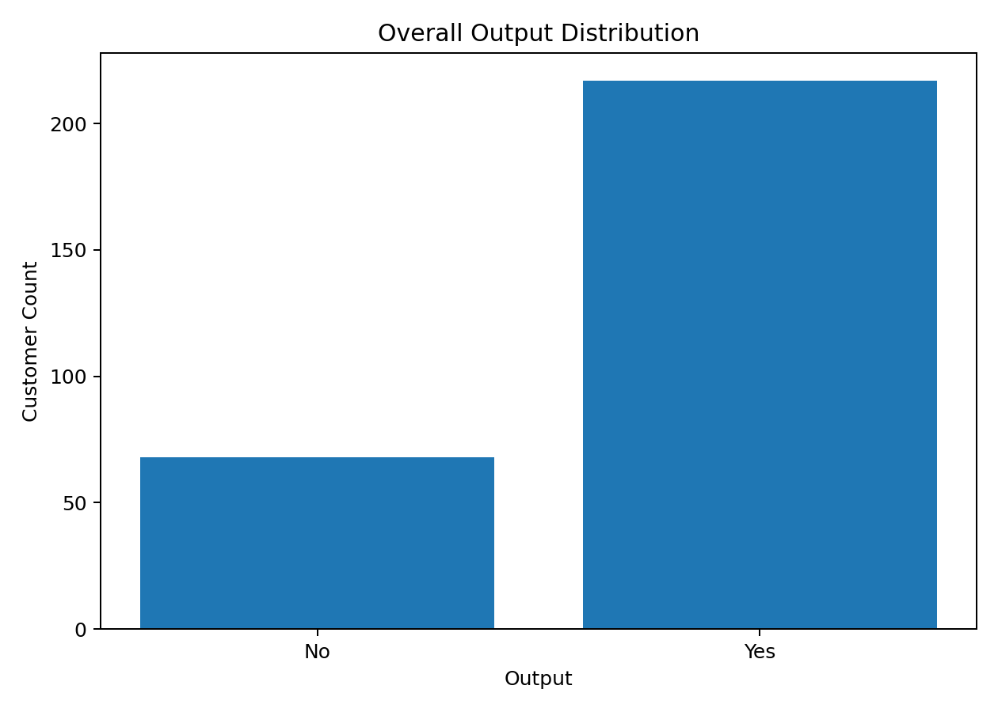
Output Rate by Occupation
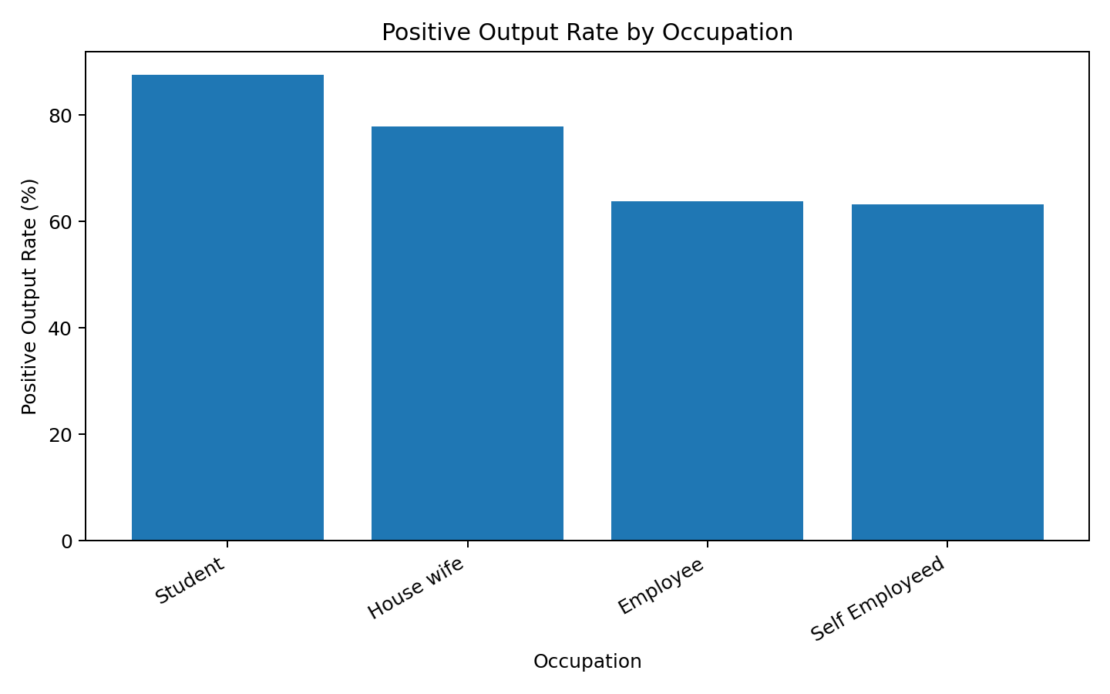
Feedback by Monthly Income
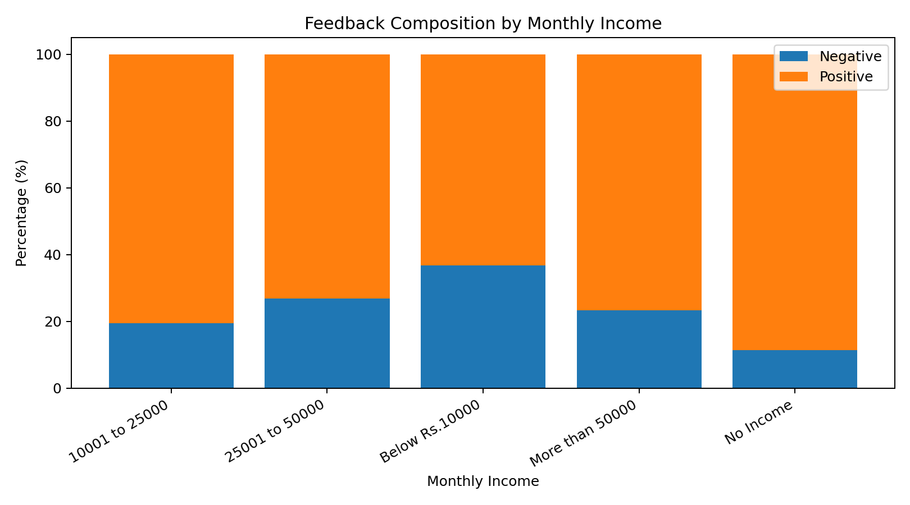

7. Machine Learning Methodology
- Use an 80:20 stratified train-test split.
- Build preprocessing with ColumnTransformer.
- Train Logistic Regression as a baseline.
- Train Random Forest as an ensemble classifier.
- Calculate Accuracy, Precision, Recall, F1-score and ROC-AUC.
- Use 5-fold Stratified Cross-Validation.
- Inspect Random Forest feature importance.

8. Model Results
Model | Accuracy | Precision | Recall | F1 | ROC-AUC
Random Forest | 0.789 | 0.830 | 0.907 | 0.867 | 0.744
Logistic Regression | 0.737 | 0.780 | 0.907 | 0.839 | 0.698
The selected model for the demonstration is Random Forest, which has the highest F1-score in this fixed test split. The mean 5-fold cross-validation accuracy is 0.782 with standard deviation 0.038.
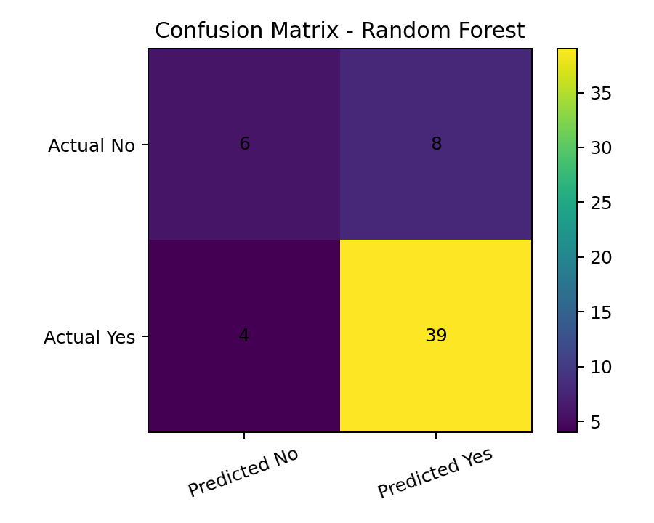

9. Feature Importance
Random Forest feature importance is used for interpretation. Importance shows model reliance, not causation.
Feature | Importance
num__latitude | 0.1485
num__Age | 0.1394
num__longitude | 0.1217
num__Pin code | 0.1174
num__Family size | 0.0774
cat__Occupation_Student | 0.0444
cat__Marital Status_Single | 0.0394
cat__Customer Type_Regular | 0.0260
cat__Monthly Income_No Income | 0.0239
cat__Educational Qualifications_Post Graduate | 0.0228
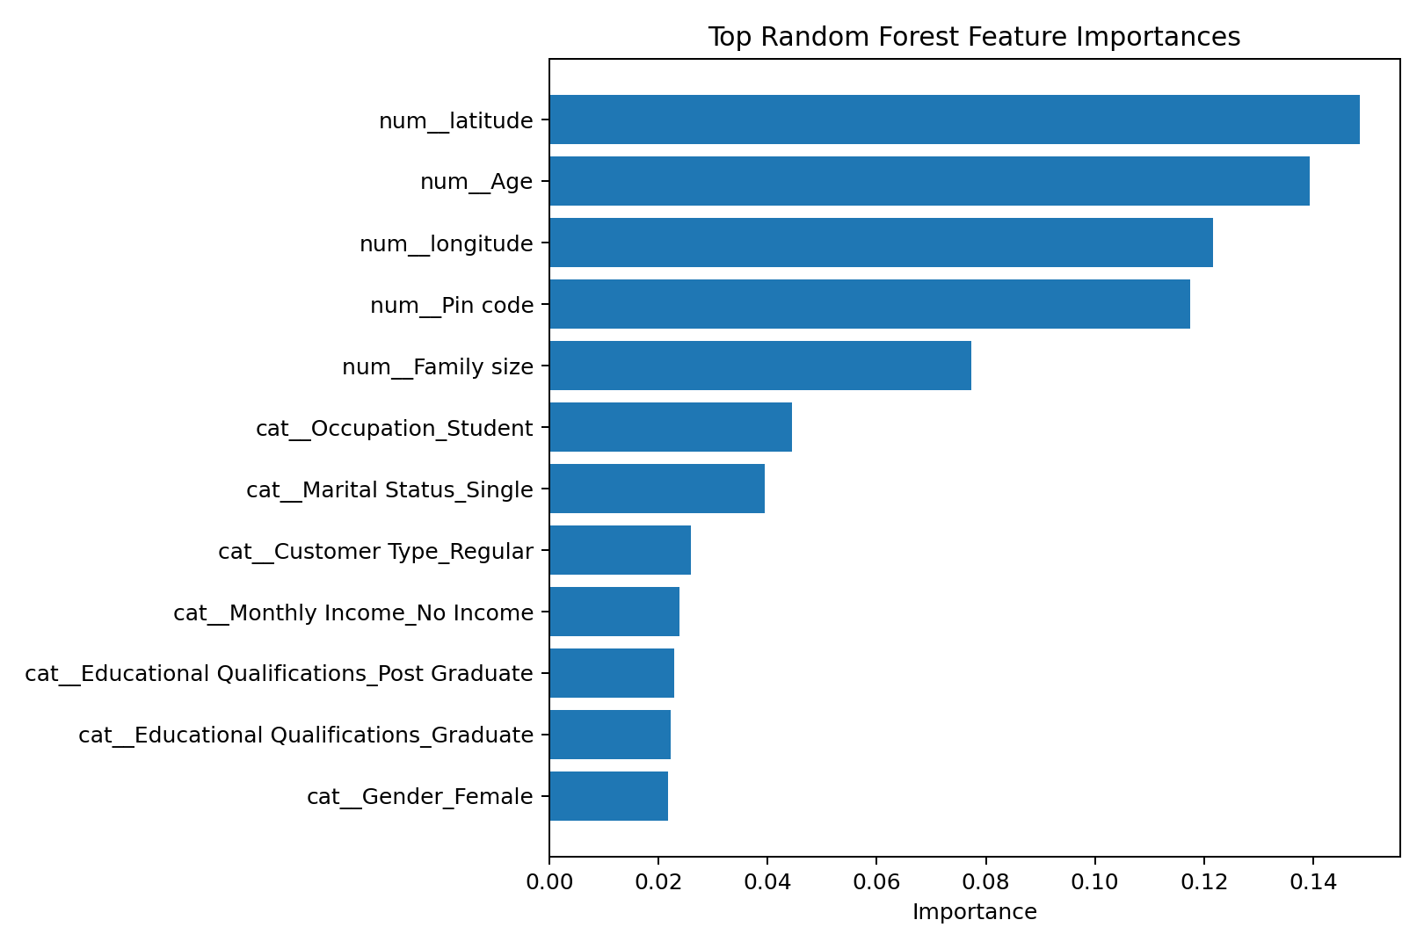

10. Sample Prediction
For a held-out sample customer, the actual Output is Yes, the predicted Output is Yes, and the predicted probability of Yes is 0.933.

11. Key Findings
- The original file contains 388 rows, including 103 exact duplicates.
- The cleaned dataset contains 285 unique records.
- The target is imbalanced toward Yes (76.1%).
- Occupation, customer type, income and household characteristics show descriptive differences in Output or Feedback.
- Removing the duplicate target column and excluding Feedback reduces obvious target leakage.
- Random Forest has the highest test-set F1-score among the two evaluated models.
- Feature importance is useful for interpretation but does not establish causation.

12. Limitations
- The cleaned dataset is relatively small.
- The target classes are imbalanced.
- No order value, delivery time, restaurant, cuisine or transaction-history fields are available.
- Geographic fields are observational and should not be interpreted causally.
- Performance may change on new datasets or different populations.
- The model is for academic/project use and should be validated on representative production data before deployment.

13. Technologies Used
Python, Pandas, NumPy, Matplotlib, Scikit-learn, Jupyter Notebook and python-docx.

14. Setup and Execution
- Install Python 3.10 or newer.
- Keep the CSV dataset in the same directory as the notebook.
- Run: pip install -r requirements.txt
- Run: jupyter notebook
- Open KotiShiva_OnlineFoodDeliveryCustomerAnalysis.ipynb.
- Run all cells.

15. Dataset Source
The dataset used for this submission was supplied with the project. A matching public source is:
https://www.kaggle.com/datasets/srisyra02/online-food-ordering-dataset

16. Conclusion
This project demonstrates an end-to-end online food delivery customer analytics and prediction workflow. It combines data quality checks, EDA, visualization, leakage-aware preprocessing, machine-learning model comparison, cross-validation, feature interpretation and prediction in a reproducible Jupyter Notebook.

