We’re Kaypartners and we connect Talent with Talent.

Our client futuresTHRIVE is looking for a

Full-Stack Developer

to report to Wendy Ward, the CEO & Founder

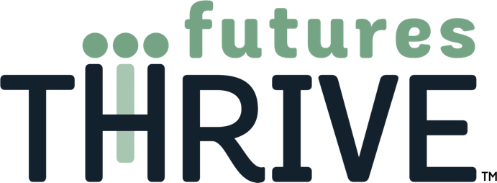

**Revolutionizing Youth Mental Health Care**

futuresTHRIVE is creating a groundbreaking early intervention mental health screening tool for youth using AI and game-based technology to affordably meet the acute needs of doctors, educators and families.

An equal opportunity employer, applicants will be considered for employment without attention to race, color, religion, sex, sexual orientation, gender identity, national origin, veteran, or disability status.

**Who’s hiring**

[futuresTHRIVE](https://www.futuresthrive.com/) is developing a modernized mental health screener that will combine a full set of new protocols to introduce an innovative set of mental health vital signs to equip the doctor and educate families. In a gamified, web-based platform, children aged 4-20 will engage in a dynamic question set designed to identify risk factors that are known indicators of mental health concerns. Using a novel combination of artificial intelligence for voice and facial biomarkers, sentiment analysis, and machine learning, the screener will provide a first-of-its-kind mental health baseline that can be used by doctors and families to better understand the child’s unique mental health qualities.

A grant from the NSF (National Science Foundation) makes it possible for the company to bring on board its first employee, a Full-Stack Developer. Essential requirements include:

* Must be able to **Work from Home**
* Eligible for the NSF salary grant – a **US citizen** or permanent resident

As employee #1, the successful hire will work with the CEO & Founder Wendy Ward and advisors to plan, develop and implement this critical web application to proactively track and foster mental wellbeing for kids.

**Expectations**

A self-motivated and curious “geek” who believes that computing can impact social good and change people’s lives. Furthermore, someone who is on the path to greatness: a college senior majoring in computing, engineering or related studies, or a recent graduate with a bachelor’s or master’s degree in similar disciplines.

Hands-on experience: Can create a fully functional website from design and establish procedures to ensure all relevant website functionality works as anticipated and accessible on a range of screen resolutions, from mobile to desktop. Other general skills for consideration include:

* Able to implement the front end, back end, and database portions of applications running on embedded devices, appliances, and cloud-based servers.
* Can develop and maintain web-based software application (Azure)
* Has worked within the full SDLC
* Upholds a high standard of code
* Familiar with utilizing TDD unit testing
* Enjoys research and recommending available technologies to solve compelling problems.

**Bonus points** for the following experiences:

* 1+ years of Full-Stack development
* Data Science and NLP
* Security and performance
* Media production or experience with Maya and/or Blender

To learn more, check out the following [demo video](https://www.youtube.com/watch?v=TvUNGFSfMNI).

Employee #1 does not mean working sadly alone. This role will require collaboration and teamwork with futuresTHRIVE founder, board advisors, outside consultants, and clients upon the software rollout. Mentoring and coaching will be available to learn and develop the communications and business skills necessary as futuresTHRIVE grows.

**What does it pay**

futuresTHRIVE is offering a competitive salary with opportunity to earn equity as the company and employees reach certain milestones.

Feel free to text Kay Cioffi at (m) 212-920-4160 or by email: [kay.cioffi@kaypartners.co](mailto:kay.cioffi@kaypartners.co) to learn more!

Kaypartners is an affiliate of Sequitor Partners LLC (est. 2004). We partner with small-cap clients in all phases to attract and secure the best talent for their evolving needs and distinct culture. Kaypartners also means structuring flexible arrangements based on our client's growth and funding stage.