Databases Project – Spring 2018
Team No:
Names:
Contents
Contents 1
Deliverable 1 2
Assumptions 2
Entity Relationship Schema 2
Schema 2
Description 2
Relational Schema 2
ER schema to Relational schema 2
DDL 3
General Comments 3
Deliverable 2 4
Assumptions 4
Data Loading 4
Query Implementation 4
Query a: 4
Description of logic: 4
SQL statement 4
Interface 4
Design logic Description 4
Screenshots 4
General Comments 4
Deliverable 3 5
Assumptions 5
Query Implementation 5
Query a: 5
Description of logic: 5
SQL statement 5
Query Analysis 5
Selected Queries (and why) 5
Query 1 5
Query 2 5
Query 3 5
Interface 6
Design logic Description 6
Screenshots 6
General Comments 6

Deliverable 1

Assumptions

We assumed that a clip could be in development which implies that it might not have yet a released date/country, a rating, defined genres, defined languages and associated countries.

We assumed that a movie staff (i.e. actor, director, producer or writer) doesn’t necessarily has a bibliography.

Entity Relationship Schema

Schema
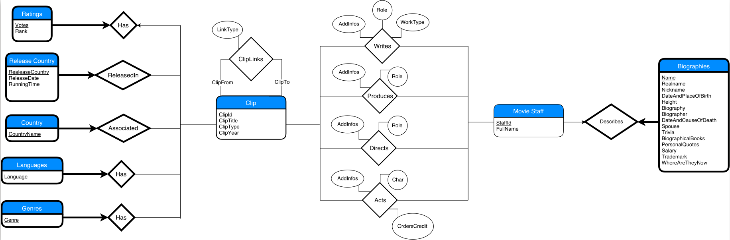

Description

We regrouped the actors, producers, directors and writers into a single entity Movie Staff whose instances are identified by a unique StaffId.

A Movie Staff can be described by at most one Biography. A Biography describes exactly one Movie Staff which makes it a weak entity.

A Movie Staff can write, produce, direct or act in Clips.

A Clip can have any number of ClipLinks with other Clips.

A Clip can have Genres, have Languages, be associated to Countries, have Release Countries and have a Rating.

A Genre instance is a pair composed of a ClipId and a Genre so each instance is linked to exactly one Clip, this makes Genres be a weak entity of Clip.

Ratings, Release Country, Country and Languages are also all weak entities of Clip following the same reasoning.

Relational Schema

ER schema to Relational schema
<Describe the transition from ER schema to Relational schema>

DDL
<Provide the DDL>

General Comments
<In this section write general comments about your deliverable (comments and work allocation between team members>

Deliverable 2

Assumptions
<In this section write down the assumptions you made about the data. Write a sentence for each assumption you made>

Data Loading

Query Implementation
<For each query>

Query a:

Description of logic:
<What does the query do and how do I decide to solve it>

SQL statement
<The SQL statement>

Interface

Design logic Description
<Describe the general logic of your design as well as the technology you decided to use>

Screenshots
<Provide some initial screen shots of your interface>

General Comments
<In this section write general comments about your deliverable (comments and work allocation between team members>

Deliverable 3

Assumptions
<In this section write down the assumptions you made about the data. Write a sentence for each assumption you made>

Query Implementation
<For each query>

Query a:

Description of logic:
<What does the query do and how do I decide to solve it>

SQL statement
<The SQL statement>

Query Analysis

Selected Queries (and why)

Query 1
<Initial Running time:
Optimized Running time:
Explain the improvement:
Initial plan
Improved plan>

Query 2
<Initial Running time:
Optimized Running time:
Explain the improvement:
Initial plan
Improved plan>

Query 3
<Initial Running time:
Optimized Running time:
Explain the improvement:
Initial plan
Improved plan>

Interface

Design logic Description
<Describe the general logic of your design as well as the technology you decided to use>

Screenshots
<Provide some initial screen shots of your interface>

General Comments
<In this section write general comments about your deliverable (comments and work allocation between team members>

