Netlist syntax:-

* For any component except for sources:-

[type][id] [node] [node] [value]

Ex: R1 1 2 10

* Regarding sources:-

[type][id] [node] [node] [value] [phase]

Ex: V1 1 2 10 30

Parameters:-

**Type:** **a positive** integer number

V: Independent voltage source

I:independent Current source

C:Capacitance

L:Inductance

R:Resistance

**Id:** just for naming the component (It must be an integer number)

Ex: V1 not Vs

**Node:** an integer number represents a node for the component.

**Node:** the second node.

**Value:** the value of the component. It must be written in decimals and with no power

i.e. If the value is for example (1 milli) it must be written as 0.001

Dependent Sources:

Note: Dependent sources are not implemented only independent.

Output:-

The output is in real and imaginary form.

Ex: (1,3) means 1 real and 3 imaginary complex number.

Procedures:-

-Firstly, put your text file which contains the netlist in the same folder of the program.

I1 0 1 4 90

L1 1 2 4

C3 2 3 0.33

R1 2 4 2

R2 4 5 2

R3 0 4 2

I2 0 5 2 0

V1 3 5 12 0

-Choose the operation.

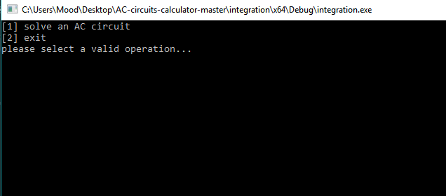

Figure :choose the operation.

-Enter the file name.

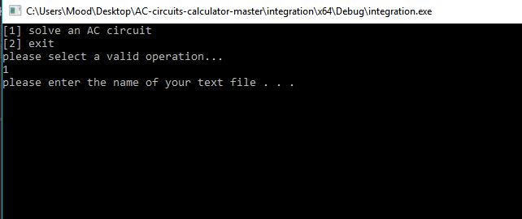

Figure :enter the text file name.

-Enter a valid angular frequency.

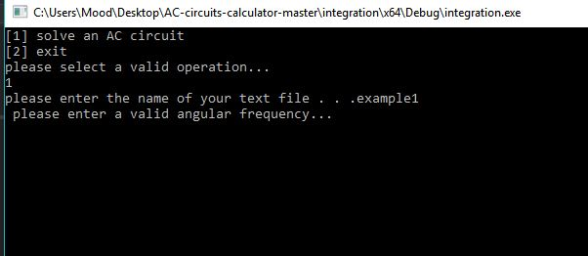

Figure :enter the angular frequency.

-Choose to solve another circuit or exit the console.

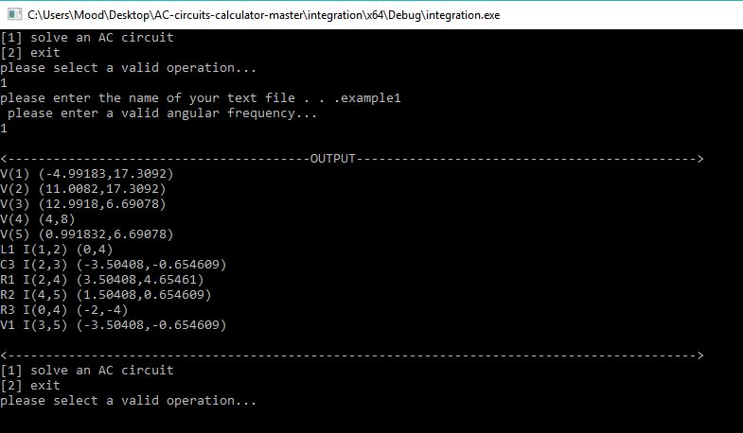

Figure :the output of the program.

V(1) means the voltage on node 1

V1 I(1,0) means the current in the source V1

L1 I(1,2) means the current on the L1 component. The same for C, L