A freelance muse and writer

Moody Lass

A cup of tea with a heart cloud and a swirl of steam


“My mood is often reflected by how I take my tea…”

~ Moody Lass

**Tea Consent:**

**A valuable lesson about Consent, shared by Moody Lass,**

**and brought to you by the English and Tea.**

[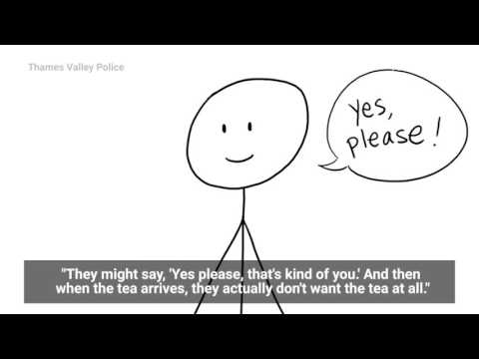](https://www.youtube.com/embed/cT4gym83QJc?feature=oembed)

**Is it Tea Time?**

[iframe src=%22https:/free.timeanddate.com/clock/i90ip9h0/n4994/szw110/szh110/hbw0/hfc000/cf100/hgr0/fav0/fiv0/mqcfff/mql15/mqw4/mqd94/mhcfff/mhl15/mhw4/mhd94/mmv0/hhcbbb/hmcddd/hsceee%22 frameborder=%220%22 width=%22110%22 height=%22110%22%3e%3c/iframe](file:///C:\Users\lanik\OneDrive\Documents\Moody%20Lass\iframe%20src=%22https:\free.timeanddate.com\clock\i90ip9h0\n4994\szw110\szh110\hbw0\hfc000\cf100\hgr0\fav0\fiv0\mqcfff\mql15\mqw4\mqd94\mhcfff\mhl15\mhw4\mhd94\mmv0\hhcbbb\hmcddd\hsceee%22%20frameborder=%220%22%20width=%22110%22%20height=%22110%22%3e%3c\iframe)

**Saturday, September 9, 2023**



**Got Tea?**



“Tea Time is anytime you need it to be.”

~ Moody Lass

**Moody Lass Musings:**

A Moody Blog by Moody Lass

****

**Moody Lass Podcast:**

A podcast dedicated to the telling of truths that are stranger

than fiction, derived from the real-life experiences of Moody Lass,

and presented here in ad-free short story format.

**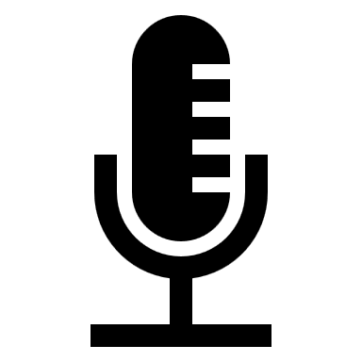**

**Common Sense Dictates:**

A pseudo advice column based primarily on Common Sense

with a strong emphasis on seeking and finding simple solutions

to life’s problems using knowledge, experience, and a cup of tea.

****

**Moody Lass Mixtapes:**

Song compilations based entirely on the moods

and musical tastes of Moody Lass.

****

**Yacht Cruise**

Mood = Light

**Bathtub Blues**

Mood = Blue

**Night Moves**

Mood = Frisky

**Slow Grooves**

Mood = Chill

**Spooky Tunes:**

Mood = Dark

**Smoody Lass Mood Map:**

An ever evolving legend of moods for use by Moody Lass to classify content

and for site visitors to reference as needed.

****

“Sipping tea is the most effective way to refrain from spilling the tea.”

~ Moody Lass

**Moody Lass Memes:**

An ever expanding album of memes, selected by Moody Lass,

to share with the world wide web that are always free, and

themed around moods and tea.

****

**Moody Lass Shoppe:**

A one-stop e-Shoppe featuring exclusively branded, high

quality, Moody Lass merchandise.

**[](https://shoppe.moodylass.com)**

**Moody Lass Tea Leaves:**

An online only amusement, designed by and for Moody Lass, to provide instant Tea Facts,

derived from the complex reading of virtual Tea Leaves.

Consult the Wisdom of Tea Leaves…

****

**The very best Tea comes from high elevations and is hand-picked.**

**Moody Lass Magic 8-Ball:**

[iframe src=%22https:mystery.jessejesse.com%22 frameborder=%220%22 width=%22400%22 height=%22600%22%3e%3c/iframe](file:///C:\Users\lanik\OneDrive\Documents\Moody%20Lass\iframe%20src=%22https:mystery.jessejesse.com%22%20frameborder=%220%22%20width=%22400%22%20height=%22600%22%3e%3c\iframe)

**Messaging Moody Lass:**

****

**Questions:**

Have a question to ask Moody Lass?

[**{INQUIRE}**](mailto:moodylass@moodylass.com?subject=INQUIRY)

**Requests:**

Have a request for Moody Lass?

[**{REQUEST}**](mailto:moodylass@moodylass.com?subject=REQUEST)

**Submissions:**

Have content to submit to Moody Lass?

[**{SUBMIT}**](mailto:moodylass@moodylass.com?subject=SUBMIT)

**Suggestions:**

Have a suggestion for Moody Lass?

[**{SUGGEST}**](mailto:moodylass@moodylass.com?subject=SUGGESTION)

**Compliments/Complaints:**

Have a compliment or complaint for Moody Lass?

[**{COMPLIMENT}**](mailto:moodylass@moodylass.com?subject=COMPLIMENT)

[**{COMPLAINT}**](mailto:moodylass@moody?subject=COMPLAINT)

**Reports:**

Have an issue to report to Moody Lass?

[**{REPORT}**](mailto:moodylass@moodylass.com?subject=REPORT)

“If you doubt the potency of the brewed leaf, ask any Willow Tree; they take their Compost Tea steeped.”

~ Moody Lass

**8-Bit Lass:**

**[](https://8bitlass.pages.dev/)**

**Moody Lass Froggy Frogger:**

****

**Location:**

Strategically located in the Milky Way Galaxy, on the Planet Earth, in the Northern Hemisphere, upon the North American Continent, within the United States of America, in the not too Deep South, but still the Wild, Wild West, in the Hill Country, of a Rural County, within a small Valley, on the edge of a little City, in an average Neighborhood, with a Cottage for a Castle, over the rainbow, way up high in the Clouds.

****

**Hours of Operation:**

A privately owned piece of the World Wide Web, being a virtual environment, with its exclusivity as an online only venture, is usually open 7 days a week, 24 hours a day, 365 days a year, which is based mostly on the random moods of, and entirely at the discretion of, the Moody Lass who adores tea and naps.

**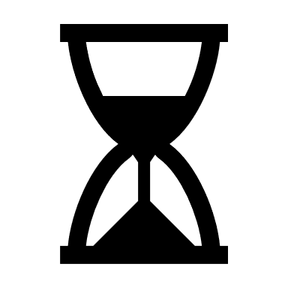**

**Frequently Asked Questions:**

**Who is Moody Lass?** A Human, Female (She/Her), Woman, Lady, Lass, Miss, Ma’am, Daughter, Stepdaughter, Sister, Half-Sister, Stepsister, Granddaughter, Grandmother, Niece, Mother, and Wife.

**What is Moody Lass?** A Freelance Muse, Ghost Writer, Pseudo-Poet, Free Thinker, both Day and Night Dreamer, Fem-Nerd, Original Content Creator, Mood Biased Blogger, Anonymous Author, Common Sense Columnist, Amateur Wordsmith, Eventual Podcaster, and occasionally a Charismatic Character.

**When is Moody Lass?** Once upon a Time, Sometime in neither the distant Past nor the immediate Future, after Dusk and before Dawn, and certainly at Tea Times, Always but probably not Forever, for the Time Being, Now including Later, a Moody Lass and her taste for tea came to be, not at Noon or Midnight, not at Midmorning or Midday, but most often in the Evenings and late at Night, coincidentally during a Blue Super Moon, and prior to a Full Solar Eclipse, as well as Anytime there is a rainbow.

**Where is Moody Lass?** Here and There, as well as Somewhere Over Yonder, or maybe Everywhere, but perhaps Nowhere, nearby to Someplace, but too Far Away walk to, and most definitely Farther Away than Closer By, not to mention considerably more convenient than the alternative, yet still next to Anyplace, and mostly located Anywhere.

**Why is Moody Lass?** Not just Because, and maybe for Some Reason, perhaps for no Cause, as well as a possible Motive, likely an Inspiration, in Response to an embracing of Moods, or perhaps no Justifiable Explanation, except for whatever Excuse, and mostly with Permission, but also Why Not?

**How is Moody Lass?** Very Carefully, with Complete Abandon, including a Strategy, but lacking Tactics, planned Spontaneously, in addition to an Idea, relatively Slowly without too much Delay, under little to No Pressure, Sans Deadlines, in the most Carefree and Amusing way possible.

****

**Moody Lass Meanderings:**

A miniature travel hub, documenting the meanderings of Moody Lass,

in some rather amusing ways.

[a href=%22https:/m.maploco.com/visited-states/mine.php?states=AK-AZ-CA-CO-FL-GA-IA-IL-IN-KS-LA-MI-MN-ND-NE-NJ-NM-NV-NY-OH-OK-OR-PA-SD-TN-TX-UT-WA-WY&w=ml%22%3e%3cimg%20src=%22https://map1.maploco.com/visited-states/ml/AK-AZ-CA-CO-FL-GA-IA-IL-IN-KS-LA-MI-MN-ND-NE-NJ-NM-NV-NY-OH-OK-OR-PA-SD-TN-TX-UT-WA-WY.png%22%20border=0%3e%3cbr%3eMoody%20Lass%20Meanderings%20across%20the%20USA.%20Create%20Your%20Own%20Map%3c/a](file:///C:\Users\lanik\OneDrive\Documents\Moody%20Lass\a%20href=%22https:\m.maploco.com\visited-states\mine.php%3fstates=AK-AZ-CA-CO-FL-GA-IA-IL-IN-KS-LA-MI-MN-ND-NE-NJ-NM-NV-NY-OH-OK-OR-PA-SD-TN-TX-UT-WA-WY&w=ml%22%3e%3cimg%20src=%22https:\\map1.maploco.com\visited-states\ml\AK-AZ-CA-CO-FL-GA-IA-IL-IN-KS-LA-MI-MN-ND-NE-NJ-NM-NV-NY-OH-OK-OR-PA-SD-TN-TX-UT-WA-WY.png%22%20border=0%3e%3cbr%3eMoody%20Lass%20Meanderings%20across%20the%20USA.%20Create%20Your%20Own%20Map%3c\a)

[Iframe src=%22https:/ free.timeanddate.com/countdown/ i90cuwux/cf107/cm0/cu4/ct0/cs1/ ca0/co0/cr0/ss0/cac000/cpc000/ pcfff/tc66c/fn3/fs100/szw320/ szh135/iso2024-05-16T00:00:00/ bas5/pd2%22 allowtransparency=%22true%22 frameborder=%220%22 width=%22329%22height=”144”%3e%3c/iframe%3e%3cbr%3eCountdown to Sweet Iced Tea on the Beach!%3c/a](file:///C:\Users\lanik\OneDrive\Documents\Moody%20Lass\Iframe%20src=%22https:\%20free.timeanddate.com\countdown\%20i90cuwux\cf107\cm0\cu4\ct0\cs1\%20ca0\co0\cr0\ss0\cac000\cpc000\%20pcfff\tc66c\fn3\fs100\szw320\%20szh135\iso2024-05-16T00:00:00\%20bas5\pd2%22%20allowtransparency=%22true%22%20frameborder=%220%22%20width=%22329%22height=)

****

**Moody Lass Tea List:**

**[](https://tealist.moodylass.com)**

**Moody Lass Kudos:**

****

**Moody Lass Support:**

**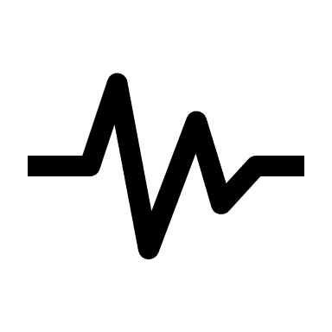**

**Moody Lass Site Visitors:**

[script type=”txt/javascript”src=”/counter.websiteout.net/js/5/0/0/1”%3e%3c/script](file:///C:\Users\lanik\OneDrive\Documents\Moody%20Lass\script%20type=)



**Moody Lass Legal:**

Moody Lass is an Adopted Pen Name, ® Registered ™ Trademark Brand, and Copyright © 2023 for a freelance muse and writer.All Rights Reserved.

****

**[Back To Top](#_top" \o "Click Here to Begin Again" \t "_self)**