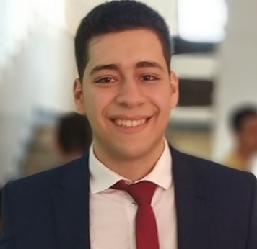

01092439691

mohamed.salah.abdelaziem.

elkholy@gmail.com

Development of sites for an engineering company and dealing with customers

Captain DEV Company

**9/2018-2/2019 | Web Developer**

**Work Experience**

2014 -2018Faculty of Science, Menofia Universy,

Department Computer science

**Education**

English language

Entity framework/LINQ/ADO.NET

Web Development/ASP.MVC

Shebin-El Kom, Menofia,Egypt

(048) 3716718

.NET Web Developer

Development Project Management

HTML5/CSS3/JS

SQL Server for Database

Design Patterns

**Skills**

**Contact**

Mohamed Salah Elkholy