SDK sample for PackWebRequest
One-page functional specification

1. Overview

Retail Server handles the interaction between clients and archive servers. Archive servers hold package files with a number of photos. Retail server holds the snapshots of the archive servers with thumbnails and the information about the location of photos. Thumbnails are exposed to and can be selected by a client. Retail server retrieves photos on archive servers that correspond to the selected thumbnails and sends them to the client.
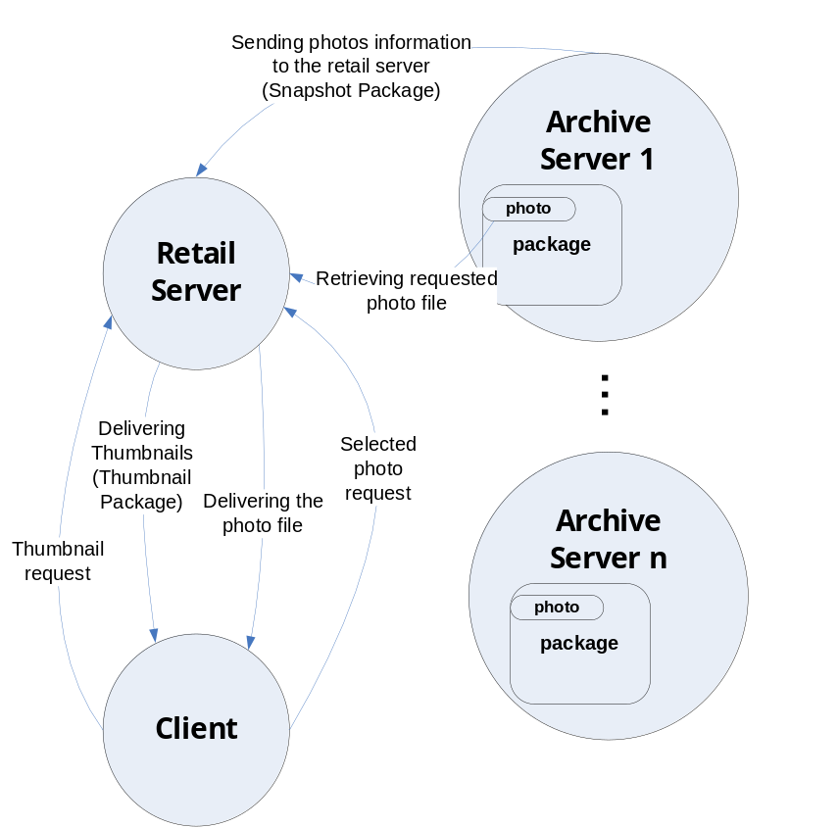

2. Scenario steps

The thumbnails of photos in the photo package on an Archive Server are stored in a snapshot package named “Snapshot.package.zip”. An xml file named “Info.xml” (described in 3.1) is also packed into the snapshot package. It has the Uri of the archive package file, part names of photo files in the archive and the keywords of the thumbnails. The snapshot package is delivered to the Retail Server.
- Client sends a thumbnail request (described in 3.3) to the Retail Server asking for thumbnails with keyword “dog”.
- Retail server processes the request and extracts related thumbnails from the snapshot packages. It packs the thumbnails and the “Info.xml” file (described in 3.2) into a package named “Thumbnails.package.zip” and sends it to the client.
- The client selects the thumbnails he/she likes and sends a photo request (described in 3.4) back to the retail server.

For each of the thumbnail selected, Retail Server:

discovers the location information of the photo using the Id attribute in the photo request.

creates the pack Uri of the selected photo file using values of the SourcePackUri attribute of the PackInfo element and PartUri attribute of the Photo element; pack Uri is created using PackUriHelper class.

retrieves the bits of the photo by passing created pack Uri to the PackWebRequest class.

creates an XPS document “Photos.xps” with retrieved photos and sends it to the client.

3. Sample names and data structures
3.1 Info.xml inside of snapshot package
<PackInfo SourcePackUri="file:///C:/PackWebRequestSample/ArchiveServer/Photos.zip">
<Photos>
<Photo
Id="10"
PartUri="/Cats/j0178764.jpg"
ThumbnailUri="/Thumbnail10.jpg"
Keywords="cat, animal, pet" />
</Photos>
</PackInfo>
Notes:
PartUri: the part Uri of the photo in the archive package defined by SourcePackUri.
ThumbnailUri: the part Uri of the thumbnail inside of the snapshot package.
3.2 Info.xml inside of thumbnail package
<Thumbnails>
<Thumbnail Id="Snapshot.zip_10" PartUri="/Thumbnail0.jpg" />
</Thumbnails>
Notes:
Id: there are 2 parts in the Id separated by ‘_’. The first part is the file name of the snapshot package. The second part is the Id attribute of the Photo element in the Info.xml in snapshot package.
3.3 Thumbnail request xml format
<Query>
<ReturnPath>C:\PackWebRequestSample\Client\Download</ReturnPath>
<Keyword>dog</Keyword>
</Query>
3.4 Photo request xml format
<Query>
<ReturnPath>C:\PackWebRequestSample\Client\Download</ReturnPath>
<Selected>
<Thumbnail Id="Snapshot.zip_10">
</Selected>
</Query>

