Core Concepts

1.SQL Select
From
Where
Understanding Joins

Block – two types
2. Names
3. Anonymous
- Declare
- Begin
- Exception
- End

4. Error Handling
Exception:
When exception then A
When exception then B
End

5. Variables and 6. type

Conditional
- 7. If then else
- 8. Case
- 9. Loop (simple, while, for, go to)

Cursors
10. CURSOR cursor_name IS select_statement
- Open
- Fetch
- Close
- Implicit
- Explicit

11. Collections --- indexing

12. Procedures: Create or replace Procedure

13. Functions: Create or replace Function

14. Package: Create or replace Package

15. Triggers: Create or replace Trigger

Fifteen Tools

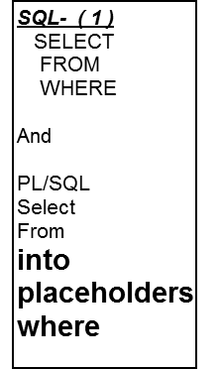
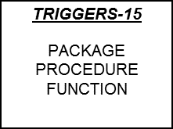
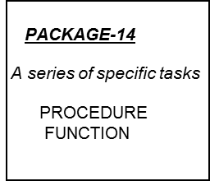
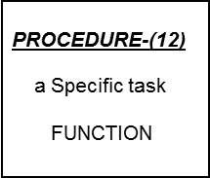
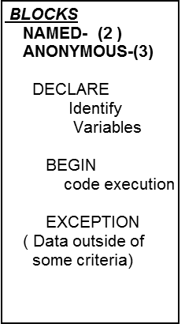
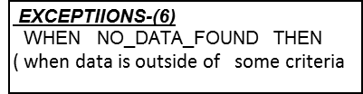
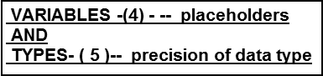
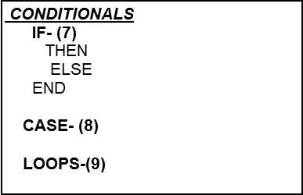

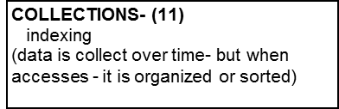






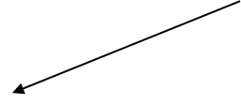







 | 
 |  |  |  | 
 |  |  |  |  |  |  | 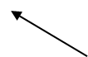 | 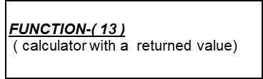

Login
Steps:
- Log onto Oracle/SQL*Plus (Remember the host is COISORCL)
- Must re-create password – first password is “welcome” then -- must change
- SQL> alter user ( username) identified by ( New Password )
- See the handout, Using Oracle SQL*Plus, for information on coding, saving, and executing your queries.
- Save the output of the queries by using the SPOOL option of the file menu.
- Print both the queries and the output of the queries to hand in.

The Problem of Nulls
1. Null values are an inescapable fact of databases. All information will not be available all of the time.
Values for row/column instances must, when allowable, have the default option of null. In the following,
we will investigate the problems and restrictions necessary to properly handle null values. For the
following discussion, we will use the following Employee/Department sample database.

EMPLOYEE DEPARTMENT

E_Nbr Name Sal D_Name D_Name Manager Tel
------- ------------------ -------- -------------- -------------- -------------- ---------------
1001 Adams 2500 Fin Acct Early 471-5222
1002 Baker 2250 Fin Fin Baker (null)
1003 Clarke 3300 Acct Sales (null) 471-3888
1004 Dexter (null) Sales Marktg (null) 471-8484
1005 Early 2900 Acct
1008 Kanter (null) (null)
1011 Marsh 2470 Fin
1013 (null) 2750 Sales

2. Null values in Primary Keys – Null values can not be allowed in Primary Keys. Primary Keys must
uniquely identify each row in a relation. This is compromised if null values are allowed as any part of the
Primary Key. This is also known as the Rule of Entity Integrity. The Primary Key clause in the CREATE
TABLE command will enforce Entity Integrity.

3. Null values in final output – Null values can occur in columns we choose in our SELECT clause in an
SQL query. These will normally print as a blank. An issue here, however, is whether the null values
count in our built-in functions such as COUNT, SUM, MAX, etc. Normally, they will be included in the
COUNT, but will not AVERAGE, SUM, etc. Also an issue is a computation in the SELECT clause: For
example – in the EMPLOYEE table above, considering the Sal column, then the SELECT clause:

SELECT SAL +25.00 ……

Would result in null for every row that Sal is null. You can override this value in Oraclemby using the
NVL function ---- the NULL value substitution function. This has the form:

SELECT NVL (Sal,0) +25.00 ……

If Sal is NULL, 0 is substituted for it.

If the SELECT clause is:

SELECT AVG(Sal) …..

Then the average will not include the 2 rows with null values in the Sal column. It will be computed by
dividing the SUM by 6 instead of 8.

If the SELECT statement includes the COUNT function on a column with NULL values:

SELECT COUNT(Sal)
FROM EMPLOYEE
WHERE D_Name = ‘Sales’:

the count would be 2 and include the row with the null value.
4. Null values in Foreign Keys – Null values will be allowed in Foreign Keys. Above, we see that Kanter
has not been assigned a department, which in many situations would be an acceptable state of affairs.
Suppose Kanter will be manager of a new department, Personel, which has not yet been created. We
could not enter Pers in Kanter’s Foreign Key field since Pers does not exist already in the
DEPARTMENT table. This would violate the second Integrity constraint known as the Rule of
Referential Integrity. This rule states that:

The value in a Foreign Key field must have a matching entry in the table to which it refers, or be NULL.

Note that Referential Integrity applies for either the Primary Key or a Candidate Key in the referenced
table.

5. Null values in other columns in the WHERE clause – Suppose we wanted to identify all employees who
are also managers. This would be a simple enough query:

SELECT E_Nbr, Name
FROM EMPLOYEE, DEPARTMENT
WHERE Name = Manager;

Everything is fine until we get to Employee 1013 and the Sales department. Does (Null) = (Null)? What
should be done with these two rows? In this case, it is clear that we don’t want to SELECT employee
1013 as manager of Sales. In other cases it may not be so clear or obvious. Also, if we reject the match,
we don’t get the information that Sales is a department without a manager.

6. Two results have come out of this type of situation. First, a DBMS no longer operates on a simple two
-valued True/False logic for WHERE clauses. A three-valued logic has been adopted with the
possibilities True/False/Maybe(?). This revises the truth tables for logical operators (NOT, AND, and
OR) in the following way: for two columns P and Q in a WHERE clause, where each may have the value
T, F, or ?

P and Q P or Q NOT P

P P P
T ? F T ? F T ? F
--------------- ------------- --------------
T | T ? F T | T T T F ? T
Q ? | ? ? F Q ? | T ? ?
F | F F F F | T ? F

Even though the DBMS evaluates the WHERE clause according to a three-valued logic, SQL has no
provision for recognizing a NULL (or Maybe) result from a logical expression. It will default the ? to
False which means NULL values will not be selected. There is typically, however, an option which will
select columns which have a NULL value. In Oracle and Informix, for example, you may add the clause
to your SQL WHERE clause:

Column IS [NOT] NULL

7. Outer Joins – Another way to retain information from a table when NULLs are likely to occur is by using
an outer join. This is similar to a normal join except that one table is designated the dominant table and
the other table as a subservient table. If the subservient table has no rows satisfying the join condition,
the outer join attaches a row of NULL values from the subservient table to the row of the dominant table
before projecting the desired columns.

In our example above, suppose we wanted to list the employees of each department. Our normal join:

SELECT E_Nbr, D_Name, Manager
FROM EMPLOYEE E, DEPARTMENT D
WHERE E.D_Name = D.D_Name
ORDER BY D_Name;

Will not produce anything for ‘Marktg’ because there are no rows satisfying the join condition. But we
might want to see the department name listed even though there are currently no employees. We could
do this by using an outer join. This is accomplished by placing a (+) in parenthesis after the subservient
column in the WHERE clause.

SELECT E_Nbr, D_Name, Manager
FROM EMPLOYEE E, DEPARTMENT D
WHERE D.D_Name = E.D_Name (+)
ORDER BY D_Name;

Here we would get Marktg in the output since DEPARTMENT is the dominant table. This is called a
right outer join because the (+) occurs on the right side of the equal sign.

Creating Tables with Constraints

- Create Table syntax

CREATE TABLE table_name
(Col1 datatype column_constraint,
Col2 datatype column_constraint,

ColN datatype column_constraint
Table_constraint1,
Table_cosntraint2,

Table_constraintN
);

- The constraints have full syntax of:

CONSTRAINT constraint_name constraint_type arguments

The constraint may appear in shortened form omitting the keyword CONSTRAINT and the constraint_name.

- The advantage of using a constraint name is that if an error occurs involving that constraint, the ORACLE error message will include the name of the constraint. Good naming conventions can indicate exactly where the error is occurring.

- PRIMARY KEY Constraint

- Enforces Entity Integrity
- Can occur as either a column constraint or table constraint. If primary key is concatenated, it must be a table constraint.
- Full syntax:

CONSTRAINT PK_name PRIMARY KEY (column1, column2…. columnX)

- Naming convention: PK_table_name
- Guarantees UNIQUE for each row:
- Does not guarantee NOT NULL for each column if primary key is concatenated.

- UNIQUE Constraint

- NULLs are allowed
- Guarantees that is the column is NOT NULL the value will be unique for that table.
- Can occur as either a column constraint or a table constraint.
- Full Syntax:

CONSTRAINT UK_name UNIQUE
- Naming convention: UK_tablename_columnname

- NOT NULL Constraint

- Guarantees a column has a value
- Only allowed as a column constraint
- Generally not given a name
- Full Syntax:

NOT NULL

- CHECK Constraint

- Defines a list of values that a column or set of columns may assume.
- Allowed as either a column constraint or a table constraint
- If the condition involves more than one column, it must be a table constraint
- Full Syntax:

CONSTRAINT CK_name CHECK (Condition)

- Naming convention: CK_TableName_ColumnName

- FOREIGN KEY Constraint

- Defines a linkage between two tables. Normally, it will be the Foreign Key from one table with the Primary Key of another table that are used to establish a join. However, a unique column could be substituted for the Primary Key column if found in both tables.
- Enforces Referential Integrity
- If the Foreign Key is more than one column, it must be a table constraint
- Full Syntax:

- CONSTRAINT FK_TableName_ColumnName FOREIGN KEY (column_name)
- REFERENCES table_name(column_name) [ON DELETE CASCADE]

- ON DELETE CASCADE clause – If a row with a primary key is deleted, then all rows in a referencing table with matching Foreign Key values are also deleted. The default is ON DELETE RESTRICT where the row of a Primary Key in one table can not be deleted as long as it is referenced by Foreign Key values in another table.

- ALTER TABLE commands – Often you need to add a column and/or a constraint, or you need to modify a column after a table is created. This can be done using the ALTER TABLE command.

- Add a column and a constraint
ALTER TABLE table_name ADD column_name datatype CONSTRAINT
CK_tableName_column_name CHECK (condition);
- Modify a column
ALTER TABLE table_name MODIFY column_name datatype:
- Add a NOT NULL constraint to a column
ALTER TABLE table_name MODIFY column_name NOT NULL;
- Add a Foreign Key, UNIQUE or CHECK constraint to a column
ALTER TABLE table_name ADD CONSTRAINT FK_tableName_ColumnName
FOREIGN KEY (column_name) REFERENCES table_name;
- Drop a constraint
ALTER TABLE table_name DROP CONTRAINT CK_tableName_columnName;

SQL Commands
SQL Data Definition Commands
COMMAND OR OPTION | DESCRIPTION
CREATE SCHEMA AUTHORIZATION | Creates a database schema
CREATE TABLE | Creates a new table in the user’s database schema
NOT NULL | Ensures that a column will not have null values
UNIQUE | Ensures that a column will not have duplicate values
PRIMARY KEY | Defines a primary key for a table
FOREIGN KEY | Defines a foreign key for a table
DEFAULT | Defines a default value for a column (where no value is given)
CHECK | Validates data in an attribute
CREATE INDEX | Creates an index for a table
CREATE VIEW | Creates a dynamic subset of rows/columns from one or more tables
ALTER TABLE | Modifies a tables definition (adds, modifies, or deletes attributes or constraints)
CREATE TABLE AS | Creates a new table based on a query in the user’s database schema
DROP TABLE | Permanently deletes a table (and its data)
DROP INDEX | Permanently deletes an index
DROP VIEW | Permanently deletes a view

SQL Data Manipulation Commands
COMMAND OR OPTION | DESCRIPTION
INSERT | Inserts row(s) into a table
SELECT | Selects attributes from rows in one or more tables or views
WHERE | Restricts the selection of rows based on a conditional expression
GROUP BY | Groups the selected rows based on one or more attributes
HAVING | Restricts the selection of grouped rows based on a condition
ORDER BY | Orders the selected rows based on one or more attributes
UPDATE | Modifies an attribute’s values in one or more tables rows
DELETE | Deletes one or more rows from a table
ROLLBACK | Restores data to their original values
COMPARISON OPERATORS
=, <, >, <=, >=, <> | Used in conditional expressions
LOGICAL OPERATORS
AND/OR/NOT | Used in conditional expressions
SPECIAL OPERATORS | Used in conditional expressions
BETWEEN | Checks whether an attribute value is within a range
IS NULL | Checks whether an attribute value is null
LIKE | Checks whether an attribute value matches a given string pattern
IN | Checks whether an attribute value matches any value within a value list
EXISTS | Checks whether a sub query returns any rows
DISTINCT | Limits values to unique values
AGGREGATE FUNCTIONS | Used with SELECT to return mathematical summaries on columns
COUNT | Returns the number of rows with non-null values for a given column
MIN | Returns the minimum attribute value found in a given column
MAX | Returns the maximum attribute value found in a given column
SUM | Returns the sum of all values for a given column
AVG | Returns the average of all values for a given column

SQL Join Expression Styles
Join Classification | JOIN TYPE | SQL SYNTAX EXAMPLE | DESCRIPTION
CROSS | CROSS JOIN | SELECT * FROM T1, T2 | Returns the Cartesian product of T1 and T2 (old style)
 |  | SELECT * FROM T1 CROSS JOIN T2 | Returns the Cartesian product of T1 and T2 (old style)
INNER | Old-Style JOIN | SELECT *  FROM T1, T2  WHERE T1.C1=T2.C1 | Returns only the tows that meet the join condition in the WHERE clause (old style). Only rows with matching values are selected.
 | NATURAL JOIN | SELECT *  FROM T1 NATURAL JOIN T2 | Returns only the rows with matching values in the matching columns. The matching columns must have the same names and similar data types.
 | JOIN USING | SELECT * FROM T1 JOIN T2 USING (C1) | Returns only the rows with matching values in the columns indicated in the USING clause.
 | JOIN ON | SELECT *  FROM T1 JOIN T2  ON T1.C1 = T2.C1 | Returns only the rows that meet the join condition indicated in the ON clause.
OUTER | LEFT JOIN | SELECT *  FROM T1 LEFT OUT JOIN T2  ON T1.C1 = T2.C1 | Returns rows with matching values and includes all rows from the left table (T1) with unmatched values.
 | RIGHT JOIN | SELECT *  FROM T1 RIGHT OUTER JOIN T2  ON T1.C1 = T2.C1 | Returns rows with matching values and includes all rows from the right table (T2) with unmatched values.

