Connecting to External ODBC Database From Microsoft Access

1. From the Windows Start menu open Microsoft Access.

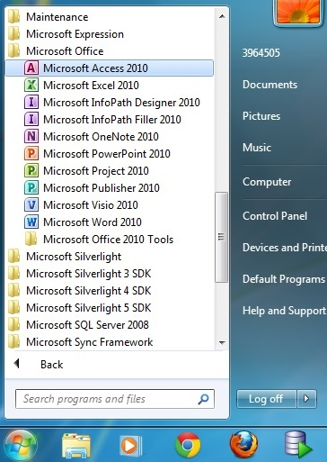

1. In Microsoft Access select File > New > Blank database and then Press the Create icon. A new blank database will open.

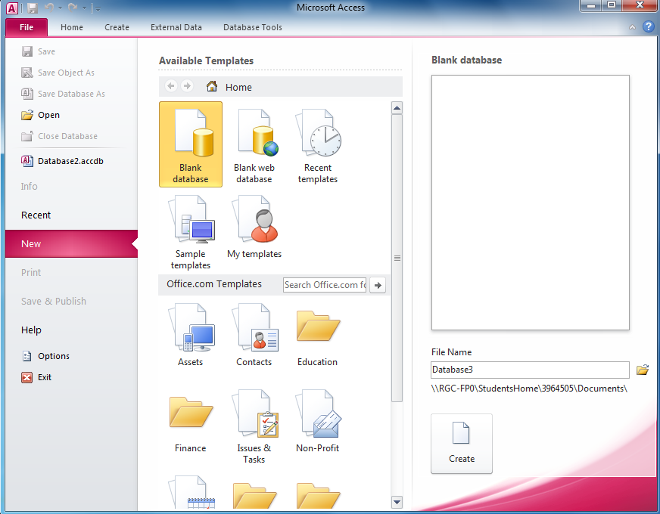

1. Select External Data tab. Press the ODBC Database button.

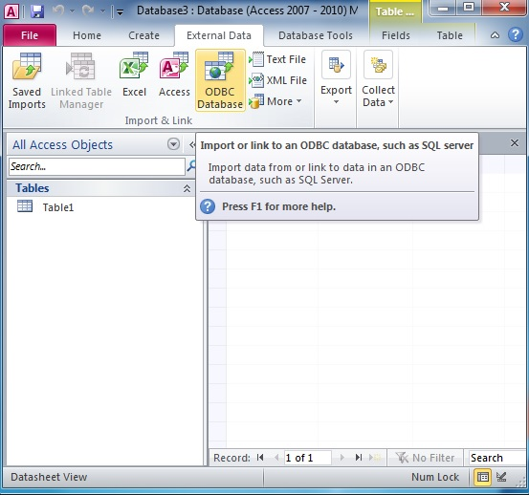

1. Select either of two options and then press OK:
   1. Import the source data into a new table in the current database.
   2. Link to the data source by creating a linked table.

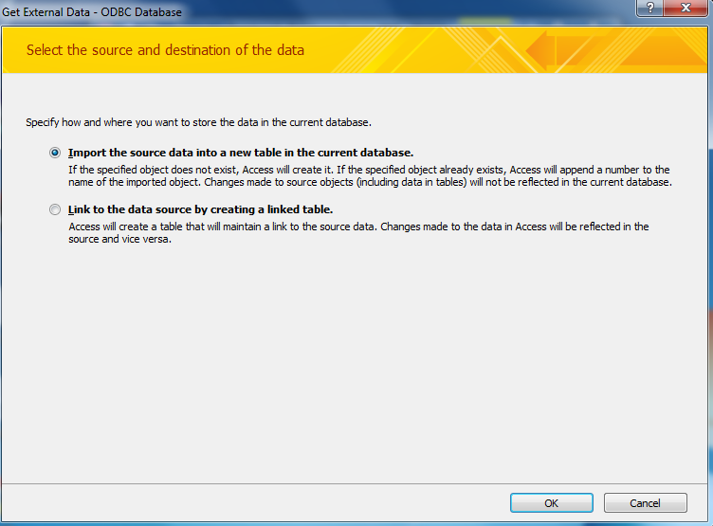

1. The Select Data Source window. Press the Machine Source tab. Press the New button.

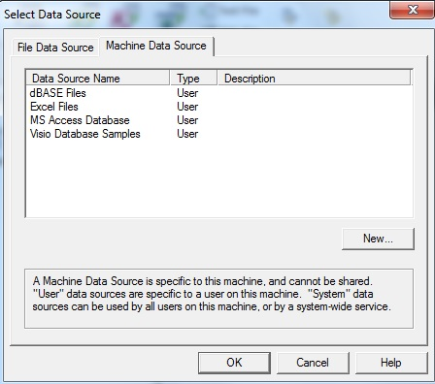

1. You will get a ODBC System DSN Warning. Press OK.

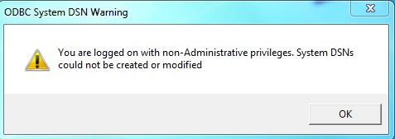

1. The Create New Data Source window will appear. Press Next.

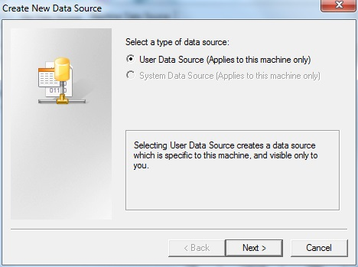

1. In the Create New Data Source window scroll down to the Oracle 11g driver and select it. Press Next.

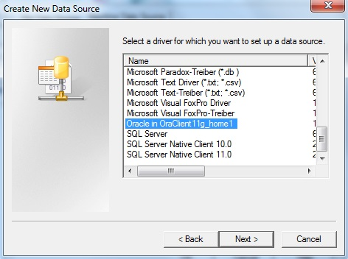

1. In the Create New Data Press Finish.

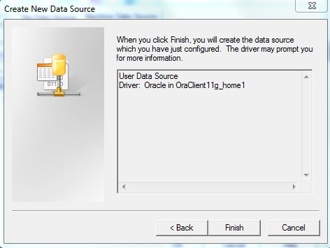

1. The Oracle ODBC Driver Configuration window will appear. Fill out the Data Source Name and the User ID.

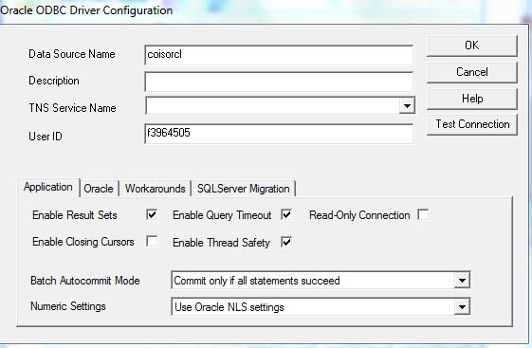

1. Press Test Connection button. The Oracle ODBC Driver Connect Window will appear. Fill in the Service Name and password. The password is ‘welcome’ by default unless you changed it.

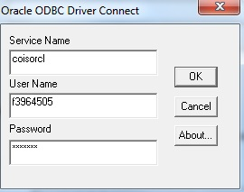

1. Press Test Connection and you should get a window that says ‘Connection successful’.



1. In the Oracle ODBC Driver Configuration window press OK.
2. The Oracle ODBC Driver Connect Window will appear. Fill in the Service Name and password. The password is ‘welcome’ by default unless you changed it.



1. The Import Objects window will appear. Select the tables you want to import. Press OK.

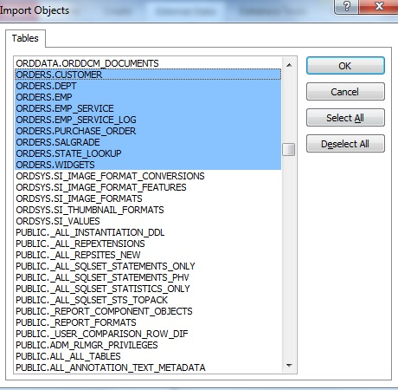

1. If successful the Get External Data – ODBC Database window will appear. It should state “All objects were imported successfully.” Press Close. The tables will now appear in the database.

