Deep Emotion Detector
AI-Powered Text & Document Emotion Analysis

A Streamlit web application built with the EmoRoBERTa transformer model

GitHub Repository: https://github.com/Moolyasri/Emotion-Detection-Learning-Support-Engine

Project Description

Deep Emotion Detector is a Streamlit-based web application that analyses natural-language text and identifies the emotion expressed within it. Powered by the EmoRoBERTa model from Hugging Face Transformers, the application classifies input text and surfaces the single best-matching emotion label instantly through a themed, sidebar-driven interface.

The application supports two modes of input, selected from a sidebar dropdown: Plain Text, where a user types directly into a text area and detects the emotion on the fly, and Documents, where a user uploads a TXT, PDF, or DOCX file. Uploaded files are saved to a local uploads/ folder, their text is extracted with format-specific logic, and the extracted text is passed through the same emotion-detection function used for plain text.

EmoRoBERTa (arpanghoshal/EmoRoBERTa) is a RoBERTa-based transformer fine-tuned for emotion classification. The application loads it through the Hugging Face transformers.pipeline API with the sentiment-analysis task, and returns the top predicted label (e.g. joy, annoyance, admiration, neutral). The interface is built with Streamlit and themed via a .streamlit/config.toml file, and the app can be run locally, deployed to a Procfile-based platform (e.g. Heroku), or containerised with Docker.

Scenarios

Scenario 1: A user pastes a short piece of text — a review, a message, or a journal entry — into the Plain Text box and clicks "Find Emotion ✨". Within moments, the app displays the single dominant emotion detected, such as Joy or Annoyance, along with a success animation.

Scenario 2: A user switches to Documents mode and uploads a .docx file (e.g. sample.docx). The app saves the file, extracts its full text using python-docx, runs it through EmoRoBERTa, and displays the detected emotion — for example "Annoyance" — directly beneath the uploaded file's name.

Scenario 3: A user uploads a PDF report or a plain .txt file instead. The app detects the file extension, routes it to the matching extractor (PyMuPDF for PDF, regex-based cleanup for TXT), and returns the detected emotion for the extracted content in the same way.

Technical Architecture

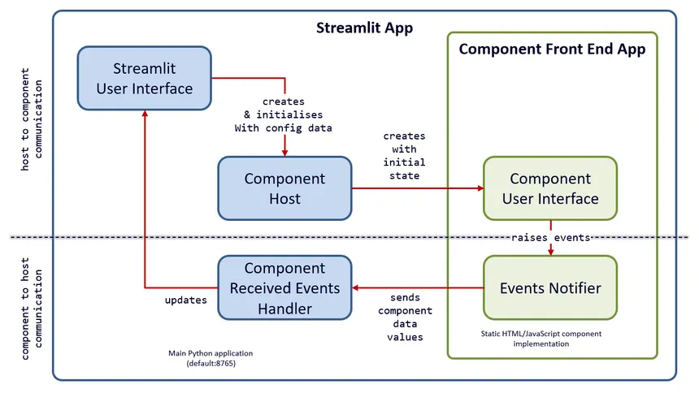

\

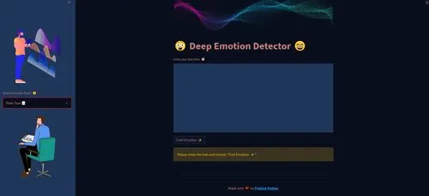

Description:
Deep Emotion Detector follows a simple two-file architecture. app.py is the Streamlit entry point: it configures the page, renders the sidebar mode selector (Plain Text / Documents) and banner images, and wires up the text area and file uploader widgets. app_funcs.py contains the processing logic — the EmoRoBERTa pipeline loader and emotion generator (emotion_generate), and three format-specific text extractors (extract_text_txt, extract_text_pdf using PyMuPDF/fitz, and extract_text_docx using python-docx).

All four functions are wrapped in @st.cache so repeated calls with the same input are not recomputed. Uploaded files are written to a local uploads/ directory before extraction. For deployment, setup.sh and Procfile configure a headless Streamlit server for Platform-as-a-Service hosting, while the Dockerfile packages the same app for container-based deployment.

Note: This project does not use a database, so no ER diagram is required.

Pre-requisites

- Python Proficiency: Python 3.12 with pip for dependency management.
- Streamlit Knowledge: Familiarity with Streamlit widgets — sidebar, text_area, file_uploader, spinner, and caching with @st.cache.
- Hugging Face Transformers: Understanding of the transformers pipeline API and the arpanghoshal/ EmoRoBERT a model.
- Deep Learning Backend: TensorFlow / Keras, since EmoRoBERTa is loaded as a TensorFlow-backed model (tensorflow==2.8.0).
- Document Parsing Libraries: PyMuPDF (fitz) for PDF text extraction and python-docx for Word documents.
- Version Control with Git: For cloning and managing the repository.
- Docker (optional): For containerised deployment via the provided Dockerfile.
- Heroku / PaaS familiarity (optional): For Procfile + setup.sh based deployment.

Project Workflow

Milestone 1: Environment Setup and Model Selection
- Activity 1.1: Clone the repository and install dependencies from requirements.txt.
- Activity 1.2: Research and select EmoRoBERTa as the emotion-detection model.
- Activity 1.3: Define the two-file architecture (app.py for UI, app_funcs.py for processing) and load the model via the Transformers pipeline.

Milestone 2: Core Functionalities Development
- Activity 2.1: Implement emotion_generate() to run EmoRoBERTa on plain text.
- Activity 2.2: Implement extract_text_txt(), extract_text_pdf(), and extract_text_docx() for document handling.

Milestone 3: App.py Development
- Activity 3.1: Build the Streamlit page configuration, sidebar mode selector, and banner images.
- Activity 3.2: Wire up the Plain Text and Documents branches to call the app_funcs.py functions and render results.

Milestone 4: Frontend Theming
- Activity 4.1: Apply the custom dark theme using .streamlit/config.toml.
- Activity 4.2: Add success/warning feedback and the balloons celebration on successful detection.

Milestone 5: Deployment
- Activity 5.1: Run and verify the application locally.
- Activity 5.2: Deploy via Procfile + setup.sh (PaaS) or containerise with the Dockerfile.

Milestone 6: Conclusion
- Summarise outcomes and outline future scope.

Project Execution

Milestone 1: Environment Setup and Model Selection
This milestone prepares the workspace and confirms the emotion-detection model that powers the application.

Activity 1.1: Clone the Repository and Install Dependencies

- Clone the repository:

git clone https://github.com/kosurusiri131-sudo/streamlit-based-Deep-Emotion-Detector.git
cd streamlit-based-Deep-Emotion-Detector

- Create a virtual environment (recommended):

python -m venv venv
# Windows:
venv\Scripts\activate
# macOS / Linux:
source venv/bin/activate

- Install dependencies from the project's requirements.txt (key libraries include streamlit==1.7.0, transformers==4.17.0, tensorflow==2.8.0, PyMuPDF==1.19.6, python-docx==0.8.11):

pip install -r requirements.txt

Activity 1.2: Research and Select the Emotion Detection Model

- Understand the requirement: The application must classify the dominant emotion of arbitrary English text, whether typed directly or extracted from an uploaded document.
- Evaluate available models: Compare pre-trained emotion-classification models available through the Hugging Face Transformers pipeline.
- Select EmoRoBERTa: Choose arpanghoshal/EmoRoBERTa, loaded via the sentiment-analysis pipeline task, for reliable single-label emotion prediction on short and long text alike.

Activity 1.3: Define the Two-File Architecture

- app.py — the Streamlit UI layer: page config, sidebar, banners, input widgets, and result rendering.
- app_funcs.py — the processing layer: model loading, emotion generation, and document text extraction, imported into app.py with from app_funcs import *.
The model is loaded exactly once per call inside emotion_generate(), using the sentiment-analysis pipeline:

from transformers import pipeline

emotion = pipeline('sentiment-analysis',
model='arpanghoshal/EmoRoBERTa')
emotion_labels = emotion(plain_text)
label = emotion_labels[0]['label']
#e.g.'joy', 'annoyance', 'neutral'

Milestone 2: Core Functionalities Development

This milestone implements the processing logic in app_funcs.py — the emotion generator and the three document text extractors — each decorated with Streamlit's caching to avoid recomputation.

Activity 2.1: Implement emotion_generate()
This function loads the EmoRoBERTa pipeline and returns the top predicted emotion label for a given piece of text. It is cached with @st.cache so the pipeline is reused across calls within a session:

@st.cache(persist=True, allow_output_mutation=True,
show_spinner=False, suppress_st_warning=True)
def emotion_generate(plain_text):
emotion = pipeline('sentiment-analysis',
model='arpanghoshal/EmoRoBERTa')
emotion_labels = emotion(plain_text)
return emotion_labels[0]['label']

Activity 2.2: Implement the Document Text Extractors
.txt files — read the raw file, keep only alphabetic tokens using a regular expression, write the cleaned text to a processed_ output file, and return the joined text:

@st.cache(persist=True, allow_output_mutation=True,
show_spinner=False, suppress_st_warning=True)
def extract_text_txt(uploaded_txt_file, downloaded_txt_file):
with open(uploaded_txt_file) as intxt:
data = intxt.read()
data = re.findall('[aA-zZ]+', data)
with open(downloaded_txt_file, 'w') as outtxt:
outtxt.write('\n'.join(data))
return ' '.join(data)

.pdf files — open the file with PyMuPDF (fitz) and concatenate the text of every page:

@st.cache(persist=True, allow_output_mutation=True,
show_spinner=False, suppress_st_warning=True)
def extract_text_pdf(uploaded_pdf_file):
with fitz.open(uploaded_pdf_file) as intxt:
text = ""
for page in intxt:
text += page.get_text()
return text

.docx files — open the file with python-docx and join the text of every paragraph:

@st.cache(persist=True, allow_output_mutation=True,
show_spinner=False, suppress_st_warning=True)
def extract_text_docx(uploaded_docx_file):
doc = docx.Document(uploaded_docx_file)
fullText = []
for para in doc.paragraphs:
fullText.append(para.text)
return ' '.join(fullText)

A small helper, download_success(), triggers Streamlit's balloon animation (st.balloons()) to celebrate a successful detection.
Milestone 3: App.py Development

Milestone 3 focuses on the main application logic in app.py — page configuration, the sidebar mode selector, and the two input branches (Plain Text and Documents) that call into app_funcs.py.

Activity 3.1: Page Configuration and Sidebar

st.set_page_config(
page_title="Emotion Detector",
page_icon="😉",
layout="centered",
initial_sidebar_state="auto",
)

top_image = Image.open('static/banner_top.png')
bottom_image = Image.open('static/banner_bottom.png')
main_image = Image.open('static/main_banner.png')

st.sidebar.image(top_image, use_column_width='auto')
format_type = st.sidebar.selectbox(
'Detect Emotion from? 😯',
["Plain Text 📝", "Documents 📑"]
)
st.sidebar.image(bottom_image, use_column_width='auto')

Activity 3.2: Plain Text Branch

if format_type == "Plain Text 📝":
text = st.text_area("Enter your text here: 🎯", height=300)
if st.button("Find Emotion ✨") and (text or len(text) != 0):
with st.spinner(f"Finding Emotion... 💫"):
emotion_output = emotion_generate(text)
if emotion_output:
st.success("✅ " + emotion_output.title())
download_success()
else:
st.warning('Please enter the text and choose "Find Emotion ✨"')

Activity 3.3: Documents Branch
The Documents branch accepts TXT, PDF, and DOCX uploads, saves the file locally, then routes it to the matching extractor based on file extension before running emotion detection on the extracted text:

if format_type == "Documents 📑":st.info('Supports all popular document formats 📄 - TXT, PDF, DOCX 😉')
uploaded_file = st.file_uploader("Upload Document 📃",
type=["txt", "pdf", "docx"])
if uploaded_file is not None:
with open(os.path.join(upload_path, uploaded_file.name), "wb") as f:
f.write((uploaded_file).getbuffer())
if uploaded_file.name.lower().endswith('.txt'):
uploaded_txt_file = os.path.abspath(
os.path.join(upload_path, uploaded_file.name))
downloaded_txt_file = os.path.abspath(os.path.join(
download_path, str("processed_" + uploaded_file.name)))
text = extract_text_txt(uploaded_txt_file, downloaded_txt_file)
emotion_output = emotion_generate(text)
st.success("✅ " + emotion_output.title())
download_success()
if uploaded_file.name.lower().endswith('.pdf'):
uploaded_pdf_file = os.path.abspath(
os.path.join(upload_path, uploaded_file.name))
text = extract_text_pdf(uploaded_pdf_file)
emotion_output = emotion_generate(text)
st.success("✅ " + emotion_output.title())
download_success()
if uploaded_file.name.lower().endswith('.docx'):
uploaded_docx_file = os.path.abspath(
os.path.join(upload_path, uploaded_file.name))
text = extract_text_docx(uploaded_docx_file)
emotion_output = emotion_generate(text)
st.success("✅ " + emotion_output.title())
download_success()
else:
st.warning('⚠ Please upload your document 😯')
Activity 3.4: app.py File

from transformers import pipeline
import streamlit as st
from PIL import Image
import os
from app_funcs import *

st.set_page_config(
page_title="Emotion Detector",
page_icon="😉",
layout="centered",
initial_sidebar_state="auto",
)

top_image = Image.open('static/banner_top.png')
bottom_image = Image.open('static/banner_bottom.png')
main_image = Image.open('static/main_banner.png')

upload_path = "uploads/"
download_path = "downloads/"

st.sidebar.image(top_image,use_column_width='auto')
format_type = st.sidebar.selectbox('Detect Emotion from? 😯',["Plain Text 📝","Documents 📑"])
st.sidebar.image(bottom_image,use_column_width='auto')

st.image(main_image,use_column_width='auto')
st.title("😲 Deep Emotion Detector 😄")

if format_type == "Plain Text 📝":
text = st.text_area("Enter your text here: 🎯", height=300)

if st.button("Find Emotion ✨") and (text or len(text) != 0):
with st.spinner(f"Finding Emotion... 💫"):
emotion_output = emotion_generate(text)
if emotion_output:
st.success("✅ " + emotion_output.title())
download_success()
else:
st.warning("Please enter the text and choose \"Find Emotion ✨\"")

if format_type == "Documents 📑":
st.info('Supports all popular document formats 📄 - TXT, PDF, DOCX 😉')
uploaded_file = st.file_uploader("Upload Document 📃", type=["txt","pdf","docx"])
if uploaded_file is not None:
with open(os.path.join(upload_path,uploaded_file.name),"wb") as f:
f.write((uploaded_file).getbuffer())
if uploaded_file.name.endswith('.txt') or uploaded_file.name.endswith('.TXT'):
with st.spinner(f"Finding Emotion... 💫"):
uploaded_txt_file = os.path.abspath(os.path.join(upload_path,uploaded_file.name))
downloaded_txt_file = os.path.abspath(os.path.join(download_path,str("processed_"+uploaded_file.name)))
text = extract_text_txt(uploaded_txt_file,downloaded_txt_file)
emotion_output = emotion_generate(text)
if emotion_output and len(emotion_output) != 0:
st.success("✅ " + emotion_output.title())
download_success()

if uploaded_file.name.endswith('.pdf') or uploaded_file.name.endswith('.PDF'):
with st.spinner(f"Finding Emotion... 💫"):
uploaded_pdf_file = os.path.abspath(os.path.join(upload_path,uploaded_file.name))
text = extract_text_pdf(uploaded_pdf_file)
emotion_output = emotion_generate(text)
if emotion_output and len(emotion_output) != 0:
st.success("✅ " + emotion_output.title())
download_success()

if uploaded_file.name.endswith('.docx') or uploaded_file.name.endswith('.DOCX'):
with st.spinner(f"Finding Emotion... 💫"):
uploaded_docx_file = os.path.abspath(os.path.join(upload_path,uploaded_file.name))
text = extract_text_docx(uploaded_docx_file)
emotion_output = emotion_generate(text)
if emotion_output and len(emotion_output) != 0:
st.success("✅ " + emotion_output.title())
download_success()

else:
st.warning('⚠ Please upload your document 😯')

st.markdown("<br><hr><center>Made with ❤️ by <a href='mailto:ralhanprateek@gmail.com?subject=Deep Emotion Detector WebApp!&body=Please specify the issue you are facing with the app.'><strong>Prateek Ralhan</strong></a></center><hr>", unsafe_allow_html=True)

Milestone 4: Frontend Theming

This milestone applies the application's dark, warm-toned visual identity through Streamlit's built-in theming file, and adds the celebratory feedback shown after a successful detection.

Activity 4.1: Apply the Custom Theme

- In the project root, create a directory named .streamlit (note the leading dot).
- Inside it, create a file named config.toml.
- Add the theme configuration below and save:

[theme]
primaryColor="#b11b1b"
backgroundColor="#080e1c"
secondaryBackgroundColor="#203659"
textColor="#bf7c7c"

Activity 4.2: Success Feedback

On a successful detection, the app shows a green st.success() banner with the title-cased emotion label, and calls download_success(), which triggers st.balloons() for a celebratory animation.
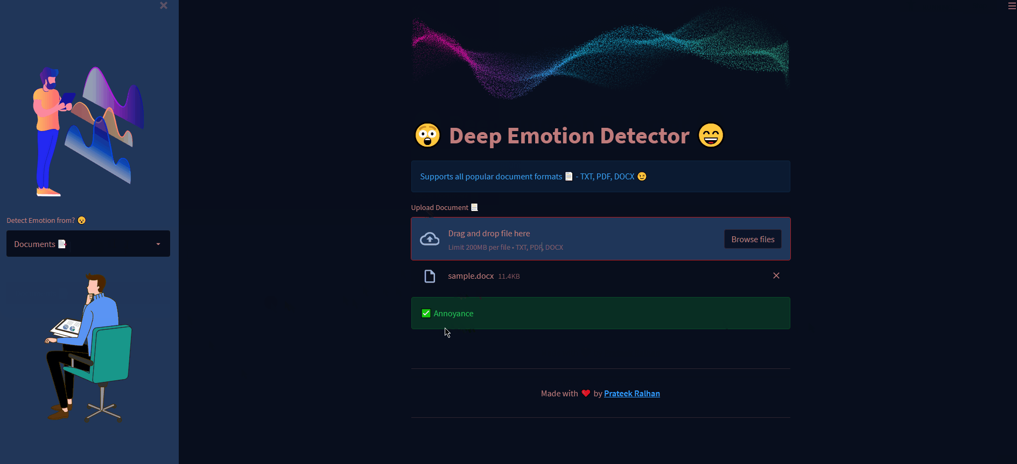

The detected emotion — "Annoyance" — displayed with the custom dark theme applied

Milestone 5: Deployment

This milestone covers three ways to run Deep Emotion Detector: locally for development and testing, via a Procfile + setup.sh for Platform-as-a-Service hosting (e.g. Heroku-style buildpacks), and via Docker for containerised deployment.

Activity 5.1: Run Locally

- From the project root, launch the app:

streamlit run app.py

- Open a browser and navigate to http://localhost:8501 to use the application.
- To allow larger file uploads (default limit is 200MB), launch with an increased limit:

streamlit run app.py --server.maxUploadSize=1028

Activity 5.2: Deploy via Procfile and setup.sh
The repository includes a Procfile and a setup.sh script for deployment to a Procfile-based platform. On startup, the platform runs the Procfile's web command:

web: sh setup.sh && streamlit run app.py

setup.sh writes the Streamlit credentials and server configuration needed for headless, CORS-disabled operation on the platform's assigned port:

mkdir -p ~/.streamlit/
echo "[general]
email = \"ralhanprateek@gmail.com\"
" > ~/.streamlit/credentials.toml
echo "[server]
headless = true
port = $PORT
enableCORS = false
" > ~/.streamlit/config.toml

Activity 5.3: Public Deployment via Docker
The provided Dockerfile builds a Python 3.7 image, installs dependencies from requirements.txt, and runs the Streamlit app on container start:

FROM python:3.12
RUN pip install virtualenv
ENV VIRTUAL_ENV=/venv
RUN virtualenv venv -p python3
ENV PATH="VIRTUAL_ENV/bin:$PATH"
WORKDIR /app
ADD . /app
# Install dependencies
RUN pip install -r requirements.txt
RUN apt-get update
# Expose port
ENV PORT 8501
# Run the application:
CMD ["streamlit","run","app.py"]

- Build the Docker image (don't forget the trailing dot):

docker build -f Dockerfile -t app:latest .

- Run the container, mapping port 8501:

docker run -p 8501:8501 app:latest

- Open http://localhost:8501/ in your browser. Check running containers with:

docker ps

Exploring the Application

Plain Text Mode

Description: With "Plain Text 📝" selected in the sidebar, the main panel shows a large text area for entering text and a "Find Emotion ✨" button. After clicking it, a spinner ("Finding Emotion... 💫") appears briefly, followed by a green success banner showing the detected emotion in title case, plus a balloon animation.

Documents Mode
Description: With "Documents 📑" selected, the panel shows an info banner listing supported formats (TXT, PDF, DOCX) and a drag-and-drop file uploader. Once a file is uploaded, it appears in a list below the uploader, and the detected emotion is shown as a green success banner beneath it.



Conclusion
Deep Emotion Detector is a Streamlit application that makes single-label emotion detection accessible through a simple, themed sidebar interface. By combining the EmoRoBERTa transformer model with lightweight, cached processing functions in app_funcs.py, it lets users detect the dominant emotion in both typed text and uploaded documents (TXT, PDF, and DOCX) within seconds.

The project spans model selection, core detection and extraction logic, Streamlit UI development, custom theming, and three deployment paths — local, Procfile-based PaaS, and Docker.

Looking ahead, the application offers clear opportunities for growth: showing confidence scores and the full label distribution rather than only the top label, supporting batch/multi-file analysis, adding a persistent history of past detections, extending format support (e.g. RTF, HTML), multilingual emotion detection, and a public hosted deployment with a stable URL. With these enhancements, the tool can evolve from a focused single-label detector into a broader emotion-analytics platform for research, support, and content teams.

Project Done By :

Name : S.Moolya Sri
Roll No : 25481DAI04
Mail Id: surapanenimoolyasri@gmail.com
Studying: MTech [Artificial Intelligence And Machine Learning]
College: Seshadri Rao Gudlavalleru Engineering College
University: JNTU Kakinada

