This directory contains implementations of Hierarchical Model-Free Transactive Control of Building Loads.

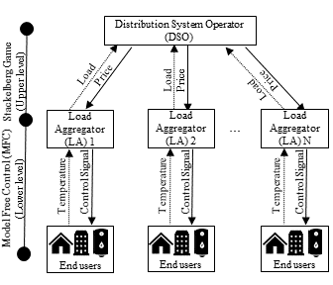

**Code Explanation:**

(1) Auxilary.py

* Includes the model-free control (MFC) function to control the building loads.
* Building load simulators to calculate the temperatures and power consumption of building loads.

(2) nominal_demand_create.py

* Calculates the nominal demand of next day for a given set of buildings and weather forecast.

(3) price_demand.py

* Day-ahead optimization of price and aggregate load profiles.
* Requires installation of IPOPT[1]

(4) weather.py

* Pulls the weather forecast of given coordinates using the OpenWeather API[2].

(5) main_deploy.py

* Wraps everything and runs the code

**References:**

Amasyali, K., Chen, Y., Telsang, B., Olama, M., & Djouadi, S. M. (2020). Hierarchical model-free transactional control of building loads to support grid services. IEEE Access, 8, 219367-219377.

Amasyali, K., Chen, Y., & Olama, M. (2022). A Data-Driven, Distributed Game-Theoretic Transactional Control Approach for Hierarchical Demand Response. IEEE Access, 10, 72279-72289.

Amasyali, K., Winstead, C., Chen, Y., Munk, J., Olama, M., & Hill, J. (2022, April). Hierarchical Model-Free Transactive Control of Residential Building Loads: An Actual Deployment. In 2022 IEEE Power & Energy Society Innovative Smart Grid Technologies Conference (ISGT) (pp. 1-5). IEEE.

1. Wächter, A., & Biegler, L. T. (2006). On the implementation of an interior-point filter line-search algorithm for large-scale nonlinear programming. *Mathematical Programming*, *106*(1), 25-57.
2. https://openweathermap.org/.