 MOONSTAR STUDIO  Web Design & Development  moonstarstudio.site  moonstarstudio.co@gmail.com | INVOICE  Invoice no. [0001]  Date [DD/MM/YYYY]  Due Before work begins

BILL TO  [Client name]  [Company name]  [Client email]  [Client phone] | FROM  MoonStar Studio  Phnom Penh, Cambodia  moonstarstudio.co@gmail.com

DESCRIPTION | QTY | UNIT PRICE | AMOUNT
LaunchPad — Website Build · 50% Deposit  Website design & build. Includes:  • Full landing page design  • Responsive layout (all devices)  • Contact form integration  • Basic SEO setup  • Social media links  • Clean custom layout design  • Smooth scroll animations | 1 | $149.50 | $149.50

Subtotal | $149.50
Tax (0%) | $0.00
TOTAL DUE (USD) | $149.50

PAYMENT — ABA BANK
Bank name ABA Bank
Account name MoonStar Studio
Account number 003 843 303
SWIFT ABAAKHPP
Please use the invoice number as your payment reference.

NOTES
Payment 1 of 2 — 50% deposit for the LaunchPad website project (total $299.00). Work begins once this deposit is received. The remaining 50% ($149.50) is invoiced on completion and must be paid before the site is connected to your domain and made live.

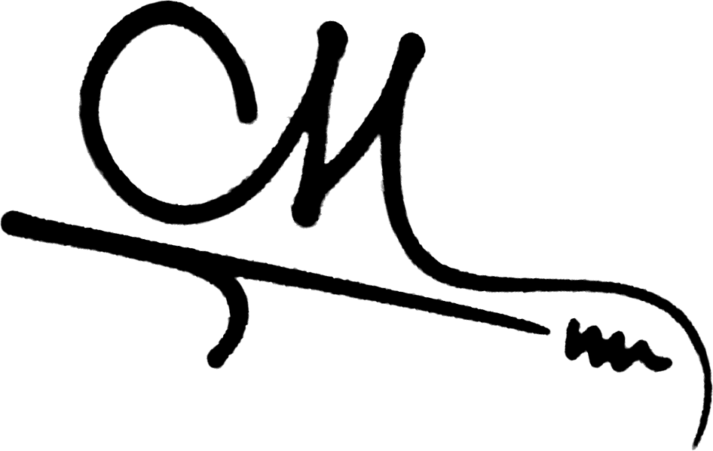  Authorised signature — MoonStar Studio  Date [ DD/MM/YYYY ] | Client signature  Date [ DD/MM/YYYY ]
Thank you for your business.

