{{^report title}}

{{report_subtitle}}

{{@report_logo}}

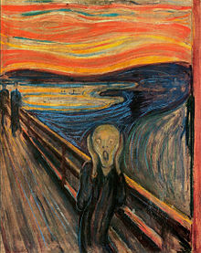

**This is a basic data rendering example.**

Recorder: {{rec_first_name}} {{rec_last_name}}
Number of recorded objects: {{rec_cnt}}
Creation Moment: {{rec_time}}
Remark: {{rec_remark}}

name | {{^t_name}} | photo | {{@t_photo}}
city | {{t_city}} | region | {{t_region}}
address | {{t_address}}

**This is an example of rendering data in a looping table.**
{{#users}}index | name | age | pets
{{#users}}index | name | age | name | toys |  |  | type
 |  |  |  | title | durability | thumbnail | type
[$index] | [name] | [age] | [pets.name] | [pets.toys.title] | [pets.toys.durability] | [@pets.toys.thumbnail] | [^pets.type]

