MECHANICAL ENGINEERING LABORATORY (ELA 301)
LABORATORY REPORTS
TD 311a: Marcet Boiler

Name: ______________________________
Matric No.: __________________________
Department: _________________________
Date: _______________________________
Contents
TD 311a Marcet Boiler
Notes before you submit
- Anything shown as [ ] is for your own readings or results from your own lab session. Nothing has been invented.
- The report follows Section C of the manual: Theory, Apparatus, Results, Analysis of Results, Observations and Precautions, Graphs, Discussion and Conclusion. The Section D questions are answered after the report.
- Section D questions 2, 3, 11, 12, 13 and 15 are personal (your role, whether you could do it alone, your suggestions, your group's suggestions, whether you copied results, whether you brought the manual), so they are left for you to fill in.
- Any dimensions taken from the manual are nominal values; check them on your own apparatus and replace them with your measured values.
- Graphs must be drawn from your own readings on graph paper (or in Excel) and attached where indicated.

TD 311a: Marcet Boiler

Objective
- To determine the relationship between the pressure and the temperature of saturated steam.
- To calculate the enthalpy of dry saturated steam at various pressures.

1. Theory
1.1 Saturated steam
When water is heated in a closed vessel, it boils when its vapour pressure equals the pressure above it. At that point the water and its steam are at the same temperature, called the saturation temperature, and the steam is saturated. If no water droplets are mixed in, it is dry saturated steam. For pure water there is only one saturation temperature for each pressure: raising the pressure raises the boiling point (about 100 °C at atmospheric pressure, 152 °C at 5 bar and 198 °C at 15 bar). This pressure-temperature relationship is the saturation curve, and in the Marcet boiler it is found by measuring the pressure and temperature of the steam above the water as the closed boiler is heated and cooled.
Pressures must be absolute: absolute pressure = gauge pressure + atmospheric pressure. The atmospheric pressure is read from a barometer (1 mm Hg = 0.001333 bar, so 760 mm Hg = 1.013 bar). Temperatures must be in kelvin (K = °C + 273.15) when used in the Clapeyron equation.
1.2 Enthalpy of evaporation and the Clausius-Clapeyron equation
To turn water at its boiling point into steam at the same temperature, heat must be supplied. The heat per kilogram is the enthalpy of evaporation (latent heat) h_{fg}. The enthalpy of dry saturated steam is h_{g} = h_{f} + h_{fg}, where h_{f} is the enthalpy of the saturated liquid. During evaporation the volume also increases from v_{f} (liquid) to v_{g} (vapour), a change of v_{fg} = v_{g} − v_{f}. The Clausius-Clapeyron relation, which comes from the second law of thermodynamics, links the slope of the saturation curve to these changes:
( dT / dP )_{sat} = T v_{fg} / h_{fg} (1)
where T is the absolute saturation temperature (K), P the absolute pressure (Pa), v_{fg} in m³/kg and h_{fg} in J/kg. The slope dT/dP is the gradient of the tangent to the T-P curve at the pressure considered. Equation (1) can be used in two ways. If we know v_{fg} and h_{fg} from steam tables, we can calculate the slope and compare it with the slope found from the experiment. Or, if we measure the slope from the graph, we can calculate the enthalpy of evaporation:
h_{fg} = T v_{fg} / ( dT / dP )_{sat} h_{g} = h_{f} + h_{fg} (2)
Since v_{f} (about 0.001 m³/kg) is very small compared with v_{g} (for example 1.69 m³/kg at 1 bar), v_{fg} is almost equal to v_{g}. The slope gets smaller as the pressure rises: a pressure increase of 1 bar raises the boiling point by about 28 K near 1 bar, but only about 3 K near 15 bar. The reference values below are taken from standard steam tables and calculated from (1); use your own steam tables for the exact values.
Absolute pressure (bar) | T_{sat} (°C) | v_{g} (m³/kg) | h_{fg} (kJ/kg) | h_{g} (kJ/kg) | dT/dP from (1) (K/bar)
1 | 99.6 | 1.694 | 2258 | 2676 | 27.9
2 | 120.2 | 0.886 | 2202 | 2707 | 15.8
3 | 133.5 | 0.606 | 2164 | 2725 | 11.4
5 | 151.8 | 0.375 | 2109 | 2749 | 7.5
7 | 165.0 | 0.273 | 2066 | 2764 | 5.8
10 | 179.9 | 0.194 | 2014 | 2776 | 4.3
15 | 198.3 | 0.132 | 1947 | 2792 | 3.2

1.3 Why the temperature falls when the pressure falls, and the effect of air
On heating, the steam temperature follows the saturation curve only if the steam and water are in equilibrium and the boiler is at a steady condition. When the boiler is heated quickly, the readings tend to lag behind (the temperature may be slightly high or low), and so readings are taken as the pressure rises (heating) and again as it falls (cooling), and the mean is used. If there is air left in the boiler (if the valve was not left open long enough to drive it out with steam), the total pressure is the sum of the partial pressure of steam and that of the air (Dalton's law), so the pressure gauge reads more than the pressure of the steam alone for a given temperature: the measured temperature is lower than the true saturation temperature for the gauge pressure.

2. Apparatus
The Marcet boiler apparatus: a heavy-duty steel boiler designed for electric heating, supplied with a valve, a pressure gauge and a water level cock. The boiler is lagged to permit rapid heating and is arranged for bench mounting. A thermometer in a pocket in the boiler measures the steam temperature, and a barometer gives the atmospheric pressure.
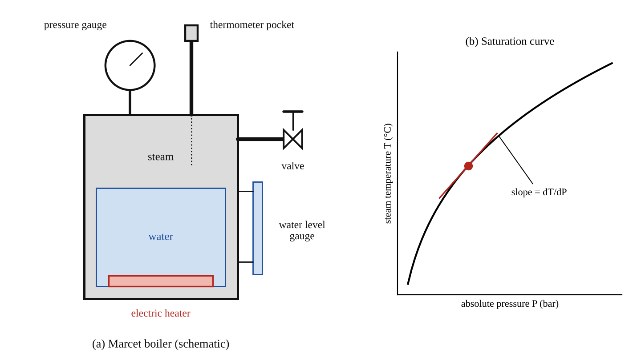
Fig. 1: (a) the Marcet boiler apparatus (schematic); (b) the saturation curve, with the slope dT/dP found as the gradient of the tangent at a chosen pressure.
Method in brief (from the manual)
- Open the valve on the side of the Marcet boiler, which ensures that the pressure above the water in the boiler is atmospheric. Switch on the heater and watch the thermometer. When the reading stops rising and steam is coming out of the valve, take a reading of the thermometer and the barometer.
- Close the valve; the pressure begins to rise. Take the thermometer reading up to 5 bar in increments of ½ bar, and thereafter in increments of 1 bar up to 15 bar.
- Switch off the heater and allow the boiler to cool. Take the temperature reading at the same pressure values as when the boiler was being heated.

3. Results
Barometric (atmospheric) pressure = [ ] mm Hg = [ ] × 0.001333 = [ ] bar. Absolute pressure = gauge pressure + atmospheric pressure. Mean temperature = (increasing + decreasing)/2. Absolute temperature = mean temperature + 273.15 (K).
Table 1: Pressure and temperature of the steam
Boiler (gauge) pressure (bar) | Absolute pressure (bar) | Steam temp, increasing (°C) | Steam temp, decreasing (°C) | Mean temp (°C) | Absolute temp (K)
0.5
1.0
1.5
2.0
2.5
3.0
3.5
4.0
4.5
5.0
6
7
8
9
10
11
12
13
14
15

Table 2: Slope and enthalpy at five pressures (for example 1, 3, 5, 10 and 15 bar absolute)
Absolute pressure (bar) | Experimental slope (dT/dP) from graph (K/bar) | Slope from steam tables (K/bar) | Difference (%) | h_{fg} from (2) (kJ/kg) | h_{fg} from steam tables (kJ/kg) | h_{g} = h_{f} + h_{fg} (kJ/kg)
1
3
5
10
15

4. Analysis of Results
1. Convert the gauge pressures to absolute pressures by adding the atmospheric pressure, and take the mean of the increasing and decreasing temperatures at each pressure.
2. Plot the mean temperature (vertical) against absolute pressure (horizontal). At five pressures draw the tangent to the curve and find its gradient (dT/dP) in K/bar (and convert to K/Pa by dividing by 10⁵ when using (1) or (2)).
3. On the same graph, plot the saturation temperatures from the steam tables at the same pressures, and compare the two curves. From the steam tables also calculate the slope (dT/dP)_{sat} = T v_{fg}/h_{fg} at the same five pressures.
4. Calculate the enthalpy of evaporation from the experimental slope, h_{fg} = T v_{fg} / (dT/dP), and the enthalpy of dry saturated steam, h_{g} = h_{f} + h_{fg}. Sample calculation at P = [ ] bar: T = [ ] K, v_{fg} = [ ] m³/kg, slope = [ ] K/bar = [ ] K/Pa, so h_{fg} = [ ] × [ ] / [ ] = [ ] J/kg = [ ] kJ/kg.

5. Observations / Precautions Taken
- Make sure the valve is open at the start and that steam comes out steadily for a time, so that all the air is driven out of the boiler before the valve is closed.
- Check the water level in the level gauge before starting; there must be enough water covering the heater, and never let the boiler boil dry.
- Read the thermometer and the pressure gauge together, at the same moment, and read the pressure gauge at eye level to avoid parallax.
- Do not exceed the maximum working pressure of the boiler (15 bar here); switch off the heater at the highest pressure.
- When cooling, take the readings at the same pressures as on heating, and do not open the valve to release the pressure suddenly.
- The boiler and steam are very hot and under pressure: keep clear of the valve outlet, and do not touch the boiler.
- Note the atmospheric pressure from the barometer, since the gauge reads pressure above atmospheric.

6. Graphs
Plot the following on graph paper from your own readings and attach them here:
Plot (1) the mean temperature against absolute pressure, with tangents at five pressures to give the slope dT/dP; (2) the same graph with the steam table values on the same axes. The expected shapes are in Fig. 2.
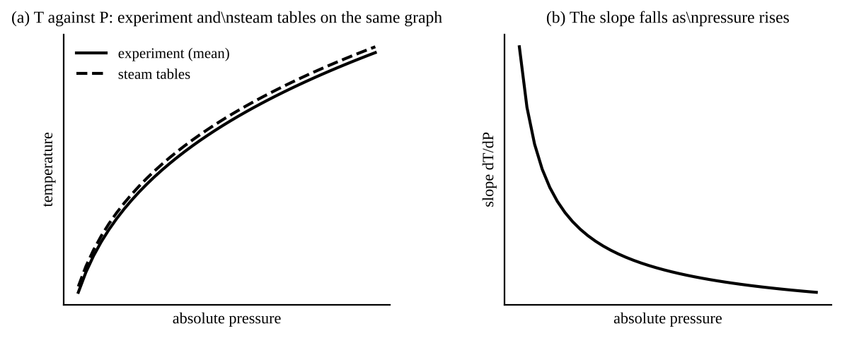
Fig. 2: Expected shapes (sketch only): (a) the measured and steam table curves of temperature against absolute pressure; (b) the slope dT/dP falls as the pressure rises.

7. Discussion
The steam temperature rose with pressure along a curve that is steep at low pressure and flattens at higher pressure, in agreement with the steam tables. The experimental slopes (dT/dP) were [ ], [ ], [ ], [ ] and [ ] K/bar at the five pressures, compared with [ ], [ ], [ ], [ ] and [ ] K/bar from the steam tables (equation 1), a difference of up to [ ] %. The enthalpy of evaporation calculated from the experimental slope was [ ] kJ/kg at [ ] bar, compared with [ ] kJ/kg from the steam tables. The accuracy can be improved by taking more readings at smaller pressure steps, drawing the tangents with care (or fitting a smooth curve through the points on a larger graph or by computer), making sure all the air is removed, allowing the boiler to reach equilibrium before reading, and using a better pressure gauge and thermometer.
1. Is there any discrepancy between the two curves on graph 2? [Yes, a small one, with the experimental temperature [slightly below / above] the steam table values.] The causes are the error in the gauge and the thermometer, air left in the boiler, the thermometer being in a pocket (so it lags behind and measures the metal near the steam and not the steam itself), and the pressure gauge being read from a low-accuracy scale.
2. Is there any discrepancy between the temperatures at corresponding pressures during heating and cooling? [Yes, a small one.] While heating, the thermometer lags behind the true steam temperature (so it reads slightly low), and while cooling it lags in the other way (reads slightly high), because the boiler wall, water and thermometer pocket take time to follow the changes. Heat also leaks through the lagging, and the pressure is not changing in a perfectly steady way. The mean of the two readings reduces this error.
3. What will be the effect of any air left in the boiler? The gauge pressure is then the sum of the pressure of the steam and the partial pressure of the air (Dalton's law of partial pressures), so for a given temperature the pressure reads higher than the steam alone would give. The temperature at a given pressure is therefore lower than the saturation temperature for that pressure, and the experimental curve falls below the steam table curve. The slope and h_{fg} calculated from it are also wrong. This is why the valve is left open at the start to let steam drive the air out.

8. Conclusion
The saturation temperature of steam was found to rise with the pressure, from about [ ] °C at atmospheric pressure to [ ] °C at 15 bar, in agreement with the steam tables, with a slope dT/dP that falls as pressure rises. The Clausius-Clapeyron equation was used to calculate the enthalpy of evaporation, giving h_{fg} = [ ] kJ/kg at [ ] bar (steam table value [ ] kJ/kg). Practical applications: design and operation of steam boilers, pressure cookers and autoclaves (higher pressure gives a higher boiling temperature), steam turbines and power plants, refrigeration, and the calculation of heat requirements for evaporation and distillation.

Section D: Questions
1. What have I gained from this experiment? How the boiling temperature of water depends on pressure, and how the Clausius-Clapeyron equation gives the enthalpy of evaporation.
4. Comment on the experimental procedure (accuracy and time saving) Simple, but it takes time for the boiler to heat and cool, and the thermometer lags behind the steam temperature.
5. Most difficult aspect of the experiment and how to reduce it Driving all the air out and drawing accurate tangents to the curve; reduced by running steam long enough and using a large graph.
6. Another method / apparatus that could be used A pressure transducer and a thermocouple inside the steam space with a data logger, for more accurate and continuous readings.
7. Parameters required in this experiment Gauge and absolute pressure, steam temperature, slope dT/dP and enthalpy of evaporation h_{fg}.
8. One measuring instrument / gauge used Pressure gauge (Bourdon) and thermometer, with a barometer for atmospheric pressure.
9. Practical relevance / applications Steam boilers, pressure cookers, autoclaves, steam turbines and refrigeration.
10. Section of the course it relates to Thermodynamics (properties of steam).
14. What interested me most That the boiling temperature rises with pressure, but by less and less per bar as the pressure gets higher.
2, 3, 11, 12, 13 and 15 (personal): to be filled in by you.
16. References (keep only the ones you actually used): Mechanical Engineering Laboratory Manual ELA 301; a fluid mechanics or theory of machines textbook of your course.

