Mechanical Engineering Laboratory ELA 301
AM317: UNIVERSAL GOVERNOR APPARATUS
Name: [your name] Matric No: [ ] Group: [ ] Date: [ ]
Objectives: (i) To determine the characteristics of sleeve position against controlling force and speed. (ii) To obtain the graph of radius of rotation against force. (iii) To obtain the graph of governor speed against sleeve displacement. (iv) To obtain the governor characteristic, i.e. controlling force against radius of the ball centre, for the Watt, Porter, Proell and Hartnell governors.

1. Theory

Function of a governor
The function of a governor is to keep the mean speed of an engine nearly constant when the load changes. If the load increases, the speed falls and the fuel supply must be increased to bring the speed back; if the load decreases, the speed rises and the fuel supply must be reduced. The governor does this automatically by moving a sleeve that is connected to the fuel (or throttle) control. Governors are classified as centrifugal governors, which balance the centrifugal force of rotating balls against an equal and opposite radial force called the controlling force, and inertia governors, in which the balls respond to the angular acceleration of the spindle as well as to centrifugal force. This experiment deals with centrifugal governors, which are of two kinds: gravity-controlled (Watt, Porter, Proell) and spring-controlled (Hartnell).

Controlling force and the governor characteristic
A ball of mass m rotating at radius r with angular velocity ω needs a radial inward force to stay on its circle. This is the controlling force, and it is equal to the centrifugal force at equilibrium:
F_c = m ω² r
The angular velocity follows from the speed N in rpm:
ω = 2πN / 60
The manual writes F_c = (W/g) ω² r with W the ball weight in kg. Since the balls are weighed in kg, W is their mass, so use F_c = W ω² r with r in metres, which gives newtons. The graph of F_c against r is the governor characteristic or controlling force curve. Its shape decides the stability of the governor (Figure 1). For a straight line F_c = a r ± b:
- b = 0 (line through the origin): the governor is isochronous, meaning it has the same equilibrium speed at every radius, and so cannot settle in one position.
- line cuts the force axis below the origin (F_c = a r − b): the governor is stable, since the controlling force grows faster than the centrifugal force as the radius increases.
- line cuts the force axis above the origin (F_c = a r + b): the governor is unstable.
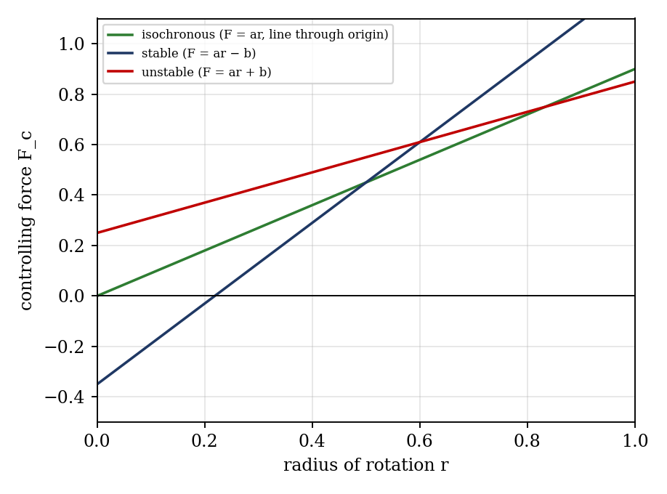
Figure 1: Controlling force curves for stable, isochronous and unstable governors

Watt governor
The Watt governor is the simplest centrifugal governor: a conical pendulum with two balls on arms of length L pivoted on the spindle, with links attached to a sleeve, all of negligible weight except the balls (Figure 2). The arm pivots are 50 mm from the spindle axis, so the radius of rotation and the height are
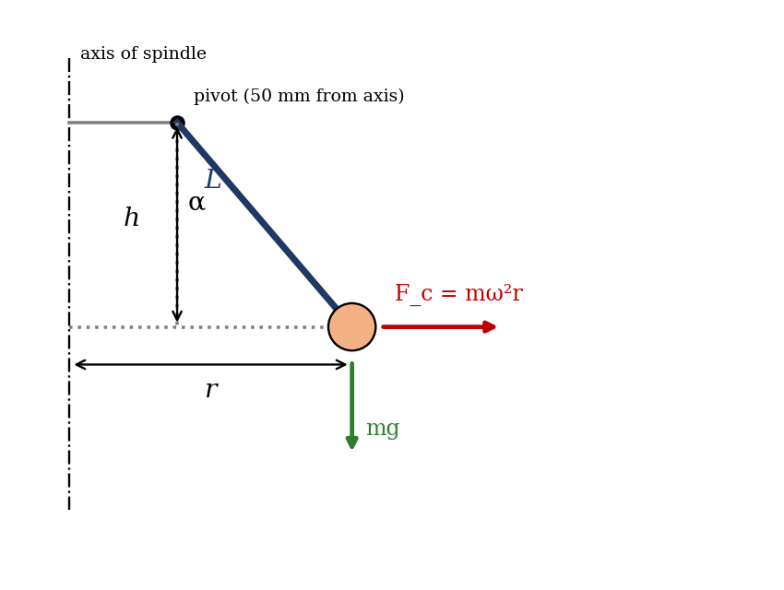
Figure 2: Geometry of the Watt governor and the forces on a ball
h = h₀ − x/2 cos α = h/L r = 50 + L sin α
where x is the sleeve displacement, h₀ the initial height and α the inclination of the arm to the vertical. Moments of the ball’s weight and centrifugal force about the pivot give tan α = F_c/(mg). For an ideal conical pendulum with the pivot on the axis, this reduces to h = g/ω² (about 895/N² metres), which shows that the height changes little at high speed, so the Watt governor is insensitive and suited only to low speeds.

Porter governor
The Porter governor adds a heavy central load M on the sleeve to the Watt design. The extra downward force means a higher speed is needed to lift the balls to a given height, and for a given sleeve movement the speed change is smaller, which improves sensitivity. For arm and link angles α and β, with q = tan β / tan α, the controlling force is
F_c = [ m g + (M g/2)(1 + q) ] tan α
and for equal arms with q = 1, N² = ((m + M)/m) × (895/h), with h in metres. The Porter governor can be made more sensitive by a heavier central load.

Proell governor
The Proell governor is like the Porter governor, with a heavy central load, but the balls are carried on extensions of the lower arms instead of at the junction of the upper and lower arms. The balls are therefore at a larger radius and move through a larger distance for the same sleeve displacement, which makes the governor highly sensitive: a large sleeve movement occurs for a very small change in speed. The force balance is taken by moments about the instantaneous centre of the lower arm. The apparatus uses half-ball flyweights on each side to make up the ball mass.

Hartnell governor
The Hartnell governor is spring-loaded. Two bell-crank levers pivot on the frame, which rotates with the spindle. Each lever has a ball on its vertical arm (length a) and a roller on its horizontal arm (length b); a helical spring in compression gives equal downward force on the two rollers through the sleeve. The controlling force comes mainly from the spring, so the speed can be set by adjusting the spring. Neglecting the weights of the balls and levers about the pivot, and when the arms are vertical and horizontal, taking moments about the pivot:
F_c × a = (S/2) × b so F_c = (b / 2a) S
where S is the total downward force on the sleeve (spring force plus sleeve weight). For a sleeve lift x, the ball radius changes by Δr = (a/b) x, and the spring stiffness is s = ΔS/Δx. Because the spring stiffness fixes the controlling force, the Hartnell governor works at higher speeds than the others and can be made stable or isochronous by choosing the initial compression and stiffness.
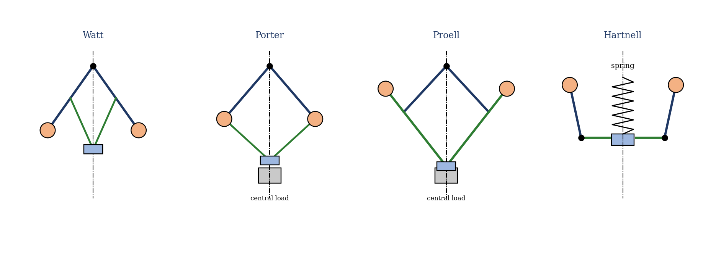
Figure 3: Schematic of the four governors (not to scale)

Sensitiveness, stability and effort
Sensitiveness measures how much the sleeve moves for a given speed change, usually expressed as the ratio of the speed range to the mean speed:
Sensitiveness = (N₂ − N₁) / N = 2(N₂ − N₁) / (N₁ + N₂)
where N₁ and N₂ are the minimum and maximum speeds for the full sleeve travel. Stability means that there is one equilibrium speed for each sleeve position. A governor that is too sensitive tends to hunt, that is, to overshoot and oscillate about the mean speed. Governor effort is the average force exerted at the sleeve for a given change in speed, and is greater for governors with larger sleeve loads such as the Porter, Proell and Hartnell.

2. Apparatus
The universal governor apparatus (AM317) consists of a motor-driven vertical spindle on which the governor mechanism is mounted, a control panel (motor speed control and a digital rpm meter), a scale for the sleeve displacement, and interchangeable parts (arms, links, sleeves and weights) so that the Watt, Porter, Proell and Hartnell governors can be assembled. The upper sleeve is removed with a 16–17 mm spanner to change the governor. See Figure 3 for the four arrangements.
Data | Watt | Porter | Proell | Hartnell
Length of each link, L (mm) | 125 | 125 | 125 | a = 75, b = 121*
Initial height h₀ (mm) | 95 | 95 | 95 | —
Initial radius r₀ (mm) | 132 | 132 | 130 | 165
Weight of each ball (kg) | 0.328 | 0.328 | 0.328 | —
Weight on sleeve (kg) | — | [ ] | 0.280 | 0.712 / 0.220
Free height of spring (mm) | — | — | — | 132
*The manual prints the horizontal arm as 12.1 mm; this looks like a misprint for 121 mm. Confirm on the apparatus.

3. Results
Procedure followed: the governor was assembled on the spindle with the correct linkage, the panel was switched on and the motor speed was increased gradually. After the speed had stabilized, the sleeve displacement x and the speed N were recorded for five speeds for each governor. The initial compression of the Hartnell spring was measured first.
Experiment 1: Watt governor
S/No | N (rpm) | x (mm)
1
2
3
4
5

Experiment 2: Porter governor
S/No | N (rpm) | x (mm) | W (kg)
1
2
3
4
5

Experiment 3: Proell governor
S/No | N (rpm) | x (mm) | W (kg)
1
2
3
4
5

Experiment 4: Hartnell governor
S/No | N (rpm) | x (mm) | W (kg)
1
2
3
4
5

Derived results (one table for each governor):
S/No | h (m) | α (°) | r (m) | ω (rad/s) | F_c (N) | Remarks
1
2
3
4
5

4. Analysis of Results
For the Watt, Porter and Proell governors (L = 125 mm), for each reading:
- Height: h = h₀ − x/2 (convert to metres).
- Angle: cos α = h/L, so α = [ ]°.
- Radius: r = 50 + L sin α (mm), then convert to metres.
- Angular velocity: ω = 2πN/60.
- Controlling force: F_c = m ω² r, with m = 0.328 kg.
For the Hartnell governor, r = r₀ + (a/b)x, then ω and F_c as above; compare F_c with (b/2a)S from the spring.
As a check on your Watt readings, the table below gives the values expected from the equations when the pivot geometry is as in the manual (an illustration, not experimental data). For a ball of mass 0.328 kg it uses tan α = (r − 50)/h and ω² = g tan α / r.
x (mm) | h (mm) | α (°) | r (mm) | N (rpm) | F_c (N)
0 | 95.0 | 40.5 | 131 | 76 | 2.75
10 | 90.0 | 43.9 | 137 | 79 | 3.10
20 | 85.0 | 47.2 | 142 | 83 | 3.47
30 | 80.0 | 50.2 | 146 | 86 | 3.86
40 | 75.0 | 53.1 | 150 | 89 | 4.29

Sensitiveness for each governor: 2(N₂ − N₁)/(N₁ + N₂) = [ ].

5. Observations and Precautions
Observations
- The sleeve rises as the speed increases, and falls when the speed is reduced.
- The Hartnell governor operates at a much higher speed than the others for the same sleeve movement.
- The Proell governor shows a large sleeve displacement for a small change in speed.
Precautions
- Increase the speed gradually and let it stabilize before reading x and N.
- Fit the governor and linkage correctly, with the spanner, and check that all the parts move freely before switching on.
- Keep clear of the rotating parts and use the guard.

6. Graphs
- Controlling force F_c against radius of rotation r (for each governor).
- Speed N against sleeve displacement x (for each governor).
- Height h against speed N for the Watt governor.
Plot the four governors on the same axes where possible, to compare them.

7. Discussion
Sources of error: reading the sleeve scale and the digital speed to the resolution of the instrument (about ±1 mm and ±1 rpm); the sleeve not settling because of friction in the links and the sleeve guide, so x depends on the direction of approach; the pivot offset and link lengths not being exact; and speed fluctuation from the motor. Friction makes the sleeve ‘sticky’, so the readings for rising and falling speed differ. A few percent difference between calculated and theoretical values would be within these limits. [Add your own comparison.]
Governor | Controlling force | Sensitiveness | Typical use
Watt | Gravity (ball weight only) | Low, because height changes little at high speed | Low speed only
Porter | Gravity plus central load | Better than Watt | Medium speed
Proell | Gravity plus central load, balls on extended arms | Highest of the gravity types | Where high sensitivity is needed
Hartnell | Spring force | Adjustable by spring | High speed, compact, e.g. engines

Answer the questions in the manual: compare your F_c–r graphs with Figure 1 to say whether each governor is stable, isochronous or unstable, and say which has the greatest sleeve movement for a given speed change.

8. Conclusion
The four governors were run and their characteristics plotted. The Watt governor is simple but insensitive and works only at low speed; the Porter governor, with a central load, is more sensitive and runs faster; the Proell governor, with balls on the lower-arm extensions, is the most sensitive of the gravity types; and the Hartnell governor uses a spring and works at high speed with an adjustable characteristic. [Add which were stable and your measured sensitiveness.] Centrifugal governors are used to hold the speed of steam engines, engines and turbines.

Section D: Questions
- What have you gained from this experiment? [ ]
- What role did you play during the experiment? [ ]
- Could you have performed this experiment all by yourself? YES / NO. Reason: [ ]
- Comment on the experimental procedure for accuracy of results and time saving. [ ]
- Most difficult aspect and suggestions for reducing it: [ ]
- Other methods or apparatus for the same experiment: [ ]
- Parameters required: ball mass, link length, initial height and radius, sleeve load, spring data (Hartnell), N and x.
- One measuring instrument discussed: [ ]
- Practical relevance: speed control of engines, turbines and generators.
- Section of your course this experiment best relates: Dynamics of Machines (governors).
- Suggestions you made while carrying out the experiment: [ ]
- Suggestions by group members that helped the group: [ ]
- Did you put down the results at the time, or copy from group members? YES / NO. Reason: [ ]
- What interested you most during the experiment: [ ]
- Did you come to the laboratory with the laboratory manual? YES / NO. Reason: [ ]
- References: [list books/journals consulted, e.g. Theory of Machines by C. S. Sharma and K. Purohit; Laboratory Manual ELA 301]

