Mechanical Engineering Laboratory ELA 301
AM318: TORSIONAL OSCILLATION
Name: [your name] Matric No: [ ] Group: [ ] Date: [ ]
Objective: To find the modulus of rigidity of a rod (1) statically and (2) dynamically.

1. Theory

Torsion of a circular rod
When a torque T is applied to the free end of a circular rod of length L whose other end is fixed, the rod twists through an angle θ. A line on the surface that was straight along the rod becomes a helix, and the surface layer is sheared through an angle γ (Figure 1). For small angles, the arc travelled by a point at radius r on the end face is rθ, so
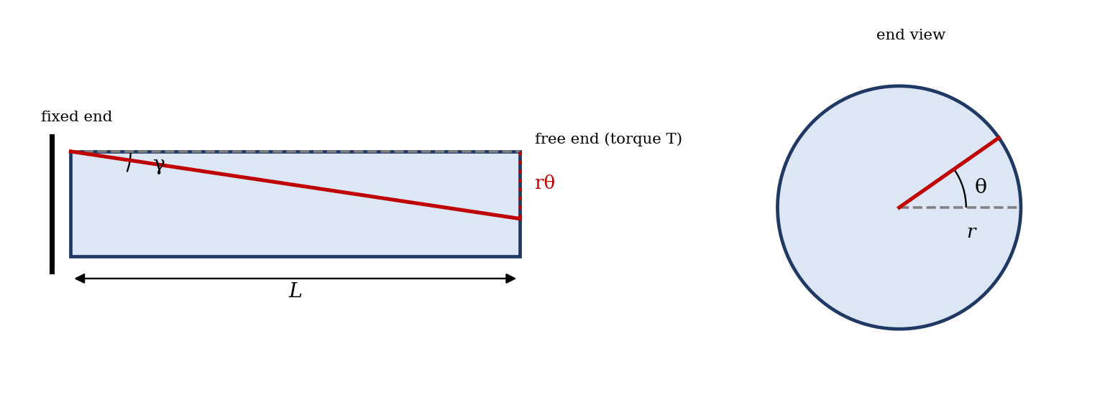
Figure 1: Twisting of a circular rod under torque
γ = r θ / L
For an elastic material the shear stress is proportional to the shear strain, with the modulus of rigidity G as the constant:
τ = G γ = G r θ / L
Consider a thin ring of radius r and thickness dr. The shear force on it is τ × 2πr dr, and its moment about the axis is this force multiplied by r. Adding up all the rings from the centre to the outer radius R = d/2 gives the total torque:
T = ∫ τ · 2πr² dr = (2πGθ/L) ∫₀ᴿ r³ dr = G θ π d⁴ / (32 L)
The polar second moment of area of a solid circular section is J = π d⁴/32, so
T / J = G θ / L = τ / r
This is the torsion equation. It shows that, for a given rod, the angle of twist is proportional to the torque, and that the torsional stiffness (torque per unit angle) is
c = T / θ = G J / L
Because J depends on d⁴, a 1% error in the diameter produces a 4% error in G. This is why the diameter must be measured with special care.

Static method
A pure couple is applied to the disc by placing equal loads W on the two hangers, which are on opposite sides of the disc. If the distance between the two cords is D, the torque is
T = W g D
Plotting θ (in radians) against T for a fixed length L gives a straight line, whose gradient is L/(GJ). The modulus of rigidity is therefore
G = L / (J × gradient) = 32 L / (π d⁴ × gradient)

Dynamic method
If a disc of moment of inertia I is fixed to the end of the rod, twisted and released, it oscillates. The restoring torque is cθ and the equation of motion is
I d²θ/dt² = − c θ
This is simple harmonic motion, with period
t = 2π √(I / c) = 2π √(I L / G J)
Squaring gives t² = (4π² I / G J) L, so a plot of t² against L is a straight line through the origin with gradient 4π²I/(GJ). The disc has moment of inertia I = M R²/2, where M is its mass and R its radius, and the mass of the rod is neglected. Then
G = 4π² I / (J × gradient) = 128 π I / (d⁴ × gradient)
The mass of the disc can be found from its dimensions and the density of steel, or by weighing. The period is found by timing a number of oscillations (say 20) and dividing, which reduces the timing error.

2. Apparatus
A selection of steel, brass and aluminium rods of different lengths and diameters, a disc to fix to the rod, a clamp at the fixed end, pulleys, cords, hangers and weights for the static method, a micrometer screw gauge for the diameter, a metre rule for the length, and a stop clock for the period (Figure 2).
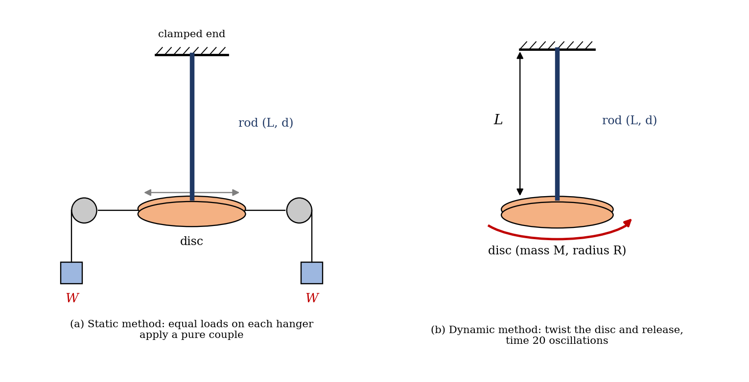
Figure 2: (a) Static and (b) dynamic arrangements for the torsion experiment
Quantity | Symbol | Value
Material of rod | — | [ ]
Mean diameter of rod (mm) | d | [ ]
Mass of disc (kg) | M | [ ]
Radius of disc (mm) | R | [ ]
Distance between the two cords (mm) | D | [ ]

3. Results
Diameter of rod, measured with the micrometer at six places spiralling along the length:
Reading | 1 | 2 | 3 | 4 | 5 | 6
d (mm)
Mean diameter d = [ ] mm.

Static method: length of rod L = [ ] mm.
S/No | Load W per hanger (kg) | Torque T = W g D (N·m) | Angular displacement θ (rad)
1
2
3
4
5

Dynamic method: time for 20 oscillations.
S/No | Length L (m) | Time for 20 oscillations (s) | Period t (s) | t² (s²)
1
2
3
4
5

4. Analysis of Results
- Polar moment of area: J = π d⁴/32 = [ ] m⁴.
- Static method: gradient of the θ–T graph = [ ] rad/(N·m), so G = L/(J × gradient) = [ ] N/m².
- Moment of inertia of the disc: I = M R²/2 = [ ] kg m².
- Dynamic method: gradient of the t²–L graph = [ ] s²/m, so G = 4π²I/(J × gradient) = [ ] N/m².
- Percentage difference from the handbook value: (G_measured − G_handbook)/G_handbook × 100% = [ ]%.
As a check, with sample values (steel rod d = 3 mm, L = 0.5 m, G = 80 GPa; disc M = 1 kg, R = 50 mm; D = 0.1 m), J = 7.95 × 10⁻¹² m⁴ and the stiffness c = GJ/L = 1.27 N·m/rad. A load of 0.1 kg per hanger gives T = 0.098 N·m and θ = 0.077 rad (4.4°), and the period is t = 2π√(I/c) = 0.20 s, so 20 oscillations take about 3.9 s. These are illustrations from the equations, not experimental data.

5. Observations and Precautions
Observations
- The angular displacement increases in proportion to the applied torque, as long as the loads are small.
- The period of oscillation increases with the length of the rod.
- The oscillations die down slowly because of friction at the clamp and air resistance.
Precautions
- Measure the diameter at several places and in two directions, with the micrometer, because G depends on d⁴.
- Keep the angle of twist small, so that the rod stays within the elastic limit, and make sure the rod is firmly clamped at both ends.
- Start the timing at the centre of an oscillation and count whole oscillations; start the oscillation with a small amplitude and with no sideways swing.

6. Graphs
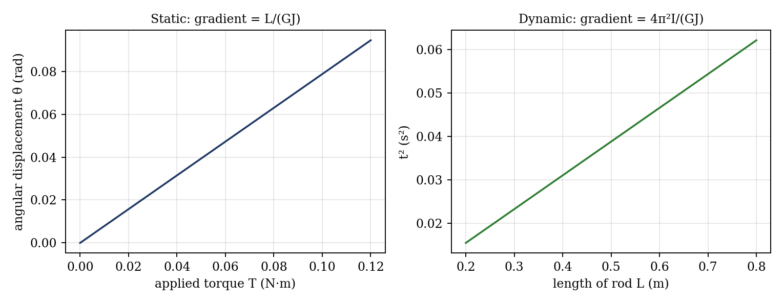
Figure 3: Expected graphs (illustrative, from the equations; not experimental data)
- Angular displacement θ against torque T, for a fixed length L (static method).
- t² against length of rod L (dynamic method).
- [If time permits] repeat for different materials or diameters.

7. Discussion
Sources of error: the diameter enters as d⁴, so a micrometer error of 0.01 mm on a 3 mm rod gives a 1.3% error in G; the diameter may also vary along the rod. In the static method, friction in the pulleys and the difficulty of reading small angles lead to scatter. In the dynamic method, the mass of the rod and the clamp slip are neglected, the disc’s I depends on measured dimensions (an error of 1% in R gives 2% in I), and timing 20 oscillations by hand has an uncertainty of about 0.3 s in 4 s, or about 7% on the period for the sample rod, so a longer total time or a longer rod should be used. Damping slightly lengthens the period. [Compare your G values with the handbook figures, which are about 80 GPa for steel, about 35 to 40 GPa for brass and about 26 GPa for aluminium.]
Which method is more reliable? The dynamic method usually gives the better result, since the rod stays in the elastic range with small twists and friction in pulleys has no effect; the timing error can be reduced by counting many oscillations. The static method has the advantage of being a direct measurement of the torque–twist relationship but is affected by friction and by the difficulty of reading small angles. [State which gave closer agreement in your results.]

8. Conclusion
The modulus of rigidity of the [ ] rod was found as [ ] N/m² by the static method and [ ] N/m² by the dynamic method. These differ from the handbook value by [ ]% and [ ]%. The dynamic method is judged to be more reliable [or: your own conclusion]. The modulus of rigidity is needed in the design of shafts, springs and torsion bars, and the torsional oscillation principle is used in the torsion pendulum and in the design of vibration of shafts.

Section D: Questions
- What have you gained from this experiment? [ ]
- What role did you play during the experiment? [ ]
- Could you have performed this experiment all by yourself? YES / NO. Reason: [ ]
- Comment on the experimental procedure for accuracy of results and time saving. [ ]
- Most difficult aspect and suggestions for reducing it: [ ]
- Other methods or apparatus for the same experiment: [ ]
- Parameters required: rod length and diameter, disc mass and radius, loads and cord distance, angular displacement and period.
- One measuring instrument discussed: the micrometer screw gauge. [Describe: reading, least count, zero error.]
- Practical relevance: design of shafts, springs, torsion bars and vibration of rotating machinery.
- Section of your course this experiment best relates: Strength of Materials (torsion).
- Suggestions you made while carrying out the experiment: [ ]
- Suggestions by group members that helped the group: [ ]
- Did you put down the results at the time, or copy from group members? YES / NO. Reason: [ ]
- What interested you most during the experiment: [ ]
- Did you come to the laboratory with the laboratory manual? YES / NO. Reason: [ ]
- References: [list books/journals consulted, e.g. a strength of materials textbook; Laboratory Manual ELA 301]

