Mechanical Engineering Laboratory ELA 302
AM321A: ACCELERATION OF A GEARED SYSTEM
Name: [your name] Matric No: [ ] Group: [ ] Date: [ ]
Objective: To verify the expression for the equivalent inertia of a geared system.

1. Theory

Equivalent inertia of a geared system
In a gear train, every shaft with its gears, pulleys and attached masses has its own moment of inertia, but the shafts turn at different speeds. For the motion of the whole train, the inertia of all shafts is referred to one shaft (here the driving shaft A), which gives the equivalent inertia I_eq: the single inertia on shaft A that needs the same driving torque to give the same acceleration. This follows from equating the energy of the train to that of the equivalent single shaft, and is derived from the torques as follows.
Consider three gear wheels A, B and C in mesh (Figure 1). Let N₁ be the speed ratio of B relative to A (ω_B/ω_A), and N₂ that of C relative to B (ω_C/ω_B), and let η_AB and η_BC be the gearing efficiencies of the two meshes. Then, for an angular acceleration α_A of shaft A, the shafts B and C have
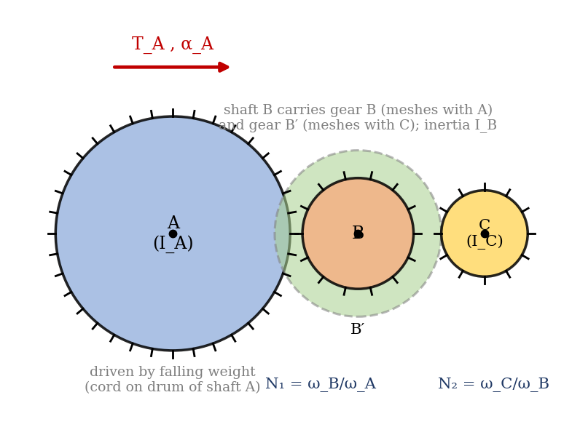
Figure 1: Three shafts in a geared train, driven at shaft A
α_B = N₁ α_A α_C = N₁ N₂ α_A
Working from the last shaft back to the first. The torque needed to accelerate shaft C is T_C = I_C α_C. A gear mesh transmits power with efficiency η, so the torque that must be applied on the driving side is the output torque multiplied by the speed ratio and divided by the efficiency:
T_B(for C) = N₂ T_C / η_BC = N₂ I_C N₁ N₂ α_A / η_BC
The torque on shaft B is the sum of that needed to accelerate B itself and that needed to drive C:
T_B = I_B N₁ α_A + N₁ N₂² I_C α_A / η_BC
Similarly, the torque on shaft A is that needed to accelerate A plus N₁ T_B/η_AB, so
T_A = [ I_A + N₁² I_B / η_AB + (N₁ N₂)² I_C / (η_AB η_BC) ] α_A
The manual prints the last term as (N₁/N₂)² I_C; this is the same result if N₂ is taken as the speed ratio of B relative to C (ω_B/ω_C), the opposite way round to the definition above. The product N₁N₂ is the speed ratio ω_C/ω_A in either case, and the symbols should be checked against your apparatus. The quantity in the square brackets is the equivalent inertia referred to shaft A:
I_eq = I_A + N₁² I_B / η_AB + (N₁ N₂)² I_C / (η_AB η_BC) T_A = I_eq α_A
With perfect gears (η = 1), this reduces to I_eq = I_A + N₁² I_B + (N₁N₂)² I_C. The inertia of a shaft that turns faster than the driving shaft counts for its inertia multiplied by the square of the speed ratio, and divided by the efficiency in a real train, which is why the high-speed shafts contribute most.

Finding the individual inertias and the acceleration
The inertia of each shaft with its associated parts is found by the falling-weight method. A mass m on a cord wrapped round a drum of radius r falls a height h in time t from rest, so its linear acceleration is a = 2h/t² and the angular acceleration of the shaft is α = a/r. The cord tension is m(g − a), and the torque on the shaft, less the friction torque T_f, is I α:
I = [ m (g − a) r − T_f ] / α a = 2h / t² α = a / r
The friction torque T_f is found as m₀ g r from the smallest mass m₀ that keeps the shaft turning at a slow, constant speed.
With the recording unit, the cam on the shaft has n indents (n = 12), and each indent closes the micro-switch to leave a pip mark on the moving chart (paper speed 1 in/s, so a distance in inches is the same as a time in seconds). The time for 1/n of a revolution, t₁, t₂, t₃ …, is read from the spacing of the pip marks (Figure 2), so the average angular velocities are ω₁ = 2π/(n t₁), ω₂ = 2π/(n t₂) …, and these occur at the midpoints of the intervals, which are t₁₂, t₂₃ … apart. The average angular accelerations are
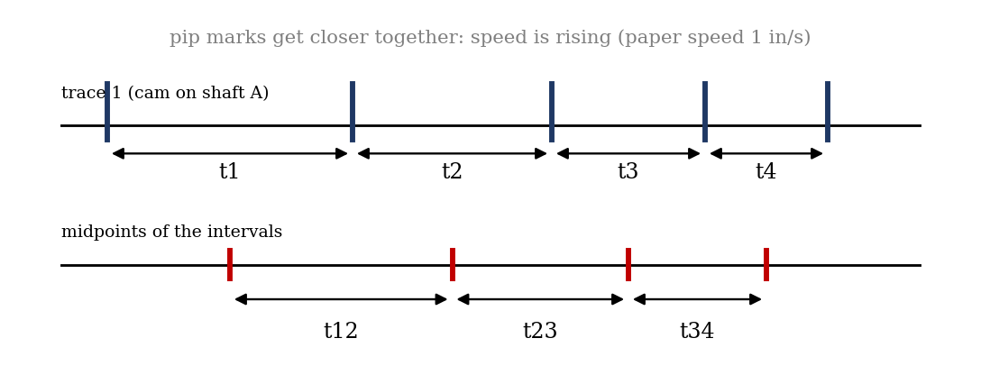
Figure 2: Pip marks on the recorder trace, and the intervals t₁, t₂ … and t₁₂, t₂₃ …
α₁ = (ω₂ − ω₁) / t₁₂ = (2π / n t₁₂)(1/t₂ − 1/t₁)
and similarly α₂ from ω₃ and ω₂ with t₂₃, and so on. The mean of α₁, α₂, α₃ … is used.

2. Apparatus
The apparatus (AM318 acceleration of a geared system) has four parallel shafts, each carrying spur gears and pinions of different sizes, with provision for disengaging any selected pairs of gears. The train is driven by a falling weight on a cord wound on a drum, and extra inertia loads can be added to the shafts. A cam wheel is fitted on each shaft with its pulley, and each cam operates a micro-switch connected to the recorder unit. The recorder has a chart drum driven at a constant speed by a synchronous motor; a high-voltage stylus carried by a lead-screw from the same motor, when the selected micro-switch closes, leaves a pip mark on the trace. Other items: cords, weights, a stopwatch, a metre rule and calipers.
Item | Value
Number of teeth: spur gear on A / pinion on B | 90 / 30
Drum diameter on shaft A | 76.2 mm
Number of indents on the cam, n | 12
Paper speed | 1 in/s

3. Results
Procedure followed: (1) the mechanical efficiencies were found with shafts A and B, A–B and C, and A–B–C and D meshed (see AM321B). (2) The individual inertia of each shaft with its associated parts was found by the falling-weight method. (3) The expected equivalent inertia was calculated from the equation in the theory, and checked from the acceleration recorded.
Table 1: Efficiencies
Meshed shafts | Driving torque T_A (N·m) | Driven torque T_B (N·m) | Efficiency (%)
A and B
A, B and C
A, B, C and D

Table 2: Falling-weight tests for the inertia of each shaft
Shaft | Mass m (kg) | Drop h (m) | Time t (s) | a = 2h/t² (m/s²) | α = a/r (rad/s²) | I (kg·m²)
A
B
C

Table 3: Recorder trace readings
Interval | t (s) | ω (rad/s) | t₁₂ etc. (s) | α (rad/s²)
1
2
3
4

4. Analysis of Results
- Speed ratios from the gear teeth: N₁ = ω_B/ω_A = teeth on A / teeth on pinion B = 90/30 = 3; find N₂ from the teeth of the next pair.
- Individual inertias from Table 2: I = [m(g − a)r − T_f]/α, and r = 38.1 mm for the drum on shaft A (diameter 76.2 mm).
- Expected equivalent inertia: I_eq = I_A + N₁² I_B/η_AB + (N₁N₂)² I_C/(η_AB η_BC), using the efficiencies of Table 1.
- Measured equivalent inertia: I_eq = T_A/α_A, with T_A = (m g − T_f) r, using the mean α from the recorder.
- Percentage difference = (measured − expected)/expected × 100%.
As an illustration (assumed values, not your data): for I_A = 0.0020 kg·m², I_B = 0.0005 kg·m², N₁ = 3 and η_AB = 0.98, I_eq = 0.0020 + 9 × 0.0005/0.98 = 0.0066 kg·m², which is more than three times I_A, although I_B is only a quarter of I_A. This shows how strongly a fast shaft contributes.

5. Observations and Precautions
Observations
- The pip marks become closer together as the train speeds up, showing steady acceleration.
- Adding inertia to a fast shaft reduces the acceleration more than the same inertia on the slow shaft.
Precautions
- Wind the cord evenly on the drum, and avoid it slipping; release the weight without a push.
- Disengage the gears that are not used, and check that the shafts turn freely before each run; use the same chart speed for all readings.

6. Graphs
- [Optional] Angular velocity ω against time from the recorder trace (the slope is α).
- [Optional] Measured against expected equivalent inertia for each gear combination.

7. Discussion
Sources of error: friction in the bearings and gear meshes, which is estimated from the minimum weight to keep the shaft turning but varies with speed; efficiencies assumed constant for each mesh; reading the spacing of the pip marks on the chart to about ±0.5 mm, which for the short intervals at high speed is a few per cent; the stopwatch error in the falling-weight tests, which is largest for short falls (0.3 s in 3 s is 10% in t, and 20% in a); the cord’s own mass and its stretch; and the inertia of the drum and the cord being included in the shaft. [Estimate the size of these for your results, and compare the measured and expected equivalent inertia to show whether the expression is verified within experimental error.]

8. Conclusion
The equivalent inertia of the geared system was found to be [ ] kg·m² from the expression using the measured shaft inertias and efficiencies, and [ ] kg·m² from the recorded acceleration, which agree within [ ]%, so the expression is verified. The result shows that the inertia of fast shafts counts with the square of the speed ratio, which matters in the design of gearboxes, in the choice of flywheels and in the acceleration of machines driven through gear trains.

Section D: Questions
- What have you gained from this experiment? [ ]
- What role did you play during the experiment? [ ]
- Could you have performed this experiment all by yourself? YES / NO. Reason: [ ]
- Comment on the experimental procedure for accuracy of results and time saving. [ ]
- Most difficult aspect and suggestions for reducing it: [ ]
- Other methods or apparatus for the same experiment: [ ]
- Parameters required: gear teeth, drum radius, weights, drop heights and times, and the pip-mark spacing.
- One measuring instrument discussed: the recorder unit (chart drum, cam and micro-switch). [Describe: how it works, accuracy.]
- Practical relevance: gearboxes, vehicle transmissions and the acceleration of machines driven through gear trains.
- Section of your course this experiment best relates: Dynamics of Machines (geared systems and equivalent inertia).
- Suggestions you made while carrying out the experiment: [ ]
- Suggestions by group members that helped the group: [ ]
- Did you put down the results at the time, or copy from group members? YES / NO. Reason: [ ]
- What interested you most during the experiment: [ ]
- Did you come to the laboratory with the laboratory manual? YES / NO. Reason: [ ]
- References: [list books/journals consulted, e.g. Hannah and Stephens, Mechanics of Machines; Laboratory Manual ELA 302]

