Mechanical Engineering Laboratory ELA 302
AM321B: MECHANICAL EFFICIENCY OF A GEAR TRAIN
Name: [your name] Matric No: [ ] Group: [ ] Date: [ ]
Objective: To find the gearing efficiency between shafts A and B (and for the trains with shafts C and D meshed).

1. Theory

Mechanical advantage, velocity ratio and efficiency
A machine transmits a load by an effort. For a gear pair, the effort is the torque on the driving shaft A (T_A) and the load is the torque on the driven shaft B (T_B). The mechanical advantage is the ratio of the load to the effort:
M.A. = Load (torque) / Effort (torque) = T_B / T_A
The velocity ratio is the ratio of the input speed to the output speed, which is fixed by the gear teeth (ω ∝ 1/teeth for meshed gears), so for gears of teeth N_A and N_B:
V.R. = ω_A / ω_B = N_B / N_A
For an ideal pair with no losses, the output power equals the input power, so T_B ω_B = T_A ω_A and M.A. = V.R. In a real pair, friction between the teeth and in the bearings absorbs some power, so the mechanical efficiency is the fraction of the input power that appears at the output:
η = M.A. / V.R. = T_B ω_B / (T_A ω_A) = Power out / Power in
The torques are found from the weights hanging on cords wrapped round drums on the two shafts. With a mass m_A on a drum of radius r_A and m_B on a drum of radius r_B:
T_A = m_A g r_A T_B = m_B g r_B
The effort weight is increased from the balanced (static) condition until the system just starts to move at constant speed. At constant speed there is no angular acceleration, so the effort needed is the load plus the friction in the system. This gives the effort for the actual (lossy) machine, and the ideal effort is smaller, which gives an efficiency below 100%.

Efficiency of several meshes
When three or more shafts are meshed, the power passes through each mesh in turn, and the efficiencies multiply:
η_total = η_AB × η_BC × η_CD
For example, three meshes with an efficiency of 98% each would give 0.98³ = 94%. The overall efficiency therefore falls as more gears are in the train.

2. Apparatus
The AM318 acceleration of a geared system apparatus (Figure 1) is used: parallel shafts A, B, C and D carrying spur gears and pinions that can be meshed in different combinations, with a drum on each of the shafts for the cords and weights, and weight hangers with slotted weights.
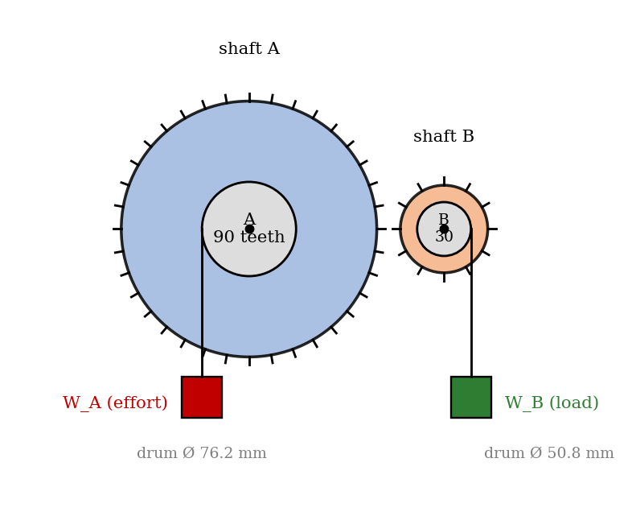
Figure 1: Shafts A and B with cords, drums and weights (schematic)
Shaft assembly | A | B
Number of teeth on spur gear | 90 | —
Number of teeth on pinion | — | 30
Diameter of drum (mm) | 76.2 | 50.8

3. Results
Procedure followed: weights were suspended on cords wrapped round the drums of the respective shafts, and the applied torques were balanced statically. The weight on the effort side was then increased until the system just started to move at constant speed. The weights on both shafts were recorded for each combination of meshed shafts and for several loads.
(a) Shafts A and B in mesh
Reading | 1 | 2 | 3 | 4 | 5 | 6 | 7
Driving torque T_A (N·m)
Driven torque T_B (N·m)
Efficiency (%)

(b) Shafts A, B and C in mesh
Reading | 1 | 2 | 3 | 4 | 5 | 6 | 7
Driving torque T_A (N·m)
Driven torque T_B (N·m)
Efficiency (%)

(c) Shafts A, B, C and D in mesh
Reading | 1 | 2 | 3 | 4 | 5 | 6 | 7
Driving torque T_A (N·m)
Driven torque T_B (N·m)
Efficiency (%)

4. Analysis of Results
- Torques: T_A = m_A g r_A and T_B = m_B g r_B (r = half the drum diameter: r_A = 38.1 mm, r_B = 25.4 mm).
- M.A. = T_B/T_A.
- V.R. = ω_A/ω_B = 30/90 = 0.333 for shafts A and B (from the gear teeth).
- Efficiency η = M.A./V.R. × 100%; take the mean of the readings.
Sample calculation from the manual (A and B in mesh): mass on shaft A = 3.26 kg, and mass on shaft B = 1.60 kg.
M.A. = (1.60 × 9.81 × 0.0508/2) / (3.26 × 9.81 × 0.0762/2) = 0.327
V.R. = 30 / 90 = 0.333 η = 0.327 / 0.333 = 98%
(The manual prints 1.69 in the numerator of this calculation; 1.60 kg is the value that gives 0.327, so 1.69 appears to be a misprint.) The efficiencies for the other combinations are found in the same way, with V.R. from the teeth of all the meshes in the train.

5. Observations and Precautions
Observations
- The effort weight needed to move the train was always larger than the ideal value, because of friction.
- The efficiency fell as more meshes were added to the train.
Precautions
- Check that all traces of oil have been removed from the places before use, where specified, and that the shafts turn freely.
- Increase the weight slowly until the motion just starts, and make sure the speed is constant and slow; wind the cords evenly.

6. Graphs
- [Optional] Driven torque T_B against driving torque T_A for each combination (the slope is the mechanical advantage).
- [Optional] Efficiency against driving torque.

7. Discussion
Factors that influence the value of η. (1) Friction between the gear teeth, which depends on the tooth profile, surface finish, lubrication and the load; (2) friction in the shaft bearings, which is a larger fraction of the power at light loads, so η is lower for small loads; (3) the speed, because friction and churning of the lubricant rise with speed; (4) misalignment and the backlash between the gears; (5) the number of meshes in the train, since the efficiencies multiply; and (6) errors in the experiment: the weights are increased in steps, so the value at which the train ‘just starts to move’ is uncertain by one step, and the drum diameters and the cord thickness affect the radius. Because the torques are found from the weights, a 1% error in the radius of one drum causes 1% error in η. [Give your own estimate of the errors.]

8. Conclusion
The gearing efficiency between shafts A and B was found to be [ ]%, and the efficiencies of the trains with three and four shafts meshed were [ ]% and [ ]%. The efficiency decreased as more gears were meshed. Gear efficiencies of this order (95 to 99% per mesh) are used in the design of gearboxes, where the efficiency of each stage is multiplied, and losses appear as heat that has to be removed.

Section D: Questions
- What have you gained from this experiment? [ ]
- What role did you play during the experiment? [ ]
- Could you have performed this experiment all by yourself? YES / NO. Reason: [ ]
- Comment on the experimental procedure for accuracy of results and time saving. [ ]
- Most difficult aspect and suggestions for reducing it: [ ]
- Other methods or apparatus for the same experiment: [ ]
- Parameters required: weights on the drums, drum diameters, gear teeth and the speeds.
- One measuring instrument discussed: the weight hangers and drums used to apply the torque (or the stopwatch). [Describe.]
- Practical relevance: gearboxes, vehicle transmissions and machine drives where power loss and heat matter.
- Section of your course this experiment best relates: Dynamics of Machines (gears and efficiency).
- Suggestions you made while carrying out the experiment: [ ]
- Suggestions by group members that helped the group: [ ]
- Did you put down the results at the time, or copy from group members? YES / NO. Reason: [ ]
- What interested you most during the experiment: [ ]
- Did you come to the laboratory with the laboratory manual? YES / NO. Reason: [ ]
- References: [list books/journals consulted, e.g. Hannah and Stephens, Mechanics of Machines; Laboratory Manual ELA 302]

