Mechanical Engineering Laboratory ELA 302
AM322: PIVOT FRICTION EXPERIMENT
Name: [your name] Matric No: [ ] Group: [ ] Date: [ ]
Objectives: (1) To obtain the coefficient of friction between the two bearing surfaces of a collar bearing, assuming uniform wear. (2) To investigate the relationship between friction torque T and axial load W, and compare the results with theory. (3) To study the effect of the vertex angle.

1. Theory

Friction in a pivot or collar bearing
A pivot or collar bearing carries an axial load W through an annular bearing surface, of inner radius R₁ and outer radius R₂, and a rotating shaft has to overcome the friction torque of this surface. For a conical surface of semi-angle α (half the included angle), the contact is on the slant, so the area of a ring of radius r and width dr measured along the cone is 2πr dr / sin α (Figure 1). A flat bearing is the case α = 90°, sin α = 1.
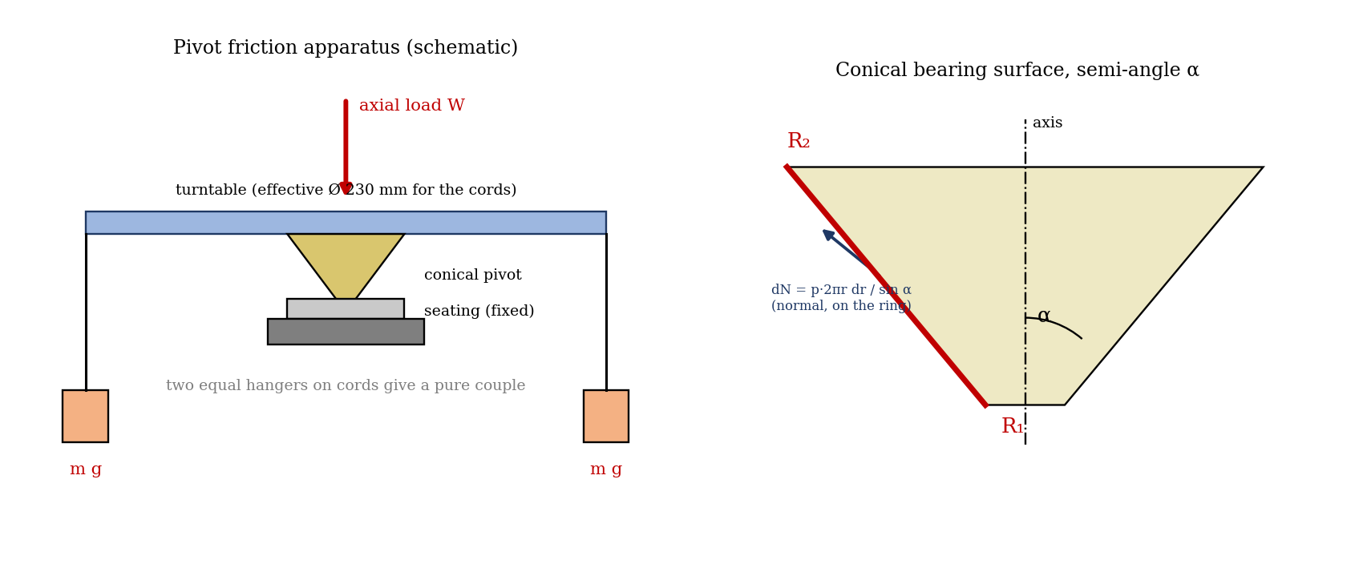
Figure 1: Pivot friction apparatus and the geometry of a conical bearing surface
Let p be the normal pressure on the ring. The normal force is dN = p · 2πr dr / sin α, and its axial component is dN sin α = p · 2πr dr, so the load is W = ∫ p 2πr dr. The friction force is dF = μ dN, and the torque from the ring is dT = r dF = μ p 2πr² dr / sin α.

Uniform wear
In a bearing that has run in, it is assumed that the wear is uniform, which means that the wear rate (proportional to pressure × sliding speed, which is proportional to p r) is the same everywhere, so p r = C is a constant. Then W = 2πC (R₂ − R₁), so C = W/[2π(R₂ − R₁)], and integrating the torque:
T = ∫ μ C 2πr dr / sin α = μ W (R₁ + R₂) / (2 sin α)
This is the expression used in the manual. For a given bearing, T is proportional to W, so a graph of T against W is a straight line through the origin, with gradient
T / W = μ (R₁ + R₂) / (2 sin α) so μ = 2 sin α × (gradient) / (R₁ + R₂)
For the flat pivot, α = 90°, so the gradient gives μ directly. For a constant axial load, the torque is proportional to 1/ sin α: the smaller the cone angle, the larger the friction torque, since the wedge action raises the normal force on the surface for the same axial load. A graph of T (at a fixed W) against 1/ sin α should therefore be a straight line through the origin.

Uniform pressure (the alternative assumption)
If the pressure is uniform instead (a new bearing), p = W/[π(R₂² − R₁²)], and
T = (2/3) μ W / sin α × (R₂³ − R₁³) / (R₂² − R₁²)
For a narrow bearing (R₂ close to R₁) the two expressions are almost equal. For a bearing with a small R₁, uniform pressure gives a larger torque (for R₁ = 0, T = 2μWR₂/3 against μWR₂/2 for uniform wear), because the pressure is greater at the outside, where the friction has a longer arm. This answers the question posed in the manual.

2. Apparatus
The pivot friction apparatus has four pairs of pivots in brass (BS 249) and mild steel (EN1A), with included angles of 60°, 90°, 120° and 180° (flat), and a ball thrust bearing set. The pivot is carried on a turntable that is loaded axially with weights and is turned by a pure couple from two equal weights on cords over the turntable, whose effective diameter (the arm of the couple) is 230 mm. The mean diameter of the pivots (and of the ball thrust bearing) is 30 mm. Check that all traces of oil have been removed from the bearing surfaces before use.
Item | Value
Effective diameter of the turntable (cords), D | 230 mm
Mean diameter of the pivots (R₁ + R₂ = 30 mm) | 30 mm
Minimum and maximum radii R₁ and R₂ | [ ] and [ ] mm
Included angles of the pivots | 60°, 90°, 120°, 180°

3. Results
Procedure followed: the minimum and maximum radii of the bearing surfaces were measured. A series of increasing axial loads was applied to the turntable, and for each, the torque needed to balance the friction torque was found by adding equal weights m to the cord hangers until the turntable rotated at a slow, constant speed. The torque is T = m g D, for two hangers each of mass m (a pure couple). The test was repeated for each cone angle, and for the ball thrust bearing.
Pivot angle (included): [ ]°; semi-angle α = [ ]°; R₁ = [ ] mm; R₂ = [ ] mm.
No. | Axial load W (N) | Hanger mass m (kg each) | Torque T = m g D (N·m) | Theoretical T (N·m)
1
2
3
4
5
6
Repeat the table for each pivot angle (60°, 90°, 120°, 180°) and for the ball thrust bearing.

4. Analysis of Results
- Plot T against W for the flat pivot (α = 90°) and find the gradient; μ = 2 × gradient/(R₁ + R₂) (with sin α = 1).
- For each cone, calculate the theoretical torque T = μ W (R₁ + R₂)/(2 sin α) using this μ, and plot the experimental and theoretical torques against W on the same graph.
- For a convenient W, take the experimental torque from each graph and plot it against 1/ sin α; this should be a straight line through the origin.
- Compare the friction torque of the ball thrust bearing with that of the flat collar bearing.
As a check, for assumed values μ = 0.15 and a mean radius of 15 mm, and a load of W = 50 N, the expected torque is T = μ W R/ sin α. Each hanger would then have a mass of about 50 g for the flat pivot (T = m g D with D = 0.23 m). This is an illustration, not your data.
Included angle | α | 1 / sin α | T at W = 50 N (N·m)
180° (flat) | 90° | 1.00 | 0.113
120° | 60° | 1.15 | 0.130
90° | 45° | 1.41 | 0.159
60° | 30° | 2.00 | 0.225

5. Observations and Precautions
Observations
- The friction torque increased in proportion to the axial load for each pivot, and it was larger for the sharper cones.
- The ball thrust bearing needed a far smaller torque than the plain pivot.
Precautions
- Clean all the bearing surfaces of oil before use, and let the turntable settle; use the same slow constant rotation (not accelerating) when the balancing torque is read.
- Add the hanger weights slowly in small steps, and keep the cords level; read the weights without the turntable swinging.

6. Graphs
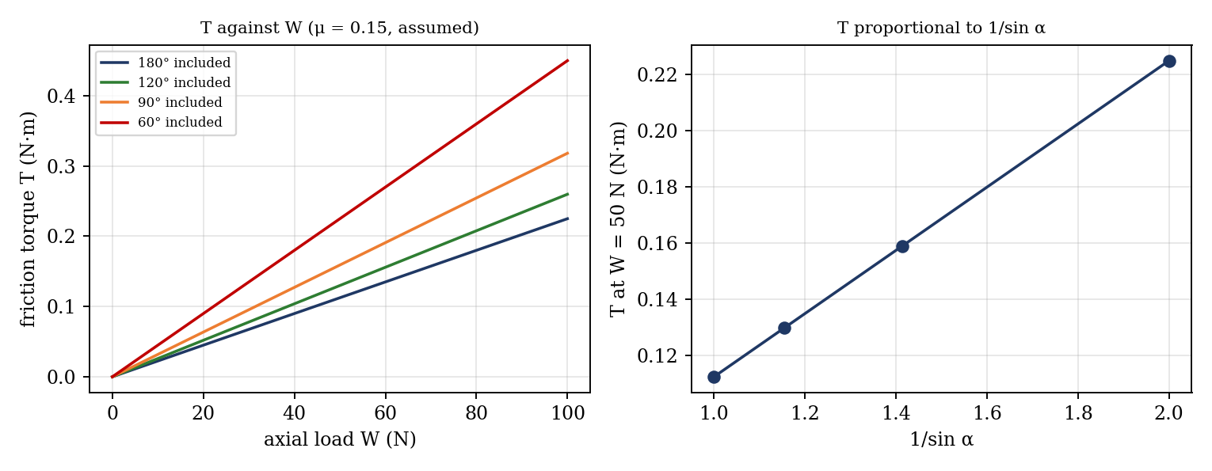
Figure 2: Expected graphs (illustrative, from the equations; not experimental data)
- Friction torque T against axial load W for each pivot (straight lines through the origin).
- Experimental and theoretical torque against W, for each cone, on the same axes.
- T (at a fixed load) against 1/ sin α.

7. Discussion
Sources of error: the pivots are not run in uniformly, so the uniform-wear assumption is approximate (a new pivot is closer to uniform pressure); the measured radii R₁ and R₂ have an error of about ±0.2 mm, and a small difference between them gives a large relative error; the torque is judged when the turntable just rotates, so static and kinetic friction are mixed, and the answer depends on the step size of the weights; the cords add friction on the pulleys and their own weight; the oil film left on the surfaces lowers μ; and the pivots of different angle have slightly different surface finishes. [Compare your μ from the flat pivot with the others and say whether T ∝ W and T ∝ 1/ sin α hold.]
The ball thrust bearing has much less friction because rolling friction occurs in it, while in the plain bearing sliding friction has to be overcome. The question about uniform pressure is answered in the theory: the torque would be (2/3) μ W (R₂³ − R₁³)/[(R₂² − R₁²) sin α], which is larger than the uniform wear value for a wide bearing.

8. Conclusion
The friction torque of the pivots was found to be proportional to the axial load, giving a coefficient of friction of [ ] for the brass and mild steel surfaces. For a given load, the torque increased as the cone angle decreased, in agreement with T ∝ 1/ sin α to within [ ]%. The ball thrust bearing had a much lower friction torque than the plain bearing. The results are used in the design of pivot and thrust bearings, clutches and brakes.

Section D: Questions
- What have you gained from this experiment? [ ]
- What role did you play during the experiment? [ ]
- Could you have performed this experiment all by yourself? YES / NO. Reason: [ ]
- Comment on the experimental procedure for accuracy of results and time saving. [ ]
- Most difficult aspect and suggestions for reducing it: [ ]
- Other methods or apparatus for the same experiment: [ ]
- Parameters required: axial load, hanger masses, turntable diameter, bearing radii R₁ and R₂ and the cone angle.
- One measuring instrument discussed: [ ]
- Practical relevance: pivot and thrust bearings, step bearings and cone clutches.
- Section of your course this experiment best relates: Dynamics of Machines (friction in bearings).
- Suggestions you made while carrying out the experiment: [ ]
- Suggestions by group members that helped the group: [ ]
- Did you put down the results at the time, or copy from group members? YES / NO. Reason: [ ]
- What interested you most during the experiment: [ ]
- Did you come to the laboratory with the laboratory manual? YES / NO. Reason: [ ]
- References: [list books/journals consulted, e.g. a theory of machines textbook; Laboratory Manual ELA 302]

