Mechanical Engineering Laboratory ELA 302
AM323: PLATE CLUTCH FRICTION EXPERIMENT
Name: [your name] Matric No: [ ] Group: [ ] Date: [ ]
Objectives: (1) To investigate the relationship between friction torque T and the axial load W applied to a single plate clutch. (2) To obtain the coefficient of friction between the two rubbing surfaces, assuming uniform wear. (3) To verify that the friction torque is proportional to the mean radius of the friction disc.

1. Theory

The single plate clutch
A plate clutch transmits torque between two rotating shafts through the friction between a friction disc (a ring of lining material, such as Ferodo) and a steel plate, which are pressed together by an axial force W. The friction disc is an annulus of inner radius R₁ and outer radius R₂ (Figure 1). The torque that it can transmit before slipping is the friction torque.
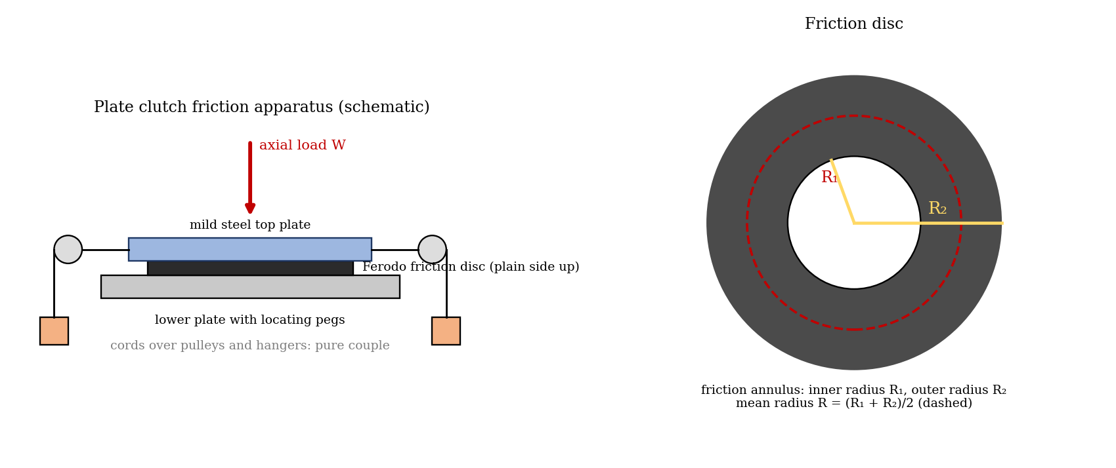
Figure 1: Plate clutch apparatus and the friction disc (schematic)

Friction torque for uniform wear
Take a ring of radius r and width dr on the disc. If p is the pressure on it, the normal force is dN = p · 2πr dr, and the friction torque contributed by the ring is dT = μ dN · r = μ p 2πr² dr. For a clutch that has worn in, the wear is uniform, which means that p r = C is constant, so the load is W = ∫ p 2πr dr = 2πC (R₂ − R₁). Therefore C = W/[2π(R₂ − R₁)] and
T = ∫ μ C 2πr dr = π μ C (R₂² − R₁²) = μ W (R₁ + R₂) / 2 = μ W R
where R = (R₁ + R₂)/2 is the mean radius of the disc. This has three consequences: (a) for a given disc, T is proportional to W, so a graph of T against W is a straight line through the origin; (b) the gradient is T/W = μ R, which gives μ; (c) for a fixed W and coefficient of friction, T/R = μ W is constant, so the torque is proportional to the mean radius R of the disc. In this experiment, the axial load W includes the weight of the top plate.

Uniform pressure
For a new clutch, the pressure is more nearly uniform, and the torque is T = (2/3) μ W (R₂³ − R₁³)/(R₂² − R₁²). This is slightly larger than μ W R when R₁ is much smaller than R₂, and for a narrow ring the two are almost the same, so the uniform wear assumption is usually the safer basis for design (it gives the lower torque capacity).

Measuring the torque
A pure couple is applied to the top plate by two equal weights m on cords over pulleys, with the effective diameter D of the top plate as the arm. When the plate turns at a very slow, steady speed, the applied torque just balances the friction torque:
T = m g D

2. Apparatus
The plate clutch friction apparatus has a mild steel top plate that is loaded axially with weights, a lower plate with locating pegs that holds the friction disc, three Ferodo friction discs of different sizes, and cords with hangers over pulleys on the top plate to apply the pure couple. Check that all traces of oil are removed from the machined surfaces before fitting the Ferodo disc (plain side up), and never allow the machined surface of the top plate to come into direct contact with the locating pegs fitted in the lower plate.
Item | Value
Effective diameter of the mild steel top plate, D | [ ] mm
Weight (mass) of the top plate | [ ] kg
Mean radii of the three discs, R | [ ], [ ], [ ] mm

3. Results
Procedure followed: the effective diameter and weight of the top plate were measured, and the inner and outer radii of the three Ferodo discs were measured, giving the mean radius of each. The largest disc was located concentrically, the cords and hangers were put over the pulleys to apply a pure couple, and a series of increasing axial loads was added to the top plate. The torque needed to balance the friction torque was found for each, when the top plate rotated at a very slow constant speed (the same for each load, checked by timing a revolution of one of the cord pulleys). The procedure was repeated for the other two discs.
Disc: [ ]; R₁ = [ ] mm; R₂ = [ ] mm; mean radius R = [ ] mm.
No. | Axial load W (N) (incl. top plate) | Hanger mass m (kg each) | Torque T = m g D (N·m) | T / W (m)
1
2
3
4
5
Repeat the table for each of the three discs.

4. Analysis of Results
- Plot T against W for each disc, and find the gradient T/W = μ R; then μ = gradient/R for each disc, and the mean μ.
- For a single axial load W, read the friction torque T for each disc from the graphs, and calculate T/R (with the mean μ, T = μ W R, so T/R = μ W is a constant); show that T/R is the same for the three discs.
- Compare the mean μ with the usual figure for dry Ferodo AM on smooth mild steel, 0.25.
As a check, for an assumed μ = 0.25, a load W = 100 N and discs of mean radius 30, 40 and 50 mm, the torques expected are T = μ W R = 0.75, 1.00 and 1.25 N·m. This is an illustration, not your data; your radii differ, but T/R = 25 N should be the same for all three discs.
Mean radius R (mm) | W (N) | T = μ W R (N·m) | T / R (N)
30 | 100 | 0.75 | 25
40 | 100 | 1.00 | 25
50 | 100 | 1.25 | 25

5. Observations and Precautions
Observations
- The friction torque increased in proportion to the axial load on each disc.
- For the same load, the larger disc needed a larger torque.
- Slow, steady rotation of the top plate is hard to hold, and the plate sometimes sticks and slips (stick–slip).
Precautions
- Remove all traces of oil from the machined surfaces before fitting the disc, since oil lowers the friction; keep the disc concentric with the top plate.
- Make sure that the top plate rotates at the same very slow constant speed for each reading (time one revolution of a cord pulley), and do not let the machined plate touch the locating pegs.

6. Graphs
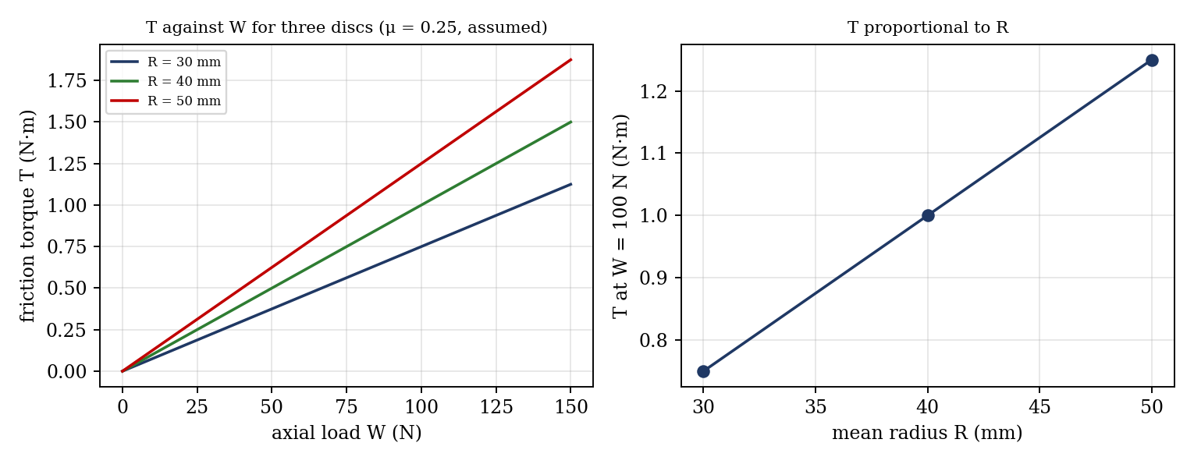
Figure 2: Expected graphs (illustrative, from the equations; not experimental data)
- Friction torque T against axial load W for each of the three discs.
- [Optional] T at a fixed load against the mean radius R of the disc (straight line through the origin).

7. Discussion
Sources of error: the speed of the top plate is not exactly constant, and the torque needed to just keep it moving is judged by eye, with the weights in steps; the friction in the pulleys and the cords adds to the apparent torque; the mean radius is found from measured radii (±0.2 mm); the disc surface may not be fully run in, so the pressure distribution differs from uniform wear; temperature rises from rubbing reduce μ; oil or dust on the surfaces affects μ; and the weight of the top plate must be added to W. [Compare your μ with 0.25, and say whether T ∝ W and T ∝ R are verified within the error.]

8. Conclusion
The friction torque of the plate clutch was proportional to the axial load, giving a mean coefficient of friction of [ ] for Ferodo on mild steel, compared with the usual figure of 0.25. For a given load, the torque was proportional to the mean radius of the disc, verified to within [ ]%. The results are used in the design of friction clutches, where the torque capacity is μ W R for each friction surface.

Section D: Questions
- What have you gained from this experiment? [ ]
- What role did you play during the experiment? [ ]
- Could you have performed this experiment all by yourself? YES / NO. Reason: [ ]
- Comment on the experimental procedure for accuracy of results and time saving. [ ]
- Most difficult aspect and suggestions for reducing it: [ ]
- Other methods or apparatus for the same experiment: [ ]
- Parameters required: axial load, top plate weight and diameter, hanger masses, and the radii R₁ and R₂ of each disc.
- One measuring instrument discussed: [ ]
- Practical relevance: single and multi-plate clutches in vehicles, and brakes.
- Section of your course this experiment best relates: Dynamics of Machines (friction clutches).
- Suggestions you made while carrying out the experiment: [ ]
- Suggestions by group members that helped the group: [ ]
- Did you put down the results at the time, or copy from group members? YES / NO. Reason: [ ]
- What interested you most during the experiment: [ ]
- Did you come to the laboratory with the laboratory manual? YES / NO. Reason: [ ]
- References: [list books/journals consulted, e.g. a theory of machines textbook; Laboratory Manual ELA 302]

