Mechanical Engineering Laboratory ELA 302
AM324: THE GENEVA WHEEL
Name: [your name] Matric No: [ ] Group: [ ] Date: [ ]
Objective: To carry out a kinematic analysis of the external Geneva wheel (six-slot Geneva wheel, model TM13).

1. Theory

The external Geneva mechanism
The external Geneva wheel is a mechanism commonly used on automatic machinery to produce intermittent rotary motion from an input rotating at constant speed. A roller on the driving crank enters a radial slot of the driven wheel and turns it through one step, and then leaves the slot, while a locking device holds the wheel still until the next slot is reached. The number of slots n fixes the ratio between the dwell period (when the wheel is locked) and the motion period (when the roller is in a slot). For the external Geneva, the dwell period always exceeds the motion period; the opposite is true of the internal Geneva (Figure 1). The roller enters the slot when the crank-to-slot line makes a right angle, which is the condition that the roller approaches the slot radially:
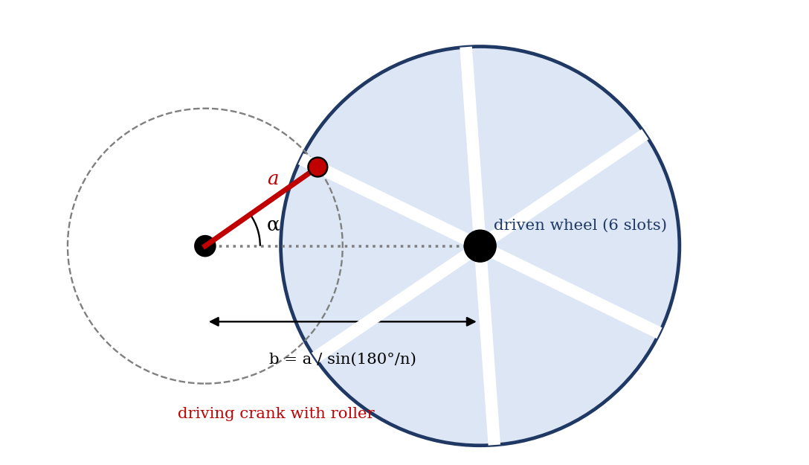
Figure 1: External Geneva wheel (six slots), with crank radius a, centre distance b and crank angle α
Crank angle in motion = 180° − 360°/n Crank angle in dwell = 180° + 360°/n
For six slots, the crank turns through 120° while the wheel indexes through 60°, and for the remaining 240° the wheel is stationary. The wheel rotates through 360°/n in each motion period.

Geometry
Let n = number of slots, a = crank radius and b = centre distance. Since the roller enters and leaves the slots at the point where the crank is perpendicular to the slot, b = a / sin(180°/n), so we put
m = 1 / sin(180°/n) b = a m
The diameter of the driven wheel is given by
D = 2 [ d²/4 + a² cot²(180°/n) ]^½
where d is the roller diameter. These two relations are the theoretical values that the measured b and D are compared with.

Kinematics
With the roller at crank angle α, the distance of the roller from the wheel centre (the driven crank radius) is
f = a (1 + m² − 2 m cos α)^½
and the angular displacement β of the wheel (measured from the line of centres) follows from the triangle formed by the crank, the line of centres and f:
cos β = (m − cos α) / (1 + m² − 2 m cos α)^½ tan β = sin α / (m − cos α)
Differentiating β with respect to time, for a constant angular speed ω of the driving crank (α̇ = ω), gives the angular velocity and acceleration of the wheel:
β̇ = ω (m cos α − 1) / (1 + m² − 2 m cos α)
β̈ = ω² m (1 − m²) sin α / (1 + m² − 2 m cos α)²
(The manual writes the second as ω × the bracket; the factor is ω², since the quantity differentiated already contains one ω.) The angular velocity is greatest at α = 0, where the roller is nearest to the wheel centre, and equals ω/(m − 1). The velocity is zero at entry, where α = 90° − 180°/n, since the roller then moves along the slot. The acceleration is zero at α = 0, grows, and has a maximum magnitude at an intermediate angle, then has a non-zero value when the roller enters (or leaves) the slot, so that the acceleration changes suddenly from zero in the dwell. This step is called the jerk problem. The quantities dβ/dα = β̇/ω and d²β/dα² = β̈/ω² are tabulated in the experiment, since they do not depend on the speed.
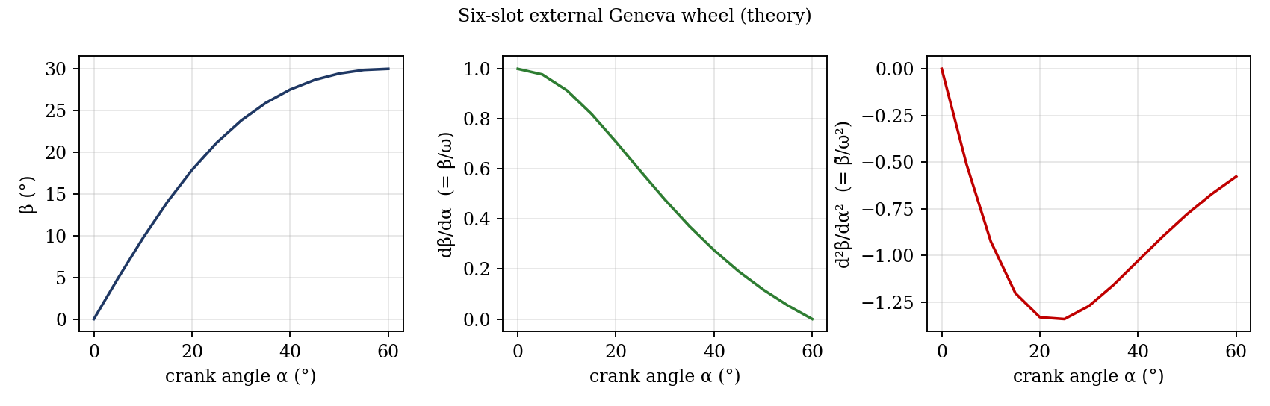
Figure 2: Wheel displacement, velocity and acceleration against crank angle for a six-slot Geneva (theory)

2. Apparatus
A six-slot Geneva wheel model (TM13), with a driving crank carrying a roller, a driven slotted wheel, a locking device, a protractor to read the crank angle α and wheel angle β, and a rule or vernier calliper for the dimensions. An electronic calculator is used for the evaluations of the appendix expressions.
Dimensional data for the external Geneva TM13 | Symbol | Value
Number of slots | n | 6
Crank radius | a | [ ] mm
Roller diameter | d | [ ] mm
Centre distance (measured, and calculated a/ sin 30° = 2a) | b | [ ] mm
Diameter of wheel (measured, and calculated) | D | [ ] mm

3. Results
Procedure followed: the dimensions of the model were measured, and the table above was completed, and the last two entries (b and D) were compared with their theoretical values. The model was then used to find experimental values of β for crank angles α from 0° to 60° in steps of 5°, and the theoretical values and derivatives were calculated from the expressions in the theory.
α (°) | β experimental (°) | β theoretical (°) | dβ/dα | d²β/dα²
0 |  | 0.00 | 1.000 | -0.000
5 |  | 4.96 | 0.978 | -0.507
10 |  | 9.71 | 0.914 | -0.926
15 |  | 14.05 | 0.820 | -1.203
20 |  | 17.88 | 0.708 | -1.332
25 |  | 21.13 | 0.591 | -1.342
30 |  | 23.79 | 0.477 | -1.272
35 |  | 25.91 | 0.370 | -1.159
40 |  | 27.52 | 0.275 | -1.029
45 |  | 28.68 | 0.191 | -0.900
50 |  | 29.44 | 0.118 | -0.779
55 |  | 29.87 | 0.054 | -0.671
60 |  | 30.00 | 0.000 | -0.577
The theoretical values are for six slots (m = 2) and are the same for any crank radius; enter your measured β in the second column.

4. Analysis of Results
- Measure a and compute b = a / sin 30° = 2a and D = 2[d²/4 + a² cot² 30°]^½, and compare with the measured b and D.
- Compare the experimental β with the theoretical β for each α, and find the difference in degrees and in per cent.
- Plot β̇/ω = dβ/dα and β̈/ω² = d²β/dα² against α; the peak velocity is ω/(m − 1) = ω at α = 0 for six slots, and the maximum acceleration magnitude is about 1.35 ω² near α = 23°.
Effect of the number of slots (from the same equations, with the crank angle α from 0 to the entry angle 90° − 180°/n):
n | m | Entry angle α | Peak velocity ω/(m−1) (× ω) | Max |β̈|/ω² and where | |β̈|/ω² at entry
3 | 1.155 | 30° | 6.46 | 31.39 at 4.8° | 1.73
4 | 1.414 | 45° | 2.41 | 5.41 at 11.5° | 1.00
5 | 1.701 | 54° | 1.43 | 2.30 at 17.6° | 0.73
6 | 2.000 | 60° | 1.00 | 1.35 at 22.9° | 0.58
8 | 2.613 | 68° | 0.62 | 0.70 at 31.6° | 0.41
12 | 3.864 | 75° | 0.35 | 0.35 at 44.0° | 0.27

5. Observations and Precautions
Observations
- The wheel stays still (locked) while the crank is outside the slot, and turns 60° while the roller is in the slot.
- The wheel starts and stops smoothly in velocity but with a noticeable knock at entry, which is the sudden change of acceleration.
Precautions
- Turn the crank slowly and by hand, and read the angles with the eye level with the scale.
- Check the zero of both protractors, and do not force the wheel when the roller is entering the slot.

6. Graphs
- β′ (= dβ/dα) against α.
- β″ (= d²β/dα²) against α.
- [Optional] β experimental and theoretical against α.

7. Discussion
Sources of error: the backlash and the clearance of the roller in the slot (about ±1° of wheel angle), the zero error and the reading of the angles on the protractors (±0.5°), and measurement of a and b (±0.2 mm), which affects the theoretical curve. Differences near entry are larger because small changes in α make large changes in β̈. The derivatives are theoretical, since the model gives only β (a numerical derivative of the experimental β would be very noisy). [Compare the measured and theoretical β, and b and D, and estimate the error.]
Maximum acceleration. The table in the analysis shows that, as the number of slots increases, the magnitude of the maximum acceleration falls sharply (from about 31 ω² for three slots to 1.35 ω² for six slots and 0.35 ω² for twelve), because the wheel turns through a smaller angle in each step, and the position at which it occurs moves away from α = 0 toward the entry angle (5° for three slots, 23° for six, 44° for twelve).
The jerk problem. The acceleration changes suddenly from zero to a finite value when the roller enters the slot, which produces an impact load, noise and wear. It can be reduced by: (1) using more slots, since the entry acceleration falls (1.73 ω² for three slots, 0.58 ω² for six); (2) running at a lower crank speed, since the acceleration is proportional to ω²; (3) curving the slots near the entry, or using a modified Geneva (or cam-driven indexing mechanism) so that the acceleration starts from zero; or (4) using a flexible or cushioned roller.

8. Conclusion
The kinematics of a six-slot external Geneva wheel were studied. The measured wheel angle agreed with the theoretical value within [ ]° over the motion period, and the measured centre distance and wheel diameter agreed with the calculated values to within [ ]%. The wheel is stationary for 240° and moves for 120° of crank rotation, and the peak velocity equals ω at α = 0. Geneva mechanisms are used for indexing in film projectors, machine tool turrets, assembly and packaging machines and watches.

Section D: Questions
- What have you gained from this experiment? [ ]
- What role did you play during the experiment? [ ]
- Could you have performed this experiment all by yourself? YES / NO. Reason: [ ]
- Comment on the experimental procedure for accuracy of results and time saving. [ ]
- Most difficult aspect and suggestions for reducing it: [ ]
- Other methods or apparatus for the same experiment: [ ]
- Parameters required: number of slots, crank radius, roller and wheel diameters, centre distance, and the angles α and β.
- One measuring instrument discussed: [ ]
- Practical relevance: film projectors, machine tool turrets, indexing tables and packaging machines.
- Section of your course this experiment best relates: Kinematics of Machines (intermittent motion mechanisms).
- Suggestions you made while carrying out the experiment: [ ]
- Suggestions by group members that helped the group: [ ]
- Did you put down the results at the time, or copy from group members? YES / NO. Reason: [ ]
- What interested you most during the experiment: [ ]
- Did you come to the laboratory with the laboratory manual? YES / NO. Reason: [ ]
- References: [list books/journals consulted, e.g. Machine Devices and Instrumentation, ed. N. P. Chironis, McGraw-Hill; Laboratory Manual ELA 302]

