Mechanical Engineering Laboratory ELA 302
AM326: MASS ON A SPRING (A: Effect of Spring Mass; II: Stiffness of Helical Springs)
Name: [your name] Matric No: [ ] Group: [ ] Date: [ ]
Objectives: (A) To study the effect of the mass of a spring on the behaviour of a spring–mass system. (II) To find the stiffness k of the three helical springs provided (1) statically, (2) dynamically and (3) using the close-coiled spring formula.

1. Theory

Stiffness and the simple spring–mass system
For a spring that obeys Hooke’s law, the force F is proportional to the extension x, where the constant k is the stiffness (N/m):
F = k x
A mass M hung on a massless spring and displaced vertically moves with simple harmonic motion, since the restoring force is −kx. Newton’s law gives M ẍ = −kx, whose solution has the natural circular frequency and period
ω = √(k / M) T = 2π / ω = 2π √(M / k)

Effect of the mass of the spring (energy method)
When the mass m of the spring is not negligible, an approximate correction is found by the energy method. Assume (1) that the system vibrates with SHM at circular frequency ω with the mass M having an amplitude a, (2) that the spring is wound uniformly, with mass m and equilibrium length L, and (3) that the displacement of a point on the spring at distance y from the support is proportional to y, so that it is y a/L (Figure 1).
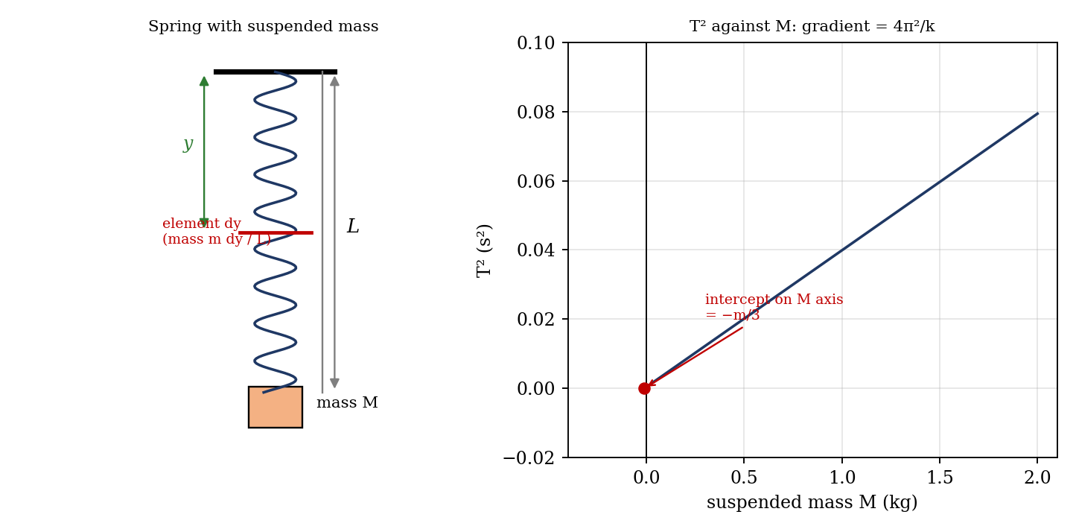
Figure 1: Spring element and the T² against M graph (illustrative)
The maximum strain energy is that of the spring, S.E. = ½ k a². The maximum kinetic energy of the mass M is ½ (ω a)² M. An element of the spring of length dy has mass (m/L) dy and a maximum velocity ω a y/L, so its kinetic energy is ½ (ω a y/L)² (m/L) dy. Integrating over the length of the spring:
K.E. (spring) = (ω² a² m / 2L³) ∫₀ᴸ y² dy = ½ ω² a² (m / 3)
So the total maximum kinetic energy is ½ ω² a² (M + m/3). Equating the maximum kinetic and strain energies, ½ k a² = ½ ω² a² (M + m/3), so
ω² = k / (M + m/3) T = 2π √[ (M + m/3) / k ]
Hence, to allow for the spring mass, one-third of the mass of the spring is added to the suspended mass, and the standard formula is used with the new mass. Squaring the period gives a straight line in M:
T² = (4π² / k)(M + m/3)
A plot of T² against M therefore has a gradient of 4π²/k, from which k is found, and an intercept on the M axis of −m/3, from which the mass of the spring can be checked (Figure 1).

Close-coiled helical spring formula
When a close-coiled helical spring of mean coil diameter D and wire diameter d carries an axial force F, each section of the wire is twisted by a torque F D/2. A wire of length π D N (N active coils) with polar second moment J = π d⁴/32 twists through θ = T L/(G J) = (F D/2)(π D N)/(G π d⁴/32) = 16 F D² N/(G d⁴). The axial deflection is δ = θ D/2 = 8 F D³ N/(G d⁴), so the stiffness is
k = F / δ = G d⁴ / (8 N D³)
where G is the modulus of rigidity (8.0 × 10¹⁰ N/m² for spring steel), d is the diameter of the wire, N is the number of active coils and D is the mean diameter of the coils. This result follows from the same torsion theory as the torsional oscillation experiment.

2. Apparatus
A heavy coil spring (and the three helical springs for part II), a hanger and weights (up to 2 kg, in steps of 0.2 or 0.25 kg), a support from a high point with a scale for the extension, a stopwatch, a balance, and a micrometer screw gauge and calipers for the wire diameter d and the mean coil diameter D.
Quantity | Value
Mass of spring, m | [ ] kg
Natural length and number of coils, N | [ ] mm, [ ]
Wire diameter d / mean coil diameter D | [ ] mm / [ ] mm
Modulus of rigidity G (spring steel) | 8.0 × 10¹⁰ N/m²

3. Results
Procedure followed: the spring was suspended from a high point and the mass M varied from 2 kg to zero in steps of 0.2 or 0.25 kg. For each mass, the time for 10 to 20 oscillations was measured, carefully avoiding ‘bumping’ of the coil and lateral swing, using the standard precautions. The stiffness was also measured statically, from the extension for each load. For part II, the same was done for each of the three springs, and the dimensions m, d, D, the natural length and the number of coils were measured.
Table 1: Spring [ ]: static and dynamic readings
No. | Mass M (kg) | Extension x (mm) | Time for 20 oscillations (s) | Period T (s) | T² (s²)
1
2
3
4
5
6
7

Table 2: Stiffness of the three springs by the three methods
Spring | k static (N/m) | k dynamic (N/m) | k from formula (N/m) | Spring mass m (from intercept) (kg)
1
2
3

4. Analysis of Results
- Static stiffness: plot the load F = M g against extension x; k = gradient (N/m).
- Dynamic stiffness: plot T² against M; the gradient is 4π²/k, so k = 4π²/gradient, and the intercept on the M axis is −m/3, so the effective mass of the spring is m/3 = [ ] kg.
- Formula: k = G d⁴/(8 N D³) from the measured d, D and N, with G = 8.0 × 10¹⁰ N/m².
- Compare the three values of k for each spring, and the spring mass from the intercept (3 × intercept) with the weighed mass.
As a check, take an assumed spring with d = 2 mm, D = 20 mm and N = 20 coils. Then k = 8.0×10¹⁰ × (2×10⁻³)⁴/(8 × 20 × (0.02)³) = 1000 N/m. The wire length is π D N = 1.257 m, so its mass is 0.031 kg (steel, 7850 kg/m³), and m/3 = 0.0103 kg. The expected periods are as below; the line of T² against M has gradient 4π²/k = 0.0395 s²/kg and cuts the M axis at −0.0103 kg. This is an illustration, not your data.
Mass M (kg) | T (s) | T² (s²)
0.25 | 0.1014 | 0.0103
0.5 | 0.1419 | 0.0201
1 | 0.1997 | 0.0399
1.5 | 0.2442 | 0.0596
2 | 0.2817 | 0.0794

5. Observations and Precautions
Observations
- The period increased with the suspended mass, and T² against M was nearly a straight line.
- The line did not pass through the origin: it cut the M axis at a negative value, showing the effect of the spring mass.
Precautions
- Start with small vertical oscillations and avoid lateral swing and ‘bumping’ of the coils (at low loads the coils may touch).
- Time at least 10 to 20 oscillations, starting the watch as the mass passes the centre; keep the amplitude small so that the spring stays elastic.

6. Graphs
- Load against extension for each spring.
- T² against M for each spring (gradient 4π²/k, intercept −m/3).

7. Discussion
Accuracy and consistency; the three assumptions. The three assumptions are: (1) the motion is simple harmonic, which holds if the spring is linear and the amplitude is small; (2) the spring is uniformly wound with its mass evenly distributed, which is approximately true except at the end coils; and (3) the displacement of a point on the spring is proportional to its distance from the support (a linear distribution of displacement), which is true for a slow motion, but at high frequency the spring has its own modes. The result m/3 is then an approximation that is good for m small compared with M. Errors: the timing (stopwatch ±0.3 s on 10 to 20 oscillations, or about 1 to 3% in T, and so 2 to 6% in T²); the extension measured to ±0.5 mm; the end coils of the spring, which are not active, so that N is not exactly the number of turns; damping; and the diameters d and D measured to about ±0.01 mm, with d entering as d⁴ (1% error in d gives 4% in k). The stiffness from the formula depends on G, which is not exactly 8.0 × 10¹⁰ N/m². [Estimate the accuracy and consistency of your three values of k.]

8. Conclusion
The stiffness of the springs was found as [ ] N/m (static), [ ] N/m (dynamic) and [ ] N/m (formula), which agree within [ ]%. The graph of T² against M had an intercept of [ ] kg, corresponding to a spring mass of [ ] kg, compared with the weighed [ ] kg, confirming that one-third of the spring mass should be added to the suspended mass. The results are used in the design of suspension springs, vibration isolators and balances.

Section D: Questions
- What have you gained from this experiment? [ ]
- What role did you play during the experiment? [ ]
- Could you have performed this experiment all by yourself? YES / NO. Reason: [ ]
- Comment on the experimental procedure for accuracy of results and time saving. [ ]
- Most difficult aspect and suggestions for reducing it: [ ]
- Other methods or apparatus for the same experiment: [ ]
- Parameters required: suspended mass, extension, period, spring mass, wire and coil diameters, and number of coils.
- One measuring instrument discussed: [ ]
- Practical relevance: vehicle suspensions, vibration isolation, valves and spring balances.
- Section of your course this experiment best relates: Vibrations (free vibration of a spring–mass system) and Strength of Materials.
- Suggestions you made while carrying out the experiment: [ ]
- Suggestions by group members that helped the group: [ ]
- Did you put down the results at the time, or copy from group members? YES / NO. Reason: [ ]
- What interested you most during the experiment: [ ]
- Did you come to the laboratory with the laboratory manual? YES / NO. Reason: [ ]
- References: [list books/journals consulted, e.g. Machine Devices and Instrumentation, ed. N. P. Chironis, McGraw-Hill; Laboratory Manual ELA 302]

