Mechanical Engineering Laboratory ELA 302
AM327: ENERGY OF A FLYWHEEL
Name: [your name] Matric No: [ ] Group: [ ] Date: [ ]
Objective: To verify the laws of motion applied to a flywheel, that is, the relationship between torque and angular acceleration, and to find its moment of inertia.

1. Theory

Rotational motion of a flywheel
A flywheel is a heavy rotating wheel that stores kinetic energy and smooths the speed of a machine. For a body that rotates about a fixed axis, Newton’s second law takes the form torque = moment of inertia × angular acceleration, T = I α. The moment of inertia I depends on the mass and how it is distributed, and is written in terms of the radius of gyration k as
I = M k² I = ½ M R² (solid disc)
so the inertia constant is K = ½ for a solid disc, since k² = K R². (The manual writes I = K (W/g) R², with W the weight of the flywheel; if the flywheel is weighed in kg, W is its mass M, and I = K M R².) The kinetic energy stored at angular velocity ω, which comes from the speed N in rpm, is
K.E. = ½ I ω² ω = 2πN / 60

Falling-weight method (neglecting friction)
A cord is wound round the axle of the flywheel (radius r) and carries a pan with weights of mass m. When the mass falls, it accelerates the flywheel (Figure 1). For the falling mass, and for the flywheel (where T is the tension in the cord):
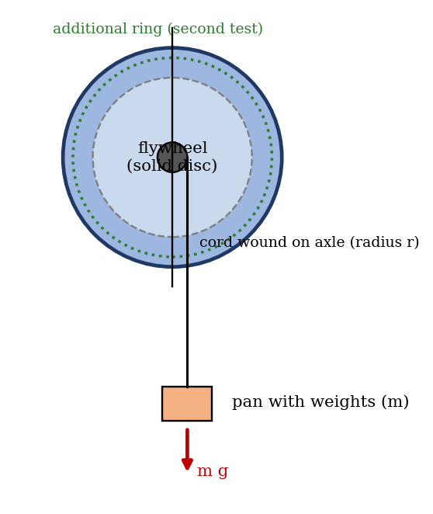
Figure 1: Flywheel driven by a falling weight (schematic)
m a = m g − T I α = T r
Eliminating the tension, and using α = a/r:
I α = m (g − a) r a = m g r² / (I + m r²) α = a / r
If the weight falls a known height h from rest in time t, the linear acceleration is a = 2h/t². In this experiment the time for one revolution of the flywheel is measured, in which the cord unwinds by h = 2πr (if the cord is wound on the axle), so
a = 4π r / t² α = 4π / t²
The moment of inertia and radius of gyration then follow:
I = m r (g − a) / α = m r² (g − a) / a k² = I / M
This expression assumes no friction. In practice a friction torque T_f in the bearings opposes the motion, so m g r − T_f = (4π/t²)(I + m r²), which gives a straight line when the weight m is plotted against 1/t²: the intercept gives the friction and the gradient the inertia.

Energy check
In one revolution the weight falls h = 2π r, and loses potential energy m g h. This appears as kinetic energy of the flywheel and the weight, plus the work done against friction:
m g h = ½ I ω² + ½ m v² + W_friction
where ω = α t = 4π/t is the angular velocity at the end of the revolution and v = ω r. The agreement of the two sides is a check on the experiment.

2. Apparatus
A flywheel (solid disc) on a horizontal shaft with bearings, with an axle on which a cord is wound, a weight pan and weights, an additional circular ring that can be fitted to the disc, a digital stopwatch, a balance, a rule or calliper for the radii.
Quantity | Value
Mass of the flywheel (solid disc), M | [ ] kg
Radius of the disc, R | [ ] m
Radius of the axle, r | [ ] m
Mass and radii of the additional ring | [ ] kg, [ ] m

3. Results
Procedure followed: the solid disc of the flywheel was attached to the pan and the cord, and the disc was allowed to revolve under the falling weight. With the digital stopwatch, the time taken to complete one revolution was recorded, and the watch was reset before the next reading. With the additional circular ring fitted, the time for one revolution of the solid disc was recorded, and then the weight in the pan was increased and the time was recorded again.
S/N | Weight of flywheel (kg) | Weight in the pan (kg) | Time for 1 revolution t (s)
1
2
3
4
5
6

S/N | a = 4πr/t² (m/s²) | α = 4π/t² (rad/s²) | I (kg·m²) | k² = I/M (m²) | K = k²/R²
1
2
3

4. Analysis of Results
- Calculate a = 4πr/t² and α = 4π/t² for each reading, and I = m r (g − a)/α, and k² = I/M, K = k²/R².
- Compare I and K with the values expected from the geometry: I = ½ M R² for the solid disc (K = ½), and for the disc with the ring, I = ½ M R² + I_ring, with I_ring = ½ M_r (R_o² + R_i²) for a ring of outer and inner radii.
- Plot the weight in the pan (g) against time, and against 1/t²; find the friction from the intercept and the inertia from the gradient.
- Check the energy balance for one revolution, m g (2πr) = ½ I ω² + ½ m v² + friction work.
As a check, for an assumed solid disc of mass 5 kg and radius 0.15 m (I = 0.0563 kg·m²), an axle radius 0.02 m and no friction, the expected times for one revolution are given below; your values will be longer, because of friction. This is an illustration, not your data.
Mass in pan m (kg) | α (rad/s²) | Time for 1 rev t (s)
0.25 | 0.87 | 3.80
0.50 | 1.74 | 2.69
1.00 | 3.46 | 1.91

5. Observations and Precautions
Observations
- The flywheel accelerates uniformly while the weight falls, and the time for one revolution falls as the weight in the pan is increased.
- The additional ring increases the time for one revolution for the same weight, since it increases the moment of inertia.
Precautions
- Wind the cord evenly on the axle so that it does not slip or overlap, and release the weight without any push.
- Start the stopwatch exactly as the flywheel starts to move and stop it after exactly one revolution (use a mark); reset the watch before each reading; keep clear of the rotating wheel.

6. Graphs
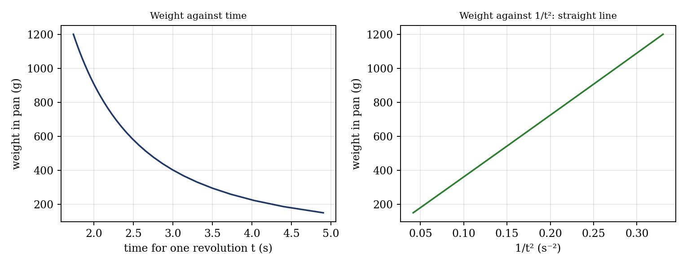
Figure 2: Expected graphs (illustrative, from the equations; not experimental data)
- Weight in the pan (g) against time (s), for the flywheel with and without the ring.
- [Optional] Weight in the pan against 1/t².

7. Discussion
Constancy of K and the limits of the method. The constancy of the inertia constant K (and of M k²) was investigated for various loads and conditions: if Newton’s laws apply, the calculated I should be the same for every weight in the pan, and larger by the known amount with the ring. Differences arise from bearing friction (which has a larger effect with small weights, because it is a larger fraction of the torque), the stopwatch error (about 0.3 s on times of 2 to 4 s, so 8 to 15% in t and up to 30% in α), the thickness of the cord (which increases the effective r), the mass of the cord, and the error in the radii. These make the method not very accurate for finding I, especially for small accelerations (times). [State how well Newton’s laws are verified: how close K is to 0.5 for the disc, and how constant I is.]
Would this method be recommended for finding I? It is a simple and direct teaching method, but it is not accurate, because of the timing and friction errors. Better methods are the torsion pendulum or trifilar suspension (the period of oscillation depends on I, and can be timed over many oscillations to reduce error), or a rotational deceleration test with an electronic timer. The advantages of flywheels are that they store energy and smooth fluctuations in speed (in engines and presses); disadvantages are the weight, the danger of bursting at high speed, and the extra energy and time needed to speed up or stop.

8. Conclusion
The relationship between torque and angular acceleration for a flywheel was verified, with the moment of inertia found to be [ ] kg·m² (K = [ ]), which compares with the calculated [ ] kg·m² to within [ ]%. The additional ring increased the inertia as predicted. Flywheels are used in engines, presses, shears and energy storage systems to smooth the speed and store energy.

Section D: Questions
- What have you gained from this experiment? [ ]
- What role did you play during the experiment? [ ]
- Could you have performed this experiment all by yourself? YES / NO. Reason: [ ]
- Comment on the experimental procedure for accuracy of results and time saving. [ ]
- Most difficult aspect and suggestions for reducing it: [ ]
- Other methods or apparatus for the same experiment: [ ]
- Parameters required: flywheel mass and radius, axle radius, weight in the pan and the time for one revolution.
- One measuring instrument discussed: the digital stopwatch. [Describe: resolution, reaction-time error.]
- Practical relevance: engines, punch presses, shears and energy-storage systems.
- Section of your course this experiment best relates: Dynamics of Machines (flywheels and rotational motion).
- Suggestions you made while carrying out the experiment: [ ]
- Suggestions by group members that helped the group: [ ]
- Did you put down the results at the time, or copy from group members? YES / NO. Reason: [ ]
- What interested you most during the experiment: [ ]
- Did you come to the laboratory with the laboratory manual? YES / NO. Reason: [ ]
- References: [list books/journals consulted; Laboratory Manual ELA 302]

