Mechanical Engineering Laboratory ELA 302
AM328: CALIBRATION OF A TRANSMISSION DYNAMOMETER
Name: [your name] Matric No: [ ] Group: [ ] Date: [ ]
Objectives: (a) To measure the forces or couples which tend to change the state of rest or uniform motion of a body. (b) To measure the power available from a uniformly revolving shaft, and to calibrate the transmission dynamometer.

1. Theory

Transmission dynamometers
A dynamometer measures the torque and power of a rotating machine. An absorption dynamometer (a brake) wastes the power that it measures as heat. A transmission dynamometer measures the power while passing it on to the driven machine, and its reading is taken without absorbing the power. The Tatham type belt dynamometer used here consists of a driving pulley A, driven by a PMDC electric motor, a driven pulley E, a belt between them, and guide pulleys B and C mounted on a horizontal beam, which is pivoted at the point about which the beam is balanced at rest (Figure 1).
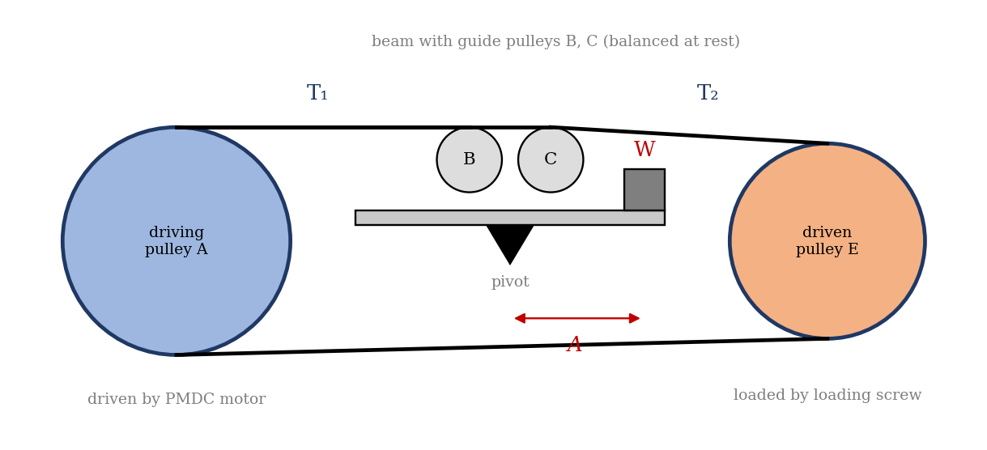
Figure 1: Tatham type transmission dynamometer (schematic)

Power from the belt tensions
Let T₁ and T₂ be the effective belt tensions (tight and slack sides) under driving conditions, and W the weight, at a distance A from the pivot, that is needed to keep the beam horizontal. B is the distance between the two guide pulleys (so each guide pulley is B/2 from the pivot). If all portions of the belt between the pulleys are vertical, then for equilibrium of the beam about the pivot (moments of the weight and of the tensions pulling on the two guide pulleys):
W g A + 2 T₂ B − 2 T₁ B = 0
so the difference between the tensions is
T₁ − T₂ = W g A / (2B)
The power transmitted is the net pull of the belt multiplied by its speed V:
Power = (T₁ − T₂) V = (W g A / 2B) V
The belt speed follows from the driven pulley diameter D and its speed S₂ in rpm:
V = π D S₂ / 60 (m/s)
In the manual, A = (a + A) is the distance of the weight pan from the pivot, made up of the fixed distance a and the measured distance A from the balance frame. The power transmitted (output) is therefore
P_out = W g (a + A) π D S₂ / (2B × 60)
(The manual states that V is ‘in rad/sec’; V = πDS₂/60 is a linear speed in m/s, which is what is needed to convert a force into power. The weight W is in kg, so multiply by g to obtain newtons.)

Calibration and efficiency
The power input to the system is measured electrically at the motor, so the dynamometer reading can be compared with a known input; that is the calibration. The transmission efficiency is the ratio of the power transmitted by the belt to the power input:
η = P_out / P_in × 100%
The output power is always smaller than the input power, since some power is lost in the motor, the bearings, the belt slip and the friction of the dynamometer.

2. Apparatus
The Tatham type belt dynamometer consists of: a driving pulley A; a driven pulley E, which is loaded by a loading screw; a control panel with the main start button (at the bottom of the panel), a red push start button and a speed control knob; a PMDC electric motor; guide pulleys B and C on a horizontal beam pivoted at a point about which the complete beam is balanced at rest; and an adjustable counter weight. A rule is used to measure the distances, and a digital display on the panel gives the speeds and the input power.
Fixed data | Value
Balanced weight, W | 0.922 kg
Distance a (fixed part of the lever arm) | 0.202 m
Diameter of the driven pulley, D | 0.123 m
Distance between the guide pulleys, B | 0.075 m

3. Results
Procedure followed: the speed control knob was set to zero (turned anticlockwise) before starting. The start button at the bottom of the control panel was pressed, and when the display showed ‘PRESS START’ the red push button was pressed. The speed was changed by turning the knob. With the load pulley at zero, the rotor was balanced with the adjustable counter weight on the left-hand side. The tension of the belt was adjusted, the motor was started, and the speed kept at 1500 rpm. The balancing arm on the right-hand side was balanced by the counter weight, and the distance from the outer surface of the balance frame to the weight was measured with a rule. The output pulley was then loaded with the loading screw, and the set of readings S₁, S₂, input power and A was taken. The test was repeated for about five different given values of S₁.
S/N | Driving pulley S₁ (rpm) | Driven pulley S₂ (rpm) | Power input (W) | Power output (W) | a (m) | A (m) | Efficiency η (%)
1 | 1593 |  |  |  | 0.202
2 | 1800 |  |  |  | 0.202
3 | 2183 |  |  |  | 0.202
4 | 2300 |  |  |  | 0.202
5 | 2596 |  |  |  | 0.202
6 | 2830 |  |  |  | 0.202

4. Analysis of Results
- Belt speed: V = π D S₂/60 = π × 0.123 × S₂/60 (m/s).
- Lever arm: L_A = a + A (m), with a = 0.202 m.
- Output power: P_out = W g L_A V/(2B) = 0.922 × 9.81 × L_A × V/0.15 (W).
- Efficiency: η = P_out/P_in × 100%.
As a check, for an assumed A = 0.100 m (so L_A = 0.302 m) the net pull is T₁ − T₂ = 0.922 × 9.81 × 0.302/0.15 = 18.2 N, and the output power is 18.2 × V, which gives about 117 W at S₂ = 1000 rpm (V = 6.44 m/s), 176 W at 1500 rpm (9.66 m/s) and 234 W at 2000 rpm (12.88 m/s). This is an illustration from the equation, not your data.
S₂ (rpm) | V (m/s) | P_out (W) for L_A = 0.302 m
1000 | 6.44 | 117
1500 | 9.66 | 176
2000 | 12.88 | 234

5. Observations and Precautions
Observations
- The output power increased as the load on the driven pulley was increased by the loading screw.
- The driven pulley ran slightly slower than the driving pulley, because of belt slip, and the slip increased with the load.
Precautions
- Set the speed knob to zero before starting, and increase the speed slowly; keep hands and clothing away from the belt and pulleys.
- Check that the beam is balanced before loading, and read the distance A when the beam is horizontal and steady.

6. Graphs
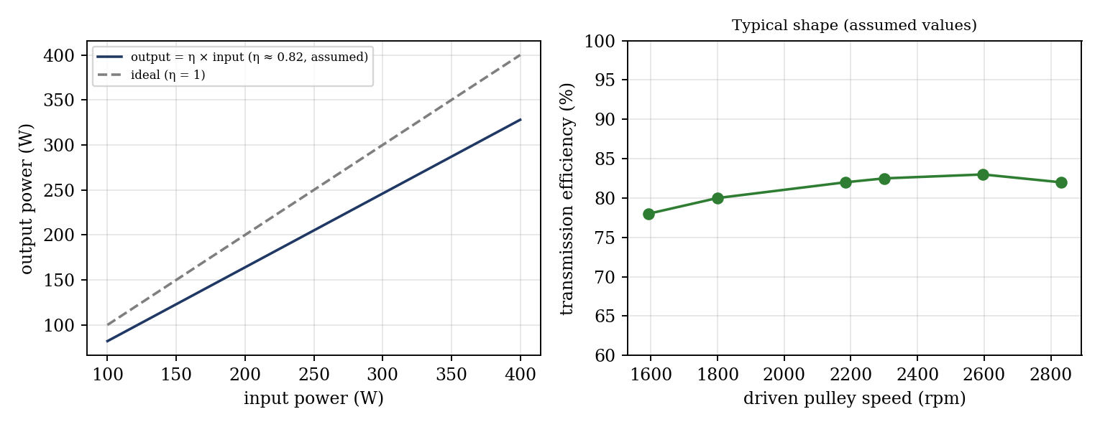
Figure 2: Expected shape of the graphs (illustrative; efficiency of about 82% assumed, not experimental data)
- Efficiency against driven pulley speed.
- Output power against input power.

7. Discussion
The output power is lower than the input power because of: (1) electrical and mechanical losses in the PMDC motor (copper and iron losses, brush friction, bearing friction); (2) friction in the bearings of the pulleys and in the dynamometer beam; (3) belt slip and the energy lost as the belt flexes; (4) the power that is absorbed by the loading screw device and any windage; and (5) readings: the input power is measured at the motor terminals, which include the motor losses, while the output is measured at the belt. Other errors: the speed from the digital display to about ±1 rpm, the distance A to ±1 mm, the balance of the beam (small imbalance causes a large error in the moment), and variation of speed during the reading. [Compare the efficiencies from your table and say how they vary with speed and load.]

8. Conclusion
The transmission dynamometer was calibrated against the electrical input power. The output power measured by the dynamometer was [ ]% to [ ]% of the input power, with the efficiency [rising/falling] with speed. The difference is due to the losses in the motor, bearings and belt. Transmission dynamometers are used where the power must reach the machine, such as in the testing of machine tools, pumps, fans and belt-driven machinery.

Section D: Questions
- What have you gained from this experiment? [ ]
- What role did you play during the experiment? [ ]
- Could you have performed this experiment all by yourself? YES / NO. Reason: [ ]
- Comment on the experimental procedure for accuracy of results and time saving. [ ]
- Most difficult aspect and suggestions for reducing it: [ ]
- Other methods or apparatus for the same experiment: [ ]
- Parameters required: weight W, lever arm distances a and A, pulley diameter D, guide pulley distance B, the speeds S₁ and S₂ and the input power.
- One measuring instrument discussed: the tachometer or digital speed display (or the rule). [Describe.]
- Practical relevance: power measurement in machine tools, pumps, fans and engines.
- Section of your course this experiment best relates: Dynamics of Machines (power measurement and dynamometers).
- Suggestions you made while carrying out the experiment: [ ]
- Suggestions by group members that helped the group: [ ]
- Did you put down the results at the time, or copy from group members? YES / NO. Reason: [ ]
- What interested you most during the experiment: [ ]
- Did you come to the laboratory with the laboratory manual? YES / NO. Reason: [ ]
- References: [list books/journals consulted; Laboratory Manual ELA 302]

