APPLIED MECHANICS LABORATORY
LABORATORY REPORTS
AM 211: Friction Experiment
AM 212: Rolling on an Inclined Plane
AM 214: Screw Jack
AM 217: Centrifugal Force Experiment
AM 218(A): Simple Wheel and Axle
AM 218(B): Wheel and Differential Axle
Tensile Test: Tensile Test on a Metal Specimen
AM 221: Radial Cam and Follower
AM 223: The Offset Slider-Crank Mechanism
SM 212: Shear Force in a Beam Experiment
SM 213: Bending Moment in a Beam Experiment
SM 214: Torsion Test to Destruction
AM 213: Slip and Creep Measurement in a Belt Drive
AM 225: The Conical Pendulum
AM 226(A): Simple Pendulum
AM 226(B): Compound Pendulum: Conditions for Minimum Period
AM 229: Flywheel and Falling Weight
AM 231: Automat Spur Gear Models (A1 to A5)

Name: ______________________________
Matric No.: __________________________
Department: _________________________
Date: _______________________________
Contents
AM 211 Friction Experiment
AM 212 Rolling on an Inclined Plane
AM 214 Screw Jack
AM 217 Centrifugal Force Experiment
AM 218(A) Simple Wheel and Axle
AM 218(B) Wheel and Differential Axle
Tensile Test Tensile Test on a Metal Specimen
AM 221 Radial Cam and Follower
AM 223 The Offset Slider-Crank Mechanism
SM 212 Shear Force in a Beam Experiment
SM 213 Bending Moment in a Beam Experiment
SM 214 Torsion Test to Destruction
AM 213 Slip and Creep Measurement in a Belt Drive
AM 225 The Conical Pendulum
AM 226(A) Simple Pendulum
AM 226(B) Compound Pendulum: Conditions for Minimum Period
AM 229 Flywheel and Falling Weight
AM 231 Automat Spur Gear Models (A1 to A5)
Notes before you submit
- Anything shown as [ ] is for your own readings or results from your own lab session. Nothing has been invented.
- Each report follows Section C of the manual: Theory, Apparatus, Results, Analysis of Results, Observations and Precautions, Graphs, Discussion and Conclusion. The Section B questions are answered after each report.
- Questions 2, 10, 11, 12, 14 and 15 are personal, so they are left for you to fill in.
- Graphs must be drawn from your own readings on graph paper (or in Excel) and attached where indicated.

AM 211: Friction Experiment

Objective
- Part A: to find the coefficient of friction μ between the mild steel plane and the different materials of the slider trays, and the angle of friction.
- Part B: to find the force parallel to an inclined plane needed to drag a tray up or down at constant velocity, to compare it with theory, and to observe the effect of rolling.

1. Theory
Friction is the force that resists motion between two surfaces in contact. It acts along the surfaces and opposes the motion. Its size is F = μN, where μ is the coefficient of friction (no units, depends on the two surfaces) and N is the normal reaction. Friction does not depend on the area of contact.
Level plane (Part A1). When the tray moves at a slow, constant velocity it is not accelerating, so the net force is zero. The pulling force P (hanger + added masses) equals the friction force, and the normal reaction equals the weight, N = W. So P = μW, which gives μ = P/W. A graph of P (vertical) against W (horizontal) is a straight line and its slope is μ.
Angle of friction (Part A2). On a tilted plane the weight has two components: W sin θ down the plane and W cos θ into the plane (the normal reaction). At the critical angle the tray just slides, so W sin θ = μW cos θ, which gives tan θ = μ. This critical θ is the angle of friction (angle of repose).
Inclined plane (Part B). The tray is pulled parallel to the plane at constant velocity.
- Up the plane, friction and W sin θ both act down the slope, so P = W(sin θ + μ cos θ).
- Down the plane, friction acts up the slope and W sin θ helps the motion, so P = W(μ cos θ − sin θ).
(The manual prints the same expression for both directions, but the sign of the sin θ term must change when the tray is pulled down.)
Rolling friction. With ball-bearing wheels, sliding is replaced by rolling, which has much less resistance. With no friction the force would be P = W sin θ. The actual force is P_{A} = P + F, where F is the rolling resistance, so F = P_{A} − W sin θ.

2. Apparatus
Mild steel plane that can be levelled and tilted, slider trays with different liner materials, a ball-bearing tray (three wheels), cord, pulley at the end of the plane, hanger with slotted masses, laboratory scale, protractor or angle scale, and a ruler.
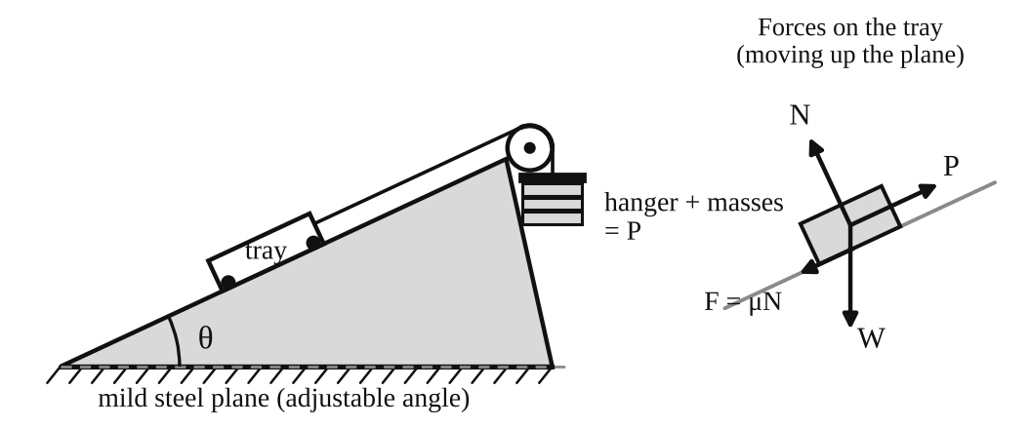
Fig. 1: Friction on an inclined plane (left) and the forces on the tray (right).
Method in brief
- Part A1: put a tray on the level plane and add mass to the hanger until the tray moves slowly at constant velocity. Record P. Add load to the tray (up to five times) and repeat.
- Part A2: tilt the plane slowly until the tray just slides down. Record θ.
- Part B: set the plane to an angle, pull the tray up (then down) at constant slow velocity and record P. Repeat for several angles and tray loads. Repeat with the ball-bearing tray.

3. Results
Table 1: Level plane (Part A1). Use one table for each tray / liner material.
Load added (N) | Total W (N) | Hanger + masses P (N) | P/W

Table 2: Angle of friction (Part A2)
Tray / liner | Critical angle θ (°) | tan θ | μ from Table 1

Table 3: Inclined plane (Part B)
θ (°) | W (N) | P exp. (up) | P theory (up) | P exp. (down) | P theory (down)

Table 4: Rolling friction (ball-bearing tray)
θ (°) | W (N) | P = W sin θ (N) | P_{A} measured (N) | F = P_{A} − P (N)

4. Analysis of Results
One worked example for each calculation (use your own readings):
- μ from the graph: μ = slope = ΔP/ΔW = [ ] ÷ [ ] = [ ] (quoted to 2 decimal places, as the manual says).
- μ from the angle: μ = tan θ = tan [ ]° = [ ].
- Theoretical P (up): P = W(sin θ + μ cos θ) = [ ] ( sin [ ]° + [ ] × cos [ ]° ) = [ ] N.
- Theoretical P (down): P = W(μ cos θ − sin θ) = [ ] N.
- Rolling resistance: F = P_{A} − W sin θ = [ ] − [ ] = [ ] N.
- Percentage difference = (experimental − theory) ÷ theory × 100 = [ ] %.

5. Observations / Precautions Taken
Observations
- The friction force increased as the load in the tray increased.
- More force was needed to pull the tray up the plane than down it.
- The ball-bearing tray needed much less force than the sliding trays.
- Different liner materials gave different values of μ, and repeated readings on the same pair of surfaces scattered a little.
Precautions
- The plane was levelled before Part A and the cord was kept parallel to the plane.
- The tray was moved slowly at constant velocity, not accelerated.
- Masses were added in small steps and readings were taken at eye level to avoid parallax.
- The trays were weighed on the scale and the plane was kept clean and dry.

6. Graphs
Plot the following on graph paper from your own readings and attach them here:
- P against W for [liner material 1]
- P against W for [liner material 2] (one graph per tray, on the graph sheets provided)
Each graph should be a straight line through the origin with slope μ.

7. Discussion
Sources of error
- It is hard to judge exactly when the tray moves at constant velocity, so the added mass is slightly wrong.
- Friction in the pulley and stiffness of the cord.
- Parallax when reading the protractor, so θ is only good to about ±[ ]°.
- Dust, damp or scratches changed μ from run to run. The manual warns of this scatter, which is why μ is quoted to two decimal places only.
- The cord may not have been exactly parallel to the plane.
Agreement with theory. My μ from the graph was [ ] and from tan θ was [ ]. They [agree closely / differ by [ ] %], which is [within / outside] the expected experimental error. The measured P values were [close to / different from] the theoretical values by about [ ] %, and the differences can be explained by the errors above.
Rolling friction. The rolling resistance was much smaller than the sliding friction, because rolling contact has far less resistance than sliding contact.

8. Conclusion
The coefficient of friction between the mild steel plane and [material] was [ ], and tan θ agreed with it to within [ ] %. The forces measured on the incline agreed reasonably with P = W(sin θ ± μ cos θ). Rolling friction was much smaller than sliding friction. Friction is useful in brakes, tyres and conveyors, in choosing safe ramp angles, and bearings are used to reduce it in machines.

Section B: Questions
1. What I learnt from the experiment. I learnt how to measure the coefficient of friction in two ways (from a graph of P against W and from the angle of friction), how friction affects the force needed on an incline, and how much rolling reduces resistance.
3. Comment on the experimental procedure. Adding load in steps and plotting a graph gives an average μ instead of relying on one reading, which improves accuracy. Using several trays on the same plane in one session saves time.
4. Most difficult aspect of the experiment. Keeping the tray at a truly constant velocity. It can be reduced by adding mass in very small steps and giving the tray a light tap to start it.
5. Another method that could be used. A spring balance can pull the tray directly and read the friction force. A tilting plane on its own can also give μ from tan θ.
6. Parameters measured / involved. Weight of the tray and load, hanger mass, angle of inclination, pulling force P and the liner material.
7. Measuring instrument used. The protractor (angle scale) measures the angle θ of the plane. It must be read at eye level to avoid parallax.
8. Practical relevance. Brakes, tyres and road grip, conveyor belts, ramps, clutches and bearings.
9. Section of the course it belongs to. Statics (friction) in applied mechanics.
13. What interested me most. The ball-bearing tray moved with far less force than the sliding trays.
2, 10, 11, 12, 14 and 15 (personal / references): to be filled in by you.

AM 212: Rolling on an Inclined Plane

Objective
- To find the radius of gyration k of a body rolling on an inclined plane, and to verify Newton's laws for this case.

1. Theory
A wheel and axle rolls without slipping down parallel rails. Let m be its mass, α the angle of the slope, r the radius from the centre of mass G to the rolling surface (the axle radius, since the axle rests on the rails), k the radius of gyration about G, f the linear acceleration of G and β the angular acceleration.
Newton's second law along the slope:
mg sin α − F_{f} = mf
F_{f} is the friction at the contact point that stops sliding. Torque about G: F_{f} r = I β = mk²β. Rolling without slipping gives β = f/r, so
F_{f} = mk²β / r = mk²f / r²
Eliminating F_{f}:
mg sin α = mf (1 + k²/r²) so f = g sin α / (1 + k²/r²)
The body starts from rest and covers a distance L in time t, so L = ½ft² and f = 2L/t². Putting this in and rearranging gives the radius of gyration:
k² = r² ( g t² sin α / (2L) − 1 )
The measured acceleration depends on t², so timing errors matter a lot. Accuracy is best when f is small, which needs a small α and a large k²/r². That is why a wheel on a small axle is better than, for example, a sphere rolling in a V-groove.
Prediction of k from geometry. For a uniform solid disc k² = R²/2, for a thin ring k² = R². For a wheel and axle, I is found by adding the contributions of the rim, hub and axle (I = Σ ½ m(R_{o}² + R_{i}²) for each hollow cylinder), then k² = I/m.
Friction needed to roll. F_{f} = mg sin α · (k²/r²)/(1 + k²/r²). The surfaces must supply at least this much friction or the body will slip.

2. Apparatus
Inclined plane with two parallel rails, wheel and axle (the rolling body), stopwatch, meter rule, protractor or a height gauge for the angle, and a balance for the mass. Other rolling bodies (solid and hollow cylinders) were also available.
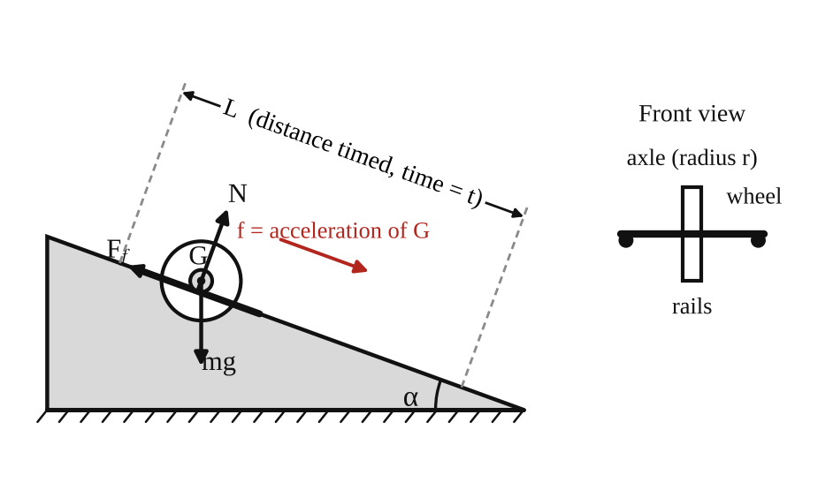
Fig. 1: Wheel and axle rolling down the rails of an inclined plane, with the forces on it.
Method in brief
- Measure the axle radius r, the mass m and the dimensions of the wheel.
- Set the plane to a small angle α. Mark a start line and a finish line a distance L apart.
- Release the wheel from rest at the start line (no push) and time it to the finish line. Repeat several times and take the mean t.
- Repeat for other angles and for other rolling bodies.

3. Results
Table 1: Timing results and radius of gyration
Body | α (°) | L (m) | t₁ (s) | t₂ (s) | t₃ (s) | Mean t (s) | f = 2L/t² (m/s²)

Body | r (m) | k from experiment (m) | k from geometry (m) | % difference

Table 2: Check of Newton's laws (acceleration from theory against acceleration measured)
α (°) | sin α | f theory = g sin α / (1 + k²/r²) | f measured | % difference

4. Analysis of Results
- Acceleration: f = 2L/t² = 2 × [ ] ÷ [ ]² = [ ] m/s².
- Radius of gyration: k² = r²(g t² sin α / 2L − 1) = [ ]²( 9.81 × [ ]² × sin [ ]° ÷ (2 × [ ]) − 1 ) = [ ] m², so k = [ ] m.
- k from geometry: I = [ ] kg m², k² = I/m = [ ], k = [ ] m.
- Percentage accuracy = (k_{exp} − k_{calc}) ÷ k_{calc} × 100 = [ ] %.
- Theoretical acceleration: f = g sin α / (1 + k²/r²) = [ ] m/s².
- Effect of timing error: since f = 2L/t², δf/f ≈ 2 δt/t. With δt ≈ [ ] s and t = [ ] s this gives an error in f of about [ ] %.

5. Observations / Precautions Taken
Observations
- The wheel rolled down slowly, with constant acceleration, without slipping.
- The time of descent was longer for a smaller angle.
- Bodies of the same shape took about the same time, whatever their mass.
- A solid cylinder (smaller k) accelerated faster than a wheel with a heavy rim (larger k).
Precautions
- The wheel was released from rest without a push and from the same start line each time.
- The rails were clean, parallel and free of dust so that the wheel did not slip.
- Each time was measured at least three times and the mean was used, because f depends on t².
- The angle was kept small and measured carefully.

6. Graphs
Plot the following on graph paper from your own readings and attach them here:
- f (measured) against sin α (should be a straight line through the origin)
- Optional: t² against 1/sin α

7. Discussion
Sources of error
- Reaction time when starting and stopping the stopwatch (about 0.2 s). This is large compared with t, and it is doubled in f.
- Difficulty in releasing the wheel exactly at the start line.
- Error in measuring α and in the effective radius r where the axle touches the rails.
- Rolling friction, air resistance and slight slipping.
- Rails not perfectly parallel or level across.
Accuracy of k. The experimental k was [ ] m and the calculated k was [ ] m, a difference of [ ] %. This is [within / outside] the expected accuracy from the timing error above.
Newton's laws. The measured acceleration agreed with g sin α/(1 + k²/r²) to within [ ] %, so the observations [do / do not] verify Newton's second law for combined translation and rotation. The acceleration was constant (L ∝ t²), which shows that the net force and torque were constant.
Rolling friction. Rolling resistance would make the measured acceleration smaller than the theoretical value. Its size can be investigated in two ways: (1) find the angle α_{c} at which the wheel just begins to roll steadily, so that the resistance is about mg sin α_{c}; or (2) use F_{r} = m [ g sin α − f(1 + k²/r²) ] from the measured f. My value was F_{r} ≈ [ ] N, which is [ ] % of mg sin α.

8. Conclusion
The radius of gyration of the wheel and axle was found to be [ ] m from experiment and [ ] m from its dimensions, a difference of [ ] %. The motion had constant acceleration and agreed with f = g sin α/(1 + k²/r²), which supports Newton's laws. Rolling bodies accelerate more slowly than sliding ones because part of the energy goes into rotation. The results are useful in designing wheels, rollers, flywheels and vehicles on slopes.

Section B: Questions
1. What I learnt from the experiment. I learnt how translation and rotation combine in rolling, how to find a radius of gyration from simple timing, and why timing errors matter when the result depends on t².
3. Comment on the experimental procedure. A slow, small-angle motion gives a long time of descent, which reduces the effect of reaction time. Repeating the timing and averaging improves accuracy, and bodies of the same shape give the same acceleration, so many bodies can be tested quickly.
4. Most difficult aspect of the experiment. Timing the descent accurately by hand. It can be reduced with a longer track, a smaller angle, timing gates (photocells) or several timings averaged.
5. Another method that could be used. The compound pendulum (oscillating the body about a knife edge, T = 2π√((k² + h²)/gh)) or a trifilar suspension can also be used to find k.
6. Parameters measured / involved. Angle of slope α, distance L, time t, acceleration f, axle radius r, mass m and radius of gyration k.
7. Measuring instrument used. The stopwatch measures the time t. It reads to 0.01 s, but the reaction time of the person (about 0.2 s) is the real limit on accuracy.
8. Practical relevance. Design of wheels, rollers, flywheels, bearings, vehicles on hills and any rolling machine part.
9. Section of the course it belongs to. Dynamics (kinetics of rigid bodies in plane motion, moment of inertia).
13. What interested me most. Bodies of different mass but the same shape reached the bottom together.
2, 10, 11, 12, 14 and 15 (personal / references): to be filled in by you.

AM 214: Screw Jack

Objective
- To obtain the velocity ratio of the screw jack.
- To plot graphs against increasing load showing the variation of (a) effort, (b) effect of friction and (c) efficiency.
- To obtain an equation relating load and effort, and from it the limiting efficiency of the machine.

1. Theory
A screw jack lifts a load W with a small effort E. In one turn of the turntable the effort moves a distance πD (D = diameter of the turntable + diameter of the cord), while the load rises by one pitch P of the thread.
Velocity ratio V.R. = distance moved by effort / distance moved by load = πD / P
Mechanical advantage M.A. = W / E Efficiency η = M.A. / V.R. × 100 %
If the machine had no friction the effort would be E₀ = W/V.R. The load that E could lift with 100 % efficiency is W₁ = E × V.R., so the effect of friction (load lost to friction) is W₁ − W.
Law of the machine. For most machines the graph of E against W is a straight line:
E = aW + b
where a is the slope and b is the effort needed to overcome friction with no load. As the load becomes very large the term b becomes small compared with aW, so M.A. = W/E tends to 1/a. Therefore
Limiting efficiency = (1/a) / V.R. × 100 %
Theory of the screw. For a square thread of mean diameter d_{m}, lead angle λ (tan λ = P/πd_{m}) and friction angle φ (tan φ = μ), the efficiency is η = tan λ / tan(λ + φ). A screw jack is self-locking (stays up when the effort is removed) if φ > λ, which means its efficiency is below 50 %.

2. Apparatus
Tec-equipment screw jack with a steel turntable, cord, effort hanger and dead weights, meter rule, vernier calipers and outside calipers.
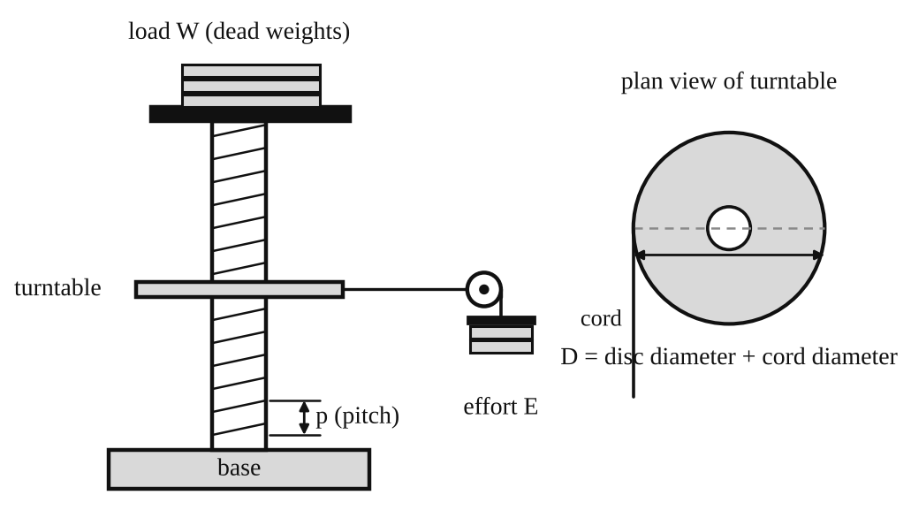
Fig. 1: Screw jack with turntable (schematic) and plan view of the turntable.
Method in brief
- Measure the pitch P of the thread, the turntable diameter plus the cord diameter (D), and calculate πD and V.R.
- With no load, add effort mass until the turntable just turns slowly at constant speed. This effort is the one needed to raise no load.
- Repeat for increasing loads (for example 5, 10, 15, 20 ... up to 80 kg) and record the effort each time.

3. Results
Pitch P = [ ] mm. D = [ ] mm. πD = [ ] mm. V.R. = πD/P = [ ].
Table 1: Screw jack results
Actual load W (kg) | Effort E (kg) | V.R. | Load if 100 % efficient W₁ = E × V.R. | Effect of friction (W₁ − W) | M.A. = W/E | Efficiency (M.A./V.R.) × 100 %
0
5
10
15
20

4. Analysis of Results
- V.R. = πD/P = π × [ ] ÷ [ ] = [ ].
- W₁ = E × V.R. = [ ] × [ ] = [ ] kg and effect of friction = W₁ − W = [ ] − [ ] = [ ] kg.
- M.A. = W/E = [ ] ÷ [ ] = [ ] and η = M.A./V.R. × 100 = [ ] %.
- From the graph of E against W: slope a = ΔE/ΔW = [ ] and intercept b = [ ] kg. So the law of the machine is E = [ ]W + [ ].
- Limiting efficiency = (1/a)/V.R. × 100 = (1/[ ]) ÷ [ ] × 100 = [ ] %.
- At W = 0 the efficiency is zero (all the effort goes into friction), so efficiency rises as the load increases.

5. Observations / Precautions Taken
Observations
- The effort needed to raise no load was not zero. It was [ ] kg because of friction in the thread and bearing.
- Effort increased steadily (almost linearly) with load.
- The jack stayed in position when the effort was removed, so it is self-locking.
- The velocity ratio was large ([ ]), so a small effort lifted a large load.
Precautions
- The turntable was turned slowly and at constant speed when the effort was read.
- The pitch and diameters were measured with calipers (more accurate than a rule), and the cord diameter was added to the turntable diameter.
- The thread was lubricated lightly and kept the same through the test.
- The effort mass was supported while the load was being changed.

6. Graphs
Plot the following on graph paper from your own readings and attach them here:
- Efficiency against load W
- Effect of friction (W₁ − W) against load W
- Effort E against load W (straight line E = aW + b)

7. Discussion
Sources of error
- It is difficult to judge the effort that gives exactly constant speed. Friction is not constant when the jack starts or stops.
- Error in measuring the pitch and the effective diameter D, which directly affects V.R.
- Friction in the turntable bearing and in the cord, and the weight of the hanger.
- Different thread surface conditions during the test.
Shapes of the graphs. The efficiency curve rises from zero and flattens towards the limiting efficiency. The friction effect (W₁ − W) increases with load, more slowly at high loads. The effort graph is a straight line with a positive intercept b. The limiting efficiency I found was [ ] %, and the theoretical value from tan λ / tan(λ + φ) was [ ] %. [They agree / differ by [ ] %].
The efficiency of the jack is low (below 50 %). That is the price of a high V.R. and self-locking: most of the effort is spent on friction in the thread.

8. Conclusion
The velocity ratio of the screw jack was [ ]. Its law of the machine was E = [ ]W + [ ], and its limiting efficiency was [ ] %. The efficiency increased with load, and the jack was self-locking. Screw jacks are used for lifting vehicles, in presses, vices, clamps, machine tool lead screws and aircraft flap actuators.

Section B: Questions
1. What I learnt from the experiment. I learnt how to find V.R., M.A. and efficiency of a machine, how to write its law E = aW + b, and how friction limits the efficiency.
3. Comment on the experimental procedure. Taking effort readings at many loads and plotting E against W reduces the effect of a single bad reading, and the straight line gives a and b more accurately than one point. The loads are quick to change, so the test takes little time.
4. Most difficult aspect of the experiment. Judging the effort that gives a slow constant speed. It can be reduced by adding very small masses and turning the turntable by hand first, and by repeating each reading.
5. Another method that could be used. A spring balance or a torque wrench on the screw handle can measure the effort. A hydraulic jack could also be used to compare efficiencies.
6. Parameters measured / involved. Pitch P, turntable diameter D (with cord), load W, effort E, V.R., M.A. and efficiency.
7. Measuring instrument used. The vernier calipers measure the pitch and the diameter. The reading is the main scale reading plus the vernier division that lines up, to about 0.02 mm.
8. Practical relevance. Car and truck jacks, lifting platforms, presses, vices, G-clamps, valve screws and the lead screws of lathes and machine tools.
9. Section of the course it belongs to. Machines and mechanisms (simple machines, velocity ratio and efficiency).
13. What interested me most. A very small effort could lift a heavy load, and the load stayed in place when the effort was removed.
2, 10, 11, 12, 14 and 15 (personal / references): to be filled in by you.

AM 217: Centrifugal Force Experiment

Objective
- To show that the centrifugal force on a rotating mass is m ω² r, by finding the speed at which a balanced bell crank "snaps over", and to study how this speed changes with the masses and with the radius.

1. Theory
A mass m moving in a circle of radius r at angular velocity ω needs an inward (centripetal) force mω²r. The equal and opposite outward force on the mass is the centrifugal force:
F = m ω² r
The apparatus has two pivoted bell cranks on a horizontal rotating arm. On each crank the vertical arm (length a) carries a mass m_{a} and the horizontal arm (length b) carries a mass m_{b}. The pivot is at radius r from the axis of rotation.
- The centrifugal force on m_{a} acts horizontally, outward, at height a above the pivot. Its moment about the pivot is m_{a}ω²r × a.
- The weight of m_{b} acts downward at distance b from the pivot. Its moment is m_{b}g × b, in the opposite sense.
- The weight of m_{a} and the centrifugal force on m_{b} both pass through the pivot, so they have no moment.
The crank snaps from one stop to the other when the two moments are equal:
m_{a} ω² r × a = m_{b} g × b so centrifugal force = m_{a} ω² r = m_{b} g b / a
This gives ω² = (m_{b} g b)/(m_{a} r a). So ω² is proportional to 1/m_{a} (Test I), proportional to m_{b} (Test II) and proportional to 1/r (Test III). The angular velocity is found from the speed N in rev/min: ω = 2πN/60.

2. Apparatus
A horizontal rotating member driven by a variable-speed motor and gearbox, carrying two brackets with pivoted balanced bell cranks. Each crank sits between two stops: one holds its arms horizontal/vertical and the other lets the vertical arm move just out of the upright position. The brackets can be locked at different radii in equally spaced holes. Accurately machined weights fit on the crank arms. Speed is read from the counter on the control box with a stopwatch, or with a tachometer.
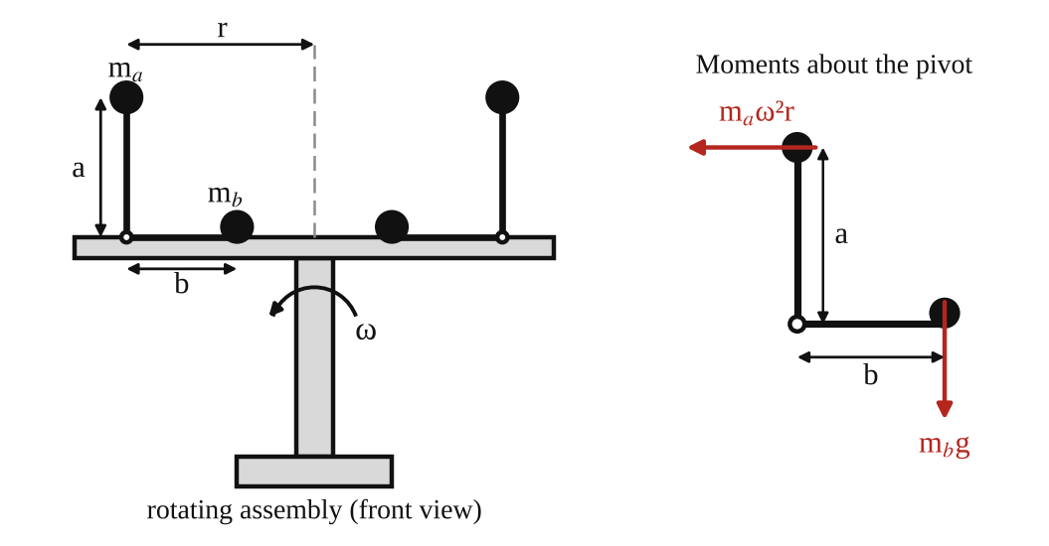
Fig. 1: Rotating assembly with two bell cranks (left) and the moments on one crank (right).
Method in brief
- Run the apparatus for a few minutes first so the bearings in the motor and gearbox reach a steady condition.
- Fix equal masses on the two vertical arms and equal masses on the two horizontal arms, and pin both brackets at equal radius.
- Start the motor very slowly and raise the speed until both cranks audibly "snap over". Measure the speed at that moment.
- Test I: keep r and m_{b} constant and vary m_{a} five times. Test II: keep r and m_{a} constant and vary m_{b} five times. Test III: keep m_{a} and m_{b} constant and vary r from the inner to the outer radius.

3. Results
Dimensions: a = [ ] mm, b = [ ] mm.
Table 1 (Test I): varying m_{a}; r = [ ] m and m_{b} = [ ] kg constant
m_{a} (kg) | 1/m_{a} (kg⁻¹) | N (rpm) | ω = 2πN/60 (rad/s) | ω² (rad²/s²) | F = m_{a}ω²r (N) | F = m_{b}gb/a (N)

Table 2 (Test II): varying m_{b}; r = [ ] m and m_{a} = [ ] kg constant
m_{b} (kg) | N (rpm) | ω (rad/s) | ω² (rad²/s²) | F = m_{a}ω²r (N) | F = m_{b}gb/a (N)

Table 3 (Test III): varying r; m_{a} = [ ] kg and m_{b} = [ ] kg constant
r (m) | 1/r (m⁻¹) | N (rpm) | ω (rad/s) | ω² (rad²/s²) | F = m_{a}ω²r (N) | F = m_{b}gb/a (N)

4. Analysis of Results
- ω = 2πN/60 = 2π × [ ] ÷ 60 = [ ] rad/s, so ω² = [ ].
- Experimental centrifugal force: F = m_{a}ω²r = [ ] × [ ] × [ ] = [ ] N.
- Calculated (balance of moments): F = m_{b}gb/a = [ ] × 9.81 × [ ] ÷ [ ] = [ ] N.
- Percentage difference = (experimental − calculated) ÷ calculated × 100 = [ ] %.
- Slope of the 1/m_{a} against ω² graph = a r/(m_{b} g b) → [ ]. The expected line passes through the origin.

5. Observations / Precautions Taken
Observations
- Both cranks changed over together, with an audible click, at almost the same speed.
- A heavier m_{a} (Test I) or a larger radius (Test III) made the cranks snap over at a lower speed.
- A heavier m_{b} (Test II) needed a higher speed.
- Small changes of speed near the snap-over point were hard to read.
Precautions
- The apparatus was left running for a few minutes before starting the test.
- The speed was raised very slowly near the snap-over speed so the reading was not overshot.
- Equal weights were fitted on both cranks, and both brackets were pinned at the same radius, so the machine stayed balanced.
- Guards were closed and everyone stood clear while the arm was spinning.

6. Graphs
Plot the following on graph paper from your own readings and attach them here:
- Reciprocal of mass (1/m_{a}) against ω² (Test I)
- Centrifugal force against ω² (Test II)
- Reciprocal of radius (1/r) against ω² (Test III)
Each should be a straight line through the origin if F = mω²r holds.

7. Discussion
Comparing calculated and experimental results
The experimental and calculated forces agreed to within [ ] %. The graphs were [straight lines through the origin / close to straight lines], which supports F = mω²r: for a given balancing moment, ω² varies as 1/m_{a} and as 1/r.
Possible reasons for any discrepancy
- The moment of the stops and friction at the crank pivot oppose the snap-over, so the real speed is a little higher.
- The moment of the weight of the crank arms themselves was not exactly balanced.
- The snap-over was identified by sound, and the speed was still rising, so there is a lag in the reading.
- The radius r was measured to the pivot, not to the exact centre of the mass.
- Errors in the speed counter, in the stopwatch timing and in the lengths a and b.

8. Conclusion
The centrifugal force on a rotating mass was shown to be mω²r and, at the snap-over speed, equal to m_{b}gb/a. The experimental and calculated values agreed to within [ ] %. The force increases with mass, with radius and with the square of the speed. The result is used in the design of centrifugal governors, centrifuges, centrifugal clutches and pumps, and in balancing rotating machinery.

Section B: Questions
1. What I learnt from the experiment. I learnt that centrifugal force depends on mass, radius and the square of the angular velocity, and how moments about a pivot can be used to measure it.
3. Comment on the experimental procedure. Using two equal cranks keeps the machine balanced. Changing one quantity at a time (mass, then radius) makes the relationship easy to see, and each test needs only a few runs, so it is quick.
4. Most difficult aspect of the experiment. Detecting the exact snap-over speed by sound. It can be reduced by increasing the speed very slowly, repeating each reading, or using a light sensor to detect the movement.
5. Another method that could be used. A whirling mass on a string with a spring balance, or a centrifugal governor, can also be used to measure centrifugal force.
6. Parameters measured / involved. Masses m_{a} and m_{b}, radius r, lengths a and b, speed N (rpm) and ω.
7. Measuring instrument used. The tachometer (or counter with stopwatch) measures the speed N in rev/min. It is read at the moment the cranks snap over.
8. Practical relevance. Governors, centrifugal clutches, centrifugal pumps, centrifuges, washing-machine drums, banked road bends and the balancing of rotating shafts.
9. Section of the course it belongs to. Dynamics (kinetics of particles, circular motion and balancing of rotating masses).
13. What interested me most. Both cranks snapped over together with an audible click at a well-defined speed.
2, 10, 11, 12, 14 and 15 (personal / references): to be filled in by you.

AM 218(A): Simple Wheel and Axle

Objective
- To determine the velocity ratio of the machine.
- To obtain an equation for the relationship between load and effort, and from it a value for the limiting efficiency of the machine.

1. Theory
A wheel and axle is a simple machine in which an effort E applied on the rim cord of a wheel of effective diameter D lifts a load W hung from the cord on an axle of effective diameter d. (Effective diameter = diameter of wheel or axle + diameter of the cord.)
In one turn the effort moves πD and the load moves πd, so
Velocity ratio V.R. = πD / πd = D / d
Mechanical advantage M.A. = W / E Efficiency η = M.A. / V.R. × 100 %
With no friction, E₀ = W/V.R. and η = 100 %. The effect of friction is the load W₁ = E × V.R. that the effort could lift if there were no friction, minus the actual load, W₁ − W.
Law of the machine. The graph of E against W is a straight line, so E = aW + b. Here a is the slope and b is the effort needed to overcome friction at no load. When W is very large, M.A. → 1/a, so
Limiting efficiency = (1/a) / V.R. × 100 %
In an ideal machine a = 1/V.R. and b = 0, so the limiting efficiency would be 100 %. Friction makes a larger than 1/V.R. and b greater than zero.

2. Apparatus
Tec-equipment wheel and axle mounted on a wall, load hanger, effort hanger, cords, meter rule, dead weights and calipers.
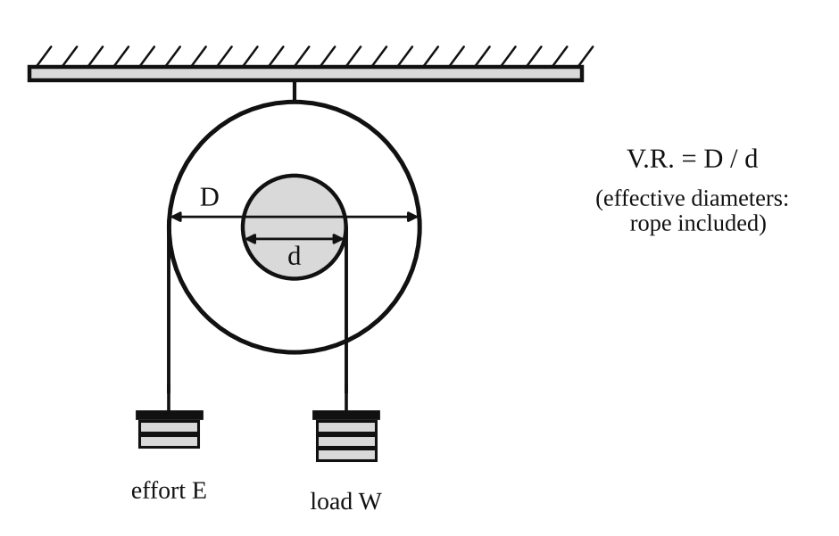
Fig. 1: Simple wheel and axle.
Method in brief
- Measure the diameters of the wheel (D) and the axle (d) with calipers and add the cord diameter to each.
- Calculate V.R. = D/d (check by counting the rope movement for one turn of the wheel).
- Wind the cords on the wheel and the axle in opposite senses. Add effort until the load hanger just rises at a constant speed. The effort with no load is the effort needed to lift the load hanger alone.
- Repeat for loads of 10, 20, 30, 40 ... up to 100 N.

3. Results
D = [ ] mm, d = [ ] mm, V.R. = D/d = [ ].
Table 1: Results
Actual load W | Effort E | V.R. | Load if 100 % efficient W₁ = E × V.R. | Effect of friction (W₁ − W) | M.A. = W/E | Efficiency (M.A./V.R.) × 100 %
0
10
20
30
40
50
60
70
80
90
100

4. Analysis of Results
- V.R. = D/d = [ ] ÷ [ ] = [ ].
- W₁ = E × V.R. = [ ] × [ ] = [ ] N and W₁ − W = [ ] N.
- M.A. = W/E = [ ] and η = M.A./V.R. × 100 = [ ] %.
- From the E–W graph: a = ΔE/ΔW = [ ] and b = [ ] N, so E = [ ]W + [ ].
- Limiting efficiency (experimental) = (1/a)/V.R. × 100 = [ ] %.
- Theoretical limiting efficiency = 100 % (no friction), so the difference = [ ] %.

5. Observations / Precautions Taken
Observations
- The effort needed increased almost in a straight line with the load.
- Efficiency was low at small loads and increased as the load increased.
- The effort was always greater than W/V.R., because of friction in the bearing and cords.
Precautions
- The cords were wound neatly in the correct senses and did not overlap.
- The effort was added slowly so the load rose at constant speed.
- Diameters were measured at several places and the cord thickness was included.
- At the end of each test the effort mass was supported while the load masses were removed, so the machine did not spin.

6. Graphs
Plot the following on graph paper from your own readings and attach them here:
- Efficiency against load
- Effect of friction against load
- Effort against load (E = aW + b)

7. Discussion
Sources of error
- Judging "just rises at constant speed" by eye, so the effort has some range of error.
- Friction in the axle bearing, which is not the same at all loads.
- Errors in D and d, which change V.R. directly.
- The weight of the hangers and the stiffness of the cords.
Agreement with theory. The experimental limiting efficiency was [ ] % against 100 % for an ideal machine. The difference is because of friction. The E–W graph [was / was not] a straight line, and its intercept b = [ ] N is the effort lost to friction at no load. The limiting efficiency is higher than the efficiency at any single load in the test.

8. Conclusion
The velocity ratio of the wheel and axle was [ ]. The law of the machine was E = [ ]W + [ ], and the limiting efficiency was [ ] %. Efficiency increased with load. Wheels and axles are used in winches, windlasses, capstans, door knobs, steering wheels and screwdrivers.

Section B: Questions
1. What I learnt from the experiment. I learnt how to find the velocity ratio, mechanical advantage and efficiency of a wheel and axle, and how to get the law of the machine from a graph.
3. Comment on the experimental procedure. Taking readings at many loads and using the graph gives a better value of the limiting efficiency than one reading. The set-up is simple, so many readings are taken in a short time.
4. Most difficult aspect of the experiment. Deciding when the load rises at constant speed. It can be reduced by adding very small masses, tapping the machine gently and repeating each reading.
5. Another method that could be used. A spring balance in place of the effort mass, or a differential wheel and axle, or a pulley system could be used to show the same ideas.
6. Parameters measured / involved. Diameters D and d, load W, effort E, V.R., M.A. and efficiency.
7. Measuring instrument used. The vernier calipers measure the diameters of the wheel and axle to about 0.02 mm.
8. Practical relevance. Winches, windlasses, capstans, cranes, steering wheels, door handles and screwdrivers.
9. Section of the course it belongs to. Machines and mechanisms (simple machines, V.R., M.A., efficiency).
13. What interested me most. A small effort on the large wheel lifted a much larger load on the axle.
2, 10, 11, 12, 14 and 15 (personal / references): to be filled in by you.

AM 218(B): Wheel and Differential Axle

Objective
- To calculate the velocity ratio of the machine.
- To obtain an equation for the relationship between load and effort, and from it a value for the limiting efficiency of the machine.

1. Theory
The wheel and differential axle has a wheel of effective diameter D and an axle in two steps: a major axle of effective diameter d₁ and a minor axle of effective diameter d₂. The load hangs from a movable pulley on a cord loop. One end of the loop is wound on d₁ and the other end is wound on d₂ in the opposite sense.
In one turn of the wheel the effort moves πD. At the same time the cord winds on by πd₁ on the major axle and unwinds by πd₂ from the minor axle, so the loop shortens by π(d₁ − d₂). The load is carried by two strands, so it rises by half of this:
distance moved by the load = π(d₁ − d₂) / 2
V.R. = πD / [ π(d₁ − d₂) / 2 ] = 2D / (d₁ − d₂)
M.A. = W / E η = M.A. / V.R. × 100 % W₁ = E × V.R. Effect of friction = W₁ − W
Law of the machine: E = aW + b. The limiting efficiency occurs when M.A. = 1/a, so limiting efficiency = (1/a)/V.R. × 100 %. The velocity ratio is large when d₁ and d₂ are nearly equal, so a small effort can lift a big load. For lifting, the cords are wound anticlockwise on D, clockwise on d₁ and anticlockwise on d₂.

2. Apparatus
Wheel and differential axle mounted on the wall, movable pulley and load hanger, effort hanger, cords, meter rule, dead weights and calipers.
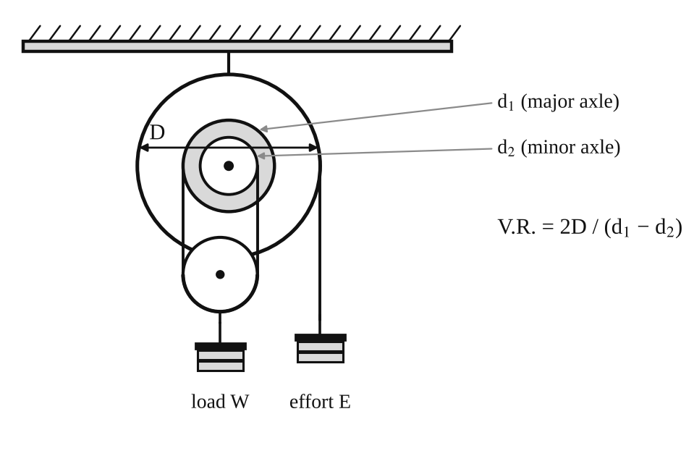
Fig. 1: Wheel and differential axle.
Method in brief
- Measure D, d₁ and d₂ with calipers and add the cord diameter to each.
- Calculate V.R. = 2D/(d₁ − d₂).
- Wind the cords as described and add effort until the load just rises at constant speed. With no load this gives the friction effort.
- Repeat for loads of 10, 20, 30 ... up to 100 N.

3. Results
D = [ ] mm, d₁ = [ ] mm, d₂ = [ ] mm. V.R. = 2D/(d₁ − d₂) = [ ].
Table 1: Results
Actual load W | Effort E | V.R. | Load if 100 % efficient W₁ = E × V.R. | Effect of friction (W₁ − W) | M.A. = W/E | Efficiency (M.A./V.R.) × 100 %
0
10
20
30
40
50
60
70
80
90
100

4. Analysis of Results
- V.R. = 2D/(d₁ − d₂) = 2 × [ ] ÷ ( [ ] − [ ] ) = [ ].
- W₁ = E × V.R. = [ ] N, effect of friction = W₁ − W = [ ] N.
- M.A. = W/E = [ ], η = M.A./V.R. × 100 = [ ] %.
- From the graph: a = [ ], b = [ ] N, so E = [ ]W + [ ].
- Limiting efficiency = (1/a)/V.R. × 100 = [ ] %.
- Theoretical limiting efficiency = 100 %, so the difference is [ ] %.

5. Observations / Precautions Taken
Observations
- The velocity ratio was large, so the effort was much smaller than the load.
- The effort needed to raise no load was [ ] N because of friction.
- The efficiency was lower than for the simple wheel and axle, and below 50 % for most loads.
- The load stayed up when the effort was removed (the machine is self-locking if the efficiency is below 50 %).
Precautions
- The cords were wound on in the correct senses and did not overlap.
- The load was raised slowly and at constant speed.
- The diameters were measured carefully, since d₁ − d₂ is a small difference and any error in it changes V.R. a lot.
- At the end of each test the effort mass was supported while the load masses were removed.

6. Graphs
Plot the following on graph paper from your own readings and attach them here:
- Efficiency against load
- Effect of friction against load
- Effort against load (E = aW + b)

7. Discussion
Sources of error
- d₁ − d₂ is small, so a small error in measuring either diameter gives a large error in V.R.
- Judging constant speed by eye.
- Friction in the bearings and the movable pulley, and cord stiffness.
- The load pulley may hang slightly sideways if the strands are not the same length.
Comparison with theory. The experimental limiting efficiency was [ ] %. The ideal value is 100 %. The difference comes from friction, which is large here because the velocity ratio is large and the cords bend around several small pulleys.

8. Conclusion
The velocity ratio of the differential axle was [ ]. The law of the machine was E = [ ]W + [ ] and the limiting efficiency was [ ] %. The machine gives a large mechanical advantage but a low efficiency. Differential axles and the similar differential chain block are used for lifting heavy loads in workshops and garages.

Section B: Questions
1. What I learnt from the experiment. I learnt how a differential axle gives a high velocity ratio, and how to get the law of the machine and its limiting efficiency from a graph.
3. Comment on the experimental procedure. Many loads are used and a graph is drawn, so the result is an average and not one reading. The test is quick because only the effort mass changes.
4. Most difficult aspect of the experiment. Measuring d₁ and d₂ accurately, because V.R. depends on their small difference. Using calipers and measuring several times reduces the error.
5. Another method that could be used. A differential chain block (Weston differential pulley block) or a screw jack can also show a high velocity ratio.
6. Parameters measured / involved. D, d₁, d₂, load W, effort E, V.R., M.A. and efficiency.
7. Measuring instrument used. The calipers (vernier or outside calipers) measure the diameters. Outside calipers are set on the axle and then read on a rule.
8. Practical relevance. Chain blocks and hoists for lifting engines and heavy parts in garages and workshops.
9. Section of the course it belongs to. Machines and mechanisms (simple machines and efficiency).
13. What interested me most. The load stayed up by itself when I removed the effort, because the machine is self-locking.
2, 10, 11, 12, 14 and 15 (personal / references): to be filled in by you.

Tensile Test: Tensile Test on a Metal Specimen
The title page of this experiment is missing from the scanned manual, so this report follows the notes and the report instructions that are in it. Please check the experiment name and code.

Objective
- To pull a metal test piece to fracture and record its load–extension curve.
- To find Young's modulus, the yield stress, the ultimate tensile strength, the percentage elongation and the percentage reduction in area, and to compare them with accepted values.

1. Theory
The tensile test is the most common way of finding the mechanical properties of a metal. A test piece is pulled at a steady rate until it breaks, while the load P and the extension ΔL are recorded.
Engineering stress σ = P / A₀ Engineering strain ε = ΔL / L₀
A₀ is the original cross-sectional area (πd₀²/4) and L₀ the original gauge length. The stress–strain diagram has these parts:
- Elastic region: stress is proportional to strain (Hooke's law), σ = Eε. The slope is Young's modulus E. The material returns to its original length when unloaded. The end of this straight line is the limit of proportionality.
- Yield point: the stress at which the metal starts to stretch permanently with little or no increase in load. For metals with no clear yield point the 0.2 % proof stress is used.
- Strain hardening up to the ultimate tensile strength (UTS) = P_{max}/A₀.
- Necking and fracture: the specimen narrows locally, the load falls, and the specimen breaks.
Percentage elongation = (L_{f} − L₀) / L₀ × 100 % Percentage reduction in area = (A₀ − A_{f}) / A₀ × 100 %
Both are measures of ductility. A ductile metal (such as mild steel) stretches a lot, necks and breaks in a "cup and cone" fracture. A brittle metal (such as cast iron) breaks with little stretch and a flat fracture. The test machine draws the load–extension curve on a chart drum, with the extension magnified by a known factor, so the chart readings must be divided by this magnification.

2. Apparatus
Hand-operated tensile testing machine (tensometer) with a recording chart drum, grips for the test piece, a test piece of metal, vernier calipers to measure the diameter and gauge length, and a meter rule for the overall length.
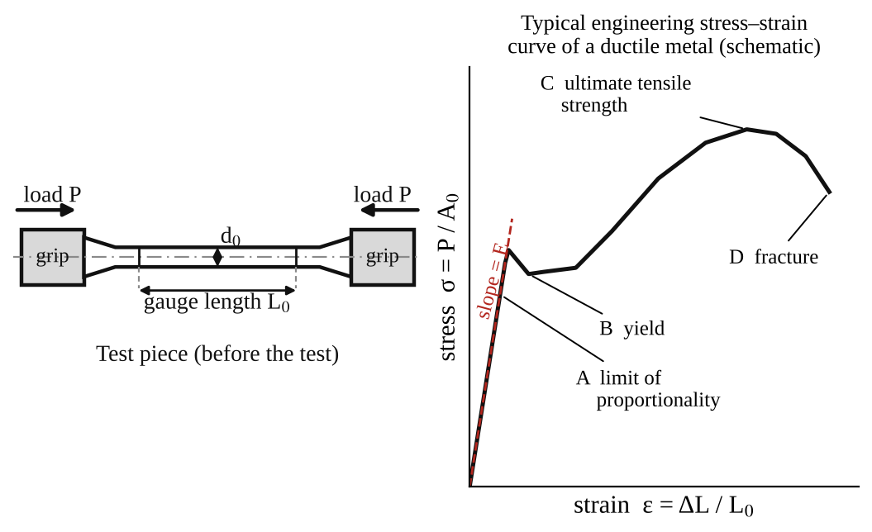
Fig. 1: Test piece (left) and typical stress–strain curve of a ductile metal (right).
Method in brief
- Measure and record the initial diameter, gauge length and overall length of the test piece.
- Fit the test piece in the grips and fit the chart paper on the drum.
- Turn the handle at a constant rate, past the yield point, until the specimen fractures. Do not stop part-way, because stopping changes the load–extension curve.
- One person turns the handle while another watches the specimen and the grips.
- Remove the broken pieces, fit them together, and measure the final diameter at the neck, the final gauge length and the overall length. Examine the fracture surface. Remove the chart paper and attach it to the report.

3. Results
Table 1: Dimensions of the test piece
Measurement | Initial | Final
Diameter (mm)
Gauge length (mm)
Overall length (mm)
Cross-sectional area (mm²)

Material of the test piece: [ ]. Magnification of the extension on the chart: [ ].
Table 2: Load and extension read from the chart
Point | Load P (N) | Extension on chart (mm) | Actual extension ΔL (mm) | Stress σ = P/A₀ (N/mm²) | Strain ε = ΔL/L₀
1
2
3
4
5
6
7
8

Table 3: Mechanical properties
Property | Result | Typical value for mild steel
Young's modulus E (N/mm²) |  | about 200 000
Yield stress (N/mm²) |  | about 250
Ultimate tensile strength (N/mm²) |  | about 400 to 500
Percentage elongation (%) |  | about 20 to 30
Percentage reduction in area (%) |  | about 50 or more

The typical values are for mild steel only. Use the values for your own material if it is not mild steel.

4. Analysis of Results
- A₀ = πd₀²/4 = π × [ ]² ÷ 4 = [ ] mm².
- Actual extension = chart extension ÷ magnification = [ ] ÷ [ ] = [ ] mm.
- σ = P/A₀ = [ ] ÷ [ ] = [ ] N/mm², ε = ΔL/L₀ = [ ] ÷ [ ] = [ ].
- Young's modulus E = slope of the straight part = Δσ/Δε = [ ] ÷ [ ] = [ ] N/mm².
- Yield stress = P_{y}/A₀ = [ ] ÷ [ ] = [ ] N/mm².
- UTS = P_{max}/A₀ = [ ] ÷ [ ] = [ ] N/mm².
- Percentage elongation = (L_{f} − L₀)/L₀ × 100 = ( [ ] − [ ] ) ÷ [ ] × 100 = [ ] %.
- Percentage reduction in area = (A₀ − A_{f})/A₀ × 100 = [ ] %.

5. Observations / Precautions Taken
Observations
- The load rose steadily at first and the specimen stretched elastically.
- At the yield point the load [dropped slightly / levelled off] and the specimen stretched without more load.
- The load rose again (strain hardening) up to a maximum, after which a neck formed and the load fell until the specimen broke.
- The fracture was [cup and cone / flat] and the surface looked [fibrous / granular].
Precautions
- The handle was turned at a constant rate and not stopped before the specimen fractured.
- The specimen was checked for slip in the jaws. A second person watched for slippage, and the test would be repeated if it were excessive.
- The diameter and lengths were measured with calipers at several places.
- The chart paper was removed from the drum carefully and attached to the report.

6. Graphs
Plot the following on graph paper from your own readings and attach them here:
- Load–extension curve (the chart from the machine, attached)
- Engineering stress–strain curve, drawn on graph paper from Table 2

7. Discussion
Importance of the stress–strain diagram. It shows the strength, stiffness and ductility of a metal in one picture. Designers use E to find deflections, the yield stress to set the safe working stress, the UTS for the maximum load, and the ductility to judge how the part will fail (with a warning, or suddenly).
Interpretation of my results. My specimen had E = [ ] N/mm², a yield stress of [ ] N/mm², a UTS of [ ] N/mm², an elongation of [ ] % and a reduction in area of [ ] %. Compared with typical mild steel (E ≈ 200 000 N/mm², yield ≈ 250 N/mm², UTS ≈ 400–500 N/mm²) these values are [close / different] by [ ] %. Compared with other metals, aluminium has a lower E (about 70 000 N/mm²) and brass is in between, while cast iron is much more brittle.
Sources of error
- Slip of the specimen in the grips, or movement of the grips themselves, makes the measured extension too big, especially in the elastic part, so E is too low.
- The extension is read from a magnified chart, so reading the chart and the magnification factor give errors.
- The cross-sectional area is not exactly circular or uniform along the gauge length.
- The turning rate of the handle was not exactly constant, and the test was done by hand.
- The final diameter at the neck is hard to measure on a broken specimen.

8. Conclusion
The tensile test gave Young's modulus = [ ] N/mm², yield stress = [ ] N/mm², UTS = [ ] N/mm², elongation = [ ] % and reduction in area = [ ] %. The specimen is [ductile / brittle]. These properties are used to choose materials for shafts, bolts, structures, cables and machine parts.

Section B: Questions
1. What I learnt from the experiment. I learnt how a tensile test is done, how to read a load–extension chart, and how to find E, yield stress, UTS and ductility.
3. Comment on the experimental procedure. The test machine draws the curve automatically, so one test gives all the properties and takes only a few minutes. The accuracy depends on keeping a steady rate and on no slip in the grips.
4. Most difficult aspect of the experiment. Turning the handle at a constant rate and watching for slip at the same time. It can be reduced by having two people (one turning, one watching), or by using a motor-driven machine.
5. Another method that could be used. A universal testing machine (Instron type) with an extensometer, or a hydraulic testing machine with a load dial and a clip-on extensometer.
6. Parameters measured / involved. Initial and final diameters, gauge lengths and overall lengths, load P, extension ΔL, magnification of the chart.
7. Measuring instrument used. The vernier calipers measure the diameter of the test piece. The chart drum records load against extension.
8. Practical relevance. Selection and quality control of steel for buildings, bridges, cables, bolts, pressure vessels and machine shafts.
9. Section of the course it belongs to. Strength of materials (stress, strain and mechanical properties).
13. What interested me most. The neck that formed on the specimen just before it broke, and the cup-and-cone fracture.
2, 10, 11, 12, 14 and 15 (personal / references): to be filled in by you.

AM 221: Radial Cam and Follower

Objective
- To record the kinematic properties (displacement, velocity and acceleration) of various radial cams.

1. Theory
A cam is a rotating or sliding part that gives a required motion to another part called the follower. In a radial cam the follower moves up and down (radially) as the cam turns on its shaft. The follower motion is set by the shape of the cam profile, so the same machine can give many different motions just by changing the cam.
For a cam turning at constant angular velocity ω, the follower displacement s is a function of the cam angle θ. The velocity and acceleration of the follower follow by differentiating:
v = ds/dt = ω (ds/dθ) a = dv/dt = ω² (d²s/dθ²)
The four cams in the experiment give four different types of motion for the rise (and the fall):
- Cam A (simple harmonic motion, SHM). s = (h/2)(1 − cos(πθ/β)), where h is the lift and β the angle of rise. The velocity is a sine curve and the acceleration a cosine curve. The acceleration is finite, but it jumps from a maximum to zero at the start and end of the rise (so there is a small jerk).
- Cam B (uniform motion, constant velocity). s = hθ/β. The velocity is constant during the stroke. At the start and end of each stroke the velocity changes suddenly, so the acceleration theoretically becomes infinite (a shock).
- Cam C (constant acceleration). The follower accelerates uniformly for the first half of the rise and decelerates uniformly in the second half: s = 2h(θ/β)² for the first half. The acceleration is constant but changes sign. This gives the smallest maximum acceleration for a given lift and rise angle, but the acceleration changes suddenly at three points.
- Cam D (tangent cam). The profile is made of straight lines (tangents) joined to circular arcs. The follower motion is a mixture of uniform and varying velocity.
The type of follower also changes the motion that results from the same cam profile. The follower types provided are the roller, lever, knife-edge, flat-footed and offset roller. A knife-edge follower gives the exact profile motion but wears quickly, a roller follower reduces wear because of rolling contact, a flat-footed follower gives a lift that depends on the cam shape and is limited to convex cams, and an offset roller follower changes the pressure angle and the displacement curve.

2. Apparatus
Radial cam and follower apparatus: four cams (A: SHM, B: uniform motion, C: constant acceleration, D: tangent), five follower types (roller, lever, knife-edge, flat-footed and offset roller), a dial gauge with 40 mm travel graduated in 0.01 mm, a revolution counter on the dial, a protractor scale (20° divisions on the lever arm scale), a centre wing nut for locking the cam and a slotted spigot for the gauge.
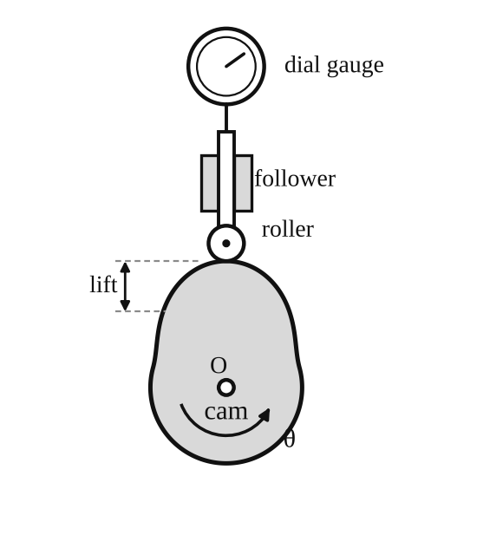
Fig. 1: Radial cam and roller follower with dial gauge (schematic).
Setting up
- Fit the screwed spigot of the gauge into the slotted hole and tighten the nut finger-tight.
- Loosen the centre wing nut, rotate the selected cam until the roller follower rests on the highest point.
- Set the dial gauge to read 50 mm (that is, 2 on the revolution counter and 0 on the main scale) and adjust the bezel for fine setting. Tighten the dial gauge fixing nut.
Method in brief
- Use a 25 mm diameter roller on the centreline of the cam. Fix cam A in position and zero the pointer and dial gauge. The centre wing nut is loosened so the cam can be turned and then locked at any position, and the other wing nuts are kept tight.
- Turn the cam a few degrees at a time and record the follower displacement (lift) from the dial gauge at each angle, for one complete revolution.
- Plot cam angle against displacement on a suitable scale.
- Repeat for the other cams, and with the other followers if time allows.
- Lever arm test: remove the push rod and dial gauge using the two wing nuts at the back of the column, screw the roller follower onto the end of the lever arm, set the cam at its lowest point under the follower, set the pointer to zero on the 20° scale, and then proceed as above, noting the angle of displacement of the lever for each cam position.

3. Results
Follower: [roller / lever / knife-edge / flat-footed / offset roller]. Cam: [A / B / C / D]. Roller diameter = 25 mm.
Table 1: Displacement of the follower against cam angle (cam ___)
Cam angle θ (°) | Dial reading (mm) | Displacement s (mm) | ds/dθ (mm/°) | d²s/dθ² (mm/°²)
0
10
20
30
40
50
60
70
80
90
100
110
120

Continue to 360° in the same way (the rows above go to 120°). If you took a different step, change the first column.
The velocity and acceleration are found by graphical differentiation of the displacement curve, as the manual asks (see the Graphs section).

4. Analysis of Results
- Displacement s = dial reading − reading at the lowest point (or highest point) of the follower = [ ] mm.
- Velocity curve: slope of the s–θ graph at each angle, ds/dθ = [ ] mm/°. The actual velocity for a given cam speed ω is v = ω(ds/dθ), with ω in rad/s and ds/dθ in mm/rad (multiply the value per degree by 57.3).
- Acceleration curve: slope of the ds/dθ graph, d²s/dθ² = [ ] mm/°². The actual acceleration is a = ω²(d²s/dθ²) (convert to per radian).
- Angles at which the acceleration peaks occur: [ ]° and [ ]°.
- Lift h = [ ] mm, angle of rise β = [ ]°, dwell angle = [ ]°, angle of return = [ ]°.
Expected shapes from the theory (see Fig. 2). The experiment should give the same shapes, but with rounded corners.
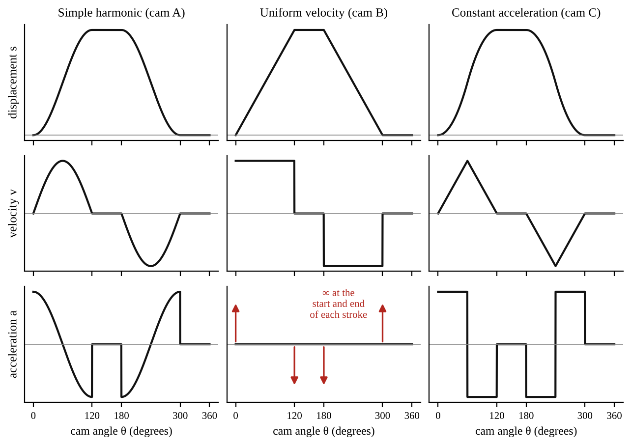
Fig. 2: Expected displacement, velocity and acceleration curves for cams A, B and C (rise, dwell, return, dwell).

5. Observations / Precautions Taken
Observations
- Cam A (SHM): the displacement curve was smooth and the acceleration curve varied smoothly.
- Cam B (uniform): the displacement rose in a straight line and the follower moved at a steady speed in the stroke, but jerked at the ends.
- Cam C (constant acceleration): the displacement curve was parabolic (S-shaped) with the greatest speed in the middle of the stroke.
- Cam D (tangent): the follower motion changed from straight-line to curved parts of the profile.
- The follower stayed at rest (dwell) over the parts of the cam with a constant radius.
Precautions
- The cam was turned slowly in one direction only, so that backlash in the follower and the dial gauge did not change the readings.
- The dial gauge was set to zero at the start, and it was checked after one complete turn.
- The centre wing nut was tightened at each reading so the cam did not move while reading.
- The roller was kept on the centreline of the cam and the follower was kept clean and lubricated.

6. Graphs
Plot the following on graph paper from your own readings and attach them here:
- Angle of rotation (θ) against displacement (s) for each cam
- Velocity diagram: ds/dθ against θ (by graphical differentiation)
- Acceleration diagram: d²s/dθ² against θ (by graphical differentiation)

7. Discussion
Merits and limitations of the experiment
- Merits: the cam profiles are tested directly, and the dial gauge shows the actual motion clearly. The same machine tests several cams and followers, so they can be compared quickly. It shows why different cams are used for different jobs.
- Limitations: the readings are taken by hand at a few angles, so peaks and sudden changes (such as the infinite acceleration of the uniform motion cam) are missed. Graphical differentiation magnifies small errors, so the acceleration diagram is very rough. Backlash and the friction of the follower affect the displacement. The test is static (slow turning), so dynamic effects such as follower bounce and cam speed are not shown.
Use and selection of cams in engineering practice
- Cams are used in internal combustion engines (valve operation), automatic machines, textile machines, printing presses, packaging machines and shoe machines.
- The SHM cam is good for moderate speeds because the acceleration is finite. Constant acceleration cams give the least peak acceleration and so the least inertia force for a given rise, so they are good for high speeds. Uniform motion cams give a steady speed but cannot be used at high speed because of the shock at the ends of the stroke. Tangent cams are easy to make, so they are often used in engine valve gear.
- The follower is chosen for the job: roller followers for low wear and heavy loads, flat followers for compact valve gear, knife-edge followers only for light loads, and offset followers to reduce the side thrust on the guide.

8. Conclusion
The displacement of the follower was recorded against cam angle for cams A to D, and velocity and acceleration diagrams were obtained by graphical differentiation. The shapes agree with those expected from cam theory: SHM (smooth), uniform motion (straight displacement, shocks at the ends), constant acceleration (parabolic) and tangent (mixed). The acceleration peaks occurred at [ ]°. The choice of cam type is a compromise between smooth motion, speed, wear and cost.

Section B: Questions
1. What I learnt from the experiment. I learnt how the shape of a cam decides the motion of the follower, and how to get velocity and acceleration diagrams from a displacement curve by graphical differentiation.
3. Comment on the experimental procedure. The dial gauge gives the follower movement directly with a good resolution of 0.01 mm. It is easy to change cams and followers, so the comparison is quick.
4. Most difficult aspect of the experiment. Reading the dial gauge accurately while turning the cam, and getting the acceleration from the slope of a slope. It can be reduced by taking readings at small angle steps, using a smooth curve, and repeating the test.
5. Another method that could be used. An electronic displacement transducer (LVDT) with a data logger on the follower could be used to record the motion, and give the velocity and acceleration by differentiating electronically.
6. Parameters measured / involved. Cam angle θ, follower displacement s (dial gauge), velocity and acceleration (by calculation), lift h, rise angle and dwell angle.
7. Measuring instrument used. The dial gauge (40 mm travel, 0.01 mm graduations) measures the displacement. The reading is the number of whole revolutions on the revolution counter plus the main scale.
8. Practical relevance. Engine valve gear, automatic machine tools, textile and packaging machines, printing presses and sewing machines.
9. Section of the course it belongs to. Mechanisms (kinematics of machines: cams and followers).
13. What interested me most. The uniform motion cam gave a straight-line displacement but a sudden jerk at the end of each stroke.
2, 10, 11, 12, 14 and 15 (personal / references): to be filled in by you.

AM 223: The Offset Slider-Crank Mechanism

Objective
- To study the kinematics of an offset slider-crank mechanism (slider displacement, velocity and acceleration against crank angle).

1. Theory
A slider-crank mechanism changes the rotation of a crank into the straight-line (reciprocating) motion of a slider, as in a piston engine. In the offset type the line of motion of the slider does not pass through the crank centre but is displaced by a distance e.
Let r = crank radius, L = connecting rod length, e = offset, θ = crank angle and φ = angle of the connecting rod. From the geometry (see Fig. 1):
L sin φ = r sin θ − e so sin φ = (1/q)(sin θ − e/r) where q = L/r
x = r(1 − cos θ) + L(cos φ₀ − cos φ) φ₀ = sin⁻¹(−e/L) = value of φ at θ = 0°
The crank turns at constant angular velocity ω. Differentiating with respect to time:
dx/dt = rω sin θ + Lφ' sin φ d²x/dt² = rω² cos θ + L φ'² cos φ + L φ'' sin φ
Exact solution. Differentiating L sin φ = r sin θ − e gives φ' cos φ = (ω/q) cos θ, and a second differentiation gives φ'' cos φ − φ'² sin φ = −(ω²/q) sin θ. For each value of θ, φ, φ' and φ'' can be found and put in the above equations.
Approximate solution. For q ≥ 4 and e/r ≤ 1/4 the square root in cos φ can be expanded and only the first two terms of the binomial series are kept. This gives
x ≈ r(1 − cos θ) + (r/2q)[ sin²θ − 2(e/r) sin θ ]
dx/dθ ≈ r[ sin θ + (1/2q)( sin 2θ − 2(e/r) cos θ ) ] d²x/dθ² ≈ r[ cos θ + (1/q)( cos 2θ + (e/r) sin θ ) ]
So the acceleration of the slider is mainly a cosine curve (simple harmonic) at the crank speed, plus a smaller second-harmonic term caused by the finite length of the connecting rod. The offset moves the top and bottom dead centre positions and makes the stroke different in the forward and return directions (a quick-return effect).

2. Apparatus
Tec-equipment model of an offset slider-crank mechanism with a crank, connecting rod, slider on a guide with a scale, an angular scale (protractor) for the crank angle, and a rule or vernier calipers to measure r, L and e.
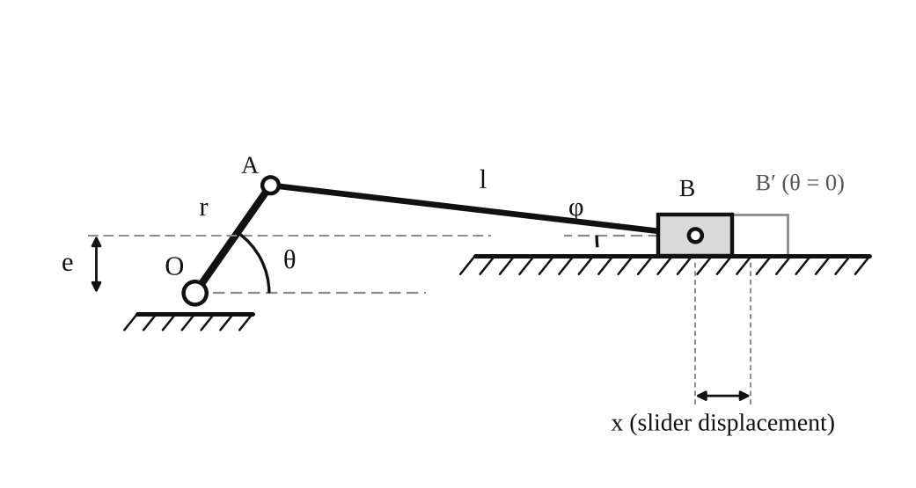
Fig. 1: Offset slider-crank mechanism (r = crank radius, L = connecting rod length, e = offset).
Method in brief
- Set the crank angle at 0° and note the slider position to get the zero-displacement reading.
- Increase the crank angle θ in small steps (10° is recommended) and record the slider displacement x for each crank angle, for a complete revolution of the crank.
- Measure the slider offset e, the crank radius r and the connecting rod length L.

3. Results
r = [ ] mm, L = [ ] mm, e = [ ] mm, q = L/r = [ ].
Table 1: Slider displacement against crank angle
θ (°) | Slider reading (mm) | x (mm) | dx/dθ (mm/rad) | d²x/dθ² (mm/rad²) | Theoretical d²x/dθ² (mm/rad²)
0
10
20
30
40
50
60
70
80
90

Continue in 10° steps up to 360° (36 readings). x is the reading minus the zero-displacement reading at θ = 0.

4. Analysis of Results
- x = slider reading at θ − slider reading at 0°.
- Velocity: differentiate the x–θ graph graphically to obtain dx/dθ. For a crank speed ω the slider velocity is v = ω dx/dθ.
- Acceleration: differentiate the dx/dθ graph to obtain d²x/dθ². The acceleration is a = ω² d²x/dθ².
- Theoretical curve: d²x/dθ² = r[cos θ + (1/q)(cos 2θ + (e/r) sin θ)], using r = [ ] mm, q = [ ] and e = [ ] mm.
- Compare the experimental and theoretical curves at the same angles; the difference at θ = 0° is [ ] %.

5. Observations / Precautions Taken
Observations
- The slider moved away from the crank and returned once for each turn of the crank.
- The slider was at rest at the ends of its stroke (dead centres). The velocity was greatest around mid-stroke.
- The acceleration was greatest near the ends of the stroke and changed sign during the stroke.
- Because of the offset, the dead centre positions were not exactly at θ = 0° and 180°, and the forward and return strokes took different crank angles.
Precautions
- The zero position of the crank angle and of the slider were checked before the test.
- The crank was turned in one direction only to avoid backlash errors.
- The scale was read at eye level to avoid parallax.
- The crank radius, rod length and offset were measured at several places and the average used.

6. Graphs
Plot the following on graph paper from your own readings and attach them here:
- Slider displacement x against crank angle θ
- dx/dθ against θ (by graphical differentiation)
- d²x/dθ² against θ (by graphical differentiation)
- Theoretical d²x/dθ² against θ, plotted on the same axes for comparison

7. Discussion
1. How would you obtain the slider velocity and acceleration at any crank angle, given that the crank rotates at a uniform rate ω rad/s? From the displacement x(θ), the velocity is v = dx/dt = (dx/dθ)(dθ/dt) = ω dx/dθ. The acceleration is a = dv/dt = ω² d²x/dθ² because ω is constant. So the values of dx/dθ and d²x/dθ² read from the graphs (or calculated from the formulae in the Theory section) are multiplied by ω and ω².
2. Variation of slider velocity and acceleration with crank position. The velocity is zero at the two dead centres, rises to a maximum when the crank is nearly at right angles to the connecting rod and then falls again. The acceleration is highest at the dead centre positions (about rω² at the outer dead centre, and a bit different at the inner one because of the second harmonic term r ω²/q cos 2θ), is zero when the velocity is greatest, and reverses in direction between the two dead centres. The curve is nearly a cosine curve if the connecting rod is long.
3. Effect of the slider offset. The offset e shifts the dead centre positions and changes the stroke. For e ≠ 0, the crank angles for the forward and return strokes are no longer equal (180° each), so the mechanism has a quick-return effect: the forward stroke is slower than the return stroke, or the other way. The terms that contain e in the displacement, velocity and acceleration formulas show this. The maximum velocity and acceleration are also changed slightly. With a large offset the rod makes a bigger angle with the slider path, so the side thrust on the slider guide is larger.
Sources of error
- Reading the slider position and crank angle by eye (parallax and limited scale divisions).
- Backlash and play in the joints of the mechanism.
- Graphical differentiation magnifies errors, and the second derivative is the least accurate.
- The approximate formula was used, which is only valid for q ≥ 4 and e/r ≤ 1/4.

8. Conclusion
The displacement of the slider of the offset slider-crank was recorded against the crank angle, and the velocity and acceleration diagrams were obtained by differentiation. The acceleration curve agreed with the theoretical curve within about [ ] %. The velocity is zero at the dead centres, and the acceleration is greatest there. The offset gives different forward and return strokes (quick return). The mechanism is used in engines, compressors, pumps and presses.

Section B: Questions
1. What I learnt from the experiment. I learnt how a slider-crank changes rotation into reciprocating motion, and how to find velocity and acceleration of the slider by differentiation of the displacement curve.
3. Comment on the experimental procedure. The mechanism is simple and a complete cycle takes only 36 readings in 10° steps. The result can be compared with a theoretical curve.
4. Most difficult aspect of the experiment. Reading the slider displacement accurately and getting the second derivative graphically. It can be reduced by using small steps and smooth curves, or by a computer to do the differentiation.
5. Another method that could be used. A rotary encoder on the crank and a linear transducer on the slider could record the motion electronically.
6. Parameters measured / involved. Crank angle θ, slider displacement x, crank radius r, rod length L and offset e.
7. Measuring instrument used. The rule or vernier calipers measure r, L and e, and the protractor scale measures the crank angle.
8. Practical relevance. Internal combustion engines, compressors, pumps, presses, shaping machines and quick-return mechanisms.
9. Section of the course it belongs to. Mechanisms (kinematics of machines: slider-crank chain).
13. What interested me most. The forward and return strokes of the slider were different because of the offset.
2, 10, 11, 12, 14 and 15 (personal / references): to be filled in by you.

SM 212: Shear Force in a Beam Experiment

Objective
- To investigate how the shear force at a cut in a simply supported beam varies with an increasing point load (Experiment 1).
- To investigate how the shear force at the cut varies for various loading conditions, and to draw shear force diagrams (Experiment 2).

1. Theory
When a beam carries loads, internal forces are set up in it. The shear force at a section is the algebraic sum of all the vertical forces acting on one side of that section. If it is worked out from the left side, an upward force (like the left reaction) is taken as positive and a downward load as negative. The same value (with the opposite sign) is got from the right side.
For a simply supported beam of span L carrying a single point load W at a distance a from the left support A, the reactions are found by taking moments:
R_{B} = W a / L R_{A} = W (L − a) / L
The cut in this experiment is on the right of the load (40 mm away from it), so the shear force at the cut, taken from the right side, is just the right reaction:
S_{c} = W a / L
For several loads the same statement is used: the shear force at the cut is equal to the algebraic sum of the forces acting to the left (or right) of the cut. The shear force diagram jumps up at an upward reaction and jumps down at a downward load, by the size of that force, and is flat between the forces.
In the apparatus the beam is cut at the section, and the cut is bridged by a mechanism that carries shear only and reacts on a load cell. The digital display therefore reads the shear force directly.

2. Apparatus
Tec-equipment SM 212 shear force in a beam apparatus: a beam with a cut, a mechanism bridging the cut to a load cell, a digital force display, hangers with slotted masses (100 g to 500 g), a test frame with thumbscrews, and a rule. The hanger supports are 20 mm apart with a central groove for the hangers.
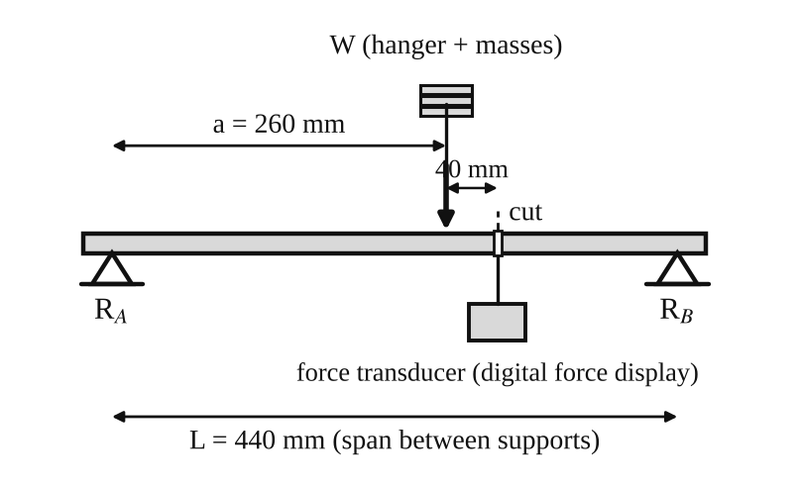
Fig. 1: Layout for Experiment 1 (a = 260 mm; the cut is 40 mm to the right of the load).
Method in brief
- Inspect all parts, leads and fastenings for damage and check that everything is secure. Fit the left and right supports into the test frame and tighten the thumbscrews. Make sure the internal bars are in the middle of their travel.
- Connect the mini DIN lead from "Force Input 1" on the digital force display to the "Force Output" socket on the left support, making sure the lead does not touch the beam. Zero the force meter using the dial. Check that the display reads zero with no load.
- Experiment 1: hang a 100 g hanger 40 mm to the left of the cut and record the display reading. Repeat with 200, 300, 400 and 500 g.
- Experiment 2: load the beam as in figures 4, 5 and 6 using the loads in the table. Record the digital display reading for each case.
Mass to load conversion (Table 1)
Mass (g) | 100 | 200 | 300 | 400 | 500
Load (N) | 0.98 | 1.96 | 2.94 | 3.92 | 4.90

3. Results
Experiment 1: shear force variation with an increasing point load
L = 440 mm, a = 260 mm, S_{c} = W a / L = 0.591 W (the ratio a/L = 260/440 = 0.5909).
Table 2: Results for Experiment 1
Mass (g) | Load W (N) | Experimental shear force (N) | Theoretical shear force (N)
0 | 0 |  | 0
100 | 0.98 |  | 0.579
200 | 1.96 |  | 1.158
300 | 2.94 |  | 1.737
400 | 3.92 |  | 2.316
500 | 4.90 |  | 2.895

Experiment 2: shear force for various loading conditions
The loads were placed as shown in figures 4, 5 and 6 of the manual. The theoretical reactions are found by moments about each support, and the theoretical shear force at the cut by summing the forces to the left of it.
Table 3: Results for Experiment 2
Fig. | W₁ (N) | W₂ (N) | Experimental shear force (N) | R_{A} (N) | R_{B} (N) | Theoretical shear force (N)
4 | 3.92 | – |  | 5.17 | −1.25 | +1.25
5 | 1.96 | 3.92 |  | 2.58 | 3.30 | −3.30
6 | 4.91 | 3.92 |  | 2.59 | 6.24 | −2.32

A negative R_{B} (figure 4) means the right support has to pull the beam down, because the load is outside the supports. The experimental column is for your own readings from the digital display.

4. Analysis of Results
Experiment 1
Theoretical shear force at the cut: S_{c} = W a / L = W × 260 / 440. For example for 300 g: 2.94 × 260 / 440 = 1.737 N. The percentage difference for each load is (experimental − theoretical) / theoretical × 100 = [ ] %.
Experiment 2
- Figure 4 (W₁ = 3.92 N, 140 mm to the left of R_{A}; span 440 mm): taking moments about B, R_{A} × 440 = 3.92 × (440 + 140), so R_{A} = 5.167 N. Then R_{B} = 5.167 − 3.92 = 1.247 N downward (written −1.247 N), and the shear force at the cut = R_{A} − W₁ = 5.167 − 3.92 = +1.247 N.
- Figure 5 (W₁ = 1.96 N at 220 mm and W₂ = 3.92 N at 260 mm from A): R_{B} = (1.96 × 220 + 3.92 × 260) / 440 = 3.296 N, R_{A} = 5.88 − 3.296 = 2.584 N, and the shear force at the cut (300 mm from A) = 2.584 − 1.96 − 3.92 = −3.296 N.
- Figure 6 (W₁ = 4.91 N at 240 mm and W₂ = 3.92 N at 400 mm from A): R_{B} = (4.91 × 240 + 3.92 × 400) / 440 = 6.242 N, R_{A} = 8.83 − 6.242 = 2.588 N, and the shear force at the cut = 2.588 − 4.91 = −2.322 N. The load W₂ lies to the right of the cut, so it does not enter the sum from the left.
In each case the shear force from the right side gives the same magnitude as from the left side, which is a useful check on the reactions.
Shear force diagrams
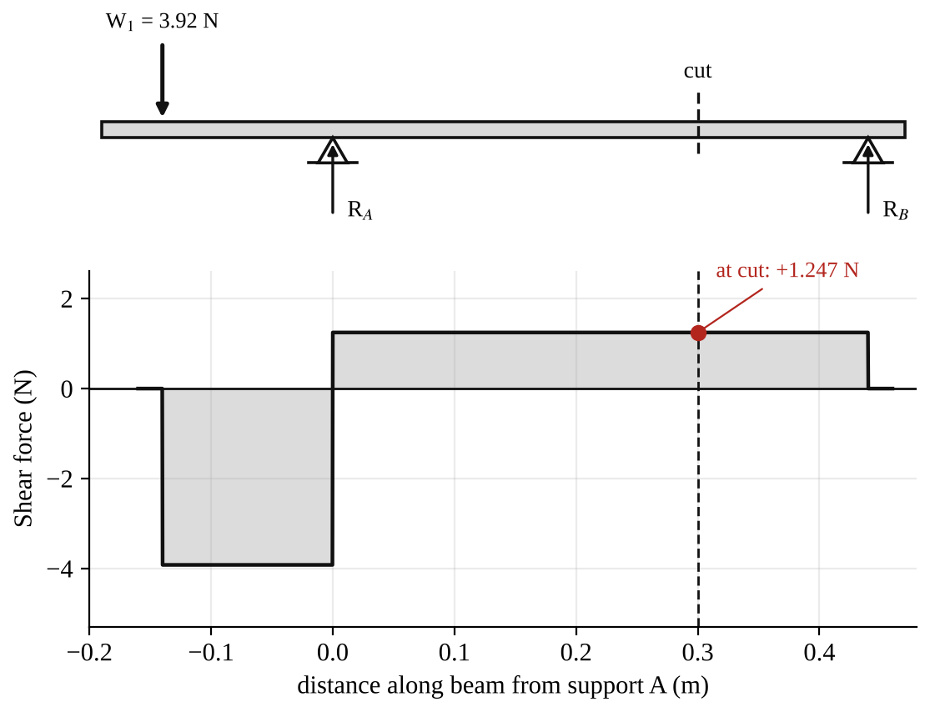
Fig. 2: Shear force diagram for figure 4 (shear force at the cut = +1.247 N).
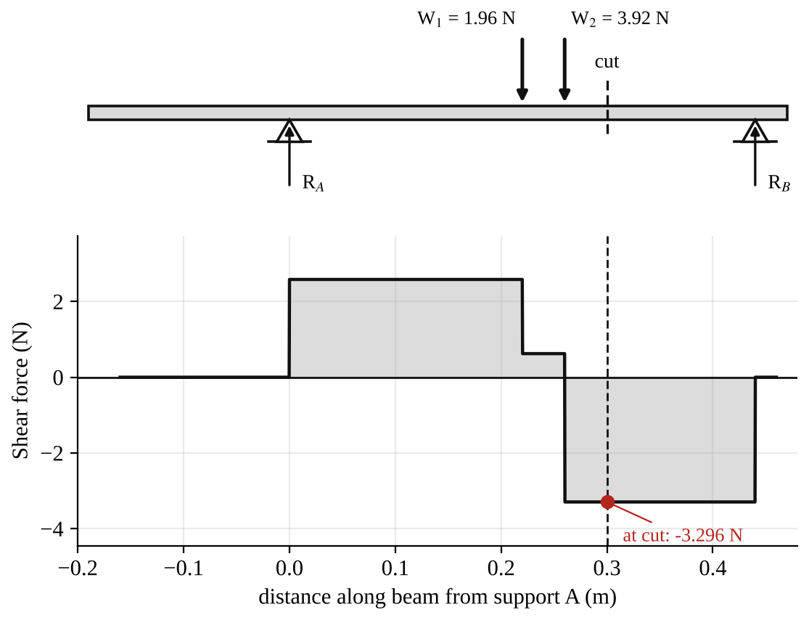
Fig. 3: Shear force diagram for figure 5 (shear force at the cut = −3.296 N).
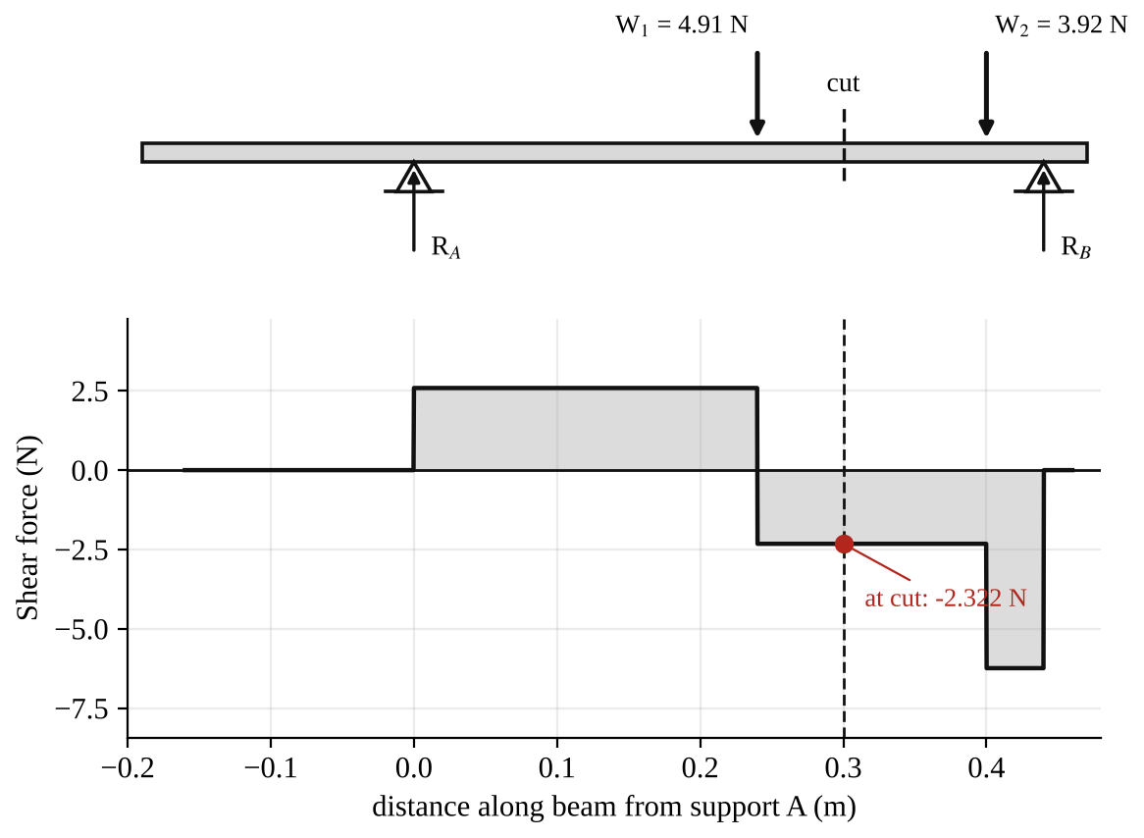
Fig. 4: Shear force diagram for figure 6 (shear force at the cut = −2.322 N).

5. Observations / Precautions Taken
Observations
- The digital reading increased steadily as the load was increased (Experiment 1), in a straight-line way.
- The experimental shear force was close to the theoretical shear force, but slightly different.
- The reading changed sign depending on which side of the cut the heavier load was, so the shear force can be positive or negative.
- When a load was moved to the right of the cut it no longer changed the sum of the forces to the left of the cut, but it changed the reactions.
Precautions
- The force display was zeroed with no load, and checked again between readings. If the meter was reading only ±0.1 N the frame was tapped lightly to overcome stiction.
- The loads were hung carefully in the grooves of the hanger supports at the stated distances.
- The lead from the load cell was kept away from the beam.
- Excessive loads were never put on any part of the equipment.
- The apparatus was on a level, steady surface.

6. Graphs
Plot the following on graph paper from your own readings and attach them here:
- Experimental and theoretical shear force at the cut against load W (Experiment 1), on the same axes
- Shear force diagrams for figures 4, 5 and 6 (shown in the Analysis section)

7. Discussion
Shape of the graph. The graph of shear force against load is a straight line through the origin, with a slope of a/L = 0.591 in theory. This tells us that the shear force at the cut is directly proportional to the load. Doubling the load doubles the shear force. So the equation S_{c} = W a / L predicts the behaviour of the beam well, provided the experimental points lie close to the theoretical line (my readings differed from theory by [ ] %).
Comparison of experiment 2 with theory. The experimental values at the cut agree with the calculated values within [ ] %. The shear force diagrams show jumps equal to the loads and reactions, and the shear force is constant between the loads.
Possible reasons for differences
- Friction ("stiction") in the cut mechanism and in the load cell.
- The weight of the beam and the cut mechanism itself is not in the theory, nor is the weight of the hangers.
- The positions of the hangers (measured to about 1 mm) and the actual span.
- Slight zero error or drift of the digital display, and the digital readings are to only 0.1 N.

8. Conclusion
The shear force at the cut increased in direct proportion to the load (S_{c} = Wa/L), and the experimental values agreed with theory to within about [ ] %. For the three loading arrangements the shear force at the cut was found by summing the forces on one side of the cut, and shear force diagrams were drawn. The shear force is needed in beam design to size the web and the connections, for example in the design of bridges and floor beams.

Section B: Questions
1. What I learnt from the experiment. I learnt what shear force is, how to calculate it at a cut from the reactions and loads, and how to draw a shear force diagram.
3. Comment on the experimental procedure. The cut and load cell give the shear force directly on a digital display, so readings are fast and clear. Using five loads and a graph shows the trend better than one reading.
4. Most difficult aspect of the experiment. Getting the display to return to zero (stiction in the mechanism) and positioning the hangers correctly. It can be reduced by tapping the frame lightly, re-zeroing, and measuring distances carefully.
5. Another method that could be used. A strain gauge beam, or a hydraulic or spring balance at the supports to measure the reactions and hence the shear force.
6. Parameters measured / involved. Load W (from mass), positions a and the span L, reactions R_{A} and R_{B}, and the shear force at the cut.
7. Measuring instrument used. The digital force display (with the load cell) measures the shear force, and a rule measures the distances.
8. Practical relevance. Design of beams in buildings, bridges and cranes, and in machine shafts and frames.
9. Section of the course it belongs to. Strength of materials / structures (shear force and bending moment in beams).
13. What interested me most. The shear force reading changed sign when the heavier load was moved from one side of the cut to the other.
2, 10, 11, 12, 14 and 15 (personal / references): to be filled in by you.

SM 213: Bending Moment in a Beam Experiment

Objective
- To verify the bending moment variation at the point of loading (Experiment 1).
- To examine how the bending moment at the cut varies for various loading conditions, and to draw bending moment diagrams (Experiment 2).

1. Theory
When a simply supported beam is loaded, there is a bending moment at every section. The bending moment at a section is the algebraic sum of the moments, about that section, of all the forces on one side of it. It is taken positive when it makes the beam sag (curve upward, like a smile).
For a single point load W at a distance a from the left support A, on a beam of span L, the reactions are R_{A} = W(L − a)/L and R_{B} = Wa/L. If the cut is under the load (Experiment 1), the bending moment there is
M (at cut) = W a (L − a) / L
This is the maximum bending moment for a single load. For several loads the bending moment at the cut is M = R_{A} × x − Σ W (x − x_{W}) for the loads to the left of the cut, where x is the distance of the cut from A and x_{W} is the position of each load.
In the apparatus the beam is cut and a load cell reads the force F that it takes to hold the two halves in place. This force acts at a lever arm of 0.125 m, so bending moment = displayed force × 0.125 (N·m).

2. Apparatus
Tec-equipment SM 213 bending moment in a beam apparatus: a beam with a cut at which a pivoting mechanism and a load cell measure the moment, a digital force display, hangers and slotted masses (100 g to 500 g), a test frame with thumbscrews, and a rule.
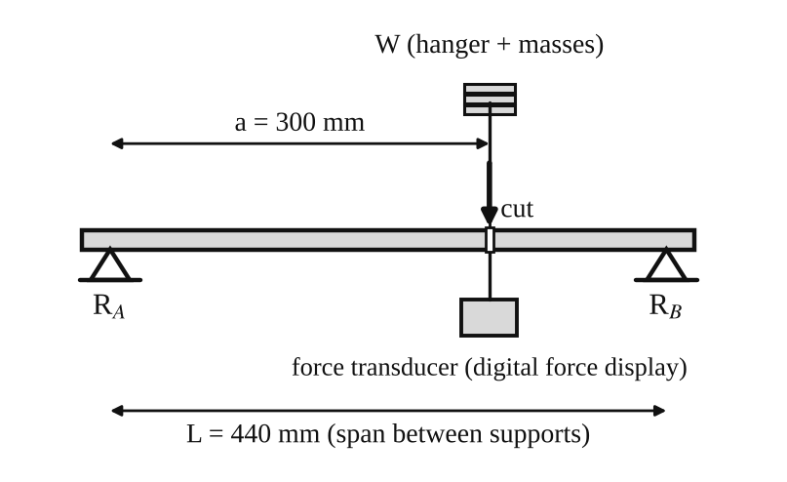
Fig. 1: Layout for Experiment 1 (load directly at the cut, a = 300 mm from the left support, span L = 440 mm).
Method in brief
- Inspect the equipment, check the electrical connections and fastenings and fit the supports to the test frame (four securing nuts, thumbscrews tight).
- Connect the mini DIN lead from "Force Input 1" to the "Force Output" socket and make sure the lead does not touch the beam. Zero the force meter and check that it reads zero with no load.
- Experiment 1: place a hanger with 100 g at the cut, record the display reading, and repeat for 200, 300, 400 and 500 g. Bending moment = displayed force × 0.125 (N·m).
- Experiment 2: load the beam as in figures 4, 5 and 6, and record the display readings.

3. Results
Experiment 1: bending moment variation at the point of loading
The readings below are the ones written in the manual. Please check them against your own notes. Theoretical bending moment = W a (L − a)/L with a = 0.30 m and L = 0.44 m, so M = 0.0955 W.
Table 1: Result table for bending moment (Experiment 1)
Mass (g) | Load (N) | Force (N) | Experimental bending moment (N·m) | Theoretical bending moment (N·m) | Difference (%)
0 | 0 | 0 | 0 | 0 | –
100 | 0.98 | 0.7 | 0.0875 | 0.0935 | −6.9
200 | 1.96 | 1.3 | 0.1625 | 0.1871 | −13.1
300 | 2.94 | 1.9 | 0.2375 | 0.2806 | −15.5
400 | 3.92 | 2.7 | 0.3375 | 0.3742 | −9.8
500 | 4.92 | 3.1 | 0.3875 | 0.4696 | −17.5

The theoretical column printed in the manual is 0.094, 0.187, 0.281, 0.374 and 0.470 N·m, which agrees with the values here to the rounding.
Experiment 2: bending moment for various loading conditions
Table 2: Results for Experiment 2
Fig. | W₁ (N) | W₂ (N) | Force (N) | Experimental bending moment (N·m) | R_{A} (N) | R_{B} (N) | Theoretical bending moment (N·m)
4 | 3.92 | – | −1.4 | −0.175 | 5.17 | −1.25 | −0.175
5 | 1.96 | 3.92 | 3.4 | 0.425 | 2.58 | 3.30 | +0.462
6 | 4.91 | 3.92 | 3.6 | 0.450 | 2.59 | 6.24 | +0.482

4. Analysis of Results
Experiment 1
Theoretical: M = W a (L − a)/L = W × 0.30 × 0.14 / 0.44 = 0.0955 W. For 300 g: 2.94 × 0.0955 = 0.2806 N·m. Experimental: M = 1.9 × 0.125 = 0.2375 N·m. Difference = (0.2375 − 0.2806)/0.2806 × 100 = −15.4 %.
Experiment 2: reactions and bending moment at the cut (cut 300 mm from A, span 440 mm)
- Figure 4 (W₁ = 3.92 N, 140 mm to the left of A): R_{A} = 3.92 × (440 + 140)/440 = 5.167 N, R_{B} = −1.247 N. The bending moment at the cut = R_{A} × 0.30 − 3.92 × 0.44 = 1.550 − 1.725 = −0.175 N·m (negative, because the beam hogs: it bends the other way, owing to the overhang).
- Figure 5 (W₁ = 1.96 N at 220 mm and W₂ = 3.92 N at 260 mm): R_{B} = 3.296 N, R_{A} = 2.584 N. M = 2.584 × 0.30 − 1.96 × 0.08 − 3.92 × 0.04 = 0.775 − 0.157 − 0.157 = +0.462 N·m.
- Figure 6 (W₁ = 4.91 N at 240 mm and W₂ = 3.92 N at 400 mm): R_{B} = 6.242 N, R_{A} = 2.588 N. M = 2.588 × 0.30 − 4.91 × 0.06 = 0.776 − 0.295 = +0.482 N·m.
Experimental bending moment = force × 0.125. For figure 5: 3.4 × 0.125 = 0.425 N·m; the difference from theory is (0.425 − 0.462)/0.462 × 100 = −7.9 %.
Bending moment diagrams
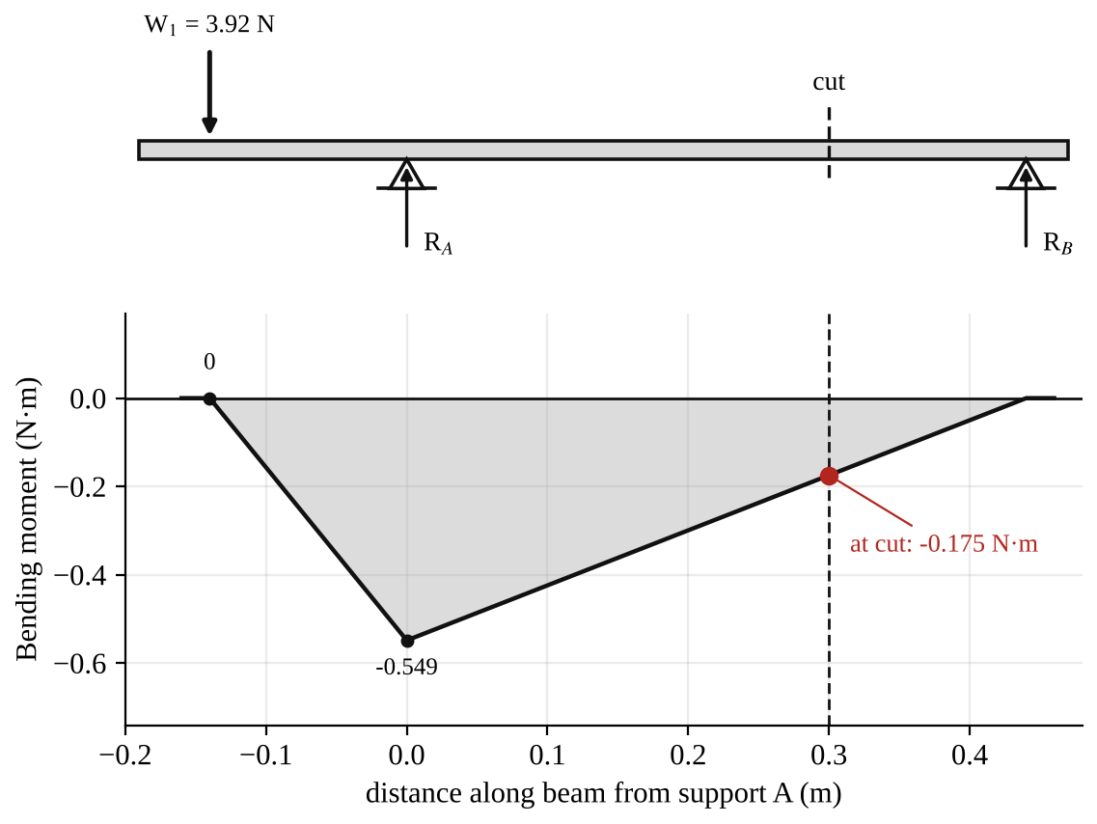
Fig. 2: Bending moment diagram for figure 4 (−0.175 N·m at the cut).
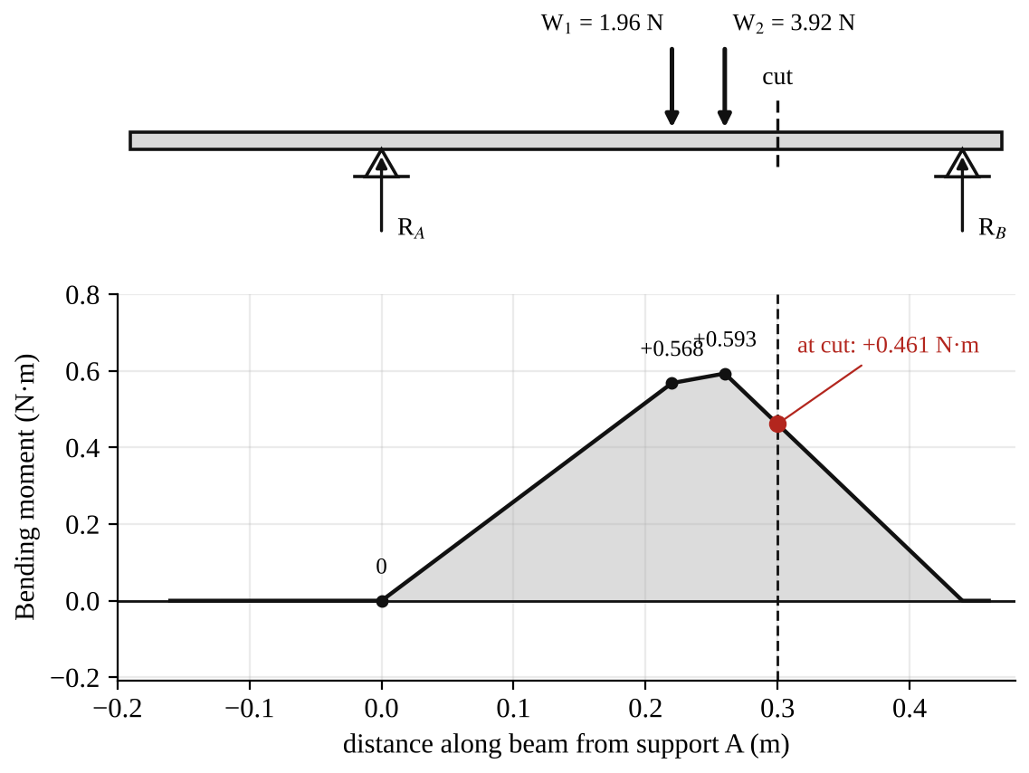
Fig. 3: Bending moment diagram for figure 5 (+0.462 N·m at the cut).
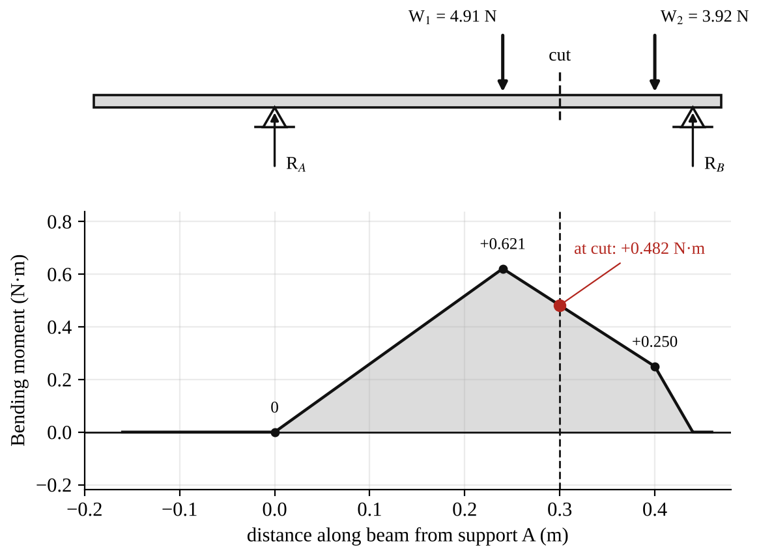
Fig. 4: Bending moment diagram for figure 6 (+0.482 N·m at the cut).

5. Observations / Precautions Taken
Observations
- The bending moment at the point of loading increased in a straight line with the load.
- The experimental values were always a bit smaller than the theoretical values (6 to 18 % lower in Experiment 1).
- When the load was outside the supports (figure 4) the bending moment at the cut was negative.
- The bending moment diagrams are made of straight lines, with a change of slope at every load and support.
Precautions
- The meter was zeroed with no load and checked again before each reading.
- The loads were put exactly at the positions given for each figure.
- The lead was kept away from the beam.
- No excessive loads were put on the beam, and the frame was on a firm level surface.

6. Graphs
Plot the following on graph paper from your own readings and attach them here:
- Experimental and theoretical bending moment at the cut against load (Experiment 1)
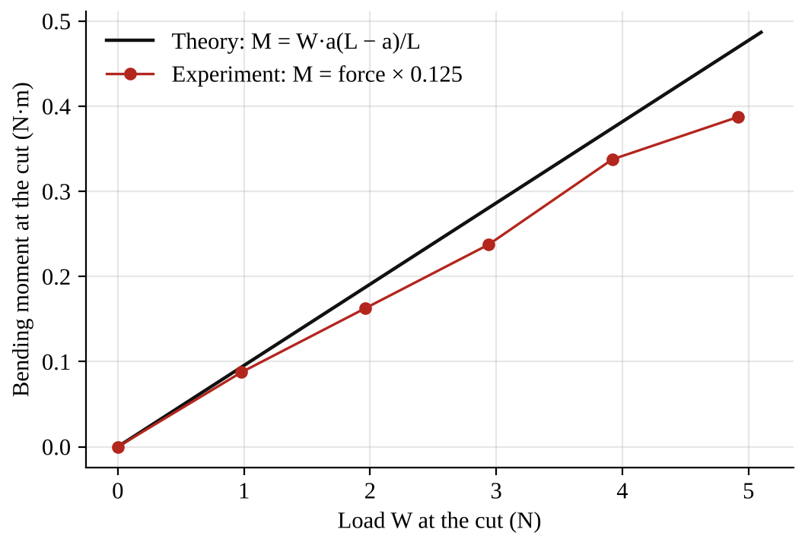
Fig. 5: Experimental and theoretical bending moment against load for Experiment 1.

7. Discussion
Shape of the graph. Both lines are straight, starting from zero. So the bending moment at the point of loading is directly proportional to the load, as the equation M = Wa(L − a)/L says (for fixed a and L, M is a constant times W). The experimental line has a smaller slope than the theoretical line, but the same shape. So the equation predicts how the beam behaves, but the measured moments are a little lower than the theory.
Experiment 2. The experimental and theoretical moments agree to within about 0.2 % for figure 4, and within 8 % for figures 5 and 6. The theory predicts the signs correctly (negative for the overhanging load, positive when the loads are between the supports).
Possible reasons for the differences
- Friction in the pivots of the cut mechanism and the load cell, which makes the force reading too low, especially at bigger loads.
- The weight of the hanger and the beam are not in the theory.
- The cut is not exactly under the load, so the lever arm and the position are not exactly as assumed (an error of a few mm changes M by several %).
- The digital display only shows 0.1 N, which is a large step when the force is under 4 N.
- The 500 g load used 4.92 N in the manual table here but 4.90 N in the shear force experiment, a small difference.

8. Conclusion
The bending moment at the point of loading was directly proportional to the load, as predicted by M = Wa(L − a)/L, although the experimental values were about 7 to 18 % lower than the theoretical values. For three loading cases the bending moment at the cut was calculated from the reactions and measured with the load cell, and bending moment diagrams were drawn. The results confirm the theory within the accuracy of the apparatus. Bending moments are used to size beams, shafts and frames so that the bending stress σ = My/I stays within safe limits.

Section B: Questions
1. What I learnt from the experiment. I learnt what bending moment is, how to calculate it at a section, and how to draw a bending moment diagram.
3. Comment on the experimental procedure. The moment is read from the force display (× 0.125), so no calculation of the internal moment is needed. Using many loads and a graph gives a clear trend. It is also fast.
4. Most difficult aspect of the experiment. Friction in the cut mechanism and the coarse resolution of the digital display (0.1 N). They can be reduced by tapping the frame lightly and repeating readings.
5. Another method that could be used. Strain gauges attached to the beam, or a dial gauge to measure the deflection of the beam and calculate the moment from it.
6. Parameters measured / involved. Load W (from mass), positions of the loads, span L, reactions R_{A} and R_{B}, force F from the display, and bending moment M = F × 0.125.
7. Measuring instrument used. The digital force display with its load cell, and a rule to measure the positions.
8. Practical relevance. Design of beams, floors, bridges, shafts, crane jibs and machine frames.
9. Section of the course it belongs to. Strength of materials / structures (bending moment and shear force in beams).
13. What interested me most. The bending moment was negative when the load was outside the supports, so the beam bent the other way.
2, 10, 11, 12, 14 and 15 (personal / references): to be filled in by you.

SM 214: Torsion Test to Destruction

Objective
- To carry out a torsion test to destruction on a metal test piece, in order to determine:
- (a) the modulus of rigidity G;
- (b) the shear stress at the limit of proportionality;
- (c) the general characteristics of the torque and angle of twist relationship.

1. Theory
When a circular shaft is twisted by a torque T, every cross-section turns relative to the next, and the material is stressed in shear. For a circular specimen of gauge length L, polar second moment of area J and radius r, the torsion equation is
T / J = G θ / L = τ / r
where T is the applied torque (N·m), J is the polar second moment of area (mm⁴), G is the modulus of rigidity (N/mm²), θ is the angle of twist over length L (radians), L is the gauge length (mm), τ is the shear stress (N/mm²) and r is the radius of the parallel length (mm).
For a solid circular bar of diameter d, J = πd⁴/32. Rearranging the torsion equation:
G = T L / (J θ) τ = T r / J
In the elastic range, torque and angle of twist are proportional (like load and extension in the tensile test), so the graph of T against θ is a straight line from the origin with slope T/θ = GJ/L, which gives G. At the limit of proportionality the line starts to curve, and the shear stress there is τ = T_{p} r / J, where T_{p} is the torque at that point. Beyond this the metal yields in shear. Twisting continues with the torque increasing slowly (strain hardening in a ductile metal) until the specimen fractures. A ductile metal fractures across a plane perpendicular to the axis (a shear fracture), after a large angle of twist. A brittle metal fractures on a helical surface at 45° to the axis (along the plane of maximum tensile stress), after a small twist.

2. Apparatus
Tec-equipment torsion testing machine (twisting by a hand wheel or handle, with a torque scale and an angle scale), prepared test piece, vernier calipers, meter rule.
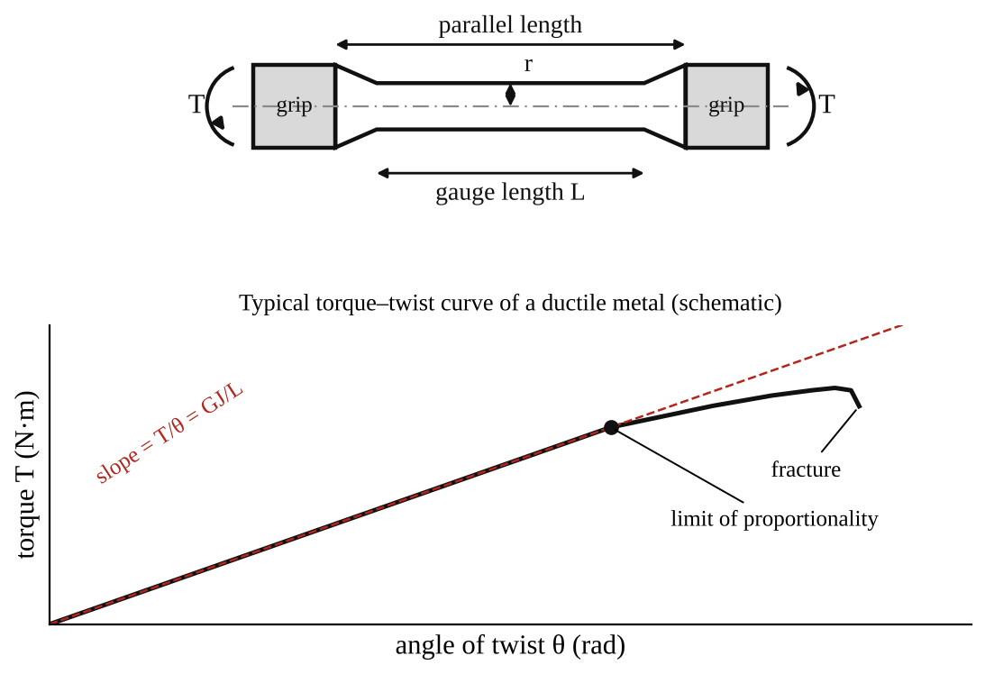
Fig. 1: Test piece (top) and typical torque–twist curve of a ductile metal (bottom).
Method in brief
- Measure the diameter of the parallel length of the test piece with the vernier calipers at several places, and the gauge length and overall length with the rule. Record them.
- Fit the test piece in the grips of the machine. Set the torque indicator and the angle scale to zero.
- Apply the torque slowly and steadily by turning the handle. At each step of angle (for example every 1° at the start) read the torque. Take more readings near the limit of proportionality.
- Continue to fracture. Note the torque and the angle at fracture.
- Remove the broken pieces, fit them together, and measure the final diameter, gauge length and overall length. Examine the fracture surface.

3. Results
Table 1: Dimensions of the test piece
Measurement | Initial | Final
Diameter (mm)
Gauge length (mm)
Overall length (mm)

Material: [ ]. J = πd⁴/32 = [ ] mm⁴.
Table 2: Torque and angle of twist
Angle of twist (°) | Angle θ (rad) | Torque T (N·m) | T/θ (N·m/rad)

Table 3: Mechanical properties
Property | Experimental | Theoretical / accepted value
Modulus of rigidity G (N/mm²) |  | steel about 80 000; aluminium about 26 000; brass about 38 000
Torque at limit of proportionality T_{p} (N·m)
Shear stress at limit of proportionality (N/mm²)
Torque at fracture (N·m) and angle at fracture (°)

The accepted values of G are typical figures. Use the one for your own material.

4. Analysis of Results
- Angle in radians: θ = degrees × π/180 = [ ] × 0.01745 = [ ] rad.
- J = πd⁴/32 = π × [ ]⁴ ÷ 32 = [ ] mm⁴ (check that the torque is in N·mm when J is in mm⁴, so multiply N·m by 1000).
- Slope of the straight part of the T–θ graph = ΔT/Δθ = [ ] N·mm/rad.
- Modulus of rigidity G = (slope) × L / J = [ ] × [ ] ÷ [ ] = [ ] N/mm².
- Shear stress at the limit of proportionality τ = T_{p} r / J = [ ] × [ ] ÷ [ ] = [ ] N/mm².
- Comparison of G with the accepted value: difference = [ ] %.
- Relationship between G, E and Poisson's ratio ν: G = E/[2(1 + ν)], so for steel (E ≈ 200 000 N/mm², ν ≈ 0.3) G ≈ 77 000 N/mm², a useful check on the value obtained.

5. Observations / Precautions Taken
Observations
- The torque rose in direct proportion to the angle of twist at first, giving a straight line through the origin.
- After the limit of proportionality the line curved over and the torque increased more slowly with each additional degree of twist (yielding).
- The specimen finally broke with a [clean / helical] fracture. The fracture surface was [flat and perpendicular to the axis (ductile) / at 45° (brittle)].
- The specimen was longer or shorter after the test by [ ] mm, and its diameter was [ ] mm.
Precautions
- The torque was applied slowly and steadily, with no sudden jerks.
- The test piece was gripped firmly and centrally so it did not slip or bend.
- The diameter was measured at several places (the radius is raised to the 4th power in J, so errors in d are very important).
- The torque and angle scales were zeroed before the test, and read at eye level.
- Everyone stood clear of the machine when the specimen fractured.

6. Graphs
Plot the following on graph paper from your own readings and attach them here:
- Torque T against angle of twist θ (radians), drawn from Table 2 on graph paper, with the straight-line slope drawn in
- Mark the limit of proportionality and the fracture point on the graph

7. Discussion
General characteristics of the torque–twist relationship. The graph has a straight elastic part, a curved part after the limit of proportionality, and ends at fracture. The straight part gives the stiffness of the shaft (GJ/L), and G is found from its slope. A larger area under the curve means the metal can absorb more energy in twisting. This is the same behaviour as the tensile test, but with shear instead of direct stress.
Comparing the results. I found G = [ ] N/mm², which differs by [ ] % from the accepted value of about [ ] N/mm². The shear stress at the limit of proportionality was [ ] N/mm², which is about [ ] % of the tensile yield stress (the shear yield stress is usually about 0.5 to 0.6 of the tensile yield stress).
Sources of error
- Reading torque and angle from scales by eye, with limited divisions.
- Slip of the specimen in the grips, and twist in the machine itself, which add to the measured angle (so G comes out too low).
- Error in measuring the diameter, which is magnified by d⁴.
- It is not easy to see exactly where the straight line ends (the limit of proportionality).
- The specimen is not perfectly circular or uniform, and the gauge length is not exactly the length between the grips.

8. Conclusion
The torsion test gave a modulus of rigidity of [ ] N/mm², a shear stress at the limit of proportionality of [ ] N/mm², and a fracture at a torque of [ ] N·m after a twist of [ ]°. The torque and angle of twist were proportional up to the limit of proportionality, then yielding followed until fracture. The results are used in the design of drive shafts, axles, springs, drill bits and screwdrivers, where twisting is the main loading.

Section B: Questions
1. What I learnt from the experiment. I learnt how a torsion test is carried out, how to get the modulus of rigidity from a torque–twist graph, and how a shaft behaves up to fracture.
3. Comment on the experimental procedure. Taking readings at regular steps of angle gives a good graph, and one test gives G, the shear stress at the limit of proportionality and the fracture behaviour. The accuracy depends on how well the scales are read and how well the specimen is gripped.
4. Most difficult aspect of the experiment. Reading the torque and the angle at the same time while turning the handle steadily, and deciding where the limit of proportionality is. It can be reduced by having two people (one turning, one reading), and by plotting the graph as the test goes on.
5. Another method that could be used. A torque sensor with an angle encoder and a data logger, or a vibrating (torsional pendulum) method to find G, or a tension test and the relation G = E/2(1 + ν).
6. Parameters measured / involved. Diameter d, gauge length L, torque T, angle of twist θ, polar second moment J, modulus of rigidity G and shear stress τ.
7. Measuring instrument used. The vernier calipers measure the diameter of the test piece. The torque and angle scales on the machine measure T and θ.
8. Practical relevance. Design of drive shafts, propeller shafts, axles, torsion bars, springs and drill bits.
9. Section of the course it belongs to. Strength of materials (torsion of circular shafts).
13. What interested me most. The straight-line relationship between torque and angle of twist, and how the specimen finally fractured.
2, 10, 11, 12, 14 and 15 (personal / references): to be filled in by you.

AM 213: Slip and Creep Measurement in a Belt Drive

Objective
- To measure the coefficient of friction between the pulley material and different belt materials.
- To measure the power transmitted with varied belt tension and plot a graph of power output against (T₁ − T₂), that is, the tension characteristics.
- To measure the percentage slip at fixed belt tension by varying the load on the brake drum, and to plot (T₁ − T₂) against percentage slip (the slip characteristics), fixing the creep zone from the graph.
- To measure belt slip speed and observe the limiting value of the load at constant speed when the slip just starts.

1. Theory
Slip in a belt
The slip in a belt drive is mainly due to reduced frictional grip between the belt and the pulley, and it depends on the angle of contact. It is defined as the relative motion between the pulley and the belt. The difference between the linear speed of the pulley rim and the belt is the measure of slip. It is expressed as a percentage and it reduces the speed of the driven pulley and the efficiency of power transmission.
Creep in a belt drive
When the pulleys rotate clockwise, the lower side of the belt is the tight side (tension T₁) and the upper side is the slack side (tension T₂). When the belt passes from the tight side to the slack side its length contracts, and when it passes from the slack side to the tight side it stretches. So the belt alternately stretches and contracts as it goes round. This causes a small difference between the speed of the belt and the speed of the pulley rim, and the relative motion that results is called creep.
Creep is mainly due to changes in belt length. It increases with load and results in greater power loss, because creep makes the driven pulley slower. Usually creep must stay within a tolerable limit of about 1 % of the load at normal conditions. If the load is raised above the designed value, slip may occur on one or both pulleys. Both slip and creep reduce the performance of a belt drive and increase maintenance.
Equations
T₁ / T₂ = e^{μθ} so μ = (1/θ) ln(T₁/T₂) θ = 180° = π rad
% Slip = (S₁ − S₂)/S₁ × 100 Torque = (T₁ − T₂) r Power = 2πN₂ (T₁ − T₂) g r / 60 000 kW
T₁ and T₂ are the tight and slack side tensions, μ is the coefficient of friction between belt and pulley, θ is the angle of lap, S₁ is the speed of the driving pulley (rpm), S₂ is the speed of the driven pulley (rpm), r is the radius of the brake drum pulley, and g = 9.81 m/s² if the tensions are read in kg.

2. Apparatus
A variable speed PMDC motor drives two cast iron pulleys P₁ and P₂ of equal diameter, with flat rims. P₁ is the driving pulley, mounted directly on the motor shaft. P₂ is the driven pulley. An endless (or stitched) belt passes over both pulleys. The bearing block of the driven pulley can slide over the base to vary the initial belt tension. P₂ is balanced on a single bearing block and carries a brake drum, over which a brake belt is passed, with its ends attached to two spring balances that give the tight and slack tensions. Output power is therefore found from the difference of the spring balance readings. The speed of the motor is varied by a variable speed drive, and two digital indicators on the control panel show S₁ and S₂, so the slip can be calculated.
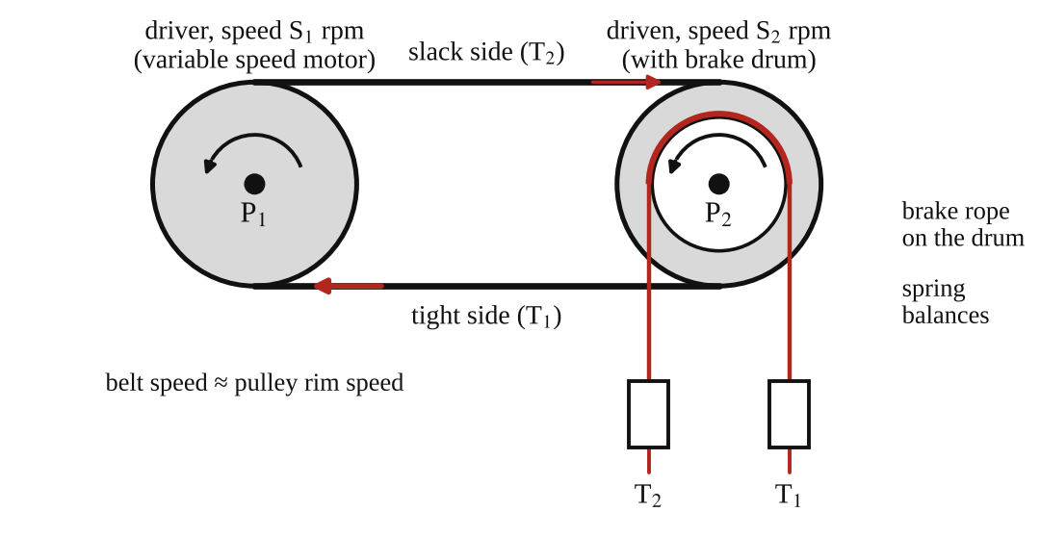
Fig. 1: Belt drive with a brake drum on the driven pulley (schematic).
General operating procedure
- Plug the apparatus into the power supply.
- Before starting, make sure the speed knob is at zero (turned anti-clockwise).
- Press the green start button at the bottom of the control panel.
- The display will glow and show "press START". Press the red push button to start the motor.
- Use the knob to increase or decrease the motor speed. Always do this slowly.
Experiment 1: coefficient of friction
- Adjust some initial tension on the belt and run the motor at a steady speed.
- Load the brake drum until the belt is just about to slip. Record S₁, S₂, T₁ and T₂.
- Repeat for five sets of readings, and for each belt material available. Calculate μ from μ = (1/π) ln(T₁/T₂).
Experiment 2: slip characteristic
- Adjust some initial tension and start the motor to a constant speed (say 600 rpm).
- Take the reading of S₁ and S₂ at zero load (the slip is almost zero).
- Increase the load on the brake drum slightly and take the T₁ − T₂, S₁ and S₂ readings. Repeat in steps, noting (T₁ − T₂) and (S₁ − S₂) each time.
Experiment 3: tension characteristic
- Repeat the procedure of Experiment 2 and adjust the initial tension.
- Start the motor, take readings of T₁, T₂, S₁ and S₂, and find the power output from (T₁ − T₂).
- Repeat for different initial tensions and compare the results.

3. Results
Table 1 (Experiment 1): coefficient of friction
S/No | S₁ (rpm) | S₂ (rpm) | T₁ (kg) | T₂ (kg) | Coefficient of friction μ
1
2
3
4
5

Table 2 (Experiment 2): slip characteristic at constant speed
S/No | S₁ (rpm) | S₂ (rpm) | T₁ (kg) | T₂ (kg) | T₁ − T₂ (kg) | (S₁ − S₂)/2 | Slip (%)
1
2
3
4
5
6

Table 3 (Experiment 3): tension characteristic and power
S/No | S₁ (rpm) | S₂ (rpm) | T₁ (kg) | T₂ (kg) | Torque (N·m) | (T₁ + T₂)/2 (kg) | Power (kW) | Slip (%)
1
2
3
4

The manual's column heading is printed as "(T₁ − T₂)/2". I have used the mean tension (T₁ + T₂)/2, which is the usual meaning, so please check this with your lecturer. The radius of the brake drum pulley is r = 0.115 m (the manual gives "0.230 m" for the pulley diameter).

4. Analysis of Results
- Coefficient of friction: μ = (1/π) ln(T₁/T₂) = 0.318 × ln( [ ] ÷ [ ] ) = [ ].
- Percentage slip = (S₁ − S₂)/S₁ × 100 = ( [ ] − [ ] ) ÷ [ ] × 100 = [ ] %.
- Torque = (T₁ − T₂) × g × r = [ ] × 9.81 × 0.115 = [ ] N·m.
- Power = 2πN(T₁ − T₂) g r / 60 000 = 2π × [ ] × [ ] × 9.81 × 0.115 ÷ 60 000 = [ ] kW, with N = S₂ (the speed of the driven pulley) in rpm. Equivalent: power (W) = torque × ω with ω = 2πS₂/60.
- Mean (average) of the values of μ for each belt material: [ ].
- Creep zone: the part of the (T₁ − T₂) against % slip graph where the line is nearly straight, and where slip rises in proportion to load. Slip occurs where the curve turns sharply upward. The creep zone is from 0 to about [ ] % slip.
Sample calculation for μ. If T₁ = 3.0 kg and T₂ = 1.0 kg, then μ = (1/π) ln 3 = 0.35. (This is only an example of the method, not a measured result.)

5. Observations / Precautions Taken
Observations
- At zero load the slip was almost zero. The driven pulley speed S₂ fell slowly as the load on the brake drum increased.
- At small loads the slip increased in proportion to the load (creep). At a higher load, the slip increased quickly and the belt slipped on the pulley.
- The tight side tension T₁ increased and the slack side tension T₂ decreased as load was added.
- Power output rose with (T₁ − T₂) up to a maximum, and then fell when the belt slipped because the speed fell.
- Higher initial tension gave a greater power capacity before slip began.
Precautions
- The speed knob was at zero before starting and the speed was changed slowly.
- The load on the brake drum was added slowly and in small steps.
- The spring balances were zeroed and read at the same time at steady speed.
- The belt was clean, free of oil and dust, and the pulleys were aligned.
- Hands were kept away from the belt and pulleys while the motor was running.

6. Graphs
Plot the following on graph paper from your own readings and attach them here:
- (T₁ − T₂) against percentage slip (the slip characteristic), and mark the creep zone
- Power output against (T₁ − T₂) (the tension characteristic) for each initial tension

7. Discussion
Effectiveness of the procedure. The procedure measures slip, tensions and power directly with simple instruments, so it clearly shows the difference between creep (small, in proportion to load) and slip (large, when the limit of friction is reached). It also shows that the power capacity depends on the initial tension. The weak points are that the spring balance readings fluctuate and that the slip points are hard to tell exactly.
Belt drives compared with other transmissions. A belt drive is quiet, cheap, needs no lubrication, can connect shafts that are far apart, absorbs shock and acts as a safety device because it slips when overloaded. But because of slip and creep the speed ratio is not exact (typically 1 to 3 % loss), it can only transmit moderate power, and it needs tension maintained, so the bearing loads are high. A gear drive or a chain drive gives an exact speed ratio and a higher power capacity in a smaller space, but needs lubrication, accurate alignment and is noisier and more expensive. For the same job, a V-belt or toothed (timing) belt reduces slip further.
Sources of error
- Fluctuation of the spring balance readings and their limited scale divisions.
- Variation of speed readings on the digital display (a few rpm).
- Belt stretch and change of the initial tension during the test, and heating of the belt.
- The angle of lap is taken as exactly 180° (equal pulleys), so small shifts in the pulley position change μ slightly.
- Dust or oil on the belt and pulley surface.

8. Conclusion
The coefficient of friction between the pulley and the belt was found to be about [ ]. The slip characteristic showed a creep zone up to about [ ] % slip, followed by a rapid increase in slip when the belt began to slip. The power transmitted increased with (T₁ − T₂) up to a maximum of [ ] kW. Belt drives are suitable for moderate power transmission over long distances, but slip and creep make the speed ratio inexact.

Section B: Questions
1. What I learnt from the experiment. I learnt the difference between slip and creep in a belt drive, how to find the coefficient of friction from T₁/T₂ = e^{μθ}, and how the power and slip change with load.
3. Comment on the experimental procedure. Digital speed indicators and spring balances give quick readings, and the three experiments use the same set-up, so a lot can be done in one session. The readings of tension fluctuate a bit.
4. Most difficult aspect of the experiment. Reading the two spring balances and the two speeds at the same moment while the load changes. It can be reduced by waiting for a steady condition, by having two people read, and by repeating the readings.
5. Another method that could be used. A torque transducer and a dynamometer (such as a Prony brake) to measure power, or stroboscope or tachometer to measure the speed.
6. Parameters measured / involved. Speeds S₁ and S₂, tensions T₁ and T₂, pulley radius, angle of lap, torque, power and percentage slip.
7. Measuring instrument used. The spring balances measure the tensions, and the digital indicators measure the speeds S₁ and S₂ in rpm.
8. Practical relevance. Belt drives in cars (fan and alternator belts), machine tools, conveyors, washing machines and generators.
9. Section of the course it belongs to. Machines and mechanisms (belt drives and power transmission).
13. What interested me most. The driven pulley slowed down very slightly as the load increased even before the belt slipped, which is creep.
2, 10, 11, 12, 14 and 15 (personal / references): to be filled in by you.

AM 225: The Conical Pendulum

Objective
- To investigate the variation in height of a conical pendulum with change of speed.
- To determine the acceleration due to gravity, g.

1. Theory
A conical pendulum is a mass (the bob) that is made to move in a horizontal circle at the end of a rod or string of length L, which then traces out a cone. Let M = the total mass, θ = the inclination of the pendulum to the vertical axis, ω = the angular velocity of the bob, r = the radius of the circle and h = the vertical height of the cone, so that h = L cos θ and r = L sin θ.
The forces on the bob are its weight Mg downwards and the tension T along the rod. The bob moves in a circle, so there is a resultant force towards the centre. The equations of motion are:
T sin θ = M ω² r (along the radius, towards the centre)
T cos θ = M g (along the vertical, no vertical acceleration)
Dividing the first by the second to eliminate T and the mass:
tan θ = ω² r / g and with r = L sin θ: ω² = g / (L cos θ) = g / h
So ω² is proportional to 1/h. A plot of ω² (vertical) against 1/h (horizontal) is a straight line through the origin whose slope is g. The height h falls as the speed rises, because the bob swings out further. The angular velocity is found from the speed N in rev/min: ω = 2πN/60.

2. Apparatus
Tec-equipment conical pendulum apparatus with a variable speed motor, a drive unit and a tachometer (speed indicator). The pendulum bob is supported on a thin steel rod and runs on a semicircular guide bar with negligible friction, and has an effective length L (read from the manual as about 230 mm; the print is unclear, so check on the rig). A protractor and pointer are fitted for measuring the angle θ: the angle is right when the conical pendulum rod coincides with the centre-line of the pointer.
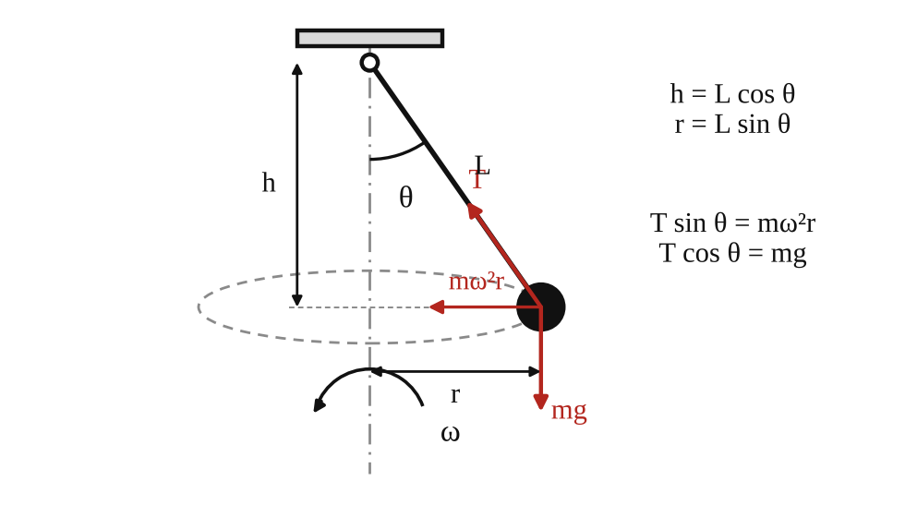
Fig. 1: Conical pendulum (left: the forces on the bob; right: the apparatus).
Method in brief
- Set the pointer to a required angle θ (start at a small angle, for example 10° or 15°).
- Increase the speed ω slowly until the pendulum rod lines up with the pointer, and note the speed from the tachometer.
- Repeat with the angle increased in steps of 5°.
- Calculate h = L cos θ and ω = 2πN/60 for each angle.

3. Results
Effective length L = [ ] mm.
Table 1: Conical pendulum results
θ (°) | h = L cos θ (m) | 1/h (m⁻¹) | N (rpm) | ω = 2πN/60 (rad/s) | ω² (rad²/s²) | ω² h (= g) (m/s²)
10
15
20
25
30
35
40

4. Analysis of Results
- h = L cos θ = [ ] × cos [ ]° = [ ] m, and 1/h = [ ] m⁻¹.
- ω = 2πN/60 = 2π × [ ] ÷ 60 = [ ] rad/s, and ω² = [ ] rad²/s².
- From the graph of ω² against 1/h: slope = Δ(ω²)/Δ(1/h) = [ ] ÷ [ ] = [ ] m/s², and this slope is g.
- Also g = ω² h for each reading; mean g = [ ] m/s².
- Percentage difference from the standard value 9.81 m/s²: ( [ ] − 9.81 ) ÷ 9.81 × 100 = [ ] %.

5. Observations / Precautions Taken
Observations
- The bob rose and moved outwards as the speed was increased, and the height h decreased.
- A very small speed was not enough to lift the bob from the vertical position. The speed had to pass a minimum value (ω² = g/L when θ = 0) before the cone could form.
- The speed needed rose quickly as the angle got larger.
- The points of ω² against 1/h lay close to a straight line.
Precautions
- The speed was increased very slowly and steadily so that the rod stayed in line with the pointer.
- The pointer was read at eye level.
- The speed was read from the tachometer only when the speed was steady.
- Guards were in place and no one reached into the rotating parts.

6. Graphs
Plot the following on graph paper from your own readings and attach them here:
- An approximate graph of ω² against 1/h, with the best straight line drawn. The slope gives g.

7. Discussion
Do the results show any appreciable deviation from theory? Explain. The points [lie close to a straight line through the origin / show some scatter] and the value of g from the slope was [ ] m/s², which differs from 9.81 m/s² by [ ] %. Where there is a deviation, it comes from the factors below.
- Friction between the bob and the guide bar, and air resistance, which are not in the theory.
- The rod and the bob are not a point mass on a weightless string (the rod has mass and the bob has size), so L is not the exact length to the centre of mass.
- The angle was set by eye with a pointer, so θ may be out by 1° or more, which has a big effect on h at small angles.
- The speed fluctuates a bit while the pendulum is lined up with the pointer.
Local value of g. The value of g from the slope of the graph is [ ] m/s².

8. Conclusion
The height of the conical pendulum decreased as the speed increased, and the graph of ω² against 1/h was a straight line through the origin, in agreement with ω² = g/h. The local value of g obtained from the slope was [ ] m/s², about [ ] % different from 9.81 m/s². The principle is used in centrifugal governors, fairground swing rides and the analysis of vehicles on banked bends.

Section B: Questions
1. What I learnt from the experiment. I learnt how a mass moving in a horizontal circle forms a cone and how the height depends on speed, and how to find g from the slope of an ω² against 1/h graph.
3. Comment on the experimental procedure. The angle is set first and the speed adjusted until the rod lines up with the pointer, so the readings are quick. Using several angles and a graph gives a better answer for g than one reading.
4. Most difficult aspect of the experiment. Judging the exact moment when the rod lines up with the pointer while the speed is changing. It can be reduced by increasing the speed very slowly and repeating each reading.
5. Another method that could be used. A simple pendulum or a free fall (falling body) experiment, or a compound pendulum, can also give g.
6. Parameters measured / involved. Pendulum length L, angle θ, height h = L cos θ, speed N (rpm) and angular velocity ω.
7. Measuring instrument used. The tachometer measures the speed in rev/min, and the protractor with pointer measures the angle θ.
8. Practical relevance. Centrifugal (Watt) governors, fairground swing rides, centrifuges, and the design of banked curves on roads and railways.
9. Section of the course it belongs to. Dynamics (circular motion and centripetal force).
13. What interested me most. The bob rose higher the faster it turned, in the same way as a swing ride.
2, 10, 11, 12, 14 and 15 (personal / references): to be filled in by you.

AM 226(A): Simple Pendulum

Objective
- To determine the acceleration due to gravity, g.

1. Theory
A simple pendulum is a small heavy bob (here a steel ball) hung from a light thread of length L. If the ball is displaced through a small angle θ and released, it swings to and fro. The restoring force is the component of the weight along the arc, mg sin θ. For small angles sin θ ≈ θ (in radians), so the motion is approximately simple harmonic motion (SHM), where the acceleration is proportional to the displacement and directed towards the middle:
ω² x = g/L × x so ω² = g / L
where ω is the angular velocity of the motion. The period of oscillation is T = 2π/ω, so
T = 2π √(L / g) T² = (4π² / g) L g = 4π² L / T²
Therefore a graph of T² (vertical) against L (horizontal) is a straight line through the origin, and its slope is 4π²/g, so g = 4π² / slope. The period does not depend on the mass of the bob or (for small swings) on the amplitude.

2. Apparatus
A spherical steel ball (bob), a length of thread, a chuck for gripping the thread at the top, a stopwatch and a meter rule.
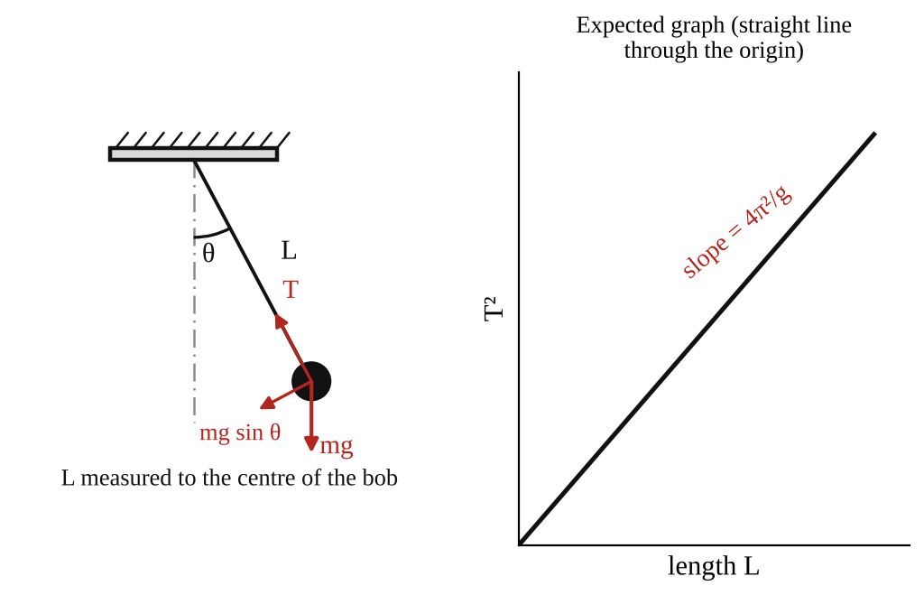
Fig. 1: Simple pendulum (L is measured from the point of support to the centre of the ball).
Method in brief
- Fix the thread in the chuck and hang the ball on it. Measure the length L from the point of support to the centre of the ball (the thread length plus the radius of the ball).
- Displace the ball through a small angle (less than about 10°) and release it. Record the time for 50 oscillations. Divide by 50 for the period T.
- Vary the length and repeat the timing. Do this about eight times so that there are enough points to plot the graph.

3. Results
Table 1: Simple pendulum results
Length L (m) | Time for 50 oscillations (s) | Period T (s) | T² (s²) | g = 4π²L/T² (m/s²)

4. Analysis of Results
- T = (time for 50 oscillations) / 50 = [ ] ÷ 50 = [ ] s, and T² = [ ] s².
- Slope of the graph of T² against L = ΔT²/ΔL = [ ] ÷ [ ] = [ ] s²/m.
- g = 4π² / slope = 39.48 ÷ [ ] = [ ] m/s².
- Mean of the individual values of g = 4π²L/T² = [ ] m/s².
- Percentage difference from the accepted value 9.81 m/s²: ( [ ] − 9.81 ) ÷ 9.81 × 100 = [ ] %.

5. Observations / Precautions Taken
Observations
- The period increased as the length increased, and the pendulum took longer for each swing.
- The swings slowly became smaller because of air resistance, but the period stayed about the same (the pendulum is isochronous for small amplitudes).
- The points on the T² against L graph lay close to a straight line through the origin.
Precautions
- The ball was displaced through a small angle only (under 10°), so that sin θ ≈ θ.
- It was released without pushing, and swung in one plane, not in an ellipse.
- The time was taken for 50 oscillations, to reduce the effect of reaction time, and was repeated.
- The length was measured from the point of support (the clamp) to the centre of the ball.
- The thread was held firmly in the chuck so it did not slip or change length.
- Timing started when the ball passed the middle point (the lowest point), where its speed is greatest and it is easier to see.

6. Graphs
Plot the following on graph paper from your own readings and attach them here:
- T² (square of the period) against L (length of the pendulum), with the best straight line drawn

7. Discussion
Sources of error
- Reaction time in starting and stopping the stopwatch (reduced by timing 50 oscillations).
- Miscounting the number of oscillations.
- Error in measuring L, particularly to the centre of the ball and the exact point of support.
- Air resistance, and the mass of the thread, which is not zero.
- Amplitude that is too big, so that the swing is not really SHM (the period increases slightly with amplitude).

8. Conclusion
From the slope of the T² against L graph, the acceleration due to gravity was found to be [ ] m/s². 1. Is your value the same as the theoretical value? Why? The accepted value is 9.81 m/s² (the exact value depends on the latitude and height; in Nigeria it is close to 9.78 m/s²). My value differs by [ ] %. The difference is mainly due to the errors listed above. 2. Limitations of this method. The method depends on the small-angle approximation, on accurate timing by hand, and on an exact length measurement. Air resistance and the thread mass affect the result, so it can give g only to about 1 or 2 % even when carefully done. More accurate values of g come from a reversible (Kater's) pendulum or a free-fall timer.

Section B: Questions
1. What I learnt from the experiment. I learnt how a simple pendulum behaves as SHM, why T² is proportional to L, and how to get g from the slope of the graph.
3. Comment on the experimental procedure. Timing 50 oscillations reduces the error from reaction time, and plotting a graph of eight points reduces the effect of any single bad reading. The apparatus is cheap and simple.
4. Most difficult aspect of the experiment. Counting a large number of oscillations while watching the stopwatch and keeping the swing in one plane. It can be reduced by using a fiducial mark at the lowest point, and by repeating each timing.
5. Another method that could be used. A compound pendulum (Kater's reversible pendulum), a free fall apparatus with an electronic timer, or a conical pendulum.
6. Parameters measured / involved. Length L, time for 50 oscillations, period T, T², and g.
7. Measuring instrument used. The stopwatch measures the time, and the meter rule measures the length of the pendulum.
8. Practical relevance. Pendulum clocks, metronomes, measuring g for geological surveys and the study of oscillations in structures and swings.
9. Section of the course it belongs to. Dynamics (simple harmonic motion).
13. What interested me most. The period did not change much as the swing died down, only the length changed it.
2, 10, 11, 12, 14 and 15 (personal / references): to be filled in by you.

AM 226(B): Compound Pendulum: Conditions for Minimum Period

Objective
- To suspend a given rigid body from a number of points and to study the variation of the period with the distance of the suspension point from the centre of mass.

1. Theory
A compound (physical) pendulum is any rigid body that swings about a horizontal axis that does not pass through its centre of mass G. Let M = the mass of the pendulum, h = the distance from the point of suspension (knife-edge) to G, k = the radius of gyration of the body about G, and θ = the angle of swing. For a small swing the restoring moment about the knife-edge is Mgh θ, and the moment of inertia about the knife-edge is M(h² + k²) (parallel axis theorem), so
M g h θ = M (h² + k²) d²θ/dt²
This is simple harmonic motion with
ω² = 4π²/T² = g h / (h² + k²) = g / L_{e} where L_{e} = (h² + k²)/h = h + k²/h
L_{e} is the length of the equivalent simple pendulum: a simple pendulum of length L_{e} has the same period. Then the period is T = 2π √(L_{e}/g), so from the measured period
L_{e} = g T² / 4π²
Condition for minimum period. The period is smallest (the frequency is greatest) when L_{e} is smallest:
dL_{e}/dh = 1 − k²/h² = 0 so h = ± k
So the minimum period occurs when the distance of the knife-edge from G equals the radius of gyration, and the minimum value of L_{e} is 2k. The ± sign corresponds to the fact that the knife-edge can be the same distance on either side of G and give the same period.
Straight-line form. Since L_{e} h = h² + k², a graph of (L_{e} h) against h² is a straight line with slope 1 and intercept k². This lets the radius of gyration be found easily from the intercept.

2. Apparatus
Stopwatch, knife-edge, rigid bar with a row of equally spaced holes (the bar used in Kater's pendulum experiment; the wall-mounted Kater's pendulum bar is stainless steel and the one on the universal vibrations rig is brass), a rule and a balance.
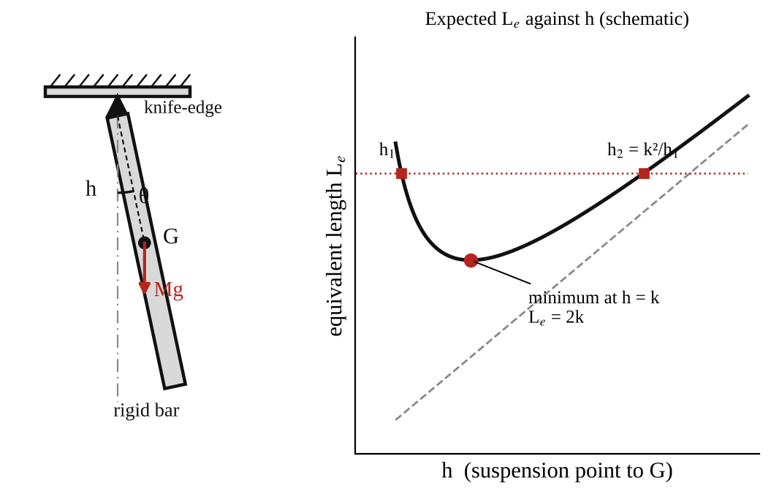
Fig. 1: Compound pendulum, bar suspended on a knife-edge at distance h from the centre of mass G.
Observations required
- Dimensions of the bar.
- Mass of the bar.
- Position of its centre of mass.
- List of periods and corresponding distances of the point of suspension from the centre of mass.
Method in brief
- Find the centre of mass G by balancing the bar on the knife-edge. Measure the dimensions and the mass.
- Suspend the bar from a hole on the knife-edge at a measured distance h from G. Give it a small swing (under 10°).
- Measure the time for 5, 10 or 20 swings with the stopwatch and calculate the period T. Repeat the observation and change observers.
- Repeat for all the holes along the bar, on both sides of G (although the bar is supposed to be symmetrical, check this; it improves accuracy). Vary the period for about eight different values of h.

3. Results
Mass of bar M = [ ] kg. Length = [ ] mm. Width = [ ] mm. Thickness = [ ] mm. Position of G = [ ] mm from one end.
Table 1: Compound pendulum results
h (m) | Time for n swings (s) | Period T (s) | L_{e} = gT²/4π² (m) | L_{e}h (m²) | h² (m²) | k² = L_{e}h − h² (m²) | k (m)

Table 2: Calculated radius of gyration from the dimensions
Quantity | From experiment | From dimensions and density
Mass M (kg)
Radius of gyration k (m)
Minimum period T_{min} (s)

4. Analysis of Results
- T = (time for n swings)/n = [ ] ÷ [ ] = [ ] s.
- L_{e} = gT²/4π² = 9.81 × [ ]² ÷ 39.48 = [ ] m.
- k² = L_{e}h − h² = [ ] × [ ] − [ ]² = [ ] m², k = [ ] m for each h, and the average k = [ ] m.
- From the dimensions: for a uniform rectangular bar of length l and width b, k² = (l² + b²)/12 about the centre of mass (for a long thin bar, k ≈ l/√12 = 0.289 l). Mass = density × volume = [ ] kg (steel ≈ 7800 kg/m³, brass ≈ 8500 kg/m³). Any holes in the bar reduce the mass and change k, so the value from the dimensions is only approximate.
- Predicted curve: L_{e} = h + k²/h, for the average k, calculated at the same values of h and plotted with the experimental points.
- Straight-line check: the graph of L_{e}h against h² should have slope 1 and intercept k². Slope found = [ ], intercept = [ ] m², so k = [ ] m.
- Minimum period: T_{min} = 2π √(2k/g) = [ ] s, at h = k = [ ] m.

5. Observations / Precautions Taken
Observations
- The period was large when the knife-edge was very near G (h small), fell to a minimum at some distance h, and then increased again as the suspension point moved towards the end of the bar.
- Holes the same distance on opposite sides of G gave nearly the same period, as expected (the bar is almost symmetrical).
- The experimental points lay close to the predicted L_{e} = h + k²/h curve.
Precautions
- The bar was swung through small angles only (under 10°), so sin θ ≈ θ.
- The swing was kept in one plane and the knife-edge was set firmly, level and without slipping.
- The period was found from 5, 10 or 20 swings, not one, to reduce timing error, and the observations were repeated with different observers.
- The distance h was measured from the centre of mass to the knife-edge accurately.

6. Graphs
Plot the following on graph paper from your own readings and attach them here:
- Predicted and experimental L_{e} against h on the same axes
- The straight-line form: L_{e}h against h² (slope 1, intercept k²), and compare the experimental and theoretical plots

7. Discussion
Conclusions and comments. How accurately was k determined? The value of k from the experiment was [ ] m and from the dimensions [ ] m, a difference of [ ] %. The experimental and calculated results are expected to agree within a few per cent if the timings are good. The theory is verified to the extent that the experimental L_{e} against h points follow the curve L_{e} = h + k²/h and the straight-line plot has a slope close to 1.
Sources of error
- Timing errors from reaction time, and miscounting swings.
- Error in finding the position of the centre of mass and in measuring h.
- Friction at the knife-edge and air resistance, which damp the swing.
- The holes in the bar and any non-uniformity, which the calculation from the dimensions ignores.
- Large swing angles, which lengthen the period.

8. Conclusion
The period of the compound pendulum was measured for different suspension points. L_{e} was smallest when h was about equal to the radius of gyration k, which agrees with the theory (minimum period at h = k). The radius of gyration was found to be [ ] m, which is within [ ] % of the value calculated from the dimensions. The compound pendulum is the basis of Kater's reversible pendulum, which gives accurate values of g, and the method is used to find the moment of inertia of connecting rods and other irregular bodies.

Section B: Questions
1. What I learnt from the experiment. I learnt how the period of a rigid body changes with the point of suspension, why there is a minimum period at h = k, and how to find the radius of gyration from the results.
3. Comment on the experimental procedure. Many holes along the bar give many readings from one set-up, and timing several swings reduces the error. The straight-line plot of L_{e}h against h² gives k directly.
4. Most difficult aspect of the experiment. Timing swings accurately and finding the exact centre of mass. It can be reduced by timing 20 swings, repeating with different observers and balancing the bar carefully on the knife-edge.
5. Another method that could be used. A torsion pendulum, or the trifilar suspension, can be used to find the moment of inertia, and Kater's reversible pendulum to find g.
6. Parameters measured / involved. Distance h, period T, length of the equivalent simple pendulum L_{e}, radius of gyration k, mass M and dimensions of the bar.
7. Measuring instrument used. The stopwatch measures the time of the swings, and the rule measures h and the dimensions of the bar. The balance measures the mass.
8. Practical relevance. Kater's pendulum for finding g, finding the moment of inertia of connecting rods and engine parts, and the design of clock pendulums and swinging machine parts.
9. Section of the course it belongs to. Dynamics (rigid body motion, moment of inertia and SHM).
13. What interested me most. The period was smallest at a certain distance from the centre of mass and larger on either side of it.
2, 10, 11, 12, 14 and 15 (personal / references): to be filled in by you.

AM 229: Flywheel and Falling Weight

Objective
- To determine the moment of inertia of a flywheel and to use it to verify Newton's laws as applied in this case.

1. Theory
A flywheel and axle of mass M and moment of inertia I = Mk² (k = radius of gyration) is turned by a weight mg hung on a cord wound round the axle of radius r. The falling weight descends a height h in a time t.
(a) Neglecting friction
For the falling mass (Newton's second law): m a = m g − T, where T is the tension in the cord. For the flywheel (torque = moment of inertia × angular acceleration): Mk² α = T r. The cord does not slip, so a = α r. Eliminating T:
Mk² α = (mg − ma) r a = α r
Mk² = m r² ( g/a − 1 ) and a = m g r² / (Mk² + m r²)
If the time t for the weight to descend the known height h is measured, the linear acceleration is found from a = 2h/t², so Mk² = mr² (gt²/2h − 1).
(b) With friction in the bearings
Let there be an opposing frictional couple L_{f}. Then m a = mg − T and Mk² α = T r − L_{f}, which gives
Mk² a / r² = (mg − ma) − L_{f}/r so a = (mg − L_{f}/r) / (m + Mk²/r²)
If L_{f} is known we can proceed as before. If L_{f} is not known, we can try two or three values of m, and a graph of m(g − a) against a gives a straight line with slope Mk²/r² and intercept L_{f}/r. The intercept is therefore the friction force at the axle radius (the weight needed just to overcome friction).
(c) The falling weight method (energy method)
Let m = the mass, H = h the distance it falls, v = its speed on reaching the floor, ω = v/r the angular velocity of the flywheel when m is detached, N = the number of revolutions made after m is detached, and n = the number of revolutions made while m falls, n = h/2πr. When the mass falls it loses potential energy mgh and gains kinetic energy ½mv², plus the flywheel's kinetic energy ½Iω², plus work done against friction 2πn L_{f}:
mgh = ½mv² + ½Iω² + 2πn L_{f}
After m is detached the flywheel comes to rest, so the work done against friction equals its kinetic energy: 2πN L_{f} = ½Iω². Eliminating L_{f}:
mgh = ½mv² + ½Iω² (N + n)/N
The motion of m is at constant acceleration, so v = 2h/t, and substituting for ω = v/r gives
I = m r² [ g t²/(2h) − 1 ] × [ N/(N + n) ]

2. Apparatus
A flywheel on a horizontal axle with bearings, a cord wound round the axle (radius r) with a hanger for the falling weights, slotted masses, a stopwatch, a rule or tape to measure h, vernier calipers for the axle diameter, a vibrating cantilever with paper (for the trace) and a balance. The length of the string is adjusted so that, when the weight reaches the ground, the string detaches itself from the axle and the flywheel is then allowed to come to rest under the friction in the bearings.
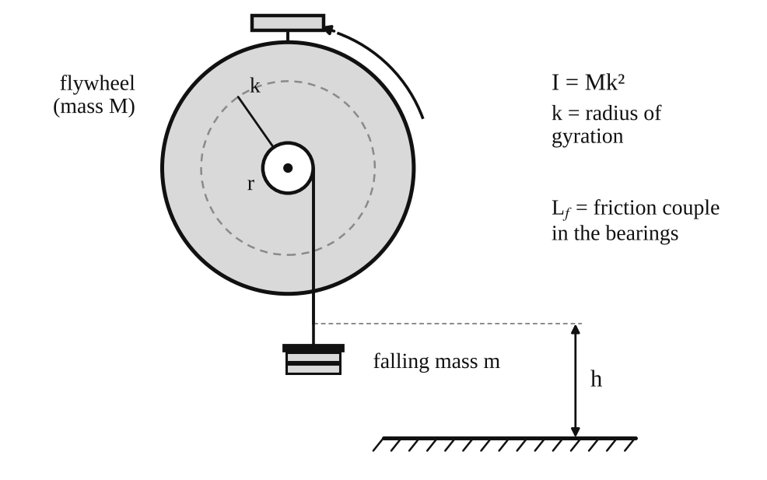
Fig. 1: Flywheel and axle with the falling weight m (h = height of fall, r = axle radius).
Observations required
- Magnitude of the falling weight = mg.
- Height of descent = h.
- Mass of the flywheel and axle = M.
- Moment of inertia of the flywheel and axle I = Mk², where k = the radius of gyration.
- Time of descent = t.
- Radius of the axle = r.
Method in brief
- Before beginning, spin the flywheel by hand to warm up the bearings; otherwise the frictional couple will not stay constant during the experiment and results will be inconsistent.
- Choose several values for m (at least 50 g upwards) that give a convenient time of fall.
- For each m, release the weight and measure t. After it detaches, count the number of revolutions N until the flywheel stops. Repeat several times for each m.
- The value of n is found more accurately from h/2πr than by counting.
- Obtain a value of I for each m, find the average if it is not constant, and compare with the value calculated from the mass and dimensions of the flywheel, neglecting the axle. Estimate the accuracy of the results.

3. Results
h = [ ] m, r = [ ] m, M = [ ] kg, g = 9.81 m/s².
Table 1: Falling weight results
m (kg) | mg (N) | t (s) | a = 2h/t² (m/s²) | Mk² from (a) (kg m²) | N (rev) | n = h/2πr | I from (c) (kg m²) | k² = I/M (m²)

Table 2: Comparison with the value from the geometry
Quantity | Experiment | Calculated from dimensions | Difference (%)
Moment of inertia I (kg m²)
Radius of gyration k (m)

4. Analysis of Results
- Acceleration of the weight: a = 2h/t² = 2 × [ ] ÷ [ ]² = [ ] m/s².
- Neglecting friction: Mk² = m r² (g/a − 1) = [ ] × [ ]² × ( 9.81 ÷ [ ] − 1 ) = [ ] kg m².
- With friction (falling weight method): I = m r² [gt²/2h − 1][N/(N + n)] = [ ] kg m², with n = h/(2πr) = [ ] and N counted from the test.
- The radius of gyration k² = I/M = [ ] ÷ [ ] = [ ] m², k = [ ] m.
- Comparison with the geometry: for a solid disc k² = R²/2, and for a rim-type flywheel k² is close to R². Calculated I = [ ] kg m²; difference = [ ] %.
- Newton's laws check: the graph of m(g − a) against a is a straight line with slope I/r² = [ ] and intercept L_{f}/r = [ ] N.

5. Observations / Precautions Taken
Observations
- The weight accelerated downwards at a roughly constant rate, and the flywheel went on turning for a number of revolutions after the weight was detached before it stopped.
- A larger falling mass gave a shorter time of fall.
- The time of fall was repeatable for each mass to within about [ ] s.
- The value of Mk² calculated ignoring friction was larger / smaller than that with friction allowed for.
Precautions (to give good accuracy)
- The flywheel was spun by hand to warm up the bearings before starting, so that the frictional couple stayed constant.
- The cord was wound neatly in a single layer and its length adjusted so it detached from the axle just as the weight reached the floor.
- The stopwatch was started when the weight was released and stopped when it hit the floor; measurements were repeated and averaged.
- The number of revolutions N was counted carefully with a marker on the flywheel.
- The radius r included half of the cord thickness. The falling weight was not allowed to swing.

6. Graphs
Plot the following on graph paper from your own readings and attach them here:
- m(g − a) against a (should be a straight line; slope I/r², intercept L_{f}/r)
- a (or t) against m, to show how the acceleration depends on the falling mass

7. Discussion
Notes on procedure. (1) The constancy of a for various loads can be investigated by timing the descent over different heights; if a is constant, the motion is uniformly accelerated, as Newton's second law predicts. (2) The ratio L_{f}/Mk² can be found by spinning the flywheel and counting the rotations in given times (the speed falls at a constant rate for constant friction). It is limited by the accuracy with which the counting and the times can be done. (3) L_{f} can also be found with a short cord, so that the weight rises again after the descent (the falling weight method), which is more accurate because it uses the same weights and bearing conditions. (4) Using different values of m and M, k² is found for each, and the results are compared with and without allowance for L_{f}. (5) The vibrating cantilever can generate a trace on paper attached to the flywheel rim; knowing the period of vibration, the angular acceleration is found directly.
Sources of error
- Friction in the bearings is not exactly constant (it changes with temperature and speed).
- Reaction time in timing the descent, particularly for short times.
- Cord thickness, slipping or bunching of the cord on the axle, and its mass.
- Estimating the moment of inertia from the geometry ignores holes, keyways and the axle.
- Counting the revolutions N while the flywheel is slowing down.

8. Conclusion
The moment of inertia of the flywheel was found to be [ ] kg m² (k = [ ] m). The values are within about [ ] % of the value calculated from the geometry. Allowing for the bearing friction (the falling weight method) gave a more accurate value than neglecting friction. Newton's laws are verified to the extent that the linear acceleration of the falling mass and the angular acceleration of the flywheel were consistent with the torque equation Mk²α = Tr − L_{f}. The method is recommended for finding moments of inertia of flywheels and rotors, but it needs a steady bearing friction and accurate timing. An alternative for irregular bodies is the torsion pendulum or the trifilar suspension.

Section B: Questions
1. What I learnt from the experiment. I learnt how to find the moment of inertia of a flywheel by timing a falling weight, how bearing friction affects the result, and how to allow for it with the falling weight method.
3. Comment on the experimental procedure. Using several masses and several repeats averages out timing errors, and the falling weight method allows for friction. The method only needs a stopwatch, rule and masses.
4. Most difficult aspect of the experiment. Counting the revolutions N while the flywheel slows down and timing the fall accurately. It can be reduced by marking the flywheel, repeating each reading, and using larger heights so that t is longer.
5. Another method that could be used. A torsion pendulum or a trifilar suspension for the moment of inertia, or a photogate and a data logger for t and N.
6. Parameters measured / involved. Falling mass m, height h, time t, axle radius r, number of revolutions N, mass M, acceleration a and moment of inertia I.
7. Measuring instrument used. The stopwatch measures the time of fall, the rule measures the height h, and the vernier calipers measure the axle diameter.
8. Practical relevance. Flywheels in engines and presses, energy storage, rotating machinery, and the design of rotors and wheels.
9. Section of the course it belongs to. Dynamics (rotation of rigid bodies: moment of inertia and angular acceleration).
13. What interested me most. The flywheel kept turning for many revolutions after the weight was detached.
2, 10, 11, 12, 14 and 15 (personal / references): to be filled in by you.

AM 231: Automat Spur Gear Models (A1 to A5)

Objective
- To examine the working of various types of toothed gearing through the Automat models, and to write a brief technical report on the use of toothed gears in engineering.

1. Theory
A gear is a toothed wheel that transmits motion and torque from one shaft to another without slip. A pair of meshing gears has a constant speed ratio set by the numbers of teeth. The gear on the shaft that supplies the power is the driver (driving gear) and the gear that receives the power is the driven gear (follower). The gear ratio is defined as
Gear ratio (G.R.) = N_{driver} / N_{driven} = T_{driven} / T_{driver}
where N is the speed in rev/min and T is the number of teeth. Meshing gears must have the same module (tooth size). External gears turn in opposite directions. When G.R. > 1 the driven shaft is slower and the torque is greater (a speed reducer); when G.R. < 1 it is faster and the torque is smaller (a speed increaser). The power is nearly the same on both shafts (apart from friction losses of the order of 1 to 3 % per stage).
The models provided are:
- A1: single stage spur gear. Two spur gears on parallel shafts. G.R. = T₂/T₁. The directions of rotation are opposite.
- A2: spur gear with idler. An idler gear sits between the driver and the driven gears. It does not change the gear ratio (the idler's teeth cancel out), G.R. = T₃/T₁, but it changes the direction of rotation.
- A3: compound gear train. Two gears are fixed on one intermediate shaft, so the speed reduction takes place in two stages. G.R. = (T₂/T₁) × (T₄/T₃), the product of the stage ratios.
- A4: worm and worm wheel. A screw-like worm (driver) meshes with a worm wheel (driven) on a shaft at right angles. For a single-start worm, one turn of the worm advances the wheel by one tooth, so G.R. = T_{wheel}/(number of starts on the worm). It gives a very high ratio in one stage and can be self-locking.
- A5: bevel gears. Cone-shaped gears that connect shafts that intersect, usually at 90°. G.R. = T_{driven}/T_{driver}.

2. Apparatus
The Automat spur gear models A1 to A5 (single-stage spur gear, spur gear with idler, compound gear, worm gear and bevel gear) with turning handles, labelled gears and shafts.
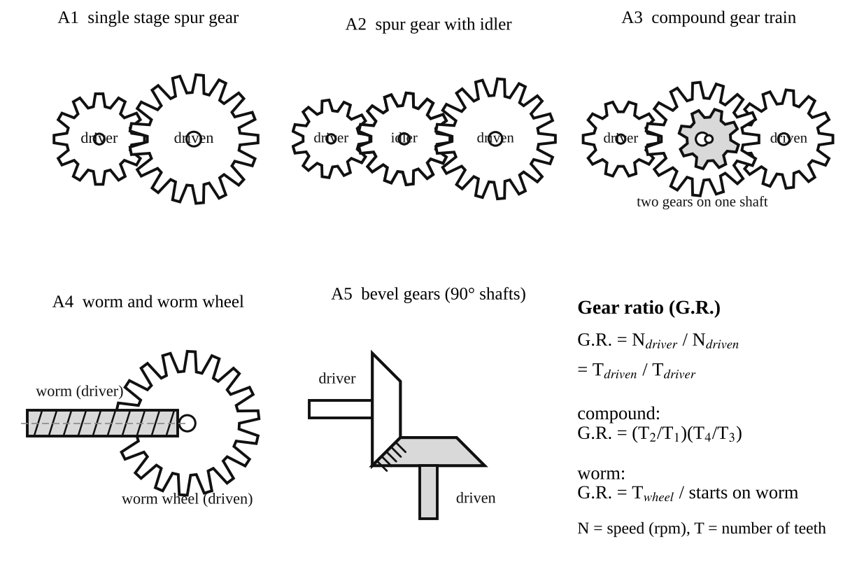
Fig. 1: The five gear arrangements and the gear ratio formulas.
Method in brief
- For each model, identify the driving and the driven shafts, and note the direction of rotation of each shaft.
- Count the teeth on every gear and, turning the driver by a known number of turns, count the turns of the driven shaft. Calculate the gear ratio in both ways.
- Vary the gear combination (change the gears on the models) and see how the ratio changes, so that the general formula for the gear ratio can be established.

3. Results
Table 1: Gear data and gear ratios
Model | Teeth on driver | Teeth on idler / intermediate gears | Teeth on driven gear | G.R. from teeth | Turns of driver per turn of driven | Direction of driven shaft (same / opposite)
A1 single stage |  | –
A2 with idler
A3 compound
A4 worm | (starts: ) | –
A5 bevel |  | –

4. Analysis of Results
Write a brief but comprehensive technical report on the use of toothed gears in engineering, using the following questions as guidelines.
1. In each case, distinguish between the driving and the driven shafts, and determine the gear ratio.
- A1: the driving shaft carries the smaller (pinion) gear T₁; the driven shaft carries the larger gear T₂. G.R. = T₂/T₁ = [ ] ÷ [ ] = [ ]. The driven shaft turns in the opposite direction.
- A2: the driving shaft carries T₁; the idler turns freely on its own shaft; the driven shaft carries T₃. G.R. = T₃/T₁ = [ ] (the idler's T₂ cancels out: (T₂/T₁)(T₃/T₂)). The driver and driven shafts turn in the same direction.
- A3: the driving shaft carries T₁, which meshes with T₂ on the intermediate shaft; T₃, fixed on the same shaft as T₂, meshes with T₄ on the driven shaft. G.R. = (T₂/T₁)(T₄/T₃) = ( [ ] ÷ [ ] ) × ( [ ] ÷ [ ] ) = [ ]. The driven shaft turns in the same direction as the driver.
- A4: the driving shaft carries the worm, and the driven shaft (at 90°, and not in the same plane) carries the worm wheel. G.R. = T_{wheel}/starts = [ ] ÷ [ ] = [ ].
- A5: the driving shaft carries one bevel gear and the driven shaft (at 90° to it) carries the other. G.R. = T_{driven}/T_{driver} = [ ] ÷ [ ] = [ ].
2. By varying the gear ratio in each model, establish a mathematical formula for the gear ratio. For any simple pair the speeds are in inverse proportion to the number of teeth, because the teeth pass the mesh point at the same rate (the pitch-circle speeds are equal): N₁T₁ = N₂T₂, so
G.R. = N_{driver}/N_{driven} = T_{driven}/T_{driver}
For a train of gears the overall ratio is the product of all stage ratios: G.R. = (product of the teeth on the driven gears) ÷ (product of the teeth on the driver gears). Idlers cancel and do not affect the ratio. For a worm drive: G.R. = T_{wheel}/(number of starts).
3. The gearing in A1 and A2 gives the same gear ratio. Suggest two important reasons for the incorporation of an idler.
- To make the driven shaft rotate in the same direction as the driving shaft (a single pair reverses the direction).
- To bridge a large centre distance between the shafts without having to use very large gears, which would be heavy and costly. It also allows the driven gear to be placed at a convenient position. (An idler also lets one driver feed several driven gears, as in a gearbox reverse gear.)
4. If you were to transmit rotary motion between two parallel shafts which are far apart and require a large speed ratio, which type of gearing would you employ? Why? I would use a compound gear train (A3 type) with spur gears, perhaps with one or more idlers to span the distance. A single pair would need a huge gear to get a large ratio (usually a single spur stage is limited to about 6:1 to 8:1), so the ratio is divided into stages of 3:1 to 6:1 on intermediate shafts. This keeps the gears a reasonable size, and the ratio is the product of the stages, e.g. 5 × 5 = 25:1. For a long distance, a chain or a belt can carry the motion across the gap at the high-speed stage, where the torque is low, followed by gears for the speed reduction. Worm and bevel gears are for shafts that are not parallel, so they are not suitable here.
Technical report on the use of gears in engineering
Gears are the most common positive drive in machines. Spur gears (parallel shafts, teeth parallel to the axis) are simple, efficient (98 to 99 % per stage) and cheap, but noisy at high speed. Helical gears run more quietly and carry more load but produce an axial thrust. Bevel gears connect intersecting shafts, as in a car differential or a hand drill. Worm gears give a high ratio (up to 100:1) in a small space and can be self-locking (used in lifting gear and tuning heads), but they are less efficient (40 to 90 %) and wear quickly because of sliding. Compound trains give large ratios, as in gearboxes, clocks and winches. Gears also change torque and speed, reverse direction, and transmit power between shafts at different positions. Compared with belts and chains, gears have no slip, so the speed ratio is exact, and they are compact; the price is the need for accurate alignment, lubrication, and higher cost.

5. Observations / Precautions Taken
Observations
- In A1 the driven shaft turned in the opposite direction to the driver, and a smaller driver turned the larger gear slowly.
- In A2 the driven shaft turned in the same direction as the driver, and the idler had no effect on the gear ratio.
- In A3 the speed was reduced in two steps, and the overall ratio was the product of the two ratios.
- In A4 many turns of the worm were needed to turn the worm wheel once, and the worm wheel could not drive the worm back (self-locking).
- In A5 the direction of rotation changed through 90°.
Precautions
- The teeth were counted carefully and a mark was used to count the turns of the shafts.
- The handle was turned slowly and smoothly, and fingers were kept clear of the meshing gears.
- The models were handled gently so that the gears did not get damaged.

6. Graphs
No graphs are required for this experiment. Neat sketches of the models are in the Apparatus section (Fig. 1) and should be redrawn in your own report if your lecturer asks for hand sketches.

7. Discussion
The measured gear ratios (by counting the turns) agreed with those calculated from the numbers of teeth, to within the error of counting. The experiment shows that the gear ratio depends only on the numbers of teeth and not on the size or the idler gears. The models make it easy to see the direction of rotation, but they cannot show the real problems of gears such as the tooth profile, backlash, noise, lubrication and wear.
Limitations of the models
- Backlash (clearance between teeth) makes the driven shaft lag when the direction is reversed.
- The models are not loaded, so the torque, power and efficiency cannot be measured.
- The turns are counted by eye, which becomes inaccurate at higher ratios.

8. Conclusion
The working of five types of gearing (single-stage spur, spur with idler, compound, worm and bevel) was examined. The gear ratio is G.R. = N_{driver}/N_{driven} = T_{driven}/T_{driver}, and for a train it is the product of the stage ratios. An idler changes the direction but not the ratio. Large ratios between far-apart parallel shafts are best obtained with a compound train. Gears are used in gearboxes, clocks, machine tools, vehicles, winches and almost every machine that transmits power.

Section B: Questions
1. What I learnt from the experiment. I learnt how the different types of gears work, how to find the gear ratio from the teeth, and why idlers and compound trains are used.
3. Comment on the experimental procedure. The models allow the gears to be turned by hand and counted directly, so the ratios can be checked by two methods. The gears can easily be changed, so the formula can be established.
4. Most difficult aspect of the experiment. Counting the turns of the driven shaft accurately when the ratio is large. It can be reduced by marking the shafts and counting slowly.
5. Another method that could be used. Real gearboxes with a tachometer on the two shafts to measure the speed ratio, or a software simulation of gear trains.
6. Parameters measured / involved. Numbers of teeth, number of turns of the driver and driven shafts, direction of rotation, and gear ratio.
7. Measuring instrument used. No instrument was needed, only the counting of teeth and turns, but a tachometer could measure the speeds.
8. Practical relevance. Car gearboxes and differentials, clocks, machine tools, winches, lifts, wind turbines, and every machine that transmits power.
9. Section of the course it belongs to. Machines and mechanisms (gears and gear trains).
13. What interested me most. The idler gear did not change the ratio but only changed the direction of rotation.
2, 10, 11, 12, 14 and 15 (personal / references): to be filled in by you.

