APPLIED MECHANICS LABORATORY
LABORATORY REPORTS
AM 211: Friction Experiment
AM 212: Rolling on an Inclined Plane
AM 214: Screw Jack

Name: ______________________________
Matric No.: __________________________
Department: _________________________
Date: _______________________________
Contents
AM 211 Friction Experiment
AM 212 Rolling on an Inclined Plane
AM 214 Screw Jack
Notes before you submit
- Anything shown as [ ] is for your own readings or results from your own lab session. Nothing has been invented.
- Each report follows Section C of the manual: Theory, Apparatus, Results, Analysis of Results, Observations and Precautions, Graphs, Discussion and Conclusion. The Section B questions are answered after each report.
- Questions 2, 10, 11, 12, 14 and 15 are personal, so they are left for you to fill in.
- Graphs must be drawn from your own readings on graph paper (or in Excel) and attached where indicated.

AM 211: Friction Experiment

Objective
- Part A: to find the coefficient of friction μ between the mild steel plane and the different materials of the slider trays, and the angle of friction.
- Part B: to find the force parallel to an inclined plane needed to drag a tray up or down at constant velocity, to compare it with theory, and to observe the effect of rolling.

1. Theory
Friction is the force that resists motion between two surfaces in contact. It acts along the surfaces and opposes the motion. Its size is F = μN, where μ is the coefficient of friction (no units, depends on the two surfaces) and N is the normal reaction. Friction does not depend on the area of contact.
Level plane (Part A1). When the tray moves at a slow, constant velocity it is not accelerating, so the net force is zero. The pulling force P (hanger + added masses) equals the friction force, and the normal reaction equals the weight, N = W. So P = μW, which gives μ = P/W. A graph of P (vertical) against W (horizontal) is a straight line and its slope is μ.
Angle of friction (Part A2). On a tilted plane the weight has two components: W sin θ down the plane and W cos θ into the plane (the normal reaction). At the critical angle the tray just slides, so W sin θ = μW cos θ, which gives tan θ = μ. This critical θ is the angle of friction (angle of repose).
Inclined plane (Part B). The tray is pulled parallel to the plane at constant velocity.
- Up the plane, friction and W sin θ both act down the slope, so P = W(sin θ + μ cos θ).
- Down the plane, friction acts up the slope and W sin θ helps the motion, so P = W(μ cos θ − sin θ).
(The manual prints the same expression for both directions, but the sign of the sin θ term must change when the tray is pulled down.)
Rolling friction. With ball-bearing wheels, sliding is replaced by rolling, which has much less resistance. With no friction the force would be P = W sin θ. The actual force is P_{A} = P + F, where F is the rolling resistance, so F = P_{A} − W sin θ.

2. Apparatus
Mild steel plane that can be levelled and tilted, slider trays with different liner materials, a ball-bearing tray (three wheels), cord, pulley at the end of the plane, hanger with slotted masses, laboratory scale, protractor or angle scale, and a ruler.
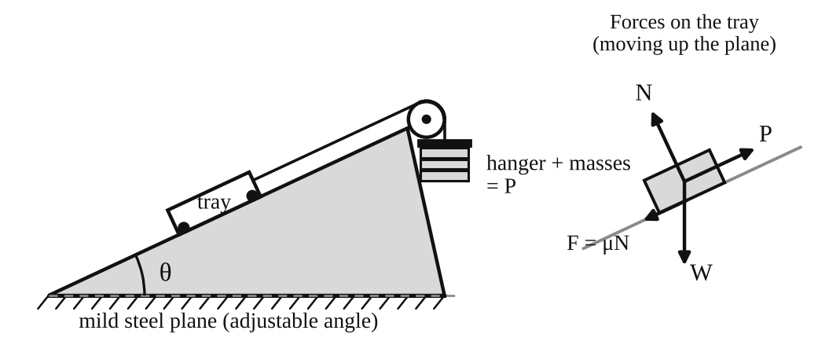
Fig. 1: Friction on an inclined plane (left) and the forces on the tray (right).
Method in brief
- Part A1: put a tray on the level plane and add mass to the hanger until the tray moves slowly at constant velocity. Record P. Add load to the tray (up to five times) and repeat.
- Part A2: tilt the plane slowly until the tray just slides down. Record θ.
- Part B: set the plane to an angle, pull the tray up (then down) at constant slow velocity and record P. Repeat for several angles and tray loads. Repeat with the ball-bearing tray.

3. Results
Table 1: Level plane (Part A1). Use one table for each tray / liner material.
Load added (N) | Total W (N) | Hanger + masses P (N) | P/W

Table 2: Angle of friction (Part A2)
Tray / liner | Critical angle θ (°) | tan θ | μ from Table 1

Table 3: Inclined plane (Part B)
θ (°) | W (N) | P exp. (up) | P theory (up) | P exp. (down) | P theory (down)

Table 4: Rolling friction (ball-bearing tray)
θ (°) | W (N) | P = W sin θ (N) | P_{A} measured (N) | F = P_{A} − P (N)

4. Analysis of Results
One worked example for each calculation (use your own readings):
- μ from the graph: μ = slope = ΔP/ΔW = [ ] ÷ [ ] = [ ] (quoted to 2 decimal places, as the manual says).
- μ from the angle: μ = tan θ = tan [ ]° = [ ].
- Theoretical P (up): P = W(sin θ + μ cos θ) = [ ] ( sin [ ]° + [ ] × cos [ ]° ) = [ ] N.
- Theoretical P (down): P = W(μ cos θ − sin θ) = [ ] N.
- Rolling resistance: F = P_{A} − W sin θ = [ ] − [ ] = [ ] N.
- Percentage difference = (experimental − theory) ÷ theory × 100 = [ ] %.

5. Observations / Precautions Taken
Observations
- The friction force increased as the load in the tray increased.
- More force was needed to pull the tray up the plane than down it.
- The ball-bearing tray needed much less force than the sliding trays.
- Different liner materials gave different values of μ, and repeated readings on the same pair of surfaces scattered a little.
Precautions
- The plane was levelled before Part A and the cord was kept parallel to the plane.
- The tray was moved slowly at constant velocity, not accelerated.
- Masses were added in small steps and readings were taken at eye level to avoid parallax.
- The trays were weighed on the scale and the plane was kept clean and dry.

6. Graphs
Plot the following on graph paper from your own readings and attach them here:
- P against W for [liner material 1]
- P against W for [liner material 2] (one graph per tray, on the graph sheets provided)
Each graph should be a straight line through the origin with slope μ.

7. Discussion
Sources of error
- It is hard to judge exactly when the tray moves at constant velocity, so the added mass is slightly wrong.
- Friction in the pulley and stiffness of the cord.
- Parallax when reading the protractor, so θ is only good to about ±[ ]°.
- Dust, damp or scratches changed μ from run to run. The manual warns of this scatter, which is why μ is quoted to two decimal places only.
- The cord may not have been exactly parallel to the plane.
Agreement with theory. My μ from the graph was [ ] and from tan θ was [ ]. They [agree closely / differ by [ ] %], which is [within / outside] the expected experimental error. The measured P values were [close to / different from] the theoretical values by about [ ] %, and the differences can be explained by the errors above.
Rolling friction. The rolling resistance was much smaller than the sliding friction, because rolling contact has far less resistance than sliding contact.

8. Conclusion
The coefficient of friction between the mild steel plane and [material] was [ ], and tan θ agreed with it to within [ ] %. The forces measured on the incline agreed reasonably with P = W(sin θ ± μ cos θ). Rolling friction was much smaller than sliding friction. Friction is useful in brakes, tyres and conveyors, in choosing safe ramp angles, and bearings are used to reduce it in machines.

Section B: Questions
1. What I learnt from the experiment. I learnt how to measure the coefficient of friction in two ways (from a graph of P against W and from the angle of friction), how friction affects the force needed on an incline, and how much rolling reduces resistance.
3. Comment on the experimental procedure. Adding load in steps and plotting a graph gives an average μ instead of relying on one reading, which improves accuracy. Using several trays on the same plane in one session saves time.
4. Most difficult aspect of the experiment. Keeping the tray at a truly constant velocity. It can be reduced by adding mass in very small steps and giving the tray a light tap to start it.
5. Another method that could be used. A spring balance can pull the tray directly and read the friction force. A tilting plane on its own can also give μ from tan θ.
6. Parameters measured / involved. Weight of the tray and load, hanger mass, angle of inclination, pulling force P and the liner material.
7. Measuring instrument used. The protractor (angle scale) measures the angle θ of the plane. It must be read at eye level to avoid parallax.
8. Practical relevance. Brakes, tyres and road grip, conveyor belts, ramps, clutches and bearings.
9. Section of the course it belongs to. Statics (friction) in applied mechanics.
13. What interested me most. The ball-bearing tray moved with far less force than the sliding trays.
2, 10, 11, 12, 14 and 15 (personal / references): to be filled in by you.

AM 212: Rolling on an Inclined Plane

Objective
- To find the radius of gyration k of a body rolling on an inclined plane, and to verify Newton's laws for this case.

1. Theory
A wheel and axle rolls without slipping down parallel rails. Let m be its mass, α the angle of the slope, r the radius from the centre of mass G to the rolling surface (the axle radius, since the axle rests on the rails), k the radius of gyration about G, f the linear acceleration of G and β the angular acceleration.
Newton's second law along the slope:
mg sin α − F_{f} = mf
F_{f} is the friction at the contact point that stops sliding. Torque about G: F_{f} r = I β = mk²β. Rolling without slipping gives β = f/r, so
F_{f} = mk²β / r = mk²f / r²
Eliminating F_{f}:
mg sin α = mf (1 + k²/r²) so f = g sin α / (1 + k²/r²)
The body starts from rest and covers a distance L in time t, so L = ½ft² and f = 2L/t². Putting this in and rearranging gives the radius of gyration:
k² = r² ( g t² sin α / (2L) − 1 )
The measured acceleration depends on t², so timing errors matter a lot. Accuracy is best when f is small, which needs a small α and a large k²/r². That is why a wheel on a small axle is better than, for example, a sphere rolling in a V-groove.
Prediction of k from geometry. For a uniform solid disc k² = R²/2, for a thin ring k² = R². For a wheel and axle, I is found by adding the contributions of the rim, hub and axle (I = Σ ½ m(R_{o}² + R_{i}²) for each hollow cylinder), then k² = I/m.
Friction needed to roll. F_{f} = mg sin α · (k²/r²)/(1 + k²/r²). The surfaces must supply at least this much friction or the body will slip.

2. Apparatus
Inclined plane with two parallel rails, wheel and axle (the rolling body), stopwatch, meter rule, protractor or a height gauge for the angle, and a balance for the mass. Other rolling bodies (solid and hollow cylinders) were also available.
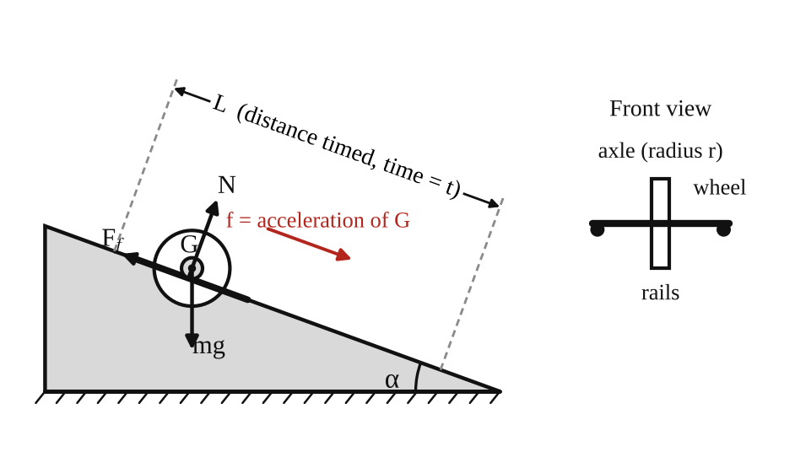
Fig. 1: Wheel and axle rolling down the rails of an inclined plane, with the forces on it.
Method in brief
- Measure the axle radius r, the mass m and the dimensions of the wheel.
- Set the plane to a small angle α. Mark a start line and a finish line a distance L apart.
- Release the wheel from rest at the start line (no push) and time it to the finish line. Repeat several times and take the mean t.
- Repeat for other angles and for other rolling bodies.

3. Results
Table 1: Timing results and radius of gyration
Body | α (°) | L (m) | t₁ (s) | t₂ (s) | t₃ (s) | Mean t (s) | f = 2L/t² (m/s²)

Body | r (m) | k from experiment (m) | k from geometry (m) | % difference

Table 2: Check of Newton's laws (acceleration from theory against acceleration measured)
α (°) | sin α | f theory = g sin α / (1 + k²/r²) | f measured | % difference

4. Analysis of Results
- Acceleration: f = 2L/t² = 2 × [ ] ÷ [ ]² = [ ] m/s².
- Radius of gyration: k² = r²(g t² sin α / 2L − 1) = [ ]²( 9.81 × [ ]² × sin [ ]° ÷ (2 × [ ]) − 1 ) = [ ] m², so k = [ ] m.
- k from geometry: I = [ ] kg m², k² = I/m = [ ], k = [ ] m.
- Percentage accuracy = (k_{exp} − k_{calc}) ÷ k_{calc} × 100 = [ ] %.
- Theoretical acceleration: f = g sin α / (1 + k²/r²) = [ ] m/s².
- Effect of timing error: since f = 2L/t², δf/f ≈ 2 δt/t. With δt ≈ [ ] s and t = [ ] s this gives an error in f of about [ ] %.

5. Observations / Precautions Taken
Observations
- The wheel rolled down slowly, with constant acceleration, without slipping.
- The time of descent was longer for a smaller angle.
- Bodies of the same shape took about the same time, whatever their mass.
- A solid cylinder (smaller k) accelerated faster than a wheel with a heavy rim (larger k).
Precautions
- The wheel was released from rest without a push and from the same start line each time.
- The rails were clean, parallel and free of dust so that the wheel did not slip.
- Each time was measured at least three times and the mean was used, because f depends on t².
- The angle was kept small and measured carefully.

6. Graphs
Plot the following on graph paper from your own readings and attach them here:
- f (measured) against sin α (should be a straight line through the origin)
- Optional: t² against 1/sin α

7. Discussion
Sources of error
- Reaction time when starting and stopping the stopwatch (about 0.2 s). This is large compared with t, and it is doubled in f.
- Difficulty in releasing the wheel exactly at the start line.
- Error in measuring α and in the effective radius r where the axle touches the rails.
- Rolling friction, air resistance and slight slipping.
- Rails not perfectly parallel or level across.
Accuracy of k. The experimental k was [ ] m and the calculated k was [ ] m, a difference of [ ] %. This is [within / outside] the expected accuracy from the timing error above.
Newton's laws. The measured acceleration agreed with g sin α/(1 + k²/r²) to within [ ] %, so the observations [do / do not] verify Newton's second law for combined translation and rotation. The acceleration was constant (L ∝ t²), which shows that the net force and torque were constant.
Rolling friction. Rolling resistance would make the measured acceleration smaller than the theoretical value. Its size can be investigated in two ways: (1) find the angle α_{c} at which the wheel just begins to roll steadily, so that the resistance is about mg sin α_{c}; or (2) use F_{r} = m [ g sin α − f(1 + k²/r²) ] from the measured f. My value was F_{r} ≈ [ ] N, which is [ ] % of mg sin α.

8. Conclusion
The radius of gyration of the wheel and axle was found to be [ ] m from experiment and [ ] m from its dimensions, a difference of [ ] %. The motion had constant acceleration and agreed with f = g sin α/(1 + k²/r²), which supports Newton's laws. Rolling bodies accelerate more slowly than sliding ones because part of the energy goes into rotation. The results are useful in designing wheels, rollers, flywheels and vehicles on slopes.

Section B: Questions
1. What I learnt from the experiment. I learnt how translation and rotation combine in rolling, how to find a radius of gyration from simple timing, and why timing errors matter when the result depends on t².
3. Comment on the experimental procedure. A slow, small-angle motion gives a long time of descent, which reduces the effect of reaction time. Repeating the timing and averaging improves accuracy, and bodies of the same shape give the same acceleration, so many bodies can be tested quickly.
4. Most difficult aspect of the experiment. Timing the descent accurately by hand. It can be reduced with a longer track, a smaller angle, timing gates (photocells) or several timings averaged.
5. Another method that could be used. The compound pendulum (oscillating the body about a knife edge, T = 2π√((k² + h²)/gh)) or a trifilar suspension can also be used to find k.
6. Parameters measured / involved. Angle of slope α, distance L, time t, acceleration f, axle radius r, mass m and radius of gyration k.
7. Measuring instrument used. The stopwatch measures the time t. It reads to 0.01 s, but the reaction time of the person (about 0.2 s) is the real limit on accuracy.
8. Practical relevance. Design of wheels, rollers, flywheels, bearings, vehicles on hills and any rolling machine part.
9. Section of the course it belongs to. Dynamics (kinetics of rigid bodies in plane motion, moment of inertia).
13. What interested me most. Bodies of different mass but the same shape reached the bottom together.
2, 10, 11, 12, 14 and 15 (personal / references): to be filled in by you.

AM 214: Screw Jack

Objective
- To obtain the velocity ratio of the screw jack.
- To plot graphs against increasing load showing the variation of (a) effort, (b) effect of friction and (c) efficiency.
- To obtain an equation relating load and effort, and from it the limiting efficiency of the machine.

1. Theory
A screw jack lifts a load W with a small effort E. In one turn of the turntable the effort moves a distance πD (D = diameter of the turntable + diameter of the cord), while the load rises by one pitch P of the thread.
Velocity ratio V.R. = distance moved by effort / distance moved by load = πD / P
Mechanical advantage M.A. = W / E Efficiency η = M.A. / V.R. × 100 %
If the machine had no friction the effort would be E₀ = W/V.R. The load that E could lift with 100 % efficiency is W₁ = E × V.R., so the effect of friction (load lost to friction) is W₁ − W.
Law of the machine. For most machines the graph of E against W is a straight line:
E = aW + b
where a is the slope and b is the effort needed to overcome friction with no load. As the load becomes very large the term b becomes small compared with aW, so M.A. = W/E tends to 1/a. Therefore
Limiting efficiency = (1/a) / V.R. × 100 %
Theory of the screw. For a square thread of mean diameter d_{m}, lead angle λ (tan λ = P/πd_{m}) and friction angle φ (tan φ = μ), the efficiency is η = tan λ / tan(λ + φ). A screw jack is self-locking (stays up when the effort is removed) if φ > λ, which means its efficiency is below 50 %.

2. Apparatus
Tec-equipment screw jack with a steel turntable, cord, effort hanger and dead weights, meter rule, vernier calipers and outside calipers.
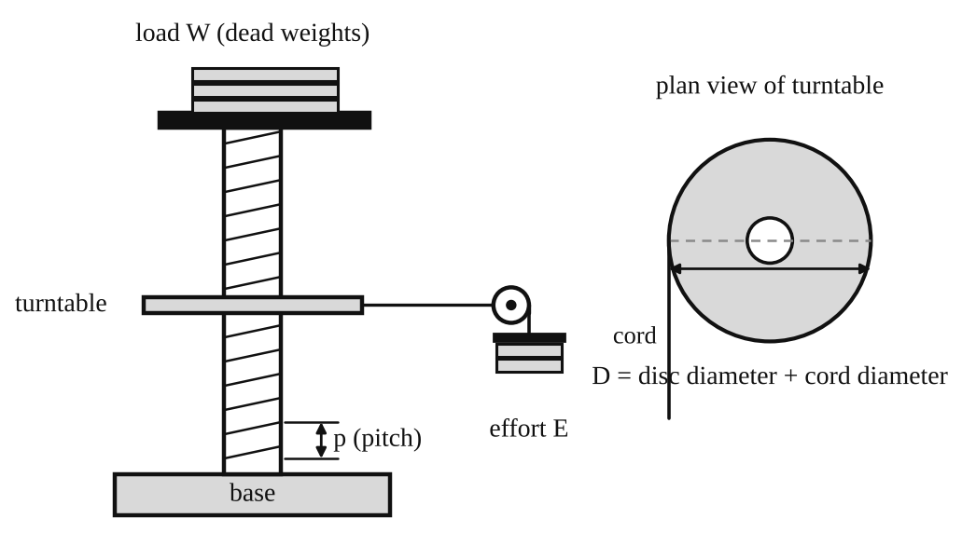
Fig. 1: Screw jack with turntable (schematic) and plan view of the turntable.
Method in brief
- Measure the pitch P of the thread, the turntable diameter plus the cord diameter (D), and calculate πD and V.R.
- With no load, add effort mass until the turntable just turns slowly at constant speed. This effort is the one needed to raise no load.
- Repeat for increasing loads (for example 5, 10, 15, 20 ... up to 80 kg) and record the effort each time.

3. Results
Pitch P = [ ] mm. D = [ ] mm. πD = [ ] mm. V.R. = πD/P = [ ].
Table 1: Screw jack results
Actual load W (kg) | Effort E (kg) | V.R. | Load if 100 % efficient W₁ = E × V.R. | Effect of friction (W₁ − W) | M.A. = W/E | Efficiency (M.A./V.R.) × 100 %
0
5
10
15
20

4. Analysis of Results
- V.R. = πD/P = π × [ ] ÷ [ ] = [ ].
- W₁ = E × V.R. = [ ] × [ ] = [ ] kg and effect of friction = W₁ − W = [ ] − [ ] = [ ] kg.
- M.A. = W/E = [ ] ÷ [ ] = [ ] and η = M.A./V.R. × 100 = [ ] %.
- From the graph of E against W: slope a = ΔE/ΔW = [ ] and intercept b = [ ] kg. So the law of the machine is E = [ ]W + [ ].
- Limiting efficiency = (1/a)/V.R. × 100 = (1/[ ]) ÷ [ ] × 100 = [ ] %.
- At W = 0 the efficiency is zero (all the effort goes into friction), so efficiency rises as the load increases.

5. Observations / Precautions Taken
Observations
- The effort needed to raise no load was not zero. It was [ ] kg because of friction in the thread and bearing.
- Effort increased steadily (almost linearly) with load.
- The jack stayed in position when the effort was removed, so it is self-locking.
- The velocity ratio was large ([ ]), so a small effort lifted a large load.
Precautions
- The turntable was turned slowly and at constant speed when the effort was read.
- The pitch and diameters were measured with calipers (more accurate than a rule), and the cord diameter was added to the turntable diameter.
- The thread was lubricated lightly and kept the same through the test.
- The effort mass was supported while the load was being changed.

6. Graphs
Plot the following on graph paper from your own readings and attach them here:
- Efficiency against load W
- Effect of friction (W₁ − W) against load W
- Effort E against load W (straight line E = aW + b)

7. Discussion
Sources of error
- It is difficult to judge the effort that gives exactly constant speed. Friction is not constant when the jack starts or stops.
- Error in measuring the pitch and the effective diameter D, which directly affects V.R.
- Friction in the turntable bearing and in the cord, and the weight of the hanger.
- Different thread surface conditions during the test.
Shapes of the graphs. The efficiency curve rises from zero and flattens towards the limiting efficiency. The friction effect (W₁ − W) increases with load, more slowly at high loads. The effort graph is a straight line with a positive intercept b. The limiting efficiency I found was [ ] %, and the theoretical value from tan λ / tan(λ + φ) was [ ] %. [They agree / differ by [ ] %].
The efficiency of the jack is low (below 50 %). That is the price of a high V.R. and self-locking: most of the effort is spent on friction in the thread.

8. Conclusion
The velocity ratio of the screw jack was [ ]. Its law of the machine was E = [ ]W + [ ], and its limiting efficiency was [ ] %. The efficiency increased with load, and the jack was self-locking. Screw jacks are used for lifting vehicles, in presses, vices, clamps, machine tool lead screws and aircraft flap actuators.

Section B: Questions
1. What I learnt from the experiment. I learnt how to find V.R., M.A. and efficiency of a machine, how to write its law E = aW + b, and how friction limits the efficiency.
3. Comment on the experimental procedure. Taking effort readings at many loads and plotting E against W reduces the effect of a single bad reading, and the straight line gives a and b more accurately than one point. The loads are quick to change, so the test takes little time.
4. Most difficult aspect of the experiment. Judging the effort that gives a slow constant speed. It can be reduced by adding very small masses and turning the turntable by hand first, and by repeating each reading.
5. Another method that could be used. A spring balance or a torque wrench on the screw handle can measure the effort. A hydraulic jack could also be used to compare efficiencies.
6. Parameters measured / involved. Pitch P, turntable diameter D (with cord), load W, effort E, V.R., M.A. and efficiency.
7. Measuring instrument used. The vernier calipers measure the pitch and the diameter. The reading is the main scale reading plus the vernier division that lines up, to about 0.02 mm.
8. Practical relevance. Car and truck jacks, lifting platforms, presses, vices, G-clamps, valve screws and the lead screws of lathes and machine tools.
9. Section of the course it belongs to. Machines and mechanisms (simple machines, velocity ratio and efficiency).
13. What interested me most. A very small effort could lift a heavy load, and the load stayed in place when the effort was removed.
2, 10, 11, 12, 14 and 15 (personal / references): to be filled in by you.

