APPLIED MECHANICS LABORATORY
LABORATORY REPORTS
AM 217: Centrifugal Force Experiment
AM 218(A): Simple Wheel and Axle
AM 218(B): Wheel and Differential Axle

Name: ______________________________
Matric No.: __________________________
Department: _________________________
Date: _______________________________
Contents
AM 217 Centrifugal Force Experiment
AM 218(A) Simple Wheel and Axle
AM 218(B) Wheel and Differential Axle
Notes before you submit
- Anything shown as [ ] is for your own readings or results from your own lab session. Nothing has been invented.
- Each report follows Section C of the manual: Theory, Apparatus, Results, Analysis of Results, Observations and Precautions, Graphs, Discussion and Conclusion. The Section B questions are answered after each report.
- Questions 2, 10, 11, 12, 14 and 15 are personal, so they are left for you to fill in.
- Graphs must be drawn from your own readings on graph paper (or in Excel) and attached where indicated.

AM 217: Centrifugal Force Experiment

Objective
- To show that the centrifugal force on a rotating mass is m ω² r, by finding the speed at which a balanced bell crank "snaps over", and to study how this speed changes with the masses and with the radius.

1. Theory
A mass m moving in a circle of radius r at angular velocity ω needs an inward (centripetal) force mω²r. The equal and opposite outward force on the mass is the centrifugal force:
F = m ω² r
The apparatus has two pivoted bell cranks on a horizontal rotating arm. On each crank the vertical arm (length a) carries a mass m_{a} and the horizontal arm (length b) carries a mass m_{b}. The pivot is at radius r from the axis of rotation.
- The centrifugal force on m_{a} acts horizontally, outward, at height a above the pivot. Its moment about the pivot is m_{a}ω²r × a.
- The weight of m_{b} acts downward at distance b from the pivot. Its moment is m_{b}g × b, in the opposite sense.
- The weight of m_{a} and the centrifugal force on m_{b} both pass through the pivot, so they have no moment.
The crank snaps from one stop to the other when the two moments are equal:
m_{a} ω² r × a = m_{b} g × b so centrifugal force = m_{a} ω² r = m_{b} g b / a
This gives ω² = (m_{b} g b)/(m_{a} r a). So ω² is proportional to 1/m_{a} (Test I), proportional to m_{b} (Test II) and proportional to 1/r (Test III). The angular velocity is found from the speed N in rev/min: ω = 2πN/60.

2. Apparatus
A horizontal rotating member driven by a variable-speed motor and gearbox, carrying two brackets with pivoted balanced bell cranks. Each crank sits between two stops: one holds its arms horizontal/vertical and the other lets the vertical arm move just out of the upright position. The brackets can be locked at different radii in equally spaced holes. Accurately machined weights fit on the crank arms. Speed is read from the counter on the control box with a stopwatch, or with a tachometer.
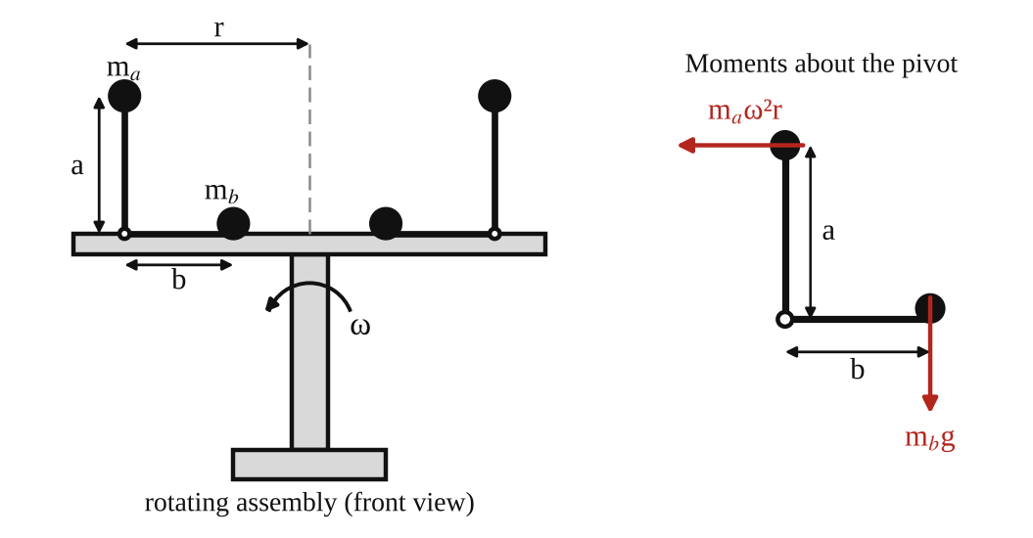
Fig. 1: Rotating assembly with two bell cranks (left) and the moments on one crank (right).
Method in brief
- Run the apparatus for a few minutes first so the bearings in the motor and gearbox reach a steady condition.
- Fix equal masses on the two vertical arms and equal masses on the two horizontal arms, and pin both brackets at equal radius.
- Start the motor very slowly and raise the speed until both cranks audibly "snap over". Measure the speed at that moment.
- Test I: keep r and m_{b} constant and vary m_{a} five times. Test II: keep r and m_{a} constant and vary m_{b} five times. Test III: keep m_{a} and m_{b} constant and vary r from the inner to the outer radius.

3. Results
Dimensions: a = [ ] mm, b = [ ] mm.
Table 1 (Test I): varying m_{a}; r = [ ] m and m_{b} = [ ] kg constant
m_{a} (kg) | 1/m_{a} (kg⁻¹) | N (rpm) | ω = 2πN/60 (rad/s) | ω² (rad²/s²) | F = m_{a}ω²r (N) | F = m_{b}gb/a (N)

Table 2 (Test II): varying m_{b}; r = [ ] m and m_{a} = [ ] kg constant
m_{b} (kg) | N (rpm) | ω (rad/s) | ω² (rad²/s²) | F = m_{a}ω²r (N) | F = m_{b}gb/a (N)

Table 3 (Test III): varying r; m_{a} = [ ] kg and m_{b} = [ ] kg constant
r (m) | 1/r (m⁻¹) | N (rpm) | ω (rad/s) | ω² (rad²/s²) | F = m_{a}ω²r (N) | F = m_{b}gb/a (N)

4. Analysis of Results
- ω = 2πN/60 = 2π × [ ] ÷ 60 = [ ] rad/s, so ω² = [ ].
- Experimental centrifugal force: F = m_{a}ω²r = [ ] × [ ] × [ ] = [ ] N.
- Calculated (balance of moments): F = m_{b}gb/a = [ ] × 9.81 × [ ] ÷ [ ] = [ ] N.
- Percentage difference = (experimental − calculated) ÷ calculated × 100 = [ ] %.
- Slope of the 1/m_{a} against ω² graph = a r/(m_{b} g b) → [ ]. The expected line passes through the origin.

5. Observations / Precautions Taken
Observations
- Both cranks changed over together, with an audible click, at almost the same speed.
- A heavier m_{a} (Test I) or a larger radius (Test III) made the cranks snap over at a lower speed.
- A heavier m_{b} (Test II) needed a higher speed.
- Small changes of speed near the snap-over point were hard to read.
Precautions
- The apparatus was left running for a few minutes before starting the test.
- The speed was raised very slowly near the snap-over speed so the reading was not overshot.
- Equal weights were fitted on both cranks, and both brackets were pinned at the same radius, so the machine stayed balanced.
- Guards were closed and everyone stood clear while the arm was spinning.

6. Graphs
Plot the following on graph paper from your own readings and attach them here:
- Reciprocal of mass (1/m_{a}) against ω² (Test I)
- Centrifugal force against ω² (Test II)
- Reciprocal of radius (1/r) against ω² (Test III)
Each should be a straight line through the origin if F = mω²r holds.

7. Discussion
Comparing calculated and experimental results
The experimental and calculated forces agreed to within [ ] %. The graphs were [straight lines through the origin / close to straight lines], which supports F = mω²r: for a given balancing moment, ω² varies as 1/m_{a} and as 1/r.
Possible reasons for any discrepancy
- The moment of the stops and friction at the crank pivot oppose the snap-over, so the real speed is a little higher.
- The moment of the weight of the crank arms themselves was not exactly balanced.
- The snap-over was identified by sound, and the speed was still rising, so there is a lag in the reading.
- The radius r was measured to the pivot, not to the exact centre of the mass.
- Errors in the speed counter, in the stopwatch timing and in the lengths a and b.

8. Conclusion
The centrifugal force on a rotating mass was shown to be mω²r and, at the snap-over speed, equal to m_{b}gb/a. The experimental and calculated values agreed to within [ ] %. The force increases with mass, with radius and with the square of the speed. The result is used in the design of centrifugal governors, centrifuges, centrifugal clutches and pumps, and in balancing rotating machinery.

Section B: Questions
1. What I learnt from the experiment. I learnt that centrifugal force depends on mass, radius and the square of the angular velocity, and how moments about a pivot can be used to measure it.
3. Comment on the experimental procedure. Using two equal cranks keeps the machine balanced. Changing one quantity at a time (mass, then radius) makes the relationship easy to see, and each test needs only a few runs, so it is quick.
4. Most difficult aspect of the experiment. Detecting the exact snap-over speed by sound. It can be reduced by increasing the speed very slowly, repeating each reading, or using a light sensor to detect the movement.
5. Another method that could be used. A whirling mass on a string with a spring balance, or a centrifugal governor, can also be used to measure centrifugal force.
6. Parameters measured / involved. Masses m_{a} and m_{b}, radius r, lengths a and b, speed N (rpm) and ω.
7. Measuring instrument used. The tachometer (or counter with stopwatch) measures the speed N in rev/min. It is read at the moment the cranks snap over.
8. Practical relevance. Governors, centrifugal clutches, centrifugal pumps, centrifuges, washing-machine drums, banked road bends and the balancing of rotating shafts.
9. Section of the course it belongs to. Dynamics (kinetics of particles, circular motion and balancing of rotating masses).
13. What interested me most. Both cranks snapped over together with an audible click at a well-defined speed.
2, 10, 11, 12, 14 and 15 (personal / references): to be filled in by you.

AM 218(A): Simple Wheel and Axle

Objective
- To determine the velocity ratio of the machine.
- To obtain an equation for the relationship between load and effort, and from it a value for the limiting efficiency of the machine.

1. Theory
A wheel and axle is a simple machine in which an effort E applied on the rim cord of a wheel of effective diameter D lifts a load W hung from the cord on an axle of effective diameter d. (Effective diameter = diameter of wheel or axle + diameter of the cord.)
In one turn the effort moves πD and the load moves πd, so
Velocity ratio V.R. = πD / πd = D / d
Mechanical advantage M.A. = W / E Efficiency η = M.A. / V.R. × 100 %
With no friction, E₀ = W/V.R. and η = 100 %. The effect of friction is the load W₁ = E × V.R. that the effort could lift if there were no friction, minus the actual load, W₁ − W.
Law of the machine. The graph of E against W is a straight line, so E = aW + b. Here a is the slope and b is the effort needed to overcome friction at no load. When W is very large, M.A. → 1/a, so
Limiting efficiency = (1/a) / V.R. × 100 %
In an ideal machine a = 1/V.R. and b = 0, so the limiting efficiency would be 100 %. Friction makes a larger than 1/V.R. and b greater than zero.

2. Apparatus
Tec-equipment wheel and axle mounted on a wall, load hanger, effort hanger, cords, meter rule, dead weights and calipers.
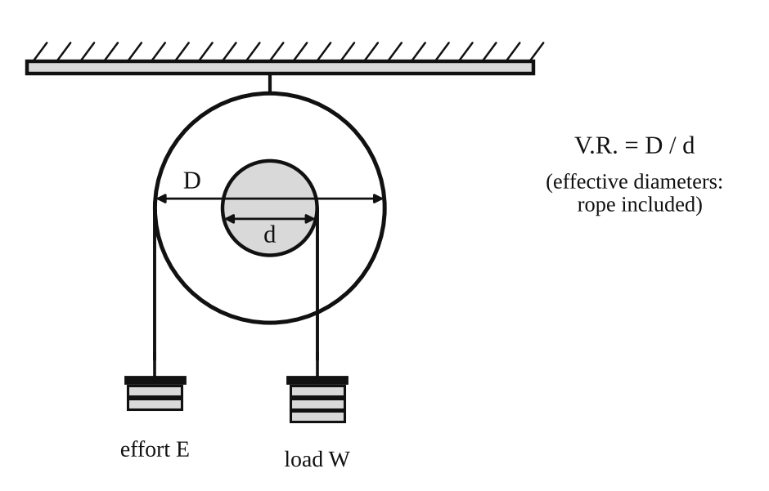
Fig. 1: Simple wheel and axle.
Method in brief
- Measure the diameters of the wheel (D) and the axle (d) with calipers and add the cord diameter to each.
- Calculate V.R. = D/d (check by counting the rope movement for one turn of the wheel).
- Wind the cords on the wheel and the axle in opposite senses. Add effort until the load hanger just rises at a constant speed. The effort with no load is the effort needed to lift the load hanger alone.
- Repeat for loads of 10, 20, 30, 40 ... up to 100 N.

3. Results
D = [ ] mm, d = [ ] mm, V.R. = D/d = [ ].
Table 1: Results
Actual load W | Effort E | V.R. | Load if 100 % efficient W₁ = E × V.R. | Effect of friction (W₁ − W) | M.A. = W/E | Efficiency (M.A./V.R.) × 100 %
0
10
20
30
40
50
60
70
80
90
100

4. Analysis of Results
- V.R. = D/d = [ ] ÷ [ ] = [ ].
- W₁ = E × V.R. = [ ] × [ ] = [ ] N and W₁ − W = [ ] N.
- M.A. = W/E = [ ] and η = M.A./V.R. × 100 = [ ] %.
- From the E–W graph: a = ΔE/ΔW = [ ] and b = [ ] N, so E = [ ]W + [ ].
- Limiting efficiency (experimental) = (1/a)/V.R. × 100 = [ ] %.
- Theoretical limiting efficiency = 100 % (no friction), so the difference = [ ] %.

5. Observations / Precautions Taken
Observations
- The effort needed increased almost in a straight line with the load.
- Efficiency was low at small loads and increased as the load increased.
- The effort was always greater than W/V.R., because of friction in the bearing and cords.
Precautions
- The cords were wound neatly in the correct senses and did not overlap.
- The effort was added slowly so the load rose at constant speed.
- Diameters were measured at several places and the cord thickness was included.
- At the end of each test the effort mass was supported while the load masses were removed, so the machine did not spin.

6. Graphs
Plot the following on graph paper from your own readings and attach them here:
- Efficiency against load
- Effect of friction against load
- Effort against load (E = aW + b)

7. Discussion
Sources of error
- Judging "just rises at constant speed" by eye, so the effort has some range of error.
- Friction in the axle bearing, which is not the same at all loads.
- Errors in D and d, which change V.R. directly.
- The weight of the hangers and the stiffness of the cords.
Agreement with theory. The experimental limiting efficiency was [ ] % against 100 % for an ideal machine. The difference is because of friction. The E–W graph [was / was not] a straight line, and its intercept b = [ ] N is the effort lost to friction at no load. The limiting efficiency is higher than the efficiency at any single load in the test.

8. Conclusion
The velocity ratio of the wheel and axle was [ ]. The law of the machine was E = [ ]W + [ ], and the limiting efficiency was [ ] %. Efficiency increased with load. Wheels and axles are used in winches, windlasses, capstans, door knobs, steering wheels and screwdrivers.

Section B: Questions
1. What I learnt from the experiment. I learnt how to find the velocity ratio, mechanical advantage and efficiency of a wheel and axle, and how to get the law of the machine from a graph.
3. Comment on the experimental procedure. Taking readings at many loads and using the graph gives a better value of the limiting efficiency than one reading. The set-up is simple, so many readings are taken in a short time.
4. Most difficult aspect of the experiment. Deciding when the load rises at constant speed. It can be reduced by adding very small masses, tapping the machine gently and repeating each reading.
5. Another method that could be used. A spring balance in place of the effort mass, or a differential wheel and axle, or a pulley system could be used to show the same ideas.
6. Parameters measured / involved. Diameters D and d, load W, effort E, V.R., M.A. and efficiency.
7. Measuring instrument used. The vernier calipers measure the diameters of the wheel and axle to about 0.02 mm.
8. Practical relevance. Winches, windlasses, capstans, cranes, steering wheels, door handles and screwdrivers.
9. Section of the course it belongs to. Machines and mechanisms (simple machines, V.R., M.A., efficiency).
13. What interested me most. A small effort on the large wheel lifted a much larger load on the axle.
2, 10, 11, 12, 14 and 15 (personal / references): to be filled in by you.

AM 218(B): Wheel and Differential Axle

Objective
- To calculate the velocity ratio of the machine.
- To obtain an equation for the relationship between load and effort, and from it a value for the limiting efficiency of the machine.

1. Theory
The wheel and differential axle has a wheel of effective diameter D and an axle in two steps: a major axle of effective diameter d₁ and a minor axle of effective diameter d₂. The load hangs from a movable pulley on a cord loop. One end of the loop is wound on d₁ and the other end is wound on d₂ in the opposite sense.
In one turn of the wheel the effort moves πD. At the same time the cord winds on by πd₁ on the major axle and unwinds by πd₂ from the minor axle, so the loop shortens by π(d₁ − d₂). The load is carried by two strands, so it rises by half of this:
distance moved by the load = π(d₁ − d₂) / 2
V.R. = πD / [ π(d₁ − d₂) / 2 ] = 2D / (d₁ − d₂)
M.A. = W / E η = M.A. / V.R. × 100 % W₁ = E × V.R. Effect of friction = W₁ − W
Law of the machine: E = aW + b. The limiting efficiency occurs when M.A. = 1/a, so limiting efficiency = (1/a)/V.R. × 100 %. The velocity ratio is large when d₁ and d₂ are nearly equal, so a small effort can lift a big load. For lifting, the cords are wound anticlockwise on D, clockwise on d₁ and anticlockwise on d₂.

2. Apparatus
Wheel and differential axle mounted on the wall, movable pulley and load hanger, effort hanger, cords, meter rule, dead weights and calipers.
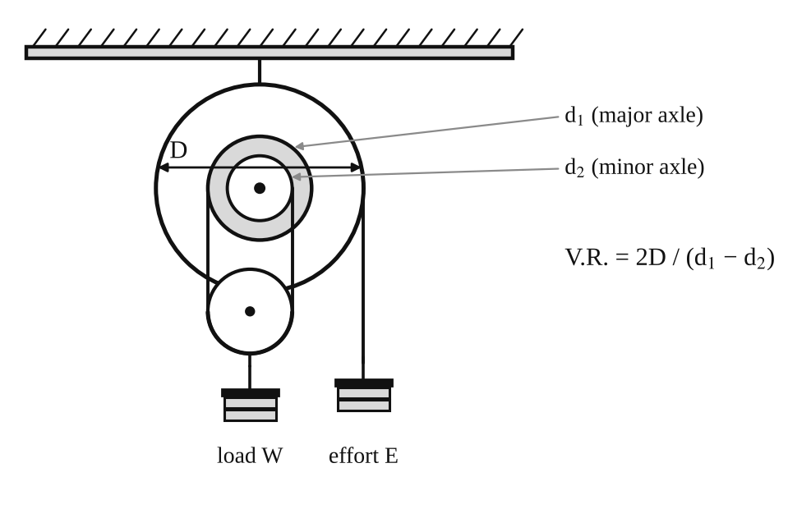
Fig. 1: Wheel and differential axle.
Method in brief
- Measure D, d₁ and d₂ with calipers and add the cord diameter to each.
- Calculate V.R. = 2D/(d₁ − d₂).
- Wind the cords as described and add effort until the load just rises at constant speed. With no load this gives the friction effort.
- Repeat for loads of 10, 20, 30 ... up to 100 N.

3. Results
D = [ ] mm, d₁ = [ ] mm, d₂ = [ ] mm. V.R. = 2D/(d₁ − d₂) = [ ].
Table 1: Results
Actual load W | Effort E | V.R. | Load if 100 % efficient W₁ = E × V.R. | Effect of friction (W₁ − W) | M.A. = W/E | Efficiency (M.A./V.R.) × 100 %
0
10
20
30
40
50
60
70
80
90
100

4. Analysis of Results
- V.R. = 2D/(d₁ − d₂) = 2 × [ ] ÷ ( [ ] − [ ] ) = [ ].
- W₁ = E × V.R. = [ ] N, effect of friction = W₁ − W = [ ] N.
- M.A. = W/E = [ ], η = M.A./V.R. × 100 = [ ] %.
- From the graph: a = [ ], b = [ ] N, so E = [ ]W + [ ].
- Limiting efficiency = (1/a)/V.R. × 100 = [ ] %.
- Theoretical limiting efficiency = 100 %, so the difference is [ ] %.

5. Observations / Precautions Taken
Observations
- The velocity ratio was large, so the effort was much smaller than the load.
- The effort needed to raise no load was [ ] N because of friction.
- The efficiency was lower than for the simple wheel and axle, and below 50 % for most loads.
- The load stayed up when the effort was removed (the machine is self-locking if the efficiency is below 50 %).
Precautions
- The cords were wound on in the correct senses and did not overlap.
- The load was raised slowly and at constant speed.
- The diameters were measured carefully, since d₁ − d₂ is a small difference and any error in it changes V.R. a lot.
- At the end of each test the effort mass was supported while the load masses were removed.

6. Graphs
Plot the following on graph paper from your own readings and attach them here:
- Efficiency against load
- Effect of friction against load
- Effort against load (E = aW + b)

7. Discussion
Sources of error
- d₁ − d₂ is small, so a small error in measuring either diameter gives a large error in V.R.
- Judging constant speed by eye.
- Friction in the bearings and the movable pulley, and cord stiffness.
- The load pulley may hang slightly sideways if the strands are not the same length.
Comparison with theory. The experimental limiting efficiency was [ ] %. The ideal value is 100 %. The difference comes from friction, which is large here because the velocity ratio is large and the cords bend around several small pulleys.

8. Conclusion
The velocity ratio of the differential axle was [ ]. The law of the machine was E = [ ]W + [ ] and the limiting efficiency was [ ] %. The machine gives a large mechanical advantage but a low efficiency. Differential axles and the similar differential chain block are used for lifting heavy loads in workshops and garages.

Section B: Questions
1. What I learnt from the experiment. I learnt how a differential axle gives a high velocity ratio, and how to get the law of the machine and its limiting efficiency from a graph.
3. Comment on the experimental procedure. Many loads are used and a graph is drawn, so the result is an average and not one reading. The test is quick because only the effort mass changes.
4. Most difficult aspect of the experiment. Measuring d₁ and d₂ accurately, because V.R. depends on their small difference. Using calipers and measuring several times reduces the error.
5. Another method that could be used. A differential chain block (Weston differential pulley block) or a screw jack can also show a high velocity ratio.
6. Parameters measured / involved. D, d₁, d₂, load W, effort E, V.R., M.A. and efficiency.
7. Measuring instrument used. The calipers (vernier or outside calipers) measure the diameters. Outside calipers are set on the axle and then read on a rule.
8. Practical relevance. Chain blocks and hoists for lifting engines and heavy parts in garages and workshops.
9. Section of the course it belongs to. Machines and mechanisms (simple machines and efficiency).
13. What interested me most. The load stayed up by itself when I removed the effort, because the machine is self-locking.
2, 10, 11, 12, 14 and 15 (personal / references): to be filled in by you.

