APPLIED MECHANICS LABORATORY
LABORATORY REPORTS
Tensile Test: Tensile Test on a Metal Specimen
AM 221: Radial Cam and Follower
AM 223: The Offset Slider-Crank Mechanism

Name: ______________________________
Matric No.: __________________________
Department: _________________________
Date: _______________________________
Contents
Tensile Test Tensile Test on a Metal Specimen
AM 221 Radial Cam and Follower
AM 223 The Offset Slider-Crank Mechanism
Notes before you submit
- Anything shown as [ ] is for your own readings or results from your own lab session. Nothing has been invented.
- Each report follows Section C of the manual: Theory, Apparatus, Results, Analysis of Results, Observations and Precautions, Graphs, Discussion and Conclusion. The Section B questions are answered after each report.
- Questions 2, 10, 11, 12, 14 and 15 are personal, so they are left for you to fill in.
- Graphs must be drawn from your own readings on graph paper (or in Excel) and attached where indicated.

Tensile Test: Tensile Test on a Metal Specimen
The title page of this experiment is missing from the scanned manual, so this report follows the notes and the report instructions that are in it. Please check the experiment name and code.

Objective
- To pull a metal test piece to fracture and record its load–extension curve.
- To find Young's modulus, the yield stress, the ultimate tensile strength, the percentage elongation and the percentage reduction in area, and to compare them with accepted values.

1. Theory
The tensile test is the most common way of finding the mechanical properties of a metal. A test piece is pulled at a steady rate until it breaks, while the load P and the extension ΔL are recorded.
Engineering stress σ = P / A₀ Engineering strain ε = ΔL / L₀
A₀ is the original cross-sectional area (πd₀²/4) and L₀ the original gauge length. The stress–strain diagram has these parts:
- Elastic region: stress is proportional to strain (Hooke's law), σ = Eε. The slope is Young's modulus E. The material returns to its original length when unloaded. The end of this straight line is the limit of proportionality.
- Yield point: the stress at which the metal starts to stretch permanently with little or no increase in load. For metals with no clear yield point the 0.2 % proof stress is used.
- Strain hardening up to the ultimate tensile strength (UTS) = P_{max}/A₀.
- Necking and fracture: the specimen narrows locally, the load falls, and the specimen breaks.
Percentage elongation = (L_{f} − L₀) / L₀ × 100 % Percentage reduction in area = (A₀ − A_{f}) / A₀ × 100 %
Both are measures of ductility. A ductile metal (such as mild steel) stretches a lot, necks and breaks in a "cup and cone" fracture. A brittle metal (such as cast iron) breaks with little stretch and a flat fracture. The test machine draws the load–extension curve on a chart drum, with the extension magnified by a known factor, so the chart readings must be divided by this magnification.

2. Apparatus
Hand-operated tensile testing machine (tensometer) with a recording chart drum, grips for the test piece, a test piece of metal, vernier calipers to measure the diameter and gauge length, and a meter rule for the overall length.
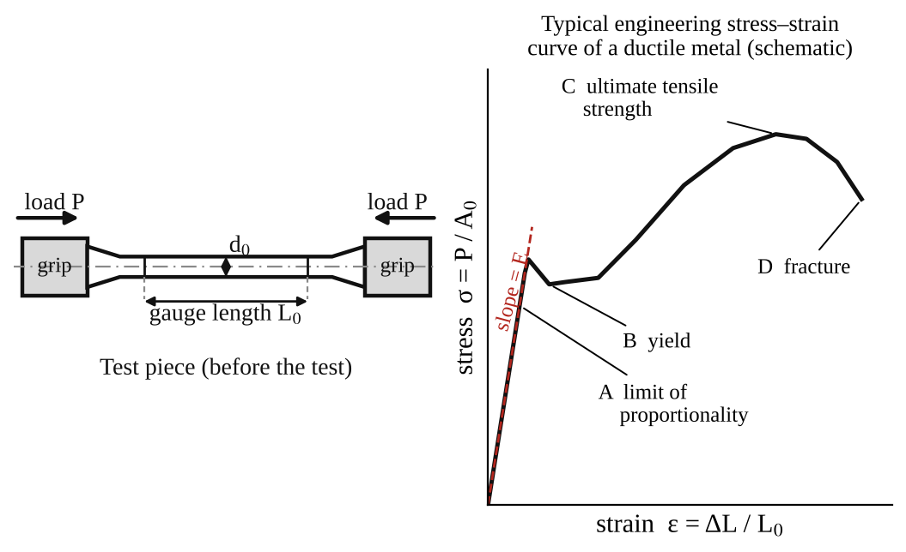
Fig. 1: Test piece (left) and typical stress–strain curve of a ductile metal (right).
Method in brief
- Measure and record the initial diameter, gauge length and overall length of the test piece.
- Fit the test piece in the grips and fit the chart paper on the drum.
- Turn the handle at a constant rate, past the yield point, until the specimen fractures. Do not stop part-way, because stopping changes the load–extension curve.
- One person turns the handle while another watches the specimen and the grips.
- Remove the broken pieces, fit them together, and measure the final diameter at the neck, the final gauge length and the overall length. Examine the fracture surface. Remove the chart paper and attach it to the report.

3. Results
Table 1: Dimensions of the test piece
Measurement | Initial | Final
Diameter (mm)
Gauge length (mm)
Overall length (mm)
Cross-sectional area (mm²)

Material of the test piece: [ ]. Magnification of the extension on the chart: [ ].
Table 2: Load and extension read from the chart
Point | Load P (N) | Extension on chart (mm) | Actual extension ΔL (mm) | Stress σ = P/A₀ (N/mm²) | Strain ε = ΔL/L₀
1
2
3
4
5
6
7
8

Table 3: Mechanical properties
Property | Result | Typical value for mild steel
Young's modulus E (N/mm²) |  | about 200 000
Yield stress (N/mm²) |  | about 250
Ultimate tensile strength (N/mm²) |  | about 400 to 500
Percentage elongation (%) |  | about 20 to 30
Percentage reduction in area (%) |  | about 50 or more

The typical values are for mild steel only. Use the values for your own material if it is not mild steel.

4. Analysis of Results
- A₀ = πd₀²/4 = π × [ ]² ÷ 4 = [ ] mm².
- Actual extension = chart extension ÷ magnification = [ ] ÷ [ ] = [ ] mm.
- σ = P/A₀ = [ ] ÷ [ ] = [ ] N/mm², ε = ΔL/L₀ = [ ] ÷ [ ] = [ ].
- Young's modulus E = slope of the straight part = Δσ/Δε = [ ] ÷ [ ] = [ ] N/mm².
- Yield stress = P_{y}/A₀ = [ ] ÷ [ ] = [ ] N/mm².
- UTS = P_{max}/A₀ = [ ] ÷ [ ] = [ ] N/mm².
- Percentage elongation = (L_{f} − L₀)/L₀ × 100 = ( [ ] − [ ] ) ÷ [ ] × 100 = [ ] %.
- Percentage reduction in area = (A₀ − A_{f})/A₀ × 100 = [ ] %.

5. Observations / Precautions Taken
Observations
- The load rose steadily at first and the specimen stretched elastically.
- At the yield point the load [dropped slightly / levelled off] and the specimen stretched without more load.
- The load rose again (strain hardening) up to a maximum, after which a neck formed and the load fell until the specimen broke.
- The fracture was [cup and cone / flat] and the surface looked [fibrous / granular].
Precautions
- The handle was turned at a constant rate and not stopped before the specimen fractured.
- The specimen was checked for slip in the jaws. A second person watched for slippage, and the test would be repeated if it were excessive.
- The diameter and lengths were measured with calipers at several places.
- The chart paper was removed from the drum carefully and attached to the report.

6. Graphs
Plot the following on graph paper from your own readings and attach them here:
- Load–extension curve (the chart from the machine, attached)
- Engineering stress–strain curve, drawn on graph paper from Table 2

7. Discussion
Importance of the stress–strain diagram. It shows the strength, stiffness and ductility of a metal in one picture. Designers use E to find deflections, the yield stress to set the safe working stress, the UTS for the maximum load, and the ductility to judge how the part will fail (with a warning, or suddenly).
Interpretation of my results. My specimen had E = [ ] N/mm², a yield stress of [ ] N/mm², a UTS of [ ] N/mm², an elongation of [ ] % and a reduction in area of [ ] %. Compared with typical mild steel (E ≈ 200 000 N/mm², yield ≈ 250 N/mm², UTS ≈ 400–500 N/mm²) these values are [close / different] by [ ] %. Compared with other metals, aluminium has a lower E (about 70 000 N/mm²) and brass is in between, while cast iron is much more brittle.
Sources of error
- Slip of the specimen in the grips, or movement of the grips themselves, makes the measured extension too big, especially in the elastic part, so E is too low.
- The extension is read from a magnified chart, so reading the chart and the magnification factor give errors.
- The cross-sectional area is not exactly circular or uniform along the gauge length.
- The turning rate of the handle was not exactly constant, and the test was done by hand.
- The final diameter at the neck is hard to measure on a broken specimen.

8. Conclusion
The tensile test gave Young's modulus = [ ] N/mm², yield stress = [ ] N/mm², UTS = [ ] N/mm², elongation = [ ] % and reduction in area = [ ] %. The specimen is [ductile / brittle]. These properties are used to choose materials for shafts, bolts, structures, cables and machine parts.

Section B: Questions
1. What I learnt from the experiment. I learnt how a tensile test is done, how to read a load–extension chart, and how to find E, yield stress, UTS and ductility.
3. Comment on the experimental procedure. The test machine draws the curve automatically, so one test gives all the properties and takes only a few minutes. The accuracy depends on keeping a steady rate and on no slip in the grips.
4. Most difficult aspect of the experiment. Turning the handle at a constant rate and watching for slip at the same time. It can be reduced by having two people (one turning, one watching), or by using a motor-driven machine.
5. Another method that could be used. A universal testing machine (Instron type) with an extensometer, or a hydraulic testing machine with a load dial and a clip-on extensometer.
6. Parameters measured / involved. Initial and final diameters, gauge lengths and overall lengths, load P, extension ΔL, magnification of the chart.
7. Measuring instrument used. The vernier calipers measure the diameter of the test piece. The chart drum records load against extension.
8. Practical relevance. Selection and quality control of steel for buildings, bridges, cables, bolts, pressure vessels and machine shafts.
9. Section of the course it belongs to. Strength of materials (stress, strain and mechanical properties).
13. What interested me most. The neck that formed on the specimen just before it broke, and the cup-and-cone fracture.
2, 10, 11, 12, 14 and 15 (personal / references): to be filled in by you.

AM 221: Radial Cam and Follower

Objective
- To record the kinematic properties (displacement, velocity and acceleration) of various radial cams.

1. Theory
A cam is a rotating or sliding part that gives a required motion to another part called the follower. In a radial cam the follower moves up and down (radially) as the cam turns on its shaft. The follower motion is set by the shape of the cam profile, so the same machine can give many different motions just by changing the cam.
For a cam turning at constant angular velocity ω, the follower displacement s is a function of the cam angle θ. The velocity and acceleration of the follower follow by differentiating:
v = ds/dt = ω (ds/dθ) a = dv/dt = ω² (d²s/dθ²)
The four cams in the experiment give four different types of motion for the rise (and the fall):
- Cam A (simple harmonic motion, SHM). s = (h/2)(1 − cos(πθ/β)), where h is the lift and β the angle of rise. The velocity is a sine curve and the acceleration a cosine curve. The acceleration is finite, but it jumps from a maximum to zero at the start and end of the rise (so there is a small jerk).
- Cam B (uniform motion, constant velocity). s = hθ/β. The velocity is constant during the stroke. At the start and end of each stroke the velocity changes suddenly, so the acceleration theoretically becomes infinite (a shock).
- Cam C (constant acceleration). The follower accelerates uniformly for the first half of the rise and decelerates uniformly in the second half: s = 2h(θ/β)² for the first half. The acceleration is constant but changes sign. This gives the smallest maximum acceleration for a given lift and rise angle, but the acceleration changes suddenly at three points.
- Cam D (tangent cam). The profile is made of straight lines (tangents) joined to circular arcs. The follower motion is a mixture of uniform and varying velocity.
The type of follower also changes the motion that results from the same cam profile. The follower types provided are the roller, lever, knife-edge, flat-footed and offset roller. A knife-edge follower gives the exact profile motion but wears quickly, a roller follower reduces wear because of rolling contact, a flat-footed follower gives a lift that depends on the cam shape and is limited to convex cams, and an offset roller follower changes the pressure angle and the displacement curve.

2. Apparatus
Radial cam and follower apparatus: four cams (A: SHM, B: uniform motion, C: constant acceleration, D: tangent), five follower types (roller, lever, knife-edge, flat-footed and offset roller), a dial gauge with 40 mm travel graduated in 0.01 mm, a revolution counter on the dial, a protractor scale (20° divisions on the lever arm scale), a centre wing nut for locking the cam and a slotted spigot for the gauge.
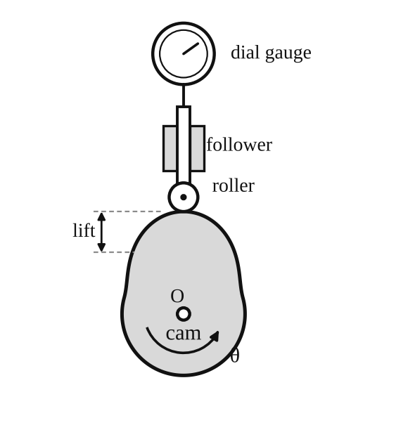
Fig. 1: Radial cam and roller follower with dial gauge (schematic).
Setting up
- Fit the screwed spigot of the gauge into the slotted hole and tighten the nut finger-tight.
- Loosen the centre wing nut, rotate the selected cam until the roller follower rests on the highest point.
- Set the dial gauge to read 50 mm (that is, 2 on the revolution counter and 0 on the main scale) and adjust the bezel for fine setting. Tighten the dial gauge fixing nut.
Method in brief
- Use a 25 mm diameter roller on the centreline of the cam. Fix cam A in position and zero the pointer and dial gauge. The centre wing nut is loosened so the cam can be turned and then locked at any position, and the other wing nuts are kept tight.
- Turn the cam a few degrees at a time and record the follower displacement (lift) from the dial gauge at each angle, for one complete revolution.
- Plot cam angle against displacement on a suitable scale.
- Repeat for the other cams, and with the other followers if time allows.
- Lever arm test: remove the push rod and dial gauge using the two wing nuts at the back of the column, screw the roller follower onto the end of the lever arm, set the cam at its lowest point under the follower, set the pointer to zero on the 20° scale, and then proceed as above, noting the angle of displacement of the lever for each cam position.

3. Results
Follower: [roller / lever / knife-edge / flat-footed / offset roller]. Cam: [A / B / C / D]. Roller diameter = 25 mm.
Table 1: Displacement of the follower against cam angle (cam ___)
Cam angle θ (°) | Dial reading (mm) | Displacement s (mm) | ds/dθ (mm/°) | d²s/dθ² (mm/°²)
0
10
20
30
40
50
60
70
80
90
100
110
120

Continue to 360° in the same way (the rows above go to 120°). If you took a different step, change the first column.
The velocity and acceleration are found by graphical differentiation of the displacement curve, as the manual asks (see the Graphs section).

4. Analysis of Results
- Displacement s = dial reading − reading at the lowest point (or highest point) of the follower = [ ] mm.
- Velocity curve: slope of the s–θ graph at each angle, ds/dθ = [ ] mm/°. The actual velocity for a given cam speed ω is v = ω(ds/dθ), with ω in rad/s and ds/dθ in mm/rad (multiply the value per degree by 57.3).
- Acceleration curve: slope of the ds/dθ graph, d²s/dθ² = [ ] mm/°². The actual acceleration is a = ω²(d²s/dθ²) (convert to per radian).
- Angles at which the acceleration peaks occur: [ ]° and [ ]°.
- Lift h = [ ] mm, angle of rise β = [ ]°, dwell angle = [ ]°, angle of return = [ ]°.
Expected shapes from the theory (see Fig. 2). The experiment should give the same shapes, but with rounded corners.
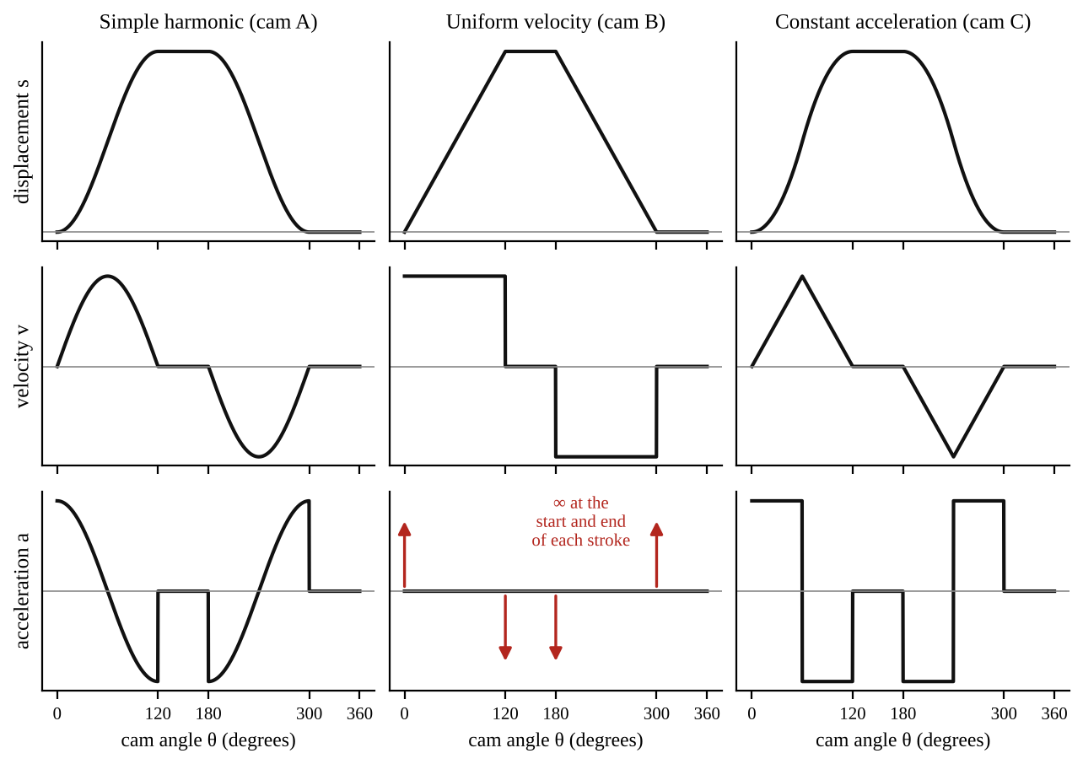
Fig. 2: Expected displacement, velocity and acceleration curves for cams A, B and C (rise, dwell, return, dwell).

5. Observations / Precautions Taken
Observations
- Cam A (SHM): the displacement curve was smooth and the acceleration curve varied smoothly.
- Cam B (uniform): the displacement rose in a straight line and the follower moved at a steady speed in the stroke, but jerked at the ends.
- Cam C (constant acceleration): the displacement curve was parabolic (S-shaped) with the greatest speed in the middle of the stroke.
- Cam D (tangent): the follower motion changed from straight-line to curved parts of the profile.
- The follower stayed at rest (dwell) over the parts of the cam with a constant radius.
Precautions
- The cam was turned slowly in one direction only, so that backlash in the follower and the dial gauge did not change the readings.
- The dial gauge was set to zero at the start, and it was checked after one complete turn.
- The centre wing nut was tightened at each reading so the cam did not move while reading.
- The roller was kept on the centreline of the cam and the follower was kept clean and lubricated.

6. Graphs
Plot the following on graph paper from your own readings and attach them here:
- Angle of rotation (θ) against displacement (s) for each cam
- Velocity diagram: ds/dθ against θ (by graphical differentiation)
- Acceleration diagram: d²s/dθ² against θ (by graphical differentiation)

7. Discussion
Merits and limitations of the experiment
- Merits: the cam profiles are tested directly, and the dial gauge shows the actual motion clearly. The same machine tests several cams and followers, so they can be compared quickly. It shows why different cams are used for different jobs.
- Limitations: the readings are taken by hand at a few angles, so peaks and sudden changes (such as the infinite acceleration of the uniform motion cam) are missed. Graphical differentiation magnifies small errors, so the acceleration diagram is very rough. Backlash and the friction of the follower affect the displacement. The test is static (slow turning), so dynamic effects such as follower bounce and cam speed are not shown.
Use and selection of cams in engineering practice
- Cams are used in internal combustion engines (valve operation), automatic machines, textile machines, printing presses, packaging machines and shoe machines.
- The SHM cam is good for moderate speeds because the acceleration is finite. Constant acceleration cams give the least peak acceleration and so the least inertia force for a given rise, so they are good for high speeds. Uniform motion cams give a steady speed but cannot be used at high speed because of the shock at the ends of the stroke. Tangent cams are easy to make, so they are often used in engine valve gear.
- The follower is chosen for the job: roller followers for low wear and heavy loads, flat followers for compact valve gear, knife-edge followers only for light loads, and offset followers to reduce the side thrust on the guide.

8. Conclusion
The displacement of the follower was recorded against cam angle for cams A to D, and velocity and acceleration diagrams were obtained by graphical differentiation. The shapes agree with those expected from cam theory: SHM (smooth), uniform motion (straight displacement, shocks at the ends), constant acceleration (parabolic) and tangent (mixed). The acceleration peaks occurred at [ ]°. The choice of cam type is a compromise between smooth motion, speed, wear and cost.

Section B: Questions
1. What I learnt from the experiment. I learnt how the shape of a cam decides the motion of the follower, and how to get velocity and acceleration diagrams from a displacement curve by graphical differentiation.
3. Comment on the experimental procedure. The dial gauge gives the follower movement directly with a good resolution of 0.01 mm. It is easy to change cams and followers, so the comparison is quick.
4. Most difficult aspect of the experiment. Reading the dial gauge accurately while turning the cam, and getting the acceleration from the slope of a slope. It can be reduced by taking readings at small angle steps, using a smooth curve, and repeating the test.
5. Another method that could be used. An electronic displacement transducer (LVDT) with a data logger on the follower could be used to record the motion, and give the velocity and acceleration by differentiating electronically.
6. Parameters measured / involved. Cam angle θ, follower displacement s (dial gauge), velocity and acceleration (by calculation), lift h, rise angle and dwell angle.
7. Measuring instrument used. The dial gauge (40 mm travel, 0.01 mm graduations) measures the displacement. The reading is the number of whole revolutions on the revolution counter plus the main scale.
8. Practical relevance. Engine valve gear, automatic machine tools, textile and packaging machines, printing presses and sewing machines.
9. Section of the course it belongs to. Mechanisms (kinematics of machines: cams and followers).
13. What interested me most. The uniform motion cam gave a straight-line displacement but a sudden jerk at the end of each stroke.
2, 10, 11, 12, 14 and 15 (personal / references): to be filled in by you.

AM 223: The Offset Slider-Crank Mechanism

Objective
- To study the kinematics of an offset slider-crank mechanism (slider displacement, velocity and acceleration against crank angle).

1. Theory
A slider-crank mechanism changes the rotation of a crank into the straight-line (reciprocating) motion of a slider, as in a piston engine. In the offset type the line of motion of the slider does not pass through the crank centre but is displaced by a distance e.
Let r = crank radius, L = connecting rod length, e = offset, θ = crank angle and φ = angle of the connecting rod. From the geometry (see Fig. 1):
L sin φ = r sin θ − e so sin φ = (1/q)(sin θ − e/r) where q = L/r
x = r(1 − cos θ) + L(cos φ₀ − cos φ) φ₀ = sin⁻¹(−e/L) = value of φ at θ = 0°
The crank turns at constant angular velocity ω. Differentiating with respect to time:
dx/dt = rω sin θ + Lφ' sin φ d²x/dt² = rω² cos θ + L φ'² cos φ + L φ'' sin φ
Exact solution. Differentiating L sin φ = r sin θ − e gives φ' cos φ = (ω/q) cos θ, and a second differentiation gives φ'' cos φ − φ'² sin φ = −(ω²/q) sin θ. For each value of θ, φ, φ' and φ'' can be found and put in the above equations.
Approximate solution. For q ≥ 4 and e/r ≤ 1/4 the square root in cos φ can be expanded and only the first two terms of the binomial series are kept. This gives
x ≈ r(1 − cos θ) + (r/2q)[ sin²θ − 2(e/r) sin θ ]
dx/dθ ≈ r[ sin θ + (1/2q)( sin 2θ − 2(e/r) cos θ ) ] d²x/dθ² ≈ r[ cos θ + (1/q)( cos 2θ + (e/r) sin θ ) ]
So the acceleration of the slider is mainly a cosine curve (simple harmonic) at the crank speed, plus a smaller second-harmonic term caused by the finite length of the connecting rod. The offset moves the top and bottom dead centre positions and makes the stroke different in the forward and return directions (a quick-return effect).

2. Apparatus
Tec-equipment model of an offset slider-crank mechanism with a crank, connecting rod, slider on a guide with a scale, an angular scale (protractor) for the crank angle, and a rule or vernier calipers to measure r, L and e.
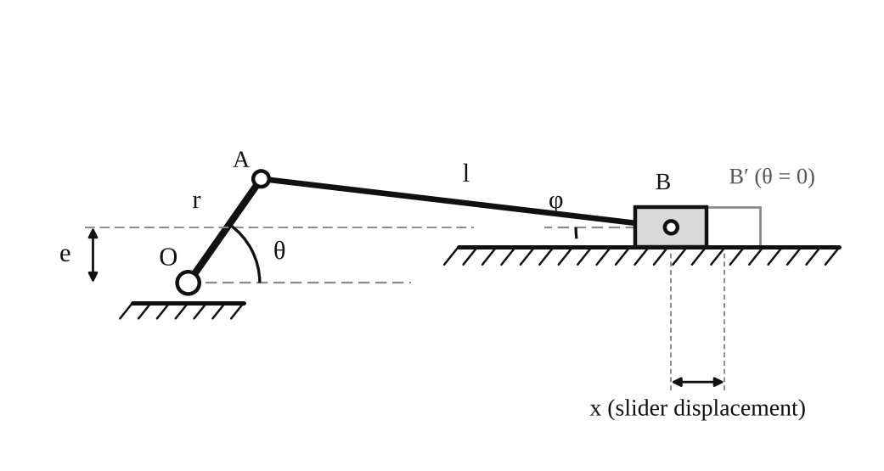
Fig. 1: Offset slider-crank mechanism (r = crank radius, L = connecting rod length, e = offset).
Method in brief
- Set the crank angle at 0° and note the slider position to get the zero-displacement reading.
- Increase the crank angle θ in small steps (10° is recommended) and record the slider displacement x for each crank angle, for a complete revolution of the crank.
- Measure the slider offset e, the crank radius r and the connecting rod length L.

3. Results
r = [ ] mm, L = [ ] mm, e = [ ] mm, q = L/r = [ ].
Table 1: Slider displacement against crank angle
θ (°) | Slider reading (mm) | x (mm) | dx/dθ (mm/rad) | d²x/dθ² (mm/rad²) | Theoretical d²x/dθ² (mm/rad²)
0
10
20
30
40
50
60
70
80
90

Continue in 10° steps up to 360° (36 readings). x is the reading minus the zero-displacement reading at θ = 0.

4. Analysis of Results
- x = slider reading at θ − slider reading at 0°.
- Velocity: differentiate the x–θ graph graphically to obtain dx/dθ. For a crank speed ω the slider velocity is v = ω dx/dθ.
- Acceleration: differentiate the dx/dθ graph to obtain d²x/dθ². The acceleration is a = ω² d²x/dθ².
- Theoretical curve: d²x/dθ² = r[cos θ + (1/q)(cos 2θ + (e/r) sin θ)], using r = [ ] mm, q = [ ] and e = [ ] mm.
- Compare the experimental and theoretical curves at the same angles; the difference at θ = 0° is [ ] %.

5. Observations / Precautions Taken
Observations
- The slider moved away from the crank and returned once for each turn of the crank.
- The slider was at rest at the ends of its stroke (dead centres). The velocity was greatest around mid-stroke.
- The acceleration was greatest near the ends of the stroke and changed sign during the stroke.
- Because of the offset, the dead centre positions were not exactly at θ = 0° and 180°, and the forward and return strokes took different crank angles.
Precautions
- The zero position of the crank angle and of the slider were checked before the test.
- The crank was turned in one direction only to avoid backlash errors.
- The scale was read at eye level to avoid parallax.
- The crank radius, rod length and offset were measured at several places and the average used.

6. Graphs
Plot the following on graph paper from your own readings and attach them here:
- Slider displacement x against crank angle θ
- dx/dθ against θ (by graphical differentiation)
- d²x/dθ² against θ (by graphical differentiation)
- Theoretical d²x/dθ² against θ, plotted on the same axes for comparison

7. Discussion
1. How would you obtain the slider velocity and acceleration at any crank angle, given that the crank rotates at a uniform rate ω rad/s? From the displacement x(θ), the velocity is v = dx/dt = (dx/dθ)(dθ/dt) = ω dx/dθ. The acceleration is a = dv/dt = ω² d²x/dθ² because ω is constant. So the values of dx/dθ and d²x/dθ² read from the graphs (or calculated from the formulae in the Theory section) are multiplied by ω and ω².
2. Variation of slider velocity and acceleration with crank position. The velocity is zero at the two dead centres, rises to a maximum when the crank is nearly at right angles to the connecting rod and then falls again. The acceleration is highest at the dead centre positions (about rω² at the outer dead centre, and a bit different at the inner one because of the second harmonic term r ω²/q cos 2θ), is zero when the velocity is greatest, and reverses in direction between the two dead centres. The curve is nearly a cosine curve if the connecting rod is long.
3. Effect of the slider offset. The offset e shifts the dead centre positions and changes the stroke. For e ≠ 0, the crank angles for the forward and return strokes are no longer equal (180° each), so the mechanism has a quick-return effect: the forward stroke is slower than the return stroke, or the other way. The terms that contain e in the displacement, velocity and acceleration formulas show this. The maximum velocity and acceleration are also changed slightly. With a large offset the rod makes a bigger angle with the slider path, so the side thrust on the slider guide is larger.
Sources of error
- Reading the slider position and crank angle by eye (parallax and limited scale divisions).
- Backlash and play in the joints of the mechanism.
- Graphical differentiation magnifies errors, and the second derivative is the least accurate.
- The approximate formula was used, which is only valid for q ≥ 4 and e/r ≤ 1/4.

8. Conclusion
The displacement of the slider of the offset slider-crank was recorded against the crank angle, and the velocity and acceleration diagrams were obtained by differentiation. The acceleration curve agreed with the theoretical curve within about [ ] %. The velocity is zero at the dead centres, and the acceleration is greatest there. The offset gives different forward and return strokes (quick return). The mechanism is used in engines, compressors, pumps and presses.

Section B: Questions
1. What I learnt from the experiment. I learnt how a slider-crank changes rotation into reciprocating motion, and how to find velocity and acceleration of the slider by differentiation of the displacement curve.
3. Comment on the experimental procedure. The mechanism is simple and a complete cycle takes only 36 readings in 10° steps. The result can be compared with a theoretical curve.
4. Most difficult aspect of the experiment. Reading the slider displacement accurately and getting the second derivative graphically. It can be reduced by using small steps and smooth curves, or by a computer to do the differentiation.
5. Another method that could be used. A rotary encoder on the crank and a linear transducer on the slider could record the motion electronically.
6. Parameters measured / involved. Crank angle θ, slider displacement x, crank radius r, rod length L and offset e.
7. Measuring instrument used. The rule or vernier calipers measure r, L and e, and the protractor scale measures the crank angle.
8. Practical relevance. Internal combustion engines, compressors, pumps, presses, shaping machines and quick-return mechanisms.
9. Section of the course it belongs to. Mechanisms (kinematics of machines: slider-crank chain).
13. What interested me most. The forward and return strokes of the slider were different because of the offset.
2, 10, 11, 12, 14 and 15 (personal / references): to be filled in by you.

