APPLIED MECHANICS LABORATORY
LABORATORY REPORTS
SM 212: Shear Force in a Beam Experiment
SM 213: Bending Moment in a Beam Experiment
SM 214: Torsion Test to Destruction

Name: ______________________________
Matric No.: __________________________
Department: _________________________
Date: _______________________________
Contents
SM 212 Shear Force in a Beam Experiment
SM 213 Bending Moment in a Beam Experiment
SM 214 Torsion Test to Destruction
Notes before you submit
- Anything shown as [ ] is for your own readings or results from your own lab session. Nothing has been invented.
- Each report follows Section C of the manual: Theory, Apparatus, Results, Analysis of Results, Observations and Precautions, Graphs, Discussion and Conclusion. The Section B questions are answered after each report.
- Questions 2, 10, 11, 12, 14 and 15 are personal, so they are left for you to fill in.
- Graphs must be drawn from your own readings on graph paper (or in Excel) and attached where indicated.

SM 212: Shear Force in a Beam Experiment

Objective
- To investigate how the shear force at a cut in a simply supported beam varies with an increasing point load (Experiment 1).
- To investigate how the shear force at the cut varies for various loading conditions, and to draw shear force diagrams (Experiment 2).

1. Theory
When a beam carries loads, internal forces are set up in it. The shear force at a section is the algebraic sum of all the vertical forces acting on one side of that section. If it is worked out from the left side, an upward force (like the left reaction) is taken as positive and a downward load as negative. The same value (with the opposite sign) is got from the right side.
For a simply supported beam of span L carrying a single point load W at a distance a from the left support A, the reactions are found by taking moments:
R_{B} = W a / L R_{A} = W (L − a) / L
The cut in this experiment is on the right of the load (40 mm away from it), so the shear force at the cut, taken from the right side, is just the right reaction:
S_{c} = W a / L
For several loads the same statement is used: the shear force at the cut is equal to the algebraic sum of the forces acting to the left (or right) of the cut. The shear force diagram jumps up at an upward reaction and jumps down at a downward load, by the size of that force, and is flat between the forces.
In the apparatus the beam is cut at the section, and the cut is bridged by a mechanism that carries shear only and reacts on a load cell. The digital display therefore reads the shear force directly.

2. Apparatus
Tec-equipment SM 212 shear force in a beam apparatus: a beam with a cut, a mechanism bridging the cut to a load cell, a digital force display, hangers with slotted masses (100 g to 500 g), a test frame with thumbscrews, and a rule. The hanger supports are 20 mm apart with a central groove for the hangers.
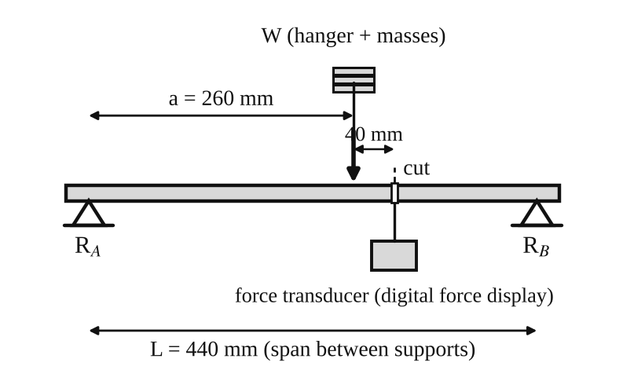
Fig. 1: Layout for Experiment 1 (a = 260 mm; the cut is 40 mm to the right of the load).
Method in brief
- Inspect all parts, leads and fastenings for damage and check that everything is secure. Fit the left and right supports into the test frame and tighten the thumbscrews. Make sure the internal bars are in the middle of their travel.
- Connect the mini DIN lead from "Force Input 1" on the digital force display to the "Force Output" socket on the left support, making sure the lead does not touch the beam. Zero the force meter using the dial. Check that the display reads zero with no load.
- Experiment 1: hang a 100 g hanger 40 mm to the left of the cut and record the display reading. Repeat with 200, 300, 400 and 500 g.
- Experiment 2: load the beam as in figures 4, 5 and 6 using the loads in the table. Record the digital display reading for each case.
Mass to load conversion (Table 1)
Mass (g) | 100 | 200 | 300 | 400 | 500
Load (N) | 0.98 | 1.96 | 2.94 | 3.92 | 4.90

3. Results
Experiment 1: shear force variation with an increasing point load
L = 440 mm, a = 260 mm, S_{c} = W a / L = 0.591 W (the ratio a/L = 260/440 = 0.5909).
Table 2: Results for Experiment 1
Mass (g) | Load W (N) | Experimental shear force (N) | Theoretical shear force (N)
0 | 0 |  | 0
100 | 0.98 |  | 0.579
200 | 1.96 |  | 1.158
300 | 2.94 |  | 1.737
400 | 3.92 |  | 2.316
500 | 4.90 |  | 2.895

Experiment 2: shear force for various loading conditions
The loads were placed as shown in figures 4, 5 and 6 of the manual. The theoretical reactions are found by moments about each support, and the theoretical shear force at the cut by summing the forces to the left of it.
Table 3: Results for Experiment 2
Fig. | W₁ (N) | W₂ (N) | Experimental shear force (N) | R_{A} (N) | R_{B} (N) | Theoretical shear force (N)
4 | 3.92 | – |  | 5.17 | −1.25 | +1.25
5 | 1.96 | 3.92 |  | 2.58 | 3.30 | −3.30
6 | 4.91 | 3.92 |  | 2.59 | 6.24 | −2.32

A negative R_{B} (figure 4) means the right support has to pull the beam down, because the load is outside the supports. The experimental column is for your own readings from the digital display.

4. Analysis of Results
Experiment 1
Theoretical shear force at the cut: S_{c} = W a / L = W × 260 / 440. For example for 300 g: 2.94 × 260 / 440 = 1.737 N. The percentage difference for each load is (experimental − theoretical) / theoretical × 100 = [ ] %.
Experiment 2
- Figure 4 (W₁ = 3.92 N, 140 mm to the left of R_{A}; span 440 mm): taking moments about B, R_{A} × 440 = 3.92 × (440 + 140), so R_{A} = 5.167 N. Then R_{B} = 5.167 − 3.92 = 1.247 N downward (written −1.247 N), and the shear force at the cut = R_{A} − W₁ = 5.167 − 3.92 = +1.247 N.
- Figure 5 (W₁ = 1.96 N at 220 mm and W₂ = 3.92 N at 260 mm from A): R_{B} = (1.96 × 220 + 3.92 × 260) / 440 = 3.296 N, R_{A} = 5.88 − 3.296 = 2.584 N, and the shear force at the cut (300 mm from A) = 2.584 − 1.96 − 3.92 = −3.296 N.
- Figure 6 (W₁ = 4.91 N at 240 mm and W₂ = 3.92 N at 400 mm from A): R_{B} = (4.91 × 240 + 3.92 × 400) / 440 = 6.242 N, R_{A} = 8.83 − 6.242 = 2.588 N, and the shear force at the cut = 2.588 − 4.91 = −2.322 N. The load W₂ lies to the right of the cut, so it does not enter the sum from the left.
In each case the shear force from the right side gives the same magnitude as from the left side, which is a useful check on the reactions.
Shear force diagrams
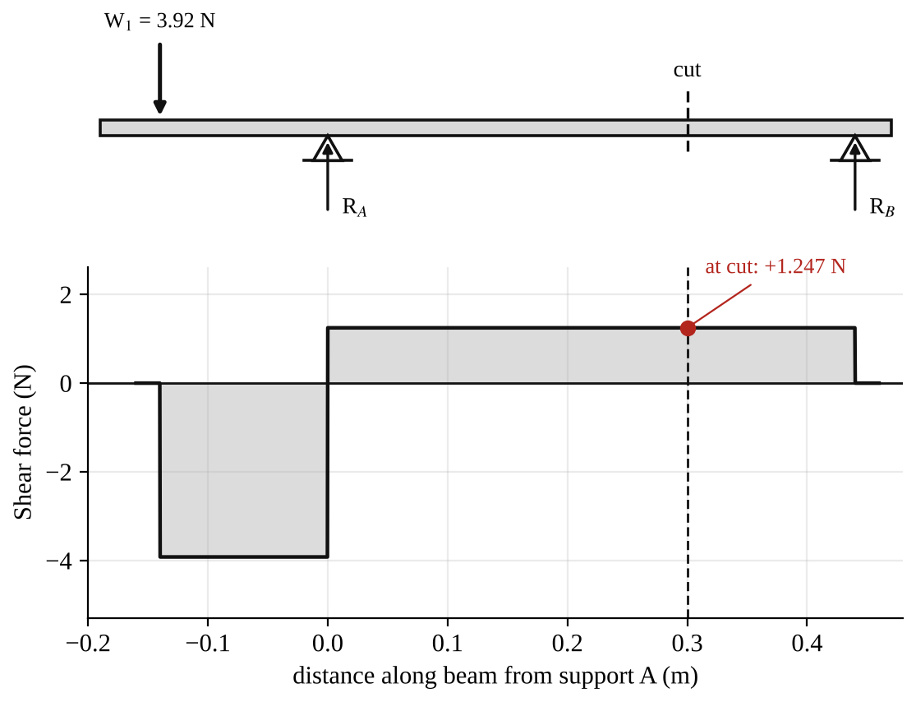
Fig. 2: Shear force diagram for figure 4 (shear force at the cut = +1.247 N).
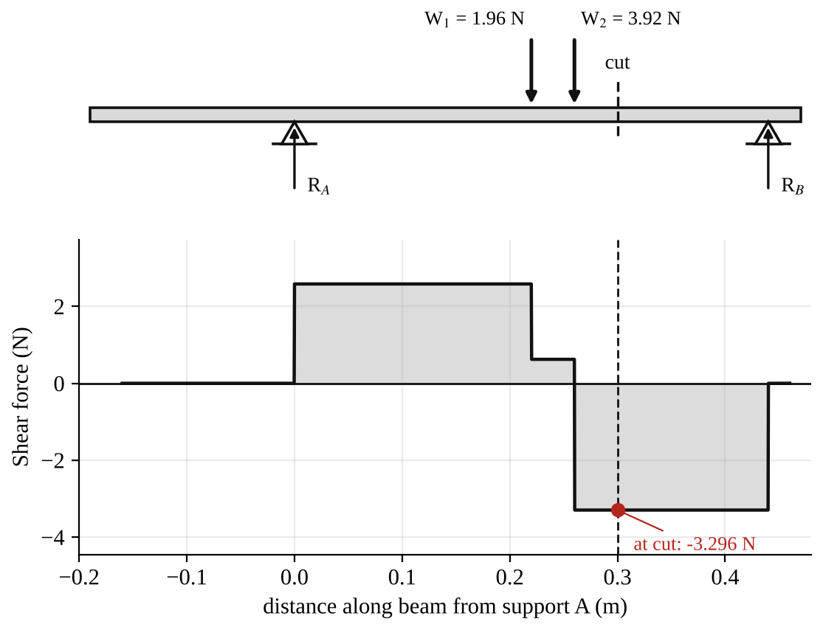
Fig. 3: Shear force diagram for figure 5 (shear force at the cut = −3.296 N).
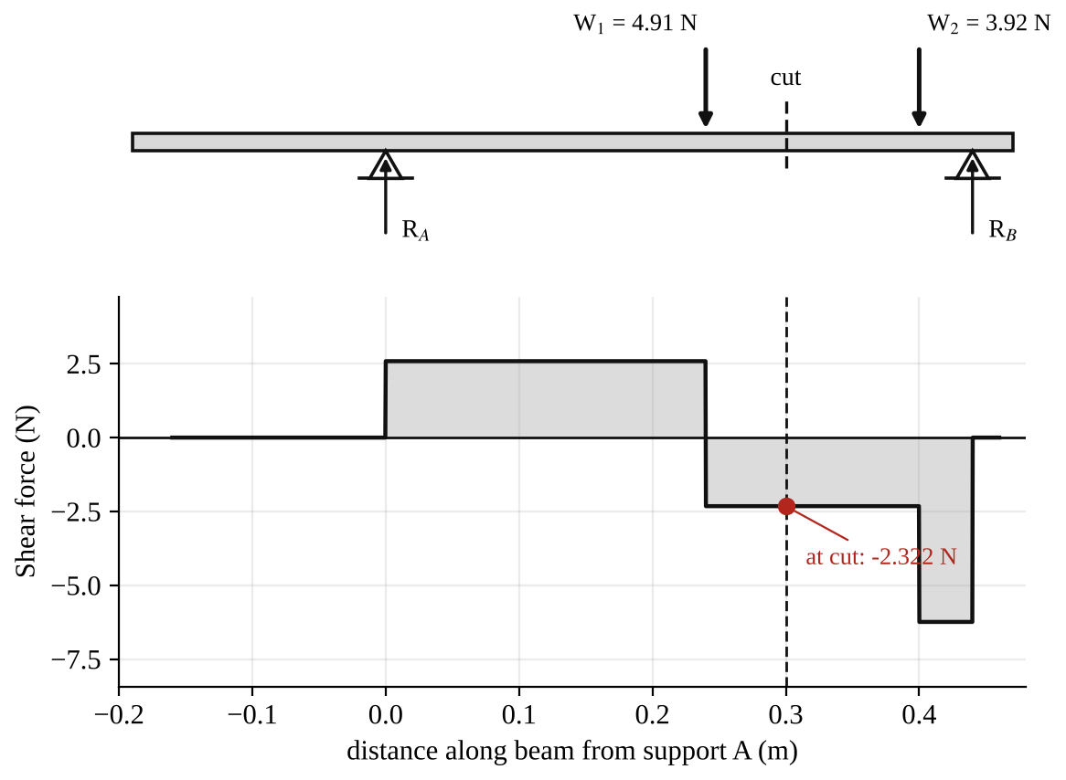
Fig. 4: Shear force diagram for figure 6 (shear force at the cut = −2.322 N).

5. Observations / Precautions Taken
Observations
- The digital reading increased steadily as the load was increased (Experiment 1), in a straight-line way.
- The experimental shear force was close to the theoretical shear force, but slightly different.
- The reading changed sign depending on which side of the cut the heavier load was, so the shear force can be positive or negative.
- When a load was moved to the right of the cut it no longer changed the sum of the forces to the left of the cut, but it changed the reactions.
Precautions
- The force display was zeroed with no load, and checked again between readings. If the meter was reading only ±0.1 N the frame was tapped lightly to overcome stiction.
- The loads were hung carefully in the grooves of the hanger supports at the stated distances.
- The lead from the load cell was kept away from the beam.
- Excessive loads were never put on any part of the equipment.
- The apparatus was on a level, steady surface.

6. Graphs
Plot the following on graph paper from your own readings and attach them here:
- Experimental and theoretical shear force at the cut against load W (Experiment 1), on the same axes
- Shear force diagrams for figures 4, 5 and 6 (shown in the Analysis section)

7. Discussion
Shape of the graph. The graph of shear force against load is a straight line through the origin, with a slope of a/L = 0.591 in theory. This tells us that the shear force at the cut is directly proportional to the load. Doubling the load doubles the shear force. So the equation S_{c} = W a / L predicts the behaviour of the beam well, provided the experimental points lie close to the theoretical line (my readings differed from theory by [ ] %).
Comparison of experiment 2 with theory. The experimental values at the cut agree with the calculated values within [ ] %. The shear force diagrams show jumps equal to the loads and reactions, and the shear force is constant between the loads.
Possible reasons for differences
- Friction ("stiction") in the cut mechanism and in the load cell.
- The weight of the beam and the cut mechanism itself is not in the theory, nor is the weight of the hangers.
- The positions of the hangers (measured to about 1 mm) and the actual span.
- Slight zero error or drift of the digital display, and the digital readings are to only 0.1 N.

8. Conclusion
The shear force at the cut increased in direct proportion to the load (S_{c} = Wa/L), and the experimental values agreed with theory to within about [ ] %. For the three loading arrangements the shear force at the cut was found by summing the forces on one side of the cut, and shear force diagrams were drawn. The shear force is needed in beam design to size the web and the connections, for example in the design of bridges and floor beams.

Section B: Questions
1. What I learnt from the experiment. I learnt what shear force is, how to calculate it at a cut from the reactions and loads, and how to draw a shear force diagram.
3. Comment on the experimental procedure. The cut and load cell give the shear force directly on a digital display, so readings are fast and clear. Using five loads and a graph shows the trend better than one reading.
4. Most difficult aspect of the experiment. Getting the display to return to zero (stiction in the mechanism) and positioning the hangers correctly. It can be reduced by tapping the frame lightly, re-zeroing, and measuring distances carefully.
5. Another method that could be used. A strain gauge beam, or a hydraulic or spring balance at the supports to measure the reactions and hence the shear force.
6. Parameters measured / involved. Load W (from mass), positions a and the span L, reactions R_{A} and R_{B}, and the shear force at the cut.
7. Measuring instrument used. The digital force display (with the load cell) measures the shear force, and a rule measures the distances.
8. Practical relevance. Design of beams in buildings, bridges and cranes, and in machine shafts and frames.
9. Section of the course it belongs to. Strength of materials / structures (shear force and bending moment in beams).
13. What interested me most. The shear force reading changed sign when the heavier load was moved from one side of the cut to the other.
2, 10, 11, 12, 14 and 15 (personal / references): to be filled in by you.

SM 213: Bending Moment in a Beam Experiment

Objective
- To verify the bending moment variation at the point of loading (Experiment 1).
- To examine how the bending moment at the cut varies for various loading conditions, and to draw bending moment diagrams (Experiment 2).

1. Theory
When a simply supported beam is loaded, there is a bending moment at every section. The bending moment at a section is the algebraic sum of the moments, about that section, of all the forces on one side of it. It is taken positive when it makes the beam sag (curve upward, like a smile).
For a single point load W at a distance a from the left support A, on a beam of span L, the reactions are R_{A} = W(L − a)/L and R_{B} = Wa/L. If the cut is under the load (Experiment 1), the bending moment there is
M (at cut) = W a (L − a) / L
This is the maximum bending moment for a single load. For several loads the bending moment at the cut is M = R_{A} × x − Σ W (x − x_{W}) for the loads to the left of the cut, where x is the distance of the cut from A and x_{W} is the position of each load.
In the apparatus the beam is cut and a load cell reads the force F that it takes to hold the two halves in place. This force acts at a lever arm of 0.125 m, so bending moment = displayed force × 0.125 (N·m).

2. Apparatus
Tec-equipment SM 213 bending moment in a beam apparatus: a beam with a cut at which a pivoting mechanism and a load cell measure the moment, a digital force display, hangers and slotted masses (100 g to 500 g), a test frame with thumbscrews, and a rule.
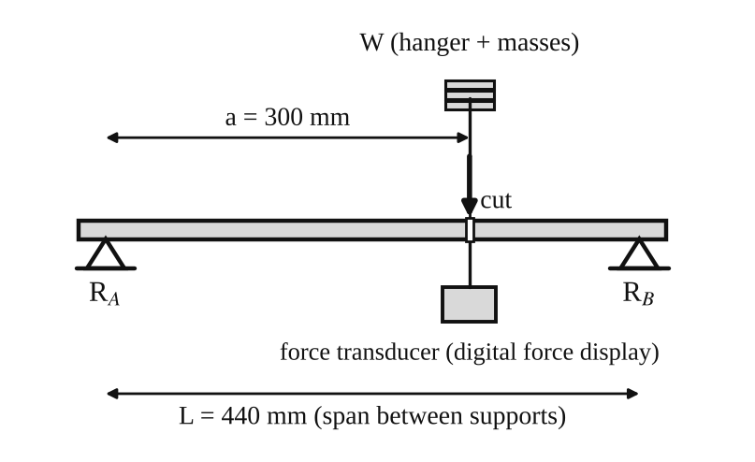
Fig. 1: Layout for Experiment 1 (load directly at the cut, a = 300 mm from the left support, span L = 440 mm).
Method in brief
- Inspect the equipment, check the electrical connections and fastenings and fit the supports to the test frame (four securing nuts, thumbscrews tight).
- Connect the mini DIN lead from "Force Input 1" to the "Force Output" socket and make sure the lead does not touch the beam. Zero the force meter and check that it reads zero with no load.
- Experiment 1: place a hanger with 100 g at the cut, record the display reading, and repeat for 200, 300, 400 and 500 g. Bending moment = displayed force × 0.125 (N·m).
- Experiment 2: load the beam as in figures 4, 5 and 6, and record the display readings.

3. Results
Experiment 1: bending moment variation at the point of loading
The readings below are the ones written in the manual. Please check them against your own notes. Theoretical bending moment = W a (L − a)/L with a = 0.30 m and L = 0.44 m, so M = 0.0955 W.
Table 1: Result table for bending moment (Experiment 1)
Mass (g) | Load (N) | Force (N) | Experimental bending moment (N·m) | Theoretical bending moment (N·m) | Difference (%)
0 | 0 | 0 | 0 | 0 | –
100 | 0.98 | 0.7 | 0.0875 | 0.0935 | −6.9
200 | 1.96 | 1.3 | 0.1625 | 0.1871 | −13.1
300 | 2.94 | 1.9 | 0.2375 | 0.2806 | −15.5
400 | 3.92 | 2.7 | 0.3375 | 0.3742 | −9.8
500 | 4.92 | 3.1 | 0.3875 | 0.4696 | −17.5

The theoretical column printed in the manual is 0.094, 0.187, 0.281, 0.374 and 0.470 N·m, which agrees with the values here to the rounding.
Experiment 2: bending moment for various loading conditions
Table 2: Results for Experiment 2
Fig. | W₁ (N) | W₂ (N) | Force (N) | Experimental bending moment (N·m) | R_{A} (N) | R_{B} (N) | Theoretical bending moment (N·m)
4 | 3.92 | – | −1.4 | −0.175 | 5.17 | −1.25 | −0.175
5 | 1.96 | 3.92 | 3.4 | 0.425 | 2.58 | 3.30 | +0.462
6 | 4.91 | 3.92 | 3.6 | 0.450 | 2.59 | 6.24 | +0.482

4. Analysis of Results
Experiment 1
Theoretical: M = W a (L − a)/L = W × 0.30 × 0.14 / 0.44 = 0.0955 W. For 300 g: 2.94 × 0.0955 = 0.2806 N·m. Experimental: M = 1.9 × 0.125 = 0.2375 N·m. Difference = (0.2375 − 0.2806)/0.2806 × 100 = −15.4 %.
Experiment 2: reactions and bending moment at the cut (cut 300 mm from A, span 440 mm)
- Figure 4 (W₁ = 3.92 N, 140 mm to the left of A): R_{A} = 3.92 × (440 + 140)/440 = 5.167 N, R_{B} = −1.247 N. The bending moment at the cut = R_{A} × 0.30 − 3.92 × 0.44 = 1.550 − 1.725 = −0.175 N·m (negative, because the beam hogs: it bends the other way, owing to the overhang).
- Figure 5 (W₁ = 1.96 N at 220 mm and W₂ = 3.92 N at 260 mm): R_{B} = 3.296 N, R_{A} = 2.584 N. M = 2.584 × 0.30 − 1.96 × 0.08 − 3.92 × 0.04 = 0.775 − 0.157 − 0.157 = +0.462 N·m.
- Figure 6 (W₁ = 4.91 N at 240 mm and W₂ = 3.92 N at 400 mm): R_{B} = 6.242 N, R_{A} = 2.588 N. M = 2.588 × 0.30 − 4.91 × 0.06 = 0.776 − 0.295 = +0.482 N·m.
Experimental bending moment = force × 0.125. For figure 5: 3.4 × 0.125 = 0.425 N·m; the difference from theory is (0.425 − 0.462)/0.462 × 100 = −7.9 %.
Bending moment diagrams
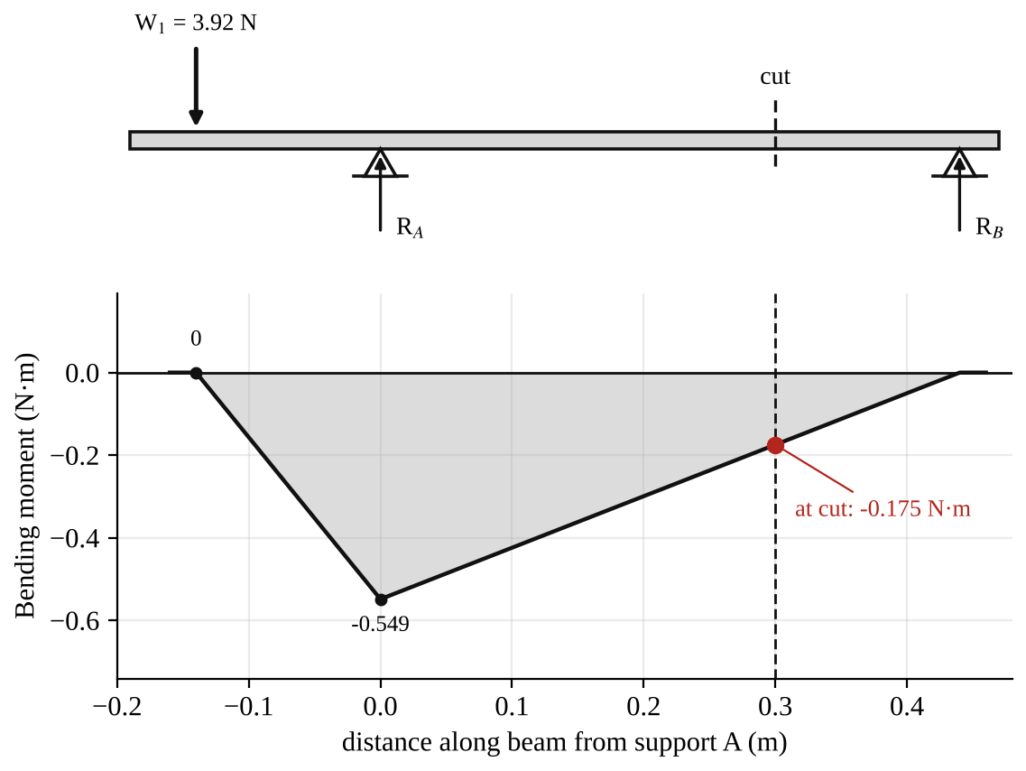
Fig. 2: Bending moment diagram for figure 4 (−0.175 N·m at the cut).
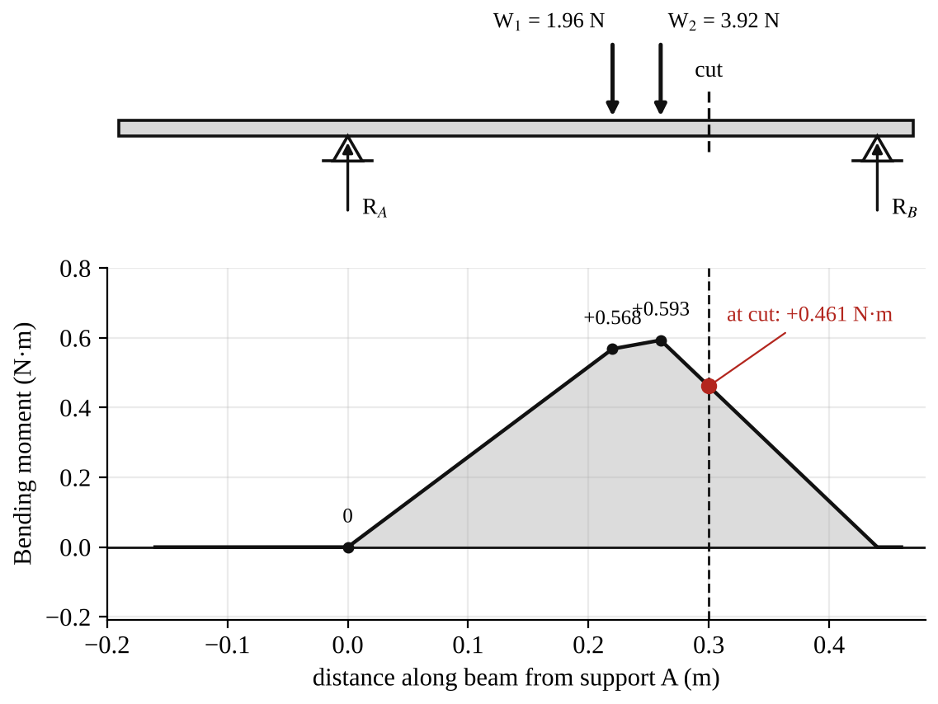
Fig. 3: Bending moment diagram for figure 5 (+0.462 N·m at the cut).
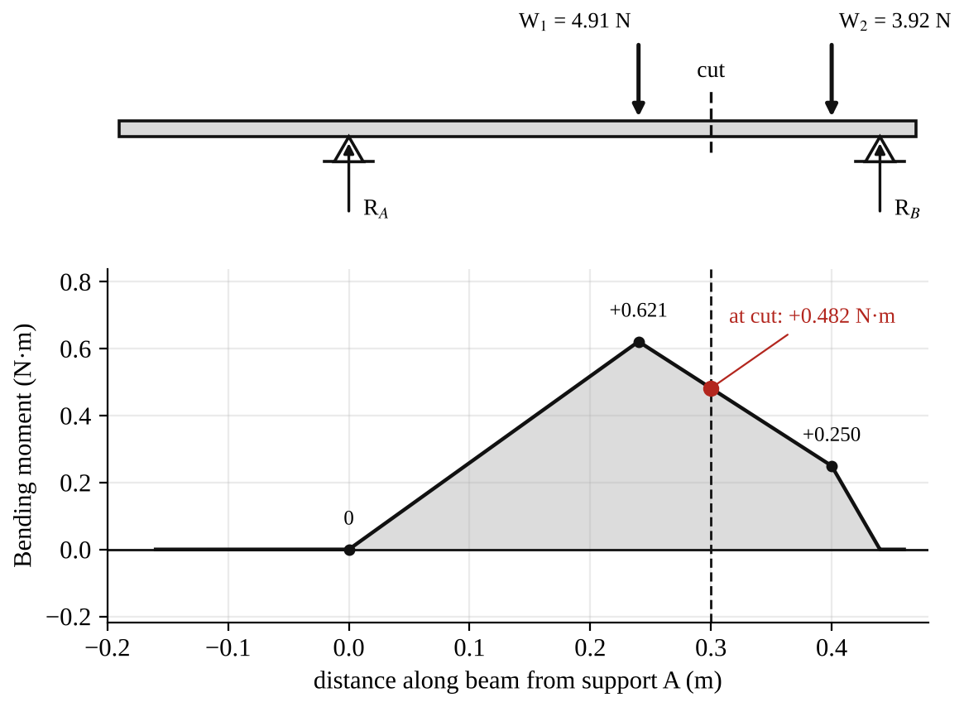
Fig. 4: Bending moment diagram for figure 6 (+0.482 N·m at the cut).

5. Observations / Precautions Taken
Observations
- The bending moment at the point of loading increased in a straight line with the load.
- The experimental values were always a bit smaller than the theoretical values (6 to 18 % lower in Experiment 1).
- When the load was outside the supports (figure 4) the bending moment at the cut was negative.
- The bending moment diagrams are made of straight lines, with a change of slope at every load and support.
Precautions
- The meter was zeroed with no load and checked again before each reading.
- The loads were put exactly at the positions given for each figure.
- The lead was kept away from the beam.
- No excessive loads were put on the beam, and the frame was on a firm level surface.

6. Graphs
Plot the following on graph paper from your own readings and attach them here:
- Experimental and theoretical bending moment at the cut against load (Experiment 1)
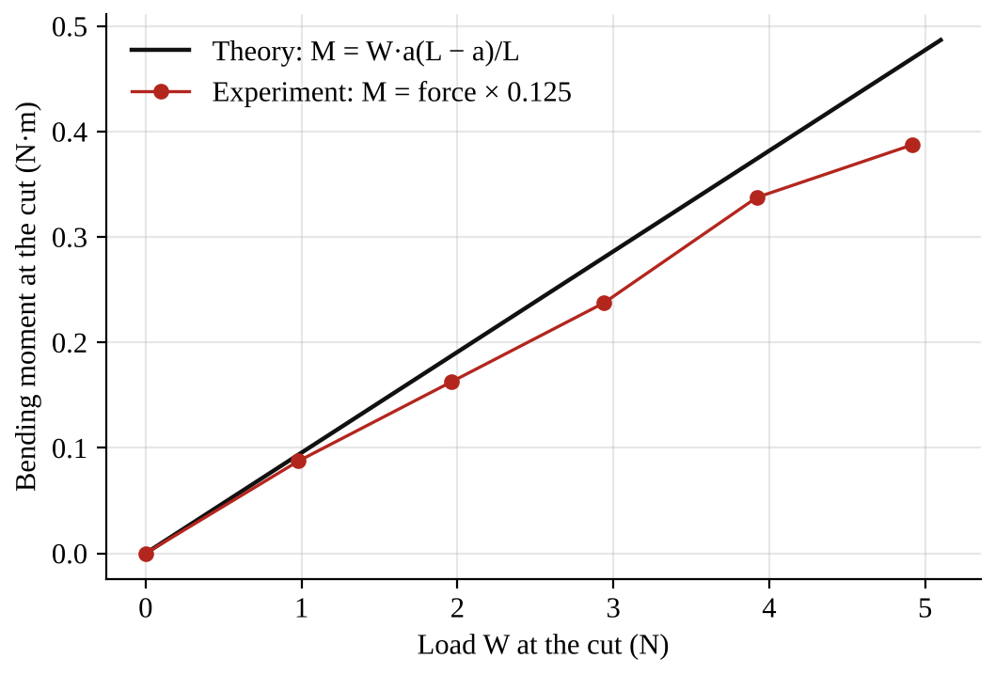
Fig. 5: Experimental and theoretical bending moment against load for Experiment 1.

7. Discussion
Shape of the graph. Both lines are straight, starting from zero. So the bending moment at the point of loading is directly proportional to the load, as the equation M = Wa(L − a)/L says (for fixed a and L, M is a constant times W). The experimental line has a smaller slope than the theoretical line, but the same shape. So the equation predicts how the beam behaves, but the measured moments are a little lower than the theory.
Experiment 2. The experimental and theoretical moments agree to within about 0.2 % for figure 4, and within 8 % for figures 5 and 6. The theory predicts the signs correctly (negative for the overhanging load, positive when the loads are between the supports).
Possible reasons for the differences
- Friction in the pivots of the cut mechanism and the load cell, which makes the force reading too low, especially at bigger loads.
- The weight of the hanger and the beam are not in the theory.
- The cut is not exactly under the load, so the lever arm and the position are not exactly as assumed (an error of a few mm changes M by several %).
- The digital display only shows 0.1 N, which is a large step when the force is under 4 N.
- The 500 g load used 4.92 N in the manual table here but 4.90 N in the shear force experiment, a small difference.

8. Conclusion
The bending moment at the point of loading was directly proportional to the load, as predicted by M = Wa(L − a)/L, although the experimental values were about 7 to 18 % lower than the theoretical values. For three loading cases the bending moment at the cut was calculated from the reactions and measured with the load cell, and bending moment diagrams were drawn. The results confirm the theory within the accuracy of the apparatus. Bending moments are used to size beams, shafts and frames so that the bending stress σ = My/I stays within safe limits.

Section B: Questions
1. What I learnt from the experiment. I learnt what bending moment is, how to calculate it at a section, and how to draw a bending moment diagram.
3. Comment on the experimental procedure. The moment is read from the force display (× 0.125), so no calculation of the internal moment is needed. Using many loads and a graph gives a clear trend. It is also fast.
4. Most difficult aspect of the experiment. Friction in the cut mechanism and the coarse resolution of the digital display (0.1 N). They can be reduced by tapping the frame lightly and repeating readings.
5. Another method that could be used. Strain gauges attached to the beam, or a dial gauge to measure the deflection of the beam and calculate the moment from it.
6. Parameters measured / involved. Load W (from mass), positions of the loads, span L, reactions R_{A} and R_{B}, force F from the display, and bending moment M = F × 0.125.
7. Measuring instrument used. The digital force display with its load cell, and a rule to measure the positions.
8. Practical relevance. Design of beams, floors, bridges, shafts, crane jibs and machine frames.
9. Section of the course it belongs to. Strength of materials / structures (bending moment and shear force in beams).
13. What interested me most. The bending moment was negative when the load was outside the supports, so the beam bent the other way.
2, 10, 11, 12, 14 and 15 (personal / references): to be filled in by you.

SM 214: Torsion Test to Destruction

Objective
- To carry out a torsion test to destruction on a metal test piece, in order to determine:
- (a) the modulus of rigidity G;
- (b) the shear stress at the limit of proportionality;
- (c) the general characteristics of the torque and angle of twist relationship.

1. Theory
When a circular shaft is twisted by a torque T, every cross-section turns relative to the next, and the material is stressed in shear. For a circular specimen of gauge length L, polar second moment of area J and radius r, the torsion equation is
T / J = G θ / L = τ / r
where T is the applied torque (N·m), J is the polar second moment of area (mm⁴), G is the modulus of rigidity (N/mm²), θ is the angle of twist over length L (radians), L is the gauge length (mm), τ is the shear stress (N/mm²) and r is the radius of the parallel length (mm).
For a solid circular bar of diameter d, J = πd⁴/32. Rearranging the torsion equation:
G = T L / (J θ) τ = T r / J
In the elastic range, torque and angle of twist are proportional (like load and extension in the tensile test), so the graph of T against θ is a straight line from the origin with slope T/θ = GJ/L, which gives G. At the limit of proportionality the line starts to curve, and the shear stress there is τ = T_{p} r / J, where T_{p} is the torque at that point. Beyond this the metal yields in shear. Twisting continues with the torque increasing slowly (strain hardening in a ductile metal) until the specimen fractures. A ductile metal fractures across a plane perpendicular to the axis (a shear fracture), after a large angle of twist. A brittle metal fractures on a helical surface at 45° to the axis (along the plane of maximum tensile stress), after a small twist.

2. Apparatus
Tec-equipment torsion testing machine (twisting by a hand wheel or handle, with a torque scale and an angle scale), prepared test piece, vernier calipers, meter rule.
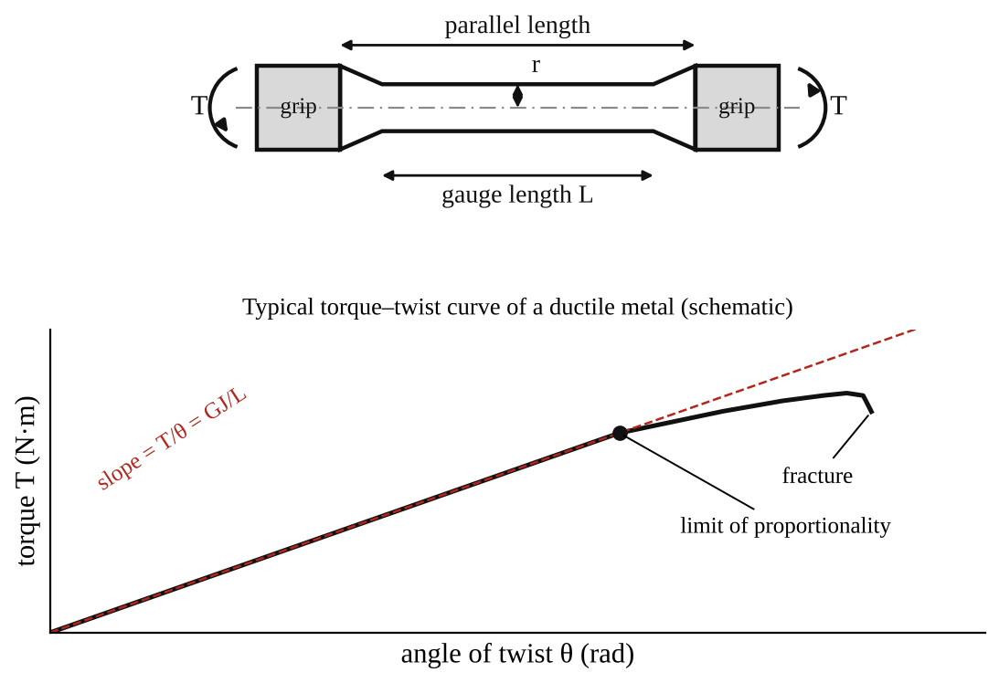
Fig. 1: Test piece (top) and typical torque–twist curve of a ductile metal (bottom).
Method in brief
- Measure the diameter of the parallel length of the test piece with the vernier calipers at several places, and the gauge length and overall length with the rule. Record them.
- Fit the test piece in the grips of the machine. Set the torque indicator and the angle scale to zero.
- Apply the torque slowly and steadily by turning the handle. At each step of angle (for example every 1° at the start) read the torque. Take more readings near the limit of proportionality.
- Continue to fracture. Note the torque and the angle at fracture.
- Remove the broken pieces, fit them together, and measure the final diameter, gauge length and overall length. Examine the fracture surface.

3. Results
Table 1: Dimensions of the test piece
Measurement | Initial | Final
Diameter (mm)
Gauge length (mm)
Overall length (mm)

Material: [ ]. J = πd⁴/32 = [ ] mm⁴.
Table 2: Torque and angle of twist
Angle of twist (°) | Angle θ (rad) | Torque T (N·m) | T/θ (N·m/rad)

Table 3: Mechanical properties
Property | Experimental | Theoretical / accepted value
Modulus of rigidity G (N/mm²) |  | steel about 80 000; aluminium about 26 000; brass about 38 000
Torque at limit of proportionality T_{p} (N·m)
Shear stress at limit of proportionality (N/mm²)
Torque at fracture (N·m) and angle at fracture (°)

The accepted values of G are typical figures. Use the one for your own material.

4. Analysis of Results
- Angle in radians: θ = degrees × π/180 = [ ] × 0.01745 = [ ] rad.
- J = πd⁴/32 = π × [ ]⁴ ÷ 32 = [ ] mm⁴ (check that the torque is in N·mm when J is in mm⁴, so multiply N·m by 1000).
- Slope of the straight part of the T–θ graph = ΔT/Δθ = [ ] N·mm/rad.
- Modulus of rigidity G = (slope) × L / J = [ ] × [ ] ÷ [ ] = [ ] N/mm².
- Shear stress at the limit of proportionality τ = T_{p} r / J = [ ] × [ ] ÷ [ ] = [ ] N/mm².
- Comparison of G with the accepted value: difference = [ ] %.
- Relationship between G, E and Poisson's ratio ν: G = E/[2(1 + ν)], so for steel (E ≈ 200 000 N/mm², ν ≈ 0.3) G ≈ 77 000 N/mm², a useful check on the value obtained.

5. Observations / Precautions Taken
Observations
- The torque rose in direct proportion to the angle of twist at first, giving a straight line through the origin.
- After the limit of proportionality the line curved over and the torque increased more slowly with each additional degree of twist (yielding).
- The specimen finally broke with a [clean / helical] fracture. The fracture surface was [flat and perpendicular to the axis (ductile) / at 45° (brittle)].
- The specimen was longer or shorter after the test by [ ] mm, and its diameter was [ ] mm.
Precautions
- The torque was applied slowly and steadily, with no sudden jerks.
- The test piece was gripped firmly and centrally so it did not slip or bend.
- The diameter was measured at several places (the radius is raised to the 4th power in J, so errors in d are very important).
- The torque and angle scales were zeroed before the test, and read at eye level.
- Everyone stood clear of the machine when the specimen fractured.

6. Graphs
Plot the following on graph paper from your own readings and attach them here:
- Torque T against angle of twist θ (radians), drawn from Table 2 on graph paper, with the straight-line slope drawn in
- Mark the limit of proportionality and the fracture point on the graph

7. Discussion
General characteristics of the torque–twist relationship. The graph has a straight elastic part, a curved part after the limit of proportionality, and ends at fracture. The straight part gives the stiffness of the shaft (GJ/L), and G is found from its slope. A larger area under the curve means the metal can absorb more energy in twisting. This is the same behaviour as the tensile test, but with shear instead of direct stress.
Comparing the results. I found G = [ ] N/mm², which differs by [ ] % from the accepted value of about [ ] N/mm². The shear stress at the limit of proportionality was [ ] N/mm², which is about [ ] % of the tensile yield stress (the shear yield stress is usually about 0.5 to 0.6 of the tensile yield stress).
Sources of error
- Reading torque and angle from scales by eye, with limited divisions.
- Slip of the specimen in the grips, and twist in the machine itself, which add to the measured angle (so G comes out too low).
- Error in measuring the diameter, which is magnified by d⁴.
- It is not easy to see exactly where the straight line ends (the limit of proportionality).
- The specimen is not perfectly circular or uniform, and the gauge length is not exactly the length between the grips.

8. Conclusion
The torsion test gave a modulus of rigidity of [ ] N/mm², a shear stress at the limit of proportionality of [ ] N/mm², and a fracture at a torque of [ ] N·m after a twist of [ ]°. The torque and angle of twist were proportional up to the limit of proportionality, then yielding followed until fracture. The results are used in the design of drive shafts, axles, springs, drill bits and screwdrivers, where twisting is the main loading.

Section B: Questions
1. What I learnt from the experiment. I learnt how a torsion test is carried out, how to get the modulus of rigidity from a torque–twist graph, and how a shaft behaves up to fracture.
3. Comment on the experimental procedure. Taking readings at regular steps of angle gives a good graph, and one test gives G, the shear stress at the limit of proportionality and the fracture behaviour. The accuracy depends on how well the scales are read and how well the specimen is gripped.
4. Most difficult aspect of the experiment. Reading the torque and the angle at the same time while turning the handle steadily, and deciding where the limit of proportionality is. It can be reduced by having two people (one turning, one reading), and by plotting the graph as the test goes on.
5. Another method that could be used. A torque sensor with an angle encoder and a data logger, or a vibrating (torsional pendulum) method to find G, or a tension test and the relation G = E/2(1 + ν).
6. Parameters measured / involved. Diameter d, gauge length L, torque T, angle of twist θ, polar second moment J, modulus of rigidity G and shear stress τ.
7. Measuring instrument used. The vernier calipers measure the diameter of the test piece. The torque and angle scales on the machine measure T and θ.
8. Practical relevance. Design of drive shafts, propeller shafts, axles, torsion bars, springs and drill bits.
9. Section of the course it belongs to. Strength of materials (torsion of circular shafts).
13. What interested me most. The straight-line relationship between torque and angle of twist, and how the specimen finally fractured.
2, 10, 11, 12, 14 and 15 (personal / references): to be filled in by you.

