APPLIED MECHANICS LABORATORY
LABORATORY REPORTS
AM 213: Slip and Creep Measurement in a Belt Drive
AM 225: The Conical Pendulum
AM 226(A): Simple Pendulum

Name: ______________________________
Matric No.: __________________________
Department: _________________________
Date: _______________________________
Contents
AM 213 Slip and Creep Measurement in a Belt Drive
AM 225 The Conical Pendulum
AM 226(A) Simple Pendulum
Notes before you submit
- Anything shown as [ ] is for your own readings or results from your own lab session. Nothing has been invented.
- Each report follows Section C of the manual: Theory, Apparatus, Results, Analysis of Results, Observations and Precautions, Graphs, Discussion and Conclusion. The Section B questions are answered after each report.
- Questions 2, 10, 11, 12, 14 and 15 are personal, so they are left for you to fill in.
- Graphs must be drawn from your own readings on graph paper (or in Excel) and attached where indicated.

AM 213: Slip and Creep Measurement in a Belt Drive

Objective
- To measure the coefficient of friction between the pulley material and different belt materials.
- To measure the power transmitted with varied belt tension and plot a graph of power output against (T₁ − T₂), that is, the tension characteristics.
- To measure the percentage slip at fixed belt tension by varying the load on the brake drum, and to plot (T₁ − T₂) against percentage slip (the slip characteristics), fixing the creep zone from the graph.
- To measure belt slip speed and observe the limiting value of the load at constant speed when the slip just starts.

1. Theory
Slip in a belt
The slip in a belt drive is mainly due to reduced frictional grip between the belt and the pulley, and it depends on the angle of contact. It is defined as the relative motion between the pulley and the belt. The difference between the linear speed of the pulley rim and the belt is the measure of slip. It is expressed as a percentage and it reduces the speed of the driven pulley and the efficiency of power transmission.
Creep in a belt drive
When the pulleys rotate clockwise, the lower side of the belt is the tight side (tension T₁) and the upper side is the slack side (tension T₂). When the belt passes from the tight side to the slack side its length contracts, and when it passes from the slack side to the tight side it stretches. So the belt alternately stretches and contracts as it goes round. This causes a small difference between the speed of the belt and the speed of the pulley rim, and the relative motion that results is called creep.
Creep is mainly due to changes in belt length. It increases with load and results in greater power loss, because creep makes the driven pulley slower. Usually creep must stay within a tolerable limit of about 1 % of the load at normal conditions. If the load is raised above the designed value, slip may occur on one or both pulleys. Both slip and creep reduce the performance of a belt drive and increase maintenance.
Equations
T₁ / T₂ = e^{μθ} so μ = (1/θ) ln(T₁/T₂) θ = 180° = π rad
% Slip = (S₁ − S₂)/S₁ × 100 Torque = (T₁ − T₂) r Power = 2πN₂ (T₁ − T₂) g r / 60 000 kW
T₁ and T₂ are the tight and slack side tensions, μ is the coefficient of friction between belt and pulley, θ is the angle of lap, S₁ is the speed of the driving pulley (rpm), S₂ is the speed of the driven pulley (rpm), r is the radius of the brake drum pulley, and g = 9.81 m/s² if the tensions are read in kg.

2. Apparatus
A variable speed PMDC motor drives two cast iron pulleys P₁ and P₂ of equal diameter, with flat rims. P₁ is the driving pulley, mounted directly on the motor shaft. P₂ is the driven pulley. An endless (or stitched) belt passes over both pulleys. The bearing block of the driven pulley can slide over the base to vary the initial belt tension. P₂ is balanced on a single bearing block and carries a brake drum, over which a brake belt is passed, with its ends attached to two spring balances that give the tight and slack tensions. Output power is therefore found from the difference of the spring balance readings. The speed of the motor is varied by a variable speed drive, and two digital indicators on the control panel show S₁ and S₂, so the slip can be calculated.
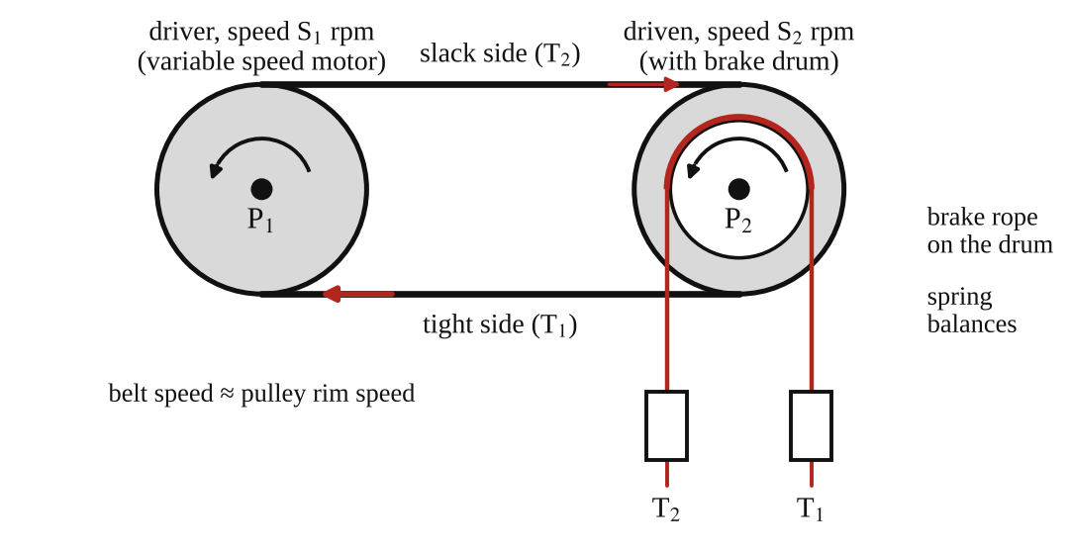
Fig. 1: Belt drive with a brake drum on the driven pulley (schematic).
General operating procedure
- Plug the apparatus into the power supply.
- Before starting, make sure the speed knob is at zero (turned anti-clockwise).
- Press the green start button at the bottom of the control panel.
- The display will glow and show "press START". Press the red push button to start the motor.
- Use the knob to increase or decrease the motor speed. Always do this slowly.
Experiment 1: coefficient of friction
- Adjust some initial tension on the belt and run the motor at a steady speed.
- Load the brake drum until the belt is just about to slip. Record S₁, S₂, T₁ and T₂.
- Repeat for five sets of readings, and for each belt material available. Calculate μ from μ = (1/π) ln(T₁/T₂).
Experiment 2: slip characteristic
- Adjust some initial tension and start the motor to a constant speed (say 600 rpm).
- Take the reading of S₁ and S₂ at zero load (the slip is almost zero).
- Increase the load on the brake drum slightly and take the T₁ − T₂, S₁ and S₂ readings. Repeat in steps, noting (T₁ − T₂) and (S₁ − S₂) each time.
Experiment 3: tension characteristic
- Repeat the procedure of Experiment 2 and adjust the initial tension.
- Start the motor, take readings of T₁, T₂, S₁ and S₂, and find the power output from (T₁ − T₂).
- Repeat for different initial tensions and compare the results.

3. Results
Table 1 (Experiment 1): coefficient of friction
S/No | S₁ (rpm) | S₂ (rpm) | T₁ (kg) | T₂ (kg) | Coefficient of friction μ
1
2
3
4
5

Table 2 (Experiment 2): slip characteristic at constant speed
S/No | S₁ (rpm) | S₂ (rpm) | T₁ (kg) | T₂ (kg) | T₁ − T₂ (kg) | (S₁ − S₂)/2 | Slip (%)
1
2
3
4
5
6

Table 3 (Experiment 3): tension characteristic and power
S/No | S₁ (rpm) | S₂ (rpm) | T₁ (kg) | T₂ (kg) | Torque (N·m) | (T₁ + T₂)/2 (kg) | Power (kW) | Slip (%)
1
2
3
4

The manual's column heading is printed as "(T₁ − T₂)/2". I have used the mean tension (T₁ + T₂)/2, which is the usual meaning, so please check this with your lecturer. The radius of the brake drum pulley is r = 0.115 m (the manual gives "0.230 m" for the pulley diameter).

4. Analysis of Results
- Coefficient of friction: μ = (1/π) ln(T₁/T₂) = 0.318 × ln( [ ] ÷ [ ] ) = [ ].
- Percentage slip = (S₁ − S₂)/S₁ × 100 = ( [ ] − [ ] ) ÷ [ ] × 100 = [ ] %.
- Torque = (T₁ − T₂) × g × r = [ ] × 9.81 × 0.115 = [ ] N·m.
- Power = 2πN(T₁ − T₂) g r / 60 000 = 2π × [ ] × [ ] × 9.81 × 0.115 ÷ 60 000 = [ ] kW, with N = S₂ (the speed of the driven pulley) in rpm. Equivalent: power (W) = torque × ω with ω = 2πS₂/60.
- Mean (average) of the values of μ for each belt material: [ ].
- Creep zone: the part of the (T₁ − T₂) against % slip graph where the line is nearly straight, and where slip rises in proportion to load. Slip occurs where the curve turns sharply upward. The creep zone is from 0 to about [ ] % slip.
Sample calculation for μ. If T₁ = 3.0 kg and T₂ = 1.0 kg, then μ = (1/π) ln 3 = 0.35. (This is only an example of the method, not a measured result.)

5. Observations / Precautions Taken
Observations
- At zero load the slip was almost zero. The driven pulley speed S₂ fell slowly as the load on the brake drum increased.
- At small loads the slip increased in proportion to the load (creep). At a higher load, the slip increased quickly and the belt slipped on the pulley.
- The tight side tension T₁ increased and the slack side tension T₂ decreased as load was added.
- Power output rose with (T₁ − T₂) up to a maximum, and then fell when the belt slipped because the speed fell.
- Higher initial tension gave a greater power capacity before slip began.
Precautions
- The speed knob was at zero before starting and the speed was changed slowly.
- The load on the brake drum was added slowly and in small steps.
- The spring balances were zeroed and read at the same time at steady speed.
- The belt was clean, free of oil and dust, and the pulleys were aligned.
- Hands were kept away from the belt and pulleys while the motor was running.

6. Graphs
Plot the following on graph paper from your own readings and attach them here:
- (T₁ − T₂) against percentage slip (the slip characteristic), and mark the creep zone
- Power output against (T₁ − T₂) (the tension characteristic) for each initial tension

7. Discussion
Effectiveness of the procedure. The procedure measures slip, tensions and power directly with simple instruments, so it clearly shows the difference between creep (small, in proportion to load) and slip (large, when the limit of friction is reached). It also shows that the power capacity depends on the initial tension. The weak points are that the spring balance readings fluctuate and that the slip points are hard to tell exactly.
Belt drives compared with other transmissions. A belt drive is quiet, cheap, needs no lubrication, can connect shafts that are far apart, absorbs shock and acts as a safety device because it slips when overloaded. But because of slip and creep the speed ratio is not exact (typically 1 to 3 % loss), it can only transmit moderate power, and it needs tension maintained, so the bearing loads are high. A gear drive or a chain drive gives an exact speed ratio and a higher power capacity in a smaller space, but needs lubrication, accurate alignment and is noisier and more expensive. For the same job, a V-belt or toothed (timing) belt reduces slip further.
Sources of error
- Fluctuation of the spring balance readings and their limited scale divisions.
- Variation of speed readings on the digital display (a few rpm).
- Belt stretch and change of the initial tension during the test, and heating of the belt.
- The angle of lap is taken as exactly 180° (equal pulleys), so small shifts in the pulley position change μ slightly.
- Dust or oil on the belt and pulley surface.

8. Conclusion
The coefficient of friction between the pulley and the belt was found to be about [ ]. The slip characteristic showed a creep zone up to about [ ] % slip, followed by a rapid increase in slip when the belt began to slip. The power transmitted increased with (T₁ − T₂) up to a maximum of [ ] kW. Belt drives are suitable for moderate power transmission over long distances, but slip and creep make the speed ratio inexact.

Section B: Questions
1. What I learnt from the experiment. I learnt the difference between slip and creep in a belt drive, how to find the coefficient of friction from T₁/T₂ = e^{μθ}, and how the power and slip change with load.
3. Comment on the experimental procedure. Digital speed indicators and spring balances give quick readings, and the three experiments use the same set-up, so a lot can be done in one session. The readings of tension fluctuate a bit.
4. Most difficult aspect of the experiment. Reading the two spring balances and the two speeds at the same moment while the load changes. It can be reduced by waiting for a steady condition, by having two people read, and by repeating the readings.
5. Another method that could be used. A torque transducer and a dynamometer (such as a Prony brake) to measure power, or stroboscope or tachometer to measure the speed.
6. Parameters measured / involved. Speeds S₁ and S₂, tensions T₁ and T₂, pulley radius, angle of lap, torque, power and percentage slip.
7. Measuring instrument used. The spring balances measure the tensions, and the digital indicators measure the speeds S₁ and S₂ in rpm.
8. Practical relevance. Belt drives in cars (fan and alternator belts), machine tools, conveyors, washing machines and generators.
9. Section of the course it belongs to. Machines and mechanisms (belt drives and power transmission).
13. What interested me most. The driven pulley slowed down very slightly as the load increased even before the belt slipped, which is creep.
2, 10, 11, 12, 14 and 15 (personal / references): to be filled in by you.

AM 225: The Conical Pendulum

Objective
- To investigate the variation in height of a conical pendulum with change of speed.
- To determine the acceleration due to gravity, g.

1. Theory
A conical pendulum is a mass (the bob) that is made to move in a horizontal circle at the end of a rod or string of length L, which then traces out a cone. Let M = the total mass, θ = the inclination of the pendulum to the vertical axis, ω = the angular velocity of the bob, r = the radius of the circle and h = the vertical height of the cone, so that h = L cos θ and r = L sin θ.
The forces on the bob are its weight Mg downwards and the tension T along the rod. The bob moves in a circle, so there is a resultant force towards the centre. The equations of motion are:
T sin θ = M ω² r (along the radius, towards the centre)
T cos θ = M g (along the vertical, no vertical acceleration)
Dividing the first by the second to eliminate T and the mass:
tan θ = ω² r / g and with r = L sin θ: ω² = g / (L cos θ) = g / h
So ω² is proportional to 1/h. A plot of ω² (vertical) against 1/h (horizontal) is a straight line through the origin whose slope is g. The height h falls as the speed rises, because the bob swings out further. The angular velocity is found from the speed N in rev/min: ω = 2πN/60.

2. Apparatus
Tec-equipment conical pendulum apparatus with a variable speed motor, a drive unit and a tachometer (speed indicator). The pendulum bob is supported on a thin steel rod and runs on a semicircular guide bar with negligible friction, and has an effective length L (read from the manual as about 230 mm; the print is unclear, so check on the rig). A protractor and pointer are fitted for measuring the angle θ: the angle is right when the conical pendulum rod coincides with the centre-line of the pointer.
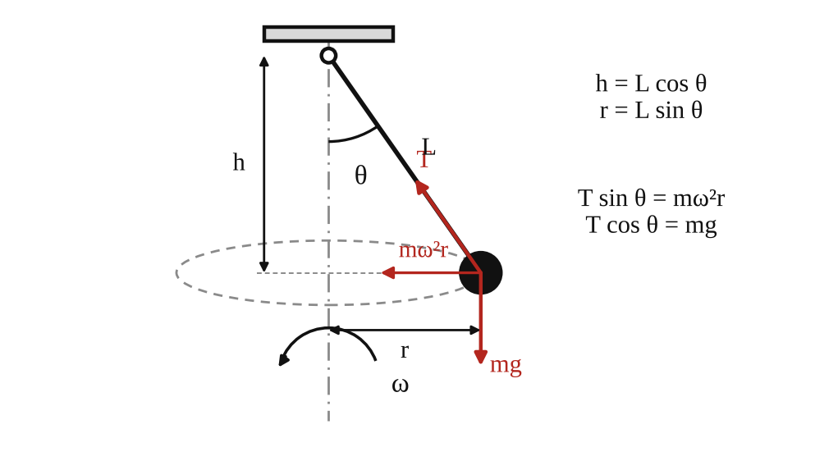
Fig. 1: Conical pendulum (left: the forces on the bob; right: the apparatus).
Method in brief
- Set the pointer to a required angle θ (start at a small angle, for example 10° or 15°).
- Increase the speed ω slowly until the pendulum rod lines up with the pointer, and note the speed from the tachometer.
- Repeat with the angle increased in steps of 5°.
- Calculate h = L cos θ and ω = 2πN/60 for each angle.

3. Results
Effective length L = [ ] mm.
Table 1: Conical pendulum results
θ (°) | h = L cos θ (m) | 1/h (m⁻¹) | N (rpm) | ω = 2πN/60 (rad/s) | ω² (rad²/s²) | ω² h (= g) (m/s²)
10
15
20
25
30
35
40

4. Analysis of Results
- h = L cos θ = [ ] × cos [ ]° = [ ] m, and 1/h = [ ] m⁻¹.
- ω = 2πN/60 = 2π × [ ] ÷ 60 = [ ] rad/s, and ω² = [ ] rad²/s².
- From the graph of ω² against 1/h: slope = Δ(ω²)/Δ(1/h) = [ ] ÷ [ ] = [ ] m/s², and this slope is g.
- Also g = ω² h for each reading; mean g = [ ] m/s².
- Percentage difference from the standard value 9.81 m/s²: ( [ ] − 9.81 ) ÷ 9.81 × 100 = [ ] %.

5. Observations / Precautions Taken
Observations
- The bob rose and moved outwards as the speed was increased, and the height h decreased.
- A very small speed was not enough to lift the bob from the vertical position. The speed had to pass a minimum value (ω² = g/L when θ = 0) before the cone could form.
- The speed needed rose quickly as the angle got larger.
- The points of ω² against 1/h lay close to a straight line.
Precautions
- The speed was increased very slowly and steadily so that the rod stayed in line with the pointer.
- The pointer was read at eye level.
- The speed was read from the tachometer only when the speed was steady.
- Guards were in place and no one reached into the rotating parts.

6. Graphs
Plot the following on graph paper from your own readings and attach them here:
- An approximate graph of ω² against 1/h, with the best straight line drawn. The slope gives g.

7. Discussion
Do the results show any appreciable deviation from theory? Explain. The points [lie close to a straight line through the origin / show some scatter] and the value of g from the slope was [ ] m/s², which differs from 9.81 m/s² by [ ] %. Where there is a deviation, it comes from the factors below.
- Friction between the bob and the guide bar, and air resistance, which are not in the theory.
- The rod and the bob are not a point mass on a weightless string (the rod has mass and the bob has size), so L is not the exact length to the centre of mass.
- The angle was set by eye with a pointer, so θ may be out by 1° or more, which has a big effect on h at small angles.
- The speed fluctuates a bit while the pendulum is lined up with the pointer.
Local value of g. The value of g from the slope of the graph is [ ] m/s².

8. Conclusion
The height of the conical pendulum decreased as the speed increased, and the graph of ω² against 1/h was a straight line through the origin, in agreement with ω² = g/h. The local value of g obtained from the slope was [ ] m/s², about [ ] % different from 9.81 m/s². The principle is used in centrifugal governors, fairground swing rides and the analysis of vehicles on banked bends.

Section B: Questions
1. What I learnt from the experiment. I learnt how a mass moving in a horizontal circle forms a cone and how the height depends on speed, and how to find g from the slope of an ω² against 1/h graph.
3. Comment on the experimental procedure. The angle is set first and the speed adjusted until the rod lines up with the pointer, so the readings are quick. Using several angles and a graph gives a better answer for g than one reading.
4. Most difficult aspect of the experiment. Judging the exact moment when the rod lines up with the pointer while the speed is changing. It can be reduced by increasing the speed very slowly and repeating each reading.
5. Another method that could be used. A simple pendulum or a free fall (falling body) experiment, or a compound pendulum, can also give g.
6. Parameters measured / involved. Pendulum length L, angle θ, height h = L cos θ, speed N (rpm) and angular velocity ω.
7. Measuring instrument used. The tachometer measures the speed in rev/min, and the protractor with pointer measures the angle θ.
8. Practical relevance. Centrifugal (Watt) governors, fairground swing rides, centrifuges, and the design of banked curves on roads and railways.
9. Section of the course it belongs to. Dynamics (circular motion and centripetal force).
13. What interested me most. The bob rose higher the faster it turned, in the same way as a swing ride.
2, 10, 11, 12, 14 and 15 (personal / references): to be filled in by you.

AM 226(A): Simple Pendulum

Objective
- To determine the acceleration due to gravity, g.

1. Theory
A simple pendulum is a small heavy bob (here a steel ball) hung from a light thread of length L. If the ball is displaced through a small angle θ and released, it swings to and fro. The restoring force is the component of the weight along the arc, mg sin θ. For small angles sin θ ≈ θ (in radians), so the motion is approximately simple harmonic motion (SHM), where the acceleration is proportional to the displacement and directed towards the middle:
ω² x = g/L × x so ω² = g / L
where ω is the angular velocity of the motion. The period of oscillation is T = 2π/ω, so
T = 2π √(L / g) T² = (4π² / g) L g = 4π² L / T²
Therefore a graph of T² (vertical) against L (horizontal) is a straight line through the origin, and its slope is 4π²/g, so g = 4π² / slope. The period does not depend on the mass of the bob or (for small swings) on the amplitude.

2. Apparatus
A spherical steel ball (bob), a length of thread, a chuck for gripping the thread at the top, a stopwatch and a meter rule.
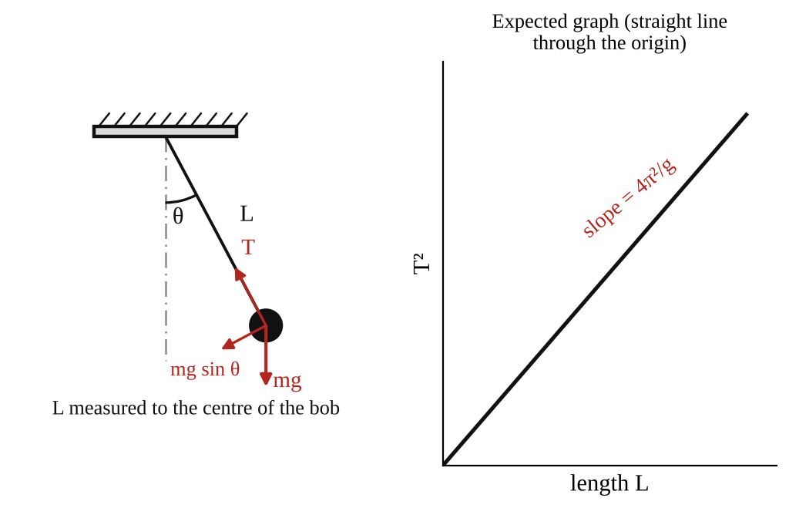
Fig. 1: Simple pendulum (L is measured from the point of support to the centre of the ball).
Method in brief
- Fix the thread in the chuck and hang the ball on it. Measure the length L from the point of support to the centre of the ball (the thread length plus the radius of the ball).
- Displace the ball through a small angle (less than about 10°) and release it. Record the time for 50 oscillations. Divide by 50 for the period T.
- Vary the length and repeat the timing. Do this about eight times so that there are enough points to plot the graph.

3. Results
Table 1: Simple pendulum results
Length L (m) | Time for 50 oscillations (s) | Period T (s) | T² (s²) | g = 4π²L/T² (m/s²)

4. Analysis of Results
- T = (time for 50 oscillations) / 50 = [ ] ÷ 50 = [ ] s, and T² = [ ] s².
- Slope of the graph of T² against L = ΔT²/ΔL = [ ] ÷ [ ] = [ ] s²/m.
- g = 4π² / slope = 39.48 ÷ [ ] = [ ] m/s².
- Mean of the individual values of g = 4π²L/T² = [ ] m/s².
- Percentage difference from the accepted value 9.81 m/s²: ( [ ] − 9.81 ) ÷ 9.81 × 100 = [ ] %.

5. Observations / Precautions Taken
Observations
- The period increased as the length increased, and the pendulum took longer for each swing.
- The swings slowly became smaller because of air resistance, but the period stayed about the same (the pendulum is isochronous for small amplitudes).
- The points on the T² against L graph lay close to a straight line through the origin.
Precautions
- The ball was displaced through a small angle only (under 10°), so that sin θ ≈ θ.
- It was released without pushing, and swung in one plane, not in an ellipse.
- The time was taken for 50 oscillations, to reduce the effect of reaction time, and was repeated.
- The length was measured from the point of support (the clamp) to the centre of the ball.
- The thread was held firmly in the chuck so it did not slip or change length.
- Timing started when the ball passed the middle point (the lowest point), where its speed is greatest and it is easier to see.

6. Graphs
Plot the following on graph paper from your own readings and attach them here:
- T² (square of the period) against L (length of the pendulum), with the best straight line drawn

7. Discussion
Sources of error
- Reaction time in starting and stopping the stopwatch (reduced by timing 50 oscillations).
- Miscounting the number of oscillations.
- Error in measuring L, particularly to the centre of the ball and the exact point of support.
- Air resistance, and the mass of the thread, which is not zero.
- Amplitude that is too big, so that the swing is not really SHM (the period increases slightly with amplitude).

8. Conclusion
From the slope of the T² against L graph, the acceleration due to gravity was found to be [ ] m/s². 1. Is your value the same as the theoretical value? Why? The accepted value is 9.81 m/s² (the exact value depends on the latitude and height; in Nigeria it is close to 9.78 m/s²). My value differs by [ ] %. The difference is mainly due to the errors listed above. 2. Limitations of this method. The method depends on the small-angle approximation, on accurate timing by hand, and on an exact length measurement. Air resistance and the thread mass affect the result, so it can give g only to about 1 or 2 % even when carefully done. More accurate values of g come from a reversible (Kater's) pendulum or a free-fall timer.

Section B: Questions
1. What I learnt from the experiment. I learnt how a simple pendulum behaves as SHM, why T² is proportional to L, and how to get g from the slope of the graph.
3. Comment on the experimental procedure. Timing 50 oscillations reduces the error from reaction time, and plotting a graph of eight points reduces the effect of any single bad reading. The apparatus is cheap and simple.
4. Most difficult aspect of the experiment. Counting a large number of oscillations while watching the stopwatch and keeping the swing in one plane. It can be reduced by using a fiducial mark at the lowest point, and by repeating each timing.
5. Another method that could be used. A compound pendulum (Kater's reversible pendulum), a free fall apparatus with an electronic timer, or a conical pendulum.
6. Parameters measured / involved. Length L, time for 50 oscillations, period T, T², and g.
7. Measuring instrument used. The stopwatch measures the time, and the meter rule measures the length of the pendulum.
8. Practical relevance. Pendulum clocks, metronomes, measuring g for geological surveys and the study of oscillations in structures and swings.
9. Section of the course it belongs to. Dynamics (simple harmonic motion).
13. What interested me most. The period did not change much as the swing died down, only the length changed it.
2, 10, 11, 12, 14 and 15 (personal / references): to be filled in by you.

