APPLIED MECHANICS LABORATORY
LABORATORY REPORTS
AM 226(B): Compound Pendulum: Conditions for Minimum Period
AM 229: Flywheel and Falling Weight
AM 231: Automat Spur Gear Models (A1 to A5)

Name: ______________________________
Matric No.: __________________________
Department: _________________________
Date: _______________________________
Contents
AM 226(B) Compound Pendulum: Conditions for Minimum Period
AM 229 Flywheel and Falling Weight
AM 231 Automat Spur Gear Models (A1 to A5)
Notes before you submit
- Anything shown as [ ] is for your own readings or results from your own lab session. Nothing has been invented.
- Each report follows Section C of the manual: Theory, Apparatus, Results, Analysis of Results, Observations and Precautions, Graphs, Discussion and Conclusion. The Section B questions are answered after each report.
- Questions 2, 10, 11, 12, 14 and 15 are personal, so they are left for you to fill in.
- Graphs must be drawn from your own readings on graph paper (or in Excel) and attached where indicated.

AM 226(B): Compound Pendulum: Conditions for Minimum Period

Objective
- To suspend a given rigid body from a number of points and to study the variation of the period with the distance of the suspension point from the centre of mass.

1. Theory
A compound (physical) pendulum is any rigid body that swings about a horizontal axis that does not pass through its centre of mass G. Let M = the mass of the pendulum, h = the distance from the point of suspension (knife-edge) to G, k = the radius of gyration of the body about G, and θ = the angle of swing. For a small swing the restoring moment about the knife-edge is Mgh θ, and the moment of inertia about the knife-edge is M(h² + k²) (parallel axis theorem), so
M g h θ = M (h² + k²) d²θ/dt²
This is simple harmonic motion with
ω² = 4π²/T² = g h / (h² + k²) = g / L_{e} where L_{e} = (h² + k²)/h = h + k²/h
L_{e} is the length of the equivalent simple pendulum: a simple pendulum of length L_{e} has the same period. Then the period is T = 2π √(L_{e}/g), so from the measured period
L_{e} = g T² / 4π²
Condition for minimum period. The period is smallest (the frequency is greatest) when L_{e} is smallest:
dL_{e}/dh = 1 − k²/h² = 0 so h = ± k
So the minimum period occurs when the distance of the knife-edge from G equals the radius of gyration, and the minimum value of L_{e} is 2k. The ± sign corresponds to the fact that the knife-edge can be the same distance on either side of G and give the same period.
Straight-line form. Since L_{e} h = h² + k², a graph of (L_{e} h) against h² is a straight line with slope 1 and intercept k². This lets the radius of gyration be found easily from the intercept.

2. Apparatus
Stopwatch, knife-edge, rigid bar with a row of equally spaced holes (the bar used in Kater's pendulum experiment; the wall-mounted Kater's pendulum bar is stainless steel and the one on the universal vibrations rig is brass), a rule and a balance.
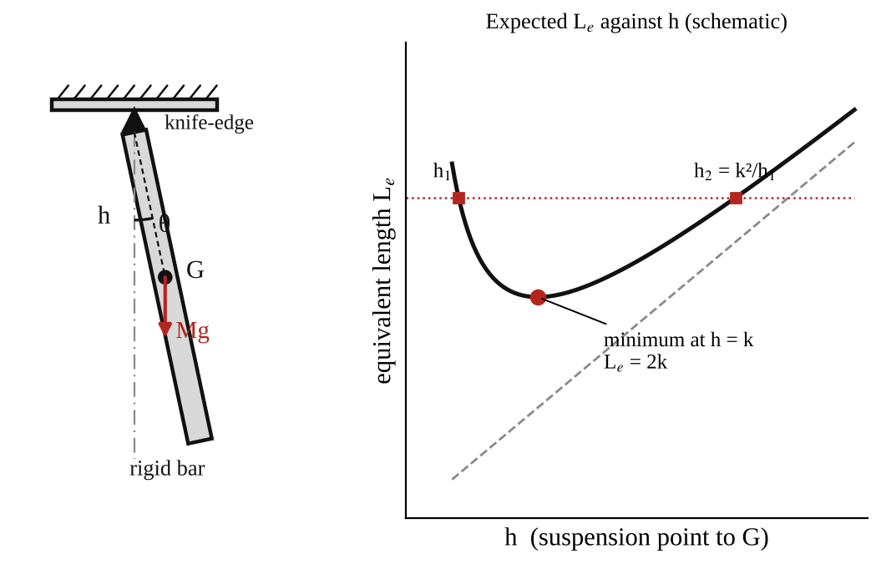
Fig. 1: Compound pendulum, bar suspended on a knife-edge at distance h from the centre of mass G.
Observations required
- Dimensions of the bar.
- Mass of the bar.
- Position of its centre of mass.
- List of periods and corresponding distances of the point of suspension from the centre of mass.
Method in brief
- Find the centre of mass G by balancing the bar on the knife-edge. Measure the dimensions and the mass.
- Suspend the bar from a hole on the knife-edge at a measured distance h from G. Give it a small swing (under 10°).
- Measure the time for 5, 10 or 20 swings with the stopwatch and calculate the period T. Repeat the observation and change observers.
- Repeat for all the holes along the bar, on both sides of G (although the bar is supposed to be symmetrical, check this; it improves accuracy). Vary the period for about eight different values of h.

3. Results
Mass of bar M = [ ] kg. Length = [ ] mm. Width = [ ] mm. Thickness = [ ] mm. Position of G = [ ] mm from one end.
Table 1: Compound pendulum results
h (m) | Time for n swings (s) | Period T (s) | L_{e} = gT²/4π² (m) | L_{e}h (m²) | h² (m²) | k² = L_{e}h − h² (m²) | k (m)

Table 2: Calculated radius of gyration from the dimensions
Quantity | From experiment | From dimensions and density
Mass M (kg)
Radius of gyration k (m)
Minimum period T_{min} (s)

4. Analysis of Results
- T = (time for n swings)/n = [ ] ÷ [ ] = [ ] s.
- L_{e} = gT²/4π² = 9.81 × [ ]² ÷ 39.48 = [ ] m.
- k² = L_{e}h − h² = [ ] × [ ] − [ ]² = [ ] m², k = [ ] m for each h, and the average k = [ ] m.
- From the dimensions: for a uniform rectangular bar of length l and width b, k² = (l² + b²)/12 about the centre of mass (for a long thin bar, k ≈ l/√12 = 0.289 l). Mass = density × volume = [ ] kg (steel ≈ 7800 kg/m³, brass ≈ 8500 kg/m³). Any holes in the bar reduce the mass and change k, so the value from the dimensions is only approximate.
- Predicted curve: L_{e} = h + k²/h, for the average k, calculated at the same values of h and plotted with the experimental points.
- Straight-line check: the graph of L_{e}h against h² should have slope 1 and intercept k². Slope found = [ ], intercept = [ ] m², so k = [ ] m.
- Minimum period: T_{min} = 2π √(2k/g) = [ ] s, at h = k = [ ] m.

5. Observations / Precautions Taken
Observations
- The period was large when the knife-edge was very near G (h small), fell to a minimum at some distance h, and then increased again as the suspension point moved towards the end of the bar.
- Holes the same distance on opposite sides of G gave nearly the same period, as expected (the bar is almost symmetrical).
- The experimental points lay close to the predicted L_{e} = h + k²/h curve.
Precautions
- The bar was swung through small angles only (under 10°), so sin θ ≈ θ.
- The swing was kept in one plane and the knife-edge was set firmly, level and without slipping.
- The period was found from 5, 10 or 20 swings, not one, to reduce timing error, and the observations were repeated with different observers.
- The distance h was measured from the centre of mass to the knife-edge accurately.

6. Graphs
Plot the following on graph paper from your own readings and attach them here:
- Predicted and experimental L_{e} against h on the same axes
- The straight-line form: L_{e}h against h² (slope 1, intercept k²), and compare the experimental and theoretical plots

7. Discussion
Conclusions and comments. How accurately was k determined? The value of k from the experiment was [ ] m and from the dimensions [ ] m, a difference of [ ] %. The experimental and calculated results are expected to agree within a few per cent if the timings are good. The theory is verified to the extent that the experimental L_{e} against h points follow the curve L_{e} = h + k²/h and the straight-line plot has a slope close to 1.
Sources of error
- Timing errors from reaction time, and miscounting swings.
- Error in finding the position of the centre of mass and in measuring h.
- Friction at the knife-edge and air resistance, which damp the swing.
- The holes in the bar and any non-uniformity, which the calculation from the dimensions ignores.
- Large swing angles, which lengthen the period.

8. Conclusion
The period of the compound pendulum was measured for different suspension points. L_{e} was smallest when h was about equal to the radius of gyration k, which agrees with the theory (minimum period at h = k). The radius of gyration was found to be [ ] m, which is within [ ] % of the value calculated from the dimensions. The compound pendulum is the basis of Kater's reversible pendulum, which gives accurate values of g, and the method is used to find the moment of inertia of connecting rods and other irregular bodies.

Section B: Questions
1. What I learnt from the experiment. I learnt how the period of a rigid body changes with the point of suspension, why there is a minimum period at h = k, and how to find the radius of gyration from the results.
3. Comment on the experimental procedure. Many holes along the bar give many readings from one set-up, and timing several swings reduces the error. The straight-line plot of L_{e}h against h² gives k directly.
4. Most difficult aspect of the experiment. Timing swings accurately and finding the exact centre of mass. It can be reduced by timing 20 swings, repeating with different observers and balancing the bar carefully on the knife-edge.
5. Another method that could be used. A torsion pendulum, or the trifilar suspension, can be used to find the moment of inertia, and Kater's reversible pendulum to find g.
6. Parameters measured / involved. Distance h, period T, length of the equivalent simple pendulum L_{e}, radius of gyration k, mass M and dimensions of the bar.
7. Measuring instrument used. The stopwatch measures the time of the swings, and the rule measures h and the dimensions of the bar. The balance measures the mass.
8. Practical relevance. Kater's pendulum for finding g, finding the moment of inertia of connecting rods and engine parts, and the design of clock pendulums and swinging machine parts.
9. Section of the course it belongs to. Dynamics (rigid body motion, moment of inertia and SHM).
13. What interested me most. The period was smallest at a certain distance from the centre of mass and larger on either side of it.
2, 10, 11, 12, 14 and 15 (personal / references): to be filled in by you.

AM 229: Flywheel and Falling Weight

Objective
- To determine the moment of inertia of a flywheel and to use it to verify Newton's laws as applied in this case.

1. Theory
A flywheel and axle of mass M and moment of inertia I = Mk² (k = radius of gyration) is turned by a weight mg hung on a cord wound round the axle of radius r. The falling weight descends a height h in a time t.
(a) Neglecting friction
For the falling mass (Newton's second law): m a = m g − T, where T is the tension in the cord. For the flywheel (torque = moment of inertia × angular acceleration): Mk² α = T r. The cord does not slip, so a = α r. Eliminating T:
Mk² α = (mg − ma) r a = α r
Mk² = m r² ( g/a − 1 ) and a = m g r² / (Mk² + m r²)
If the time t for the weight to descend the known height h is measured, the linear acceleration is found from a = 2h/t², so Mk² = mr² (gt²/2h − 1).
(b) With friction in the bearings
Let there be an opposing frictional couple L_{f}. Then m a = mg − T and Mk² α = T r − L_{f}, which gives
Mk² a / r² = (mg − ma) − L_{f}/r so a = (mg − L_{f}/r) / (m + Mk²/r²)
If L_{f} is known we can proceed as before. If L_{f} is not known, we can try two or three values of m, and a graph of m(g − a) against a gives a straight line with slope Mk²/r² and intercept L_{f}/r. The intercept is therefore the friction force at the axle radius (the weight needed just to overcome friction).
(c) The falling weight method (energy method)
Let m = the mass, H = h the distance it falls, v = its speed on reaching the floor, ω = v/r the angular velocity of the flywheel when m is detached, N = the number of revolutions made after m is detached, and n = the number of revolutions made while m falls, n = h/2πr. When the mass falls it loses potential energy mgh and gains kinetic energy ½mv², plus the flywheel's kinetic energy ½Iω², plus work done against friction 2πn L_{f}:
mgh = ½mv² + ½Iω² + 2πn L_{f}
After m is detached the flywheel comes to rest, so the work done against friction equals its kinetic energy: 2πN L_{f} = ½Iω². Eliminating L_{f}:
mgh = ½mv² + ½Iω² (N + n)/N
The motion of m is at constant acceleration, so v = 2h/t, and substituting for ω = v/r gives
I = m r² [ g t²/(2h) − 1 ] × [ N/(N + n) ]

2. Apparatus
A flywheel on a horizontal axle with bearings, a cord wound round the axle (radius r) with a hanger for the falling weights, slotted masses, a stopwatch, a rule or tape to measure h, vernier calipers for the axle diameter, a vibrating cantilever with paper (for the trace) and a balance. The length of the string is adjusted so that, when the weight reaches the ground, the string detaches itself from the axle and the flywheel is then allowed to come to rest under the friction in the bearings.
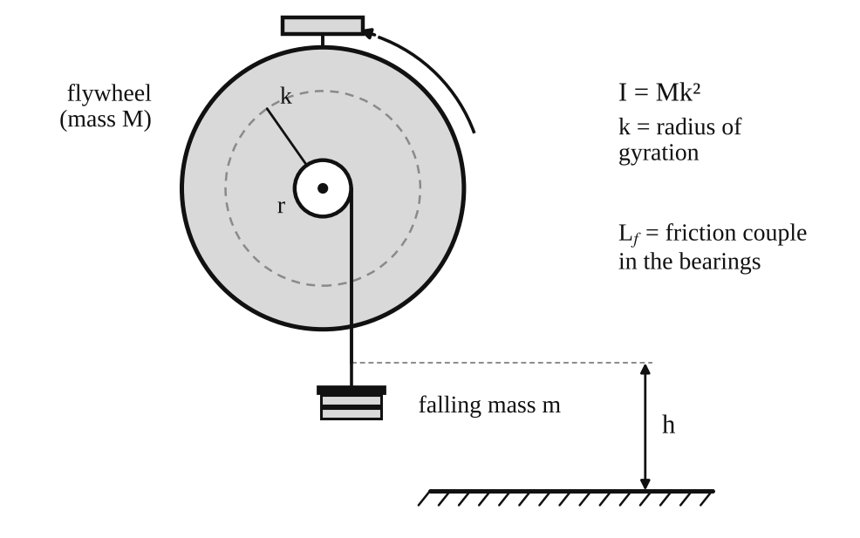
Fig. 1: Flywheel and axle with the falling weight m (h = height of fall, r = axle radius).
Observations required
- Magnitude of the falling weight = mg.
- Height of descent = h.
- Mass of the flywheel and axle = M.
- Moment of inertia of the flywheel and axle I = Mk², where k = the radius of gyration.
- Time of descent = t.
- Radius of the axle = r.
Method in brief
- Before beginning, spin the flywheel by hand to warm up the bearings; otherwise the frictional couple will not stay constant during the experiment and results will be inconsistent.
- Choose several values for m (at least 50 g upwards) that give a convenient time of fall.
- For each m, release the weight and measure t. After it detaches, count the number of revolutions N until the flywheel stops. Repeat several times for each m.
- The value of n is found more accurately from h/2πr than by counting.
- Obtain a value of I for each m, find the average if it is not constant, and compare with the value calculated from the mass and dimensions of the flywheel, neglecting the axle. Estimate the accuracy of the results.

3. Results
h = [ ] m, r = [ ] m, M = [ ] kg, g = 9.81 m/s².
Table 1: Falling weight results
m (kg) | mg (N) | t (s) | a = 2h/t² (m/s²) | Mk² from (a) (kg m²) | N (rev) | n = h/2πr | I from (c) (kg m²) | k² = I/M (m²)

Table 2: Comparison with the value from the geometry
Quantity | Experiment | Calculated from dimensions | Difference (%)
Moment of inertia I (kg m²)
Radius of gyration k (m)

4. Analysis of Results
- Acceleration of the weight: a = 2h/t² = 2 × [ ] ÷ [ ]² = [ ] m/s².
- Neglecting friction: Mk² = m r² (g/a − 1) = [ ] × [ ]² × ( 9.81 ÷ [ ] − 1 ) = [ ] kg m².
- With friction (falling weight method): I = m r² [gt²/2h − 1][N/(N + n)] = [ ] kg m², with n = h/(2πr) = [ ] and N counted from the test.
- The radius of gyration k² = I/M = [ ] ÷ [ ] = [ ] m², k = [ ] m.
- Comparison with the geometry: for a solid disc k² = R²/2, and for a rim-type flywheel k² is close to R². Calculated I = [ ] kg m²; difference = [ ] %.
- Newton's laws check: the graph of m(g − a) against a is a straight line with slope I/r² = [ ] and intercept L_{f}/r = [ ] N.

5. Observations / Precautions Taken
Observations
- The weight accelerated downwards at a roughly constant rate, and the flywheel went on turning for a number of revolutions after the weight was detached before it stopped.
- A larger falling mass gave a shorter time of fall.
- The time of fall was repeatable for each mass to within about [ ] s.
- The value of Mk² calculated ignoring friction was larger / smaller than that with friction allowed for.
Precautions (to give good accuracy)
- The flywheel was spun by hand to warm up the bearings before starting, so that the frictional couple stayed constant.
- The cord was wound neatly in a single layer and its length adjusted so it detached from the axle just as the weight reached the floor.
- The stopwatch was started when the weight was released and stopped when it hit the floor; measurements were repeated and averaged.
- The number of revolutions N was counted carefully with a marker on the flywheel.
- The radius r included half of the cord thickness. The falling weight was not allowed to swing.

6. Graphs
Plot the following on graph paper from your own readings and attach them here:
- m(g − a) against a (should be a straight line; slope I/r², intercept L_{f}/r)
- a (or t) against m, to show how the acceleration depends on the falling mass

7. Discussion
Notes on procedure. (1) The constancy of a for various loads can be investigated by timing the descent over different heights; if a is constant, the motion is uniformly accelerated, as Newton's second law predicts. (2) The ratio L_{f}/Mk² can be found by spinning the flywheel and counting the rotations in given times (the speed falls at a constant rate for constant friction). It is limited by the accuracy with which the counting and the times can be done. (3) L_{f} can also be found with a short cord, so that the weight rises again after the descent (the falling weight method), which is more accurate because it uses the same weights and bearing conditions. (4) Using different values of m and M, k² is found for each, and the results are compared with and without allowance for L_{f}. (5) The vibrating cantilever can generate a trace on paper attached to the flywheel rim; knowing the period of vibration, the angular acceleration is found directly.
Sources of error
- Friction in the bearings is not exactly constant (it changes with temperature and speed).
- Reaction time in timing the descent, particularly for short times.
- Cord thickness, slipping or bunching of the cord on the axle, and its mass.
- Estimating the moment of inertia from the geometry ignores holes, keyways and the axle.
- Counting the revolutions N while the flywheel is slowing down.

8. Conclusion
The moment of inertia of the flywheel was found to be [ ] kg m² (k = [ ] m). The values are within about [ ] % of the value calculated from the geometry. Allowing for the bearing friction (the falling weight method) gave a more accurate value than neglecting friction. Newton's laws are verified to the extent that the linear acceleration of the falling mass and the angular acceleration of the flywheel were consistent with the torque equation Mk²α = Tr − L_{f}. The method is recommended for finding moments of inertia of flywheels and rotors, but it needs a steady bearing friction and accurate timing. An alternative for irregular bodies is the torsion pendulum or the trifilar suspension.

Section B: Questions
1. What I learnt from the experiment. I learnt how to find the moment of inertia of a flywheel by timing a falling weight, how bearing friction affects the result, and how to allow for it with the falling weight method.
3. Comment on the experimental procedure. Using several masses and several repeats averages out timing errors, and the falling weight method allows for friction. The method only needs a stopwatch, rule and masses.
4. Most difficult aspect of the experiment. Counting the revolutions N while the flywheel slows down and timing the fall accurately. It can be reduced by marking the flywheel, repeating each reading, and using larger heights so that t is longer.
5. Another method that could be used. A torsion pendulum or a trifilar suspension for the moment of inertia, or a photogate and a data logger for t and N.
6. Parameters measured / involved. Falling mass m, height h, time t, axle radius r, number of revolutions N, mass M, acceleration a and moment of inertia I.
7. Measuring instrument used. The stopwatch measures the time of fall, the rule measures the height h, and the vernier calipers measure the axle diameter.
8. Practical relevance. Flywheels in engines and presses, energy storage, rotating machinery, and the design of rotors and wheels.
9. Section of the course it belongs to. Dynamics (rotation of rigid bodies: moment of inertia and angular acceleration).
13. What interested me most. The flywheel kept turning for many revolutions after the weight was detached.
2, 10, 11, 12, 14 and 15 (personal / references): to be filled in by you.

AM 231: Automat Spur Gear Models (A1 to A5)

Objective
- To examine the working of various types of toothed gearing through the Automat models, and to write a brief technical report on the use of toothed gears in engineering.

1. Theory
A gear is a toothed wheel that transmits motion and torque from one shaft to another without slip. A pair of meshing gears has a constant speed ratio set by the numbers of teeth. The gear on the shaft that supplies the power is the driver (driving gear) and the gear that receives the power is the driven gear (follower). The gear ratio is defined as
Gear ratio (G.R.) = N_{driver} / N_{driven} = T_{driven} / T_{driver}
where N is the speed in rev/min and T is the number of teeth. Meshing gears must have the same module (tooth size). External gears turn in opposite directions. When G.R. > 1 the driven shaft is slower and the torque is greater (a speed reducer); when G.R. < 1 it is faster and the torque is smaller (a speed increaser). The power is nearly the same on both shafts (apart from friction losses of the order of 1 to 3 % per stage).
The models provided are:
- A1: single stage spur gear. Two spur gears on parallel shafts. G.R. = T₂/T₁. The directions of rotation are opposite.
- A2: spur gear with idler. An idler gear sits between the driver and the driven gears. It does not change the gear ratio (the idler's teeth cancel out), G.R. = T₃/T₁, but it changes the direction of rotation.
- A3: compound gear train. Two gears are fixed on one intermediate shaft, so the speed reduction takes place in two stages. G.R. = (T₂/T₁) × (T₄/T₃), the product of the stage ratios.
- A4: worm and worm wheel. A screw-like worm (driver) meshes with a worm wheel (driven) on a shaft at right angles. For a single-start worm, one turn of the worm advances the wheel by one tooth, so G.R. = T_{wheel}/(number of starts on the worm). It gives a very high ratio in one stage and can be self-locking.
- A5: bevel gears. Cone-shaped gears that connect shafts that intersect, usually at 90°. G.R. = T_{driven}/T_{driver}.

2. Apparatus
The Automat spur gear models A1 to A5 (single-stage spur gear, spur gear with idler, compound gear, worm gear and bevel gear) with turning handles, labelled gears and shafts.
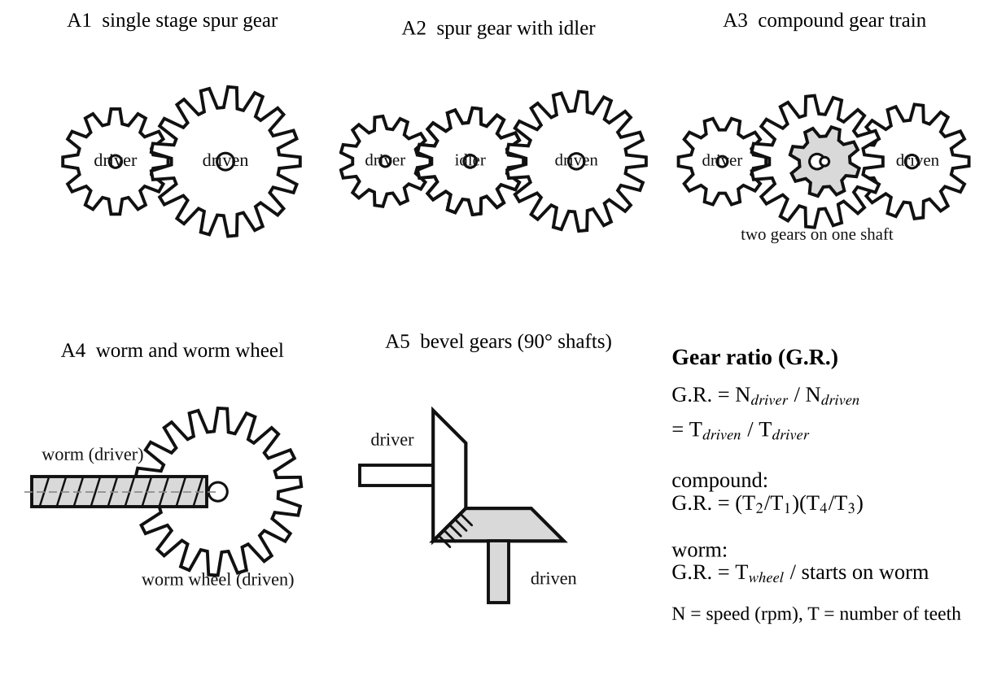
Fig. 1: The five gear arrangements and the gear ratio formulas.
Method in brief
- For each model, identify the driving and the driven shafts, and note the direction of rotation of each shaft.
- Count the teeth on every gear and, turning the driver by a known number of turns, count the turns of the driven shaft. Calculate the gear ratio in both ways.
- Vary the gear combination (change the gears on the models) and see how the ratio changes, so that the general formula for the gear ratio can be established.

3. Results
Table 1: Gear data and gear ratios
Model | Teeth on driver | Teeth on idler / intermediate gears | Teeth on driven gear | G.R. from teeth | Turns of driver per turn of driven | Direction of driven shaft (same / opposite)
A1 single stage |  | –
A2 with idler
A3 compound
A4 worm | (starts: ) | –
A5 bevel |  | –

4. Analysis of Results
Write a brief but comprehensive technical report on the use of toothed gears in engineering, using the following questions as guidelines.
1. In each case, distinguish between the driving and the driven shafts, and determine the gear ratio.
- A1: the driving shaft carries the smaller (pinion) gear T₁; the driven shaft carries the larger gear T₂. G.R. = T₂/T₁ = [ ] ÷ [ ] = [ ]. The driven shaft turns in the opposite direction.
- A2: the driving shaft carries T₁; the idler turns freely on its own shaft; the driven shaft carries T₃. G.R. = T₃/T₁ = [ ] (the idler's T₂ cancels out: (T₂/T₁)(T₃/T₂)). The driver and driven shafts turn in the same direction.
- A3: the driving shaft carries T₁, which meshes with T₂ on the intermediate shaft; T₃, fixed on the same shaft as T₂, meshes with T₄ on the driven shaft. G.R. = (T₂/T₁)(T₄/T₃) = ( [ ] ÷ [ ] ) × ( [ ] ÷ [ ] ) = [ ]. The driven shaft turns in the same direction as the driver.
- A4: the driving shaft carries the worm, and the driven shaft (at 90°, and not in the same plane) carries the worm wheel. G.R. = T_{wheel}/starts = [ ] ÷ [ ] = [ ].
- A5: the driving shaft carries one bevel gear and the driven shaft (at 90° to it) carries the other. G.R. = T_{driven}/T_{driver} = [ ] ÷ [ ] = [ ].
2. By varying the gear ratio in each model, establish a mathematical formula for the gear ratio. For any simple pair the speeds are in inverse proportion to the number of teeth, because the teeth pass the mesh point at the same rate (the pitch-circle speeds are equal): N₁T₁ = N₂T₂, so
G.R. = N_{driver}/N_{driven} = T_{driven}/T_{driver}
For a train of gears the overall ratio is the product of all stage ratios: G.R. = (product of the teeth on the driven gears) ÷ (product of the teeth on the driver gears). Idlers cancel and do not affect the ratio. For a worm drive: G.R. = T_{wheel}/(number of starts).
3. The gearing in A1 and A2 gives the same gear ratio. Suggest two important reasons for the incorporation of an idler.
- To make the driven shaft rotate in the same direction as the driving shaft (a single pair reverses the direction).
- To bridge a large centre distance between the shafts without having to use very large gears, which would be heavy and costly. It also allows the driven gear to be placed at a convenient position. (An idler also lets one driver feed several driven gears, as in a gearbox reverse gear.)
4. If you were to transmit rotary motion between two parallel shafts which are far apart and require a large speed ratio, which type of gearing would you employ? Why? I would use a compound gear train (A3 type) with spur gears, perhaps with one or more idlers to span the distance. A single pair would need a huge gear to get a large ratio (usually a single spur stage is limited to about 6:1 to 8:1), so the ratio is divided into stages of 3:1 to 6:1 on intermediate shafts. This keeps the gears a reasonable size, and the ratio is the product of the stages, e.g. 5 × 5 = 25:1. For a long distance, a chain or a belt can carry the motion across the gap at the high-speed stage, where the torque is low, followed by gears for the speed reduction. Worm and bevel gears are for shafts that are not parallel, so they are not suitable here.
Technical report on the use of gears in engineering
Gears are the most common positive drive in machines. Spur gears (parallel shafts, teeth parallel to the axis) are simple, efficient (98 to 99 % per stage) and cheap, but noisy at high speed. Helical gears run more quietly and carry more load but produce an axial thrust. Bevel gears connect intersecting shafts, as in a car differential or a hand drill. Worm gears give a high ratio (up to 100:1) in a small space and can be self-locking (used in lifting gear and tuning heads), but they are less efficient (40 to 90 %) and wear quickly because of sliding. Compound trains give large ratios, as in gearboxes, clocks and winches. Gears also change torque and speed, reverse direction, and transmit power between shafts at different positions. Compared with belts and chains, gears have no slip, so the speed ratio is exact, and they are compact; the price is the need for accurate alignment, lubrication, and higher cost.

5. Observations / Precautions Taken
Observations
- In A1 the driven shaft turned in the opposite direction to the driver, and a smaller driver turned the larger gear slowly.
- In A2 the driven shaft turned in the same direction as the driver, and the idler had no effect on the gear ratio.
- In A3 the speed was reduced in two steps, and the overall ratio was the product of the two ratios.
- In A4 many turns of the worm were needed to turn the worm wheel once, and the worm wheel could not drive the worm back (self-locking).
- In A5 the direction of rotation changed through 90°.
Precautions
- The teeth were counted carefully and a mark was used to count the turns of the shafts.
- The handle was turned slowly and smoothly, and fingers were kept clear of the meshing gears.
- The models were handled gently so that the gears did not get damaged.

6. Graphs
No graphs are required for this experiment. Neat sketches of the models are in the Apparatus section (Fig. 1) and should be redrawn in your own report if your lecturer asks for hand sketches.

7. Discussion
The measured gear ratios (by counting the turns) agreed with those calculated from the numbers of teeth, to within the error of counting. The experiment shows that the gear ratio depends only on the numbers of teeth and not on the size or the idler gears. The models make it easy to see the direction of rotation, but they cannot show the real problems of gears such as the tooth profile, backlash, noise, lubrication and wear.
Limitations of the models
- Backlash (clearance between teeth) makes the driven shaft lag when the direction is reversed.
- The models are not loaded, so the torque, power and efficiency cannot be measured.
- The turns are counted by eye, which becomes inaccurate at higher ratios.

8. Conclusion
The working of five types of gearing (single-stage spur, spur with idler, compound, worm and bevel) was examined. The gear ratio is G.R. = N_{driver}/N_{driven} = T_{driven}/T_{driver}, and for a train it is the product of the stage ratios. An idler changes the direction but not the ratio. Large ratios between far-apart parallel shafts are best obtained with a compound train. Gears are used in gearboxes, clocks, machine tools, vehicles, winches and almost every machine that transmits power.

Section B: Questions
1. What I learnt from the experiment. I learnt how the different types of gears work, how to find the gear ratio from the teeth, and why idlers and compound trains are used.
3. Comment on the experimental procedure. The models allow the gears to be turned by hand and counted directly, so the ratios can be checked by two methods. The gears can easily be changed, so the formula can be established.
4. Most difficult aspect of the experiment. Counting the turns of the driven shaft accurately when the ratio is large. It can be reduced by marking the shafts and counting slowly.
5. Another method that could be used. Real gearboxes with a tachometer on the two shafts to measure the speed ratio, or a software simulation of gear trains.
6. Parameters measured / involved. Numbers of teeth, number of turns of the driver and driven shafts, direction of rotation, and gear ratio.
7. Measuring instrument used. No instrument was needed, only the counting of teeth and turns, but a tachometer could measure the speeds.
8. Practical relevance. Car gearboxes and differentials, clocks, machine tools, winches, lifts, wind turbines, and every machine that transmits power.
9. Section of the course it belongs to. Machines and mechanisms (gears and gear trains).
13. What interested me most. The idler gear did not change the ratio but only changed the direction of rotation.
2, 10, 11, 12, 14 and 15 (personal / references): to be filled in by you.

