MECHANICAL ENGINEERING LABORATORY (ELA 301)
LABORATORY REPORTS
FM 312: Impact of a Jet

Name: ______________________________
Matric No.: __________________________
Department: _________________________
Date: _______________________________
Contents
FM 312 Impact of a Jet
Notes before you submit
- Anything shown as [ ] is for your own readings or results from your own lab session. Nothing has been invented.
- Each report follows Section C of the manual: Theory, Apparatus, Results, Analysis of Results, Observations and Precautions, Graphs, Discussion and Conclusion. The Section D questions are answered after each report.
- Section D questions 2, 3, 11, 12, 13 and 15 are personal (your role, whether you could do it alone, your suggestions, your group's suggestions, whether you copied results, whether you brought the manual), so they are left for you to fill in.
- The experiments are in reverse order, last one in the manual first. The pressure measurement pages are headed 3.10 and have no experiment number of their own, so they are filed as FM 314 (Part 2); the density/viscosity/capillarity pages are FM 314 (Part 1). Rename them if your lecturer numbers them differently.
- AM 319, FM 313 and the pressure and hydrostatic reports use dimensions printed in the manual; everything you must measure is left as [ ].
- Graphs must be drawn from your own readings on graph paper (or in Excel) and attached where indicated.

FM 312: Impact of a Jet

Objective
- To determine the coefficient of impact, K, of a water jet striking a stationary vane, under the following conditions: (1) the jet striking the centre of a hemispherical vane, and (2) the jet striking a flat vane kept perpendicular to the direction of the jet. (The results table in the manual also has the inclined vane.)
- To compare the actual force on the vane (found with a lever and sliding weight) with the theoretical force calculated from the momentum of the jet.

1. Theory
1.1 Why a jet exerts a force: momentum
A jet of water leaving a nozzle carries momentum: each kilogram of water moves with a velocity V, so it has momentum V per kilogram. When the jet hits a solid surface (a vane) the water is made to change direction and speed, so its momentum changes. By Newton's second law, a force is needed to change the momentum of the water, and that force is supplied by the vane. By Newton's third law, the water pushes back on the vane with an equal and opposite force. That is the force due to the impact of the jet, and it is the force we want to measure.
In its most useful form, Newton's second law for a steady flow says: the force on the fluid in a given direction is equal to the rate of change of momentum of the fluid in that direction, which is the mass flow rate multiplied by the change of velocity in that direction:
F = ṁ ( V_{out} − V_{in} ) = ρ Q ( V_{out} − V_{in} ) (1)
where ṁ = ρ Q is the mass of water flowing per second (kg/s), ρ the density of water (1000 kg/m³), Q the volume flow rate (m³/s), and V_{in} and V_{out} are the velocity components in the chosen direction before and after the impact. The force on the vane is equal and opposite to this force on the water. Because the jet leaves the nozzle at atmospheric pressure and the vane is also in the open air, no pressure forces appear in the equation, so only the momentum change matters.
Velocity of the jet. The nozzle has a circular opening of diameter d = 10 mm, so its area is a = π d²/4 = π (0.010)²/4 = 7.85 × 10⁻⁵ m². By continuity (the same volume of water per second must pass through any section), the velocity of the jet is
V = Q / a (2)
with Q in m³/s. The discharge Q is read from the rotameter in litres per minute (LPM): Q = (rotameter reading × 10⁻³) / 60 m³/s. For instance, 20 LPM is 3.33 × 10⁻⁴ m³/s, which gives V = 3.33 × 10⁻⁴ / 7.85 × 10⁻⁵ = 4.24 m/s.
1.2 The theoretical force on different vanes
Take the direction of the jet (vertical in this apparatus) as positive, and suppose the vane is held still (a stationary vane). The water arrives with velocity V in that direction. Consider each vane in turn. (We ignore friction between the water and the vane, so the speed of the water along the vane stays V, and we ignore the effect of gravity on the water over the short distance involved.)
Flat vane, perpendicular to the jet. The water cannot continue forward, since the plate is in the way, so it spreads out sideways over the plate and leaves in directions at right angles to the jet. After impact the water has no velocity component along the jet: V_{out} = 0. Then F = ρ Q (V − 0), that is
F_{t} = ρ Q V (flat vane) (3)
Curved (hemispherical) vane. The jet hits the centre of the cup and the water is turned back through a large angle, leaving the cup with its outlet tip at an angle φ to the direction of the jet. If there is no friction, the water leaves with the same speed V, and its component along the original jet direction, measured in the backward direction, is V cos φ. So the velocity changes from +V to −V cos φ, a change of V + V cos φ. Therefore
F_{t} = ρ Q V ( 1 + cos φ ) (curved vane with outlet tip at φ to the jet direction) (4)
For a perfect hemisphere the water is turned through 180° so it comes back exactly parallel to the jet, φ = 0, cos φ = 1, and F_{t} = 2 ρ Q V: twice the force on a flat plate for the same jet, because the water has to be stopped and then sent back, and so its momentum change is doubled. (The manual's specification list prints an angle of 68° next to the hemispherical vane, but the print is unclear. Use the vane's actual outlet angle from the vane itself; if φ is not 0°, equation (4) gives a force between ρ Q V and 2 ρ Q V. For example, φ = 68° gives 1.375 ρ Q V.)
Inclined flat vane. If a flat vane is tilted so that it makes an angle α with the direction of the jet, the water can only leave along the plate, so it is deflected sideways. The force of a frictionless jet on a plate always acts at right angles to the plate (no friction means no tangential force), and its magnitude is F_{n} = ρ Q V sin α. The component of this force along the direction of the jet, which is what the lever measures, is F_{n} sin α = ρ Q V sin² α. (When α = 90°, the plate is perpendicular to the jet and this reduces to ρ Q V, the same as equation 3.) The manual does not print a formula or an angle for the inclined vane, so use the angle marked on your vane and say clearly which component you have compared.
Effect of flow rate. Since V = Q/a, the force is F_{t} = ρ Q² / a for the flat vane and 2 ρ Q² / a for the hemisphere. So the force is proportional to the square of the discharge: doubling Q gives four times the force. A graph of F against Q² should be a straight line through the origin, with a slope of ρ/a = 1000 / 7.85 × 10⁻⁵ = 1.27 × 10^7 N s²/m⁶ for the flat vane, and twice this for the hemispherical vane.
1.3 Measuring the actual force with the lever
The vane is fixed to a "T"-shaped lever, the left end of which is held firmly by a double bearing block that acts as a fulcrum (hinge). A balance weight on the other side of the hinge brings the lever to the horizontal position with no flow, and a scale with a sliding weight is fitted to the right side. When the jet strikes the vane, the force of impact acts upward on the vane and tries to lift the lever. We slide the weight W₁ along the scale, away from the hinge, until the lever is again horizontal. For equilibrium of the lever, the moments about the hinge are equal:
F_{a} × X₂ = W₁ g × X₁ so F_{a} = ( W₁ X₁ / X₂ ) × 9.81 newtons (5)
where F_{a} is the actual force on the vane (N), W₁ is the sliding weight (mass in kg), X₁ is the distance of the sliding weight from the hinge when the lever is balanced (m), and X₂ is the distance of the vane from the hinge (X₂ = 123 mm in the manual). Since X₂ is fixed and W₁ is known, a measurement of X₁ gives the force. The initial balance without any flow cancels the weights of the vane and lever, so only the force from the jet is measured by the sliding weight.
Notice that the lever works as a force multiplier: a small force on the vane near the hinge is balanced by a small sliding weight far from the hinge (a long arm), so a measurable position X₁ on the scale is obtained from a small force. If X₁ would go beyond the end of the scale, the heavier sliding weight (180 g instead of 108 g) is used.
1.4 Coefficient of impact
The measured (actual) force is not exactly equal to the theoretical force, because the ideal theory ignores friction, splashing, the loss of speed of the jet on its way from the nozzle to the vane, the spreading of the jet, and the fact that the water does not leave exactly in the assumed direction. The ratio between the two is the coefficient of impact:
K = F_{a} / F_{t} = ( actual force exerted on the vane ) / ( theoretical force exerted on the vane ) (6)
K is a number which is generally a little less than 1 (typically 0.85 to 1) for a smooth vane. A value near 1 means that the real jet behaves close to the ideal theory. Values noticeably above 1 can only come from measurement errors (for example, Q read too low on the rotameter, or X₁ read too high), as the vane cannot give more force than the momentum change allows. The rotameter reading is the largest source of uncertainty because F depends on Q².
A note on the velocity at the vane. The jet slows down a little as it rises from the nozzle to the vane, as it loses kinetic energy to gain height h: by Bernoulli's equation, V_{vane}² = V² − 2 g h. For a vane only a few centimetres above the nozzle and V of 4 to 10 m/s the effect is small (for h = 0.05 m and V = 4.24 m/s, V_{vane} = 4.14 m/s, a 2.4 % change in V and about 5 % in the force), but it explains part of the reason why K is slightly less than 1.
1.5 Extension: moving vanes and the Pelton wheel (background, not measured here)
The same ideas apply to a vane that moves in the direction of the jet at a speed u (the case of a turbine). The relative speed of the water to the vane is (V − u), and the mass flow striking the vane is ρ a (V − u) for a single moving vane (or ρ a V for a wheel carrying a series of vanes, since a fresh vane is always in the jet). For a series of curved vanes: F = ρ a V (V − u)(1 + cos φ), and the work done per second (power) is P = F u. Differentiating P with respect to u and putting it equal to zero gives the best vane speed u = V/2, and for φ = 0 the power at that speed is P = ρ a V³ / 2, which is exactly the kinetic energy per second of the jet, so the ideal efficiency is 100 %. This is why the buckets of a Pelton wheel (the double-cup shape which turns the jet back by nearly 180°) are designed to move at about half the jet speed. The stationary hemispherical vane in this experiment is the starting point for understanding such machines.

2. Apparatus
The impact of jet apparatus (FM 312): a transparent acrylic casing supported by plates at the top and bottom; a brass nozzle of 10 mm diameter fixed at the centre of the bottom plate; a "T"-shaped lever on the top plate, with its left side held by a double bearing block (the fulcrum or pivot) and permanent stoppers on either side to keep it horizontal; a balance weight (512 g) on the left; a scale with a sliding weight arrangement (sliding weights of 108 g and 180 g) on the right side; three interchangeable vanes (hemispherical 106 g, flat 60 g and inclined 60 g), the vane distance from the hinge being X₂ = 123 mm; a rotameter (0 to 3000 LPH, 0 to 50 LPM) on the side of the main tank (600 × 400 × 210 mm); a 0.5 HP mono-block centrifugal pump with a bypass to the tank; a discharge pipe of 44 mm internal diameter; a drain valve to empty the tank at the end; all mounted on a rigid frame. The piping (1-inch hose pipe) goes from the tank bottom to the pump suction, from the pump discharge to the rotameter inlet, through the rotameter to the system inlet, and from the system outlet back to the tank.
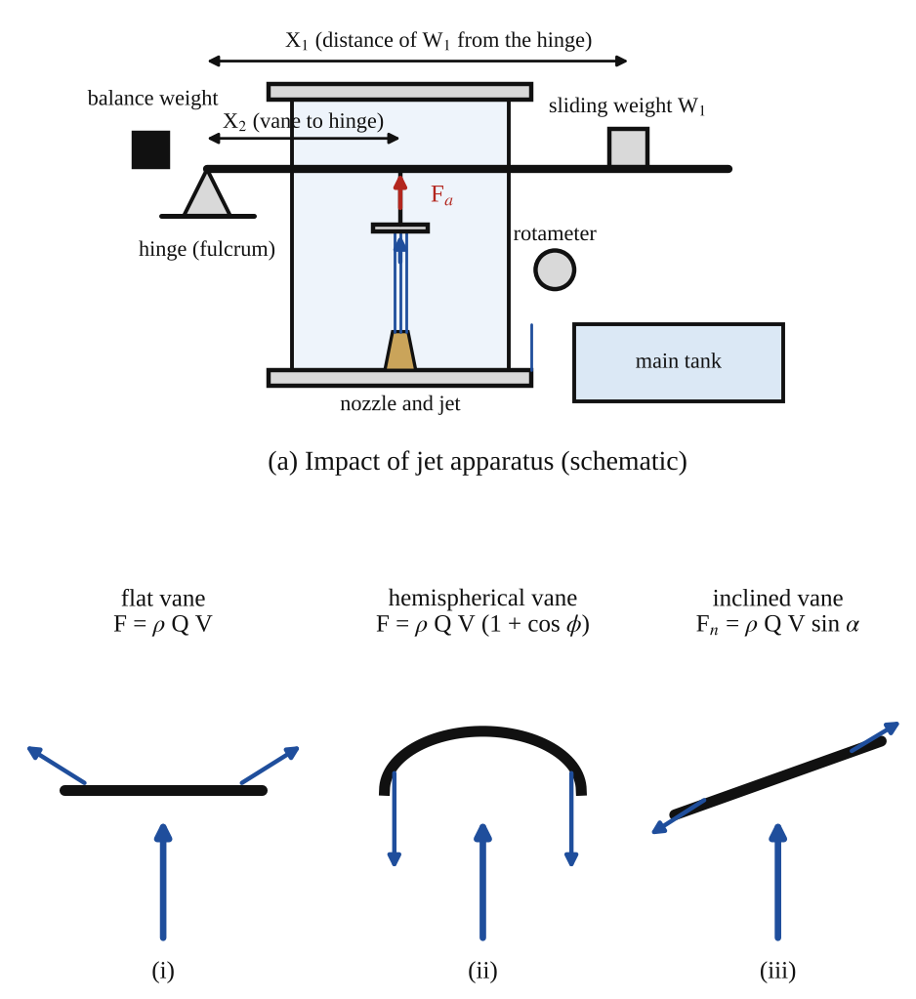
Fig. 1: (a) the impact of jet apparatus, with the lever, hinge, balance weight and sliding weight W₁ at distance X₁; (b) how the water leaves (i) a flat vane, (ii) a hemispherical vane and (iii) an inclined vane.
Method in brief (from the manual)
- Remove the top cover by lifting it upwards (it comes off the screws easily).
- Fix the required vane (to begin with, the flat plate) to the lever.
- Add the balance weight on the right side of the lever and adjust it so that the lever becomes horizontal.
- Now add the force weight (the sliding weight) to the right side of the lever.
- Start the water supply by pressing the switch. The jet of water through the nozzle impinges on the vane. The force of impact acts on the vane in the upward direction, which disturbs the initial balance of the lever.
- Adjust the position of the sliding weight so that the lever returns to the horizontal balanced position. Record the position X₁ of the sliding weight.
- Adjust the supply valve to set different water discharges in LPM, as shown on the rotameter, and repeat for each setting.
- With the different vanes attached, repeat steps 1 to 8.

3. Results
Diameter of nozzle D = 10 mm, so a = 7.85 × 10⁻⁵ m². Distance of the vane from the hinge X₂ = 123 mm = 0.123 m. Sliding weight W₁ = [ ] kg (0.108 kg or 0.180 kg). ρ = 1000 kg/m³, g = 9.81 m/s².
Observation table (one table for each vane): hemispherical / flat / inclined (circle the vane)
S/No. | Position of movable weight X₁ (cm or m) | F_{a} = force on the vane (N) (calculated) | F_{t} = theoretical force (N) (calculated) | K = F_{a}/F_{t} (coefficient of impact) | Q = actual discharge, rotameter reading (LPM) | Q (m³/s)
1
2
3
4
5
6

Table 2: Theoretical values for this nozzle (calculated, not measured), for comparison
Rotameter reading (LPM) | Q (10⁻⁶ m³/s) | Jet velocity V = Q/a (m/s) | F_{t} flat vane ρQV (N) | F_{t} hemisphere, φ = 0, 2ρQV (N)
10 | 166.7 | 2.12 | 0.35 | 0.71
15 | 250.0 | 3.18 | 0.80 | 1.59
20 | 333.3 | 4.24 | 1.41 | 2.83
25 | 416.7 | 5.31 | 2.21 | 4.42
30 | 500.0 | 6.37 | 3.18 | 6.37
35 | 583.3 | 7.43 | 4.33 | 8.67
40 | 666.7 | 8.49 | 5.66 | 11.32

Table 2 comes from equations (2), (3) and (4) with a = 7.85 × 10⁻⁵ m². It gives the size of the forces to expect. The force on the hemispherical vane assumes φ = 0 (the manual's print of 68° is unclear), so recalculate with your vane's angle if it is not zero. The sliding weight must be able to balance these forces within the lever scale, so use the 180 g weight for the larger discharges.
Results (coefficient of impact K): (1) hemispherical vane K = [ ] (2) flat vane K = [ ] (3) inclined vane K = [ ]

4. Analysis of Results
- Discharge: Q = (rotameter reading × 10⁻³) / 60 = ( [ ] × 10⁻³ ) / 60 = [ ] m³/s.
- Jet velocity: V = Q / a = [ ] ÷ 7.85 × 10⁻⁵ = [ ] m/s.
- Actual force: F_{a} = ( W₁ X₁ / X₂ ) × 9.81 = ( [ ] × [ ] ÷ 0.123 ) × 9.81 = [ ] N (W₁ in kg, X₁ and X₂ in the same unit).
- Theoretical force, flat vane: F_{t} = ρ Q V = 1000 × [ ] × [ ] = [ ] N.
- Theoretical force, hemispherical vane: F_{t} = ρ Q V (1 + cos φ) = 1000 × [ ] × [ ] × (1 + cos [ ]°) = [ ] N.
- Theoretical force, inclined vane (if used): component along the jet = ρ Q V sin² α = [ ] N for α = [ ]° (normal force ρ Q V sin α = [ ] N).
- Coefficient of impact: K = F_{a} / F_{t} = [ ] ÷ [ ] = [ ]. Mean K for each vane = [ ].
- Check on the Q² law: the slope of the graph of F_{a} against Q² = [ ] N s²/m⁶, compared with ρ/a = 1.27 × 10⁷ for the flat vane (or 2.55 × 10⁷ for the hemisphere). Ratio = [ ].
- Ratio of the forces on the hemispherical and flat vanes at the same Q = [ ] (theory: 2 for φ = 0, or 1 + cos φ).
Worked check with the printed dimensions (not your data). At 20 LPM, Q = 3.33 × 10⁻⁴ m³/s, V = 4.24 m/s. Flat vane: F_{t} = 1000 × 3.33 × 10⁻⁴ × 4.24 = 1.41 N. Suppose the 108 g weight balances at X₁ = 0.17 m: F_{a} = (0.108 × 0.17 / 0.123) × 9.81 = 1.46 N, so K = 1.46 / 1.41 = 1.04. (That would be slightly above 1, which suggests a small error in Q or X₁.)

5. Observations / Precautions Taken
Observations
- When the jet struck the vane the lever was pushed upwards, and the sliding weight had to be moved further from the hinge to bring it level when the discharge was increased.
- For the same discharge, the hemispherical vane needed the sliding weight to be much further out than the flat vane (about twice as far, if φ is near 0).
- The water, after hitting the flat vane, spread out sideways as a thin sheet; from the hemispherical vane it fell back down as two streams in the opposite direction.
- The lever oscillated a little and took time to settle at each setting because of the fluctuating flow and splashing.
- K was a little below / above 1 for all the vanes, and was nearly constant over the range of discharge.
Precautions
- The lever was checked to be exactly horizontal, with no flow, before each set of readings (with the balance weight), and the vane was fixed firmly and level.
- The nozzle diameter was taken as 10 mm and the vane distance from the hinge as 123 mm, and these were checked against the apparatus.
- The discharge was set with the supply valve and held steady, and the rotameter float was read at its top edge at eye level.
- The sliding weight was moved slowly and the lever was allowed to settle before the position X₁ was read; readings were repeated.
- The top cover was replaced before the water was turned on, to stop splashing, and the electrical switch for the pump was handled with dry hands.
- The tank was kept filled to the proper level so that the pump did not run dry, and the tank was drained by the drain valve at the end.

6. Graphs
Plot the following on graph paper from your own readings and attach them here:
- Actual force F_{a} against Q² for each vane (a straight line through the origin; the slope for the hemisphere is about double that of the flat vane).
- Actual and theoretical force against the discharge Q, on the same axes, for each vane (Fig. 2a).
- Optional: K against Q for each vane, to show whether the coefficient is constant.
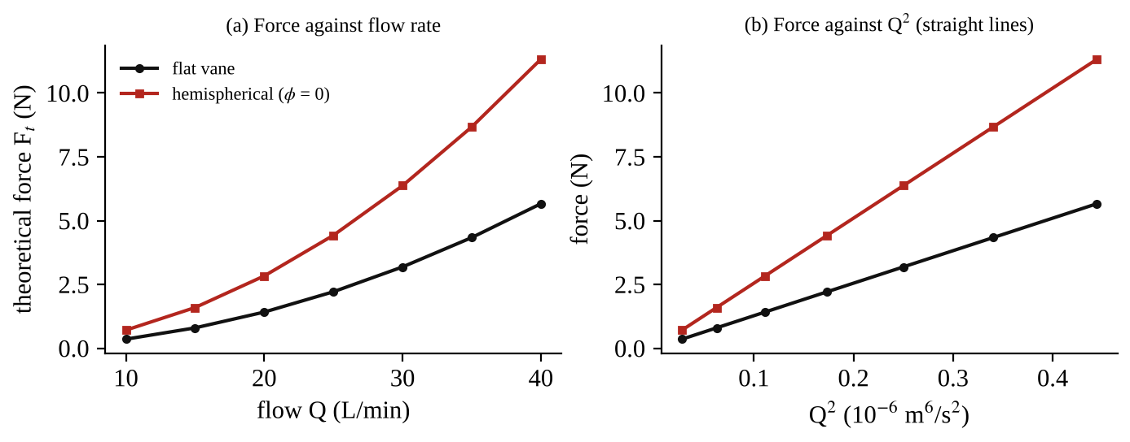
Fig. 2: The expected form of the theoretical force against discharge for the flat and the hemispherical vane (calculated, not measured): (a) F against Q, (b) F against Q², a straight line.

7. Discussion
Agreement with theory. The results show whether the momentum theory represents the real impact of the jet. The coefficient of impact for the flat vane was [ ] and for the hemispherical vane [ ] (inclined: [ ]). Values close to 1 mean the actual force is close to the theoretical force ρ Q V (flat) and ρ Q V (1 + cos φ) (curved). A value less than one is expected because of friction, the loss of speed between the nozzle and the vane, the spread of the jet and splashing. The ratio of the forces on the hemispherical and the flat vane was [ ], close to the theoretical value 2, which confirms that the water that is turned back gives a double change of momentum.
Variation with flow. The force increased in proportion to Q² (the graph of F_{a} against Q² was a straight line through the origin), which is what F = ρ Q² / a requires. The coefficient K stayed approximately constant, so the theory is valid over the range of discharge used. At small discharges, K usually varies more because the force is small and the reading is affected by friction in the lever bearing and by the splashing.
Sources of error
- The rotameter reading (Q) is the main uncertainty: it is read to about ±1 LPM, which is an error in F of about 10 % at 20 LPM, since F depends on Q².
- Friction in the hinge (bearing block) and the lever not being perfectly horizontal when judged by eye.
- The jet loses speed between the nozzle and the vane (gravity and air) so the velocity at the vane is less than Q/a.
- Splashing, the jet not being exactly centred on the vane, and water falling back on the vane and adding to its weight (the water that collects on the vane changes the balance).
- Fluctuations in the flow from the pump, which make the lever oscillate and the position X₁ hard to read.
- The nozzle diameter and distance X₂ have manufacturing tolerances, and the nozzle flow may contract slightly (a coefficient of contraction), so the real area of the jet is a little less than the nozzle area.
- For the hemispherical vane, the actual outlet angle φ (not exactly 0°) and the friction on the vane surface reduce the force.

8. Conclusion
The coefficient of impact of a water jet on stationary vanes was found to be K = [ ] for the hemispherical vane, K = [ ] for the flat vane and K = [ ] for the inclined vane, so the actual forces measured with the lever are within about [ ] % of the theoretical forces from the momentum equation. The force was proportional to the square of the discharge, and the hemispherical vane gave about twice the force of the flat vane, as theory predicts. Practical applications: design of Pelton wheel turbines (the double-cup buckets turn the jet back through nearly 180° to get the maximum force), water jet cutting, fire hose nozzles (the reaction force on the firefighter), the thrust of jet engines and rockets (the reaction to the momentum of the exhaust), sprinklers and lawn sprays, and the design of pipe bends and supports that have to resist the force of the flowing fluid.

Section D: Questions
1. What have I gained from this experiment? I learnt how the force of a water jet on a vane comes from the change of momentum, why a hemispherical vane gives twice the force of a flat vane, and how the coefficient of impact compares the actual force with the theoretical one.
4. Comment on the experimental procedure (accuracy and time saving) The lever and sliding weight give the force directly from a length measurement, so the procedure is simple and quick and gives good accuracy for a laboratory. Several flow rates and three vanes can be tested in a short time, but the accuracy depends on reading the rotameter, since F depends on Q².
5. Most difficult aspect of the experiment and how to reduce it Judging when the lever was exactly horizontal, because it kept oscillating with the flow, and reading the rotameter float. It can be reduced by waiting for the lever to settle, taking the average of several readings, and setting the flow with the supply valve slowly.
6. Another method / apparatus that could be used A force transducer (load cell) fixed to the vane to read the force directly, or a measurement of Q by collecting the water in a tank over a measured time (volumetric method) to check the rotameter.
7. Parameters required in this experiment Nozzle diameter and area, discharge Q, jet velocity V, position X₁ of the sliding weight, distance X₂ of the vane from the hinge, sliding weight W₁, actual and theoretical force, and coefficient of impact K.
8. One measuring instrument / gauge used The rotameter: a tapered vertical tube with a float, which rises with the flow rate and is read on the scale in LPM at the top edge of the float.
9. Practical relevance / applications Pelton wheel turbines, water jet cutting, fire hose nozzles, jet engines and rockets (thrust from momentum), and the design of supports for pipe bends and nozzles.
10. Section of the course it relates to Fluid mechanics (momentum equation and impact of jets).
14. What interested me most That the hemispherical vane needed the sliding weight to be about twice as far out as the flat vane, which shows the effect of turning the jet back.
2, 3, 11, 12, 13 and 15 (personal): to be filled in by you.
16. References (keep only the ones you actually used): Mechanical Engineering Laboratory Manual ELA 301; a fluid mechanics or theory of machines textbook of your course.

