MECHANICAL ENGINEERING LABORATORY (ELA 301)
LABORATORY REPORTS
AM 319: Static and Dynamic Balancing of a Rotor
FM 314 (Part 2): Pressure Measurement: Bourdon Gauge Calibration, Liquid Column Manometers and Hare's Tube
FM 313: Forces on Plane Surfaces: Centre of Pressure
FM 311: Buoyancy, Flotation and Stability of Floating Bodies
FM 314 (Part 1): Hydrostatic Experiment: Density, Specific Gravity, Capillarity, Viscosity and Pascal's Law

Name: ______________________________
Matric No.: __________________________
Department: _________________________
Date: _______________________________
Contents
AM 319 Static and Dynamic Balancing of a Rotor
FM 314 (Part 2) Pressure Measurement: Bourdon Gauge Calibration, Liquid Column Manometers and Hare's Tube
FM 313 Forces on Plane Surfaces: Centre of Pressure
FM 311 Buoyancy, Flotation and Stability of Floating Bodies
FM 314 (Part 1) Hydrostatic Experiment: Density, Specific Gravity, Capillarity, Viscosity and Pascal's Law
Notes before you submit
- Anything shown as [ ] is for your own readings or results from your own lab session. Nothing has been invented.
- Each report follows Section C of the manual: Theory, Apparatus, Results, Analysis of Results, Observations and Precautions, Graphs, Discussion and Conclusion. The Section D questions are answered after each report.
- Section D questions 2, 3, 11, 12, 13 and 15 are personal (your role, whether you could do it alone, your suggestions, your group's suggestions, whether you copied results, whether you brought the manual), so they are left for you to fill in.
- The experiments are in reverse order, last one in the manual first. The pressure measurement pages are headed 3.10 and have no experiment number of their own, so they are filed as FM 314 (Part 2); the density/viscosity/capillarity pages are FM 314 (Part 1). Rename them if your lecturer numbers them differently.
- AM 319, FM 313 and the pressure and hydrostatic reports use dimensions printed in the manual; everything you must measure is left as [ ].
- Graphs must be drawn from your own readings on graph paper (or in Excel) and attached where indicated.

AM 319: Static and Dynamic Balancing of a Rotor

Objective
- To balance statically a four-mass rotating system (the masses all lie in different planes along a shaft).
- To determine the magnitude of the force and the angular position of each mass that is needed for the shaft to be dynamically balanced, using the force polygon and the couple polygon, and to check the result on the rig.

1. Theory
1.1 Why a rotor must be balanced
A rotor is any part that spins about a fixed axis: a motor armature, a turbine disc, a car wheel, a crankshaft, a fan. In the ideal rotor the centre of mass lies exactly on the axis of rotation and the mass is spread evenly round it. In a real rotor this is never exactly true, because of machining errors, keyways, bolts, non-uniform material, or because someone has attached something to one side. The result is that the centre of mass is a small distance r (the eccentricity) away from the axis.
When such a rotor turns, its mass centre moves round a circle of radius r. A body moving on a circle needs a centripetal (centre-seeking) force to keep it there. This force is supplied by the shaft and the bearings. By Newton's third law, the shaft and bearings feel an equal and opposite force, which we call the centrifugal force (the "inertia force"), pushing radially outward on the bearings. For a mass M rotating at angular velocity ω with eccentricity r its size is
F_{c} = M ω² r (1)
where M is the mass of the rotor (kg), ω the angular velocity (rad/s) and r the distance between the axis of rotation and the mass centre (m). Two things make this force dangerous:
- It grows with the square of the speed. If the speed doubles, the force becomes four times as large. A small unbalance which is harmless at 300 rev/min can be serious at 3000 rev/min.
- It rotates with the shaft. The magnitude stays the same, but its direction keeps changing, so the bearing feels a force that goes round once every revolution. That is a periodic (alternating) force, and it shakes the frame, causes noise, wears the bearings, fatigues the shaft and, if the shaft speed matches the natural frequency of the frame, can give violent resonance.
A worked feel for the numbers. Take a small unbalance of M = 0.1 kg at r = 5 mm on a shaft turning at 3000 rev/min. ω = 2π × 3000 / 60 = 314 rad/s, so F_{c} = 0.1 × 314² × 0.005 = 49 N. That is about 5 kg weight pushing round and round on the bearing, from a mass the size of a few coins. At 6000 rev/min the same unbalance gives about 197 N. This is why balancing is done on everything from washing machine drums to turbine rotors.
1.2 Static balance (single plane)
Consider a rotor made of one thin disc with a single unbalanced mass m at radius r. The force is m ω² r, directed along the radius to the mass. To cancel it we add a balancing mass m_{b} at radius r_{b} in the same plane, on the opposite side (180° away). The two centrifugal forces are then equal and opposite:
m ω² r = m_{b} ω² r_{b} so, with ω² cancelling, m r = m_{b} r_{b} (2)
The product m r is called the "unbalance" (or the mass moment) and it is the quantity we work with. Because ω² is common to every term it drops out, and it does not matter what speed the rotor will run at: a rotor that is balanced at one speed (for a rigid rotor) is balanced at all speeds.
When there are several masses m₁, m₂, m₃, … in the same plane at radii r₁, r₂, r₃, … and angles θ₁, θ₂, θ₃, … measured from a chosen reference radius, each one gives a vector of size m r in its own direction. The system is in static balance if the vector sum of all these unbalances is zero:
Σ m r = 0 (the m r polygon closes)
Resolving into two perpendicular directions, which is how we do the sum by calculation:
Σ m r cos θ = 0 and Σ m r sin θ = 0
If the masses as given do not satisfy this, the balancing mass supplies the missing vector. The resultant of the given masses has components X = Σ m r cos θ and Y = Σ m r sin θ, so the magnitude and the angle of the balancing unbalance are
m_{b} r_{b} = √[ (Σ m r sin θ)² + (Σ m r cos θ)² ] (3)
tan θ_{b} = Σ m r sin θ / Σ m r cos θ (4)
In equation (4) the angle found from the tangent must be put in the correct quadrant by looking at the signs of the two sums. Strictly, the balancing mass is placed 180° from the resultant of the given masses (that is what the minus sign of a balancing vector means). The usual way of saying this in words is: "the balancing mass closes the polygon".
What static balance means physically. A statically balanced rotor has its centre of mass on the axis. If the shaft is laid on two horizontal knife-edges (or frictionless supports) and is turned to any position, it stays where it is put, because gravity gives no turning moment. An unbalanced one rolls until the heavy side is at the bottom. This is why static balance can be tested without spinning the rotor. It is also why the manual says that the centre of gravity of each block is found by hanging it on a fine thread in a horizontal position: the point where it balances horizontally is the centre of gravity.
1.3 Why static balance is not enough: dynamic balance
Static balance only deals with the forces. But when the masses lie in different planes along the shaft, each force acts at a different place along the axis, and so the forces also produce moments (couples) about the bearings. Picture the simplest case: two equal masses on opposite sides of the shaft, 180° apart, but separated along it by a distance x (like a person standing on a spinning pole with one arm up and a leg down on the opposite side). The two centrifugal forces are equal and opposite, so the resultant force is zero and the shaft is statically balanced and will rest in any position. But the two forces do not act in the same line. They form a couple of size m ω² r x, which tries to twist the shaft in the plane that contains the axis, and this couple turns with the shaft. The bearings feel it as an alternating force that is equal and opposite at the two ends. So the rotor is statically balanced but dynamically unbalanced, and it will shake when it spins.
Conditions for complete (dynamic) balance. For a rigid rotor with any number of masses in different planes to be dynamically balanced, two conditions must both be satisfied:
- the resultant force is zero: the vector sum of all the m r terms is zero (this is also the static balance condition). On a diagram this means the force polygon is a closed figure.
- the resultant couple is zero: the vector sum of all the couples m r x about any chosen reference plane is zero. On a diagram, the couple polygon is a closed figure.
Written in components (reference plane at x = 0, angles from a common reference line):
Σ m r cos θ = 0 Σ m r sin θ = 0 (force condition)
Σ m r x cos θ = 0 Σ m r x sin θ = 0 (couple condition)
The note at the end of the manual ties this together: a dynamically balanced shaft is automatically statically balanced (because the first condition is included), but a statically balanced shaft is not always dynamically balanced (because the second condition may not be met, as in the two-equal-masses example).
Why the couple is measured from a reference plane. The "x" in the couple is the axial distance of the mass from a reference plane which we choose. A couple vector has the same value whichever plane is chosen as long as the forces themselves are balanced (this is a property of a system whose forces add to zero). It is therefore convenient to choose the reference plane through one of the masses so that mass has x = 0 and contributes no couple, which removes one term from the sum. In this experiment plane 1 is the natural choice.
1.4 How the couple and force polygons are used (the graphical method)
The usual way to balance several masses in different planes is to fix the angular positions of some masses and find the angles of the others:
- Step 1, tabulate. For each mass write down m, r, the unbalance m r, the distance x from the reference plane and the couple m r x.
- Step 2, couple polygon. The masses are laid out as vectors of length m r x. Because the reference plane passes through mass 1, its couple is zero and only the other masses appear. The vectors are drawn tip to tail in a direction parallel to the radius of the mass (angles measured from the reference radius, for instance with mass 2 at 0°). The polygon must close. If there are three couples, it is a triangle, which fixes the angles of the other two masses uniquely.
- Step 3, force polygon. Now, with these angles known, the m r vectors for masses 2, 3 and 4 are drawn in the same way. The closing side of this polygon is the unbalance needed for mass 1. Its length gives the value of m₁ r₁ that is needed and its direction gives the angle of mass 1.
- Step 4, set the rig to these angles, lock the shaft, and check by running the rotor that it is smooth. If you now move one mass to another angle the vibration immediately increases, which confirms that the setting was the balanced one (this is step 16 and 17 of the manual procedure).
Analytical form of the couple triangle. Let C₂, C₃, C₄ be the couple magnitudes m r x of masses 2, 3, 4 and put mass 2 at the reference angle θ₂ = 0°. Closure of the couple triangle requires C₂ + C₃ e^{jθ3} + C₄ e^{jθ4} = 0. Taking the magnitude of C₄ from the other two and using the cosine rule gives the two unknown angles directly:
cos θ₃ = ( C₄² − C₂² − C₃² ) / ( 2 C₂ C₃ ) cos θ₄ = ( C₃² − C₂² − C₄² ) / ( 2 C₂ C₄ ) (5)
Equation (5) gives each angle only up to the sign, because cos θ = cos(−θ). The second condition (that the sine terms add to zero) shows that θ₃ and θ₄ lie on opposite sides of the reference line: one is between 0° and 180° and the other between 180° and 360°. Then the force condition gives the mass 1 term:
m₁ r₁ cos θ₁ = − ( m₂ r₂ + m₃ r₃ cos θ₃ + m₄ r₄ cos θ₄ )
m₁ r₁ sin θ₁ = − ( m₃ r₃ sin θ₃ + m₄ r₄ sin θ₄ )
so m₁ r₁ is the square root of the sum of the squares of these two right-hand sides, and θ₁ is the angle found from their ratio (placed in the right quadrant). If r₁ is fixed by the rig, the equality fixes the mass or the distance needed. If the calculation does not close exactly with the actual values of m r, the small difference is the residual unbalance and shows up as vibration.
1.5 Relating the theory to this rig
The rig has a steel shaft mounted on ball bearings in a stiff rectangular frame. Six detachable blocks of different weights can be clamped to the shaft; four of them (212 g, 206 g, 196 g and 182 g) are used. A disc with a circular protractor scale is fitted to one side of the frame and is used to set the angular position of each block. A 30 mm spacer is placed between consecutive blocks, and the total centre-to-centre distance between neighbouring blocks is 40 mm, so the four planes are at x = 0, 4, 8 and 12 cm. The distance of the centre of gravity of each block from the axis (r) is measured, and the "degree of unbalance of each mass" is expressed as the product (w × r), the weight times the distance of its centre of gravity from the axis, exactly the quantity m r used above (with weights in grams instead of kg, since g cancels). A 230 V single-phase, 50 Hz, fractional-horsepower motor drives the shaft, and a speed-control knob lets us run it up slowly. The main frame hangs from chains, so the vibration caused by any unbalance is easy to see and feel.
The manual gives the order of the blocks as 212 g, 206 g, 196 g and 182 g and quotes the angles 200°, 0° and 68° for three of them. These angles belong to the manual's own measured values of r, so your own calculation will probably give slightly different answers. Use your own r values and compare your angles with the manual's, which are written in the results table for reference.

2. Apparatus
A steel shaft mounted in ball bearings in a stiff rectangular main frame; a set of six detachable blocks of different weights (the 212 g, 206 g, 196 g and 182 g blocks are used); a disc carrying a circular protractor scale, fitted at one side of the frame, for setting the angular position of each block; a 30 mm spacer fixture to keep a fixed distance between consecutive blocks (total centre-to-centre distance 40 mm); a 230 V single-phase 50 Hz fractional-horsepower motor with a speed-control knob; the main frame supported to the building by chains; an Allen (alley) key to fix the blocks; a right-angle set square; a fine thread and a balance for finding the centre of gravity and weight of each block.
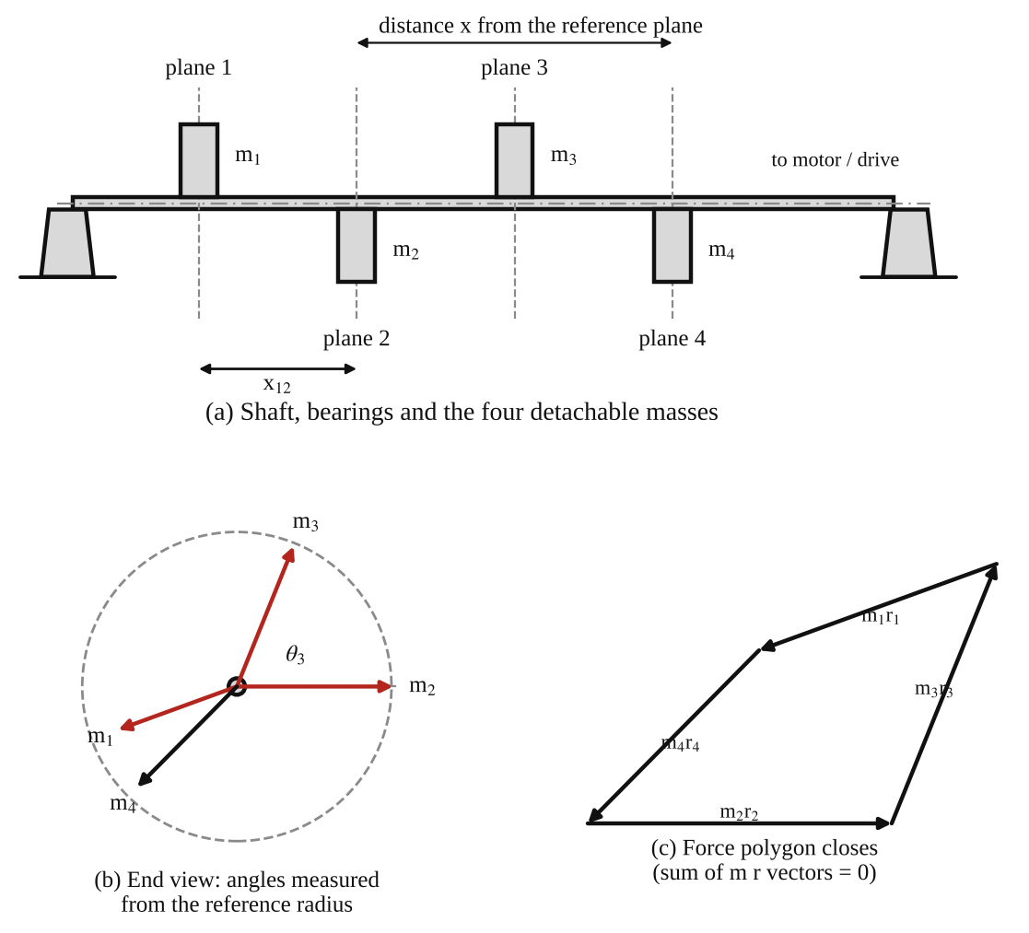
Fig. 1: (a) Shaft with the four masses in planes 1 to 4, (b) end view with the angles of the masses, (c) the closed force polygon (the radii and angles are only illustrative).
Method in brief (from the manual)
- The degree of unbalance of each block is w × r. Find the centre of gravity of each block by hanging it on a fine thread in a horizontal position and measure r, its distance from the axis of rotation.
- Choose four rotating masses and decide where they go on the shaft. Calculate the angular positions by using the couple polygon and the force polygon.
- Arrange the blocks on the shaft in this order: (a) 212 g, (b) 206 g, (c) 196 g and (d) 182 g, separated by the spacer.
- Set the angle disc to 0° and tighten block number 2 (206 g) with the Allen key so that it is perpendicular to the horizontal plane (use the right-angle set square).
- Put the spacer between the next two blocks (196 g and 206 g), set the disc to the calculated angle (68° in the manual), and lock the shaft at the same angle with the locking bolt. Loosen the locking bolt. Repeat for the other blocks: spacer between 182 g and 196 g, and between 212 g and 206 g (200° in the manual), each time setting the angle that was obtained by calculation, locking, and then loosening the locking bolt.
- Start the motor and watch the balancing effect. Then change the position or angle of any one block and watch the vibration increase.

3. Results
Radius of each block (distance of its centre of gravity from the axis) measured with the rig stationary: r₁ = [ ] cm, r₂ = [ ] cm, r₃ = [ ] cm, r₄ = [ ] cm. Distances between neighbouring planes: 4 cm. Reference plane: through block 1 (x = 0).
Table 1: Force and couple calculations (the manual's table)
S/N | Weight w (g) | Distance of C.G. from centre of rotation r (cm) | Force = w × r (g cm) | Distance between weights x (cm) | Couple = F × x (g cm²) | Angle calculated θ (°) | Angle in manual θ (°)
1 | 212 |  |  | 0 |  |  | 200
2 | 206 |  |  | 4 |  | 0 (reference) | 0
3 | 196 |  |  | 8 |  |  | 68
4 | 182 |  |  | 12 |  |  | –

The 0, 4, 8 and 12 cm are the distances between the weights taken from block 1, as in the manual. The manual does not print a value for block 4, because it is the one worked out last. The calculated angle for blocks 1, 3 and 4 and the force and couple values are filled in from your own r values.
Table 2: Observation of the balancing effect
Condition | Vibration observed (none / slight / strong) | Comment
Blocks at the calculated angles, motor running slowly
Blocks at the calculated angles, motor at higher speed
One block moved to a different angle
One block removed or moved along the shaft

4. Analysis of Results
The calculation follows the steps in the theory. Reference plane through block 1 (x = 0), block 2 taken as 0°. All r in cm, w in grams.
- Force of each block: F = w r. F₁ = 212 × [ ] = [ ] g cm; F₂ = 206 × [ ] = [ ] g cm; F₃ = 196 × [ ] = [ ] g cm; F₄ = 182 × [ ] = [ ] g cm.
- Couple of each block about plane 1: C = F x. C₁ = 0 (x = 0); C₂ = F₂ × 4 = [ ]; C₃ = F₃ × 8 = [ ]; C₄ = F₄ × 12 = [ ] g cm².
- Couple triangle (blocks 2, 3, 4): draw C₂ along 0° to a chosen scale, then C₃ and C₄ so that the triangle closes. Read θ₃ and θ₄ from the drawing and check by calculation: cos θ₃ = (C₄² − C₂² − C₃²) / (2 C₂ C₃) = [ ], so θ₃ = [ ]°; cos θ₄ = (C₃² − C₂² − C₄²) / (2 C₂ C₄) = [ ], so θ₄ = [ ]° (360° minus the calculator value, because θ₃ and θ₄ lie on opposite sides of the reference line).
- Force polygon: Σ_{x} = F₂ + F₃ cos θ₃ + F₄ cos θ₄ = [ ]; Σ_{y} = F₃ sin θ₃ + F₄ sin θ₄ = [ ]. The closing vector gives the unbalance needed for block 1: F₁ = √(Σ_{x}² + Σ_{y}²) = [ ] g cm, which gives r₁ = F₁ / 212 = [ ] cm, and the angle θ₁ = tan⁻¹(Σ_{y} / Σ_{x}) + 180° = [ ]°.
- Balancing mass, single-plane check (equations 3 and 4): m_{b} r_{b} = √[ (Σ w r sin θ)² + (Σ w r cos θ)² ] = [ ] g cm. The angle is θ_{b} = tan⁻¹( Σ w r sin θ / Σ w r cos θ ) = [ ]°, measured from the reference radius and put in the correct quadrant.
- Comparison with the manual: calculated angles θ₁ = [ ]°, θ₃ = [ ]°, θ₄ = [ ]° against the manual's 200°, 68° and the value it leaves blank. Difference = [ ]°.
- Residual check: if the angles set on the rig are used in the sums, Σ w r cos θ = [ ] and Σ w r sin θ = [ ], and the couple sums are [ ] and [ ] (these should be close to zero).
For orientation only: if all four blocks have r of about 4 to 5 cm, the force values are about 800 to 1000 g cm and the couples are of the order of 4000 to 10 000 g cm². A quick consistency check of your sums is that the three couple vectors must be able to form a triangle (each one must be smaller than the sum of the other two).

5. Observations / Precautions Taken
Observations
- With the four blocks set at the calculated angles the shaft ran smoothly, with very little vibration, as the motor was brought up to speed.
- When any one block was moved to another angle (or moved along the shaft), the vibration of the frame increased at once, and increased further as the speed was raised.
- The vibration became more obvious near a certain speed (the resonance of the hanging frame) and then decreased again above it.
- The shaft, when turned by hand with the motor off, did not tend to come to rest at any particular angle when statically balanced. This shows that the centre of gravity is on the axis. (Note that the shaft also needs the couple condition to run smoothly at speed.)
Precautions
- Each block was fixed perpendicular to the horizontal plane using a right-angle set square, and tightened firmly with the Allen key so that it could not slip when running.
- The shaft was locked with the locking bolt at the calculated angle while the block was being fixed, and the locking bolt was loosened before the motor was started.
- The spacer was always placed between the correct pair of blocks so that the distances (4 cm) were the same as in the calculation.
- The centre of gravity of each block was found with a fine thread in a horizontal position and r was measured carefully.
- The motor was started at a low speed and the speed was increased slowly, with the guard in place and with hands and clothes kept away from the rotating parts.
- The blocks were checked for tightness again after the first run.

6. Graphs
Plot the following on graph paper from your own readings and attach them here:
- Force polygon: the vectors w r for the four blocks drawn to scale, tip to tail at the calculated angles; the polygon must close (Fig. 2).
- Couple polygon: the vectors w r x for blocks 2, 3 and 4 drawn to scale (block 1 has x = 0), which must close into a triangle (Fig. 2).
- Optional: a sketch of the vibration against speed for the balanced and the unbalanced condition.
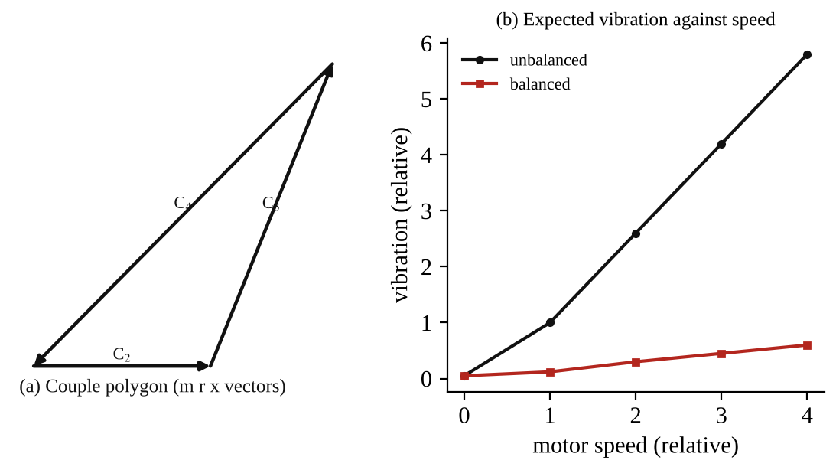
Fig. 2: (a) the couple polygon for the four blocks, (b) the expected shape of vibration against speed for an unbalanced and a balanced rotor (illustration, not measured).

7. Discussion
Agreement with theory. The rig behaved as the theory predicts: with the force polygon and the couple polygon both closed, the rotor ran smoothly, and when one block was moved, at least one of the two conditions was broken and the frame shook. The angles worked out from the r values were within [ ]° of the manual's values (200°, 0° and 68°); the small differences come from the different measured r values, since the angles depend on the products w r and w r x.
Static against dynamic balance. The rig shows clearly the difference between the two. The shaft stays still at any angle when statically balanced (which only needs Σ m r = 0), but it still shakes at speed if the couple condition Σ m r x = 0 is not met. This is the reason the manual says a dynamically balanced shaft is automatically statically balanced but not the other way round. In practice, the usual method for a long rotor such as a crankshaft is to balance it in two planes, since a balancing mass in two chosen planes can always cancel both the force and the couple.
Sources of error
- The centre of gravity of each block was found by hanging it by a thread and judging the horizontal position by eye, so r is accurate only to about ±0.5 mm.
- Angles set on the protractor disc by eye have a reading error of about ±1°. A small error in angle gives a small residual unbalance.
- The blocks may not sit exactly square to the shaft, and the spacers may have small differences, which change x slightly.
- The weights of the blocks are nominal values (212, 206, 196 and 182 g) and may differ slightly from the real weights.
- The shaft itself, the bearing fits and the motor are not perfectly balanced, so some vibration will remain even when the calculation is exact.
- Judging "smooth running" by feel is subjective. A vibration meter or a dial indicator on the frame would give a number.
- A rotor with a flexible shaft would need balancing in more than two planes. The simple theory assumes a rigid shaft.

8. Conclusion
A four-mass rotor was balanced both statically and dynamically. The magnitude of the force and the angular positions of the masses needed for balance were determined from the force polygon and the couple polygon, giving θ₁ = [ ]°, θ₂ = 0° (reference), θ₃ = [ ]° and θ₄ = [ ]°, with the distance of the centre of gravity of each block from the axis measured as [ ] cm. When the blocks were set at these angles the rotor ran smoothly, and when any block was moved the vibration increased, which confirms the calculation. The experiment also showed that a statically balanced shaft is not always dynamically balanced, while a dynamically balanced shaft is automatically statically balanced. Practical applications: balancing of crankshafts, car wheels (the small lead weights on the rim), turbine and compressor rotors, electric motor armatures, fans, centrifuges and washing machine drums, wherever a spinning part would otherwise cause vibration, noise and bearing wear.

Section D: Questions
1. What have I gained from this experiment? I learnt why an unbalanced rotor vibrates, the difference between static and dynamic balance, and how to use the force polygon and the couple polygon to find the angles at which the masses must be placed.
4. Comment on the experimental procedure (accuracy and time saving) The procedure is suitable because each block is set to a calculated angle and the result is checked at once by running the motor, so a mistake shows up as vibration. It is also quick, since the calculation is done before the practical. The accuracy is limited by setting the angle by eye on the protractor disc.
5. Most difficult aspect of the experiment and how to reduce it Setting each block at the exact angle while it is being tightened, and finding the centre of gravity (r) of each block accurately. It can be reduced by using the right-angle set square, by locking the shaft with the locking bolt, and by taking the r measurements twice.
6. Another method / apparatus that could be used A balancing machine (a dynamic balancer) with vibration sensors, which measures the unbalance in two planes directly and tells you where to add or remove mass; or a graphical or computer solution of the same polygons.
7. Parameters required in this experiment Weight w of each block, distance of the centre of gravity r, force w r, distance x between the blocks, couple w r x, and the angle θ of each block.
8. One measuring instrument / gauge used The protractor (angle) disc, which sets and reads the angular position of each block. It has a circular scale in degrees and is read against a fixed pointer; the locking bolt holds the shaft at that angle.
9. Practical relevance / applications Balancing of crankshafts and engine parts, car wheels, turbines and compressors, motor armatures, fans, centrifuges and washing machine drums.
10. Section of the course it relates to Theory of machines (balancing of rotating masses and vibration).
14. What interested me most The vibration increased at once when I changed the position of just one block, which showed how sensitive a rotor is to unbalance.
2, 3, 11, 12, 13 and 15 (personal): to be filled in by you.
16. References (keep only the ones you actually used): Mechanical Engineering Laboratory Manual ELA 301; a fluid mechanics or theory of machines textbook of your course.

FM 314 (Part 2): Pressure Measurement: Bourdon Gauge Calibration, Liquid Column Manometers and Hare's Tube
The manual heads these pages "3.10 Pressure Measurement" and uses the H314 hydrostatics apparatus, but it does not print a separate experiment number, so I have put it with FM 314. Change the number if your lecturer calls it something else.

Objective
- To check the accuracy of a Bourdon pressure gauge by loading it with known pressures from a dead-weight tester, for both increasing and decreasing pressure, and to plot the gauge reading and the gauge error against the actual pressure.
- To study how liquid columns (U-tube and single-limb manometers) are used to measure pressure and pressure difference.
- To compare different fluids in the manometers and to find the specific gravity of a liquid with Hare's tube apparatus.

1. Theory
1.1 What pressure is and how it is measured
Pressure is the force a fluid exerts on each unit of area of a surface that is in contact with it:
p = F / A (1)
The SI unit is the newton per square metre (N/m²), called the pascal (Pa). Since this is a very small unit we normally use kN/m² (kPa) or bar (1 bar = 100 kN/m²). A fluid at rest presses on a surface at right angles to it, and at any point in the fluid the pressure is the same in every direction (Pascal's law).
Pressure can be measured from two different starting points (zero levels):
- Absolute pressure: measured from a perfect vacuum.
- Gauge pressure: measured from the pressure of the surrounding atmosphere, so that the gauge reads zero when it is open to the air. Most gauges and manometers read gauge pressure.
- The two are related by p_{abs} = p_{gauge} + p_{atm}, where p_{atm} is about 101.3 kN/m² (a little less on high ground). A pressure below atmospheric is a vacuum (negative gauge pressure).
Pressure measurement is important not just in fluid mechanics but in nearly every branch of engineering: boilers, hydraulic machines, pipelines, tyres, aircraft altimeters and cabin pressure, and process plants all depend on it. Many of the instruments used rely on hydrostatic principles, which is why this experiment is done on the hydrostatics bench.
1.2 Pressure in a static fluid
Consider a vertical column of liquid of constant density ρ, with constant cross-sectional area A and height h. The downward forces on the column are the pressure p₁ acting on the top over area A and the weight of the liquid, ρ g h A. For equilibrium the upward force from the pressure p₂ on the bottom must balance them:
p₂ A = p₁ A + ρ g h A so p₂ = p₁ + ρ g h (2)
The area cancels, which is why the shape of the container does not matter: the pressure at a point depends only on the vertical depth below the surface, the density of the liquid and g. Pressure therefore increases linearly with depth, and two points at the same level in the same continuous liquid are at the same pressure. This single idea (equation 2) is the basis of the manometer, the barometer and the Hare's tube. Also, a pressure can be expressed as a head of liquid: h = p / (ρ g). For water, 1 kN/m² corresponds to 1000 / (1000 × 9.81) = 0.102 m, about 102 mm of water.
1.3 The Bourdon pressure gauge
The Bourdon gauge is the commonest mechanical pressure gauge. Inside it is a thin-walled tube with an oval (flattened) cross-section, bent into an arc of about 270° (Fig. 1a). One end is held rigidly and is open to the pressure being measured, and the other end is sealed and free to move. When pressure is admitted, the pressure inside tries to make the oval section more circular. Because the tube is curved, the outside of the curve is longer than the inside, so this change of shape makes the tube straighten slightly. The free end therefore moves, and a small linkage with a toothed sector and pinion magnifies this movement and turns a pointer round a graduated dial. The movement of the pointer is intended to be proportional to the pressure applied. The sensitivity depends on the material and the dimensions of the tube, which is why gauges for many pressure ranges are made.
Calibration with a dead-weight tester. To find out how accurate a gauge is, it is loaded with known pressures. In the dead-weight tester, a piston of known cross-section area A fits in a cylinder filled with liquid (oil normally; water is used here) which is connected to the gauge. A mass M placed on the piston, together with the mass of the piston itself, produces a force Mg, so the pressure in the liquid is
p = M g / A (kN/m²: p = M × 9.81 / A × 10⁻³) (3)
with M in kg (the added masses plus the mass of the piston and its platform) and A in m². This is the "actual pressure" (known to a good accuracy since mass and diameter can be measured accurately). It is compared with what the gauge reads. The piston must be free to float, so it is turned gently to avoid sticking, which would make the actual pressure smaller than Mg/A.
Gauge error and hysteresis. The difference between the reading and the actual pressure is the gauge error:
error = gauge reading − actual pressure (4)
Two kinds of error are normally found. (i) Hysteresis, caused by friction and backlash in the mechanism and by elastic effects in the tube. The gauge reads lower when the pressure is increasing than when it is decreasing. It gives a "loop" between the up and down readings. The size is typically about 1 kN/m² for the gauge used here. (ii) Scale (calibration) error, because the dial may not be marked off exactly. This error usually increases with pressure up to about 2.5 % of the full-scale reading, which is acceptable for most engineering uses, although gauges with errors of only 0.5 % of full scale can be bought.
1.4 Liquid column manometers
A liquid column can be used to measure pressures in many arrangements, for both static and moving fluids. A barometer is a special case which measures absolute pressure (the pressure of the atmosphere, using a column of mercury over a vacuum). In general, though, liquid columns measure differential pressures, the difference in pressure between two points in a system. Strictly "manometer" means any instrument for measuring pressure, but in normal use it refers to liquid columns, particularly the U-tube.
The U-tube manometer (general case). In Fig. 1b a U-tube is filled with a heavier manometer liquid of density ρ₂ (it must not mix with the fluid being measured). The two limbs are connected to two points A and B (at the same level) of a system that contains a fluid of density ρ₁ (liquid or gas). The pressure at A is higher, so the manometer liquid is pushed down on the left and up on the right, making a height difference Δh between the two surfaces. Using equation (2) and the fact that pressures at the same level in the same liquid are equal (at the lower manometer surface):
p_{A} + ρ₁ g ( y + Δh ) = p_{B} + ρ₁ g y + ρ₂ g Δh
p_{A} − p_{B} = ( ρ₂ − ρ₁ ) g Δh (5)
The unknown depth y (from the taps to the upper surface) cancels out. So the pressure difference depends only on Δh and on the difference in the two densities. If the fluid being measured is a gas such as air, ρ₁ is very small compared with ρ₂ and the formula becomes p_{A} − p_{B} = ρ₂ g Δh. If one limb is open to the atmosphere, the result is the gauge pressure of the other limb, p = ρ₂ g Δh. The manometers on the H314 apparatus all have one column open to atmospheric pressure, which gives a common datum.
Choice of manometer liquid. For a given pressure, the lighter the manometer liquid, the larger Δh, so the instrument is more sensitive, and for a large pressure range a heavy liquid like mercury keeps the column short. The liquid must not mix with, or react with, the fluid being measured, and should have a clear and sharp meniscus. Two liquids in the same manometer subjected to the same pressure give heights in inverse proportion to their densities: ρ_{a} Δh_{a} = ρ_{b} Δh_{b}.
Direct-reading (unequal limb) manometers. Finding Δh as the difference of two readings is laborious, and it would be easier to take one reading. If the limbs were of equal area, each surface would move Δh/2 from its starting level and the reading on one limb could simply be doubled, but this loses accuracy. The better way is to use limbs with different cross-sectional areas a₁ (narrow tube) and a₂ (wide reservoir) (Fig. 1c). The liquid volume that leaves one limb enters the other, so
a₁ Δh₁ = a₂ Δh₂ so Δh₂ = Δh₁ ( a₁ / a₂ ) (6)
Δh = Δh₁ + Δh₂ = Δh₁ ( 1 + a₁ / a₂ ) (7)
If a₂ is made large compared with a₁, nearly all the movement is in the narrow limb, the term a₁/a₂ is very small, and the pressure can be read from the narrow limb alone. This is the common "single-limb" or reservoir manometer. Equation (7) can be used to mark a scale on the narrow limb that reads Δh directly. The pressure is still given by equations (5) and (3), since the area of the limbs does not affect the pressure difference.
Effect of the water in the connecting tubes. On the H314 apparatus the connecting tubes are filled with water, and the heights are measured to a datum, so a small correction of the form ρ₁ g (h₁ − h₂) must be included in equation (5). This correction is constant if the height of the columns above the tapping at zero pressure difference is taken as the datum, and can be removed by setting the zero before the reading.
1.5 Hare's tube: specific gravity by suction
Hare's apparatus finds the specific gravity (relative density) of a liquid by comparing it with water. Two vertical glass tubes dip into two beakers, one with water and one with the other liquid, with the liquid surfaces at the same level. The tops of the tubes are joined together and to a suction bulb. When air is sucked out, the pressure above the liquid in both tubes falls to the same value p_{s}, below atmospheric pressure p_{atm}. In each tube the liquid column is held up by the difference between the atmospheric pressure acting on the free surface in the beaker and p_{s}. Using equation (2) in each tube:
p_{atm} − p_{s} = ρ_{w} g h_{w} = ρ_{x} g h_{x}
Specific gravity of the liquid = ρ_{x} / ρ_{w} = h_{w} / h_{x} (8)
The height of the column is inversely proportional to the density of the liquid: the denser liquid rises less. The specific gravity is simply the ratio of the two column heights, which is the formula in the manual. The liquid levels in the beakers must be the same and the tubes must be at the same depth, so that the heights are measured from the same datum. Because only a ratio of heights is needed, no density or volume measurement is required.

2. Apparatus
The H314 hydrostatics apparatus: (1) a Bourdon pressure gauge calibrator, with a transparent cylinder with a lightly oiled piston, a set of calibration masses (up to 5.2 kg in total), and the Bourdon gauge connected to the cylinder; (2) liquid column manometers fitted to the rear panel, namely an air/water manometer open to the atmosphere and a second fluid manometer, with an isolating valve (V3), an air pump fitted to a Schrader valve, and water supply lines from which the air bubbles are removed; (3) Hare's tube apparatus with two 100 ml beakers, two vertical glass tubes at the same height, a suction bulb with a built-in one-way valve, and a small hand-operated valve under the bulb to retain the suction. A rule or a stopwatch is not needed; a vernier caliper or a rule is used to measure the diameter of the piston.
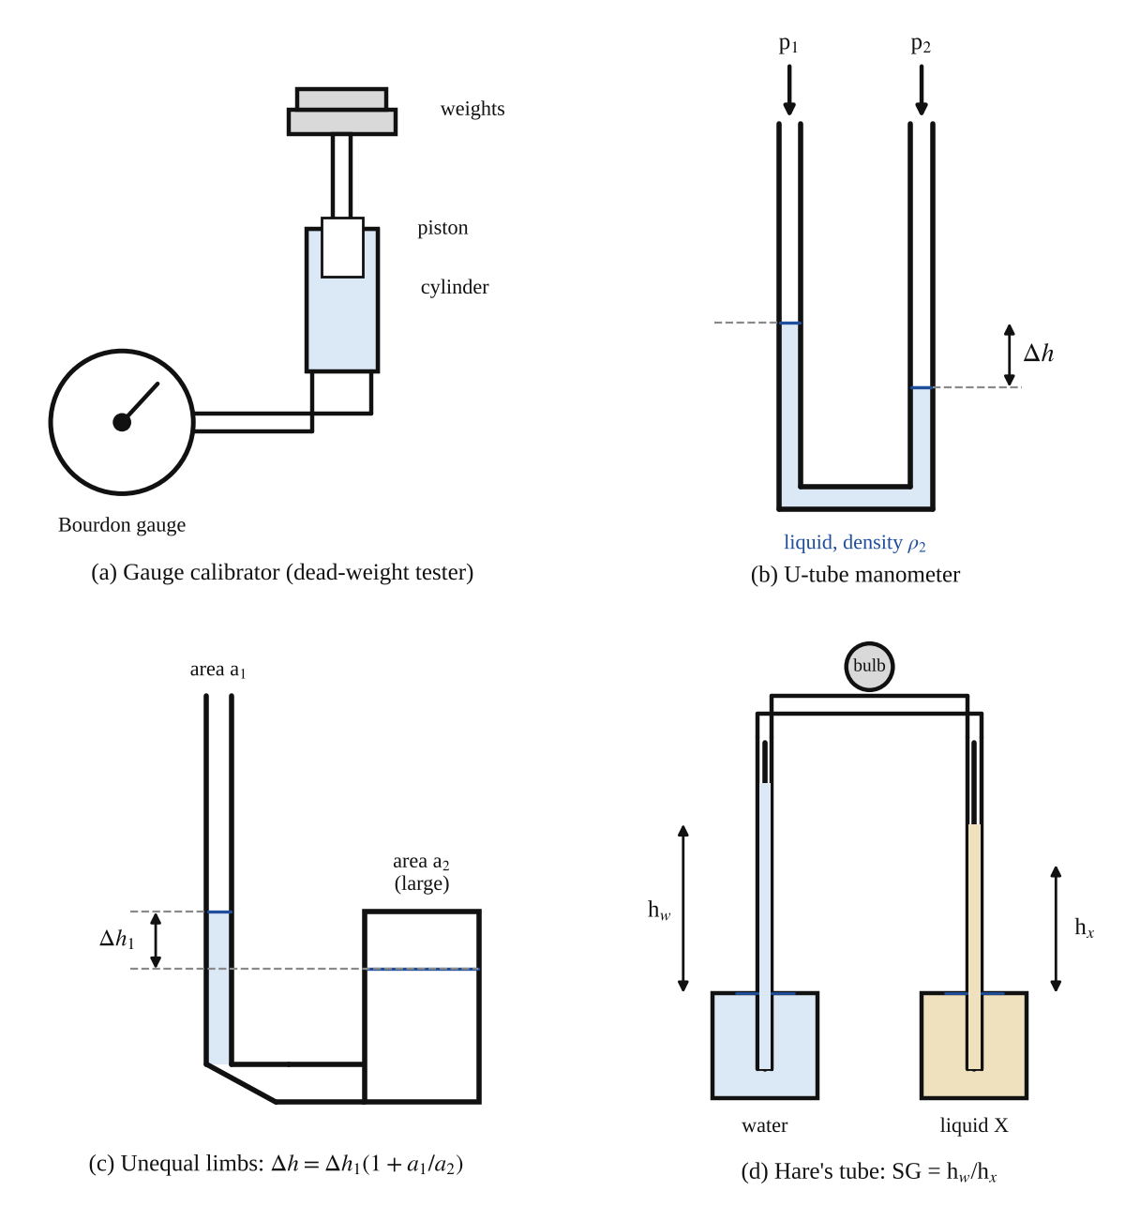
Fig. 1: (a) Bourdon gauge calibrator (dead-weight tester), (b) U-tube manometer, (c) manometer with unequal limbs, (d) Hare's tube apparatus.
Method in brief
- Gauge calibration. Remove the piston (it is lightly oiled; wipe it only when the unit is to be used), fill the cylinder with water and remove trapped air by tapping gently. Top up with water, insert the piston and let the excess water and air escape through the hole in the side of the cylinder. Let the piston settle. Note the mass of the piston and its platform and the cross-sectional area of the piston.
- With the cylinder vertical, add the masses in about eight increments to a maximum of 5.2 kg, taking the gauge reading after each addition. Load the masses gradually and carefully and do not drop them onto the platform. Rotate the piston gently as each mass is added so that it does not stick. Then reverse the procedure by taking the masses off one by one, and read the gauge for decreasing pressure.
- Manometer comparison. With the isolating valve on the pipe (V3) open to the air/water manometer, attach the air pump to the Schrader valve and pump gently until a pressure is registered on both the fluid and the water manometers. Compare the two readings until the water manometer approaches the limit of its range. Then isolate the water manometer and increase the pressure until the fluid manometer is at full capacity. To vent, insert the top of the Schrader valve cap into the centre of the valve, open the isolating valve for the water manometer and vent again through the Schrader valve.
- Hare's tube. Fill one 100 ml beaker with water and the other with the liquid under test, to the same level. Place the beakers under the vertical glass tubes at the same height so that the tubes go into the liquid. Open the small valve under the bulb fully, squeeze the bulb and release it slowly to draw the two liquids up the tubes. Shut the small valve to keep the liquids in the tubes. Record the liquid levels, then open the valve again to let the liquids return to the beakers (squeeze the bulb a few times if needed).

3. Results
Piston diameter d = [ ] mm, area A = πd²/4 = [ ] m². Mass of piston and platform = [ ] kg. g = 9.81 m/s².
Table 1: Results for increasing and decreasing pressure (gauge calibration)
Mass added to piston (kg) | Total mass on piston M (kg) | Actual pressure P (kN/m²) | Increasing: gauge reading (kN/m²) | Increasing: gauge error (kN/m²) | Decreasing: gauge reading (kN/m²) | Decreasing: gauge error (kN/m²)

Table 2: Comparison of two manometers connected to the same air pressure
Reading no. | Water manometer h_{w} (mm) | Other fluid manometer h_{f} (mm) | Ratio h_{w} / h_{f} | Pressure ρ_{w} g h_{w} (N/m²)

Table 3: Hare's tube results
Trial | Height of water column h_{w} (mm) | Height of other liquid h_{x} (mm) | SG = h_{w} / h_{x}
1
2
3

4. Analysis of Results
- Actual pressure from equation (3): P = M × 9.81 / A × 10⁻³ = [ ] × 9.81 ÷ [ ] × 10⁻³ = [ ] kN/m². M includes the added masses and the piston with its platform.
- Gauge error for each point: error = gauge reading − actual pressure = [ ] − [ ] = [ ] kN/m² (both for increasing and decreasing pressure).
- Hysteresis at each pressure = (decreasing reading) − (increasing reading) = [ ] kN/m². Largest value = [ ] kN/m², at P = [ ] kN/m².
- Error as a percentage of the full-scale reading = (largest error ÷ full-scale reading) × 100 = [ ] ÷ [ ] × 100 = [ ] %.
- Check on the dead-weight method: a gauge reading of the same size as P means the piston friction is small. If the readings are always lower than P on the way up, part of the load is being carried by friction.
- Manometer comparison: for the same pressure, ρ_{w} h_{w} = ρ_{f} h_{f}, so the density of the second manometer fluid is ρ_{f} = ρ_{w} (h_{w}/h_{f}) = 1000 × [ ] = [ ] kg/m³, and its specific gravity is [ ]. The pressure from the water manometer is p = ρ g h = 1000 × 9.81 × [ ] = [ ] N/m².
- Equivalent head: for a pressure of P kN/m² the head of water is h = P / 9.81 m of water. For P = [ ], h = [ ] m, which should be close to the water manometer reading.
- Unequal limb correction: Δh = Δh₁ (1 + a₁/a₂) = [ ] × (1 + [ ]) = [ ] mm.
- Specific gravity by Hare's tube (equation 8): SG = h_{w} / h_{x} = [ ] ÷ [ ] = [ ] (mean of three trials = [ ]); density = SG × 1000 = [ ] kg/m³.

5. Observations / Precautions Taken
Observations
- The gauge reading increased with every added mass, and the readings were a little lower when the pressure was increasing than when it was decreasing.
- The errors were small (about 1 kN/m² on the whole scale in the typical case) but a little larger at higher pressure.
- When air was pumped in, the water manometer and the other fluid manometer both responded together, and the lighter fluid showed the larger deflection.
- In Hare's tube the denser liquid rose less than the water, and the heights stayed in the same ratio however hard the bulb was squeezed.
Precautions
- The piston was lightly oiled and wiped only when the unit was to be used. After the experiment its surface was smeared lightly with oil (no emery cloth or abrasive was used on it).
- The cylinder was kept vertical, and air was removed by gentle tapping, since a little air left in the system does not affect the result.
- Masses were added gradually and not dropped, and the piston was rotated gently while loading and unloading so that it did not stick. Only the supplied masses were used (not more than 5.2 kg in total).
- In the manometers, bubbles were removed from the water lines. The air was pumped in gently and the pressure was not allowed to go beyond the range of the water manometer.
- Readings were taken at eye level, at the bottom of the meniscus of the water.
- In Hare's tube the two liquids were set at the same level, the tubes were at the same height, and the small valve was closed before reading the levels.

6. Graphs
Plot the following on graph paper from your own readings and attach them here:
- Gauge reading against actual pressure, for increasing and decreasing pressure on the same axes (with the ideal line, reading = actual, as a dashed line).
- Gauge error against actual pressure, for increasing and decreasing pressure (Fig. 2).
- Optional: water manometer height h_{w} against the other manometer height h_{f}, a straight line through the origin whose slope is ρ_{f}/ρ_{w} (since ρ_{w} h_{w} = ρ_{f} h_{f}).
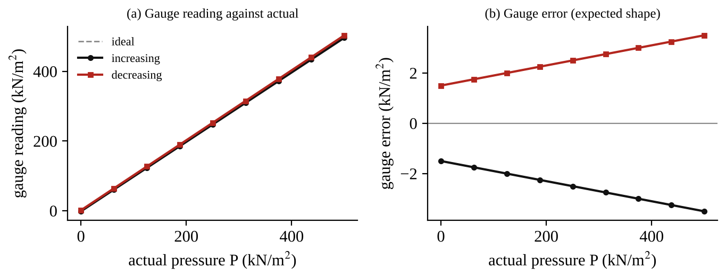
Fig. 2: The expected form of the gauge calibration graphs (illustration, not measured results).

7. Discussion
Agreement with theory. The graph of gauge reading against actual pressure should be a straight line close to the ideal line of slope 1, since a Bourdon tube deflects in proportion to the pressure. The two curves for increasing and decreasing pressure should lie on either side of this line and form a narrow loop, which is the hysteresis. In my results the largest error was [ ] kN/m² ([ ] % of full scale), which is [ within / outside ] the typical 2.5 % that is acceptable for general engineering uses.
Manometers. The readings of the two manometer fluids for the same pressure were in inverse proportion to their densities, as given by equation (5) when one limb is open to the air. The more sensitive instrument is the one with the lighter liquid, but it has a shorter range. The unequal limb manometer allows a single reading, and the error from neglecting the movement of the large limb is of the order a₁/a₂.
Hare's tube. The specific gravity found was [ ], which should be compared with a table value for the liquid used [ ] (the difference is [ ] %). The method gives the result as a simple ratio of two heights, so it is useful for quick comparisons, but its accuracy is limited by the height reading, by the meniscus and by the capillary rise in the narrow tubes.
Sources of error
- Friction between the piston and the cylinder (the piston must float freely) and friction and backlash in the gauge movement (hysteresis).
- Reading the pointer of the gauge by eye, with a parallax error if it is not read from directly in front.
- The mass of the piston and platform may not be known exactly, and its diameter measured with a small error (the area depends on d², so a 1 % error in d gives about a 2 % error in P).
- Air left in the cylinder or in the manometer tubes, which makes the readings sluggish.
- Reading the manometer menisci (meniscus and capillary effects in narrow tubes), and any difference between the zero levels.
- Temperature changes affect the density of the liquids, but this effect is small here.
- In Hare's tube, the liquid levels in the beakers and the immersion depth of the tubes were not exactly equal, and the liquid surfaces move as the liquid is sucked up.

8. Conclusion
The Bourdon gauge was calibrated against known pressures from a dead-weight tester. The gauge error was at most [ ] kN/m² ([ ] % of full scale) and the hysteresis was up to [ ] kN/m², so the gauge is [ accurate enough / not accurate enough ] for ordinary engineering use. The liquid column manometers gave pressure readings consistent with p = ρ g Δh, the heights of two different manometer liquids being inversely proportional to their densities. Hare's tube gave a specific gravity of [ ] for the unknown liquid, using SG = h_{w}/h_{x}. Practical applications: pressure gauges in boilers, pipelines, compressors and hydraulic systems; manometers for ventilation and air flow, for small pressure differences and for calibrating other instruments; dead-weight testers as a standard for calibrating industrial gauges; and Hare's tube and hydrometers for finding liquid densities.

Section D: Questions
1. What have I gained from this experiment? I learnt how a Bourdon gauge works, how it is checked with a dead-weight tester, why a gauge shows hysteresis, how liquid column manometers measure pressure with p = ρ g Δh, and how Hare's tube compares two liquids.
4. Comment on the experimental procedure (accuracy and time saving) The dead-weight method is suitable because the actual pressure comes from known masses and a measured area, so it is very accurate, and going up and down gives the hysteresis as well. It takes only a little time. The manometer readings are quick, but they depend on reading the meniscus.
5. Most difficult aspect of the experiment and how to reduce it Getting the piston to float freely without sticking, and removing all the air from the system. It can be reduced by rotating the piston gently, by oiling it lightly, and by tapping the unit to release air.
6. Another method / apparatus that could be used A digital pressure transducer or a pressure sensor with a data logger to check the Bourdon gauge, or a mercury U-tube manometer or a standard test gauge.
7. Parameters required in this experiment Mass on the piston, area of the piston, actual pressure, gauge reading (increasing and decreasing), gauge error, heights of liquid columns, and the density of the liquids.
8. One measuring instrument / gauge used The Bourdon pressure gauge. A curved flattened tube straightens with pressure, and a sector and pinion move the pointer over the scale in kN/m². It is read directly from the dial.
9. Practical relevance / applications Pressure gauges on boilers, compressors, pipelines, hydraulic presses, tyres, and calibration with dead-weight testers; manometers in ventilation ducts and laboratories; Hare's tube and hydrometers for liquid density.
10. Section of the course it relates to Fluid mechanics (hydrostatics and pressure measurement).
14. What interested me most That a few kilograms on a small piston can be read as a pressure on a dial, and that the gauge reads slightly different values going up and going down.
2, 3, 11, 12, 13 and 15 (personal): to be filled in by you.
16. References (keep only the ones you actually used): Mechanical Engineering Laboratory Manual ELA 301; a fluid mechanics or theory of machines textbook of your course.

FM 313: Forces on Plane Surfaces: Centre of Pressure

Objective
- To measure the moment of the total hydrostatic thrust on a plane surface (fully and partly submerged) about a fixed pivot, using a quadrant tank on a balance.
- To compare the measured moment with the theoretical value, and to locate the centre of pressure, defined as the point in a plane at which the total fluid thrust can be said to act normal to that plane.

1. Theory
1.1 Pressure and force on a submerged surface
A fluid at rest produces a force on every surface it touches. This force always acts at right angles to the surface (a fluid at rest cannot carry shear). The pressure at a depth z below the free surface of a liquid of density ρ is p = ρ g z (gauge pressure), so the pressure is zero at the surface and increases uniformly with depth. Written as a force per unit area, we use the specific weight ω = ρ g (N/m³); for water ω = 1000 × 9.81 = 9810 N/m³.
On a plane surface which is vertical or tilted, the pressure is not the same at all points, because the deeper parts feel a larger pressure. So the total force (the thrust) has to be found by adding up (integrating) the small forces on thin strips. Take a plane surface of area A that is inclined at an angle to the free surface, and a small strip of area δA at a vertical depth z. The force on the strip is δF = p δA = ω z δA, and the total thrust is
F = ∫ ω z dA = ω ∫ z dA = ω A z̄ (1)
because ∫ z dA is the first moment of area about the free surface, which equals the area times the depth z̄ of its centroid. So the thrust on any plane surface equals the pressure at the centroid multiplied by the area: F = ρ g z̄ A. This is a very useful result, but notice it only gives the size of the force. To know the moment it produces we must also know where it acts.
1.2 The centre of pressure
The centre of pressure is the point on the plane where the total thrust can be said to act so that it produces the same moment as the real, distributed pressure. It is always below the centroid (for a surface that is not horizontal) because the pressure is greater at greater depth. For a plane surface inclined at angle α to the horizontal, taking moments about the free-surface line, the depth of the centre of pressure z_{p} comes out as
z_{p} = z̄ + I_{G} sin²α / ( A z̄ ) (2)
where I_{G} is the second moment of area of the surface about its own centroidal axis in the plane of the surface (parallel to the free surface). For a vertical plane (α = 90°) this is z_{p} = z̄ + I_{G}/(A z̄). For a rectangle of breadth B and depth d, I_{G} = B d³/12. The result shows that the centre of pressure sinks deeper below the centroid when the surface is only just below the surface (z̄ small) and gets closer to the centroid the deeper it is submerged (then the pressure is almost uniform). Example: a vertical rectangle with its top edge at the free surface has z̄ = d/2, A = Bd, I_{G} = Bd³/12, so z_{p} = d/2 + (Bd³/12)/(Bd × d/2) = d/2 + d/6 = 2d/3. The thrust acts two-thirds of the way down. This agrees with the triangular pressure diagram: the centre of area of a triangle is at 2/3 of its height from the apex.
The centre of pressure is important because it is the point about which the thrust produces no turning effect if it is held there; in engineering it tells us where to put supports and what moment a gate, a lock door or a dam wall must resist.
1.3 The apparatus and why it measures the moment directly
The apparatus is a quadrant-shaped tank that is part of a balance (Fig. 1). The tank is bounded by two concentric circular arcs of radius R₁ = 100 mm and R₂ = 200 mm, centred on the pivot O of the balance, by the vertical (or tilted) plane surface whose centre of pressure we want, and by a horizontal top. Water is poured into the tank. The pressure on a curved surface always acts at right angles to the surface, and on a circular arc this direction is along a radius, so it passes through the centre O. The forces on the two circular sides therefore have no moment about O. The thrust on the end faces is also in line (they are the sides of the tank). The only force that gives a moment about O is the thrust on the plane surface, so the moment which has to be balanced by the weights is the moment of the fluid thrust on the plane surface. This is the real use of the apparatus: it lets the moment be measured directly with weights on a hanger at the other end of the balance, with no force measurement of the water thrust.
The plane surface has breadth B = 75 mm. It extends along its length from R₁ to R₂ (100 mm to 200 mm) from the pivot. The balance can be tilted to bring the plane to an angle θ from the vertical, but for this part the balance is trimmed to the vertical position (θ = 0°). A second small tank, on the same side as the weight hanger, is used for trimming, and a scale on the quadrant tank gives the water level, h, below the pivot O.
1.4 Theory of the moment about O
Let O be the pivot, the plane be at an angle θ to the vertical, and the water surface be a vertical distance h below O. Consider a strip of width δy of the plane at a distance y from O measured along the plane (Fig. 1). Its vertical depth below O is y cos θ, so its depth below the water surface is (y cos θ − h). Using the specific weight ω:
force on the strip: δF = ω ( y cos θ − h ) B δy
moment of the strip about O: δM = ω B ( y cos θ − h ) y δy
Total moment about O: M = ω B ∫ ( y² cos θ − h y ) dy (3)
Case 1: the plane is fully submerged (the water is above the top edge of the plane). The limits of integration are R₁ to R₂:
M = ω B [ y³ cos θ / 3 − h y² / 2 ] from R₁ to R₂
M = ( ω B cos θ / 3 ) ( R₂³ − R₁³ ) − ( ω B / 2 ) ( R₂² − R₁² ) h (4)
This equation has the form y = m x + c. So a graph of M against h is a straight line whose gradient is −(ω B / 2)(R₂² − R₁²) and whose intercept is (ω B cos θ / 3)(R₂³ − R₁³). The value of ω can be found from the gradient, and compared with 9810 N/m³.
Case 2: the plane is partly submerged (the water surface is below the top edge). Now only the part below the water surface counts, so the lower limit is where the water surface meets the plane, y = h sec θ, and the upper limit is R₂:
M = ω B ∫ ( y² cos θ − h y ) dy from h sec θ to R₂
M = ( ω B cos θ / 3 ) ( R₂³ − h³ sec³ θ ) − ( ω B h / 2 ) ( R₂² − h² sec² θ ) (5)
For the vertical plane, θ = 0, so sec θ = 1 and cos θ = 1, and this simplifies to
M = ω B [ R₂³/3 − h R₂²/2 + h³/6 ] (6)
Rearranging so that the experimental variable h appears in a straight-line form:
M + ω B R₂² h / 2 = ω B R₂³ / 3 + ( ω B / 6 ) h³ (7)
So a graph of (M + ω B R₂² h / 2) against h³ is a straight line with gradient ω B/6 and intercept ω B R₂³/3. This is the plot required in the manual (the table has the column M + ω B R₂² h/2 and the column h³). The value of ω already obtained from Case 1 is used in the quantity ω B R₂² h/2.
Thrust and the position of the centre of pressure. The thrust on the plane (partly submerged, vertical) is F = ω B ∫ (y − h) dy from h to R₂, which gives F = ω B (R₂ − h)² / 2 (the pressure at the centroid times the wetted area). Dividing the moment by the thrust gives the distance of the centre of pressure from the pivot:
y_{p} = M / F (8)
For the vertical partly-submerged plane the theory above says the centre of pressure is two-thirds of the way down the wetted part, measured from the water surface: y_{p} = h + (2/3)(R₂ − h). Both ways of finding y_{p} should agree, and this is a check of the whole analysis. (For the fully submerged plane the centre of pressure lies below the centroid of the plane by I_{G}/(A z̄).)
The experimental moment. At balance the plane is held in the vertical position (θ = 0°) by a weight of mass m on the hanger at a distance L from the pivot. The tilting moment of the water about O is balanced by the moment of the weight, so M = m g L (taking the trim as the reference, so only the additional weight counts). L is the arm of the weight hanger from the pivot; it is a fixed dimension of the apparatus which is marked on it (measure it if it is not marked).
The manual notes that SECTION 4.0 gives an alternative theory for this experiment. The result above is the same: the moment of the thrust about the pivot is what is measured.

2. Apparatus
A quadrant tank assembly (cylindrical sides of radius R₁ = 100 mm and R₂ = 200 mm, rectangular plane surface of breadth B = 75 mm) mounted on a balance with its pivot O at the centre of the arcs; a weight hanger, a second weight hanger and a set of weights; a trim tank; a scale on the quadrant tank for reading the water level h below the pivot; coloured dye; a pipette to remove excess water; a water supply or jug.
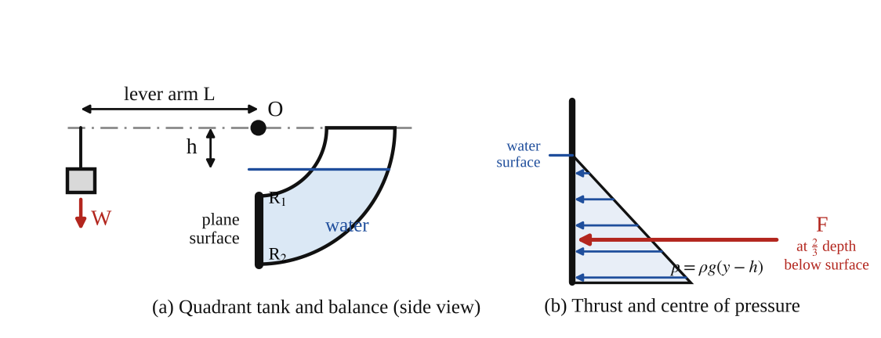
Fig. 1: (a) quadrant tank and balance, with the water level h below the pivot O and the weight W at lever arm L; (b) the pressure distribution on the vertical plane and the thrust F acting at the centre of pressure (two-thirds of the depth).
Method in brief
- Before each experiment make sure both tanks are empty and trim the assembly to bring the submerged plane to the vertical (θ = 0°) position: pour water gently into the trim tank until the balance reaches the 0° position. If necessary, add a weight hanger and a few masses to help (hook it to the bar next to the trim tank). Use the pipette (supplied) to remove excess water.
- Add the second weight hanger and some weight. Pour water into the quadrant tank until the 0° balance is restored. Note the additional weight (not the trim weight) and the level of the water h on the scale.
- Repeat for the full range of weights (from a small weight, when the plane is only partly submerged, up to a larger weight when the plane is fully submerged). A few drops of dye in the water make the level easier to see.
- Tabulate the results as in Table 1 and calculate with the theory above.

3. Results
Breadth of plane B = 75 mm; R₁ = 100 mm; R₂ = 200 mm; lever arm of the weight hanger L = [ ] mm; g = 9.81 m/s²; specific weight of water ω = 9810 N/m³.
Table 1: Format of results table: centre of pressure for the vertical plane (θ = 0°)
Added mass m (g) | M = m g L /10³ (N m) | h (mm) | h (m) | h³ (m³) | M + ω B R₂² h/2 (N m)

Table 2: Theoretical values for these dimensions (θ = 0°, ω = 9810 N/m³), for comparison with Table 1
h (mm) | State of plane | Theoretical M (N m) | Thrust F (N) | y_{p} = M/F (mm) | M + ω B R₂² h/2 (N m)
0 | fully submerged | 1.717 | 11.04 | 155.6 | 1.717
20 | fully submerged | 1.496 | 9.57 | 156.4 | 1.790
40 | fully submerged | 1.275 | 8.09 | 157.6 | 1.864
60 | fully submerged | 1.055 | 6.62 | 159.3 | 1.938
80 | fully submerged | 0.834 | 5.15 | 161.9 | 2.011
100 | just submerged | 0.613 | 3.68 | 166.7 | 2.085
120 | partly submerged | 0.408 | 2.35 | 173.3 | 2.174
140 | partly submerged | 0.238 | 1.32 | 180.0 | 2.299
160 | partly submerged | 0.110 | 0.59 | 186.7 | 2.464
180 | partly submerged | 0.028 | 0.15 | 193.3 | 2.677

Table 2 is calculated, not measured. It comes from equations (4) and (6), with the dimensions printed in the manual (B = 75 mm, R₁ = 100 mm, R₂ = 200 mm), and tells you what your results should look like: M falls from about 1.7 N m (tank full) to zero as the water level drops to the bottom edge of the plane. The weights you need are m = M / (g L).

4. Analysis of Results
- Moment from the weights: M = m g L = [ ] × 9.81 × [ ] ÷ 10⁶ = [ ] N m (m in g and L in mm), for each reading.
- Fully submerged readings (h < 100 mm), Case 1: plot M against h. Gradient = ΔM/Δh = [ ] ÷ [ ] = [ ] N m per m. Equating this to −(ω B/2)(R₂² − R₁²) gives ω = −2 × gradient ÷ [ B (R₂² − R₁²) ] = [ ] N/m³ (compare 9810 N/m³). The intercept at h = 0 is [ ] N m (theory 1.717 N m).
- Partly submerged readings (h > 100 mm), Case 2: calculate M + ω B R₂² h / 2 = [ ] + 9810 × 0.075 × 0.2² × [ ] ÷ 2 = [ ] N m, using ω from Case 1 (or 9810). Plot this against h³. Gradient = [ ] N m/m³ (theory ω B/6 = 122.6 N m/m³), intercept = [ ] N m (theory ω B R₂³/3 = 1.962 N m).
- Thrust: F = ω B (R₂ − h)² / 2 = [ ] N for the partly submerged readings, and F = ω B [ (R₂² − R₁²)/2 − h (R₂ − R₁) ] = [ ] N for the fully submerged ones.
- Centre of pressure: y_{p} = M / F = [ ] ÷ [ ] = [ ] m below the pivot. For the partly submerged plane the theory gives y_{p} = h + (2/3)(R₂ − h) = [ ] m. Percentage difference = [ ] %.
- Comparison with theory: theoretical M (Table 2 or equation 4 and 6) = [ ] N m against the measured [ ] N m, a difference of [ ] % at each h.
Worked check using the printed dimensions (not your data). At h = 120 mm the plane is partly submerged. M = ω B [R₂³/3 − h R₂²/2 + h³/6] = 735.75 × [0.0026667 − 0.0024 + 0.000288] = 0.408 N m. The thrust is F = ω B (R₂ − h)²/2 = 735.75 × 0.08²/2 = 2.35 N. So y_{p} = 0.408 / 2.35 = 0.173 m. The 2/3-depth rule gives 0.12 + (2/3)(0.08) = 0.173 m, which agrees.

5. Observations / Precautions Taken
Observations
- A larger weight was needed to hold the balance at 0° when the water level in the tank was higher, and the weight needed became zero when the tank was empty.
- The weight needed fell steadily with h while the plane was fully submerged, and fell faster, in a curve, when the plane was only partly submerged.
- The water surface was easy to read when the dye was used. The balance came to rest slowly because of the water surface moving.
- The points of M against h (fully submerged) lay close to a straight line, and those of M + ω B R₂² h/2 against h³ also lay close to a straight line.
Precautions
- Both tanks were empty and the assembly was trimmed to the vertical (0°) position before each experiment.
- The water was poured in gently, so that the balance was not disturbed and no splashing was caused.
- The additional weight was recorded without the trim weight.
- Excess water was removed with the pipette (by dipping it into the tank and holding the water with a finger on top), and not by tipping the balance.
- The water level was read at eye level on the scale, at the bottom of the meniscus.
- Only a few drops of dye were used so that the density of the water was not changed.
- The lever arm L was measured or read from the apparatus, and not assumed.

6. Graphs
Plot the following on graph paper from your own readings and attach them here:
- M against h for the fully submerged plane (a straight line; gradient −(ω B/2)(R₂² − R₁²), used to find ω).
- M + ω B R₂² h / 2 against h³ for the partly submerged plane (a straight line; gradient ω B/6, intercept ω B R₂³/3).
- Optional: experimental and theoretical M against h on the same axes.
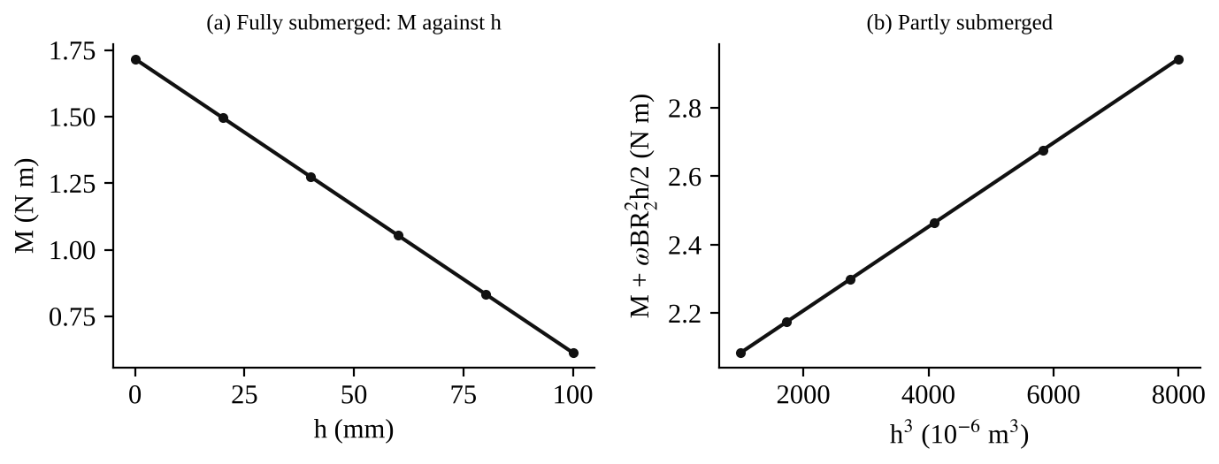
Fig. 2: The expected form of the two graphs for the given dimensions (calculated from theory, not measured).

7. Discussion
Agreement with theory. If the experiment has been done carefully, the experimental moments should agree with equations (4) and (6) within a few per cent, and the specific weight ω obtained from the gradient should be close to 9810 N/m³. The experimental centre of pressure y_{p} = M/F should lie at two-thirds of the wetted depth below the surface for the partly submerged vertical plane. In my results the difference between the experimental and the theoretical moment was [ ] % at the worst point and the value of ω was [ ] N/m³ ([ ] % from 9810).
Why the centre of pressure is below the centroid. The thrust is not at the centroid of the wetted area because the pressure increases with depth, so the lower part of the plane carries more of the load. As the plane goes deeper below the surface the pressure becomes more uniform and the centre of pressure moves towards the centroid. The theory (equation 2) gives z_{p} − z̄ = I_{G}/(A z̄) for the vertical plane, which tends to zero when z̄ is large. The experiment shows this: y_{p} in Table 2 is 155.6 mm when the plane is fully submerged with the surface at the pivot (the centroid is at 150 mm) and the difference is smaller than for the partly submerged case.
Sources of error
- Reading the water level on the scale (parallax and meniscus) is accurate only to about ±1 mm. Since M depends on h² and h³, a small error in h matters most at small water levels.
- The balance does not come to rest exactly at 0°, because of friction in the pivot and the movement of the water surface. The "0° position" is judged by eye.
- Water on the sides of the tank or a drop left on the hanger changes the balance slightly, and the trim weight must be exactly the same for each reading.
- The lever arm L and the dimensions R₁, R₂ and B are taken from the apparatus and are only accurate to the machining tolerance.
- The specific weight of water changes slightly with temperature and with the dye added.
- The theory assumes the pressure on the curved sides passes exactly through the pivot, which requires the arcs to be concentric with the pivot.

8. Conclusion
The moment of the hydrostatic thrust on a plane surface about a pivot was measured using a quadrant tank balance and was compared with the theory. For the fully submerged plane, M varied linearly with the water level h, and the gradient gave ω = [ ] N/m³ (theory 9810 N/m³). For the partly submerged plane, the plot of M + ω B R₂² h/2 against h³ was a straight line, as theory predicts. The centre of pressure was found to lie at [ ] m below the pivot, below the centroid of the wetted area, and close to two-thirds of the wetted depth for the partly submerged plane, in agreement with theory. Practical applications: design of dam walls, sluice gates, lock gates, the sides of tanks and ships, and the hinges and supports of inclined gates, since it is the centre of pressure and the thrust that fix the moment on the hinge or the foundation.

Section D: Questions
1. What have I gained from this experiment? I learnt how to find the thrust and the centre of pressure on a submerged plane, why the pressure on the curved sides passes through the pivot, and how the straight line graphs give the specific weight of water.
4. Comment on the experimental procedure (accuracy and time saving) The procedure is suitable because the quadrant tank gives the moment directly from weights, with no need to measure the thrust, so the accuracy is good. It is quick since only the added weight and the water level are measured, but the balance takes a while to settle.
5. Most difficult aspect of the experiment and how to reduce it Judging when the balance has returned exactly to 0° and reading the water level accurately. It can be reduced by adding dye to the water, reading the scale at eye level, waiting for the water to settle and using the pipette for small adjustments.
6. Another method / apparatus that could be used A pressure sensor or a force transducer on a flat plate in a tank, or the hydrostatic pressure apparatus with the plane immersed in a rectangular tank on a balance arm.
7. Parameters required in this experiment Added weight (mass) m, lever arm L, water level h below the pivot, moment M, breadth B, radii R₁ and R₂, specific weight ω, thrust F and centre of pressure y_{p}.
8. One measuring instrument / gauge used The balance with the weight hanger and masses, and the level scale on the quadrant tank. The balance shows when the plane is at 0° and the scale is read in mm.
9. Practical relevance / applications Design of dams, sluice gates, lock gates, tank walls, ship hulls and the hinges and supports of gates and hatches.
10. Section of the course it relates to Fluid mechanics (hydrostatics: forces on submerged surfaces).
14. What interested me most That the pressure on the curved sides has no moment about the pivot, so only the flat plane matters, which makes the experiment possible.
2, 3, 11, 12, 13 and 15 (personal): to be filled in by you.
16. References (keep only the ones you actually used): Mechanical Engineering Laboratory Manual ELA 301; a fluid mechanics or theory of machines textbook of your course.

FM 311: Buoyancy, Flotation and Stability of Floating Bodies

Objective
- To verify Archimedes' principle: the upthrust on a body immersed in a liquid equals the weight of the liquid it displaces.
- To study the stability of a floating pontoon (a rectangular floating body) by finding its metacentric height GM from the tilt produced by moving a weight sideways, to compare it with the theoretical value, and to see how GM changes with the height of the centre of gravity.

1. Theory
1.1 Pressure, upthrust and Archimedes' principle
In a liquid at rest, the pressure at a depth h below the free surface is p = p₀ + ρ g h, where p₀ is the pressure on the surface and ρ the density of the liquid. Because pressure increases with depth, the pressure on the bottom of a submerged body is greater than on its top. The pressures on the sides are equal and opposite at any level and cancel, but the pressures on top and bottom do not. The difference gives a net upward force on the body: the upthrust (buoyancy force).
The simplest case is a rectangular block of plan area A and height h, fully immersed with its top at depth h₁ and bottom at depth h₂ = h₁ + h. The downward force on the top is (p₀ + ρ g h₁) A and the upward force on the bottom is (p₀ + ρ g h₂) A. The net upthrust is
U = ( p₀ + ρ g h₂ ) A − ( p₀ + ρ g h₁ ) A = ρ g ( h₂ − h₁ ) A = ρ g h A = ρ g V (1)
ρ g V is the weight of a volume V of the liquid, and V = hA is exactly the volume of the block. This is a particular case of a general rule, Archimedes' principle: the upthrust on a body wholly or partly immersed in a fluid is equal to the weight of the fluid displaced by the body. It holds for a body of any shape, because any shape can be built from many small blocks like the one above. (The same fluid pressure that would support the displaced liquid supports the body.)
Floating and sinking. The upthrust depends only on the immersed volume and the liquid density, not on the weight of the body. Whether a body floats or sinks depends on the comparison of its weight W and the maximum upthrust ρ g V (when fully immersed). If W > ρ g V, the body is heavier than the water it can displace and sinks. If W < ρ g V, it rises until it displaces just enough water so that U = W, and then floats in equilibrium with part of its volume above the surface. The condition for flotation, in terms of density, is that the average density of the body (including any air inside it) must be less than the density of the liquid. This is why a steel ship floats: it contains a large volume of air, so its average density is less than that of water, even though steel is nearly eight times denser than water.
For a floating body in equilibrium: W = ρ g V_{d}, where V_{d} is the volume of water displaced; for a rectangular pontoon of length L and breadth D, the depth of immersion is d = V_{d} / (L D) = W / (ρ g L D).
1.2 Measuring the upthrust (the experiment with the cylinder and beaker)
The apparatus (Fig. 1) has a solid cylindrical body hung from the arm of a balance, with a beaker of water standing on the weigh pan. The beaker is raised until the water level just touches the bottom of the body (the "datum" condition), and the pan is balanced. If water is now added, the level rises by a height h above the datum, the body is immersed by the same depth h, and the balance is restored by adding weight to the other side. Let A_{b} be the plan area of the body and A_{k} the internal plan area of the beaker.
- The volume of water displaced by the body = A_{b} h, so its weight (= the upthrust U) is U = ρ g A_{b} h.
- The volume of water added = (A_{k} − A_{b}) h, since the body takes up the area A_{b}.
- The extra load to be balanced on the pan is therefore the weight of the water added plus the upthrust: W_{a} = ρ g (A_{k} − A_{b}) h + ρ g A_{b} h = ρ g A_{k} h, as one would expect, since the water level has risen h in a beaker of area A_{k}.
- Dividing the two: U / W_{a} = A_{b} / A_{k}. For the body and beaker in the manual (70 mm and 96 mm diameters), A_{b} = 0.00385 m² and A_{k} = 0.0072 m², so U ≈ 0.53 W_{a}: the upthrust is roughly half of the applied weight. That is the reason for the manual's second comparison ("0.5 × applied weight above datum").
So there are two independent ways to find the upthrust, and they should give the same result: (i) from the volume of water displaced (from the height rise h and the areas), U = ρ g A_{b} h; (ii) from the balance, as the extra weight W_{a} minus the weight of water added, U = W_{a} − ρ g (A_{k} − A_{b}) h (or approximately 0.5 W_{a}). Plotting the displaced weight against h gives a straight line through the origin, and the second set of results should fall on, or very close to, the same line, which verifies Archimedes' principle.
1.3 Stability of a floating body: G, B and the metacentre
When a body floats, two forces act on it: its weight W, acting downwards through its centre of gravity G, and the upthrust U, acting upwards through the centre of buoyancy B, which is the centre of gravity of the liquid displaced (the centroid of the immersed volume). For equilibrium these two are equal and opposite and in the same vertical line. For an even-keel rectangular pontoon, B lies on the centre line at half the depth of immersion below the water surface (Fig. 2a).
Now suppose the pontoon is tilted by a small angle δθ. The shape of the immersed part changes, so the centre of buoyancy moves from B to a new position B₁, towards the side that has gone down, because more volume is immersed on that side and less on the other. The weight still acts through G (G is fixed in the body), but the upthrust now acts vertically up through B₁. The vertical line through B₁ cuts the centre line of the body (the original line BG extended) at a point M, the metacentre (Fig. 2b). For small angles M stays at nearly the same place, so it is a fixed point of the body for small tilt.
The weight and the upthrust now form a couple, since they are equal, parallel and not in the same line. Its moment about G is W × GM × sin δθ, and its direction depends on where M is relative to G:
- M above G (GM positive): the couple restores the body to even keel. The equilibrium is STABLE.
- M below G (GM negative): the couple increases the tilt. The equilibrium is UNSTABLE and the body capsizes.
- M and G coincide (GM = 0): there is no couple, and the equilibrium is NEUTRAL.
The distance GM is the metacentric height. It is the measure of stability: the larger GM, the greater the righting moment W GM δθ for a given tilt, and the more stable (and the "stiffer", with a shorter rolling period) the body is. A ship with too small GM rolls slowly and is dangerous, and with too large GM it is uncomfortable. The two are tied together by the relationship GM = BM − BG when G is above B (or BM + BG when G is below B).
1.4 Finding GM by moving a weight sideways (the experimental method)
Let the whole floating assembly have weight W, and let a small adjustable weight (the "jockey" weight) w be moved across the pontoon by a distance δx₁ from its central position. This moves the centre of gravity of the whole assembly sideways, parallel to the base, by
CG₁ = ( w / W ) δx₁ (2)
(a moment balance: W × (shift of G) = w × (shift of w)). The pontoon takes up a new equilibrium position at a small angle of list δθ. In the new position, the centre of gravity G₁ of the whole must be on the same vertical line as the centre of buoyancy B₁, and so G₁ is on the vertical through M. From the geometry of the tilted figure:
GG₁ = GM × δθ (3)
Equating (2) and (3) (and the angle is small, so sin δθ ≈ δθ), and taking the limit for small movements:
GM = ( w / W ) ( δx₁ / δθ ) or GM = ( w / W ) ( dx₁ / dθ ) (4)
This is the main working equation of the experiment. It says that a graph of angle of list θ against the position x₁ of the jockey weight should be a straight line for small angles, and the gradient dx₁/dθ (mm per degree, or per radian) gives GM when multiplied by w/W. Since w and W are known from weighing, GM is found with no other measurement. Remember that θ should be in radians when GM is calculated (1° = 0.01745 rad) if dx₁/dθ is in mm per radian; with dx₁/dθ in mm per degree, multiply by 57.3 to convert to mm per radian.
1.5 The theoretical value of BM and of GM for a rectangular pontoon
The metacentric height can also be calculated from the dimensions of the floating body, so that the experiment can be checked. Look at the pontoon tilted by δθ (Fig. 2b). A wedge of volume emerges on one side and an equal wedge is immersed on the other, and this shifts the centre of buoyancy from B to B₁. A small element of the water-plane of area δs at distance x from the axis through the centroid of the water-plane (the axis about which it tilts, perpendicular to the plane of tilt) has a thickness of x δθ in the wedge, so its volume is x δθ δs and its weight (the extra or missing buoyancy) is ω x δθ δs, where ω = ρ g. The moment of that element about the axis is ω x² δθ δs, and the total restoring moment due to the shift of the wedges is
ω δθ ∫ x² ds = ω δθ I where I = ∫ x² ds (5)
I is the second moment of area of the water-plane (the area where the body cuts the surface) about its axis of tilt. It is also the moment of the total upthrust ω V acting at B₁ (shifted a distance BB₁ from B). Equating them:
ω V × BB₁ = ω δθ I so BB₁ = ( I / V ) δθ (6)
From the geometry of the tilted figure BB₁ = BM × δθ, and therefore
BM = I / V (7)
This depends only on the shape of the body at the water surface and on the immersed volume. For a rectangular pontoon of length L and breadth D, tilting about its long axis:
I = ∫ x² ds = ∫ from −D/2 to D/2 of x² L dx = L D³ / 12 (8)
The volume displaced is V = W / (ρ g) (from the weight of the floating assembly), the depth of immersion is d = V / (L D), and B is at depth d/2 below the water line, so the height of the centre of buoyancy above the base is CB = d/2. Then the height of the metacentre above the base is CM = CB + BM, and, if the height of G above the base is CG, the theoretical metacentric height is
GM = CM − CG = CB + BM − CG = d/2 + I/V − CG (9)
In words, if G is high, the pontoon is less stable. It is only stable if G is below M. This gives us a way to examine the effect of the position of the centre of gravity. If the height of the jockey weight on the mast (the sail) is increased, the centre of gravity of the whole is raised, GM falls, and the angle of list produced by a given sideways movement increases (the gradient dx₁/dθ gets smaller). When G is raised to the level of M the gradient reaches zero and the pontoon is on the point of being unstable. Plotting dx₁/dθ against the height CG of G and extrapolating the straight line to dx₁/dθ = 0 gives the limiting height of G, above which the pontoon would capsize (when M and G coincide, so that CG = CM). This is the graph required at the end of the manual's section on the pontoon.
Height of G for different positions of the jockey weight. The height ȳ of the centre of gravity of the whole assembly above the base depends on the height y₁ of the adjustable weight above the base:
ȳ = y₁ ( w / W ) + A (10)
where A is a constant for the pontoon (the contribution of the rest of the assembly to the height of G). One measurement of ȳ and y₁ (found by hanging the pontoon and noting where the plumb line crosses the centre line, as in the manual) gives A, and then ȳ can be found for any other y₁. When measuring heights from the inside floor of the pontoon, the thickness of the sheet metal bottom must be added to ȳ and y₁. The height CG of G above the water surface used in the tables is ȳ minus the depth of immersion d.
The manual points out that SECTION 4.0 gives an alternative theory for this experiment. The relationships above (equations 4 to 9) are the standard ones.
1.6 Simple demonstrations of flotation and stability
The manual also describes demonstrations with a plastic beaker that give a feel for these ideas. (a) A beaker floated bottom downwards is unstable and tips over because it is "top heavy": the centre of gravity is high and M falls below G; it will not float upright. (b) A few weights placed at the centre of the bottom lower G, and the beaker floats more upright. (c) More weights lower G further and the beaker floats lower and more steadily. (d) If still more weight is added (about 450 g in the example), the average density of the beaker equals that of water, and any more makes it sink, even though a lot of its volume is air. This is the density criterion above, shown with real objects.

2. Apparatus
Part A, fluid upthrust: a three-beam balance, a solid cylindrical body hanging from the balance arm (diameter 70 mm), a beaker (internal diameter 96 mm) on the weigh pan, a set of weights and a weight hanger, a pipette, water, and a rule to read the water level (the height scale on the balance, or the volume scale on the beaker). Part B, stability of a floating body: a rectangular pontoon of length L and breadth D, floating in a water tank (vessel), with a plastic sail carrying five rows of V-slots at equally spaced heights; a two-part adjustable (jockey) weight that fits in the slots (centres spaced at 7.5 mm intervals about the centre line); a plumb bob hung from the top of the sail, with a scale fitted below the base of the sail for the angle of list; two magnetic weights for trimming; a thick cord with hook for finding the centre of gravity; a balance for weighing, a vernier caliper and rule for the dimensions; the simple plastic beakers and weights for the flotation demonstrations.
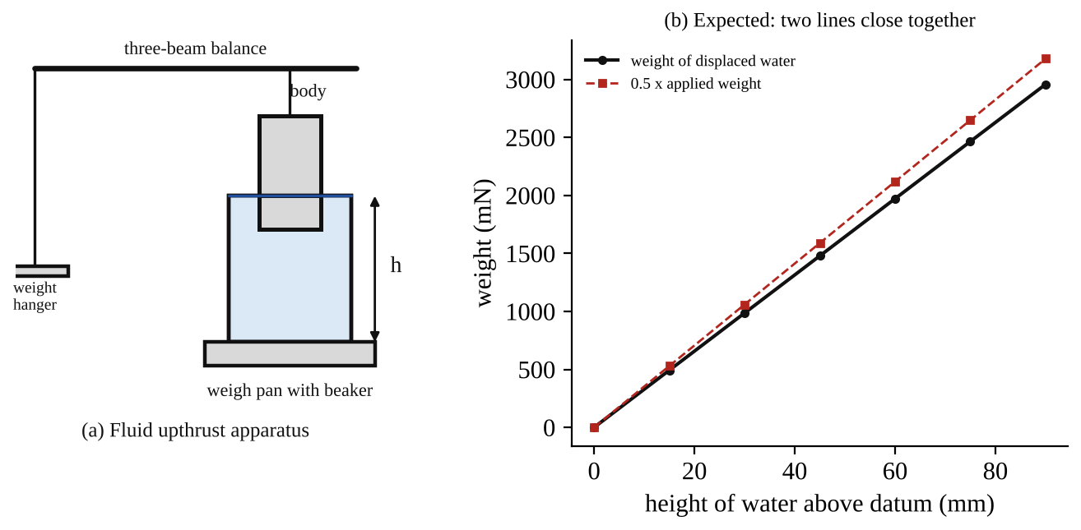
Fig. 1: (a) the fluid upthrust apparatus (body hung from the balance arm, beaker on the weigh pan, height h of water above the datum); (b) the expected agreement between the weight of displaced water and half the applied weight.
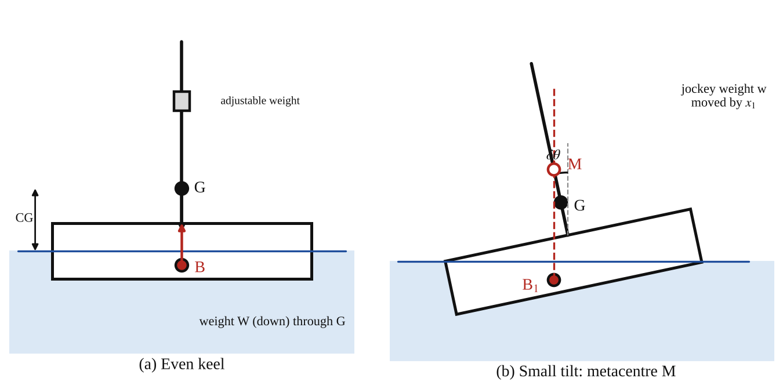
Fig. 2: The floating pontoon. (a) On an even keel: weight W acts down through G, and the upthrust acts up through B. (b) After a small tilt δθ: the centre of buoyancy moves to B₁, and the vertical through B₁ meets the centre line at the metacentre M.
Method in brief: Part A (upthrust)
- Measure the diameter of the body to find its area. Measure the internal diameter of the beaker to find the area of the water surface (the difference gives the area of the water that rises). Slide the body out of its parked position over the weigh pan, place it in the beaker by rotating it through 90°, fit the beaker and let beaker and body rest on the pan.
- (a) Fill the beaker with water until the body is just in the water, then balance the scale. The water level will rise slightly. (b) Record the weight needed for balance and the new height of the water: these are the datum values. (c) Add a small amount of water, balance again and record the weight and the height of the water above the datum. (d) Repeat to give at least six steps up to somewhere near the maximum volume of the beaker. (e) Convert the heights to metres and the weights to newtons.
- The weights applied to balance the scale should be equal to the increase in weight of the water plus the upthrust, which equals the weight of the displaced water. Alternatively, half of the applied weight must equal the weight of the displaced water. Using the area of the cylinder in the beaker and the changes in height, the volume of water displaced can be found and its weight calculated. Plot a chart of displaced weight of water (vertical axis) against height of water above the datum, and compare the two sets of results.
- To drain the beaker after the experiment, slide the body and beaker together off the support and pour the water through the working surface.
Method in brief: Part B (stability of the pontoon)
- The total mass of the apparatus (including the two magnetic weights but not the jockey weight) is written on a label on the sail housing. Weigh the jockey weight, measure L and D.
- Centre of gravity: fit the two magnetic weights to the base of the pontoon. Fit the hook of the centre of gravity cord through the hole in the sail so that the plumb weight hangs down on the side of the sail that has the scored centre line. Clamp the adjustable weight into the V-slot on the centre line of the lowest row and suspend the pontoon from the free end of the thick cord. Mark the point where the plumb line crosses the centre line of the sail (with correcting fluid or a marker). Repeat for the other four rows (Fig. 3 of the manual).
- Tilt readings: with the adjustable weight at the centre of one row, let the pontoon float and place the two magnetic weights on the base to trim it. Once the vessel is trimmed, move the adjustable weight to positions either side of the centre line, at 7.5 mm intervals up to ±52.5 mm. At each position, read the angle of list from the plumb line against the scale below the sail housing. Decide which side is to be called negative. Do this for all five rows (heights y₁).

3. Results
Part A: fluid upthrust
Diameter of body d_{b} = [ ] mm, so A_{b} = [ ] m² (manual's example: 70 mm, 0.00385 m²). Internal diameter of beaker d_{k} = [ ] mm, A_{k} = [ ] m² (manual's example: 96 mm, 0.0072 m²). Net area A_{k} − A_{b} = [ ] m² (manual's example: 0.00335 m²). Datum: water height [ ] mm, balance weight [ ] g.
Table 1: Blank results table, fluid upthrust
Water height on scale (mm) | Height above datum h (m) | Applied weight for balance (g) | Applied weight above datum (N) | Volume of displaced water A_{b}h (m³) | Weight of displaced water (N) | 0.5 × applied weight (N)

The manual's typical calculation (not your data): datum at 37.5 mm with a balance weight of 472 g (4.63 N). Adding some water gave a height of 60 mm (0.0225 m above the datum) and a weight needed of 621 g (6.09 N), i.e. 1.46 N above the datum. The water volume increase is (h × net area) = 0.0225 × 0.00335 = 0.000075 m³, and its weight is 1000 × 9.81 × 0.000075 = 0.736 N. So the weight for balance (1.46 N) is roughly twice the weight of the water (0.736 N). The rest is the upthrust, which equals the weight of the displaced water.
Part B: stability of the pontoon
Total weight of the floating assembly W = [ ] N. Adjustable weight w = [ ] N. Breadth of pontoon D = [ ] mm. Length of pontoon L = [ ] mm.
Quantity | Formula | Value
Second moment of area of the water plane I (m⁴) | L D³/12 × 10⁻¹²
Volume of water displaced V (m³) | W / (ρ g)
Height of metacentre above the centre of buoyancy BM (m) | I / V
Depth of immersion d (m) | V / (L D)
Depth of the centre of buoyancy CB (m) | d / 2

Table 4: Values of list angles (degrees) for height and position of the adjustable weight (manual's format)
Height of jockey weight y₁ (mm) | −52.5 | −45 | −37.5 | −30 | −22.5 | −15 | −7.5 | 0 | 7.5 | 15 | 22.5 | 30 | 37.5 | 45 | 52.5
row 1
row 2
row 3
row 4
row 5

The column headings are the lateral displacement x₁ (mm) of the jockey weight from the centre line of the sail. Fill in the angles (positive on one side, negative on the other).
Table 5: Metacentric height, height of G and height of M for the five heights of the adjustable weight
Height of adjustable weight y₁ (mm) | Height of G above water surface CG (mm) | dx₁/dθ (mm/°) | Metacentric height GM (mm) | Height of M above water surface CM (mm)

4. Analysis of Results
Part A: upthrust
- Height of water above the datum: h = (height on scale − datum height) ÷ 1000 = [ ] m.
- Applied weight above the datum: ΔW_{a} = (balance mass − datum mass) × 9.81 ÷ 1000 = [ ] N.
- Volume of displaced water = A_{b} × h = [ ] × [ ] = [ ] m³; its weight = ρ g × volume = 1000 × 9.81 × [ ] = [ ] N. This is the upthrust U.
- Weight of water added = ρ g (A_{k} − A_{b}) h = [ ] N. Check: weight of added water + U = [ ] N, to be compared with the applied weight above datum [ ] N.
- Half of the applied weight = [ ] N, to be compared with U = [ ] N (ratio U / ΔW_{a} should be about A_{b}/A_{k} = [ ]).
- Percentage difference between the two sets of results at each h = [ ] %.
Part B: stability
- Angle of list against jockey position: for each of the five rows, plot θ against x₁, draw the best straight line through the small-angle points, and find the gradient dθ/dx₁, and so dx₁/dθ = 1 ÷ gradient = [ ] mm/° (convert to mm per radian by multiplying by 57.3 = [ ] mm/rad).
- Metacentric height from experiment (equation 4): GM = (w / W)(dx₁/dθ) = ( [ ] ÷ [ ] ) × [ ] mm/rad = [ ] mm for each row.
- Height of G above the base: ȳ = y₁(w/W) + A (equation 10), with A found from the measured ȳ and y₁ of one row: A = ȳ − y₁ w/W = [ ] mm. Then CG = ȳ − d = [ ] mm above the water surface (adding the bottom thickness when needed).
- Height of the metacentre above the water surface: CM = CG + GM = [ ] mm for each row.
- Theoretical value (equations 7, 8 and 9): I = L D³/12 = [ ] m⁴; V = W/(ρ g) = [ ] m³; BM = I/V = [ ] m; d = V/(L D) = [ ] m; CB = d/2 = [ ] m. The height of M above the water surface is CM_{theory} = BM − d/2 = [ ] m. It should be constant for all rows (it does not depend on G), and the experimental CM should agree with it.
- Limiting height of G: plot dx₁/dθ against CG, and extrapolate the line to dx₁/dθ = 0. The value of CG at which it cuts the axis = [ ] mm; this is the limiting height of G (M and G coincide). Compare with CM_{theory} = [ ] mm.
- Effect on stability: as y₁ rises, CG = [ ] → [ ] mm, GM falls from [ ] to [ ] mm.

5. Observations / Precautions Taken
Observations
- Part A: the weight needed to balance the scale increased steadily as water was added, and was about twice the weight of the water added. The change was in direct proportion to the rise in the water level.
- Part B: when the jockey weight was moved sideways, the pontoon tilted towards that side, and the angle of list increased in proportion to the displacement for small angles. The pontoon tilted more for the same movement when the jockey weight was higher on the sail.
- When the jockey weight was at its highest position, the pontoon was much less stiff, and it tilted a lot for a small movement, which means GM was small, and near the limit it would not return.
- The beaker demonstration: a beaker floated bottom down was unstable. With a few weights in the centre of the bottom it was more stable, and when many weights were added it floated lower and steadily and finally sank.
Precautions
- The body and beaker were assembled carefully by rotating the body through 90°, and they were allowed to hang freely without touching the sides of the beaker.
- The water was added in small amounts and the scale was balanced each time, and the height was read at the bottom of the meniscus at eye level.
- The area of the beaker and of the body were calculated from diameters measured with the caliper at several places.
- The pontoon was trimmed on an even keel (zero list with the jockey weight at the centre) before each series of readings.
- The jockey weight was clamped firmly in the V-slot at the correct position, and the plumb line was allowed to settle before reading the angle.
- Angles were kept small (a few degrees), so that the small-angle formulas apply, and the same side was always treated as negative.
- The height measurements were taken from the inside floor of the pontoon, and the thickness of the bottom was added.
- The pontoon was kept clean and dry on the outside, and the water was kept still while reading.

6. Graphs
Plot the following on graph paper from your own readings and attach them here:
- Part A: weight of displaced water (vertical axis) against height of water above datum; on the same axes plot 0.5 × the applied weight above datum, and compare the two lines (Fig. 1b).
- Part B: angle of list θ against the position x₁ of the adjustable weight, one straight line for each of the five heights y₁ (Fig. 3a).
- Part B: metacentric height GM against the angle of list (optional, to show that GM stays nearly constant for small angles) (Fig. 3b).
- Part B: dx₁/dθ against the height of G above the water, CG, extrapolated to cut the axis, giving the limiting height of the centre of gravity (Fig. 3c).
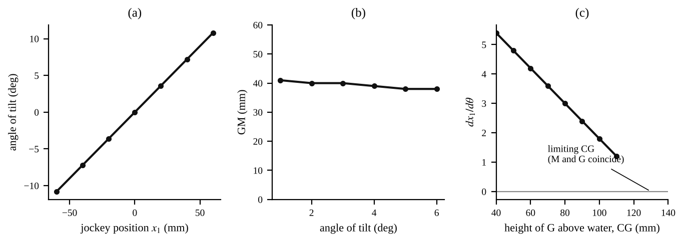
Fig. 3: The expected form of the three graphs for Part B (illustration, not measured values): (a) angle of list against jockey position, (b) GM against angle of list, (c) dx₁/dθ against CG, extrapolated to the limiting CG.

7. Discussion
Part A, agreement with theory. The weight of the displaced water and half the applied weight should give two lines that lie close together and straight through the origin, because Archimedes' principle says U = ρ g A_{b} h, and the extra weight on the pan is W_{a} = ρ g A_{k} h; the ratio U/W_{a} = A_{b}/A_{k} is about 0.53 for the given diameters, not exactly one half. My results gave a difference of [ ] % between the two sets, so Archimedes' principle is [ verified / not verified ] within the accuracy of the apparatus.
Part B, agreement with theory. The experimental value of the height of the metacentre above the water, CM = CG + GM, was [ ] mm for the five rows and the theoretical value BM − d/2 was [ ] mm. M should stay at the same place whatever the height of the jockey weight, because BM = I/V depends only on the shape of the water plane and the displaced volume. G, in contrast, rises with y₁, so GM = CM − CG falls. The experiment confirms both, and the extrapolated limiting CG ([ ] mm) is close to CM, as theory says it must be, since when G reaches M, the pontoon is neutral.
Effect of the density of the liquid. In a denser liquid (e.g. salt water), the same pontoon displaces less volume V, sinks less, and so d is smaller. BM = I/V increases because V is smaller, while B is nearer the base, so the stability of the pontoon would increase. This is why ships ride higher and are a little more stable in sea water than in fresh water.
Sources of error
- The measurements of the very small water level changes (Part A) from the scale are limited by the meniscus and parallax, and the balance reading is to the nearest gram.
- The diameters of the body and beaker are measured with some error. The areas depend on the diameter squared, so a 1 % error in d gives 2 % in the area.
- The body may touch the beaker wall or an air bubble may stick to the body, changing the displaced volume.
- The plumb line oscillates and the angle of list can be read only to about ±0.5°. At small angles this is a large percentage error in the gradient.
- The pontoon may not be exactly trimmed, so there is an initial list at x₁ = 0, which must be allowed for by plotting the angle relative to this zero.
- The position of the centre of gravity found from the plumb line is judged by eye, and the weight of the pontoon, the dimensions L and D and the bottom thickness have small errors.
- The theory uses small angles, with sin δθ ≈ δθ, and a rectangular water plane. At bigger angles the waterline shape changes (the deck edge may go under) and M moves.
- The ripples and surface tension at the edges of the pontoon affect the displaced volume slightly.

8. Conclusion
Part A: the upthrust on the body was found from the weight of water displaced and from the balance, and the two agreed within [ ] %, which verifies Archimedes' principle. Part B: the metacentric height of the floating pontoon was found from the tilt produced by moving a weight sideways, GM = (w/W)(dx₁/dθ), with values of [ ] mm to [ ] mm for the five heights of the jockey weight. GM decreased as the centre of gravity was raised, and the plot of dx₁/dθ against CG extrapolated to a limiting CG of [ ] mm, above which the pontoon would be unstable. The height of M above the water surface was [ ] mm and agreed with the theoretical BM − d/2 = [ ] mm. Practical applications: design and loading of ships, barges and submarines (stability and the position of the cargo), pontoons and floating bridges, buoys, hydrometers, life jackets, floating oil rigs, and checking that a ship does not capsize when its cargo is moved or when a crane lifts a load.

Section D: Questions
1. What have I gained from this experiment? I learnt that the upthrust equals the weight of fluid displaced, how stability depends on the positions of G, B and the metacentre M, and how the metacentric height can be found by tilting the floating body with a moving weight.
4. Comment on the experimental procedure (accuracy and time saving) The procedure is suitable because the metacentric height is found from simple measurements of weight and angle, and several heights of the weight are tested on the same pontoon to show the effect of the centre of gravity. It takes a long time to take all the angle readings, and the accuracy depends on reading the plumb line.
5. Most difficult aspect of the experiment and how to reduce it Reading the angle of list on the plumb line scale accurately (the plumb bob keeps swinging), and trimming the pontoon exactly. It can be reduced by waiting for the plumb bob to settle, using larger displacements of the weight and repeating the readings.
6. Another method / apparatus that could be used Calculating GM from the dimensions (GM = I/V + CB − CG), a floating model tested in a towing tank, or a ship model with an inclining experiment, where a known weight is moved across the deck and the heel angle is measured.
7. Parameters required in this experiment Weight of the assembly W, adjustable weight w, dimensions L and D, position x₁ of the weight, height y₁, angle of list θ, metacentric height GM, height of the centre of gravity CG and height of the metacentre CM.
8. One measuring instrument / gauge used The plumb bob and the angle scale below the sail, which gives the angle of list in degrees, and the three-beam balance for the upthrust. The plumb bob hangs vertically, and its line is read against the scale on the sail housing.
9. Practical relevance / applications Ship and boat design and loading (the inclining experiment), submarines, pontoons and floating bridges, buoys and offshore platforms, hydrometers and life jackets.
10. Section of the course it relates to Fluid mechanics (buoyancy, flotation and stability of floating bodies).
14. What interested me most That moving a small weight a few millimetres can tilt the whole pontoon, and that raising the weight made the pontoon much less stable.
2, 3, 11, 12, 13 and 15 (personal): to be filled in by you.
16. References (keep only the ones you actually used): Mechanical Engineering Laboratory Manual ELA 301; a fluid mechanics or theory of machines textbook of your course.

FM 314 (Part 1): Hydrostatic Experiment: Density, Specific Gravity, Capillarity, Viscosity and Pascal's Law

Objective
- To determine the density of a liquid (water) by three methods (measuring beaker, Eureka can and density bottle) and to find the density of an irregular solid such as sand.
- To find specific gravity with a hydrometer, and to study capillary rise in tubes and between plates.
- To observe and measure the viscosity of liquids with a falling-ball viscometer, using Stokes' law.
- To demonstrate Pascal's law and the hydrostatic pressure in a column of fluid using the liquid level apparatus, and Archimedes' law.

1. Theory
A. Density and specific gravity
1.1 Density
The density ρ of a fluid is its mass per unit volume, ρ = m / V (kg/m³). To find it we need the mass of a known volume of liquid. Mass is easy to measure on a balance; volume is the more difficult quantity, and the manual gives three methods which differ in how the volume is found. The density of pure water at 20°C is 998.2 kg/m³, which is rounded to 1000 kg/m³ for engineering. The result of an experiment should be within about 1 % of this.
- Measuring beaker: weigh the empty beaker, fill it with water, read the volume on the graduations, and weigh again. ρ = (mass in grams / volume in ml) × 10⁶/10³ kg/m³ = (mass in g ÷ volume in ml) × 1000. Since the graduations cannot be checked, this is the least precise method.
- Eureka (displacement) can: a can with a fixed spout. If it is filled until liquid just stops running from the spout and an object is lowered in gently, the liquid that overflows is exactly equal in volume to the immersed object (Archimedes). The overflow is caught in a weighed beaker. The mass of liquid displaced is found by subtraction, and, if the volume of the solid is known from its dimensions, the density is ρ = mass / volume. The result is more fundamental than with the beaker but it is limited by how well the can is filled and the drip stops; the error is smaller if the can and the object are large.
- Density bottle: a bottle made to a known volume (50 cm³ here) with a glass stopper that has a hole through which the excess liquid escapes, so that the volume of liquid is always exactly the volume of the bottle. Weigh the bottle with the stopper dry, fill it, replace the stopper, dry the outside, weigh again. ρ = (m_{full} − m_{empty}) / V. This is the most accurate of the three, limited only by the balance.
Density of solids. The same methods give the density of an irregular solid such as sand. Put a weighed sample of sand into the Eureka can, in place of the solid object. The volume of the sand is the volume of water displaced, which is found from the mass of the overflow, since the density of water is known. The density of sand = (mass of sand) ÷ (volume of water displaced). The density bottle can be used in the same way.
1.2 Specific gravity (relative density) and the hydrometer
The specific gravity (SG) of a liquid is the ratio of its density to the density of water, SG = ρ / ρ_{w}. It is a number with no units (for example, paraffin 0.8, mercury 13.6, carbon tetrachloride 1.6). It has the same numerical value as density in g/cm³, but it must not be confused with density, nor with specific weight (weight per unit volume, N/m³), which depends on the local value of g. A useful discussion question is whether the density of water would be the same on the Moon (g is one-sixth), and whether the methods give the same result there: the mass of a given volume is the same, so density is unchanged, but a spring balance would read differently, and a balance that compares masses (as a beam balance does) would still give the same result.
A hydrometer reads SG directly. It is a hollow glass float with a weighted bulb at the bottom, so that it floats upright, and a thin stem with a scale. By Archimedes' principle the hydrometer floats at the depth where the weight of the liquid displaced equals its own weight W: W = ρ g (V_{bulb} + a x), where a is the stem area and x the length of the stem below the surface. For a given hydrometer W is fixed, so the depth to which the stem sinks depends on the liquid density: a denser liquid needs less volume to be displaced, so the hydrometer floats higher, and the scale reads higher values downwards. The sensitivity depends on the stem diameter: a thin stem with a large bulb is very sensitive (a small change in density gives a large movement of the scale), but it covers a smaller range (Fig. 1a). To use it, place a tall glass cylinder on the measuring surface, fill it with liquid, insert the hydrometer so it settles in the middle, and read the scale at the level of the free surface of the liquid (the bottom of the meniscus), with the hydrometer not touching the sides, because surface tension would affect it.
B. Capillarity (surface tension)
1.3 Capillary rise
When a narrow tube is dipped into water, the water rises inside it above the level outside. This is capillary action. It is caused by surface tension σ (the force per unit length acting along the surface of the liquid) and by the attraction between the water and the glass, so that the water "wets" the glass and the surface curves up at the edges, forming a meniscus. The surface tension acts along the line of contact round the inside of the tube, at an angle to the vertical, and has an upward component. We assume the water is drawn up at the edge so that it forms a tangent to the surface (contact angle zero) and that the force acts vertically. For a tube of diameter d the upward force is
F = π d σ (1)
This force holds up the weight of the column of water in the tube, which is approximately (the meniscus volume being neglected):
W = ( π d² / 4 ) ρ g h_{t} (2)
Equating the two and solving for the rise h_{t}:
h_{t} = 4 σ / ( ρ g d ) (3)
For two parallel plates a distance b apart, the surface tension acts on two edges, each of length l, so F = 2 σ l, and the weight of the column of width l is ρ g b l h_{p}. Equating gives
h_{p} = 2 σ / ( ρ g b ) (4)
These show that the rise is inversely proportional to the diameter of the tube (or the gap between the plates): the finer the tube, the higher the rise. For water, σ ≈ 0.073 N/m, so h_{t} for a tube of 1 mm diameter is 4 × 0.073 / (1000 × 9.81 × 0.001) = 0.030 m = 30 mm, and for a 5 mm tube it is only 6 mm, so the effect is only important for narrow tubes (bore less than about 5 mm) and is ignored in most hydrostatic calculations. But it needs to be taken into account in manometers with small tubes (Part 2 of the experiment) and in the measurement of small heads.
The actual heights depend very much on the cleanliness of the tubes or plates and on any impurities in the water, so it is not worth calculating h from the accepted value of σ, since the heights are unlikely to agree with the observations. It is worth checking that the heights are in the correct proportions: if σ and ρ are constant, h_{t}d/4 and h_{p}b/2 should be constant (equal to σ/ρg) for various tubes and plate separations. The manual's typical results (Table 1 of the manual) are for the tubes: h_{t} d / 4 = 2.8, 2.4 and 2.3 (for 1.6 mm, 0.8 mm and 0.4 mm tubes, with h_{t} = 7, 12 and 23 mm) and h_{p}d/2 = 2.5 for plates 0.35 mm apart (h_{p} = 14 mm), so these are roughly constant, as the theory says.
C. Viscosity
1.4 What viscosity is
Viscosity is the property of a fluid that resists relative movement between its layers: "internal friction". It determines how a fluid behaves whenever there is relative movement between the fluid and a solid (flow in pipes, lubrication, drag on bodies). In a simple case where a layer of fluid is acted on by a shear stress τ, a velocity gradient is produced which is proportional to the applied shear stress. The constant of proportionality is the coefficient of viscosity μ (dynamic viscosity), so
τ = μ du / dy (5)
where du/dy is the velocity gradient normal to the plane of the applied stress. This is the model for laminar (viscous) flow, in which layers of fluid move smoothly over one another; μ is constant at any given temperature. At higher speeds the flow becomes turbulent and this simple model does not work. μ has units of N s/m² (Pa s) and varies with temperature (the viscosity of oils falls strongly when heated, so values are tabulated for given temperatures). The ratio of μ to the density is the kinematic viscosity:
ν = μ / ρ (m²/s) (6)
1.5 Falling-ball viscometer and Stokes' law
One of the most common ways to measure μ is to see how fast a smooth sphere falls through the liquid. At first the ball accelerates, but as its speed rises the viscous drag on it rises too, until the forces balance and the ball falls at a constant speed, the terminal velocity. At that moment: weight of sphere = buoyancy (upthrust) + viscous drag. With sphere diameter d and density σ_{s}, liquid density ρ and dynamic viscosity μ, and Stokes' law for the drag on a small sphere in slow viscous flow (drag = 3 π μ d u):
π d³ σ_{s} g / 6 = π d³ ρ g / 6 + 3 π μ d u
u = ( g d² / 18 ν ) ( σ_{s}/ρ − 1 ) (7)
This is the equation in the manual (with σ_{s}/ρ shown there as σ/ρ, and ν the kinematic viscosity). It shows that (i) the terminal velocity is proportional to d², so a larger ball falls much faster (a ball twice the diameter falls four times faster), which can be shown by timing balls of two sizes; (ii) the velocity decreases as the viscosity increases, so thick oils give long times; (iii) a heavier ball falls faster. Rearranged, the kinematic viscosity from a measured terminal velocity u = s/t (s = the distance between the timing markers, t = the time) is
ν = ( g d² / 18 u ) ( σ_{s}/ρ − 1 ) (8)
Limit of validity. Stokes' law applies only to viscous flow, with a Reynolds number below a certain value: Re = ρ u d / μ = u d / ν. The limiting value is usually taken as 0.2; above this, the error in equation (7) becomes significant. So it is only suitable for fairly viscous liquids (oils, glycerine, castor oil), and the smaller the ball the better the accuracy, because the Reynolds number is smaller and the time is longer, which can be timed more accurately. The manual's table of viscosity data for typical liquids gives kinematic viscosity ν × 10⁻⁶ m²/s: medium oil 12, thick oil 30, glycerine 65, castor oil 100, and typical times to fall 200 mm of 2.8 s (medium oil, 1.6 mm ball) up to 20 s (castor oil, 1.6 mm ball). Water (ν about 1 × 10⁻⁶ m²/s) is far too thin for this method, because the ball falls in a fraction of a second.
Manual's typical example (not your data). A 1.59 mm steel ball (density 7800 kg/m³) in lubricating oil (density 900 kg/m³, at 18°C) took 4.2 s to fall 200 mm, so u = 0.2/4.2 = 0.048 m/s, and σ_{s}/ρ = 8.7. From equation (7), ν = g d² (σ_{s}/ρ − 1) / (18 u) = 9.81 × (1.59×10⁻³)² × 7.7 / (18 × 0.048) = 2.2 × 10⁻⁴ m²/s. (The manual prints this as 22.1 × 10⁻⁵ m²/s.) Check Re = u d / ν = 0.048 × 0.00159 / 2.2×10⁻⁴ = 0.35, which is a little above 0.2, so the accuracy would be limited.
D. Hydrostatic principles
1.6 Pressure in a column of liquid and Pascal's law
In a liquid at rest the pressure at a point depends on the depth. Take a vertical column of liquid of constant cross-sectional area A, height h, and density ρ, with pressure p₁ on the top plane 1. The downward force on plane 2 at the bottom is the pressure force p₁A plus the weight ρ g h A. This is balanced by p₂ A acting upwards, so
p₂ = p₁ + ρ g h (9)
The area A cancels. It plays no part in determining p₂; so, if the area is very small, we can regard p₂ as the pressure at a point in the liquid. Since the liquid at plane 2 also presses downward with the same pressure, the pressure at a point acts equally in all directions. This is Pascal's law. Two further facts follow: (a) pressure forces between a liquid and a solid boundary always act normal (at right angles) to the boundary if the liquid is at rest; if they did not, there would be a shear force and the liquid would move. (b) The pressure is the same at all points on any horizontal plane in a liquid at rest; if it were not, there would be a sideways force on an element of liquid, and it would move.
The liquid level apparatus. The apparatus consists of vertical tubes of different sizes, shapes and cross-sections, joined by a horizontal pipe at the bottom and permanently connected to the header tank. When it is filled, the levels are always the same in all of the tubes, whatever their cross-section, shape, or the weight of water in them. The only slight variation is due to surface tension and capillary action in the two thinner tubes (which can be discussed). This leads to several conclusions: (a) there is no flow along the horizontal pipe between the tubes, so the pressure in the horizontal pipe is constant; (b) the pressure at the bottom of each tube is the same, so a given height of liquid always produces the same pressure, irrespective of the area of the tube or the weight of water it holds (the "hydrostatic paradox"); (c) the same pressure is produced by a certain height of liquid, irrespective of the shape of the tube; (d) the pressure is transmitted down the bent tube in the same way as in the other tubes, which shows that pressure acts equally in all directions.
1.7 Archimedes' law
The upthrust on a body wholly or partly immersed in a liquid is equal to the weight of the liquid it displaces. For a rectangular body of plan area A floating with depth h of the body below the liquid surface: the force on the bottom is (p₁ + ρ g h)A upwards; the weight W acts down; at equilibrium, W = (p₁ + ρ g h)A − p₁A = ρ g h A, which is the weight of the liquid displaced (volume hA). The same holds for any shape (see FM 311 for the experiment with the cylinder and beaker).

2. Apparatus
The H314 hydrostatic experiments apparatus (FM 314) with: a measuring beaker (1), a triple-beam balance (3), a Eureka can (4) and a density bottle with stopper (5); tall glass cylinders (11) with hydrometers (27); the capillarity apparatus with three glass capillary tubes (bores 0.4, 0.8 and 1.6 mm) (7), glass plates (8) with plastic shim (thicknesses 0.050, 0.075, 0.100, 0.125, 0.190, 0.250, 0.400 and 0.500 mm), and a header tank (6) with clips; three graduated jars with a ball guide (28), a set of steel balls (10) with timing band markers, a stopwatch (12) and a thermometer for the falling-ball viscometer; the liquid level (Pascal) apparatus (13) of vertical tubes joined by a horizontal pipe, connected to the header tank; a bilge pump (44) and an 800 ml beaker for filling the header tank; and the cylindrical body (14) for fluid upthrust. Liquids: water, medium oil, thick oil or glycerine, castor oil (the oil supplied with the H314 is for maintenance of the piston of the pressure instruments, not for the viscosity experiments).
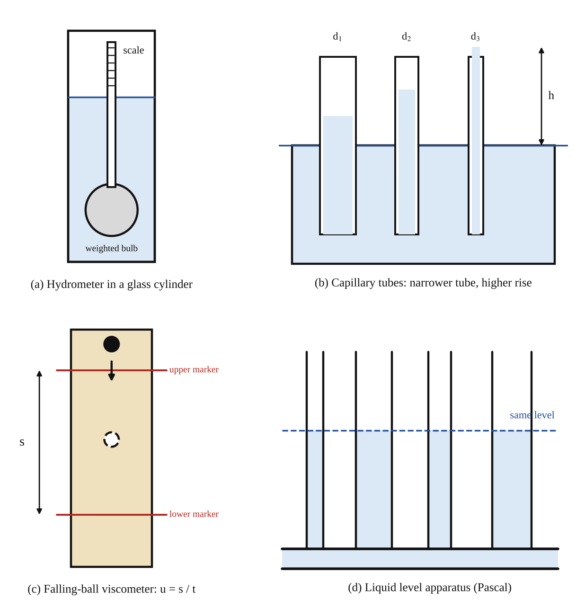
Fig. 1: (a) hydrometer in a glass cylinder, (b) capillary rise in tubes of different diameters, (c) falling-ball viscometer with timing markers, (d) the liquid level apparatus (Pascal's law).
Method in brief
- Density. Measuring beaker: weigh the empty beaker with the triple-beam balance, fill with water and read the volume as accurately as possible, weigh again; ρ = (mass in g / volume in ml) × 10⁶/10³ kg/m³. Eureka can: take a solid (cylinder or cube) that fits the can and measure its dimensions to calculate the volume; fill the can until it overflows from the spout; weigh an empty beaker and place it under the spout; lower the object gently until fully immersed and collect the liquid; weigh the beaker plus liquid again. Density bottle: weigh dry with stopper; fill with liquid and replace the stopper; dry the outside and remove any excess liquid so that the liquid in the hole is level with the top of the stopper; re-weigh. The bottle volume is 50 cm³.
- Specific gravity. Place a tall glass cylinder on the measuring surface, fill with the liquid and allow the air to rise to the top. Insert the hydrometer so it settles in the middle without touching the sides; read the scale at the level of the free surface (the bottom of the meniscus).
- Capillarity. Fill the header tank with water (before filling, ask what levels will be seen in the different tubes). Put the capillary tubes in the water and compare the heights. For the plates, use the yellow shim (0.5 mm) for a separation of about 0.5 mm: place one strip 5 to 10 mm wide down two edges of a plate, clamp the second plate to it with the clips, and place the assembly in the header tank in the slot provided. Adjust the water level with the drain valve if necessary. Measure the levels.
- Viscosity. Fill each of the three graduated jars with a different liquid (water, oil, glycerine). Insert the ball guide and set the upper timing band about 20 mm below the base of the guide and the lower one about 200 mm below the first. Drop the ball into the fluid and time its descent between the markers with the stopwatch. Measure the distance between the markers and the temperature of the liquid. Repeat with balls of different diameter. Moveable timing bands are used for very viscous fluids where less than 200 mm of fall is needed.
- Liquid level apparatus. Fill the apparatus from the header tank using the bilge pump and the 800 ml beaker, with the drain valve closed. Compare the levels in the different tubes and draw conclusions from it.

3. Results
Table 1: Density of water
Method | Mass of empty vessel (g) | Mass with water (g) | Mass of water (g) | Volume (ml) | Density ρ (kg/m³) | Difference from 1000 (%)
Measuring beaker
Eureka can (object: ____ )
Density bottle |  |  |  | 50

Density of sand (if done): mass of sand = [ ] g, mass of water displaced = [ ] g, so volume = [ ] cm³ and density = [ ] kg/m³.
Table 2: Specific gravity by hydrometer
Liquid | Hydrometer used | Reading (SG) | Temperature (°C)

Table 3: Capillary rise
Tube / plates | Diameter d or gap b (mm) | Rise h (mm) | h d / 4 (tube) or h b / 2 (plates) (mm²)
Tube 1 | 1.6
Tube 2 | 0.8
Tube 3 | 0.4
Plates

Manual's typical results for comparison (not your data): 1.6 mm tube h = 7 mm (h d/4 = 2.8); 0.8 mm tube h = 12 mm (2.4); 0.4 mm tube h = 23 mm (2.3); plates 0.35 mm apart h = 14 mm (h b/2 = 2.5).
Table 4: Falling-ball viscometer
Liquid | Ball diameter d (mm) | Distance s (mm) | Time t (s) | u = s/t (m/s) | Temp. (°C) | ν from equation (8) (m²/s) | Re = u d / ν

Densities used: steel ball σ_{s} = 7800 kg/m³ (check), liquid ρ = [ ] kg/m³ (measured or from SG × 1000).
Table 5: Liquid level apparatus
Tube (shape / size) | Liquid level (mm) | Remark
Tube 1
Tube 2
Tube 3
Tube 4

4. Analysis of Results
- Density from the measuring beaker: ρ = (m / V) × 10⁶/10³ = ( [ ] ÷ [ ] ) × 1000 = [ ] kg/m³ (m in g, V in ml).
- Density from the Eureka can: volume of the object from its dimensions = [ ] m³; mass of the overflow = [ ] g, so the volume of water displaced = mass ÷ 1000 kg/m³ = [ ] m³, which should equal the volume of the object. Using the overflow and the known object volume gives ρ = [ ] kg/m³.
- Density from the density bottle: ρ = (m_{full} − m_{empty}) / V = ( [ ] − [ ] ) ÷ 50 = [ ] g/cm³ = [ ] kg/m³.
- Percentage difference from 998 (or 1000) kg/m³ for each method = [ ] %. The best result is expected from the density bottle.
- Sand: ρ_{sand} = mass of sand ÷ volume of water displaced = [ ] ÷ [ ] = [ ] kg/m³.
- Specific gravity (hydrometer) = [ ]; density = SG × 1000 = [ ] kg/m³.
- Capillarity: h_{t} d / 4 = [ ] × [ ] ÷ 4 = [ ] mm² for each tube, and h_{p} b / 2 = [ ] mm² for the plates. These should be approximately constant. For perfectly clean water they would equal σ/(ρ g) = 7.4 mm² (σ = 0.073 N/m); the manual's typical values of 2.3 to 2.8 mm² are lower, which shows how dirt and the contact angle reduce the rise. From the mean, σ = ρ g × [mean h d/4 in m²] = 9810 × [ ] = [ ] N/m.
- Viscosity: u = s / t = [ ] ÷ [ ] = [ ] m/s; σ_{s}/ρ = 7800 ÷ [ ] = [ ]; ν = g d² (σ_{s}/ρ − 1) / (18 u) = 9.81 × [ ]² × ( [ ] − 1 ) ÷ (18 × [ ]) = [ ] m²/s; μ = ν ρ = [ ] N s/m². Reynolds number Re = u d / ν = [ ] (valid if less than about 0.2).
- Effect of ball size: ratio of the speeds for two balls of diameter d₁ and d₂ = [ ] (theory: (d₁/d₂)² = [ ]).
- Comparison with tables: the manual's table gives ν = [ ] × 10⁻⁶ m²/s for this liquid, my value = [ ] × 10⁻⁶ m²/s; the difference is [ ] %.

5. Observations / Precautions Taken
Observations
- The three methods gave a density of water close to 1000 kg/m³, with the density bottle the closest and the measuring beaker the furthest.
- The hydrometer floated higher in a denser liquid; the stem moved noticeably with a small change of density when the stem was thin.
- Water rose highest in the thinnest tube and least in the widest, and rose between the glass plates, and the narrower the gap the higher the rise.
- The ball fell fastest in water (too quick to time), slower in oil, and very slowly in glycerine and castor oil; the larger ball fell faster than the smaller one in the same liquid, and the speed became steady after the first part of the fall.
- In the liquid level apparatus, the water stood at the same level in all the tubes whatever their shape and area, apart from a slight difference in the thinner tubes caused by capillary action.
Precautions
- The balance was zeroed and the vessels were dry and clean before weighing; the outside of the density bottle was dried and no air bubble was left under the stopper.
- The Eureka can was filled until the dripping from the spout stopped, the can was level and the object was lowered gently without splashing.
- The hydrometer was clean and did not touch the sides of the cylinder; it was read at the bottom of the meniscus at eye level.
- The capillary tubes and plates were clean, because grease or impurities change the rise; the plates were clamped with the strips down the edges and the same gap along the length.
- The balls were clean and were dropped in the centre of the guide, and the stopwatch was started and stopped as the ball passed the markers (viewing the markers at the same level to avoid parallax). The liquid temperature was noted since the viscosity varies with temperature.
- The oil supplied with the H314 was not used in the viscometer jars (it is for the piston of the pressure instruments).
- The header tank was filled slowly with the bilge pump to avoid air bubbles in the tubes, and the apparatus was kept level.

6. Graphs
Plot the following on graph paper from your own readings and attach them here:
- Capillary rise h against 1/d for the three tubes (a straight line through the origin; gradient 4σ/ρg) (Fig. 2a).
- Terminal velocity u against d² for the two ball sizes in the same liquid (a straight line through the origin) (Fig. 2b). Optional.
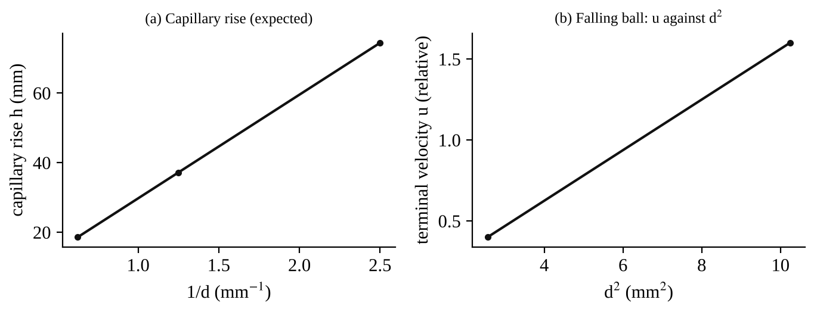
Fig. 2: The expected form of the graphs for Part 1: (a) capillary rise against 1/d, (b) terminal velocity of a falling ball against the square of its diameter (illustration, not measured).

7. Discussion
Density. The density of water by the density bottle was [ ] kg/m³ ([ ] % from 998 to 1000 kg/m³), by the Eureka can [ ] kg/m³ and by the measuring beaker [ ] kg/m³. The density bottle is the most accurate because its volume is fixed exactly by the stopper, whereas the measuring beaker depends on reading graduations that cannot be checked, and the Eureka can depends on how well the can was filled and the drips counted. For the Eureka can the error is reduced if the can and the solid object are larger (a wide shallow can or a narrow deep can may be asked about: the narrow deep can gives a larger change of level but the overflow is the same; accuracy is better when the object is large compared with the meniscus and drip errors).
Capillarity. The rise is bigger in thinner tubes and the quantity h d/4 stayed approximately constant ([ ] to [ ] mm²), in line with h = 4σ/ρ g d. The heights do not agree exactly with the accepted σ because of dirt and the unknown contact angle. The effect is only important in narrow tubes (below about 5 mm), so it is generally ignored in hydrostatic calculations but must be allowed for in manometers with small bores.
Viscosity. The kinematic viscosity found was [ ] m²/s for [ liquid ] against the table value [ ]. The velocity of the ball was proportional to the square of its diameter, as Stokes' law (equation 7) says, and the Reynolds number was [ ], [ below / above ] the limit 0.2. A smaller ball gives a smaller Reynolds number and a longer time, which can be timed more accurately, so it is better for accurate work, as the manual's table shows. Water is far too thin for this method.
Liquid level apparatus. The same level in all tubes shows that the pressure at the bottom depends only on the height of liquid and not on the shape of the tube or the weight of water it holds. This is Pascal's law and the hydrostatic principle in equation (9).
Sources of error
- Reading the volume of the beaker or the hydrometer scale (parallax and meniscus), and the balance reading only to the nearest gram.
- Air bubbles in the density bottle or under the body in the Eureka can, a wet outside of the bottle, or liquid still dripping from the spout.
- Dirty capillary tubes or plates, a different contact angle, and the water level in the header tank not exactly constant. The meniscus makes the exact height hard to read.
- Reaction time in starting and stopping the stopwatch, particularly for fast falls (water and thin oils); parallax in sighting the timing bands.
- The ball not falling along the centre, so that it is influenced by the wall of the jar, and a Reynolds number above the limit for Stokes' law.
- Variation of the viscosity and density of the liquid with temperature during the experiment, and the actual density of the ball being slightly different from 7800 kg/m³.

8. Conclusion
The density of water was found by three methods and was [ ] (measuring beaker), [ ] (Eureka can) and [ ] kg/m³ (density bottle), the last being the most accurate and close to 1000 kg/m³; the density of sand was [ ] kg/m³. The hydrometer gave the specific gravity of [ ] for the liquid tested. Capillary rise was inversely proportional to the tube diameter (h d/4 approximately constant at [ ] mm²). The falling-ball viscometer gave a kinematic viscosity of [ ] m²/s using Stokes' law, with the terminal velocity proportional to d². The liquid level apparatus showed that the pressure depends only on the height of liquid, in agreement with Pascal's law. Practical applications: density and specific gravity measurement in quality control of fuels, oils, milk, battery acid and coolants (hydrometers); lubricant selection and viscosity grading (falling-ball and other viscometers); capillary action in wicks, soil moisture, and in the design of small bore manometers; and Pascal's law in hydraulic presses, brakes and jacks, and in water supply from a header tank.

Section D: Questions
1. What have I gained from this experiment? I learnt several ways to measure density and specific gravity, how capillary rise depends on the tube diameter, how Stokes' law is used to find viscosity from a falling ball, and why the water stands at the same level in tubes of different shapes.
4. Comment on the experimental procedure (accuracy and time saving) The procedures are simple and quick and each one uses a different principle, so the results can be compared. The density bottle gives good accuracy but the beaker and the Eureka can are less accurate. Timing the balls by stopwatch limits the accuracy.
5. Most difficult aspect of the experiment and how to reduce it Timing the fall of the ball accurately and reading the meniscus. It can be reduced by using a smaller ball and a more viscous liquid (longer time), by repeating the timing and by reading the levels at eye level.
6. Another method / apparatus that could be used A rotational viscometer or a capillary (Ostwald) viscometer for viscosity, a pycnometer or electronic density meter for density, and a travelling microscope for the capillary rise.
7. Parameters required in this experiment Mass and volume of liquid, density, specific gravity, tube diameter and rise, ball diameter, distance and time of fall, terminal velocity, temperature, and liquid levels.
8. One measuring instrument / gauge used The hydrometer: a weighted glass float with a graduated stem, which sinks to a depth that depends on the liquid density, and is read at the free surface of the liquid. (Or the triple-beam balance for the mass.)
9. Practical relevance / applications Fuel, oil, milk and battery acid testing with hydrometers, lubricant viscosity grading, capillary action in plants and soil, and Pascal's law in hydraulic jacks, brakes and presses.
10. Section of the course it relates to Fluid mechanics (fluid properties and hydrostatics).
14. What interested me most That water stood at the same level in tubes of completely different shapes, and that the big ball fell much faster than the small one.
2, 3, 11, 12, 13 and 15 (personal): to be filled in by you.
16. References (keep only the ones you actually used): Mechanical Engineering Laboratory Manual ELA 301; a fluid mechanics or theory of machines textbook of your course.

