MECHANICAL ENGINEERING LABORATORY (ELA 301)
LABORATORY REPORTS
TD (no. not shown): Linear Heat Conduction in a Metal Bar

Name: ______________________________
Matric No.: __________________________
Department: _________________________
Date: _______________________________
Contents
TD (no. not shown) Linear Heat Conduction in a Metal Bar
Notes before you submit
- Anything shown as [ ] is for your own readings or results from your own lab session. Nothing has been invented.
- The report follows Section C of the manual: Theory, Apparatus, Results, Analysis of Results, Observations and Precautions, Graphs, Discussion and Conclusion. The Section D questions are answered after the report.
- Section D questions 2, 3, 11, 12, 13 and 15 are personal (your role, whether you could do it alone, your suggestions, your group's suggestions, whether you copied results, whether you brought the manual), so they are left for you to fill in.
- Any dimensions taken from the manual are nominal values; check them on your own apparatus and replace them with your measured values.
- Graphs must be drawn from your own readings on graph paper (or in Excel) and attached where indicated.

TD (no. not shown): Linear Heat Conduction in a Metal Bar
Only the last page of this experiment (manual p. 46: "Good thermal connection", "Thermal log" and "Results and conclusion") was in the PDF, so its number, aim, apparatus and Procedure 1 were not visible. The Theory, Apparatus and Procedure 1 below are written from standard conduction theory and the usual layout of this apparatus (a heater, a bar with seven thermocouples T1 to T7, and a water-cooled end). Check them against your own manual and rename the experiment to match.

Objective
- To measure the temperature distribution along a metal bar carrying a steady heat flow, and to find the thermal gradient from the plot of temperature (T₁ to T₇) against distance along the bar.
- To calculate the thermal conductivity of the metal bar (brass) from the heater power, the cross-sectional area and the gradient.
- To show the effect of a good thermal connection (with and without heat transfer paste at the joints), and to record a thermal log of how the temperatures change with time until they stabilise.

1. Theory
1.1 Conduction and Fourier's law
Heat flows through a solid by conduction: the vibrating atoms and the free electrons of the metal pass energy from the hot end to the cold end. The rate of heat flow is given by Fourier's law: it is proportional to the cross-sectional area A and to the temperature gradient dT/dx along the direction of flow,
Q = − k A (dT / dx) (1)
where Q is the heat flow (W), A the area (m²), dT/dx the gradient (K/m), and k the thermal conductivity (W/m K). The minus sign shows that heat flows from high temperature to low temperature. Metals are good conductors (copper about 390, aluminium about 200 and brass about 110 W/m K; the exact value depends on the alloy), while air is about 0.026 and water about 0.6 W/m K.
1.2 Steady state and the straight-line temperature profile
When the heater power is constant and nothing changes with time (steady state), the same heat flow Q passes through every section of a bar of uniform area, if no heat is lost from its sides. Since k and A are constant, equation (1) says the gradient dT/dx is constant, so the temperature falls linearly with distance (T = T₁ − (dT/dx) x). A plot of temperature against distance is therefore a straight line, whose slope is the gradient. Rearranging (1), for a bar of area A = π d²/4 (round) or b h (rectangular):
k = Q / ( A × gradient ) gradient = ΔT / Δx = (T_{a} − T_{b}) / (x_{b} − x_{a}) (2)
Here Q is taken as the electrical power supplied to the heater (V × I, in watts), with the side losses neglected when the bar is well lagged (insulated). In practice a little heat is lost, so the calculated k is slightly high, and this is one of the sources of error. A bar of a different metal (for example the brass middle section) with the same Q and A has a different gradient: the poorer the conductor, the steeper the gradient.
1.3 Thermal contact resistance and the "good thermal connection"
The bar is made of several sections that are joined end to end. Two surfaces pressed together are never perfectly smooth, so they touch only at a few points and the gaps are filled with air, which is a very poor conductor. This produces a contact resistance and a sudden drop in temperature at the joint. Heat transfer paste (a thermally conductive grease) fills the gaps and reduces the contact resistance, so that the temperature profile is smooth. If the experiment is repeated after the paste is completely removed, there is a visible step in the temperature line at each joint, and the k found from the whole bar comes out too low, because the extra resistance is included in the measured temperature difference. The "good thermal connection" part of the experiment shows how important this is in practice.
1.4 The thermal log (unsteady conduction)
When the heater is first switched on, the bar is cold and part of the heat goes into warming the metal itself, so the temperatures rise with time and only slowly approach steady values. The thermal log records T against time, every 10 s, with no cooling water, at a low power (about 30 W). The temperatures nearest the heater rise first and fastest, and those farthest away follow later; as the bar approaches steady state, the temperatures begin to level off. The time needed depends on the thermal diffusivity α = k/(ρ c_{p}) of the metal (for brass about 3 × 10⁻⁵ m²/s) and on the length L of the bar, roughly t ≈ L²/α. Metals with a high diffusivity (copper) settle much faster than poor conductors.

2. Apparatus
A linear heat conduction unit with: an electric heater at one end with a power control and display; a bar made of sections joined end to end, including a brass middle section, of cross-section A = [ ] m² (diameter d = [ ] mm), lagged to reduce heat loss; seven thermocouples T₁ to T₇ fixed at known distances along the bar (spacing [ ] mm), read on a digital temperature display (or by data logger); a water-cooled end (cooler) whose water supply is switched on and off with a valve, and heat transfer paste for the joints. Stopwatch for the thermal log.
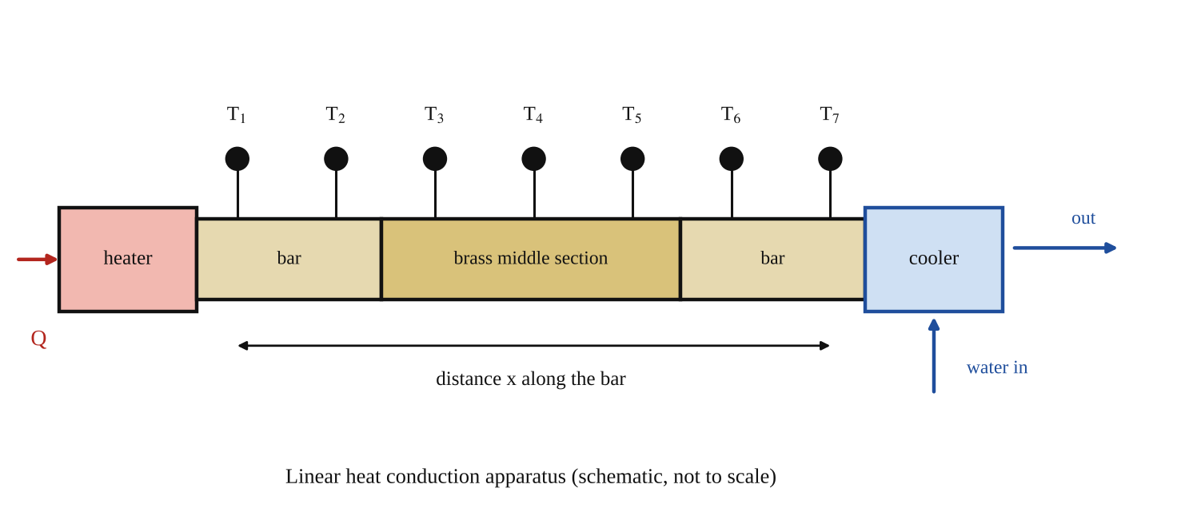
Fig. 1: The linear heat conduction apparatus (schematic): heater, bar with thermocouples T₁ to T₇ and the water-cooled end.
Method in brief
- Procedure 1 (with heat transfer paste; not visible in the copy I had, written from the usual method): make sure all the joints are coated with heat transfer paste and tightly joined; switch on the cooling water; set the heater to the first power setting; wait for steady state (the temperatures stop changing) and record T₁ to T₇. Repeat at each of the higher power settings.
- Good thermal connection: repeat Procedure 1 after completely removing the heat transfer paste.
- Thermal log: repeat Procedure 1 using the brass middle section, at a low heater setting, for example 30 W, with no cooling water flowing. Record the temperatures every 10 seconds until they begin to stabilise.

3. Results
Cross-sectional area of bar A = [ ] m². Positions of the thermocouples from the heater end: x₁ = [ ] mm, x₂ = [ ] mm, x₃ = [ ] mm, x₄ = [ ] mm, x₅ = [ ] mm, x₆ = [ ] mm, x₇ = [ ] mm.
Table 1: Steady-state temperatures with heat transfer paste (one row for each heater power setting)
Heater power Q (W) | T₁ (°C) | T₂ (°C) | T₃ (°C) | T₄ (°C) | T₅ (°C) | T₆ (°C) | T₇ (°C)

Table 2: Thermal gradient and thermal conductivity
Heater power Q (W) | Gradient ΔT/Δx from graph (K/m) | Thermal conductivity k = Q / (A × gradient) (W/m K) | Typical k of brass (W/m K)
 |  |  | about 110
 |  |  | about 110
 |  |  | about 110
 |  |  | about 110
 |  |  | about 110

Table 3: Steady-state temperatures without heat transfer paste (at one power setting: [ ] W)
Heater power Q (W) | T₁ (°C) | T₂ (°C) | T₃ (°C) | T₄ (°C) | T₅ (°C) | T₆ (°C) | T₇ (°C)

Table 4: Thermal log (brass middle section, heater [ ] W, no cooling water, readings every 10 s)
Time (s) | T₁ (°C) | T₂ (°C) | T₃ (°C) | T₄ (°C) | T₅ (°C) | T₆ (°C) | T₇ (°C)
0
10
20
30
40
50
60
70
80
90
100

4. Analysis of Results
(i) Thermal gradient. For each power setting plot a chart of temperature (T₁ to T₇, vertical) against distance along the bar (horizontal). Draw the best straight line through the points and calculate its gradient, ΔT/Δx = (T₁ − T₇)/(x₇ − x₁) = [ ] K/m (use metres for x).
(ii) Thermal conductivity. From equation (2), k = Q / (A × gradient). Sample calculation: Q = [ ] W, A = [ ] m², gradient = [ ] K/m, so k = [ ] / ([ ] × [ ]) = [ ] W/m K. Find k for each power setting and take the average; compare it with the typical value for brass (about 110 W/m K).
(iii) Good thermal connection. On the same axes, plot the results of Table 3 (without paste) and compare with Table 1: the steps in temperature at the joints show the contact resistance, and k worked out over the whole bar is lower.
(iv) Thermal log. Plot temperature against time for each thermocouple and note the time taken for the temperatures to begin to stabilise.
(v) Causes of error: explained in the Discussion.

5. Observations / Precautions Taken
- Switch on the cooling water before the heater, and never exceed the maximum heater power or temperature given for the equipment.
- Wait until the temperatures are steady (no more change in T₁ to T₇ over several minutes) before recording each set of readings; steady state takes time at each new power setting.
- Coat the joints evenly with heat transfer paste, and join the sections tightly with no gaps.
- Measure the bar's diameter (or width and thickness) with a micrometer or caliper to find the area A, and note the positions of the thermocouples.
- Keep the bar lagged and away from draughts, to reduce heat losses from its sides.
- Take the thermal log readings exactly every 10 s with the stopwatch, and switch off the heater and let the equipment cool afterwards. Take care, since the heater and bar become hot.

6. Graphs
Plot the following on graph paper from your own readings and attach them here:
Plot: temperature (T₁ to T₇) against distance along the bar for each power setting (and without paste for comparison); and temperature against time for the thermal log. The expected shapes are in Fig. 2.
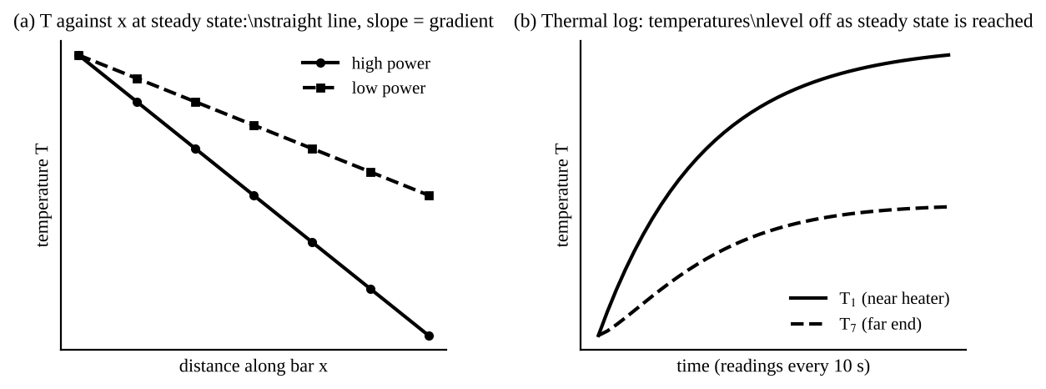
Fig. 2: Expected shapes (sketch only): (a) at steady state, temperature falls in a straight line along the bar, more steeply at higher power; (b) the thermal log: the temperatures rise and level off.

7. Discussion
At steady state the temperature fell along the bar in a straight line from T₁ near the heater to T₇ near the cooler, which agrees with the theory of linear conduction (constant gradient). The gradient was steeper at higher heater powers, as Q = k A × gradient predicts for a constant k. The thermal conductivity of the bar worked out to be k = [ ] W/m K on average, compared with the typical value of about 110 W/m K for brass, a difference of [ ] %. Without the heat transfer paste there was a [visible step / larger drop] in temperature at the joints and the calculated k was [lower], which shows the effect of contact resistance. In the thermal log the temperatures began to stabilise after about [ ] s.
Causes of error:
- Heat lost from the sides of the bar by convection and radiation (and through the lagging), so the heat actually conducted along the bar is less than the heater power, and k is overestimated, especially at the cooler end.
- Not waiting long enough for steady state, so the temperatures were still changing when read.
- Contact resistance at the joints, from paste that is unevenly applied or too thin or too thick, which changes the gradient.
- The positions of the thermocouples being nominal, and the thermocouples themselves having some error (calibration, and contact with the bar).
- Error in the diameter (area) of the bar: k depends on A, so for a round bar a 2 % error in d gives about 4 % in k.
- Heater power read from the display having some error, and part of the heater power going to the heater block and not to the bar.
- Drawing the best straight line by eye through the points, which affects the gradient.

8. Conclusion
The temperature distribution along the bar at steady state was linear, with a thermal gradient of [ ] K/m at [ ] W, and the thermal conductivity of the bar was found to be [ ] W/m K (typical value for brass about 110 W/m K). A good thermal connection, with heat transfer paste at the joints, was shown to be necessary for accurate results, and the thermal log showed that about [ ] s were needed to reach steady state. Practical applications: design of heat sinks and heat exchangers, cooling of electronic components, insulation of buildings and pipes, selecting materials for cookware and engine parts, and the use of thermal paste between processors and their coolers.

Section D: Questions
1. What have I gained from this experiment? How to find thermal conductivity from the temperature gradient, and how contact resistance affects heat flow.
4. Comment on the experimental procedure (accuracy and time saving) Simple, but slow because steady state takes time, and heat losses affect the accuracy.
5. Most difficult aspect of the experiment and how to reduce it Knowing when the temperatures had become steady; reduced by waiting longer and watching the readings.
6. Another method / apparatus that could be used A guarded hot plate apparatus, which reduces the effect of heat loss from the sides.
7. Parameters required in this experiment Heater power, area of the bar, temperatures T₁ to T₇, distances, gradient and thermal conductivity k.
8. One measuring instrument / gauge used Thermocouples with a digital temperature display.
9. Practical relevance / applications Heat sinks, heat exchangers, insulation, and cooling of electronic parts.
10. Section of the course it relates to Heat transfer (conduction).
14. What interested me most That joints without heat transfer paste cause a sudden drop in temperature.
2, 3, 11, 12, 13 and 15 (personal): to be filled in by you.
16. References (keep only the ones you actually used): Mechanical Engineering Laboratory Manual ELA 301; a fluid mechanics or theory of machines textbook of your course.

