MECHANICAL ENGINEERING LABORATORY (ELA 302)
LABORATORY REPORTS
FM 323: Flow over Weirs (Volumetric Hydraulic Bench)

Name: ______________________________
Matric No.: __________________________
Department: _________________________
Date: _______________________________
Contents
FM 323 Flow over Weirs (Volumetric Hydraulic Bench)
Notes before you submit
- Anything shown as [ ] is for your own readings or results from your own lab session. Nothing has been invented.
- The report follows Section C of the manual: Theory, Apparatus, Results, Analysis of Results, Observations and Precautions, Graphs, Discussion and Conclusion. The Section D questions are answered after the report.
- Section D questions 2, 3, 11, 12, 13 and 15 are personal (your role, whether you could do it alone, your suggestions, your group's suggestions, whether you copied results, whether you brought the manual), so they are left for you to fill in.
- Dimensions of the weirs are the nominal ones printed in the manual; check them on your weirs and replace them with your measured values.
- Graphs must be drawn from your own readings on graph paper (or in Excel) and attached where indicated.

FM 323: Flow over Weirs (Volumetric Hydraulic Bench)

Objective
- Experiment 1 (flow and head): to show how the flow Q over a weir varies with the upstream head H; to show how the coefficient of discharge changes slightly with flow; and to find the mean coefficient of discharge of each weir so that it can be used as its "constant" for calibration. The weirs tested are the rectangular notch, the two V notches (30° and 90°), the Cipoletti weir, the linear head/flow weir and the broad-crested weir.
- Experiment 2 (predicting flow): to show how the flow can be calculated from the upstream head using the constants found in Experiment 1, and to check how accurately those constants predict the real flow (percentage error).

1. Theory
1.1 What a weir is and why we use one
A weir is a barrier built across an open channel (a river, a canal or the channel of the hydraulic bench) over which the water has to flow. Engineers use weirs to raise the upstream water level, to hold back fish stocks in a section of river, and, most importantly for this experiment, to measure and regulate flow. If a weir has been calibrated, we only need to measure one thing, the height of the water just upstream of it, to find the flow rate. A weir is therefore a very cheap flow meter with no moving parts.
The upstream level fixes the flow because the water has to "pile up" to a height that gives it enough energy to get over the crest. A higher head means more energy and more flow. If the water level downstream also rises high enough to touch the nappe, the flow starts to depend on both levels and the weir is said to be drowned or suppressed. All the tests in this experiment are done with free discharge (the water springs clear of the crest and falls into air), where the head upstream is the only variable we need.
1.2 Types of weir
A sharp-crested (sharp-edged) weir has a thin plate with a bevelled edge, so the water touches only a line on the crest and then springs clear in a curved jet (the nappe). A notch is a shape cut in the plate, usually rectangular or V-shaped. The notch weirs are good for measurement because the geometry is simple and well known. A broad-crested weir is different: its crest is long compared with the head, so the flow becomes level and nearly uniform along the crest before it falls away. The set of weirs for this bench has five of these: the rectangular notch (width B = 30 mm, depth 100 mm), two V notches (total angle 30° and 90°), the Cipoletti weir, the linear head/flow (Sutro) weir, and the broad-crested weir (width 30 mm, crest thickness 12 mm).
1.3 Basic theory of flow over a sharp-edged notch
Assume the water approaching the notch is uniform and moving slowly. Then the cross-section of the upstream channel is much larger than the flow area over the notch, so the velocity head upstream is negligible, and the total head H of the flow is just the height of the undisturbed upstream water surface above the bottom of the notch (the crest). Take a typical streamline from a point M in the upstream water to a point N in the plane of the notch, a depth h below the upstream surface. With no loss of energy, Bernoulli's equation gives
p_{M}/w + z_{M} + u_{M}²/2g = p_{N}/w + z_{N} + u_{N}²/2g (1)
where p is pressure, w the specific weight of water (9810 N/m³), z the height above a datum and u the velocity. At M the water is almost still (u_{M} ≈ 0) and at the surface p_{M} is atmospheric, so the total head is H = z_{M}. At N the pressure is also atmospheric (the water jet is in the air), so p_{N} = 0. Calling h = z_{M} − z_{N} the depth of N below the upstream surface,
u_{N} = √(2 g h) (2)
which is the speed of a particle falling freely through a height h. Now take a thin horizontal strip of the notch at depth h, of width b and height δh. Its area is δA = b δh, so the flow through it is δQ = u_{N} δA = √(2gh) · b δh. Adding up all the strips from the surface (h = 0) down to the crest (h = H) gives the total flow for a notch of any shape:
Q = ∫₀^{H} √(2 g h) · b · dh (3)
Rectangular notch. The width b = B is constant, so Q = B√(2g) ∫ h^{1/2} dh = B √(2g) · (2/3) H^{3/2}, that is
Q_{theory} = (2/3) √(2g) · B · H^{3/2} = 2.95 B H^{3/2} (4)
V notch of total angle 2θ. At a depth h below the surface the width of the notch is b = 2(H − h) tan θ (the width is zero at the point of the V and 2H tan θ at the surface). Putting this in equation (3) and integrating gives
Q_{theory} = (8/15) √(2g) · tan θ · H^{5/2} = 2.36 tan θ · H^{5/2} (5)
The important thing to see is the power of H. For the rectangular notch Q ∝ H^{3/2}, and for the V notch Q ∝ H^{5/2}. The V notch has a larger power because the flow area grows in both width and depth as the head rises. That is why a V notch is better for measuring small flows accurately (a small flow still gives a noticeable head), while the rectangular notch is better for larger flows. For the 30° and 90° notches in this set, θ = 15° and θ = 45°, so tan θ = 0.268 and 1.000.
1.4 The coefficient of discharge, C_d
Equations (4) and (5) ignore contraction. In a real flow the upper surface of the water is drawn downwards as it nears the notch (vertical plane), and the water springs from the edges of the notch in a curve, reducing the width of the stream (horizontal plane). The jet is therefore smaller than the notch, in the same way as for a sharp-edged orifice. Real flows are also slightly affected by viscosity and surface tension at low heads. All of this is allowed for by a coefficient of discharge C_{d}, which is the ratio of the actual flow to the theoretical flow, so the working equations are
Q = C_{dR} · 2.95 · B · H^{3/2} (rectangular) Q = C_{dV} · 2.36 · tan θ · H^{5/2} (V notch) (6)
Textbooks give typical values (roughly 0.6 for sharp-edged notches), but a designer should calibrate the weir to get an accurate value and to see how it changes over the flow range. That is the purpose of this experiment. Rearranging (6) gives the coefficient from each reading:
C_{dR} = Q / (2.95 B H^{3/2}) C_{dV} = Q / (2.36 tan θ H^{5/2}) (7)
1.5 Finding the mean coefficient from a graph
For a rectangular notch define a constant k_{R} = Q / H^{3/2} so that C_{dR} = k_{R} / (2.95 B), and for a V notch k_{V} = Q / H^{5/2} so that C_{dV} = k_{V} / (2.36 tan θ). If C_{d} were truly constant, a plot of Q against H^{3/2} (rectangular) or Q against H^{5/2} (V notch) would be a straight line through the origin, and its gradient is the mean k. We then put the mean k in the equations above to find the mean coefficient of discharge. This graph is more reliable than the average of single values, because it uses all the points together.
1.6 Predicting flow (Experiment 2)
Once k is known for a weir, the flow can be predicted from the head alone:
Q = k_{R} H^{3/2} (rectangular) Q = k_{V} H^{5/2} (V notch) (8)
We compare this predicted flow with the actual flow measured at the same head, and calculate the percentage error = (calculated − actual) / actual × 100.
1.7 The general weir equation (log-log method)
Every weir can be described by the same general law Q = k H^{n}, where k and n are constants of the weir. Taking logarithms gives log Q = log k + n log H, which is a straight line. A plot of log Q (vertical) against log H (horizontal) gives a line with gradient n and intercept log k. This is a good way of finding the power of H of a weir without assuming it. For a rectangular notch we expect n = 3/2 and for a V notch n = 5/2.
1.8 The Cipoletti (trapezoidal) weir
Experiments on rectangular notches show that C_{d} falls slightly as the head, and therefore the ratio H/B, increases. The Italian engineer Cipoletti proposed a small change in profile: the sides of the notch slope outwards (here 4 units vertical to 1 unit horizontal, so the width at the top is bigger than at the bottom: 75 mm and 25 mm for a 100 mm depth). The extra width at higher heads compensates for the reduction in C_{d}, so that C_{d} stays almost constant over a wide range of heads and Q = k H^{3/2} with a constant k and n close to 3/2. We check this by testing the weir in the same way as a rectangular notch and plotting log Q against log H.
1.9 The linear head/flow (Sutro) weir
In the general law Q = k H^{n}, a rectangular notch has n = 3/2 and a V notch has n = 5/2. The Sutro weir is designed so that n = 1, that is, Q is directly proportional to H (a straight line through the axis, which makes the weir very easy to read and to use in control systems). To do that, the notch must become narrower as the head rises, as in the figure (a rectangular base portion with curved sides above it). For low flows, the water passes through the lower rectangular section only and the weir behaves exactly like a simple rectangular notch. For higher flows the water passes through both the rectangular and the curved parts, and the flow follows
Q = K_{L} ( H − H₀ ) K_{L} = C_{dL} B √(2 g x) H₀ = x / 3 (9)
where B is the width of the rectangular base section and x its height (the manual gives a base of 50 mm and a cut-out height of 77 mm, but the printing of these dimensions is not clear, so check them on the weir). A plot of Q against H is a straight line whose gradient gives K_{L}, and which meets the head axis at H₀; with these, equation (9) gives C_{dL}.
1.10 The broad-crested weir
This weir has a crest that is not sharp but long compared with the head. Along the crest the flow accelerates and tends to a uniform, horizontal flow at the outlet section C, where the depth of flow is z_{c} and the uniform velocity is u_{c}. The discharge is
Q = u_{c} B z_{c} (10)
Applying Bernoulli's equation along the surface streamline, u_{c} = √(2g(H − z_{c})). Substituting,
Q = √(2g (H − z_{c})) · B z_{c} (11)
This shows that Q depends on both H and z_{c}, but z_{c} itself depends on H. For a chosen H, z_{c} will settle at the value between zero and H that gives the maximum possible flow (the flow adjusts itself to carry as much as it can, which is called critical flow). Setting dQ/dz_{c} = 0 gives z_{c} = (2/3) H. Putting this back in (11),
Q_{theory} = (2 / (3√3)) √(2g) · B · H^{3/2} = 1.705 B H^{3/2} (12)
In practice we include a coefficient of discharge C_{db}, which is less than 1 and may vary a little with H, because of friction and of the ratio of head to crest breadth (H/B) changing:
Q = C_{db} · (2/(3√3)) √(2g) · B H^{3/2} C_{db} = Q / (1.705 B H^{3/2}) (13)
Since C_{db} is not exactly constant, a log-log plot is not an exact straight line of slope 3/2. For best results we calculate C_{db} for every reading and plot it against H/B.
1.11 Theoretical flows for the weirs in this set (for comparison)
Equations (4), (5) and (12) with C_{d} = 1 give the following ideal flows. These are calculated, not measured. Real flows will be lower by the factor C_{d} (about 0.6 for the notches).
Head H (mm) | Rectangular, B = 30 mm (L/min) | V notch 90° (L/min) | V notch 30° (L/min) | Broad-crested, B = 30 mm (L/min)
20 | 15.0 | 8.0 | 2.1 | 8.7
30 | 27.6 | 22.1 | 5.9 | 15.9
40 | 42.5 | 45.4 | 12.2 | 24.6
50 | 59.4 | 79.2 | 21.2 | 34.3

This shows why the highest flow of the bench (about 60 L/min) limits the head to about 50 mm for the rectangular notch, and why the V notch heads are larger at the same flow.

2. Apparatus
The TecQuipment Set of Weirs (H1D/a), with the Advanced Set (H1D/b), fitted into the open channel at the top of the Volumetric Hydraulic Bench. The bench supplies the water (pump, tank and valve) and measures the flow (a weighing/volumetric tank, from which the water quantity in litres and the time are taken). The set has: a rectangular notch weir (depth 100 mm, width 30 mm); two V-notch weirs (depth 100 mm, total notch angle 30° and 90°, so θ = 15° and 45°); a Cipoletti weir (depth 100 mm, width 75 mm at the top and 25 mm at the base, side slope 4 vertical to 1 horizontal, 12 mm thick); a linear head/flow weir; and a broad-crested weir (depth 100 mm, width 30 mm, 12 mm thick). A depth gauge (precision height gauge) is fixed on the open channel to measure the upstream water level. A small cup or beaker is used to add or remove water when setting the datum, a rule or flat edge to check the level against the notch, and a stopwatch to time the collection.
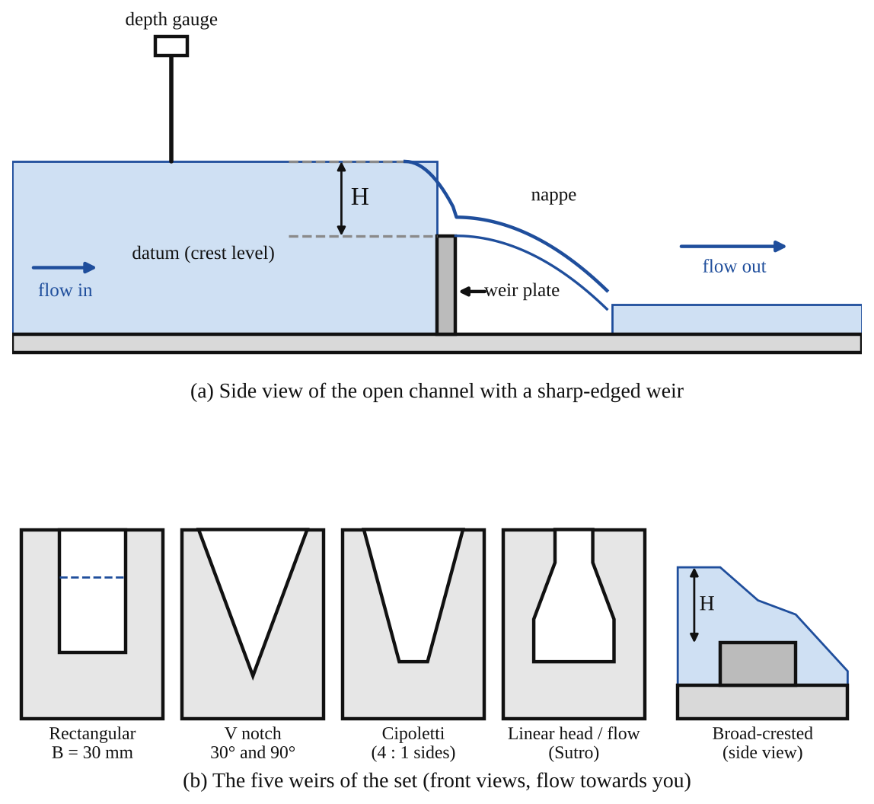
Fig. 1: (a) side view of the open channel with a weir, showing the datum, the head H and the depth gauge; (b) the five weirs of the set.
Method in brief (from the manual)
- Datum. Start the pump until the upstream water just begins to pour over the bottom of the notch, then stop the pump. Wait for the level to settle and use a rule or flat edge to check that the water upstream is exactly level with the bottom of the notch (for the V notch, use the reflection of the weir in the water to see when the level matches the point of the V). Add or remove water with the cup if needed. Adjust the depth gauge until its tip just touches the water surface. This reading is the datum value of head.
- Highest flow. Start the pump and set the highest flow (around 1 L/s, or 60 L in one minute).
- Wait for the flow and upstream level to settle, then note the quantity of water collected and the time taken. Convert to Q in m³/s.
- Measure the new water level with the gauge, subtract the datum value to get the true head H and convert to metres.
- Repeat for at least seven more lower flows that give roughly equal decreases in head (about 10 mm steps).
- Watch the water as it leaves the weir. At some point, as the flow gets lower, the water no longer springs clear of the weir and starts to run down the downstream face. Stop taking readings when this happens.
- Repeat for the V notches (record the notch angle θ and tan θ), for the Cipoletti and linear weirs, and for the broad-crested weir.

3. Results
Constants: ρ = 1000 kg/m³, g = 9.81 m/s². Q = water quantity (L) × 10⁻³ / time (s). Head H = (gauge reading − datum value) / 1000 (m). Datum value of head = [ ] mm for each weir.
Table 1: Rectangular notch weir. Datum value of head: [ ] mm. Width of notch B = [ ] m (nominal 0.030 m).
No. | Water quantity (L) | Time (s) | Flow Q (m³/s) | Gauge reading (mm) | Head H (m) | H^{3/2} | C_{dR}
1
2
3
4
5
6
7
8

Table 2: V notch weir, total angle 90° (θ = 45°, tan θ = 1.000). Datum value of head: [ ] mm. Measured angle θ = [ ], tan θ = [ ].
No. | Water quantity (L) | Time (s) | Flow Q (m³/s) | Gauge reading (mm) | Head H (m) | H^{5/2} | C_{dV}
1
2
3
4
5
6
7
8

Table 3: V notch weir, total angle 30° (θ = 15°, tan θ = 0.268). Datum value of head: [ ] mm. Measured angle θ = [ ], tan θ = [ ].
No. | Water quantity (L) | Time (s) | Flow Q (m³/s) | Gauge reading (mm) | Head H (m) | H^{5/2} | C_{dV}
1
2
3
4
5
6
7
8

Table 4: Cipoletti weir (repeat the table for the linear head/flow weir). Datum value of head: [ ] mm. Width of notch B = [ ] m.
No. | Water quantity (L) | Time (s) | Flow Q (m³/s) | Gauge reading (mm) | Head H (m) | log Q | log H
1
2
3
4
5
6
7
8
9
10

Table 5: Broad-crested weir. Datum value of head: [ ] mm. Width of crest B = [ ] m (nominal 0.030 m).
No. | Water quantity (L) | Time (s) | Flow Q (m³/s) | Gauge reading (mm) | Head H (m) | H^{3/2} | C_{db} | H/B
1
2
3
4
5
6
7
8

Table 6: Predicting flow (Experiment 2). Weir: [ ]. Datum value of head: [ ] mm. Width of notch B = [ ] m. Mean constant k = [ ] from the graph in Experiment 1.
No. | Water quantity (L) | Time (s) | Actual flow Q (m³/s) | Gauge reading (mm) | Head H (m) | H^{3/2} or H^{5/2} or H | Calculated flow (m³/s) | Error (%)
1
2
3
4
5
6
7

4. Analysis of Results
Rectangular notch. For each line calculate H^{3/2} and then use equation (7): C_{dR} = Q / (2.95 B H^{3/2}). Plot C_{dR} (vertical) against Q to see how it changes with flow. Plot Q (vertical) against H^{3/2}; the line should be straight, and its gradient is the mean k_{R}. Mean C_{dR} = k_{R} / (2.95 B). Sample calculation for one reading: Q = [ ] m³/s, H = [ ] m, H^{3/2} = [ ], so C_{dR} = [ ] / (2.95 × [ ] × [ ]) = [ ].
V notches. For each line calculate H^{5/2} and C_{dV} = Q / (2.36 tan θ H^{5/2}). Plot C_{dV} against Q for each notch, then plot Q against H^{5/2}. The gradient is the mean k_{V}, and mean C_{dV} = k_{V} / (2.36 tan θ).
Cipoletti and linear head/flow weirs. Calculate log Q and log H for each line and plot log Q (vertical) against log H. The gradient is n and the intercept on the log Q axis is log k, so k = 10^{intercept}. For the Cipoletti weir confirm that n is close to 3/2. For the linear weir, also plot Q against H: the gradient is K_{L} and the intercept on the H axis is H₀, which should be about x/3; then C_{dL} = K_{L} / (B √(2gx)).
Broad-crested weir. Calculate H^{3/2} and use equation (13) to find C_{db} for each reading. Plot C_{db} (vertical) against Q, then plot Q against H^{3/2} and use its gradient to find the mean C_{db} = gradient / (1.705 B). Finally plot C_{db} against H/B to see how it changes with the head to breadth ratio.
Experiment 2. For each reading find H^{3/2} (rectangular), H^{5/2} (V notch) or H (linear), and use Q = kH^{n} with your own k to get the calculated flow. Then percentage error = (calculated − actual) / actual × 100.

5. Observations / Precautions Taken
- The datum has to be set carefully: the water must be level with the bottom of the notch before the depth gauge is zeroed. An error of even 1 mm in the datum is a large error in a head of 10 to 50 mm, and is much worse for small heads (and for the V notch, whose flow depends on H^{5/2}).
- Wait for the flow and the water level to settle before reading the gauge and the collection time. The surface oscillates a little, so read the gauge at the middle of the oscillation.
- Measure the head upstream, well away from the notch, where the water surface has not yet been drawn down towards the weir (the drop begins a short distance upstream).
- The gauge tip must just touch the surface of the water. Watching for the dimple that the tip makes when it touches the surface helps avoid parallax and a depth that is too large.
- The water must spring clear of the weir, and air must reach under the nappe. Take no readings once the water clings to the downstream face.
- Make sure the weir plate is vertical and fitted with the grease seal (supplied) so that no water leaks around the edges. Remove the wax coating, if present, before use.
- Use two people, one to take the weir readings and the other to time the collection and check the flow. Be ready for small splashes of water on the bench.
- The collection time should be long enough (a few tens of seconds) to reduce the timing error.

6. Graphs
Plot the following on graph paper from your own readings and attach them here:
Plot the following from your own readings (the general shapes expected are shown in Fig. 2):
- Rectangular and both V notches: Q (vertical) against H, to show the non-linear curve.
- Rectangular notch: Q against H^{3/2}, with the gradient k_{R}; C_{dR} against Q.
- V notches: Q against H^{5/2}, with the gradient k_{V}; C_{dV} against Q.
- Cipoletti and linear weirs: log Q against log H (gradient n, intercept log k); linear weir also Q against H.
- Broad-crested weir: C_{db} against Q, Q against H^{3/2}, and C_{db} against H/B.
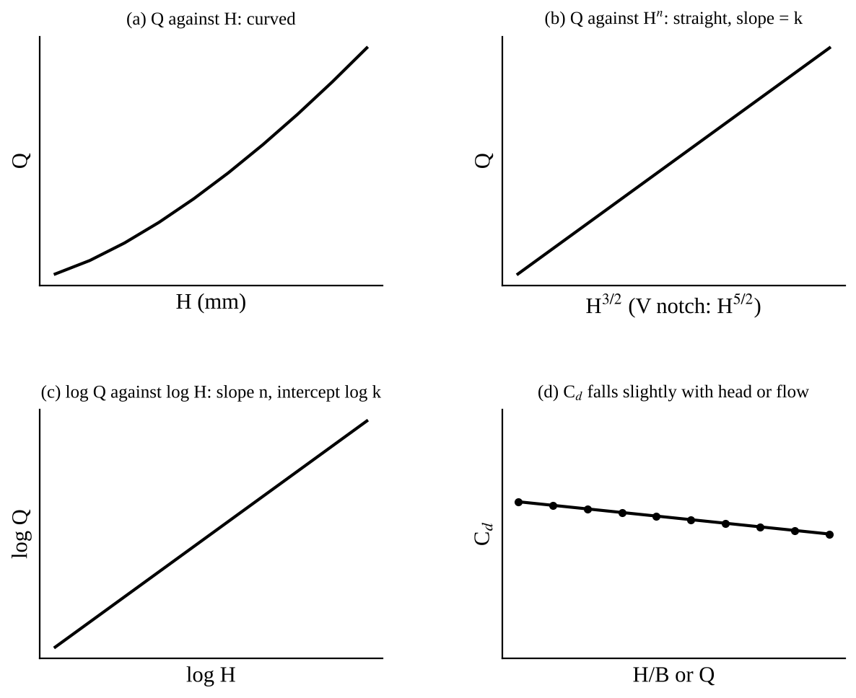
Fig. 2: Expected shapes (sketch only, not to scale): (a) Q against H is curved; (b) Q against H^{3/2} (or H^{5/2}) is a straight line through the origin; (c) log Q against log H is a straight line; (d) C_{d} falls slightly with head or flow. Your own plots will have scatter.

7. Discussion
The plots of Q against H are curved for the rectangular and V notches, as shown by Q ∝ H^{3/2} and Q ∝ H^{5/2}, and the plots of Q against H^{3/2} and H^{5/2} should be nearly straight lines through the origin, which confirms the theory. The gradient gives the mean constant and so the mean coefficient of discharge, which is [ ] for the rectangular notch, [ ] for the 90° V notch and [ ] for the 30° V notch. Typical textbook values for sharp-edged notches are about 0.6, and the actual values being below 1 shows the effect of contraction of the jet. [Compare your own result with 0.6 and comment.]
The coefficient was expected to change slightly with flow: it is usually larger at low heads (surface tension and viscosity matter more when the nappe is thin) or at high heads, depending on the weir. [Describe what your C_{d} against Q graph showed.] For the Cipoletti weir the log-log graph gave n = [ ] (expected near 1.5), which shows that its C_{d} is more nearly constant than for the plain rectangular notch. For the linear weir the Q against H graph gave a straight line with gradient K_{L} = [ ] and an intercept H₀ = [ ] mm (expected near x/3), so flow is proportional to head above H₀. For the broad-crested weir C_{db} was [ ] and [varied / did not vary much] with H/B.
In Experiment 2 the flows calculated from the constants matched the measured flows within [ ] %. The biggest errors are expected at the lowest heads, where a small error in the head (datum, gauge reading and surface oscillation) is a large percentage of the head, and so produces an even bigger percentage error in Q.
Sources of error:
- Setting the datum: the water was not exactly level with the bottom of the notch, or the gauge tip was not exactly at the surface (parallax, surface tension on the gauge tip).
- Surface waves and ripples on the upstream water, making the reading uncertain by about ±[ ] mm.
- The timing and volume of the collection: starting and stopping the stopwatch at the same moment as the water reaches the mark.
- Leakage around the weir plate, or air not reaching under the nappe, which makes the water cling to the plate and alters the flow.
- Measuring the head too near the weir where the surface has dropped, instead of in the still upstream water.
- Manufacturing tolerances of the notch width B and notch angle θ, especially for the V notches, where tan θ is a direct multiplier.
- The nominal dimensions used may be different from the actual ones (the manual says to check them).

8. Conclusion
The flow over each weir was found to increase with the upstream head, as Q ∝ H^{3/2} for the rectangular, Cipoletti and broad-crested weirs, Q ∝ H^{5/2} for the V notches and Q ∝ H for the linear head/flow weir. The mean coefficients of discharge were C_{dR} = [ ], C_{dV(90°)} = [ ], C_{dV(30°)} = [ ], C_{db} = [ ], and the constants found were then used to predict flow from head alone, with errors of about [ ] %. Practical applications: measuring flow in rivers, irrigation canals and drainage channels; flow measurement and control at treatment works and in industry; raising the water level for abstraction or navigation; and the linear weir for dosing and level control, where flow proportional to head is useful.

Section D: Questions
1. What have I gained from this experiment? How flow over a weir depends on the upstream head, and how the coefficient of discharge is found.
4. Comment on the experimental procedure (accuracy and time saving) Simple and quick, but accuracy depends on setting the datum and reading the head.
5. Most difficult aspect of the experiment and how to reduce it Setting the datum exactly at crest level; reduced by letting the water settle first.
6. Another method / apparatus that could be used A flow meter in the supply pipe to measure the flow directly.
7. Parameters required in this experiment Head H, flow Q and coefficient of discharge C_{d}.
8. One measuring instrument / gauge used Depth gauge (point gauge).
9. Practical relevance / applications Measuring flow in rivers and irrigation canals.
10. Section of the course it relates to Fluid mechanics.
14. What interested me most That a V notch gives a measurable head even at very small flows.
2, 3, 11, 12, 13 and 15 (personal): to be filled in by you.
16. References (keep only the ones you actually used): Mechanical Engineering Laboratory Manual ELA 302; a fluid mechanics or theory of machines textbook of your course.

