MECHANICAL ENGINEERING LABORATORY (ELA 302)
LABORATORY REPORTS
FM 325: Bernoulli's Theorem

Name: ______________________________
Matric No.: __________________________
Department: _________________________
Date: _______________________________
Contents
FM 325 Bernoulli's Theorem
Notes before you submit
- Anything shown as [ ] is for your own readings or results from your own lab session. Nothing has been invented.
- The report follows Section C of the manual: Theory, Apparatus, Results, Analysis of Results, Observations and Precautions, Graphs, Discussion and Conclusion. The Section D questions are answered after the report.
- Section D questions 2, 3, 11, 12, 13 and 15 are personal (your role, whether you could do it alone, your suggestions, your group's suggestions, whether you copied results, whether you brought the manual), so they are left for you to fill in.
- Dimensions of the weirs are the nominal ones printed in the manual; check them on your weirs and replace them with your measured values.
- Graphs must be drawn from your own readings on graph paper (or in Excel) and attached where indicated.

FM 325: Bernoulli's Theorem

Objective
- To verify experimentally the validity of Bernoulli's equation for fluid flow, by measuring the pressure head and velocity head at points along a duct of varying cross-section and checking that the total head stays (almost) constant.

1. Theory
1.1 Bernoulli's theorem
Bernoulli's theorem is the statement of conservation of energy for a flowing fluid. For a fluid that is incompressible (constant density), flowing steadily (nothing changes with time), without friction, and followed along a streamline, the total energy per unit weight (the total head) is the same at every point:
P_{A}/ρg + V_{A}²/2g + Z_{A} = P_{B}/ρg + V_{B}²/2g + Z_{B} = constant (1)
where P is the static pressure (N/m²), ρ the density (1000 kg/m³ for water), g = 9.81 m/s², V the mean velocity of the flow at the cross-section (m/s) and Z the height of the centre of the section above a datum. Each term is a height, in metres of water: P/ρg is the pressure head, V²/2g is the velocity head and Z is the elevation (potential) head. In this apparatus the duct is horizontal, so Z is the same everywhere and the elevation head can be left out.
In plain words: the water has a fixed amount of "head" to share between pressure and speed. Where the duct narrows, the water must speed up, so its velocity head rises and its pressure head must fall. Where the duct widens again, the water slows down and the pressure head recovers. In a real fluid there is a small friction loss, so the total head falls slightly in the direction of flow.
1.2 Continuity
Water cannot disappear, so the volume flow rate is the same through every section of the duct (continuity): Q = A₁V₁ = A₂V₂ = … With Q in litres per minute from the rotameter (LPM):
Q = LPM / (60 × 1000) m³/s V = Q / A A = π d²/4 (2)
so the velocity at each tube is found from the flow and the diameter of the duct at that tube. The velocity is highest at the throat (smallest area). For the printed diameters, the area at the throat is 1.815 × 10⁻⁴ m², compared with 3.906 × 10⁻⁴ m² at the ends, so the velocity at the throat is about 2.15 times the velocity at the inlet and the velocity head is about 4.6 times as great.
1.3 What is measured
Piezometer tubes are fixed along the top of the duct. Each is a clear vertical tube open to the air at the top, so the water rises in it to a height that equals the pressure head at that section (the height of water that the local pressure can support). The velocity head is calculated from Q and the diameter, and the total head = pressure head + velocity head is compared from tube to tube. Bernoulli's theorem is verified if the total head is about the same at all nine tubes.

2. Apparatus
The Bernoulli's theorem apparatus is a self-contained, compact, closed-circuit set-up: a sump tank with a mono-block pump, a control valve and a rotameter (flow measurement), an inlet tank and an outlet tank connected by a flow channel that tapers (converges) for a length and then gradually enlarges (diverges) for a length, with piezometer tubes fixed along the top of the channel at fixed distances to measure the pressure head, and a discharge (outlet) valve to regulate the flow. The diameters of the channel at the nine tubes are printed in the manual (Table 1).
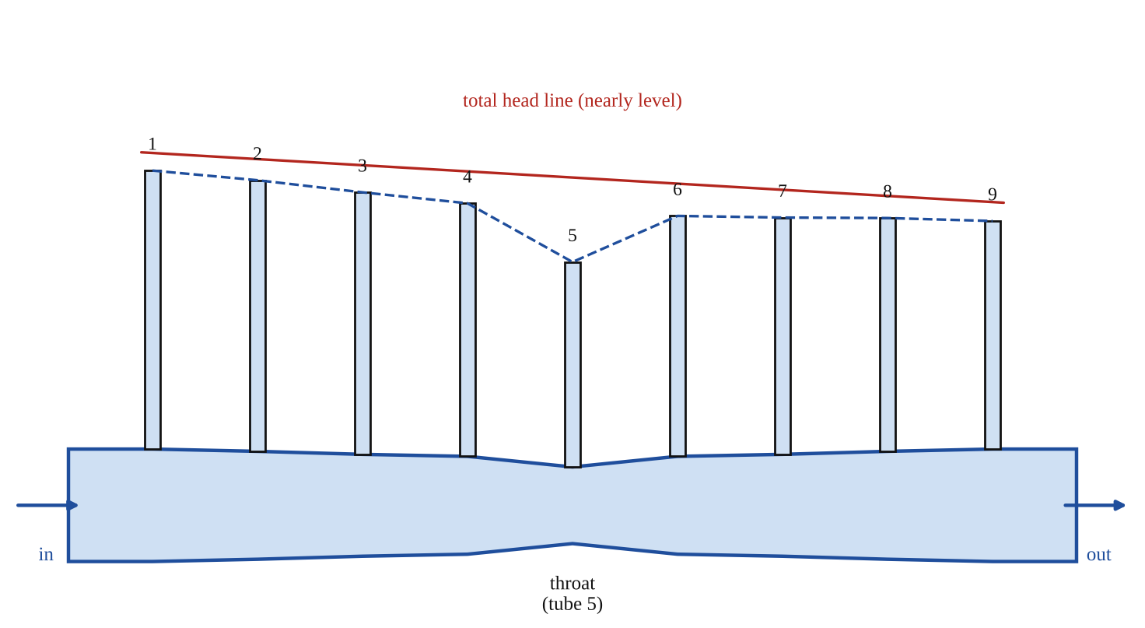
Fig. 1: Convergent-divergent duct with piezometer tubes 1 to 9: the pressure head falls at the throat (tube 5) and recovers after it, while the total head stays nearly level (sketch).
Method in brief (from the manual)
- Fill the sump tank with sufficient water.
- Start the pump by pressing the ON button.
- Keep the outlet valve closed: the water level in the piezometer tubes will rise to the same height, since there is no flow.
- Open the outlet valve; when steady state is reached, record the pressure head at the different points along the flow channel.
- Vary the flow rate using the rotameter and repeat to get other steady discharges.

3. Results
Actual discharge Q = [ ] LPM = [ ] / (60 × 1000) = [ ] m³/s. ρ = 1000 kg/m³, g = 9.81 m/s². The areas in the third column are calculated from the printed diameters (A = πd²/4). Pressure head = piezometer reading (m of water).
Table 1: Results (one table for each flow rate)
Tube No. | Tube diameter (m) | Area A (× 10⁻⁴ m²) | Manometer reading = pressure head (m) | Velocity V = Q/A (m/s) | Velocity head V²/2g (m) | Total head (m)
1 | 0.0223 | 3.906
2 | 0.0214 | 3.597
3 | 0.0202 | 3.205
4 | 0.0194 | 2.956
5 | 0.0152 | 1.815
6 | 0.0194 | 2.956
7 | 0.0202 | 3.205
8 | 0.0214 | 3.597
9 | 0.0223 | 3.906

4. Analysis of Results
For each tube: (1) convert the rotameter reading to Q in m³/s; (2) velocity V = Q/A; (3) velocity head = V²/2g; (4) pressure head = manometer reading (m); (5) total head = pressure head + velocity head. Sample calculation for tube 5 (throat): Q = [ ] m³/s, A = 1.815 × 10⁻⁴ m², V = [ ] / 1.815 × 10⁻⁴ = [ ] m/s, V²/2g = [ ] m, pressure head = [ ] m, total head = [ ] m.

5. Observations / Precautions Taken
- Make sure there are no air bubbles in the piezometer tubes or in the duct, since trapped air gives false pressure heads. Bleed the tubes if needed.
- With the outlet valve closed, check that all tubes read the same level (no flow, so equal heads); this checks the tubes and the zero.
- Wait for steady state (the levels stop moving) before reading, and read each level at the bottom of the meniscus with your eye at the same level.
- Keep the flow steady while reading all nine tubes; read quickly, since the levels can drift.
- Do not let the sump tank run dry, and do not exceed the rotameter range.

6. Graphs
Plot the following on graph paper from your own readings and attach them here:
Plot pressure head, velocity head and total head (vertical) against tube number (or distance along the duct), on the same axes, for each flow rate. The expected shape is in Fig. 2.
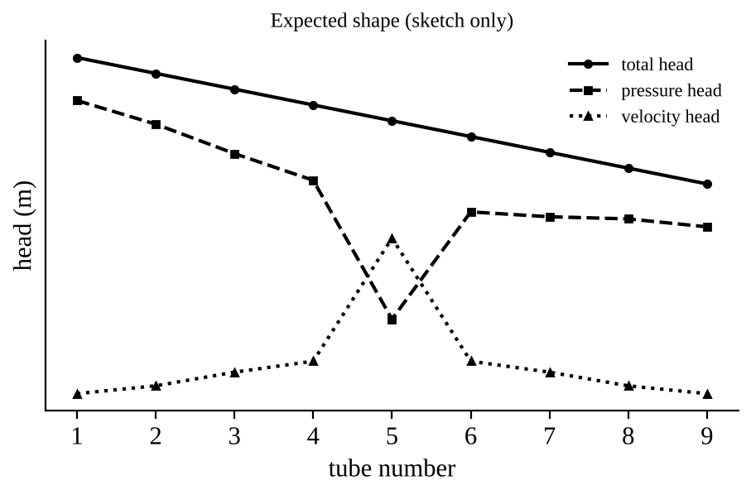
Fig. 2: Expected shape (sketch only, not to scale). Your own plots will differ.

7. Discussion
The pressure head fell as the duct narrowed towards the throat (tube 5), where it was lowest at [ ] m, and rose again in the diverging part, while the velocity head did the opposite, being highest at the throat at [ ] m. The total head was [ ] m at tube 1 and [ ] m at tube 9, so it stayed almost constant, which verifies Bernoulli's equation within about [ ] %. The small fall in total head along the duct is due to friction losses (and to the loss of energy in the diverging section, where the flow tends to separate from the walls), which Bernoulli's equation ignores. The pressure head did not recover quite to its original value at tube 9 for the same reason.
Sources of error: air bubbles in the tubes or duct; unsteady flow and fluctuating levels; reading errors at the meniscus (parallax); the error in the rotameter reading, which is used for all velocities; the diameters being nominal; and the fact that the piezometer tube measures the pressure at the wall, while the velocity used is only the mean velocity.

8. Conclusion
Bernoulli's theorem was verified: the total head stayed nearly constant (about [ ] m) along the convergent-divergent duct, the pressure head fell where the velocity head rose at the throat and recovered afterwards, and the small drop in total head is due to friction. Practical applications: venturi meters and orifice meters for flow measurement, carburettors, aircraft wing lift and airspeed (pitot) indicators, and spray nozzles and pumps.

Section D: Questions
1. What have I gained from this experiment? That pressure head falls when velocity head rises, while the total head stays almost constant.
4. Comment on the experimental procedure (accuracy and time saving) Simple and quick, but accuracy depends on reading the tubes while the flow is steady.
5. Most difficult aspect of the experiment and how to reduce it Reading nine tubes whose levels keep fluctuating; reduced by waiting for steady flow.
6. Another method / apparatus that could be used Pressure transducers connected to the tappings instead of piezometer tubes.
7. Parameters required in this experiment Flow Q, diameter, velocity, velocity head, pressure head and total head.
8. One measuring instrument / gauge used Rotameter (flow) and piezometer tubes (pressure head).
9. Practical relevance / applications Venturi meters, carburettors and aircraft airspeed indicators.
10. Section of the course it relates to Fluid mechanics.
14. What interested me most That the pressure at the throat is the lowest even though the water moves fastest there.
2, 3, 11, 12, 13 and 15 (personal): to be filled in by you.
16. References (keep only the ones you actually used): Mechanical Engineering Laboratory Manual ELA 302; a fluid mechanics or theory of machines textbook of your course.

