MECHANICAL ENGINEERING LABORATORY (ELA 302)
LABORATORY REPORTS
FM 326: Channel Flow (Spillway and Hydraulic Jump)

Name: ______________________________
Matric No.: __________________________
Department: _________________________
Date: _______________________________
Contents
FM 326 Channel Flow (Spillway and Hydraulic Jump)
Notes before you submit
- Anything shown as [ ] is for your own readings or results from your own lab session. Nothing has been invented.
- The report follows Section C of the manual: Theory, Apparatus, Results, Analysis of Results, Observations and Precautions, Graphs, Discussion and Conclusion. The Section D questions are answered after the report.
- Section D questions 2, 3, 11, 12, 13 and 15 are personal (your role, whether you could do it alone, your suggestions, your group's suggestions, whether you copied results, whether you brought the manual), so they are left for you to fill in.
- Dimensions of the weirs are the nominal ones printed in the manual; check them on your weirs and replace them with your measured values.
- Graphs must be drawn from your own readings on graph paper (or in Excel) and attached where indicated.

FM 326: Channel Flow (Spillway and Hydraulic Jump)

Objective
- To study the relationship between the head above the crest of a spillway and the flow rate, and to find the spillway constants C and n.
- To study the relation between specific energy and depth for a hydraulic jump, and to check the depths and energy loss against theory.

1. Theory
1.1 Spillways
A spillway is a structure over which the excess water of a dam is passed safely downstream, without harming the dam or eroding the ground below. To work properly, its surface has a special shape that fits the underside of the nappe of an equivalent sharp-crested weir, so the water stays in contact with the profile and does not cause low-pressure damage. The flow over the crest depends on the head h above the crest:
Q = C L h^{n} (1)
where L is the width of the spillway, h the head above the crest, C the spillway coefficient and n an index (about 3/2 for a weir-type crest). Taking logs gives log Q = log (CL) + n log h, so a plot of log Q against log h is a straight line with gradient n and intercept log (CL), from which C is found.
1.2 Specific energy and critical depth
The specific energy E of an open channel flow is the energy per unit weight measured from the channel bed. For a rectangular channel with discharge q per unit width (q = Q/b) and depth d, the velocity is V = q/d, and
E = d + V²/2g = d + q²/(2 g d²) (2)
For a given q, this has a minimum at the critical depth d_{c} = (q²/g)^{1/3}, where the Froude number F = V/√(g d) equals 1 and E_{min} = 1.5 d_{c}. For any larger E there are two possible depths: a shallow, fast supercritical flow (F > 1) and a deep, slow subcritical flow (F < 1). These are called alternate depths. Critical depth is found from the graph of E against d (the nose of the curve) and checked with F = 1.
1.3 The hydraulic jump
A hydraulic jump is the sudden rise in water level when a fast supercritical flow (depth d₁) changes to a slow subcritical flow (depth d₂). It is a very good energy dissipator: much of the kinetic energy is turned into turbulence and heat. It is used below spillways and dams to slow down the fast water and so prevent erosion of the bed, and for head recovery downstream of a measuring flume.
Energy is lost in the jump, so Bernoulli cannot be used across it, but momentum is conserved. Taking sections 1 and 2 just before and after the jump, the change in momentum per second is equal to the difference of the hydrostatic pressure forces:
P₁ + M₁ = P₂ + M₂ (3)
where P is the pressure force (ρ g A ȳ, with ȳ the depth of the centroid) and M the momentum flow (ρ Q V). For a rectangular channel of width b, P = ρ g b d²/2 and M = ρ q² b / d, so (3) gives d₁ d₂ (d₁ + d₂) = 2q²/g, which solves to
d₂ = ½ d₁ ( √(1 + 8F₁²) − 1 ) i.e. d₂/d₁ = √(¼ + 2F₁²) − ½ F₁ = V₁/√(g d₁) (4)
For a jump to occur, d₂ > d₁, which needs F₁ > 1: the incoming flow must be supercritical. If F₁ = 1, then d₁ = d₂ = critical depth and there is no jump. The energy lost in the jump is
E₁ − E₂ = (d₁ − d₂) + (q²/2g)(1/d₁² − 1/d₂²) = (d₂ − d₁)³ / (4 d₁ d₂) (5)
The second form of (5) is obtained by eliminating q using d₁d₂(d₁+d₂) = 2q²/g. It shows that the loss is always positive (if d₂ > d₁) and that it grows quickly as the jump gets bigger.

2. Apparatus
A tilting flume with a spillway fitted in it. Water is supplied by a pump through a flow control valve, with the flow measured by a flow meter (and checked by a pitot tube). The flap (gate) at the end of the flume can be wound up or down to control the downstream depth and so the position of the hydraulic jump. A depth gauge measures the depths of water on the crest of the spillway and at other positions, and a scale along the flume gives the position of the jump. The width of the flume is b = [ ] m and the width of the spillway is L = [ ] m.
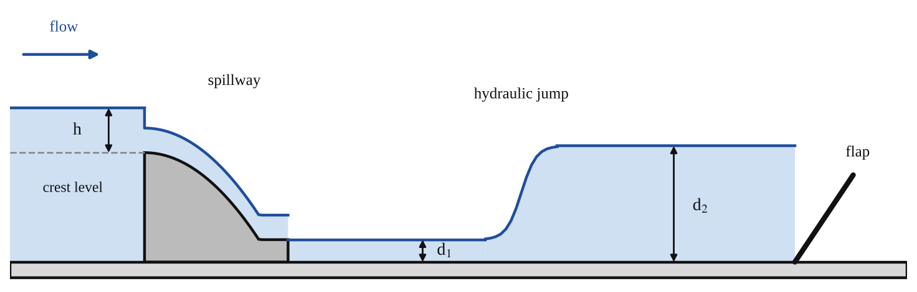
Fig. 1: Layout of the tilting flume: the spillway with head h above the crest, and the hydraulic jump between depths d₁ and d₂ held in place by the flap (sketch).
Method in brief (from the manual)
- Start the pump and adjust the valve to give maximum flow. Make sure the flap at the end of the channel is fully wound down. Allow the flow to become steady.
- Using the depth gauge, take readings at the highest point on the crest of the spillway and at the surface of the water above this point. Record these depths and the flow rate.
- Reduce the flow to zero in about ten even steps, reading the flow rate and the surface of the water each time.
- Check the calibration of the flow meter: set the flow to maximum and choose a section where the surface is fairly flat; measure the velocity head (pitot tube) and the depth at this section. Repeat for about half the maximum flow.
- Set the flow to maximum and adjust the flap until a jump is produced about 0.2 m from the end of the flume. Measure the depth just before and just after the jump and record them. Make sure the flow is steady (the jump stays in roughly the same position) before measuring.
- Raise the flap to move the jump upstream by about 0.2 m and repeat each time, until the start of the jump is only about 0.5 m from the toe of the spillway. Repeat for each position of the jump.
- Repeat the jump measurements for half the maximum flow rate.

3. Results
Width of flume b = [ ] m. Width of spillway L = [ ] m. g = 9.81 m/s². Depth gauge reading at the crest = [ ] mm; head h = (gauge reading on the water surface − crest reading) / 1000 (m).
Table 1: Head above the crest of the spillway and flow rate
No. | Flow rate Q (m³/s) | Gauge reading on water surface (mm) | Head h above crest (m) | log Q | log h
1
2
3
4
5
6
7
8
9
10

Table 2: Hydraulic jump (maximum flow Q = [ ] m³/s, q = Q/b = [ ] m²/s; repeat for half flow)
Position of jump (m) | d₁ (m) | d₂ (m) | V₁ = q/d₁ (m/s) | Froude no. F₁ | d₂ from eq. (4) (m) | E₁ (m) | E₂ (m) | Energy loss E₁−E₂ (m)

Table 3: Specific energy against depth (for the graph, at the maximum flow)
Depth d (m) | Velocity V = q/d (m/s) | Specific energy E = d + V²/2g (m)

4. Analysis of Results
Spillway. From Table 1 plot log Q (vertical) against log h. The gradient is n and the intercept is log (CL), so CL = 10^{intercept} and C = CL / L. Check that n is near 1.5. Sample: Q = [ ] m³/s, h = [ ] m, so log Q = [ ], log h = [ ].
Flow rate check. Compare the flow rate given by the pitot tube (V = √(2g × velocity head), Q = V × area of flow) with that given by the flow meter; they should be very close. Percentage difference = [ ] %.
Hydraulic jump. For each position of the jump: V₁ = q/d₁; F₁ = V₁ / √(g d₁); then the theoretical d₂ from equation (4) and compare it with the measured d₂; E = d + V²/2g before and after the jump, and the energy loss E₁ − E₂, which can be checked with (d₂ − d₁)³/(4 d₁ d₂). Sample calculation: d₁ = [ ] m, V₁ = [ ] m/s, F₁ = [ ], d₂(theory) = [ ] m.
Specific energy. Plot E (horizontal) against d (vertical) for the two flow rates and find the critical depth at the minimum E. Check by calculating d_{c} = (q²/g)^{1/3} and by confirming that F = 1 there.

5. Observations / Precautions Taken
- The flow must be steady before readings are taken (the jump must remain in the same position).
- Measure the head h over the crest well upstream of the spillway, where the surface has not yet dropped.
- Zero the depth gauge on the crest of the spillway and read the water surface at the same position each time; avoid parallax and ripples.
- Measure d₁ and d₂ just before and just after the jump, where the surface is flat, and not in the turbulent part of the jump itself.
- Wind the flap slowly, and wait for the jump to settle before measuring.
- Keep clear of the moving water and make sure the flume is level and the tilt is as set.

6. Graphs
Plot the following on graph paper from your own readings and attach them here:
Plot: log Q against log h (the spillway); and specific energy E against depth d (for the two flow rates), marking the critical depth. The general shapes are in Fig. 2.
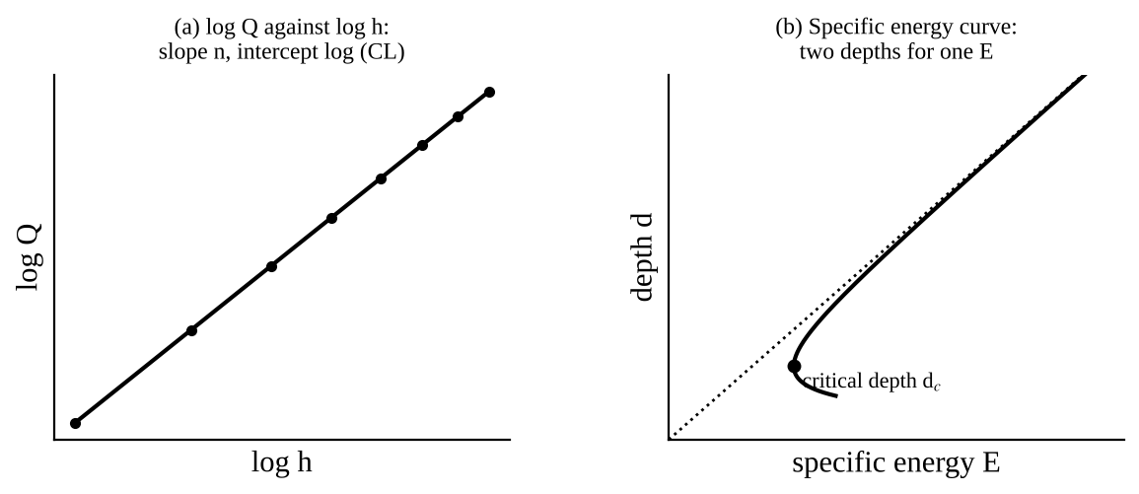
Fig. 2: Expected shapes (sketch only): (a) log Q against log h is a straight line; (b) the specific energy curve has a minimum at the critical depth. Your own plots will have scatter.

7. Discussion
The log Q against log h graph was a straight line with gradient n = [ ] (expected about 1.5) and C = [ ], so the flow over the spillway follows Q = C L h^{n}. The pitot tube and flow meter flows agreed within [ ] %. The measured depths after the jump agreed with those from equation (4) within [ ] %, and the Froude number before the jump was above 1 in every case ([ ] to [ ]), as it must be for a jump to occur. The energy loss in the jump increased as the jump became bigger (larger d₂ − d₁), as shown by equation (5). The critical depth from the graph was [ ] m, compared with [ ] m calculated from (q²/g)^{1/3}.
Sources of error: unsteady flow and a jump that moves about; reading the depths on a rippled and turbulent surface; measuring d₁ and d₂ at positions that are not exactly before and after the jump; error in the flow meter reading; friction at the walls and bed of the flume, which the theory ignores; and the head h being read where the surface has already begun to drop.

8. Conclusion
The flow over the spillway was found to follow Q = C L h^{n} with n = [ ] and C = [ ]. The hydraulic jump occurred only when the incoming flow was supercritical (F₁ > 1), the depth after the jump agreed with the momentum equation, and the energy loss was found to be [ ] m. Practical applications: dam spillways and stilling basins (the jump dissipates the energy so that the water does not erode the river bed), flow measurement flumes, irrigation canals and sluice gates, and flood control.

Section D: Questions
1. What have I gained from this experiment? How flow over a spillway depends on the head, and how a hydraulic jump dissipates energy.
4. Comment on the experimental procedure (accuracy and time saving) Quick, but accuracy depends on reading depths on a rippled, unsteady surface.
5. Most difficult aspect of the experiment and how to reduce it Keeping the jump steady while measuring d₁ and d₂; reduced by adjusting the flap slowly.
6. Another method / apparatus that could be used A point gauge or ultrasonic level sensor to measure the depths.
7. Parameters required in this experiment Head h, flow Q, depths d₁ and d₂, Froude number and specific energy.
8. One measuring instrument / gauge used Depth gauge, flow meter and pitot tube.
9. Practical relevance / applications Dam spillways, stilling basins, canals and flow measurement flumes.
10. Section of the course it relates to Fluid mechanics (open channel flow).
14. What interested me most That a hydraulic jump can be predicted from the Froude number alone.
2, 3, 11, 12, 13 and 15 (personal): to be filled in by you.
16. References (keep only the ones you actually used): Mechanical Engineering Laboratory Manual ELA 302; a fluid mechanics or theory of machines textbook of your course.

