MECHANICAL ENGINEERING LABORATORY (ELA 302)
LABORATORY REPORTS
SM 321: Shear Centre

Name: ______________________________
Matric No.: __________________________
Department: _________________________
Date: _______________________________
Contents
SM 321 Shear Centre
Notes before you submit
- Anything shown as [ ] is for your own readings or results from your own lab session. Nothing has been invented.
- The report follows Section C of the manual: Theory, Apparatus, Results, Analysis of Results, Observations and Precautions, Graphs, Discussion and Conclusion. The Section D questions are answered after the report.
- Section D questions 2, 3, 11, 12, 13 and 15 are personal (your role, whether you could do it alone, your suggestions, your group's suggestions, whether you copied results, whether you brought the manual), so they are left for you to fill in.
- Dimensions of the weirs are the nominal ones printed in the manual; check them on your weirs and replace them with your measured values.
- Graphs must be drawn from your own readings on graph paper (or in Excel) and attached where indicated.

SM 321: Shear Centre

Objective
- To find the position of the shear centre of a channel section by loading a cantilever at different distances from the web, until the beam bends without twisting (pure bending).
- To compare the position found by experiment with the theoretical value.

1. Theory
1.1 What is the shear centre?
When a beam carries a transverse load, the load causes bending, and it also causes shear stresses in the section. If the load is applied along a line that does not pass through one special point of the section, the beam also twists as it bends. The shear centre (also called the centre of twist) is the point in the cross-section through which the line of action of the load must pass for the beam to bend without twisting. It depends only on the shape of the section and not on the size of the load.
For a section with an axis of symmetry (like a rectangle, or an I-section), the shear centre lies on that axis (and at the centroid if there are two axes of symmetry). But for a section like the channel (a "C" section), the shear centre is not at the centroid: it lies on the axis of symmetry, outside the section, on the side of the web away from the flanges. If a load is applied through the centroid of a channel, it will twist; it must be applied through the shear centre to avoid twisting.
1.2 Why the shear centre lies outside the web of a channel
A vertical shear force V on a channel produces a shear flow q (shear force per unit length of the wall) that runs along the walls: along the flanges, in opposite directions on the top and bottom flange, and down the web. The flange flows give two equal and opposite horizontal forces F, separated by the depth h, so they form a couple F h. The web carries nearly all of the vertical force V. For the total force to be equal to V with no net moment about the beam, the line of V must be placed at a distance e from the web such that its moment balances the couple of the flange forces:
V e = F h (1)
Suppose the section is thin-walled, with web depth h (between the centre lines of the flanges), flange width b and constant thickness t. Its second moment of area about the neutral axis is approximately I = t h³/12 + 2 (b t)(h/2)² = t h² (h + 6b)/12. The shear flow in the flange at a distance s from its free tip is q = V A ȳ / I = V (t s)(h/2) / I, and the force in one flange is the sum of this along its width:
F = ∫₀ᵇ q ds = V t h b² / (4 I) (2)
Putting (2) into (1) gives the position of the shear centre from the centre line of the web:
e = F h / V = t h² b² / (4 I) = 3 b² / (h + 6 b) (3)
This depends only on the dimensions b and h (the thickness cancels), as a shear centre should. For example, for b = h/2, e = 3(h²/4)/(h + 3h) = 0.1875 h. The shear centre lies a distance e outside the web, on the side opposite to the flanges.
1.3 How the experiment finds it
In the apparatus, a channel is held as a cantilever and loaded by a cord and weight at a notched bar, which allows the load to be placed at different distances from the web. The free end of the cantilever carries a "twisting head", and two dial gauges (LH and RH, left-hand and right-hand) bear on its machined face on either side of the axis. If the load line is not through the shear centre, the section twists, so one dial reads more than the other. As the load is moved closer to the shear centre, the twist falls; when the load is exactly through the shear centre the twisting is zero and the two dial readings are equal. So the position at which the LH and RH readings become equal (where the two lines of a graph of dial reading against notch position cross) is the shear centre.

2. Apparatus
The shear centre apparatus: a main upright unit, calibrated from 0° to 360° in increments of 22.5° with a single engraved line, whose swivel head allows measurement of the angular position (a thumbnut fixes the swivel head in position); a pulley that helps in loading the cantilever; weights added to a weight hanger attached by an "S" hook to the cord at the notched bar on the twisting head; a white Perspex cursor with a central red line and black parallel lines, engraved across its width in the same sense as the loading cord, which lets the direction of the applied load be adjusted into the same plane every time a reading is taken; two dial gauges whose plungers bear on the machined face of the twisting head; the channel specimen (cantilever); and a micrometer to check its dimensions.
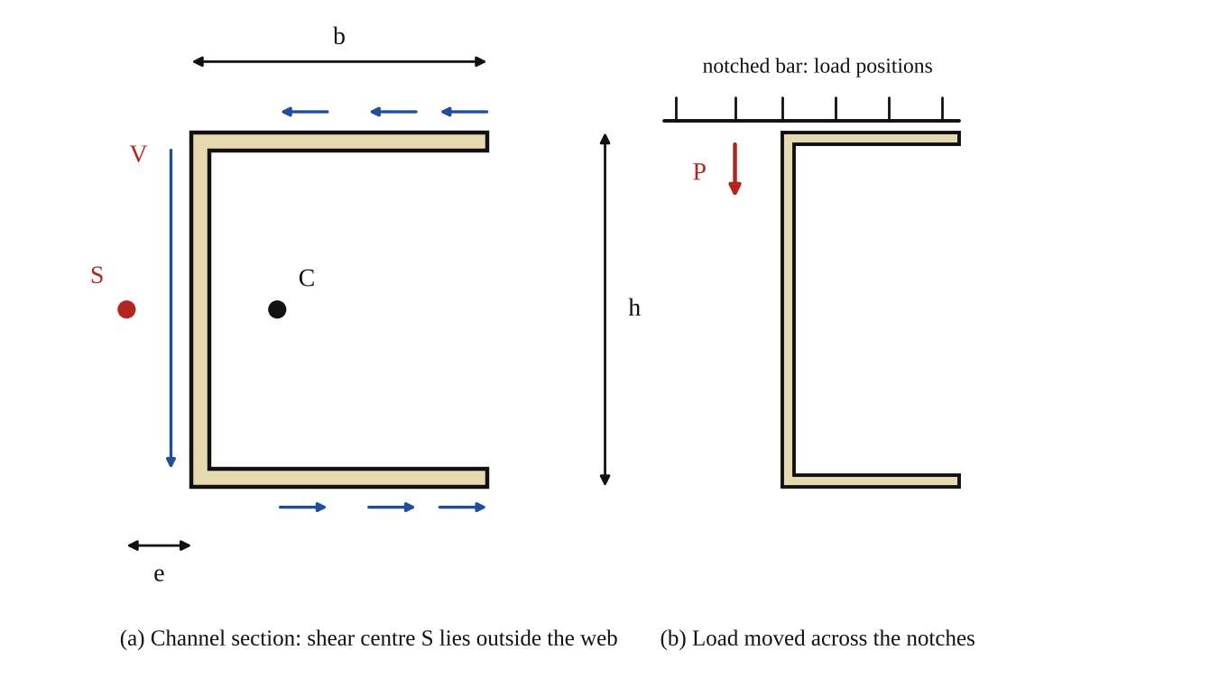
Fig. 1: (a) channel section, showing the shear flow, the centroid C, the shear centre S and the distance e; (b) the load moved across the notches of the bar (sketch, not to scale).
Method in brief (from the manual)
- Check the dimensions of the channel specimen with a micrometer, for any deviation from the nominal dimensions. With no load on the specimen, set the two dial gauge plungers to bear on the machined face of the twisting head.
- Position the swivel head so that the red line on the Perspex cursor is directly in line with the outside edge of the channel web. A tightly loaded cord attached to the notched bar and hung over the pulley will help to position the head.
- Remove the load and zero each dial. Now position the load at some arbitrary notch distance from the web and load the hanger with weights large enough for a reasonably large deflection to be seen on the dials (between 3 and 4.5 kg is usually enough).
- Bring the loading cord into the same plane by use of the pulley adjustment and the cursor provided. Note the reading on each dial.
- Move the load to the next notch, that is towards the web, with the line of action of the load brought parallel with the corresponding cursor line. Note each dial reading.
- Repeat for each notch until the dials read approximately the same deflection. This indicates that the shear centre has been reached and the beam is in pure bending.
- Continue moving the load in the same manner and in the same direction, and note the dial readings.

3. Results
Channel dimensions (micrometer): depth h = [ ] mm, flange width b = [ ] mm, thickness t = [ ] mm. Load P = [ ] kg = [ ] N (the same for every reading). Distance between notches = [ ] mm.
Table 1: Dial readings for each position of the load
No. | Notch position (distance from web, mm) | LH dial reading (mm) | RH dial reading (mm) | Difference (LH − RH) (mm)
1
2
3
4
5
6
7
8
9
10

Shear centre from the graph: e = [ ] mm from the web. Theoretical shear centre from equation (3): e = 3 b²/(h + 6b) = 3 × [ ]² / ([ ] + 6 × [ ]) = [ ] mm.

4. Analysis of Results
1. Tabulate the results and calculate the difference (LH − RH) for each notch position.
2. Plot a graph of dial gauge reading (LH and RH, vertical) against notch position (horizontal) on the same axes. The two lines should cross; the position of the crossing point, where LH = RH, is the shear centre. (Equivalently, plot LH − RH against position and read where it is zero.) Read off e, the distance of the shear centre from the web.
3. Calculate the theoretical position from e = 3b²/(h + 6b) using the measured dimensions, and compare: percentage difference = (e_{exp} − e_{th})/e_{th} × 100 = [ ] %.

5. Observations / Precautions Taken
- Check the dimensions of the channel with the micrometer before the test and use the measured values in the theory.
- Zero both dial gauges with no load, and make sure the plungers bear on the machined face of the twisting head.
- Keep the same load for every reading, and bring the cord into the same plane each time using the pulley adjustment and the cursor, so that the load stays vertical and parallel to the cursor line.
- Fix the swivel head with the thumbnut so that it does not turn, and set the red line of the cursor in line with the outside edge of the web.
- Do not overload the specimen: stay within the elastic range (3 to 4.5 kg is enough), and apply the load gently without shock.
- Read both dials with the load steady, and take the readings for every notch in the same direction (towards and then beyond the shear centre).

6. Graphs
Plot the following on graph paper from your own readings and attach them here:
Plot LH and RH dial readings (vertical) against notch position (horizontal) on the same axes, and mark the position where they cross: this is the shear centre. The expected shape is in Fig. 2.
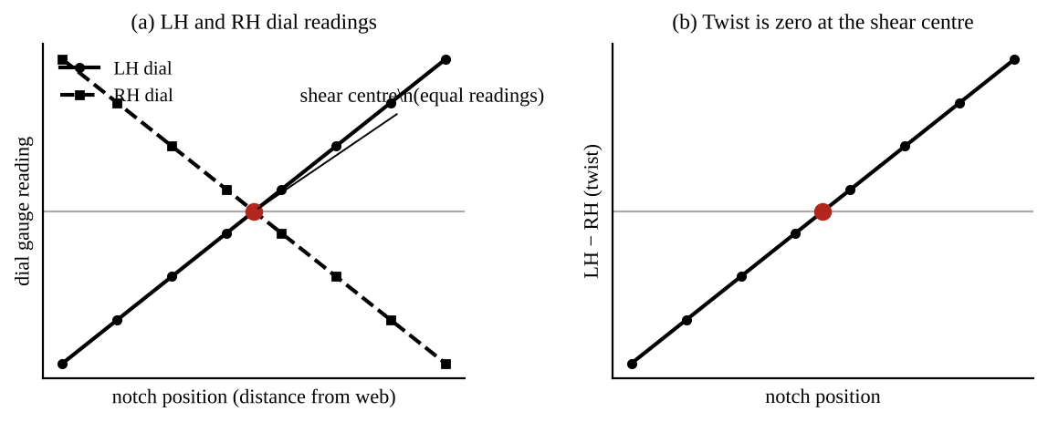
Fig. 2: Expected shape (sketch only): (a) the LH and RH dial readings cross at the shear centre; (b) the difference between them (the twist) is zero at that point.

7. Discussion
As the load was moved from the notch farthest from the web towards the web, the LH and RH dial readings came closer together and became equal at a notch position of [ ] mm from the web. At this position the section bent without twisting, so this is the shear centre, e = [ ] mm outside the web. The theoretical value from equation (3) is [ ] mm, so the two agree within [ ] %. Beyond this position the twist changed direction, as shown by the difference between the readings changing sign. This also shows that the shear centre is not at the centroid of the channel, but outside the web, on the opposite side to the flanges.
Sources of error: the cord not being exactly in the plane of the load line (the cursor adjustment), friction in the pulley, the dimensions of the channel being different from the nominal (the walls are not exactly thin, so equation (3) is an approximation), the dial gauges having a small zero error or the plungers not being on the face squarely, the load swinging or the specimen vibrating when the readings were taken, and the specimen having been loaded beyond the elastic range.

8. Conclusion
The shear centre of the channel section was found to lie [ ] mm outside the web, which agrees with the theoretical value of [ ] mm (e = 3b²/(h + 6b)) to within about [ ] %. A load applied through the shear centre causes bending without twisting. Practical applications: design of beams with open sections (channels, angles, Z and T sections) used in buildings, bridges, aircraft wings and ships, where the load must pass through the shear centre to avoid twisting, and the use of closed sections (tubes), which resist twist much better.

Section D: Questions
1. What have I gained from this experiment? How to find the shear centre of a channel and why a load must pass through it to avoid twisting.
4. Comment on the experimental procedure (accuracy and time saving) Quick and clear, since the dial gauges show the twist directly, but it depends on keeping the load in the same plane.
5. Most difficult aspect of the experiment and how to reduce it Keeping the cord in the same plane at every notch; reduced by using the cursor lines carefully.
6. Another method / apparatus that could be used Strain gauges on the specimen, or an optical method to measure the twist angle directly.
7. Parameters required in this experiment Notch position (distance from web), LH and RH dial readings and the shear centre distance e.
8. One measuring instrument / gauge used Dial gauges (dial indicators).
9. Practical relevance / applications Design of channel, angle and Z-section beams in buildings, bridges and aircraft.
10. Section of the course it relates to Strength of materials (shear and bending of beams).
14. What interested me most That the shear centre of a channel lies outside the section, not at its centroid.
2, 3, 11, 12, 13 and 15 (personal): to be filled in by you.
16. References (keep only the ones you actually used): Mechanical Engineering Laboratory Manual ELA 302; a fluid mechanics or theory of machines textbook of your course.

