MECHANICAL ENGINEERING LABORATORY (ELA 302)
LABORATORY REPORTS
SM 322: Unsymmetrical Bending of Beams

Name: ______________________________
Matric No.: __________________________
Department: _________________________
Date: _______________________________
Contents
SM 322 Unsymmetrical Bending of Beams
Notes before you submit
- Anything shown as [ ] is for your own readings or results from your own lab session. Nothing has been invented.
- The report follows Section C of the manual: Theory, Apparatus, Results, Analysis of Results, Observations and Precautions, Graphs, Discussion and Conclusion. The Section D questions are answered after the report.
- Section D questions 2, 3, 11, 12, 13 and 15 are personal (your role, whether you could do it alone, your suggestions, your group's suggestions, whether you copied results, whether you brought the manual), so they are left for you to fill in.
- Dimensions of the weirs are the nominal ones printed in the manual; check them on your weirs and replace them with your measured values.
- Graphs must be drawn from your own readings on graph paper (or in Excel) and attached where indicated.

SM 322: Unsymmetrical Bending of Beams

Objective
- To measure the horizontal and vertical deflections (ΔH and ΔV) of a cantilever of unsymmetrical section when the load is applied at different angles α in a horizontal plane.
- To show that the maximum and minimum values of ΔV occur where ΔH/W is zero, and to find the second moments of area I_{x} and I_{y} of the section from the results and compare them with theory.

1. Theory
1.1 Symmetrical and unsymmetrical bending
In ordinary (symmetrical) bending, the load acts along a principal axis of the cross-section (an axis of symmetry for a rectangle or I-section), the beam bends in the plane of the load and the deflection is in the same direction as the load. The bending equation M/I = σ/y = E/R then applies directly. In unsymmetrical bending, the load acts at an angle to the principal axes of the section: the beam still bends, but the plane of bending is not the plane of the load, and the deflection is in a direction different from that of the load. This happens when the section is unsymmetrical (such as an angle) or when a symmetrical section is loaded at an angle to its axes, as in this experiment.
1.2 Principal axes and the two second moments of area
For any section there is a pair of perpendicular axes through the centroid, called the principal axes, about which the product of inertia is zero. The second moments of area about them, I_{x} and I_{y}, are the maximum and minimum values for the section. For a rectangle of width b (along x) and depth d (along y), I_{x} = b d³/12 (bending in the y direction) and I_{y} = d b³/12 (bending in the x direction). A thin strip is therefore much stiffer in the direction of its depth than in the direction of its thickness.
1.3 Deflection of the cantilever under a load at an angle
The cantilever has length L, Young's modulus E and its principal axes along the horizontal (H) and vertical (V) directions of the apparatus (H and V here are directions in the horizontal plane of the load, as seen from above). A load W is applied at the free end in this plane at an angle α to the H axis. Break the load into components along the principal axes: W cos α along H and W sin α along V. Each component bends the beam independently (superposition), and for a cantilever with an end load the deflection is F L³/(3 E I). So
ΔH = W cos α · L³ / (3 E I_{V}) ΔV = W sin α · L³ / (3 E I_{H}) (1)
Here I_{V} is the second moment of area for bending in the H direction (about the V axis) and I_{H} the one for bending in the V direction (about the H axis). Dividing by W:
ΔH / W = ( L³ / 3 E I_{V} ) cos α ΔV / W = ( L³ / 3 E I_{H} ) sin α (2)
Equation (2) tells us what to expect. ΔH/W is a cosine curve of α: largest at α = 0° and zero at α = 90°. ΔV/W is a sine curve: zero at α = 0° and largest at α = 90°, which is exactly where ΔH/W is zero. So the extreme values of the deflection component ΔV occur at the angles where the other component ΔH/W is zero, that is, where the load acts along a principal axis, as the manual asks to show. At these angles the deflection is in line with the load. At any other angle the beam deflects in a direction that makes an angle φ with the H axis, where
tan φ = ΔV / ΔH = ( I_{V} / I_{H} ) tan α (3)
Since I_{V} ≠ I_{H}, φ ≠ α: the beam deflects towards the weaker (more flexible) direction, not in the direction of the load. Only if I_{V} = I_{H} (for example a square or a circle) would the deflection always be along the load.
1.4 Finding the second moments from the experiment
Within the elastic range, the deflections are proportional to the load, so the graphs of ΔH and ΔV against W are straight lines through the origin, and their gradients give ΔH/W and ΔV/W for each α. Rearranging (2), using the values at α = 0° (for I_{V}) and α = 90° (for I_{H}), or the values at any angle:
I_{V} = L³ cos α / ( 3 E (ΔH/W) ) I_{H} = L³ sin α / ( 3 E (ΔV/W) ) (4)
These are compared with the theoretical values from the dimensions, I = b d³/12 for the rectangular section. Note that the experimental I is found with E taken as the value for the material (about 200 GPa for steel, 70 GPa for aluminium: use the value for your specimen).

2. Apparatus
The unsymmetrical bending apparatus: a vertical cantilever rigidly fixed to the base of the apparatus; the load on its free end is applied in a horizontal plane by a simple system of cord and pulley that can be rotated in any direction about the vertical axis of the cantilever (so that the angle α of the load can be set); a weight hanger with weights W; and two Vernier scales fixed to the top of the apparatus, which measure the horizontal (ΔH) and vertical (ΔV) displacements of the cantilever for any angular position of the load. The length of the cantilever is L = [ ] m and the section dimensions are b = [ ] mm and d = [ ] mm, which you must measure.
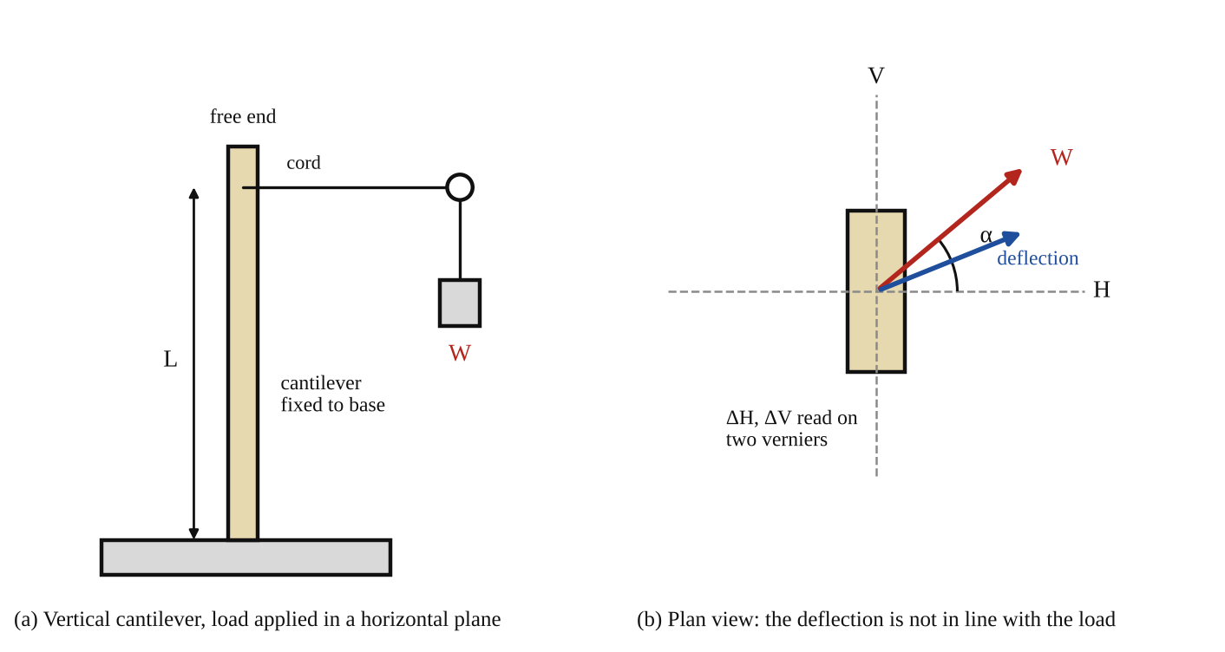
Fig. 1: (a) the vertical cantilever loaded through a cord and pulley; (b) plan view showing the load at angle α and the deflection in a different direction (sketch, not to scale).
Method in brief (from the manual)
- Vary the angle α from 0° to 157.5° in intervals of 22.5° (0°, 22.5°, 45°, 67.5°, 90°, 112.5°, 135°, 157.5°).
- At each angle, proceed with equal increments of load and record ΔH and ΔV at each value of the load.
- Plot graphs of load W against ΔH and ΔV. From the curves obtain ΔV/W and ΔH/W for each value of α.
- Plot ΔV/W and ΔH/W against α, and show that the maximum and minimum values of ΔV occur where ΔH/W is zero.
- Calculate each of I_{x} and I_{y} and compare with the theoretical values.

3. Results
Length of cantilever L = [ ] m. Section: b = [ ] mm, d = [ ] mm. Young's modulus of the specimen E = [ ] N/m². Equal load increments of [ ] N.
Table 1: Deflections for each load (repeat for each angle α = 0°, 22.5°, 45°, 67.5°, 90°, 112.5°, 135°, 157.5°). Angle α = [ ]°
No. | Load W (N) | Horizontal deflection ΔH (mm) | Vertical deflection ΔV (mm)
1
2
3
4
5
6

Table 2: Summary of the gradients for each angle
Angle α (°) | ΔH/W (mm/N) | ΔV/W (mm/N) | tan φ = ΔV/ΔH | I_{V} from (4) (mm⁴) | I_{H} from (4) (mm⁴)
0
22.5
45
67.5
90
112.5
135
157.5

Theoretical values: I_{V} = d b³/12 = [ ] mm⁴ and I_{H} = b d³/12 = [ ] mm⁴ (with b the thickness in the H direction and d the depth in the V direction).

4. Analysis of Results
1. For each angle, plot W (or deflection) against ΔH and ΔV, and find the gradients ΔH/W and ΔV/W (in mm/N). Convert to m/N for use in the equations (multiply by 10⁻³).
2. Plot ΔH/W and ΔV/W (vertical) against α (horizontal). They should follow a cosine and a sine curve. Show that the maximum and minimum values of ΔV/W occur at the angles where ΔH/W is zero (α = 90° and 0°/180°).
3. Calculate I_{V} and I_{H} from equation (4) (the most reliable values are at α = 0° and 90°, where the gradient is largest) and compare with the theoretical values: percentage difference = (I_{exp} − I_{th})/I_{th} × 100 = [ ] %. Sample: at α = 90°, ΔV/W = [ ] m/N, I_{H} = L³ / (3E × [ ]) = [ ] m⁴.
4. For each α calculate tan φ = ΔV/ΔH and compare it with (I_{V}/I_{H}) tan α, to check equation (3) and show that the deflection is not in the direction of the load.

5. Observations / Precautions Taken
- Use the same equal increments of load at every angle, and keep within the elastic range of the cantilever (small deflections), so that deflection is proportional to load.
- Set the angle α of the cord and pulley accurately and make sure the cord is horizontal (in the same plane) at every angle, so that the load acts in the horizontal plane only.
- Zero the Vernier scales (or note the initial readings) with no load at each angle before adding the load, because the cantilever may not return exactly to zero.
- Apply each load gently and without shock, and wait for the cantilever to stop vibrating before reading the Verniers.
- Measure the length L (from the fixed base to the point where the load acts) and the section dimensions b and d carefully with a vernier caliper or micrometer.
- Take care when reading the two Vernier scales: read both at the same moment and avoid parallax.

6. Graphs
Plot the following on graph paper from your own readings and attach them here:
Plot: W against ΔH and ΔV at each angle (straight lines through the origin); ΔH/W and ΔV/W against α; and, if desired, φ against α. The general shapes are in Fig. 2.
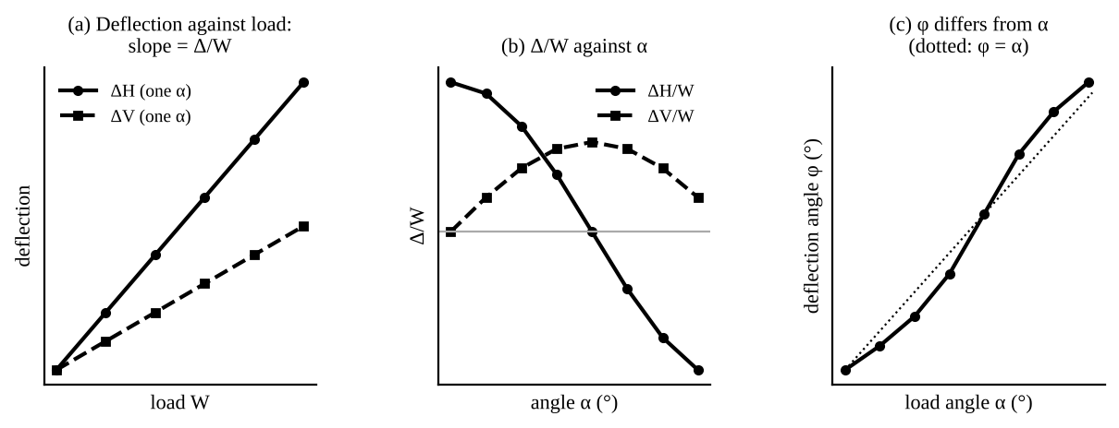
Fig. 2: Expected shapes (sketch only): (a) deflection is proportional to load at each angle; (b) ΔH/W follows a cosine and ΔV/W a sine of α; (c) the deflection angle φ is different from the load angle α (the dotted line is φ = α).

7. Discussion
The graphs of deflection against load were straight lines, so the cantilever behaved elastically. The values of ΔH/W and ΔV/W changed with the angle α in the way expected from equation (2): ΔH/W was greatest at α = 0° and zero at α = 90°, while ΔV/W was zero at α = 0° and greatest at α = 90°. So the maximum (and minimum) of ΔV/W occurred where ΔH/W was zero, as the manual states, because at those angles the load acts along a principal axis. At all other angles the cantilever deflected in a direction different from that of the load (φ ≠ α), towards the weaker direction. The experimental second moments of area were I_{V} = [ ] mm⁴ and I_{H} = [ ] mm⁴ compared with the theoretical [ ] mm⁴ and [ ] mm⁴, a difference of [ ] % and [ ] %.
Sources of error: the load not acting exactly in the horizontal plane or at exactly the angle set; friction in the pulley; the fixing of the cantilever at its base not being perfectly rigid (some rotation at the base adds to the deflection); the value of E used being only the typical value; errors in the dimensions of the section, especially the thickness b, which is cubed in I; reading the Vernier scales (parallax and the vibration of the cantilever); and the cantilever not being exactly aligned with its principal axes along H and V.

8. Conclusion
The deflections of the cantilever were proportional to the load, and ΔH/W and ΔV/W varied with the load angle as the cosine and sine of α, with the maximum and minimum values of ΔV occurring where ΔH/W was zero. The second moments of area found from the experiment were I_{V} = [ ] mm⁴ and I_{H} = [ ] mm⁴, in agreement with the theoretical values to within about [ ] %. The beam deflected in a different direction from the load at all angles except along the principal axes. Practical applications: design of beams with unsymmetrical sections (angles, channels, Z-sections) and of purlins on sloping roofs, crane jibs, aircraft wing and tail spars, and any member loaded in a plane that is not a principal plane.

Section D: Questions
1. What have I gained from this experiment? That a beam deflects along the weaker principal axis rather than along the load unless the load acts on a principal axis.
4. Comment on the experimental procedure (accuracy and time saving) Quick and simple with the two Verniers, but accuracy depends on the load angle being set exactly.
5. Most difficult aspect of the experiment and how to reduce it Setting the load angle and keeping the cord horizontal; reduced by checking each angle before loading.
6. Another method / apparatus that could be used Strain gauges on the cantilever, or dial gauges in place of the Verniers.
7. Parameters required in this experiment Load W, angle α, deflections ΔH and ΔV, and the second moments of area I_{x} and I_{y}.
8. One measuring instrument / gauge used Vernier scales.
9. Practical relevance / applications Design of angle and channel beams, roof purlins, crane jibs and aircraft spars.
10. Section of the course it relates to Strength of materials (bending of beams).
14. What interested me most That a beam does not deflect in the direction of the load unless the load acts along a principal axis.
2, 3, 11, 12, 13 and 15 (personal): to be filled in by you.
16. References (keep only the ones you actually used): Mechanical Engineering Laboratory Manual ELA 302; a fluid mechanics or theory of machines textbook of your course.

