MECHANICAL ENGINEERING LABORATORY (ELA 302)
LABORATORY REPORTS
SM 324: Tensile Test

Name: ______________________________
Matric No.: __________________________
Department: _________________________
Date: _______________________________
Contents
SM 324 Tensile Test
Notes before you submit
- Anything shown as [ ] is for your own readings or results from your own lab session. Nothing has been invented.
- The report follows Section C of the manual: Theory, Apparatus, Results, Analysis of Results, Observations and Precautions, Graphs, Discussion and Conclusion. The Section D questions are answered after the report.
- Section D questions 2, 3, 11, 12, 13 and 15 are personal (your role, whether you could do it alone, your suggestions, your group's suggestions, whether you copied results, whether you brought the manual), so they are left for you to fill in.
- Dimensions of the weirs are the nominal ones printed in the manual; check them on your weirs and replace them with your measured values.
- Graphs must be drawn from your own readings on graph paper (or in Excel) and attached where indicated.

SM 324: Tensile Test

Objective
- To use a tensile test to find the Young's modulus of a mild steel specimen.
- To show the force against elongation characteristics of the same material in two different conditions: "as drawn" (specimen TH4010) and heat treated (normalised) to remove internal stresses (specimen TH4015), and to compare their strength and ductility.

1. Theory
1.1 Stress, strain and Young's modulus
When a bar is pulled by an axial force F, it stretches. To compare bars of different size we use stress and strain instead of force and extension. Stress σ is the force per unit of the original cross-sectional area A, and strain ε is the extension per unit of original length:
σ = F / A (N/mm² = MPa) ε = ΔL / L (no units) (1)
For a round bar of diameter d, A = π d²/4. Strain has no units because it is a ratio of two lengths. Within the elastic range, stress is proportional to strain (Hooke's law), and the constant of proportionality is Young's modulus E, a measure of the stiffness of the material (not of the shape of the specimen):
E = stress / strain = σ / ε = (F/A) / (ΔL/L) = F L / (A ΔL) (2)
On a graph of stress against strain, E is the gradient of the straight part of the line. Steels all have very nearly the same Young's modulus, about 200 GPa (200 × 10³ N/mm²), whatever their strength, which is why the test is done on two steels in different conditions: the modulus should be nearly the same for both, while the strength and ductility differ.
1.2 The stress-strain curve for mild steel
The curve (Fig. 2a) has these regions. From the origin to point A the curve is a straight line (elastic and proportional): if the load is removed, the specimen returns to its original length. At the yield point (B) mild steel suddenly stretches a large amount with little increase in force: the material has "yielded" and has started to deform plastically (permanently). Beyond yield the steel work-hardens, and the stress needed to continue stretching rises up to the ultimate tensile strength (UTS) at C, which is the maximum force divided by the original area. After C the specimen forms a local narrow region, necking; the area falls quickly, the force needed falls, and the specimen fractures at D. (The curve drawn from force and original area, called the engineering curve, drops after C because the area used is the original one; the true stress, using the real smaller area, keeps rising.)
1.3 Ductility
Ductility is how much a material can be stretched plastically before it breaks. It is measured in two ways, using the final length L_{f} and the final (minimum) diameter d_{f} at the fracture:
% elongation = (L_{f} − L) / L × 100 % reduction in area = (A − A_{f}) / A × 100 (3)
A ductile material (like mild steel) gives warning by stretching and necking before it breaks, while a brittle material (like cast iron or glass) breaks suddenly with almost no plastic deformation.
1.4 "As drawn" and normalised steel
In the as drawn condition the steel has been pulled through a die at room temperature (cold working). Cold working makes it stronger and harder (higher yield strength and UTS), but less ductile, and leaves internal (residual) stresses. Normalising heats the steel and lets it cool in air, which removes internal stresses and refines the grain: the steel becomes softer, with a lower yield strength and UTS, but much more ductile (longer elongation and bigger reduction in area). The Young's modulus is nearly unchanged by either (Fig. 2b).

2. Apparatus
A tensile test frame with a hydraulic ram operated by a hand pump, a DL1 digital load meter (strain gauge force sensors, with a "peak hold" button) and a digital displacement indicator fixed to the front left column (or the Versatile Data Acquisition System, VDAS); two sets of chucks (each with an inner part in two matching halves called collets and one outer part) with ball joints; a guard around the test area; the two test specimens: TH4010 (as drawn: bright coloured with no identification ring on its head) and TH4015 (normalised: one ring engraved at its end); and a micrometer or vernier caliper and rule to measure the specimens.
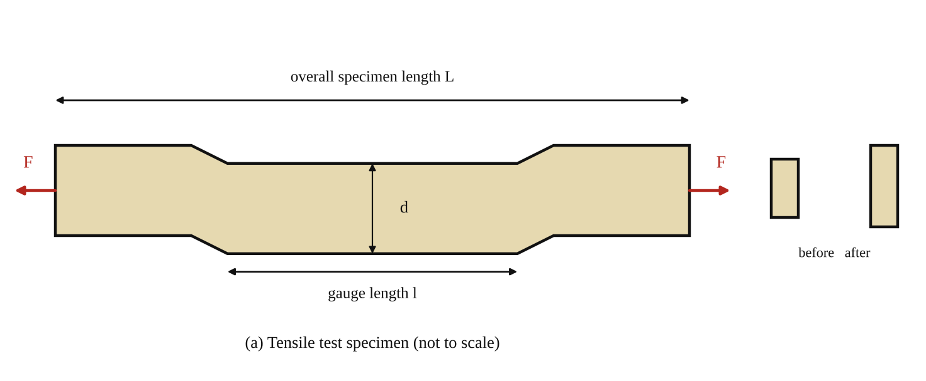
Fig. 1: The tensile test specimen with its gauge length l, diameter d and overall length L, pulled by an axial force F (sketch).
Method in brief (from the manual)
- Connect up and switch on the DL1 load meter and let the strain gauges warm up. Use the pump to fully raise the ram (select the "tensile test experiment" if VDAS is used). Create a blank results table.
- Find the TH4010 specimen. Accurately measure its overall length and the diameter of its thinnest part (the gauge area), and record the specimen type and dimensions.
- Fit the outer parts of the chucks to the top and bottom ball joints (use the small bar to stop the ball joint turning while tightening). Fit the collets to the ends of the specimen, then fit the specimen in its collets to the bottom chuck and secure with the large pins. Slowly lower the ram and fit the top collets into the top chuck, aligning the other pin (slightly "wobbling" the assembly helps). The specimen must be free to move by a small amount of force, not under tension.
- Fit the digital displacement indicator to the front left column (handle it only by its clips). Slide the assembly up the column until the magnet clamps are under the loading platform, giving at least 60 mm of upward movement. Press the button to zero the display.
- Raise the ram slowly to remove any looseness in the specimen, watching the load meter, and stop when it just begins to register a force. Re-zero the load meter and the displacement indicator. (You may need to change the display from negative to positive.) Fit the guard.
- In steps of 0.5 kN, increase the ram force slowly (never decrease it). At each step record the force and the readings of the displacement indicator (and extensometer).
- Continue until the specimen yields (above its elastic limit): the force changes only by a small amount while the specimen still stretches. Then take results at set steps of displacement instead of force (for example 0.5 mm). Study the specimen for the "necking" effect until it fails. Be prepared for a loud noise when it breaks. If peak hold was selected, note the peak load.
- Repeat the test for the TH4015 (normalised) specimen.

3. Results
Specimen type: [ ] (TH4010 as drawn / TH4015 normalised). Gauge length L = [ ] mm. Diameter d = [ ] mm. Cross-sectional area A = π d²/4 = [ ] mm². Peak load = [ ] kN.
Table 1: Results for each specimen (one table per specimen). Stress = F/A with F in N and A in mm² gives N/mm². Change in length is taken from the displacement indicator reading.
Force F (kN) | Digital displacement indicator (mm) | Extensometer reading (mm) | Stress σ (N/mm²) | Change in length ΔL (mm) | Strain ε = ΔL/L
0 | 0 | 0
0.5
1.0
1.5
2.0
2.5
3.0
3.5
4.0
4.5

Table 2: Ductility and strength of the two specimens
Quantity | TH4010 (as drawn) | TH4015 (normalised)
Original gauge length L (mm)
Final length L_{f} (mm)
% elongation
Original diameter d (mm)
Diameter at fracture d_{f} (mm)
% reduction in area
Peak load (kN)
Ultimate tensile strength (N/mm²)
Young's modulus E (N/mm²)

4. Analysis of Results
1. For each specimen plot force (vertical) against displacement (extension) from the displacement indicator, and comment on the differences between the two graphs (Fig. 2b).
2. For the first specimen, calculate the cross-sectional area A = π d²/4 and use equation (1) to calculate the stress for each line of the results. Find the change in length between results, and use ε = ΔL/L to calculate the strain for each line.
3. Plot stress (vertical) against strain (horizontal) for the first specimen. The gradient of the straight part is Young's modulus E = Δσ/Δε = [ ] N/mm² = [ ] GPa. Compare it with the typical value of about 200 GPa for steel.
4. Compare the peak loads of the two specimens, and the ultimate tensile strength UTS = peak load / original area.
5. Ductility: find the final length and use it to find the % elongation. Measure the minimum diameter at the fracture to find the % reduction in area. Compare these ductile qualities between the two specimens (the different steel grades).

5. Observations / Precautions Taken
- Measure the diameter of the thinnest part of the specimen in several places and take an average; an error in d is squared in the area and stress.
- The specimen must not be under tension when fitted, and the chucks must be aligned, otherwise the first readings are false.
- Zero the load meter and displacement indicator after taking up the looseness, and increase the force slowly and never reduce it.
- Change to steps of displacement after yielding, since the force hardly changes there.
- Keep the guard in place and keep clear of the test area: the specimen breaks suddenly with a loud noise and the ends may fly.
- Handle the displacement indicator only by its clips (do not push or pull on its display), as it can be damaged.
- Record the peak load with the peak hold button (or note it just before fracture) and fit the broken pieces together to measure the final length and diameter.

6. Graphs
Plot the following on graph paper from your own readings and attach them here:
Plot force against displacement for both specimens (on the same axes if possible), and stress against strain for the first specimen to find the gradient E. The general shapes are in Fig. 2.
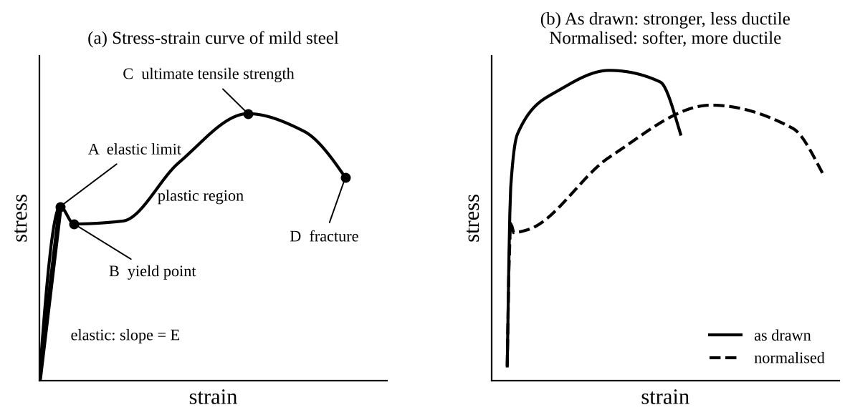
Fig. 2: Expected shapes (sketch only, not to scale): (a) the stress-strain curve of mild steel, with the elastic region (slope E), yield, ultimate tensile strength and fracture; (b) as drawn steel compared with normalised steel.

7. Discussion
The stress-strain graph was a straight line at first, with a gradient (Young's modulus) of E = [ ] GPa, compared with about 200 GPa for steel, a difference of [ ] %. The specimen then yielded at a stress of about [ ] N/mm², stretched plastically and began to neck before breaking at a peak load of [ ] kN (UTS = [ ] N/mm²). The as drawn specimen TH4010 [had a higher yield strength and peak load] than the normalised specimen TH4015, but stretched less: its elongation was [ ] % and its reduction in area [ ] %, against [ ] % and [ ] % for the normalised specimen, which was more ductile. This agrees with theory: cold working strengthens but reduces ductility, and normalising removes internal stresses and softens the steel. The Young's modulus of the two was about the same [say whether yours were].
Sources of error: the elongation from the displacement indicator includes slack and the movement of the chucks and collets (not just the gauge length), so strain is overestimated and E comes out low (an extensometer on the gauge length is more accurate); error in measuring the diameter and length; the specimen not perfectly aligned (giving some bending); the force being increased too fast or reduced at some step; reading the load meter at yield, where it changes quickly; and the difficulty of measuring the final length and the necked diameter from the broken pieces.

8. Conclusion
The Young's modulus of the mild steel specimen was found to be [ ] GPa (typical value about 200 GPa). The as drawn steel was stronger (peak load [ ] kN) but less ductile than the normalised steel (elongation [ ] % against [ ] %), while the modulus was about the same. Practical applications: selecting materials for structures, bridges, machine parts and pressure vessels; quality control of steel (checking yield strength, UTS and ductility); and deciding on heat treatment (normalising, annealing) or cold working to get the properties required.

Section D: Questions
1. What have I gained from this experiment? How to find Young's modulus, yield and ultimate strength from a tensile test, and how cold working and heat treatment change strength and ductility.
4. Comment on the experimental procedure (accuracy and time saving) Simple and clear, but the displacement indicator includes slack in the chucks, which affects the strain.
5. Most difficult aspect of the experiment and how to reduce it Aligning the specimen with no tension and increasing the force slowly; reduced by careful fitting.
6. Another method / apparatus that could be used An extensometer clamped on the gauge length, which measures the strain more accurately.
7. Parameters required in this experiment Force, extension, stress, strain, Young's modulus, % elongation and % reduction in area.
8. One measuring instrument / gauge used Digital load meter, displacement indicator and a micrometer or caliper.
9. Practical relevance / applications Selecting and testing steel for bridges, buildings, machines and pressure vessels.
10. Section of the course it relates to Strength of materials.
14. What interested me most That heat treatment can make the same steel much more ductile without changing its stiffness.
2, 3, 11, 12, 13 and 15 (personal): to be filled in by you.
16. References (keep only the ones you actually used): Mechanical Engineering Laboratory Manual ELA 302; a fluid mechanics or theory of machines textbook of your course.

