MECHANICAL ENGINEERING LABORATORY (ELA 302)
LABORATORY REPORTS
SM 325: Deflection of a Coil Spring

Name: ______________________________
Matric No.: __________________________
Department: _________________________
Date: _______________________________
Contents
SM 325 Deflection of a Coil Spring
Notes before you submit
- Anything shown as [ ] is for your own readings or results from your own lab session. Nothing has been invented.
- The report follows Section C of the manual: Theory, Apparatus, Results, Analysis of Results, Observations and Precautions, Graphs, Discussion and Conclusion. The Section D questions are answered after the report.
- Section D questions 2, 3, 11, 12, 13 and 15 are personal (your role, whether you could do it alone, your suggestions, your group's suggestions, whether you copied results, whether you brought the manual), so they are left for you to fill in.
- Dimensions of the weirs are the nominal ones printed in the manual; check them on your weirs and replace them with your measured values.
- Graphs must be drawn from your own readings on graph paper (or in Excel) and attached where indicated.

SM 325: Deflection of a Coil Spring

Objective
- To measure the force and deflection characteristics of a coil spring and find its spring rate (stiffness).
- To compare the measured stiffness with the theoretical value S = G d⁴ / (8 n D³), and to find the modulus of rigidity G of the spring wire.
- (Part B) To obtain the relationship between the loads applied to a compression spring and its change in length, using a load hanger.

1. Theory
1.1 Hooke's law and spring stiffness
A spring is a part that stores energy by deforming elastically and gives it back when the load is removed. Within its elastic limit, the deflection of a spring is directly proportional to the force applied (Hooke's law):
F = S δ so S = F / δ (1)
F is the axial force (N), δ the axial deflection (extension or compression, m) and S the stiffness or spring rate (N/m, also written K or k). A graph of F against δ is a straight line through the origin and its gradient is S. A stiff spring has a large S and needs a large force for a small deflection. If the force is in kN and the deflection in mm, the gradient is in kN/mm (equal to MN/m), so convert to N/m before comparing it with the theory.
1.2 Theoretical stiffness of a close-coiled helical spring
When an axial force F acts on a coil spring, the wire is mainly loaded in torsion (twisting). Consider a spring of mean coil diameter D, wire diameter d and n active coils. The force F acts at a distance D/2 from the axis of the wire, so the twisting moment (torque) on the wire is T = F D/2. The length of the wire is about L_{w} = π D n. From the theory of torsion of a round bar, the angle of twist of a wire of polar second moment of area J = π d⁴/32 and modulus of rigidity G is θ = T L_{w} / (G J):
θ = (F D/2)(π D n) / ( G π d⁴/32 ) = 16 F D² n / (G d⁴) (2)
Each small piece of the wire twists by an angle, which moves the end of the spring axially by that angle multiplied by the radius D/2. So the total axial deflection is δ = θ D/2:
δ = 8 F D³ n / (G d⁴) so S = F/δ = G d⁴ / (8 n D³) (3)
Equation (3) is the theoretical stiffness. It tells us how each dimension matters: S is proportional to d⁴ (a slightly thicker wire makes a much stiffer spring), inversely proportional to the number of coils n (more coils make a softer spring, like springs in series), and inversely proportional to D³ (a bigger coil diameter makes the spring much softer). Plots of S against d⁴, S against 1/n and S against 1/D³ should therefore all be straight lines through the origin. For steel, G ≈ 80 × 10⁹ N/m² (80 GPa). (The manual writes the unit as N/m; the correct unit of G is N/m², that is pascals.) The equation is for a spring that is not too short or too highly stressed; a correction (the Wahl factor) is used for the stress, but it does not change the stiffness much.
1.3 Why the graph may not pass through the origin
If the F against δ line does not pass through the origin, it is because of a preload or zero error: the load meter or displacement indicator was not zeroed exactly at zero load, or a small force was applied to take up the slackness in the test rig (the manual says to apply a preload of no more than 0.5 kN to remove looseness), or the coils at the ends of the spring were still settling (seating) on the bosses at low forces. A spring that is stressed beyond its elastic limit or whose coils touch (solid length) also stops following Hooke's law.

2. Apparatus
A compression test frame with a hydraulic ram operated by a hand pump, a DL1 digital load meter (force sensors using strain gauges) and a digital displacement indicator fixed to the front left column, or the Versatile Data Acquisition System (VDAS) to record the results automatically; upper and lower spring bosses to hold the spring, a guard around the test area, and the test spring, together with a micrometer or vernier caliper and a rule to measure the spring dimensions. For Part B: a spring on a stand with a scale, a load hanger with weights, a stem and slide, and a wing-nut to zero the scale.
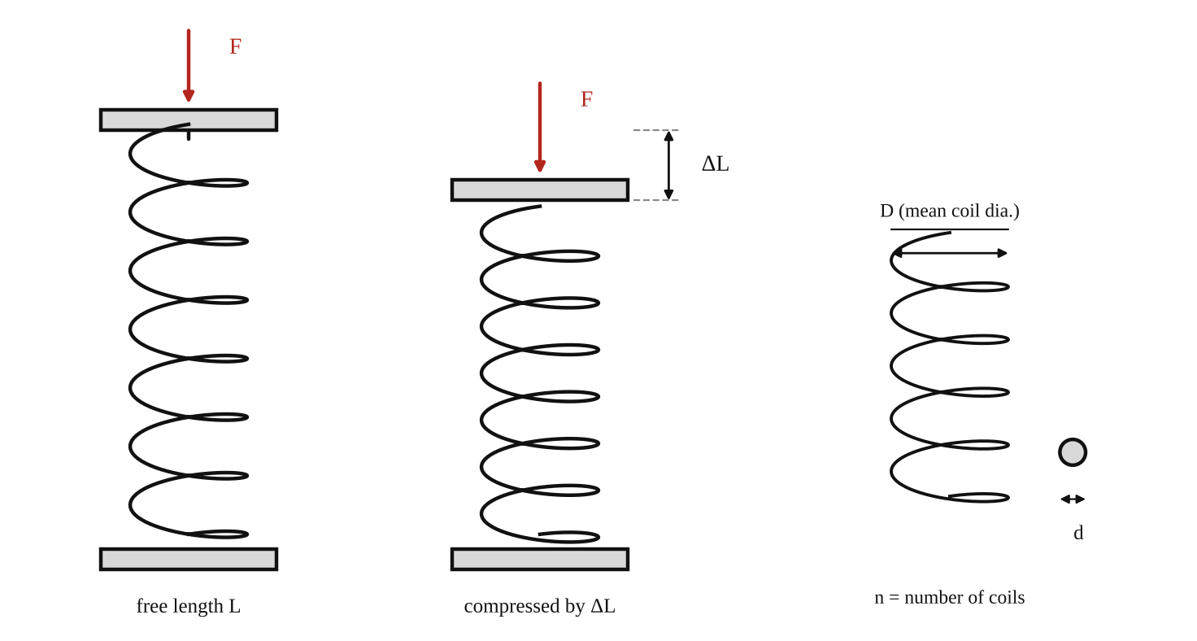
Fig. 1: A coil spring in its free state, and compressed by a force F through a deflection ΔL; and the dimensions D, d and n (sketch).
Method in brief, Part A (from the manual)
- Connect up and switch on the DL1 digital load meter, and allow it to warm up the strain gauges in the force sensors.
- Use the pump to lower the ram. (If VDAS is used, select the "deflection of a coil spring" experiment.) Create a blank results table.
- Accurately measure the spring's dimensions, the wire thickness, and count the number of complete coils.
- Fit the spring bosses to the upper and lower parts of the compression test area. Put the spring onto the bottom boss and use the pump to slowly raise the ram until the bosses hold the spring securely, but not under compression. Fit the displacement indicator carefully (grip it with the metal clips, never push or pull on its display).
- Slide the whole assembly up the column until the magnet clamps are underneath the loading platform, giving at least 60 mm of upward movement. Press the button to zero the displacement display.
- Raise the ram slowly to remove any looseness in the spring. Watch the load meter and stop when it just begins to register a "preload" (no more than 0.5 kN). Re-zero the load meter and the displacement indicator. Fit the guard.
- In steps of 0.5 kN, up to a maximum of 3 kN, increase the force slowly (never decrease it during the test, as that makes the results wrong). At each step record the load and the reading of the displacement indicator.
Method in brief, Part B (compression with weights)
- Unscrew the base of the hanger and withdraw the stem and slide; fit the selected compression spring and assemble.
- With the wing-nut, zero the scale.
- Add increasing weight to the load hanger and record the corresponding deflection for each load, continuing until about 30 mm extension has been achieved.

3. Results
Spring type: [ ]. Number of coils n = [ ]. Initial (unloaded) length = [ ] mm. Wire diameter d = [ ] mm = [ ] m. Mean coil diameter D = [ ] mm = [ ] m. G = 80 × 10⁹ N/m² (approx.).
Table 1 (Part A): Force and displacement of the spring
Force F (kN) | Force F (N) | Displacement δ (mm) | Displacement δ (m) | Stiffness S = F/δ (N/m)
0 | 0 | 0 | 0 | –
0.5 | 500
1.0 | 1000
1.5 | 1500
2.0 | 2000
2.5 | 2500
3.0 | 3000

Table 2 (Part B): Load and extension (compression spring on the hanger)
No. | Load on hanger (N) | Scale reading / deflection (mm) | Stiffness S = F/δ (N/m)
1
2
3
4
5
6
7
8

4. Analysis of Results
1. Plot force F (vertical) against displacement δ (horizontal) for Part A. The gradient of the line, S_{exp} = ΔF/Δδ, is the spring's stiffness (convert from kN/mm to N/m by multiplying by 10⁶). S_{exp} = [ ] N/m.
2. Calculate the theoretical stiffness S_{th} = G d⁴ / (8 n D³) = (80 × 10⁹ × [ ]⁴) / (8 × [ ] × [ ]³) = [ ] N/m, and compare: percentage difference = (S_{exp} − S_{th})/S_{th} × 100 = [ ] %.
3. Find the modulus of rigidity from the experimental stiffness by rearranging (3): G = 8 n D³ S_{exp} / d⁴ = [ ] N/m², and compare it with the typical value of 80 × 10⁹ N/m² for steel.
4. If several springs are available, verify that S = G d⁴/(8 n D³) by plotting S against d⁴, S against 1/n and S against 1/D³; each should be a straight line through the origin. Repeat the F against δ graph and stiffness calculation for Part B.

5. Observations / Precautions Taken
- Apply the force slowly and never decrease it during the test (reducing the load causes friction and hysteresis, making the results wrong).
- Zero both the load meter and the displacement indicator after taking up the looseness, using a small preload (not more than 0.5 kN).
- Do not exceed 3 kN, or let the coils touch, or the spring will leave its elastic range.
- Handle the displacement indicator only by the metal clips: pulling or pushing hard on its display or slide can damage it.
- Measure the wire diameter and coil diameter at several positions with a micrometer or caliper and take the average; count only the active (complete) coils.
- Keep the guard around the test area in place, and keep hands clear when the ram is moving.

6. Graphs
Plot the following on graph paper from your own readings and attach them here:
Plot force (vertical) against displacement (horizontal) from Table 1 and Table 2, and find the gradient. If more than one spring is tested, plot S against d⁴, S against 1/n and S against 1/D³ (shapes in Fig. 2).
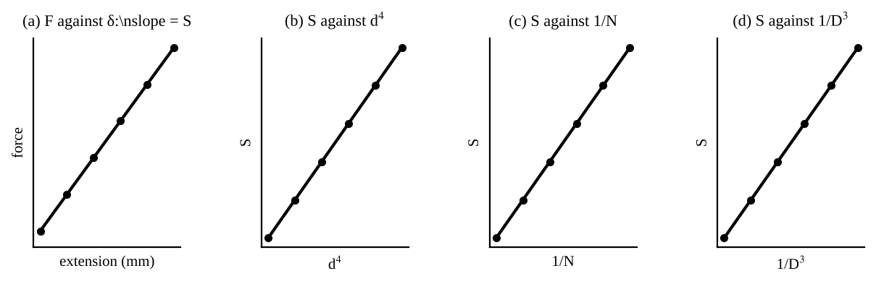
Fig. 2: Expected shapes (sketch only): (a) a straight force-extension line whose gradient is S; (b), (c), (d) S plotted against d⁴, 1/N and 1/D³ should each be straight lines through the origin.

7. Discussion
Relationship between force and extension. The graph of force against displacement was a straight line, so the force is directly proportional to the extension, F = S δ. The spring therefore behaved according to Hooke's law over the range tested (0 to 3 kN). The measured stiffness was S = [ ] N/m, compared with the theoretical value of [ ] N/m, a difference of [ ] %, and the modulus of rigidity found from the test was G = [ ] N/m², against about 80 × 10⁹ N/m² for steel.
If the graph does not pass through the origin: [Say whether yours did.] The reason would be the preload or zero error, taking up of slackness in the rig, or the end coils seating at low forces, as explained in the theory.
Sources of error: error in measuring the coil diameter D and wire diameter d, which appear in the theory as D³ and d⁴ and so are magnified (a 1 % error in d gives a 4 % error in S); the number of active coils being uncertain (the end coils do not all deflect); friction in the rig and the preload; the nominal value of G being used instead of the true value for this wire; and reading errors on the load meter and the displacement indicator.

8. Conclusion
The force on the coil spring was proportional to its deflection (Hooke's law), with a measured stiffness of [ ] N/m, which agrees with the theoretical value G d⁴/(8 n D³) = [ ] N/m to within about [ ] %. The modulus of rigidity of the wire was found to be [ ] N/m². Practical applications: vehicle suspensions, valve springs in engines, mattresses and seats, pens and switches, weighing scales, and shock absorbers and vibration isolators.

Section D: Questions
1. What have I gained from this experiment? That a spring's force is proportional to its deflection, and how to find its stiffness and the modulus of rigidity.
4. Comment on the experimental procedure (accuracy and time saving) Simple and quick, but accuracy depends on measuring the coil and wire dimensions.
5. Most difficult aspect of the experiment and how to reduce it Applying the force slowly without ever reducing it; reduced by turning the pump gently.
6. Another method / apparatus that could be used Hanging weights on the spring and measuring the extension with a rule.
7. Parameters required in this experiment Force, deflection, stiffness, number of coils and the wire and coil diameters.
8. One measuring instrument / gauge used Digital load meter and digital displacement indicator.
9. Practical relevance / applications Vehicle suspensions, engine valve springs and weighing scales.
10. Section of the course it relates to Strength of materials (springs).
14. What interested me most That the stiffness depends on the fourth power of the wire diameter.
2, 3, 11, 12, 13 and 15 (personal): to be filled in by you.
16. References (keep only the ones you actually used): Mechanical Engineering Laboratory Manual ELA 302; a fluid mechanics or theory of machines textbook of your course.

