MECHANICAL ENGINEERING LABORATORY (ELA 302)
LABORATORY REPORTS
TD 323: Conductivity of Liquids and Gases

Name: ______________________________
Matric No.: __________________________
Department: _________________________
Date: _______________________________
Contents
TD 323 Conductivity of Liquids and Gases
Notes before you submit
- Anything shown as [ ] is for your own readings or results from your own lab session. Nothing has been invented.
- The report follows Section C of the manual: Theory, Apparatus, Results, Analysis of Results, Observations and Precautions, Graphs, Discussion and Conclusion. The Section D questions are answered after the report.
- Section D questions 2, 3, 11, 12, 13 and 15 are personal (your role, whether you could do it alone, your suggestions, your group's suggestions, whether you copied results, whether you brought the manual), so they are left for you to fill in.
- Dimensions of the weirs are the nominal ones printed in the manual; check them on your weirs and replace them with your measured values.
- Graphs must be drawn from your own readings on graph paper (or in Excel) and attached where indicated.

TD 323: Conductivity of Liquids and Gases

Objective
- To find the power losses of the equipment and calibrate it using air, whose thermal conductivity is known.
- To find the thermal conductivity of test liquids and gases, and compare the values with typical ones.

1. Theory
1.1 Conduction and Fourier's law
Heat moves from a hot place to a cold place in three ways: conduction (through a material by the vibration and collision of its particles, with no bulk movement), convection (carried by moving fluid) and radiation (electromagnetic waves). In this experiment we want pure conduction through a thin layer of fluid, so the apparatus is designed to remove the other two as far as possible.
The rate of conduction is given by Fourier's law: the heat flow Q (in watts) is proportional to the area A that the heat passes through and to the temperature gradient dT/dx along the direction of flow:
Q = − k A (dT / dx) (1)
The constant k is the thermal conductivity of the material (W/m K); it tells us how easily the material conducts heat. The minus sign only shows that heat flows from high to low temperature. For a thin layer of thickness Δr whose two faces are at temperatures T₁ (hot) and T₂ (cold), the gradient is almost uniform, so (1) becomes
Q = k A (T₁ − T₂) / Δr (2) so k = Q Δr / ( A (T₁ − T₂) ) (3)
This is the working equation: if we know the heat flowing through the layer, its thickness Δr, the area A and the temperature difference, we get k. (In the apparatus the layer is a thin radial gap between two concentric cylinders, so A is the mean area of the gap. Because the gap is very thin compared with the diameter, treating it as a flat layer, as in (2), is a very good approximation. Exactly, for a cylinder of length L with inner and outer radii r₁ and r₂, Q = 2π k L (T₁ − T₂) / ln(r₂/r₁).)
1.2 Why a thin gap and a hot inner part
Hot fluid is lighter and tends to rise, which sets up convection currents that carry heat and make k look larger than it is. Convection is suppressed if the layer of fluid is very thin (the fluid has no room to circulate) and if the hot surface is on the inside and the cold surface outside, and the fluid is held by viscosity in the small gap. Radiation across such a gap is also small at these temperatures. What remains is almost entirely conduction, and equation (3) applies.
1.3 How different fluids conduct
In a gas, the molecules are far apart and heat is carried when faster (hotter) molecules collide with slower ones, so k is small (air is about 0.026 W/m K at 20 °C) and rises with temperature because the molecules move faster (roughly in proportion to the square root of the absolute temperature). In a liquid the molecules are close together and pass on energy more easily, so k is much larger (water about 0.6 W/m K, oils about 0.13 W/m K) and usually decreases slightly with temperature (water is an exception, where it rises up to about 130 °C). Metals are best of all because free electrons carry the heat (copper is about 400 W/m K). Still air is a very good insulator, which is why double glazing, wool and foam work.
For air, the manual gives a chart and line of best fit (Fig. 1 of the manual) for the thermal conductivity against the temperature in °C:
k_{air} = 7 × 10⁻⁵ T + 0.0243 (W/m K, T in °C) (4)
Temperature T (°C) | 20 | 40 | 60 | 80 | 100
k of air from (4) (W/m K) | 0.0257 | 0.0271 | 0.0285 | 0.0299 | 0.0313

1.4 Power losses and calibration with air
The electrical power supplied to the heater is not all conducted across the gap: some leaks away through the supports, the ends of the cylinders and the connections, and some goes by radiation and convection outside the gap. This is the power loss. To find it, we run the experiment first with air in the gap. Because we know k for air from equation (4), we can calculate how much power actually crosses the gap:
W_{calc} = k_{air} A (T₁ − T₂) / Δr (5)
Power loss = W_{heater} − W_{calc} (6)
Doing this at several heater powers (70 W down to 10 W in steps of 10 W) shows how the loss depends on power. This is the calibration of the equipment. For a test liquid or gas, the heat that crosses the gap is then the heater power less the loss found from the calibration (at the same temperatures), and k follows from (3):
k_{test} = ( W_{heater} − loss ) Δr / ( A (T₁ − T₂) ) (7)
Why air first? Its k is known and the temperature differences are large (a poor conductor needs a large ΔT to pass the same power), so the calibration is reliable.

2. Apparatus
The TecQuipment conductivity of liquids and gases experiment: an electric heater at one end (the heat source) inside a metal cylinder, and a small chamber (the heat sink) at the other end, cooled by flowing water, with the test fluid in the thin radial gap between the two. The set also has a thermal switch (a safety cut-out, which switches the heater off if it gets too hot), thermocouples that read T₁ on the hot side and T₂ on the cold side of the gap, a heater power control and display, a water inlet and outlet valve, and a thermometer (not part of the equipment) for the local ambient air temperature. A Versatile Data Acquisition System (VDAS) can be used to record the results automatically. The gap thickness Δr and the mean area A of the gap are given on the apparatus data sheet: Δr = [ ] m, A = [ ] m².
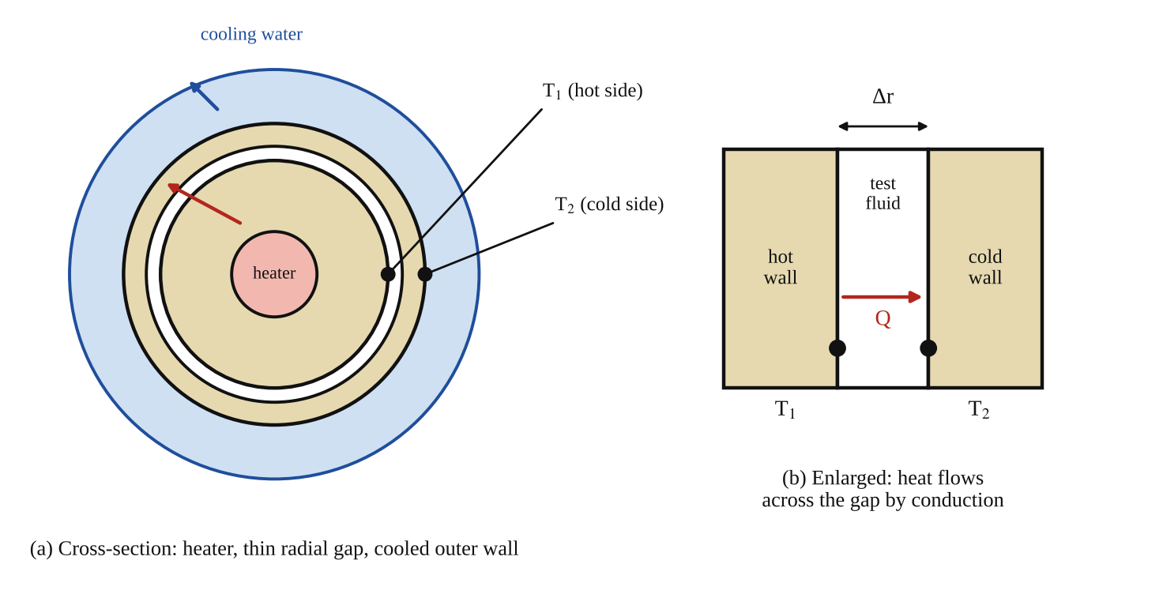
Fig. 1: (a) cross-section of the apparatus with the heater at the centre, the thin radial gap and the water-cooled outer wall; (b) enlarged view of the gap showing T₁, T₂ and Δr (sketch, not to scale).
Method in brief (from the manual)
- Make sure the experiment is clean and dry.
- Connect and set up the experiment (heater, thermocouples, water supply and VDAS if used).
- With air in the gap, use an accurate thermometer to check the local ambient air temperature for reference.
- Open the water outlet valve so that the cooling water flows, then switch on the heater and set it to 70 W.
- Wait for the temperatures to stabilise, then record T₁ and T₂.
- Repeat for heater powers decreasing in steps of 10 W (60, 50, 40, 30, 20, 10 W).
- Switch off the heater and the water supply.
- Repeat with the test liquids and gases in the gap, as directed by the lecturer.

3. Results
Local ambient air temperature (thermometer) = [ ] °C. Gap thickness Δr = [ ] m. Mean area of gap A = [ ] m².
Table 1: Calibration with air in the gap. (Average temperature = (T₁ + T₂)/2; k_{air} from equation (4); W_{calc} from equation (5); power loss from equation (6).)
Heater power (W) | T₁ (°C) | T₂ (°C) | Average temp (T₁+T₂)/2 (°C) | T₁ − T₂ (°C) | k of air (W/m K) | Calculated power W_{calc} (W) | Power loss (W)
70
60
50
40
30
20
10

Table 2: Test fluid: [ ] (liquid or gas). Heat across the gap = heater power − power loss (loss read from Table 1 at the same temperatures).
Heater power (W) | T₁ (°C) | T₂ (°C) | T₁ − T₂ (°C) | Power loss (W) (from Table 1) | Heat across gap (W) | k of fluid (W/m K) | Typical k (W/m K)
70
60
50
40
30
20
10

4. Analysis of Results
1. Find the average temperature across the radial gap, (T₁ + T₂)/2, in °C, for each line.
2. Use this average temperature to find k of air, either directly from the chart of thermal conductivity of air (Fig. 1 of the manual) or from the printed equation k = 7 × 10⁻⁵ T + 0.0243.
3. Calculate the power conducted across the gap with the rearranged equation, W_{calc} = k A (T₁ − T₂) / Δr. Sample calculation: for 70 W, T₁ = [ ] °C, T₂ = [ ] °C, average = [ ] °C, k = [ ] W/m K, so W_{calc} = [ ] × [ ] × [ ] / [ ] = [ ] W.
4. Subtract W_{calc} from the heater power to find the power loss: loss = W_{heater} − W_{calc} = [ ] W.
5. For the test fluids use equation (7), k = (W_{heater} − loss) Δr / (A (T₁ − T₂)), for each line, take the mean, and compare it with typical values (water about 0.6 W/m K, oil about 0.13 W/m K, air about 0.026 W/m K, other gases from tables).

5. Observations / Precautions Taken
- The gap and the outside of the apparatus must be clean and dry, because water or dirt in the gap would change k.
- Start the cooling water before switching on the heater, and never run the heater without the water, to avoid overheating (the thermal switch protects the heater, but should not be relied on).
- Wait for the temperatures to be steady (no more change in T₁ and T₂) before recording. Steady state is needed because equation (3) assumes the heat flow is constant.
- Check the local ambient air temperature with an accurate thermometer, because the heat loss depends on the difference between the apparatus and the surroundings.
- Reduce the power in steps of 10 W and do not exceed the maximum power or temperature on the equipment.
- Do not touch the hot parts; switch off the heater and water at the end and let the apparatus cool.
- Keep the apparatus away from draughts and direct sunlight, which add to the heat losses.

6. Graphs
Plot the following on graph paper from your own readings and attach them here:
Plot from your own readings (general shapes are shown in Fig. 2):
- Power loss (vertical) against heater power, from Table 1 (the calibration curve).
- Temperature difference (T₁ − T₂) against heater power for air and for each test fluid.
- k of air from your results against average temperature, to compare with the line k = 7 × 10⁻⁵ T + 0.0243.
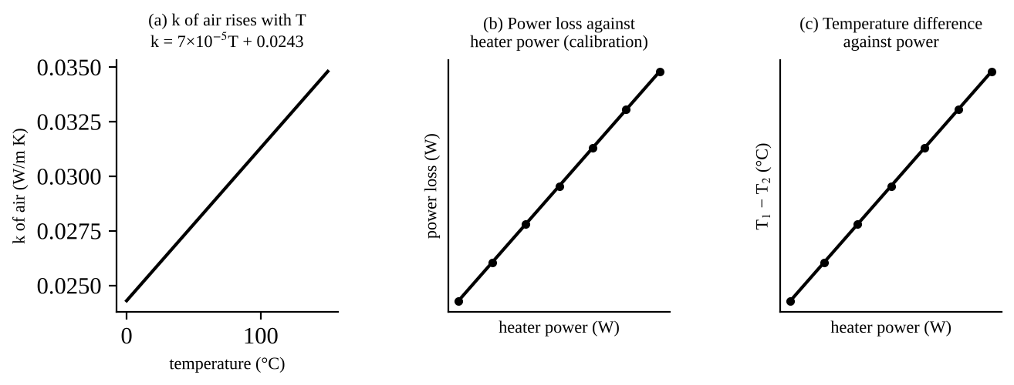
Fig. 2: Expected shapes (sketch only): (a) the manual's line for the conductivity of air; (b) power loss against heater power; (c) temperature difference against power. Your own plots will have scatter.

7. Discussion
The calculated power across the gap with air, W_{calc}, was always less than the electrical power supplied, and the difference is the power loss of the equipment, which was [ ] W at 70 W and [ ] W at 10 W. [Say whether the loss grew with heater power: it is expected to grow as the apparatus gets hotter, because the loss to the surroundings depends on how hot the apparatus is compared with the room.] This loss has to be subtracted when finding k of the test fluids, which is the purpose of the calibration.
For the test fluid [ ] the mean thermal conductivity was found to be [ ] W/m K, compared with the typical value of [ ] W/m K, a difference of [ ] %. The temperature difference across the gap was much larger for the poor conductor (gas) than for a liquid at the same power, as expected, since from (2) ΔT = Q Δr / (kA), so a smaller k needs a larger ΔT for the same heat flow. [Comment on how k of air changed with temperature: it is expected to rise slowly, as in equation (4).]
Sources of error:
- Convection in the gap, which makes k of liquids look higher (it is greatest at high ΔT, and for the larger gaps).
- The loss found with air was used for the test fluids, but at a different temperature distribution, so the loss is not exactly the same.
- Steady state not fully reached before readings were taken (the thermocouple readings were still drifting).
- Radiation across the gap and conduction along the supports and connections, which are not part of the conduction through the fluid.
- Thermocouple accuracy and their position (they read the wall temperatures near the gap, not exactly at the faces), and the accuracy of the gap thickness Δr and area A, which are used directly in k.
- The line for k of air is an approximation (best fit), and the ambient temperature changes during the test.

8. Conclusion
The power loss of the equipment was found by calibration with air and was [ ] W at 70 W falling to [ ] W at 10 W. Using this, the thermal conductivity of the test fluid [ ] was found to be [ ] W/m K, which agrees with the typical value of [ ] W/m K to within about [ ] %. Gases conduct much worse than liquids, so they need a much larger temperature difference for the same heat flow. Practical applications: thermal insulation (still air, foam, double glazing), choosing coolants and lubricants, heat exchanger and heat sink design, heating and cooling of buildings and engines, and cooling of electronic components.

Section D: Questions
1. What have I gained from this experiment? How thermal conductivity is measured with Fourier's law and why the equipment must be calibrated with air.
4. Comment on the experimental procedure (accuracy and time saving) Simple, but slow because the temperatures take time to settle.
5. Most difficult aspect of the experiment and how to reduce it Knowing when the temperatures were steady; reduced by waiting longer.
6. Another method / apparatus that could be used A guarded hot plate or hot-wire method.
7. Parameters required in this experiment Heater power, temperatures T₁ and T₂, and thermal conductivity k.
8. One measuring instrument / gauge used Thermocouples.
9. Practical relevance / applications Insulation design and choosing coolants.
10. Section of the course it relates to Heat transfer.
14. What interested me most That air needs a much bigger temperature difference than liquids for the same power.
2, 3, 11, 12, 13 and 15 (personal): to be filled in by you.
16. References (keep only the ones you actually used): Mechanical Engineering Laboratory Manual ELA 302; a fluid mechanics or theory of machines textbook of your course.

