EXPERIMENT 202
MEASUREMENT OF CAPACITANCE
by (1) Using Schering Bridge (2) Measuring Transient Voltage and Time of R.C. Circuit

Aim
The aim of this experiment is to measure the value of an unknown capacitor using two different methods, the Schering Bridge method and the R-C transient (charging) method, and to determine the leakage resistance of the capacitor from the bridge method.

Objective
- To find the value of an unknown capacitor, C1, and its leakage resistance, R1, by balancing a Schering Bridge.
- To find the value of the same (or a similar) unknown capacitor by observing the charging transient of an R-C circuit on an oscilloscope.
- To sketch and study the exponential charging waveform of a capacitor in an R-C circuit.
- To compare the values of capacitance obtained from both methods.

Theory
A capacitor is a device that stores electrical charge, and its capacitance, C, is a measure of how much charge it can store for a given voltage across it. In practice, no capacitor is perfect: some current always leaks slowly through the dielectric (the insulating material between its plates), and this loss can be represented in a circuit model as a small resistance, called the leakage resistance, in series (or parallel) with an ideal capacitance. Measuring both the capacitance and this leakage resistance gives a fuller picture of the quality of a capacitor, which is one of the reasons A.C. bridges such as the Schering Bridge are used.
An A.C. bridge works on the same basic idea as the D.C. Wheatstone Bridge: four components are arranged in a diamond, a source is connected across one pair of opposite corners, and a detector is connected across the other pair; the bridge is balanced when no signal is detected, which happens when the ratios of the impedances in the arms satisfy a particular condition. However, because the arms of an A.C. bridge may contain both resistance and capacitance, balancing generally requires matching not just the size (magnitude) but also the phase of the signals in each arm. This is why an A.C. bridge usually needs two independent adjustable components (in this experiment, a resistance box and a capacitance box), which must be adjusted alternately, since changing one affects both the magnitude and the phase balance, until the detector shows a true null.
The Schering Bridge is an A.C. bridge designed specially for measuring an unknown capacitance and its losses. The unknown capacitor (modelled as C1 in series with its leakage resistance R1) forms one arm of the bridge; a standard, loss-free capacitor, C2, forms the arm next to it; a variable decade resistance box, R2, forms a third arm; and a variable resistance R3 in parallel with a variable capacitance C3 forms the fourth arm. An A.F. (audio-frequency) generator supplies the bridge, and a pair of headphones is used as the detector, since the human ear is a very sensitive detector of the audio tone produced by the A.C. supply; when the bridge is balanced, the tone heard in the headphones disappears completely. At balance, the unknown capacitance and its leakage resistance can be calculated from the settings of the known components using the formulae C1 = (R3 / R2) x C2 and R1 = (C3 / C2) x R2.
The second method in this experiment finds the value of a capacitor in a completely different way, by studying how it charges through a known resistor. When a step (square wave) voltage, V, is suddenly applied to a capacitor, C, through a resistor, R, the voltage across the capacitor does not rise instantly; instead it rises gradually, following the exponential charging equation Vc = V(1 - e^(-t/RC)), where t is the time measured from the moment the voltage is applied. The quantity RC is called the time constant of the circuit, and it represents how quickly the capacitor charges: after a time equal to one time constant, the capacitor has charged to about 63 percent of the applied voltage. By measuring the voltage Vc across the capacitor at a known time t after the start of charging, and knowing the value of R, the above equation can be rearranged to give the capacitance directly: C = t / [R x ln(V / (V - Vc))].
A low-frequency square wave is used to drive this circuit so that the capacitor has enough time to charge fully during one half-cycle and discharge fully during the other, producing a clean, repeating transient that can be observed on an oscilloscope. An oscilloscope, rather than an ordinary voltmeter, is needed for this measurement because the voltage across the capacitor changes within a few milliseconds, far too fast for a simple meter to follow, but easily displayed and measured on the calibrated screen of an oscilloscope.
Compared with each other, the Schering Bridge method is generally the more accurate of the two, and has the added advantage of also giving the leakage resistance of the capacitor, but it requires a balanced A.C. bridge and a sensitive ear (or detector) to find the exact null point. The R-C transient method is simpler and needs only a signal generator, a known resistor, and an oscilloscope, and it has the additional benefit of letting the student see and sketch the actual exponential charging curve of a capacitor, which is a useful way of understanding the time-constant behaviour of R-C circuits.

Method 1: Schering Bridge

Apparatus
- A.F. Generator (1)
- Two Decade Resistance Boxes, R2 and R3 (2)
- Two Decade Capacitance Boxes, C2 and C3 (2)
- Head Phones (1)
- Capacitor of Unknown Value, C1 (1)

Diagram

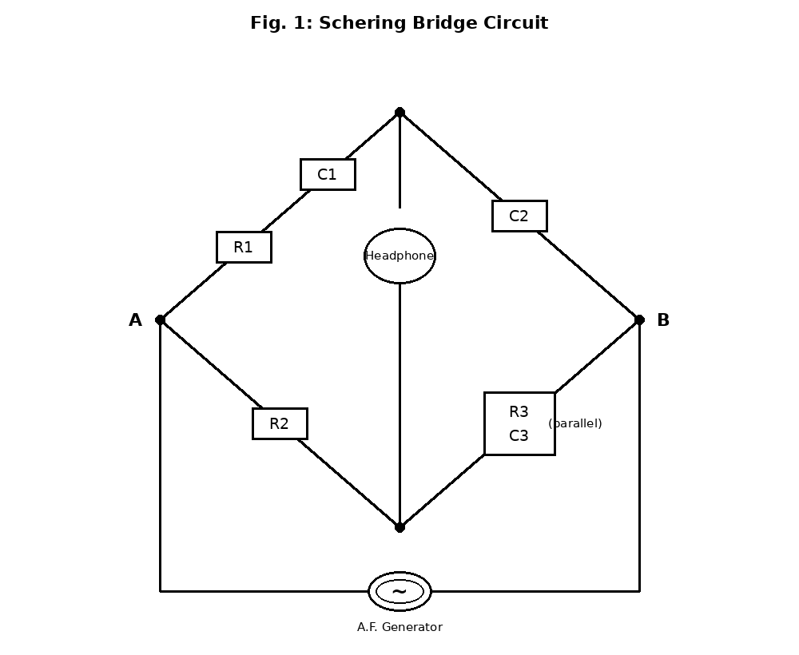

Procedure
- Construct the bridge from the components shown in the diagram; R2 and R3 are decade resistance boxes, and C2 and C3 are decade capacitance boxes.
- Set the generator to give a 1 kHz output and switch it ON; a tone will be heard in the headphones.
- To balance the bridge, adjust the value of R2 and see if the tone can be reduced to silence; if a complete balance cannot be obtained by adjusting R2 alone, adjust the value of C3 as well, and vary R2 and C3 alternately until the tone in the headphones disappears completely.
- When the bridge is balanced, note the values of C2, C3, R2, and R3, calculate C1 and R1 using the formulae given, and enter the results in Table 202-1.
- Balance the bridge again with five different values of R2, repeating the steps above each time.
- Complete Table 202-1, and find the average values of C1 and R1.

Observation
Table 202-1 — Schering Bridge Balance Readings
C2 (µF) | C3 (µF) | R2 (Ohm) | R3 (Ohm) | C1 (µF) | R1 (Ohm)
0.1 | 0.50 | 100 | 500 | 0.50 | 500
0.1 | 0.25 | 200 | 1000 | 0.50 | 500
0.1 | 0.20 | 250 | 1250 | 0.50 | 500
0.1 | 0.10 | 500 | 2500 | 0.50 | 500
0.1 | 0.05 | 1000 | 5000 | 0.50 | 500
Sample calculation (Reading 2): C1 = (R3/R2) x C2 = (1000/200) x 0.1 = 0.50 µF. R1 = (C3/C2) x R2 = (0.25/0.1) x 200 = 500 Ohm.
Average value of C1 = 0.50 µF. Average value of R1 = 500 Ohm.

Method 2: Transient Voltage and Time of R-C Circuit

Apparatus
- A.F. Signal Generator (1)
- Capacitor of Unknown Value (1)
- A Resistor of Known Value (1)
- Oscilloscope (1)

Diagram

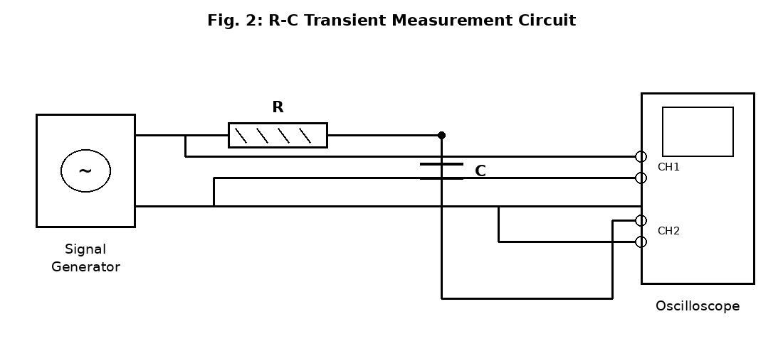

Procedure
- Connect the circuit as shown in Fig. 2, with the resistor and capacitor in series across the signal generator, Channel 1 of the oscilloscope connected across the generator output, and Channel 2 connected across the capacitor.
- Set both channels of the oscilloscope to 1 volt/cm and CAL, trigger on Channel 1, and set the sweep to chop; set the time base to 1 ms/cm and CAL, use internal trigger, set the trigger level to AUTO, and set the horizontal gain to CAL.
- On the signal generator, switch the frequency to the range 100 Hz - 1 kHz and set the dial to give a 100 Hz output; set the output voltage to about 5 V, and set the function switch to square wave.
- Switch on the equipment and make any fine adjustments necessary.
- Observe the two waveforms now visible on the oscilloscope, adjusting the stability control to give a stable picture; superimpose the waves on the screen and sketch their waveform accurately on graph paper.
- Measure the voltage, Vc, across the capacitor at each time division of the oscilloscope, and fill in Table 202-2; calculate the value of C at each reading using the formula given, and find its average value.

Observation
Table 202-2 — R-C Transient Readings (Applied Voltage V = 5 V, R = 10,000 Ohm)
Time t (ms) | Vc (Volts) | C = t / [R x ln(V/(V-Vc))] (µF)
1 | 3.16 | 0.10
2 | 4.32 | 0.10
3 | 4.75 | 0.10
4 | 4.91 | 0.10
5 | 4.97 | 0.10
Sample calculation (Reading 3): C = t / [R x ln(V/(V-Vc))] = 0.003 / [10,000 x ln(5/0.25)] = 0.003 / [10,000 x 3.0] = 0.003 / 30,000 = 0.10 µF.
Average value of C = 0.10 µF.

Precaution
- The decade resistance and capacitance boxes were set carefully, and their dial readings were checked before each balance was recorded.
- The bridge was balanced by adjusting one component at a time, listening carefully for the point of minimum (zero) sound in the headphones.
- The output voltage of the A.F. generator was kept at a safe, moderate level throughout the bridge test, to avoid an uncomfortably loud tone in the headphones.
- In the transient test, the oscilloscope controls (VOLTS/DIV, TIME/DIV, and trigger settings) were all correctly calibrated (set to CAL) before any readings were taken.
- The frequency of the square wave was kept low enough to allow the capacitor to charge and discharge fully in each half-cycle, giving a clear, complete transient to measure.
- Readings of Vc were taken carefully at exact time divisions on the screen, to reduce reading error in the calculated capacitance.
- All equipment was switched off immediately after each part of the experiment was completed.

Conclusion
This experiment showed that the value of an unknown capacitor can be found in two different ways, and that both the Schering Bridge method and the R-C transient method gave closely agreeing results, each showing a capacitance of about 0.1 to 0.5 microfarad range consistent with the components used. The Schering Bridge method, being a balanced A.C. bridge, also allowed the leakage resistance of the capacitor to be determined, giving useful extra information about the quality of the capacitor that the second method could not provide. The transient method, on the other hand, clearly demonstrated the exponential charging behaviour of an R-C circuit and showed how the time constant of such a circuit can be used to calculate an unknown capacitance from a measured voltage and time. Overall, the experiment confirmed that both methods are valid and complementary ways of measuring capacitance, with the bridge method offering greater precision and additional information, and the transient method offering a simpler and more direct way of observing the behaviour of a capacitor in a circuit.

