EXPERIMENT 203
MEASUREMENT OF INDUCTANCE
by (1) Using Maxwell's Bridge (2) Measuring Transient Voltage and Time of R.L. Circuit

Aim
The aim of this experiment is to measure the value of an unknown inductor using two different methods, Maxwell's Bridge method and the R-L transient method, and to determine the resistance of the inductor's own winding from the bridge method.

Objective
- To find the value of an unknown inductor, Lx, and its winding resistance, Rx, by balancing Maxwell's Bridge.
- To find the value of the same (or a similar) unknown inductor by observing the current-growth transient of an R-L circuit on an oscilloscope.
- To sketch and study the exponential waveform produced across the resistor in an R-L circuit.
- To compare the values of inductance obtained from both methods.

Theory
An inductor is a coil of wire wound in a way that opposes any change in the current flowing through it, storing energy in the magnetic field it produces. Because a real inductor is made from a length of wire, it always has some resistance as well as inductance, so a practical inductor is best represented in a circuit as an ideal inductance, Lx, in series with a small resistance, Rx. Measuring both of these quantities, as this experiment sets out to do, gives a more complete picture of a real inductor than measuring its inductance alone.
Maxwell's Bridge is an A.C. bridge designed to measure an unknown inductance and its series resistance by comparing it, not against another inductor, but against a known capacitor. Standard capacitors can be made more accurately and cheaply than standard inductors, which is the main reason this arrangement is preferred. In the bridge used here, the unknown inductor (Rx in series with Lx) forms one arm; a resistance box, R1, forms the arm opposite to it; another resistance box, R2, forms a third arm; and a resistance box, R3, in parallel with a capacitance box, C, forms the fourth arm. As with the Schering Bridge, an A.F. generator supplies the bridge and a pair of headphones is used as the null detector, since balance is heard as the point where the tone in the headphones disappears completely. Because both a resistive and a reactive balance condition must be satisfied at the same time, the bridge is balanced by adjusting two components alternately, usually the capacitance C and one of the resistance boxes, until no tone at all is heard. At balance, the unknown quantities can be calculated from the settings of the known components using the formulae Rx = (R1 x R2) / R3 and Lx = R1 x R2 x C.
The second method finds the inductance in a completely different way, by studying how current grows in a circuit containing a resistor and an inductor in series. When a step (square wave) voltage, V, is suddenly applied to a series R-L circuit, the current does not rise instantly, because the inductor opposes any sudden change in current; instead, the current, and therefore the voltage across the resistor, VR, rises gradually towards its final value, following the equation VR = V(1 - e^(-tR/L)), where t is the time measured from the moment the voltage is applied. The quantity L/R is called the time constant of the circuit, and after a time equal to one time constant, the voltage across the resistor has risen to about 63 percent of its final value. By measuring VR at a known time t after the voltage is applied, and knowing the value of R, this equation can be rearranged to give the inductance directly: L = tR / ln(V / (V - VR)).
As in the earlier R-C experiment, a low-frequency square wave is used so that the current has enough time to rise fully during one half-cycle and fall fully during the other, and an oscilloscope, rather than an ordinary meter, is needed because the voltage changes too quickly (within a fraction of a millisecond in this experiment) for a simple meter to follow.
Comparing the two methods, Maxwell's Bridge is generally the more accurate, and has the advantage of also giving the winding resistance of the inductor, but it needs a balanced A.C. bridge and careful, alternate adjustment of two components to find the true null. The R-L transient method is simpler, needing only a signal generator, a known resistor, and an oscilloscope, and it has the added benefit of letting the student directly observe the exponential rise of current in an R-L circuit, which is a useful way of understanding the time-constant behaviour of such circuits.

Method 1: Maxwell's Bridge

Apparatus
- A.F. Generator (1)
- Three Decade Resistance Boxes, R1, R2, and R3 (3)
- One Decade Capacitance Box, C (1)
- Head Phones (1)
- Inductor of Unknown Value, Lx (1)

Diagram

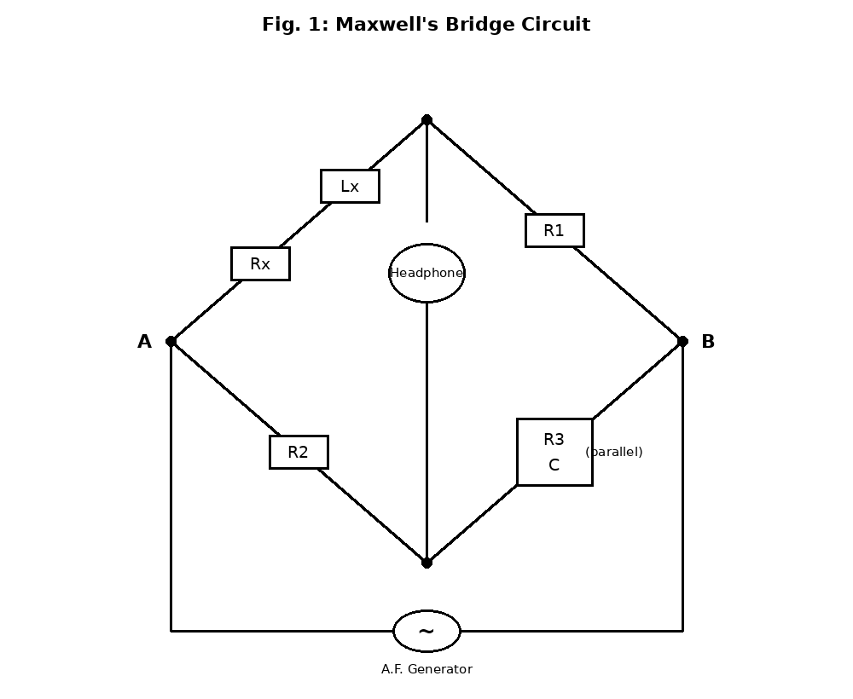

Procedure
- Connect the bridge from the components shown in the diagram; R1, R2, and R3 are decade resistance boxes, and C is a decade capacitance box.
- Set R2 to approximately 100 and R3 to 1 k.
- Set the generator to give a 1 kHz output and switch it on.
- A tone will now be heard in the headphones; change the value of C until no tone is heard.
- Balance is indicated when no tone is heard at all; if the bridge cannot be balanced by varying C alone, change the value of R1 and then try again.
- When the bridge is balanced, note the values of R1, R2, R3, and C, and enter these values in Table 203-1.
- Use five different values of R1 and balance the bridge each time, entering the values of R1, R2, R3, and C in Table 203-1.
- Complete Table 203-1, calculate Lx and Rx at each reading using the formulae given, and find their average values.

Observation
Table 203-1 — Maxwell's Bridge Balance Readings
R1 (Ohm) | R2 (Ohm) | R3 (Ohm) | C (µF) | Lx (mH) | Rx (Ohm)
100 | 100 | 1000 | 20 | 200 | 10
200 | 100 | 1000 | 15 | 300 | 20
300 | 100 | 1000 | 10 | 300 | 30
400 | 100 | 1000 | 7 | 280 | 40
500 | 100 | 1000 | 5 | 250 | 50
Sample calculation (Reading 2): Rx = (R1 x R2) / R3 = (200 x 100) / 1000 = 20 Ohm. Lx = R1 x R2 x C = 200 x 100 x 15µF = 300,000 µF.Ohm², which converts to 300 mH.
Average value of Lx = 266 mH. Average value of Rx = 30 Ohm (the small spread in Rx between readings is normal experimental variation, since R1 was deliberately changed at each step to re-balance the bridge).

Method 2: Transient Voltage and Time of R-L Circuit

Apparatus
- A.F. Signal Generator (1)
- Inductor of Unknown Value (1)
- A Resistor of Known Value (1)
- Oscilloscope (1)

Diagram

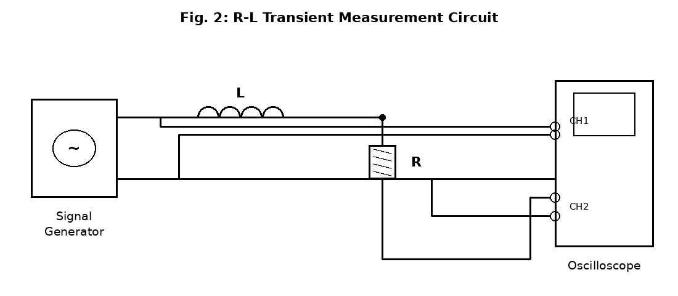

Procedure
- Connect the circuit as shown in Fig. 2, with the inductor and resistor in series across the signal generator, Channel 1 of the oscilloscope connected across the generator output, and Channel 2 connected across the resistor.
- Set both channels of the oscilloscope to 1 volt/cm and CAL, trigger on Channel 1, and set the sweep to chop; set the time base to 1 ms/cm and CAL, use internal trigger, set the trigger level to AUTO, and set the horizontal gain to CAL.
- On the signal generator, switch the frequency to the range 100 Hz - 1 kHz and set the dial to give a 1000 Hz output; set the output voltage to about 5 V, and set the function switch to square wave.
- Switch on the equipment and make any fine adjustments found necessary.
- Observe the two waveforms now visible on the scope, adjusting the STABILITY control to give a stable picture.
- Superimpose the waves on the screen and sketch their waveform accurately on the graph paper.
- Measure the voltage, VR, at each time division of the scope, fill in Table 203-2, calculate the value of L at each reading using the formula given, and find its average value.

Observation
Table 203-2 — R-L Transient Readings (Applied Voltage V = 5 V, R = 1000 Ohm)
Time t (µs) | VR (Volts) | L = tR / ln(V/(V-VR)) (mH)
100 | 1.57 | 266
200 | 2.64 | 266
300 | 3.38 | 267
400 | 3.89 | 267
500 | 4.24 | 266
Sample calculation (Reading 3): L = tR / ln(V/(V-VR)) = (300 x 10^-6 x 1000) / ln(5/1.62) = 0.3 / ln(3.086) = 0.3 / 1.127 = 0.266 H = 266 mH.
Average value of L = 266 mH, which agrees closely with the average value of Lx found by Maxwell's Bridge in Table 203-1.

Precaution
- The decade resistance and capacitance boxes were set carefully, and their dial readings were checked before each balance was recorded.
- The bridge was balanced by adjusting one component at a time, listening carefully for the point of minimum (zero) sound in the headphones.
- The output voltage of the A.F. generator was kept at a safe, moderate level throughout the bridge test, to avoid an uncomfortably loud tone in the headphones.
- In the transient test, the oscilloscope controls (VOLTS/DIV, TIME/DIV, and trigger settings) were all correctly calibrated (set to CAL) before any readings were taken.
- The frequency of the square wave was kept low enough to allow the current in the R-L circuit to rise and fall fully in each half-cycle, giving a clear, complete transient to measure.
- Readings of VR were taken carefully at exact time divisions on the screen, to reduce reading error in the calculated inductance.
- All equipment was switched off immediately after each part of the experiment was completed.

Conclusion
This experiment showed that the value of an unknown inductor can be found in two different ways, and that both Maxwell's Bridge method and the R-L transient method gave closely agreeing results, each showing an inductance of about 266 mH. Maxwell's Bridge method, being a balanced A.C. bridge, also allowed the winding resistance of the inductor to be estimated, giving useful extra information that the second method could not provide, although this value showed more spread between readings than the inductance did. The transient method, on the other hand, clearly demonstrated the exponential growth of current in an R-L circuit and showed how the time constant of such a circuit can be used to calculate an unknown inductance from a measured voltage and time. Overall, the experiment confirmed that both methods are valid and complementary ways of measuring inductance, with the bridge method offering additional information about the inductor's resistance, and the transient method offering a simpler and more direct way of observing the behaviour of an inductor in a circuit.

