EXPERIMENT 206
THE SINGLE PHASE TRANSFORMER

Aim
The aim of this experiment is to study the single phase transformer by carrying out three related tests: a Ratio Test, to verify that the voltage ratio between the primary and secondary of a transformer is equal to its turns ratio; a No-Load Test, to study the transformer's behaviour and losses when its secondary is open-circuited; and a Load Test, to study its behaviour, and calculate its efficiency, when a load is connected to its secondary.

Objective
- To verify that the secondary to primary voltage ratio, V2/V1, of a transformer is equal to its secondary to primary turns ratio, N2/N1.
- To demonstrate that a transformer takes a small power from the mains supply even when no power is taken from its secondary, due to core (iron) losses inside it.
- To measure how the no-load current and power taken by a transformer change as the primary voltage is increased.
- To measure the primary and secondary voltage, current, and power of a transformer under different load conditions, and to calculate its efficiency at each load.

Apparatus
- Variac, 0 - 270 V, 8 A, 2 kVA (1)
- Transformer, Foster Type 2/3 (1)
- A.C. Voltmeter, 0 - 300 V (2)
- A.C. Voltmeter, 0 - 100 V (1)
- A.C. Ammeter, 0 - 10 A (2)
- A.C. Ammeter, 0 - 1 A (3)
- Low Power Factor Wattmeter (1)
- Wattmeter, 1/5 - 10 A, 125/240/600 V (1)
- Resistance Load Bank (1)

Theory
A transformer is a static (no moving parts) electrical machine that transfers electrical energy from one circuit to another, at the same frequency, usually with a change in voltage, by the principle of mutual electromagnetic induction. It consists of two windings, called the primary and the secondary, wound on a common iron core. When an alternating voltage is applied to the primary winding, it sets up an alternating magnetic flux in the core; this changing flux links with the secondary winding and induces an e.m.f. in it.
For an ideal transformer (one with no losses), the ratio of the primary voltage to the secondary voltage is equal to the ratio of the number of turns on the primary winding to the number of turns on the secondary winding, that is, V1/V2 = N1/N2, or equivalently V2/V1 = N2/N1. In a real transformer, this relationship holds only approximately, since there are always some small losses and voltage drops in the windings; the Ratio Test carried out in this experiment checks how closely a real transformer follows this ideal relationship.
Even when a transformer is on open-circuit (no load connected to its secondary, so no current flows in it), it still draws a small current and a small amount of power from the mains supply. This happens because an alternating flux in the iron core produces two kinds of core (or iron) losses: hysteresis loss, caused by the repeated magnetising and demagnetising of the core material, and eddy current loss, caused by small circulating currents induced within the core itself. Since these losses depend only on the supply voltage and frequency, and not on the load, they are present all the time the transformer is switched on, whether or not it is supplying any load. The No-Load Test measures this core loss directly, by supplying the primary at various voltages with the secondary left open, and recording the small current and power taken at each voltage; because the current on no-load is small and mostly magnetising (reactive) in nature, the power factor, Cosβ, on no-load is usually quite low.
When a load is connected to the secondary of a transformer, a current flows in both windings, and an additional loss appears: copper loss (also called I-squared-R loss), caused by the resistance of the copper wire in the windings heating up as current flows through it. Unlike the core loss, copper loss increases rapidly as the load current increases, since it is proportional to the square of the current. The Load Test carried out in this experiment measures the input power (on the primary side) and the output power (on the secondary side) at several different load currents, so that the efficiency of the transformer, defined as the ratio of output power to input power, can be calculated at each load. In general, the efficiency of a transformer is lower at very light loads (where the constant core loss is large compared with the small power being delivered), rises as the load increases, and then falls again at very heavy loads (where the rapidly growing copper loss begins to dominate).
Copper loss is not directly investigated in the No-Load Test, since almost no current flows in the windings when the secondary is open. It occurs whenever current flows through the resistance of the primary and secondary windings, and, being an I-squared-R loss, it becomes significant only when the transformer is carrying a reasonable load current, which is why it is instead studied in the Load Test. A separate test, called the Short-Circuit Test, is normally used to measure copper loss on its own: the secondary terminals are short-circuited through an ammeter, and only a small voltage is applied to the primary, just enough to circulate the full-load rated current in the windings. Because this applied voltage is so small, the flux in the core, and therefore the core loss, is negligible during this test, so almost all of the power measured by the wattmeter in this condition can be taken as the copper loss of the transformer at full load.

Test 1: Transformer Ratio Test
Aim: To show that the secondary to primary voltage ratio, V2/V1, is equal to the turns ratio, N2/N1.

Diagram

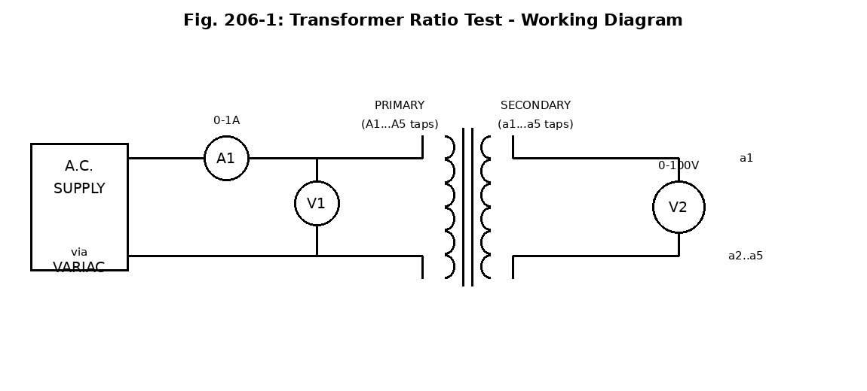

Procedure
- Set the Variac control dial to the zero (0) position.
- Connect up the Variac, the voltmeter V1 (0-220 V), the ammeter (0-1 A), and the transformer as shown in the working diagram.
- Connect the voltmeter V2 (0-100 V) across the secondary terminals a1-a2.
- Connect the Variac to the mains supply and switch it on, then turn the Variac dial to obtain 220 V on V1.
- Record on Table 206-1 the values of V1, V2, and the primary and secondary turns (as marked on the transformer).
- Connect voltmeter V2 in turn across terminals a1-a2, a1-a3, a1-a4, and a1-a5, and repeat the readings above at each connection.
- Fill up Table 206-1, and calculate the voltage ratio, V2/V1, and the turns ratio, N2/N1, at each setting.

Observation
Table 206-1 — Transformer Ratio Test Readings
N1 (Primary Turns) | N2 (Secondary Turns) | V1 (V) | V2 (V) | V2/V1 | N2/N1
192 | 8 | 220 | 10.0 | 0.045 | 0.042
192 | 16 | 220 | 17.5 | 0.080 | 0.083
192 | 32 | 220 | 37.5 | 0.170 | 0.167
192 | 40 | 220 | 45.0 | 0.205 | 0.208
Sample calculation (Reading 2): V2/V1 = 17.5 / 220 = 0.080. N2/N1 = 16 / 192 = 0.083. Since the voltage ratio and the turns ratio agree closely at every reading, the voltage ratio of the transformer is confirmed to be equal to its turns ratio.

Test 2: Transformer No-Load Test
Aim: To demonstrate that power losses (called core losses) occur internally in a transformer, by showing that the transformer takes power from the mains supply even when no power is taken out of it (that is, when the secondary terminals are on open-circuit).

Diagram

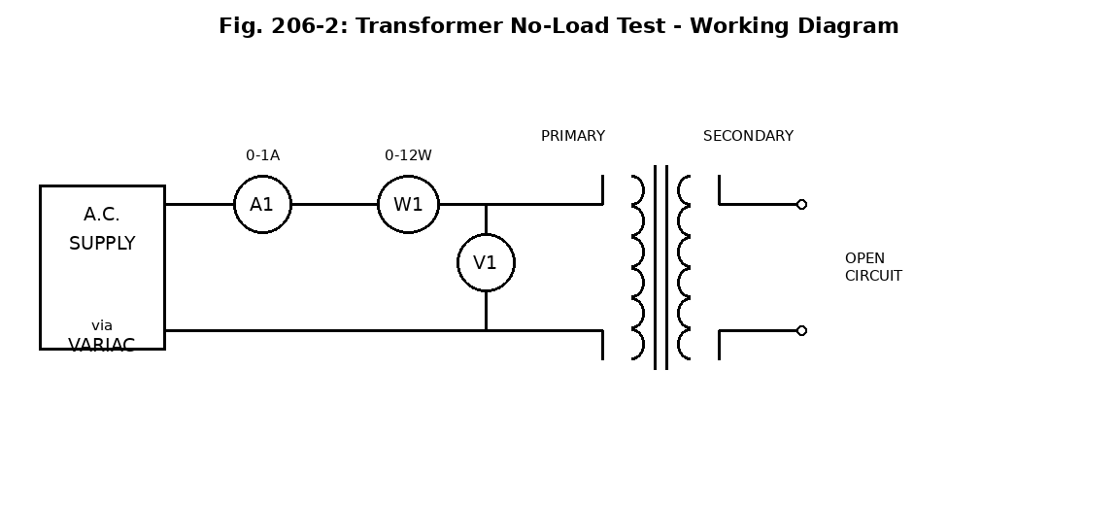

Procedure
- Reduce the Variac output to zero (0) and switch off the mains.
- Connect up the circuit shown in the working diagram, leaving the secondary terminals on open circuit, and using the wattmeter (0-12 W); get the supervisor to check the circuit.
- Switch on the mains to the Variac and turn the Variac control to obtain 40 V on voltmeter V1.
- Take the ammeter and wattmeter readings and record them on Table 206-2 as I1 and W1 respectively.
- Vary the Variac control to obtain 80, 120, 160, 200, and 220 V in turn on voltmeter V1, and repeat the readings above at each setting.
- Fill up Table 206-2, and plot a graph of the primary voltage, V1, against the loss, W1.

Observation
Table 206-2 — Transformer No-Load Test Readings
V1 (V) | I1 (A) | W1 (W) | Cosβ = W1/(I1V1)
40 | 0.04 | 1 | 0.625
80 | 0.08 | 3 | 0.469
120 | 0.12 | 5 | 0.347
160 | 0.18 | 7 | 0.243
200 | 0.22 | 10 | 0.227
220 | 1.00 | 12 | 0.055
Sample calculation (Reading 3): Cosβ = W1 / (I1 x V1) = 5 / (0.12 x 120) = 5 / 14.4 = 0.347.
The no-load current and the core loss, W1, both increase as the primary voltage increases, with a much sharper rise near and above the rated voltage (220 V), where the iron core begins to saturate; the power factor on no-load, Cosβ, is low throughout and falls further as the voltage increases, since the no-load current is mostly a magnetising (reactive) current rather than a current in phase with the voltage.

Test 3: Transformer Load Test
Aim: To determine transformer efficiency, that is, the ratio of output power to input power.

Diagram

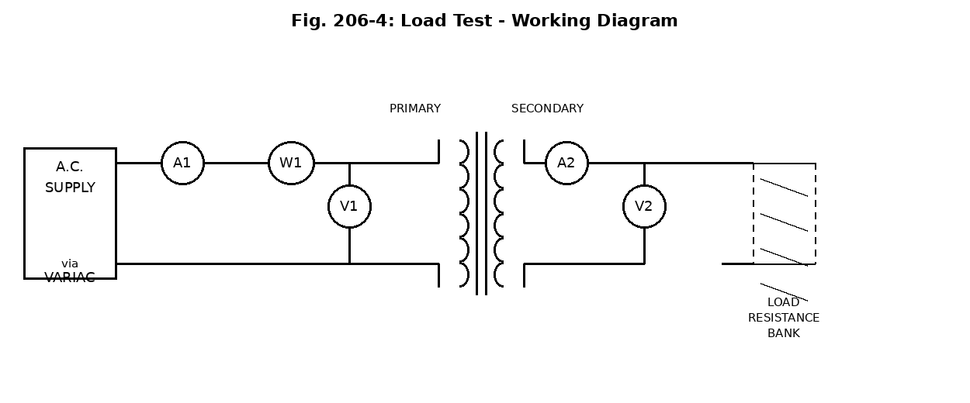

Procedure
- Turn the Variac dial to the '0' position, and switch off the mains from the Variac.
- Connect up the circuit shown in the working diagram; use the instrument ranges indicated, connect the load bank resistance circuits in parallel, and turn all load bank dial settings to the OFF position; get the supervisor to check the circuit.
- Connect the mains to the load bank and switch on its fan (the load bank must not be used if the fan is not working).
- Switch on the mains to the Variac and vary the dial to obtain 220 V on voltmeter V1.
- Switch one of the load bank dials to position 400 and use its associated trimmer control to set the current on ammeter A2 to 2 A (caution: the higher the dial number setting, the larger the current).
- Record the readings of V1, V2, A1, A2, and the wattmeter on Table 206-4.
- Use the load bank dial switches and trimmers to set the reading of A2 to 4, 6, 8, and 10 A in turn, and repeat the readings above at each setting.
- Turn the Variac dial to the '0' position and switch off the mains to the Variac, then fill up Table 206-4.

Observation
Table 206-4 — Transformer Load Test Readings
V1 (V) | I1 (A) | W1 (W) | V2 (V) | I2 (A) | W2=V2xI2 (W) | Efficiency W2/W1
220 | 1.2 | 40 | 47.5 | 2 | 95.0 | 98.9%
220 | 1.5 | 80 | 47.5 | 4 | 190.0 | 97.8%
220 | 1.8 | 120 | 47.5 | 6 | 285.0 | 96.7%
220 | 2.1 | 160 | 47.5 | 8 | 380.0 | 95.6%
220 | 2.5 | 200 | 47.5 | 10 | 475.0 | 94.4%
The secondary voltage, V2, falls slightly as the load current increases, because of the small voltage drop inside the transformer's own windings, while the efficiency is high throughout but falls gradually as the load current increases, since the copper loss (which grows with the square of the current) takes up a larger share of the input power at the heavier loads.

Discussion
(i) Why does copper loss occur? Copper loss occurs because the copper wire used to wind the primary and secondary coils has some electrical resistance, and whenever a load current flows through this resistance, electrical energy is converted into heat (an I-squared-R loss). Since this loss depends on the square of the current, it is very small on no-load (where the current is small) but becomes significant as the load, and therefore the current, increases.
(ii) How would copper loss be measured? Copper loss can be measured separately using a Short-Circuit Test: the secondary terminals are short-circuited (through an ammeter, to monitor the current), and a small, gradually increasing voltage is applied to the primary until the full-load rated current flows in the windings. Since the applied voltage in this test is very small, the flux in the core, and therefore the core loss, is negligible; so almost all of the power recorded by the wattmeter during this test can be taken as the full-load copper loss of the transformer.

Precaution
- The Variac control dial was set to zero before switching on or off, and before making or changing any connection.
- The circuit was checked by a supervisor before power was applied, in every part of the experiment, including help with connecting the wattmeter.
- The instrument ranges specified were used throughout, to avoid damaging the meters, and the wattmeter range was changed appropriately between the No-Load Test (0-12 W) and the Load Test (higher range).
- The secondary was kept strictly open-circuit during the No-Load Test, and no load was connected to it at that stage.
- The load bank's cooling fan was switched on and checked to be working before the load bank was used, and the load bank dials were all left in the OFF position until the circuit had been checked.
- The load was increased gradually, in the steps specified, and the higher dial-number settings (which give larger currents) were approached carefully, as instructed.
- The Variac was returned to the zero position and the mains switched off at the end of each test, before changing the circuit for the next test.

Conclusion
This experiment showed that the voltage ratio of the transformer under test agreed closely with its turns ratio at every secondary tap tried, confirming the basic transformer voltage equation V2/V1 = N2/N1. The No-Load Test showed that the transformer takes a small current and a small amount of power from the supply even when no load is connected, confirming the existence of core (iron) losses, and that this no-load current and loss increase sharply as the primary voltage approaches and exceeds its rated value. The Load Test showed that the transformer delivers power to a resistive load with a high efficiency, generally above 94% over the range of currents tested, with the efficiency falling slightly as the load current increased, due to the growing copper loss in the windings. Together, the three tests gave a good overall picture of the characteristics of a single phase transformer, both on no-load and on load, and confirmed the theory of transformer action and transformer losses discussed above.

