EXPERIMENT EE 201
MEASUREMENT OF AN UNKNOWN RESISTANCE
by (1) Current-Voltage Measurement Method (2) Wheatstone Bridge Method

Aim
The aim of this experiment is to measure the value of an unknown resistor using two different methods, the current-voltage (V-I) measurement method and the Wheatstone Bridge method, and to determine the characteristics of the resistor.

Objective
- To determine the value of an unknown resistor using the current-voltage measurement method.
- To determine the value of the same unknown resistor using the Wheatstone Bridge method.
- To plot the voltage-current graph of the resistor and use it to study its characteristic.
- To compare the values of the unknown resistance found by both methods.

Theory
Every resistor obeys, at least approximately, Ohm's Law, which states that the current flowing through a conductor is directly proportional to the voltage applied across it, provided the temperature and other physical conditions remain constant. This relationship is written as V = IR, where V is the voltage across the resistor, I is the current flowing through it, and R is its resistance in ohms. For a resistor that obeys Ohm's Law (an ohmic resistor), a graph of voltage against current is a straight line passing through the origin, and the resistance R can be found either from a single pair of readings (R = V/I) or, more accurately, from the slope of the V-I graph, since using the slope makes use of all the readings taken and reduces the effect of small errors in any one reading.
Before any measurement is taken, the approximate value of a resistor can usually be found from the colour code printed on its body. Each colour represents a digit, and the bands are read in order to give the first two (or three) significant figures of the resistance, a multiplier, and finally a tolerance band; this gives a quick estimate of the resistance which can then be checked against the value found experimentally.
In the current-voltage method, a known current is passed through the unknown resistor from a D.C. power supply, and the corresponding voltage across it is measured with a voltmeter connected in parallel with the resistor, while an ammeter connected in series with the resistor measures the current. By taking several pairs of readings of current and voltage, and using R = V/I at each point (or the slope of the V-I graph), the value of the unknown resistance can be calculated. This method is simple, but its accuracy is limited by the accuracy of the meters used, and by small errors caused by the meters themselves drawing or diverting a little current or voltage from the circuit (meter loading error).
The Wheatstone Bridge method works differently, and does not depend directly on the accuracy of a voltmeter or ammeter to read the actual value. The bridge consists of four resistances arranged in a diamond shape: two known resistors, R1 and R2; the unknown resistor, Rx; and a variable resistor, R3, which can be adjusted using a four-dial resistance box. A galvanometer, together with a key (switch), is connected between the two midpoints of the diamond (points P and Q in the diagram), while the D.C. power supply is connected across the other two corners (points A and B). When the key is pressed and the value of R3 is adjusted until the galvanometer shows no deflection at all, the bridge is said to be balanced. At balance, no current flows through the galvanometer, which means the ratio of the resistances in the two arms on one side of the bridge is equal to the ratio of the resistances in the two arms on the other side. This gives the balance condition R1 / Rx = R2 / R3, from which the unknown resistance can be calculated as: Rx = (R1 x R3) / R2.
Because the Wheatstone Bridge method is a null method (it depends only on detecting zero current, not on reading an exact value from a meter), it can give a more accurate result than the direct current-voltage method, provided the known resistors R1, R2 and R3 are accurate and the galvanometer is sensitive enough to detect very small currents near the balance point. Taking several different combinations of R1 and R2, as done in this experiment, and averaging the values of Rx obtained, further improves the accuracy and reliability of the result.

Method 1: Current-Voltage Measurement Method

Apparatus
- Unknown Resistor (1)
- D.C. Power Supply, 0 - 15 V, 2 A (1)
- D.C. Voltmeter, 0 - 30 V (1)
- D.C. Ammeter, 0 - 2 A (1)

Diagram

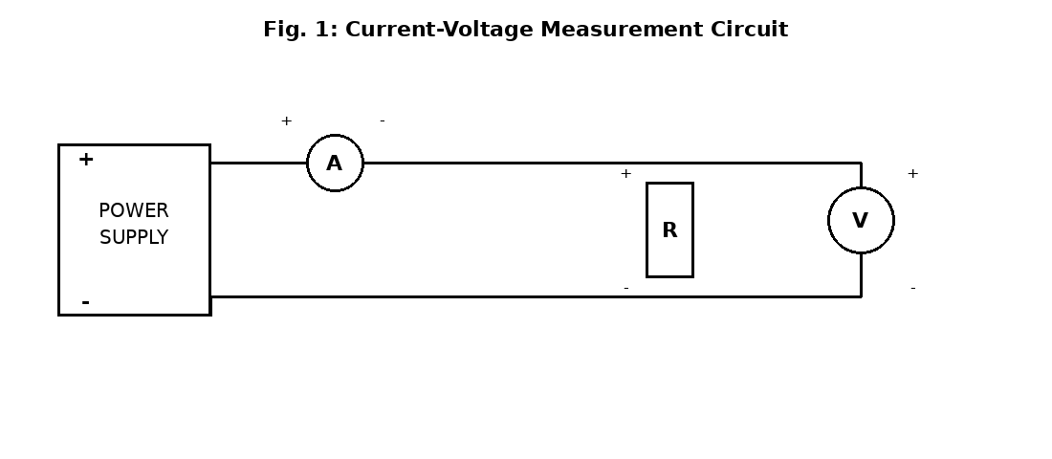

Procedure
- Find the value of the resistor given, using its colour code.
- Connect the circuit as shown in Fig. 1, with the ammeter in series with the resistor and the voltmeter connected in parallel across it, then switch on the power supply.
- Set the voltage so that the ammeter reads 3 mA, and read the corresponding voltage from the voltmeter; repeat this, increasing the voltage gradually so that the ammeter reads 6 mA, 9 mA, 12 mA, and so on, up to 30 mA, recording the voltage at each step.
- Record all the results in Table 201-1, calculate R = V/I at each step, and plot a graph of voltage against current.

Observation
Table 201-1 — Value of the Resistor by Current-Voltage Method
I | V (Volts) | R = V/I (Ohm)
3 mA | 3.0 | 1000
6 mA | 6.0 | 1000
9 mA | 9.0 | 1000
12 mA | 12.0 | 1000
15 mA | 15.0 | 1000
18 mA | 18.0 | 1000
21 mA | 21.0 | 1000
24 mA | 24.0 | 1000
27 mA | 27.0 | 1000
30 mA | 30.0 | 1000

Sample calculation (Reading 1): R = V / I = 3.0 / 0.003 = 1000 Ohm. The value of R = V/I is the same, 1000 Ohm, at every reading, which agrees with the straight-line V-I characteristic expected of an ohmic resistor.
Average value of R = 1000 Ohm (1 k Ohm).

Method 2: Wheatstone Bridge Method

Apparatus
- Unknown Resistor, Rx (the same resistor used in Method 1) (1)
- D.C. Power Supply (1)
- Wheatstone Bridge, with resistance boxes R1, R2, and a four-dial variable resistance box R3 (1)
- Galvanometer, Key, and Galvanometer sensitivity (protective) resistor (as part of the bridge unit)

Diagram

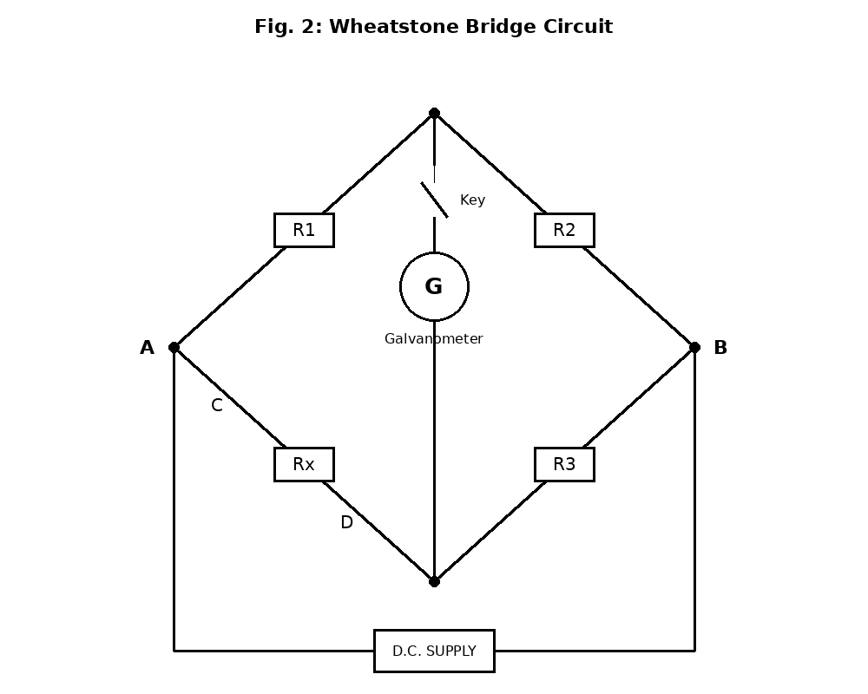

Procedure
- Connect the circuit as shown in Fig. 2; the connections shown by dotted lines on the bridge unit must also be made.
- Connect the unknown resistor, Rx, across the terminals C and D, and connect the D.C. power supply across the terminals A and B.
- Switch on the supply and set it to 2 V, with R1 = 10 and R2 = 10.
- Press the key and adjust R3 until the galvanometer shows zero deflection (the bridge is balanced); note this value of R3, and calculate Rx using Rx = (R1 x R3) / R2; enter the results in Table 201-2.
- Repeat the balancing process for each of the following settings, in turn: leave R1 = 10 but change R2 to 100; leave R2 = 100 but change R1 to 100; leave R1 = 100 but change R2 to 1000; and finally set R1 = 1000 and R2 = 100.
- Find the average value of Rx from the five values obtained.

Observation
Table 201-2 — Value of the Resistor by Wheatstone Bridge Method
R1 | R2 | R3 | Rx
10 | 10 | 1000 | 1000
10 | 100 | 10000 | 1000
100 | 100 | 1000 | 1000
100 | 1000 | 10000 | 1000
1000 | 100 | 100 | 1000
Sample calculation (Reading 2): Rx = (R1 x R3) / R2 = (10 x 10000) / 100 = 1000 Ohm.
Average value of Rx = 1000 Ohm (1 k Ohm), which agrees closely with the value found by the current-voltage method in Table 201-1.

Precaution
- The colour code of the resistor was read carefully and cross-checked against the measured value.
- The voltage was increased gradually and smoothly in both methods, and was never raised suddenly to a high value.
- In the Wheatstone Bridge test, the key was pressed only briefly while balancing, to avoid heating the resistors and to protect the galvanometer from a large deflection.
- The galvanometer sensitivity (protective resistor) was kept at a high value at the start of balancing, and only reduced gradually as the bridge got closer to balance, to protect the galvanometer from damage.
- All connections were checked to be firm and correct before switching on the power supply.
- The meter ranges used were checked to make sure they were suitable for the currents and voltages expected in the circuit.
- All equipment was switched off immediately after readings were completed.

Conclusion
This experiment showed that the value of an unknown resistor can be determined in more than one way, and that both the current-voltage method and the Wheatstone Bridge method gave closely agreeing results, each showing a resistance of about 1000 Ohm for the resistor tested. The current-voltage method also confirmed that the resistor obeys Ohm's Law, since the ratio V/I remained constant at every reading taken. The Wheatstone Bridge method, being a null method that depends on balancing rather than on direct meter readings, gave a result that did not depend on the accuracy of a voltmeter or ammeter, and repeating the balance with different combinations of R1 and R2 helped to confirm the reliability of the value obtained. Overall, the experiment demonstrated that the Wheatstone Bridge method is generally the more accurate of the two, while the current-voltage method remains a simple and useful way to check a resistance value and to study a resistor's voltage-current characteristic.

